Word Autocomplete Task Analysis

Program Description:-
In my program, I built an autocomplete system that recommends words for the given dictionary file. It loads a list of words from the dictionary text file and stores them in a balanced AVL tree. Then the user is prompted to enter a part of a word, which the program then searches the tree for words that start with the same letters and suggests possible words the user is trying to type.
The program implements a self balancing AVL tree, by using the rotation functions {rotateRight() and rotateLeft() } to balance the tree, whenever it detects that the tree is becoming unbalanced using the checkBalance() function. It is able to check the balance, because each node keeps track of its height (level), and after every single insertion, the tree is checked to see if any rotations are needed if it became unbalanced.
Recursion is used when searching the tree to check if the prefix matches any words, and since the tree is sorted alphabetically, the search avoids any unnecessary parts.

Function Breakdown:-
Function | Purpose
getHeight() | Returns the height of a node. Used to calculate the balance.
checkBalance() | Finds the difference in height between the left and right sides of the tree.
rotateLeft() / rotateRight() | These two rebalance the tree when it becomes unbalanced after insertions.
insert() | Inserts new words into the AVL tree while keeping it balanced.
findPrefix() | Recursively finds and stores all words starting with a user entered prefix.
toLower() | Converts all words and user input to lowercase so that the comparisons are not case sensitive.

Code Explained:-
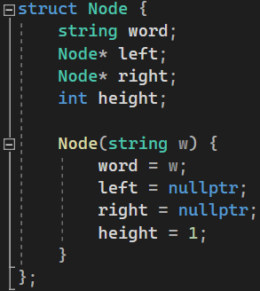
This part of the code creates the Node used in the AVL tree. Each node stores a word and links to its left and right child nodes and keeps track of its height which is used for balancing. In the constructor, I set the word, make both child pointers empty, and start the height at 1.

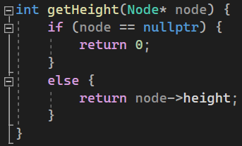
This function returns the height of a given node, and If the node doesn’t exist (nullptr) it returns 0. Otherwise, it returns the node’s stored height value. This is used the calculate balance and decide if rotations are needed for balancing.
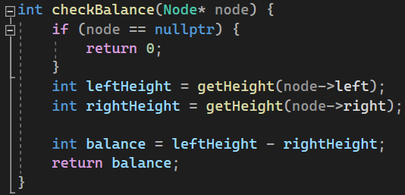
This function checks the balance of a node. It compares the heights of the left and right subtrees using the getHeight() function. The result shows if a node is unbalanced, a positive number means it’s unbalanced on the left, and a negative number means it’s unbalanced to the right.

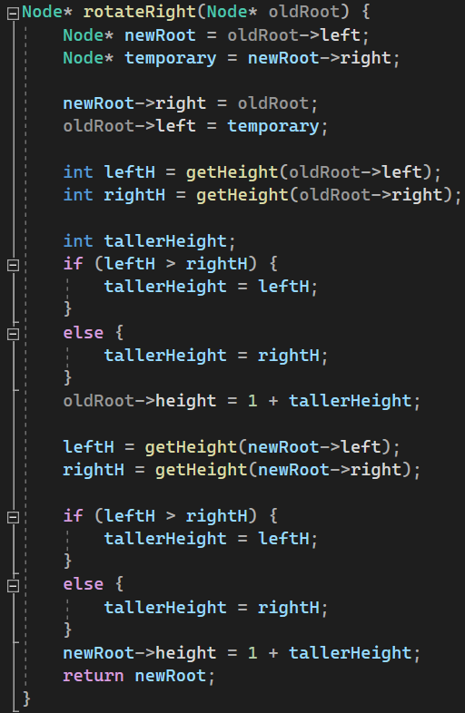
This function is used when a node becomes unbalanced to the left. It performs a right rotation to fix the unbalance. The left child node moves up and becomes the new root of that subtree, while the original node (oldRoot) moves down to become the right child of the newRoot. A temporary pointer is used to safely store any subtree that needs to be reattached, making sure no links are lost during the rotation. After the rotation is done, the function updates the height values of both nodes using the getHeight() function. This keeps the height information accurate, to make sure the tree is still balanced and ready for future words to be inserted.

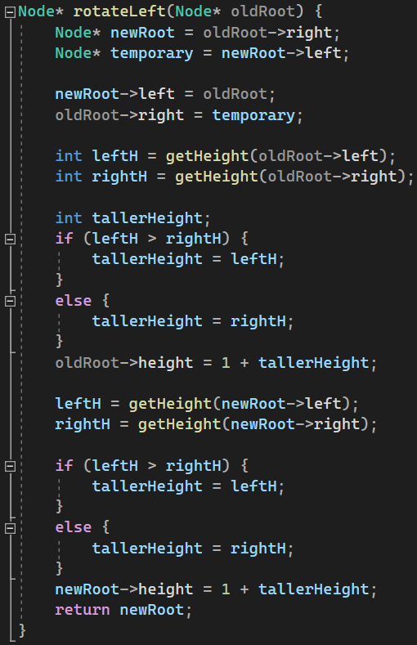
This function is very similar to the rotateRight() function, except this is used when a node becomes unbalanced to the right. It performs a left rotation to fix the unbalance. The right child node moves up and becomes the newRoot of that subtree, while the original node (oldRoot) moves down to become the left child of the newRoot. This function also maintains balance for future insertions, like the right rotation version.
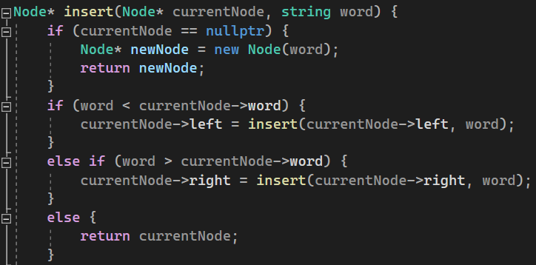
This is the first part of the insert function, and it is responsible for placing a new word in the correct position inside the AVL tree. First checks if the current spot is empty (nullptr). If it is, a new node is created with the given word and returned. If the node already exists, the new word is compared alphabetically with the word stored in the node.
- If the new word is smaller, it becomes the left child,
- If it’s larger, it becomes the right child.
Finally, If the word is exactly the same, it returns the current node since you cannot store the same word twice. Recursion is used, allowing the function to move down the tree until it finds the correct position for the new word.

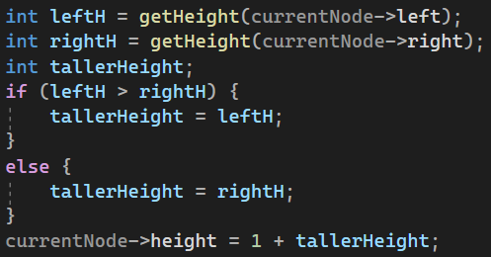
This part of the function updates the height of the currentNode after inserting a new word. It first gets the heights of the left and right child nodes using the getHeight() function, then finds which one is taller. The node’s height is set to one plus the taller child’s height, keeping the height information accurate, which is important for checking the balance of the tree later.

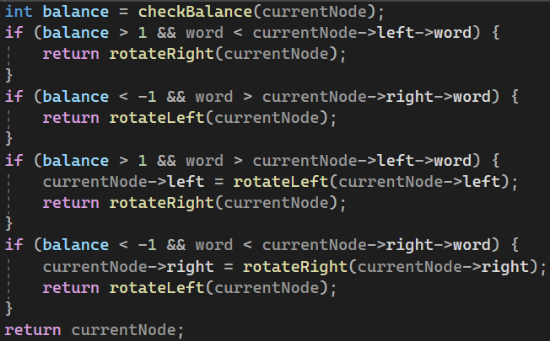
This is the final part of the insert function, where it checks whether the current node has become unbalanced after inserting a new word. It first calculates the balance using the checkBalance() function, which compares the heights of the left and right subtrees. Depending on the balance value, the code decides which type of rotation is needed:
- Left heavy (balance > 1): uses rotateRight() to balance the tree.
- Right heavy (balance < -1): uses rotateLeft() to balance the tree.
- For more complex cases (left- right or right-left imbalance), it performs two rotations to balance the tree.
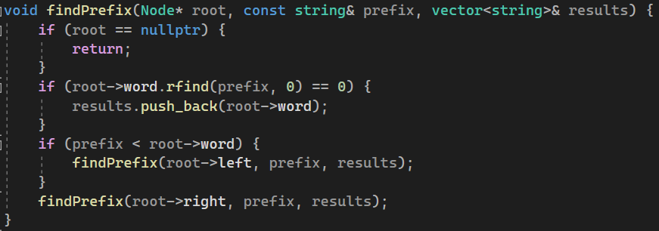
This function searches the tree to find all words that start with the user’s entered prefix. First, it checks if the current node exists if it doesn’t, the function stops. Then it checks if the word in the node starts with the same letters as the prefix, if it does, it is added to the results list (using vector). The function keeps searching both left and right sides of the tree to make sure all words are compared to user’s input.

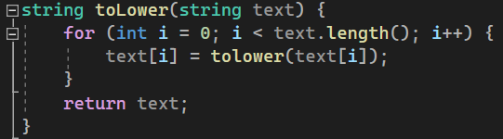
This function converts every character in a string to lowercase, to make sure that capital letters don’t affect the search.

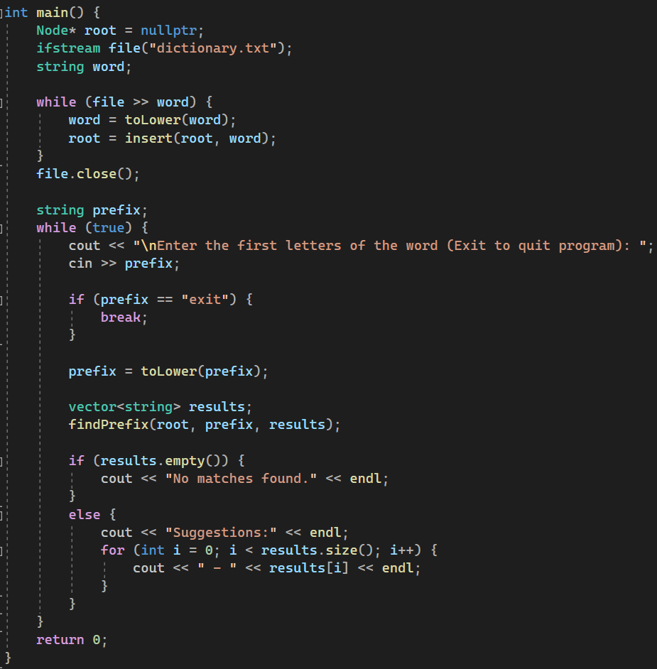
This is the main function, it opens the dictionary text file, converting each word to lower case, before adding it to the AVL tree. After loading, the user can type a prefix to get suggestions or type (exit) to quit. For each input, the program searches the tree using findPrefix() and displays all the matching words.

Sample Output:
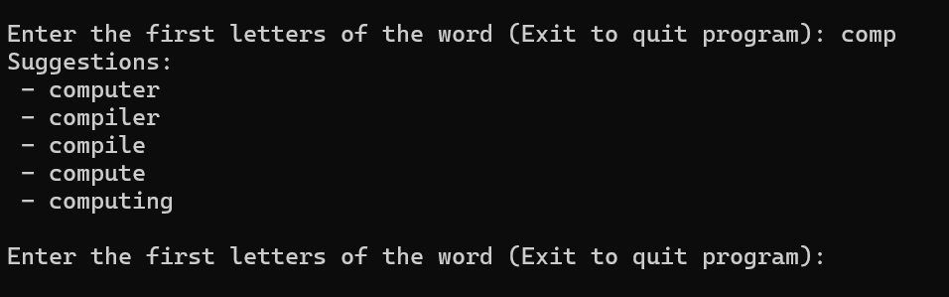

Complexity Analysis:-
The self balancing AVL tree balances itself after every insertion, so the height of the tree stays at log(n), where n is the number of words in the dictionary, meaning that inserting a new word and searching for a match takes O(log n) time. However, because the findPrefix() function checks every possible node for the user’s input, the total time can become O(k + log n), where k is the number of matching words found. The program is very efficient because balancing the tree prevents long unbalanced branches that would significantly slow it down.

Conclusion:-
In conclusion, my program builds an autocomplete system using an AVL tree to store and search for words effectively. It demonstrates how the AVL structure keeps data sorted and balanced, allowing for quick insertions and searches. The program automatically balances itself after every insertion, and after testing it many times in different ways, it was successful in every test.

GitHub Link:-
https://github.com/Abdulrahman-Elzemety/Task-3-Word-Autocomplete/tree/main

