Anagrams Detector Analysis

Program Description:-
In this task I was asked to implement a program that compares two words which are entered by the user and checks if they are anagrams. In my program this was done using a bubble sorting algorithm to sort both words in alphabetical order. Then both words are compared against each other, if they are ana exact match then they are anagrams, if not then the program returns that the words are not anagrams. Also, I implemented a quick length check before the sorting of the words is done, because if they are not the same length then they can never be anagrams. This skips the sorting step fully, saving time.

Code Explained:-
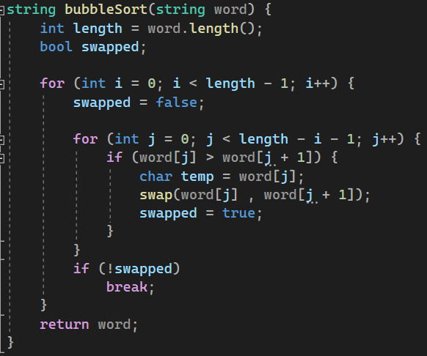
This is the bubble sort function, which takes the words given by the user later in the program and sorts each one alphabetically. The function uses two nested loops, the outer loop is for the number of passes that will be done, depending on the length of the word. The inner loop compares characters that are next to each other and swaps them if they are not in alphabetical order. This repeats until the whole word is sorted. Swapped is used to break out of the loop early if no swaps are done during a full pass, since this means that the word is already sorted.

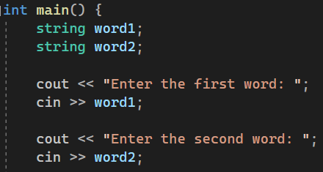
This simply just takes both words from the user.

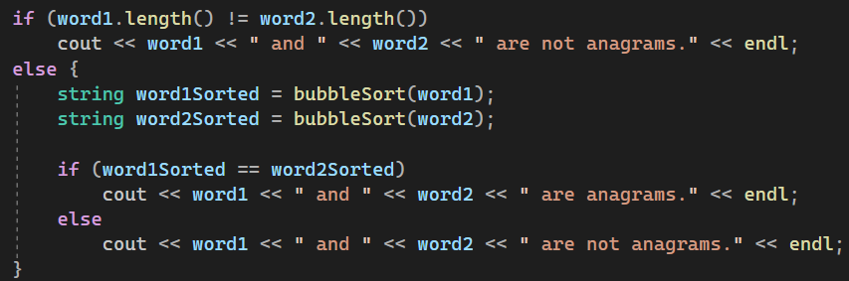
Here, before the bubble sort is used, the words lengths are compared, since they have to be equal length for them to be anagrams, this prevents unnecessary sorting and optimizes my program. If they are equal length, both words are sorted alphabetically using the previous bubble sort function, then the sorted words are compared and if they are exactly the same they are anagrams, otherwise they are not.

Complexity Analysis:-
The complexity of my program is O(n²), this is because of the bubble sort function which has two nested loops used for passing through the characters of the word. This would be considered inefficient if it was going to be used for larger datasets, but since it is used for only comparing two words it will not matter.

GitHub Link:-
https://github.com/Abdulrahman-Elzemety/Task-4-Anagrams

