Alternating Disks Task Analysis

Program Description:-
In this task, I implemented a program that solves the alternating disks problem. The alternating disks problem starts with an initial state of a row of 2n disks where n is the number of dark disks as well as the number of light disks. Dark and light disks are always equal. They are arranged in an alternating pattern (DLDLDLDL). The objective is to rearrange the disks so that all light disks are on the left side and all of the dark disks are on the right side (LLLLDDDD), while only swapping the adjacent elements. The easiest solution was to use a bubble sorting algorithm, as this compares adjacent elements.
First, my program takes the n (number of disks of each type of disk) from the user , then it creates the alternating starting pattern. After that, it uses a bubble sorting algorithm, but instead of integers it compares D (dark disk) and L (light disk). In the bubble sort, it moves dark disks to the right and the light disks to the left by swapping any adjacent D and L where the L is to the right of the D. The number of swaps are counted to show the total number of moves required to reach the goal state.

Code Explained:-
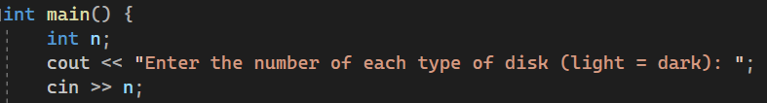
This part of the code simply takes the n (number of each type of disk) from the user.

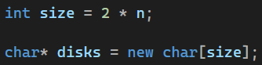
First, I calculate the total number of disks by multiplying n by 2, since there are an equal number of light and dark disks. Then I create a dynamic character array of that size, which will store the alternating pattern of D and L, which will be used later for the swapping to sort it.

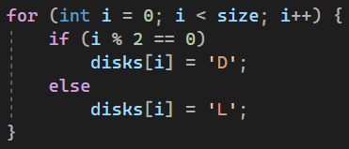
This section creates the initial state. The program loops through the entire array and assigns a character to each position. All even indexes are assigned the character D (dark disk) and all odd indexes are assigned the character L (light disk). This creates the initial state (DLDL), which is the starting state of the alternating disks problem.
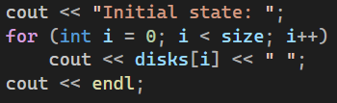
This part of the code just displays the initial state of the alternating discs puzzle (before any swaps are done), using the parts of the code above.

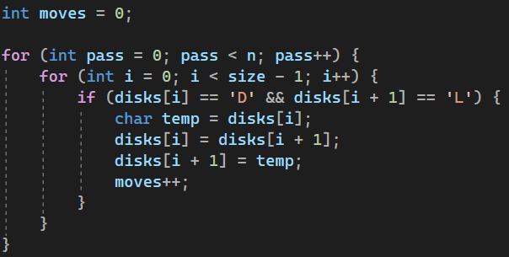
This is the main part of the program where the swaps occur using a bubble sort like method. There are two nested loops like in a bubble sort, where the outer loop controls the number of passes, and the inner loop checks each pair of adjacent disks. Whenever it finds a D (dark disk) followed by a L (light disk) it swaps them, which moves the light disk to the left and the dark disk to the right. With each swap the moves counter is increased, to keep track of the total number of moves to reach the goal state from the initial state.

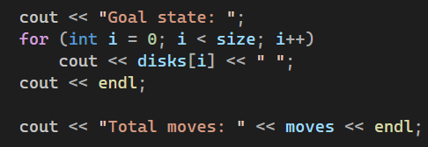
This just prints the final goal state as well as the total number of moves taken to reach it.

Sample Output:
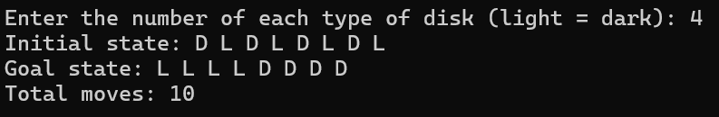
Complexity Analysis:-
The main part of the program uses two nested loops to perform the swapping process. The outer loop runs n times, because the disks must be checked repeatedly to make sure that all light disks are moved to the left and that all dark disks are moved to the right. Inside each pass, the inner loop goes through the entire array of size 2n and checks each pair of adjacent disks. This means that the complexity is O(n²), just like a normal bubble sorting algorithm.

Conclusion:-
In conclusion, my program is able to successfully solve the alternating disks problem by using a bubble sort like approach to arrange the disks correctly to reach the goal state. It starts by creating the alternating pattern based on the number inputted by the user and then it keeps swapping any adjacent D and L disks that are out of order. Eventually, it moves all L disks to the left followed by all D disks to their right. In addition, the program also keeps track of the number of swaps needed to reach the goal state from the initial state. After testing the program with different n values, it always produced the correct goal state, showing that my program successfully solves the alternating disks problem.

GitHub Link:-
https://github.com/Abdulrahman-Elzemety/Task-5-Alternating-Disks

