Fake Coin Task Analysis

Program Description:-
In this task I wanted to create a program that is able to detect a fake coin from a group of coins, by using a two pan scale. In the task requirements, I had to take an input from the user where n (number of coins) was more than 2, and the complexity of the program had to be O(1). This however is impossible, because taking an unknown number from a user and storing it in a dynamic array will require loops and will make the program have a time complexity of O(n). So, for this task I created two programs, the first one has a time complexity of O(n) but stores any number of coins inputted by the user. The second program has a time complexity of O(1), but only compares 3 coins, which cannot be changed.
Program 1 (Any number of coins O(n)):
In the first program, the user can enter any value of n (total number of coins), as long as it is bigger than 2, however because n is unknown, I created a dynamic array to store all coin weights, which are also entered by the user, making sure that all real coins have the same weight and that there is only one fake coin which is either lighter or heavier than the rest. To fill this array a loop is required that runs n times, which automatically makes the program have a time complexity of O(n).
After storing the coins, I divided them into three equal groups, and if n was not divisible by 3, the extra coins (1 or 2) are not stored in any groups and will only be used later in the code if all three groups had equal weight, which means that the fake coin was one of the extras not stored in a group.
It starts by comparing group A and group B:
- If they are equal, then that means that the fake coin must be in group C or in the extras.
  - Then group A is compared to group C
  - If group A > group C, then that means that the coin is lighter and in group C.
  - If group A < group C, then that means that the coin is heavier and in group C.
  - The last scenario is if group A is equal to group C.
    - This takes us to the final step which is comparing a coin from group A (all are real coins) to each of the ungrouped coins one by one (using a for loop).
    - If coin from group A > ungrouped coin, then the fake coin is lighter.
    - If coin from group A < ungrouped coin, then the fake coin is heavier.
- If group A > group B, then that means that the fake coin is heavier and in group A or lighter and in group B.
- If group A < group B, then that means that the fake coin is lighter and in group A or heavier and in group B.
Because there is only one fake coin, and all real coins have the same weight the program can determine if the fake coin is heavier or lighter by comparing the total weights of the groups, or if all groups are equal then it compares the weight of one coin known to be real from group A to the extra coins not allocated in any group.
Program 2 (Exactly 3 coins O(1)):
In the second program, I solved the same problem but with the time complexity being O(1). To do this, the number of coins had to be fixed, because allowing the user to enter an unknown number of coins would require loops or dynamic memory, which means that the time complexity is increased to O(n).
Therefore, in this program, I assume that there is only 3 coins and the user is only asked to enter the weights of these three coins, two of them being the same wight (real coins) and only one having a lighter or heavier weight (fake coin). Because the amount of work done by the program does not change regardless of input, the complexity remains constant at O(1).
This is how the program works:
- First it takes the weight of the 3 coins from the user.

- Then it checks if coin 1 and coin 2 have the same weight.
  - If they do this means that the fake coin is coin 3.
  - Then it compares Coin 1 (real coin) with coin 3. If coin 3 > coin 1 then the fake coin is heavier otherwise it is lighter.
- If coin 1 > coin 2, then that means that the fake coin is coin 1 and heavier or it is coin 2 and lighter.
  - Then if coin 1 > coin 3, then that means that coin 1 is the fake one and it is heavier.
  - Otherwise, the fake coin was coin 2 and it is lighter.
- If coin 2 > coin 1, then that means that the fake coin is heavier and is coin 2 or it is lighter and is coin 1.
  - Then if coin 2 > coin 3, then that means that coin 2 is the fake coin and it is heavier.
  - Otherwise, it is coin 1 and is lighter.
The above three cases are the only possible scenarios in this program, and it is successfully able to determine whether the fake coin is heavier or lighter using a fixed number of comparisons, without any loops or arrays, and because the amount of work performed is always the same, regardless of user input, the time complexity is O(1).

Code Explained:-
Program 1 (Any number of coins O(n)):

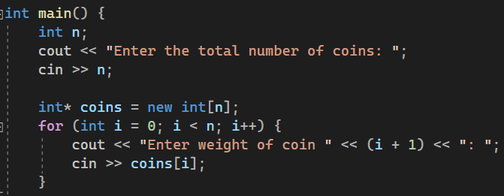
This part of the code takes the total number of coins (n) from the user and stores it. Then a dynamic array is created based on the user’s input and then using a for loop, the user is asked to enter the weight of each coin and finally all the weights are stored in the array.

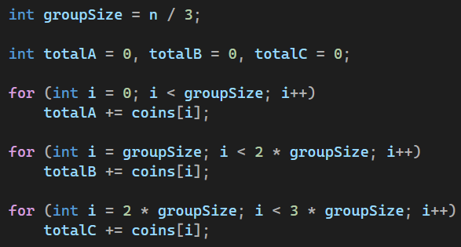
This part of the code divides the coins into three equal groups and calculates the total weight of each group (stored in totalA, totalB and totalC). groupSize splits the coins into three equal piles with any extra coins not stored in any group (1 or 2 coins) and will be handled in a later part of the code.

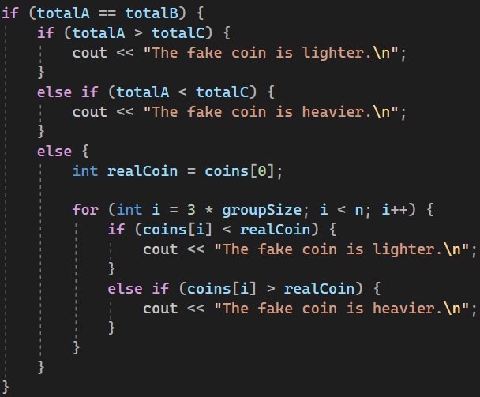
This part of the code is checks if group A and group B have the same total weight. If they do, then group A (now known that all coins in it are real) is compared to group C.
- If Group C is lighter, the fake coin is in Group C and is lighter.
- If Group C is heavier, the fake coin is in Group C and is heavier.
- If all three groups have equal weight, then the fake coin has to be in the extra coins (the coins not included in any of the three groups).
To find the fake coin from the extras, the program:
We take a sample coin from group A (which is guaranteed to be real (realCoin)) and compares it against each extra coin.
- If an extra coin is lighter, then the fake coin is lighter.
- If an extra coin is heavier, then the fake coin is heavier.
This comparison is done by the for loop, starting from groupSize * 3, which makes us skip all the coins in the three groups.

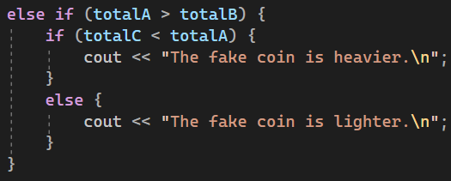
This is the second case, where group A is heavier than group B, since one group is heavier, then that means that the fake coin must be either:
- heavier and in Group A.
- lighter and in Group B.
To know which one, we compare group C with group A:
- If group C is lighter than group A, then the fake coin is in group A, and it is heavier.
- Otherwise, if group C is not lighter than group A, then the fake coin is in group B, and it is lighter.
This is because all coins in group C are now know to be real (since Group A is not equal group B).

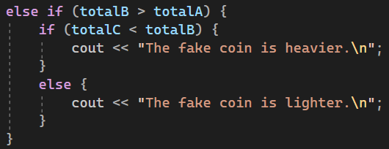
This is the third and final case, where group B is heavier than group A. The logic is exactly as in case 2, except that group B is compared to group C (since it was heavier this time not group A).

Program 2 (Exactly 3 coins O(1)):
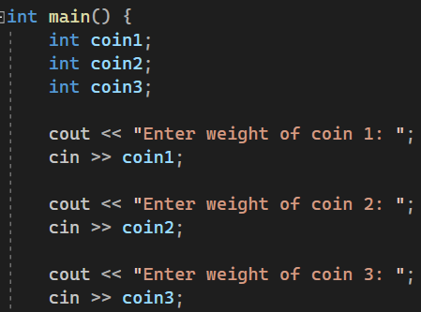
Here we simply create the three coins, and we take each of their weights from the user and store them (coin1, coin2 and coin 3).

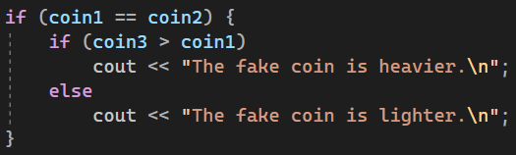
This is the first of the three possible scenarios. If coin 1 and coin 2 are equal, then that must mean that coin 3 is the fake one. To know if it is heavier or lighter, coin3 is compared to coin 1 and if it is heavier then the fake coin is heavier than the real coins, otherwise the fake coin is lighter.

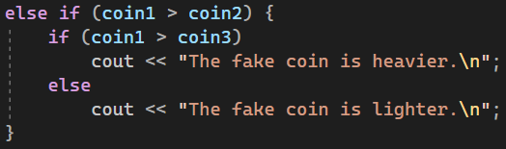

This is the second scenario, where coin 1 is heavier than coin 2. This means that one of them is the fake coin and coin 3 is definitely a real coin. To know which one is fake and if it is heavier or lighter, we compare coin 1 to coin 3. If coin 1 is heavier then that means that it was the fake coin and is heavier than the real ones. Otherwise, coin 2 was the fake one and is lighter than the real coins.
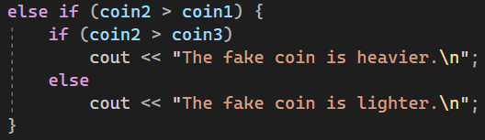
This is the third and final scenario, where coin 2 is heavier than coin 1. This also means that one of them is the fake coin and coin 3 is a real coin. To determine the fake coin, we compare coin 2 to coin 3 (real coin) and if it is heavier then it was the fake coin and is heavier. Otherwise, coin 1 was the fake coin and is lighter.

Complexity Comparison:-
This is a brief comparison between the two programs as the time complexity of each was discussed in detail previously. Program 1 and program 2 solve the same problem but with different time complexities. Program 1 allows the user to enter any number of coins, which requires loops for storing the coin weights and comparing groups. This makes its time complexity O(n), since the amount of work increases as the number of coins increases. However, Program 2 works with a fixed set of exactly three coins, performing only a constant number of comparisons with no loops or dynamic memory. Because the amount of work never changes regardless of input, its time complexity remains O(1).

Conclusion:-
In this task, I had to implemented two different solutions to the fake coin problem, each with a different time complexity. This is because it is impossible to take any number of coins from the user and keep the program’s time complexity at O(1). The first program takes any number of coins from the user and therefore requires loops, resulting in a linear time complexity of O(n). The second program solves the same problem using a constant number of operations by fixing the coin number at three, achieving an O(1) time complexity.

GitHub Link:-
https://github.com/Abdulrahman-Elzemety/Task-5-Fake-coin

