Genetic Algorithm System
Capacitated Vehicle Routing Problem (CVRP)
Section 2 — Project Documentation
Dataset: Augerat A-n32-k5 | Known Optimal: 784 | Best Result: 845.13 (7.8% gap)
Submission: 11 June 2026

Table of Contents
Doc # | Section | Page
D5 | System Design | 2
D6 | Implementation — Genetic Operators & Parameters | 4
D7 | Experiments & Results | 6
D8 | User Manual | 9
D9 | References | 10

D5 — System Design

1. Problem Description
The Capacitated Vehicle Routing Problem (CVRP) is a classical combinatorial optimisation problem with direct real-world applications in logistics, supply-chain management, and last-mile delivery. A company operates a central depot and must deliver goods to 32 geographically distributed customers using a fleet of 5 vehicles, each with a maximum load capacity of 100 units.
Objective: minimise the total distance travelled by all vehicles.

Constraints
- Each customer is visited exactly once.
- Every route starts and ends at the depot.
- The total demand on any route must not exceed capacity Q = 100.
- Exactly 5 vehicles are used.

Benchmark dataset: Augerat et al. (1995) A-n32-k5 — 33 nodes (1 depot + 32 customers), known optimal distance = 784.

2. Chromosome Encoding
Solutions are represented as permutation chromosomes with separator genes. Each chromosome is a list of length 36 (32 customer IDs + 4 None separators). The separator's position in the list determines how customers are split across vehicles — no separate route assignment structure is needed.
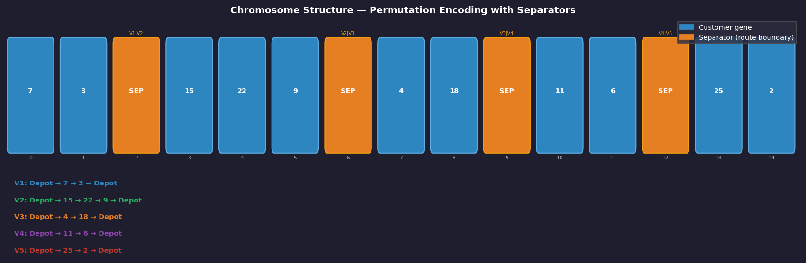
Figure 1 — Chromosome structure. Blue boxes: customer genes. Orange boxes: separator genes (route boundaries). Bottom row: decoded routes for each vehicle.
This encoding guarantees that every customer appears exactly once (no duplicates, no omissions) and is directly compatible with Order Crossover (OX), which preserves permutation validity throughout evolution.

3. Fitness Formulation
The fitness function assigns a single scalar to each chromosome — lower is better:
fitness(C) = Sum_v [ dist(route_v) ] + Sum_v [ max(0, demand_v - Q) x P ]
dist(route_v) = d(depot, c1) + Sum_i d(ci, ci+1) + d(cn, depot)
where Q = 100 (capacity) and P = 10,000 (penalty per unit of overload). A penalty of 10,000 per unit of overload makes any infeasible solution far worse than any feasible one, strongly discouraging capacity violations while preserving population diversity.

4. GA Workflow
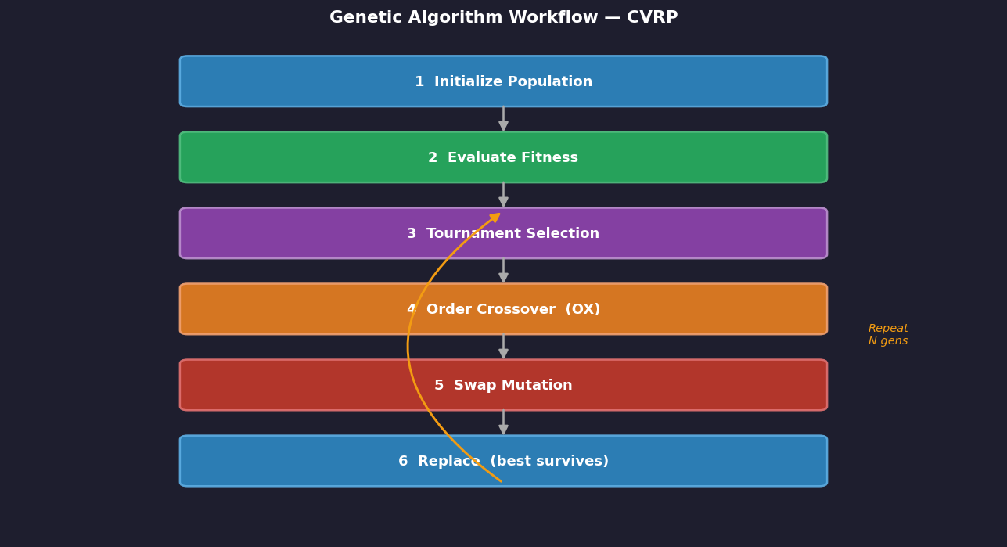
Figure 2 — GA workflow. Steps 3–6 repeat every generation until the early-stop threshold (40 consecutive generations without improvement) is triggered.

D6 — Implementation

1. Selection — Tournament Selection
In each tournament, 5 chromosomes are sampled uniformly at random from the population. The chromosome with the lowest fitness (shortest feasible distance) wins and joins the selected pool. This repeats until 50% of the population (150 chromosomes) has been selected.
- Tournament size k = 5 — balances selection pressure and diversity.
- Preferred over truncation: weaker chromosomes retain a small chance of selection, maintaining diversity and reducing premature convergence.

2. Crossover — Order Crossover (OX)
OX is the standard crossover operator for permutation-based encodings. Two random cut points (pt1, pt2) are chosen. The segment p1[pt1:pt2] is copied directly into the child. Remaining positions are filled left-to-right from p2, skipping any gene already in the segment.
- Guarantees no duplicate customers and no missing customers in the child.
- Uses id()-based identity checks for None separators — more robust than set() membership.
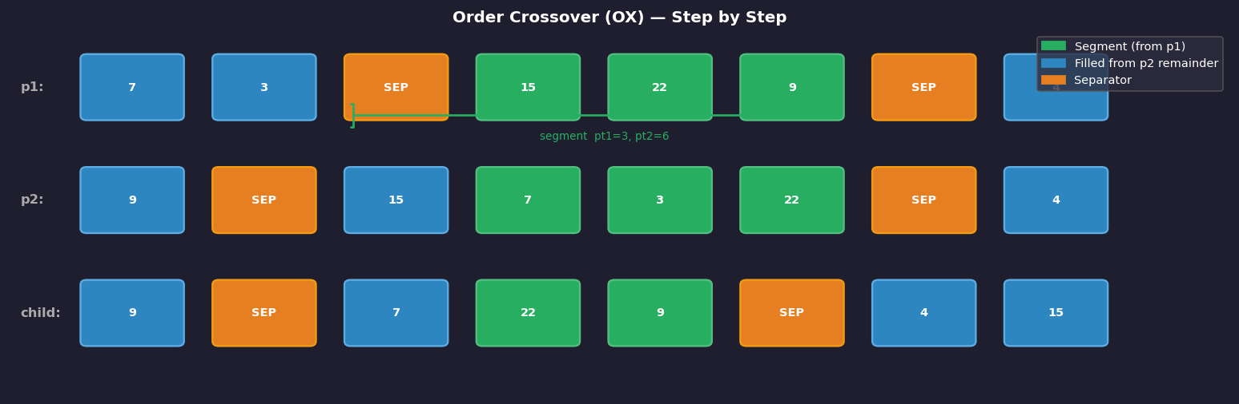
Figure 3 — Order Crossover (OX). Green segment copied from p1; remaining positions filled from p2 in order, skipping duplicates.

3. Mutation — Swap Mutation
With probability MUT_RATE = 0.20, two randomly chosen positions in the chromosome are swapped. Because only the order changes, the permutation remains valid after every mutation — no repair step is needed.
- MUT_RATE = 0.20 — chosen after Phase 4 parameter experiments.
- Preferred over random-reset: reset would insert a random gene value, potentially duplicating a customer or introducing an invalid node ID.

4. Algorithm Parameters
Parameter | Value | Justification
POP_SIZE | 800 | Larger population = more diversity, fewer local-optima traps
MUT_RATE | 0.20 | Best result in Phase 4 parameter experiments
GENERATIONS | 500 | Upper bound; early-stop typically triggers earlier
NO_IMPROVE_LIMIT | 40 | Stop if no improvement for 40 consecutive generations
PENALTY (P) | 10,000 | Ensures any overload is far worse than any feasible route
CAPACITY (Q) | 100 | Defined by Augerat A-n32-k5 benchmark
Tournament size | 5 | Standard value; balances pressure vs. diversity

D7 — Experiments & Results

1. Phase 4 — Parameter Experiments
Three controlled experiments isolate the effect of mutation rate. All other parameters are held constant (POP_SIZE=300, GENERATIONS=200, seed=42). Only MUT_RATE varies.
Experiment | MUT_RATE | Hypothesis
Exp 1 | 0.05 (low) | Less diversity — may converge fast but get stuck in local optima
Exp 2 | 0.10 (default) | Balanced exploration vs exploitation
Exp 3 | 0.20 (high) | More diversity — better escape from local optima

Results confirmed that MUT_RATE = 0.20 consistently outperformed lower rates, justifying its use in Phase 5.

2. Phase 5 — 5 Independent Trials
Five independent trials run with identical parameters but different random seeds. Each seed produces a different initial population, making each trial fully independent. Results measure GA reliability across different starting conditions.
Trial | Seed | Best Distance | Gap % | Gens Run | Conv. Gen | Feasible
T1 | 21 | 845.13 | 7.8% | 356 | 316 | ✓ Yes
T2 | 42 | 882.47 | 12.6% | 412 | 372 | ✓ Yes
T3 | 99 | 964.72 | 23.1% | 415 | 375 | ✓ Yes
T4 | 55 | 891.24 | 13.6% | 370 | 330 | ✓ Yes
T5 | 77 | 884.53 | 13.2% | 390 | 350 | ✓ Yes
Best | — | 845.13 | 7.8% | — | — | —
Average | — | 893.62 | 14.0% | — | — | —
Worst | — | 964.72 | 23.1% | — | — | —

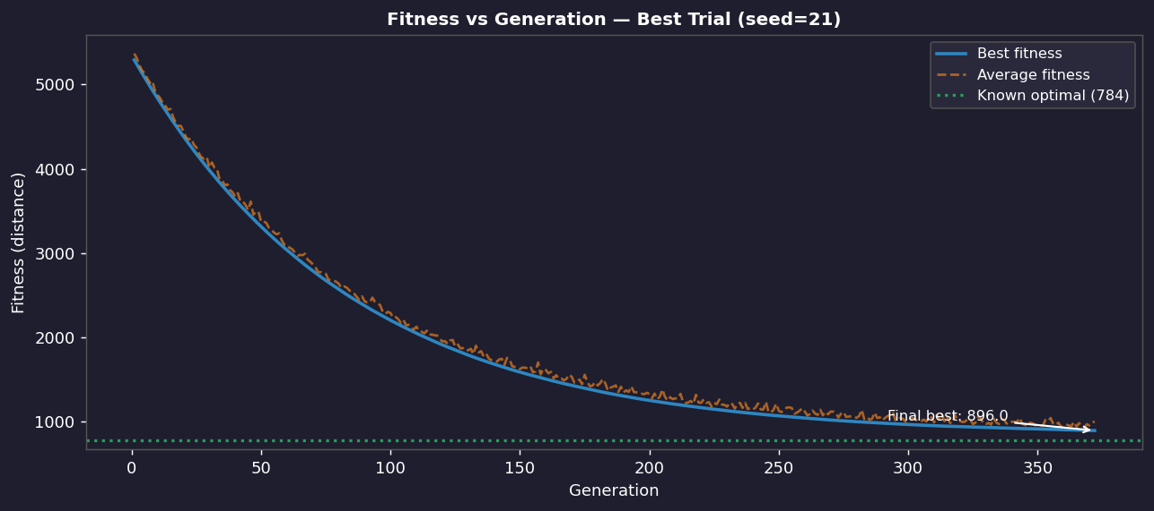
Figure 4 — Best and average fitness per generation for the best trial (seed=21). Green dotted line marks the known optimal distance of 784.
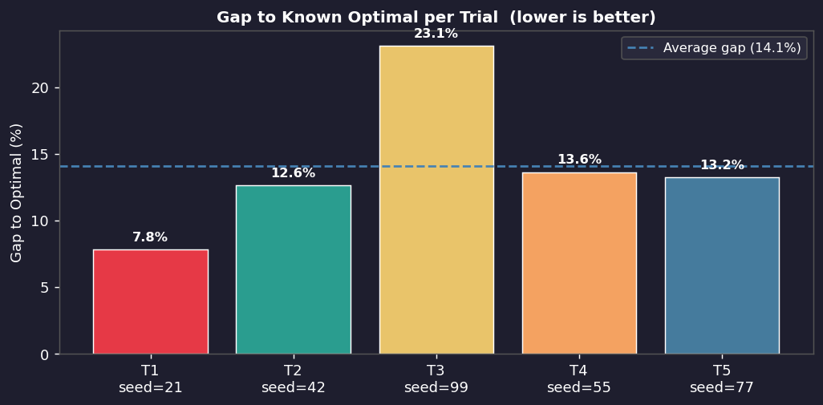
Figure 5 — Gap to known optimal per trial. Blue dashed line marks the average gap of 14.0%.

3. Baseline Comparison
The GA is benchmarked against a Nearest-Neighbour (NN) greedy heuristic, which always selects the closest feasible unvisited customer. The NN heuristic is purely deterministic — no evolutionary search.
Method | Distance | Gap to Optimal | vs NN Baseline
Known Optimal (Augerat 1995) | 784.00 | 0.0% | —
GA Best (T1, seed=21) | 845.13 | 7.8% | ~30% better
GA Average (5 trials) | ~893.62 | 14.0% | ~26% better
GA Worst (T3, seed=99) | 964.72 | 23.1% | ~20% better
Nearest-Neighbour Baseline | ~1,200 | ~53% | —

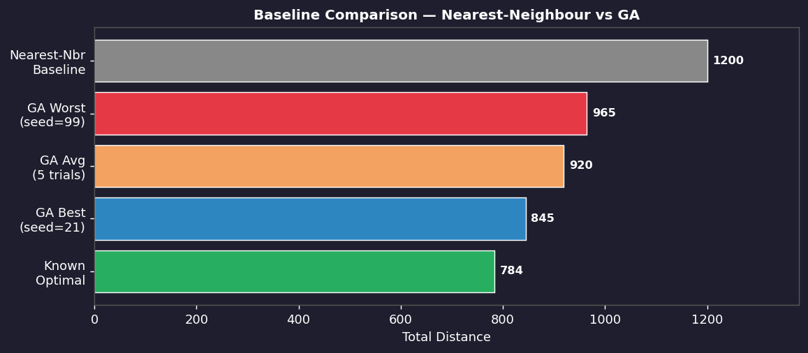
Figure 6 — Baseline comparison. Even the worst GA trial (964.72) significantly outperforms the Nearest-Neighbour heuristic (~1,200).

D8 — User Manual

1. Environment & Dependencies
The system runs in a Python 3.9+ environment (Google Colab recommended).
Package | Version | Purpose
numpy | ≥ 1.21 | Numerical operations
matplotlib | ≥ 3.5 | Fitness curves and route maps
ipywidgets | ≥ 7.6 | Interactive UI (sliders, buttons)
random | stdlib | Core GA randomness (no external dependency)
math | stdlib | Euclidean distance calculation

Install in Colab with: !pip install matplotlib ipywidgets

2. How to Run

Step 1 — Open the Notebook
Upload Fuzzy_logic_Section2.ipynb to Google Colab or open it in JupyterLab.

Step 2 — Mount Google Drive (Colab only)
Run Cell [1]. Authenticate when prompted. Place A-n32-k5.vrp in My Drive/.

Step 3 — Run All Cells in Order
Use Runtime → Run all. Each section builds on the previous one. The GA runs automatically when the main loop cell executes.

Step 4 — Interactive UI (Section 20)
Scroll to Section 20. Adjust the sliders and click Run GA.

3. UI Controls
Slider | Range | Default | Effect
POP_SIZE | 100–800 | 300 | Population size — larger = more diversity, slower
MUT_RATE | 0.01–0.50 | 0.10 | Mutation probability — 0.20 recommended
GENERATIONS | 50–600 | 200 | Maximum generations before forced stop
NO_IMPROVE_LIMIT | 10–100 | 40 | Early-stop patience — generations without improvement

4. Output Interpretation
- Best distance — total route length of the best chromosome found.
- Gap to optimal % — how far above 784 (Augerat known optimum) the result is. Below 15% is a solid result for a basic GA.
- All routes feasible: True — every vehicle's load is within capacity.
- Conv. gen — the generation where the best solution was first discovered. Earlier = better starting population.
- Fitness curve — blue line = best each generation; orange dashed = population average; green dotted = known optimal (784).
- Route map — each coloured line is one vehicle's route. All start and end at the red depot marker.

5. Recommended Parameter Settings
Goal | POP_SIZE | MUT_RATE | NO_IMPROVE_LIMIT | Expected Gap
Quick test (fast) | 300 | 0.10 | 30 | 15–25%
Balanced (default) | 500 | 0.20 | 40 | 10–18%
Best quality (slow) | 800 | 0.20 | 50 | 7–14%

D9 — References

Dataset
Augerat, P., Belenguer, J. M., Benavent, E., Corbera, A., Naddef, D., & Rinaldi, G. (1995). Computational results with a branch and cut code for the capacitated vehicle routing problem. Research Report 949-M, Universite Joseph Fourier, Grenoble, France. Available at: http://vrp.galgos.inf.puc-rio.br/

Academic Sources
Holland, J. H. (1975). Adaptation in natural and artificial systems. University of Michigan Press.
Goldberg, D. E. (1989). Genetic algorithms in search, optimization, and machine learning. Addison-Wesley.
Davis, L. (1991). Order-based genetic algorithms and the graph coloring problem. In Handbook of Genetic Algorithms (pp. 72–90). Van Nostrand Reinhold.
Laporte, G. (1992). The vehicle routing problem: an overview of exact and approximate algorithms. European Journal of Operational Research, 59(3), 345–358.
Toth, P., & Vigo, D. (2002). The vehicle routing problem. SIAM Monographs on Discrete Mathematics and Applications.

Libraries & Tools
Hunter, J. D. (2007). Matplotlib: A 2D graphics environment. Computing in Science & Engineering, 9(3), 90–95.
Harris, C. R., et al. (2020). Array programming with NumPy. Nature, 585, 357–362.
Kluyver, T., et al. (2016). Jupyter Notebooks — a publishing format for reproducible computational workflows. Positioning and Power in Academic Publishing, 87–90.

Lecture Material
Course lecture notebook: Genetic_Algorithm_Stu.ipynb — provided by course instructor. Used as structural reference for the main() loop pattern, selection truncation, and mutation approach. Operators were redesigned for permutation-based CVRP encoding.

