**Lebanon vote holds little hope for change despite disasters**

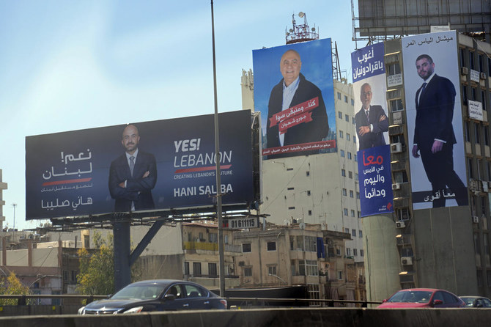

SIDON, Lebanon: Running for parliament for the first time, independent Hania Zaatari walks down the meandering alleyways of the old souk in the port city of Sidon, telling impoverished workers and traders that fixing Lebanon’s devastating economic crisis is her top priority.  
“The economic plan needs to consider marginalized people like you and give them a chance for revival,” she said to 70-year-old Ahmed Abu Dhahr, one of two carpenters remaining on a street that just two years ago boasted roughly 50.  
The engineer-turned-candidate exuded confidence and hope. Yet her enthusiasm was met by shrugs and resignation, reflecting widespread fears that the mid-May vote will only perpetuate the grim status quo.  
With Lebanon in free-fall for more than two years, it should be a make-or-break vote for the country’s ruling class. Their decades-long grip on power has driven one of the Middle East’s most spirited countries to ruin.  
The May 15 elections for parliament are the first since Lebanon’s economic meltdown began in late 2019. The government’s factions have done virtually nothing to address the collapse, leaving Lebanese to fend for themselves as they plunge into poverty, without electricity, medicine, garbage collection or any other semblance of normal life.  
These are also the first elections since the August 4, 2020, catastrophic explosion at Beirut port that killed more than 215 people and wrecked large parts of the city. The destruction sparked widespread outrage at the traditional parties’ endemic corruption and mismanagement.  
A new generation of political opposition activists, like Zaatari, emerged after mass waves of protests that began in October 2019, a historic moment when Lebanese temporarily dropped their confessional identities and chanted shoulder-to-shoulder for the toppling of the ruling elite.  
The activists are trying to build off that political engagement and awareness in Lebanon to enact change.  
Yet instead of uniting, self-declared opposition groups are divided along ideological lines on virtually every issue, including over how to revive the economy.  
As a result, there are an average of at least three different opposition lists in each of the 15 electoral districts, a 20 percent increase from the 2018 elections. A total of 103 lists with 1,044 candidates are vying for the 128-seat legislature, which is equally divided between Christians and Muslims.  
Many are dreading the prospective outcome.  
Lebanon’s rulers, many of them warlords and militia holdovers from the days of the 1975-90 civil war, have proven extremely resilient.  
They hang on to their seats from one election to the next and can behave with impunity in power, largely because the sectarian power-sharing system and an antiquated electoral law virtually guarantee their spots in parliament.  
Their parties can rally followers who remain fiercely loyal for sectarian or ideological reasons despite outrage over the state of the country. The economic crisis has only made people more dependent on the patronage and cash that parties hand out.  
For many, the elections are an exercise in futility.  
“I am extremely disappointed and to be honest this is the last card before immigrating from Lebanon,” said Carmen Geha, an associate professor of political studies at the American University of Beirut. She said she was moving to Spain in the summer and that she no longer felt safe in the country.  
“It is unacceptable that they wasted the momentum that was on the streets and the suffering that people have,” she said. In the past two years, over 250,000 people have left the country of nearly 7 million.  
In the lead-up to the vote, streets have been festooned with giant billboards and posters of candidates with improbable promises of change. It’s a jarring sign of the money being spent on campaigns as the currency continues to slide and inflation, poverty and hunger grow.  
Even the mainstream factions have tried to use anger over the port explosion for gain in the election, claiming to be on the side of reform. The Christian Lebanese Forces party has put out campaign messages insisting it pushed for better oversight at the port before the blast.  
The explosion was caused by hundreds of tons of ammonium nitrate haphazardly stored at a port warehouse. The ruling class united to block the investigation into the blast. Nevertheless, the militant Hezbollah group, which dominates the political landscape and the government, touts in its campaign messages that it wants an investigation.  
In an act of blatant defiance, two former ministers wanted for questioning on criminal negligence in connection to the port explosion are running in the elections. The two, Ali Hassan Khalil and Ghazi Zeaiter, belong to the Hezbollah-allied Shiite Amal party.  
“If they are to be elected again, I would find it a direct insult to all of the country and all of the victims of the blast, to every normal human being left in this country,” said Paul Naggar, the father of one of the youngest victims of the blast, 3-year-old Alexandra.  
Naggar, director of the newly formed political advocacy group Kulluna Irada, said the election was a historic opportunity but expressed frustration at the opposition’s failure to unite.  
“We don’t have the luxury to think of right and left and center and socialism or liberalism, we are in a state of survival. It is either we survive or we leave,” he said.  
In the northern city of Jounieh, candidate Jad Ghosn, a journalist who recently decided to run for elections with the leftist group Citizens in a State, said the divisions have been obvious from the start.  
“We have 300 political groups claiming to be of the opposition and of the revolution, and we don’t have any structure for having a discussion or of trying to coordinate between all of these opposition groups.”  
Ghosn is running on a list in the Metn district with the youngest candidate, 25-year-old Verena Al-Amil and three others.  
Outside a Starbucks, Al-Amil approached a man who said he was voting for the Lebanon Forces, one of the main traditional Christian parties. He said he was open to change, but he had not heard of many other parties.  
Minutes before, a group of teenagers swarmed flashing hand gestures referring to another Christian party, founded by President Michel Aoun, which is politically allied with Hezbollah. It was a potent sign of the mainstream parties’ power over constituents.  
The new independent lists are “non-sectarian so they lack communitarian support, which is the dominant discourse in Lebanese politics,” said Imad Salameh, a professor of political science at the Lebanese American University.  
“If the groups had been well-financed, or backed by foreign powers like traditional parties, they might have had a better chance.”

**Tunisia launches national consultation on reforms**

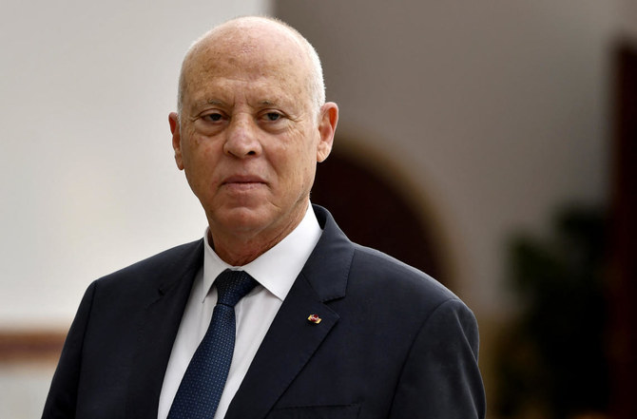

TUNIS: Tunisia on Saturday launched a wide-ranging national consultation that will feed into drafting a new constitution, the North African country’s technology ministry said.  
Part of a reform package pushed by President Kais Saied, who is seeking to bolster his authority, the exercise calls on citizens to send in suggestions and will last until March 20.  
Eligible topics include electoral, economic, financial, social, developmental, health, education and cultural affairs.  
The constitutional referendum is planned for July 25, 2022 — exactly a year after Saied sacked the government, suspended parliament and seized wide-ranging powers.  
His power grab was initially supported by many Tunisians, amid frustration surrounding repeated deadlocks within the fractious legislature in recent years.  
The president later took steps to rule by decree, and in early December vowed to press on with reforms to the political system.  
The consultation — dubbed “Your opinion, our decision” — is initially targeting youth centers through an electronic platform across the country’s 24 regions, the technology ministry said.  
“The platform will be open to everyone from January 15,” it added.  
Citizens will alternatively be able to give their views in local committees, since only 45 percent of Tunisian homes are connected to the Internet.Critics have said the move underlines the “populist” approach of the president, who won elections in 2019 with a landslide 73 percent of votes.  
Saied’s one-man crusade to rebuild Tunisia’s broken political structures has sparked accusations that he is establishing a new autocracy in the birthplace of the Arab Spring uprisings.  
Rights groups have pointed to military trials of opposition figures on charges such as “insulting the president.”  
A senior official of Islamist-inspired Ennahdha — one of the country’s main political parties — was arrested by plainclothes officers on Friday.  
The party decried Noureddine Bhiri’s arrest as “a kidnapping and dangerous precedent marking the country’s entry into a tunnel to dictatorship.”

**Kuwait’s emir accepts resignation of cabinet — state news agency**

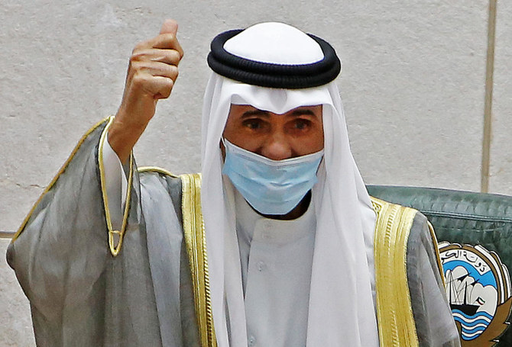

KUWAIT: Kuwait’s Emir Sheikh Nawaf Al-Ahmad Al-Jaber Al-Sabah has accepted the resignation of Prime Minister Sheikh Sabah Al-Khalid Al-Sabah and his cabinet, state news agency KUNA said on Monday.  
Sheikh Sabah’s cabinet will continue in a caretaker capacity until the formation of a new government, KUNA said.

[**Egypt's parliament approves easing reconciliation in construction violations**](https://english.ahram.org.eg/News/512567.aspx)

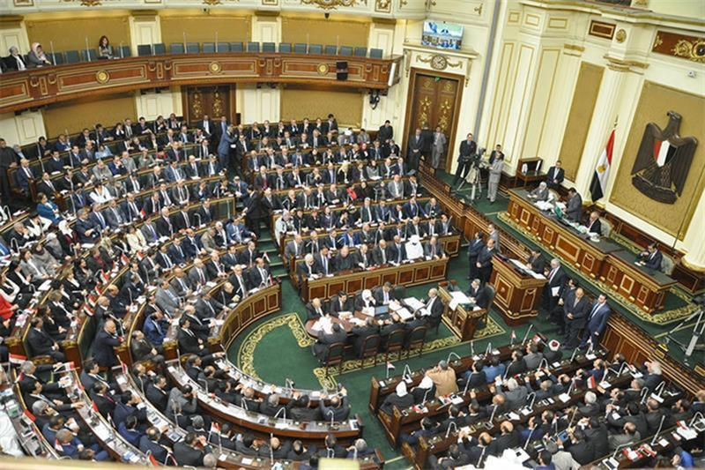

The bill states that citizens can reach reconciliation on construction violations that existed until the most recent aerial survey for buildings conducted by the Egyptian government on 15 October 2023.

The law grants a 25 percent discount to those who pay complete reconciliation fees or pay in instalments over no more than five years.

It will also legalize constructions built on state-owned lands or added to buildings with distinct architectural styles in return for paying reconciliation fees ranging from EGP 50 to EGP 2500.

Furthermore, the law mandates forming committees in all governorates to examine the reconciliation requests.

The new law was, however, rejected by Abdel-Moneim Imam, head of the Justice (Al-Adl) party, and independent MP Mostafa Bakri.

Imam and Bakri said the government should first submit a unified building bill to solve all the construction problems that face citizens.

For his part, Minister of Parliamentary Affairs Alaaeddin Fouad said the law aims to safeguard public interest by "making it easier for citizens to settle construction violations with state authorities."

"This law provides an opportunity for citizens to keep their housing units intact and live in them in safety and security," said Fouad.

He added that, unlike the 2019 law, the new law's executive regulations, which will be issued soon, will be simple and avoid confusion for citizens.

Parliament speaker Hanafi Gebaly said there are fears that the new law, like the old one, could face problems while implementing it.

Therefore, Gebaly called on the government to ensure that the executive regulations are drafted clearly to guarantee that the law is implemented correctly.

He also argued that legalizing construction violations should not constitute a licence to build on agricultural land.

"Article 26 of the constitution stipulates that the government should take all measures necessary to protect agricultural land from illegal construction violations," said Gebaly.

**President Sisi raises public sector wages & Takaful and Karama benefits**

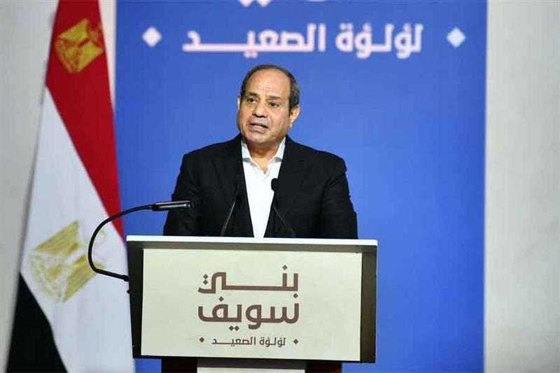

President Abdel-Fattah El-Sisi announced a series of measures on Saturday to alleviate the financial strains on citizens, including raising the minimum wage for public sector employees from EGP 3,500 to EGP 4,000.

El-Sisi raised the exceptional cost of living allowance to EGP 600, up from EGP 300, for all employees within the state administrative apparatus, economic entities, state-owned enterprises, and the public sector.

The president also raised the annual income tax exemption threshold by 25 percent from EGP 36,000 to EGP 45,000 for all state employees.

El-Sisi announced the new measures while inaugurating via video conference several development projects in the Beni Suef governorate as part of the Decent Life initiative.

In addition, he raised Takaful and Karama benefits for its five million households by 15 percent and doubled the exceptional grant for 11 million pensioners and beneficiaries to EGP 600 from EGP 300.

The minimum wage for government employees was last raised in March 2023 [from EGP 3,000 to EGP 3,500.](https://english.ahram.org.eg/News/491010.aspx)

The president also directed an increase in technology allowances for journalists registered with the syndicate, in accordance with the provisions in the general budget.

He directed the Egyptian Agricultural Bank to ease the burden on small farmers and individuals who were unable to pay interest on their loans prior to 1 January 2022.

The president also announced that those who acquired land from the General Authority for Urban and Rural Development Projects and have been unable to pay interest and late penalty payments would be exempted from doing so, with a deadline by the end of 2024.

Remembering Daniel victims

El-Sisi presented his condolences to the families of Storm Daniel’s victims from the governorate.

He asked the citizens attending the event to observe a minute of silence in memory of storm victims in Libya.

At least 250 Egyptian migrants died in Derna alone due to Storm Daniel, according to estimates from the International Organization of Migration (IOM).

On Tuesday, Libyan authorities handed [Egypt over 185 dead bodies](https://english.ahram.org.eg/News/508243.aspx) of Egyptians found across eastern Libya.

On Wednesday, 75 of the deceased, mostly from El-Sherif village, were buried during a mass funeral in Beni Suef.

Work is still underway to determine the total number of Egyptian victims, according to the Ministry of Foreign Affairs.

Food security

The president said supply chain disruptions triggered by the COVID-19 pandemic and the current shortage in dollars have raised the cost of food imports.

He said the government is directing large sums of dollars to import millions of wheat in order to ensure that citizens can find enough bread.

The president noted that he is aware of the circumstances faced by the people, expressing his appreciation to the citizens for bearing such difficulties.

"But we are leaving no stone unturned to solve problems," he stressed.

The state is racing to reclaim five million new feddans in the coming two to three years to produce necessary crops in a very short period, noted the president.

These projects, which will create new jobs and produce more food, aim to lower our dependence on imports.

Impact of Dollar Crisis

The state is spending billions of dollars more to import oil needed to produce electricity amid rising global prices, El-Sisi noted.

"Every dollar increase in the price of an oil barrel has an enormous annual cost on us tantamount to billions of dollars," he noted.

The country's electrical power plants can produce more than enough electricity but the price of a barrel of diesel needed to operate them jumped from $65-$70 to $90, added the president.

He concluded that the country faces no shortages in gas or diesel needed for vehicles despite these challenges.