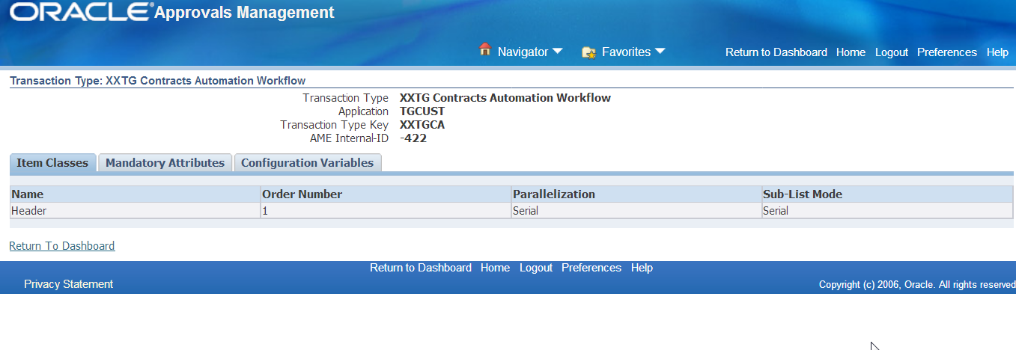

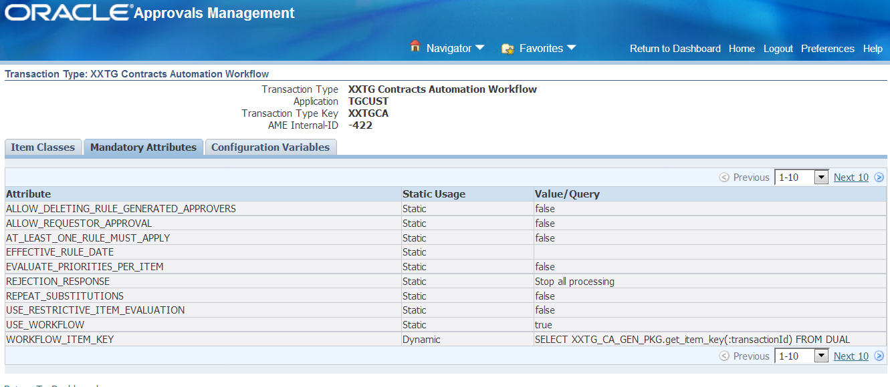

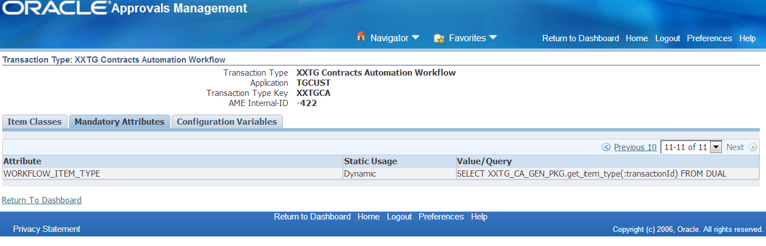

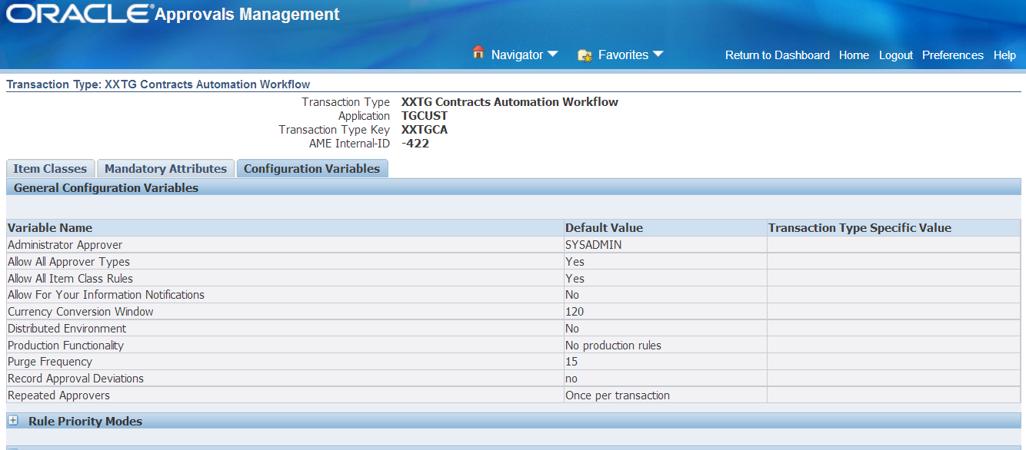

Attribute

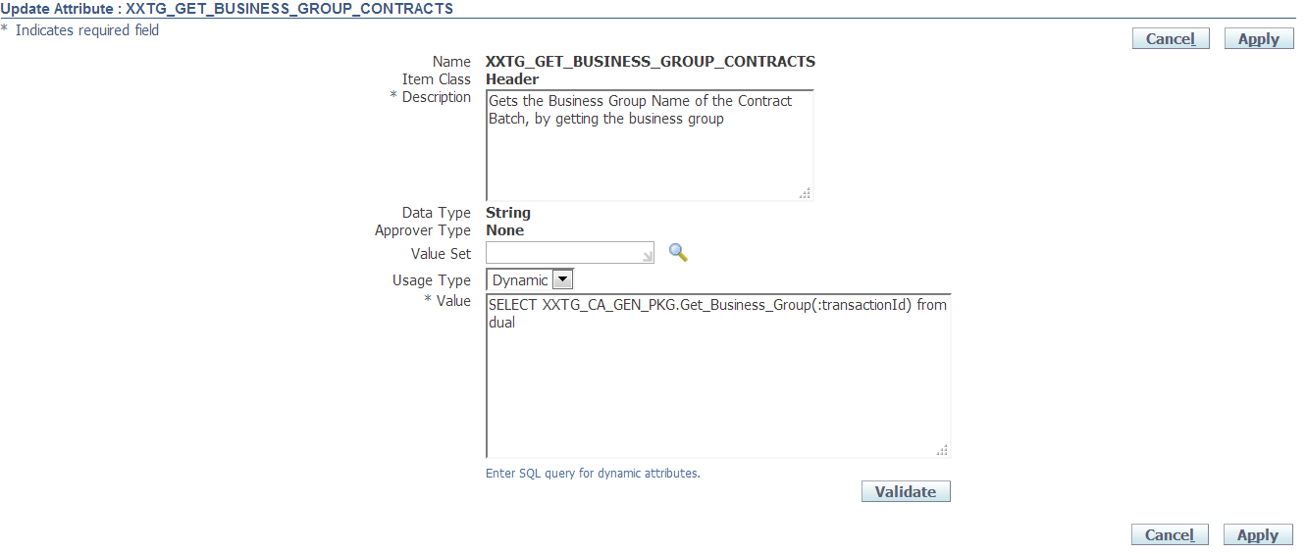

|  |  |
| --- | --- |
| Name | XXTG_GET_BUSINESS_GROUP_CONTRACTS http://dhoodev02v.transguard.ae:8001/OA_HTML/cabo/images/swan/t.gif |
| Item Class | Header http://dhoodev02v.transguard.ae:8001/OA_HTML/cabo/images/swan/t.gif |
| Description | Gets the Business Group Name of the contract Batch, by getting the business group |
| Data Type | String |
| Usage Type | Dynamic |
| Value | SELECT XXTG_CA_GEN_PKG.GET_BUSINESS_GROUP(:transactionId) FROM DUAL |

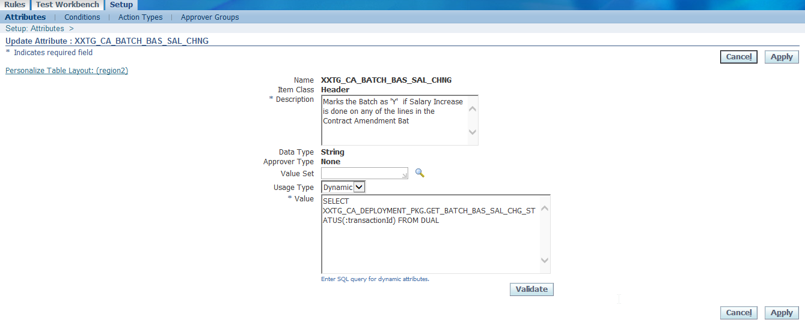

|  |  |
| --- | --- |
| Name | XXTG_CA_BATCH_BAS_SAL_CHNG http://dhoodev02v.transguard.ae:8001/OA_HTML/cabo/images/swan/t.gif |
| Item Class | Header http://dhoodev02v.transguard.ae:8001/OA_HTML/cabo/images/swan/t.gif |
| Description | Marks the Batch as 'Y' if Salary Increase is done on any of the lines in the Contract Amendment Bat |
| Data Type | String |
| Usage Type | Dynamic |
| Value | SELECT XXTG_CA_DEPLOYMENT_PKG.GET_BATCH_BAS_SAL_CHG_STATUS(:transactionId) FROM DUAL |

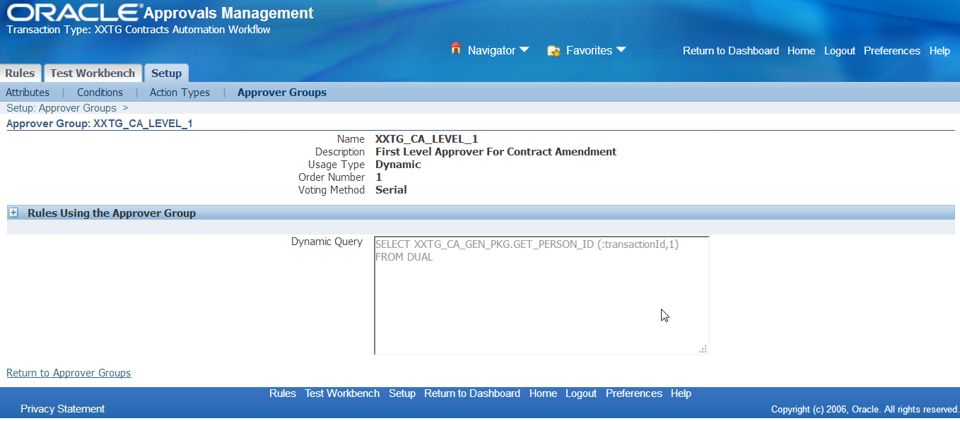

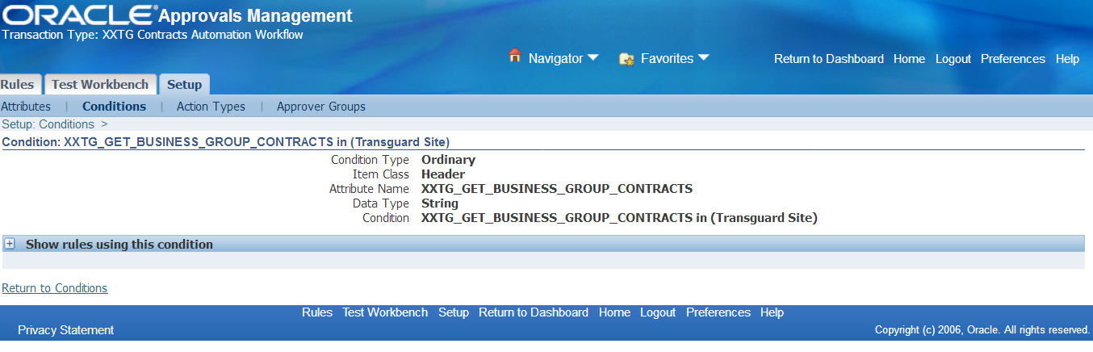

Approver Group Setup

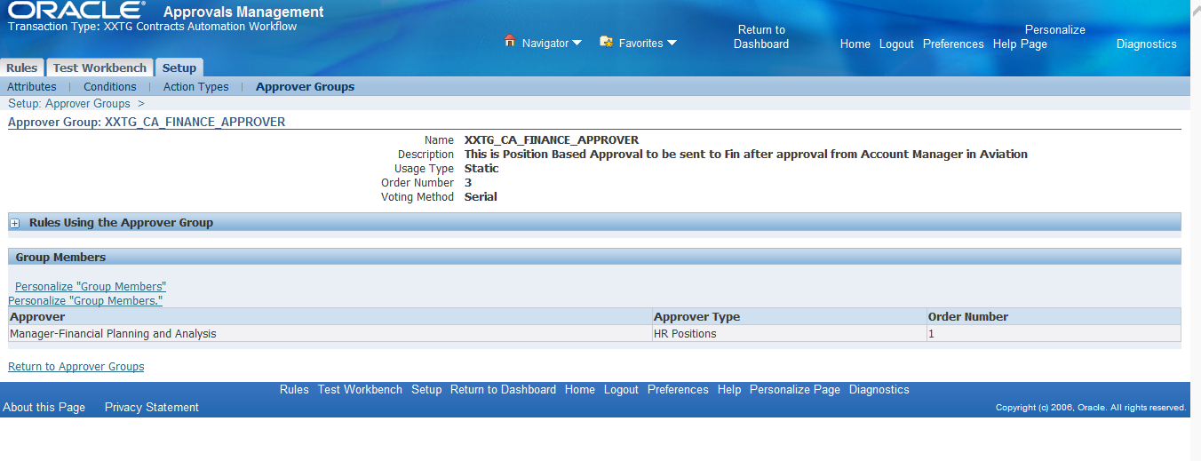

|  |  |
| --- | --- |
| Name | XXTG_CA_FINANCE_APPROVER |
| Description | This is Position Based Approval to be sent to Fin after approval from Account Manager in Aviation |
| Usage Type | Static |
| Order Number | 3 |
| Voting Method | Serial |
| Approver | Manager-Financial Planning and Analysis |
| Approver Type | HR Positions |
| Order Number | 1 |

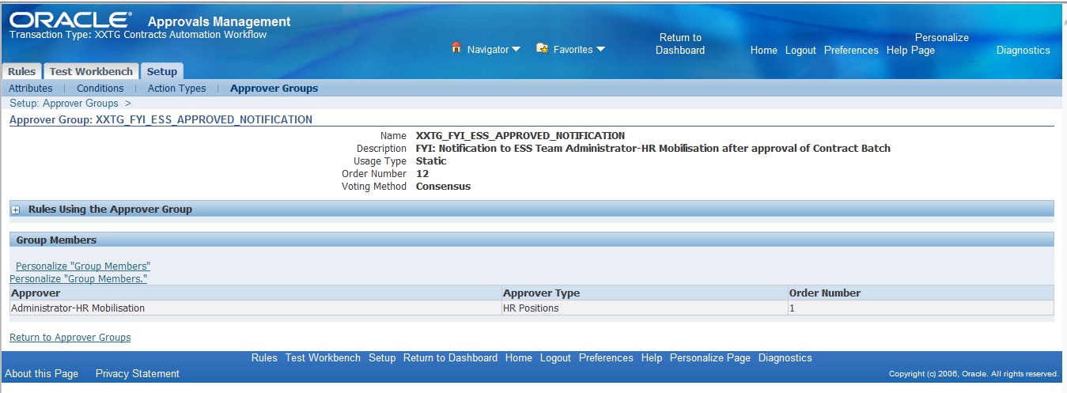

|  |  |
| --- | --- |
| Name | XXTG_FYI_ESS_APPROVED_NOTIFICATION |
| Description | FYI: Notification to ESS Team Administrator-HR Mobilisation after approval of Contract Batch http://dhoodev02v.transguard.ae:8001/OA_HTML/cabo/images/swan/t.gif |
| Usage Type | Static |
| Order Number | 12 |
| Voting Method | Serial |
| Approver | Administrator-HR Mobilisation |
| Approver Type | HR Positions |
| Order Number | 1 |

Rules

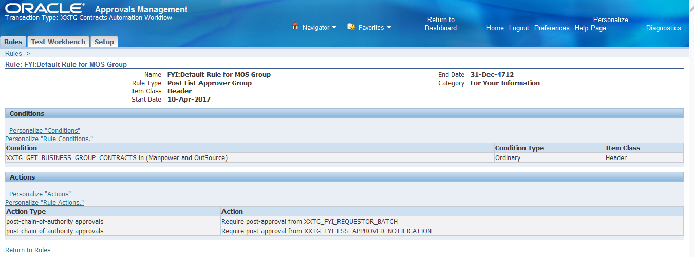

|  |  |
| --- | --- |
| Name | FYI:Default Rule for MOS Group |
| Rule Type | Post List Approver Group |
| Category | For Your Information |
| Condition | XXTG_GET_BUSINESS_GROUP_CONTRACTS in (Manpower and OutSource) |
|  |  |
| Action Type |  |
| post-chain-of-authority approvals | Require post-approval from XXTG_FYI_REQUESTOR_BATCH |
| post-chain-of-authority approvals | Require post-approval from XXTG_FYI_ESS_APPROVED_NOTIFICATION |

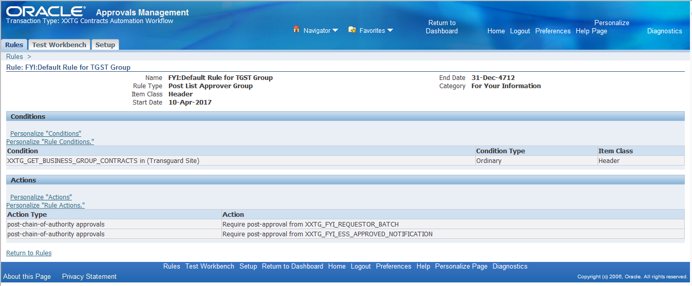

|  |  |
| --- | --- |
| Name | FYI:Default Rule for TGST Group |
| Rule Type | Post List Approver Group |
| Category | For Your Information |
| Condition | XXTG_GET_BUSINESS_GROUP_CONTRACTS in (Transguard Site) |
|  |  |
| Action Type |  |
| post-chain-of-authority approvals | Require post-approval from XXTG_FYI_REQUESTOR_BATCH |
| post-chain-of-authority approvals | Require post-approval from XXTG_FYI_ESS_APPROVED_NOTIFICATION |

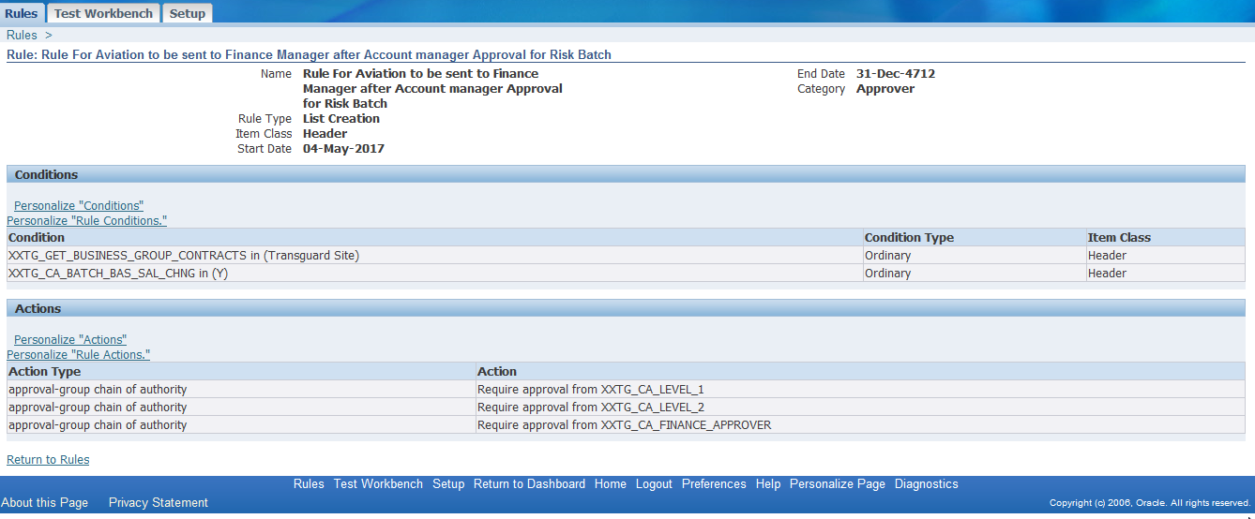

|  |  |
| --- | --- |
| Name | Rule For Aviation to be sent to Finance Manager after Account manager Approval |
| Rule Type | Post List Approver Group |
| Category | Approver |
| Condition | XXTG_GET_BUSINESS_GROUP_CONTRACTS in (Transguard Site) |
| Condition | XXTG_CA_BATCH_BAS_SAL_CHNG in (Y) |
| Action Type |  |
| approval-group chain of authority | Require approval from XXTG_CA_LEVEL_1 |
| approval-group chain of authority | Require approval from XXTG_CA_LEVEL_2 |
| approval-group chain of authority | Require approval from XXTG_CA_FINANCE_APPROVER |

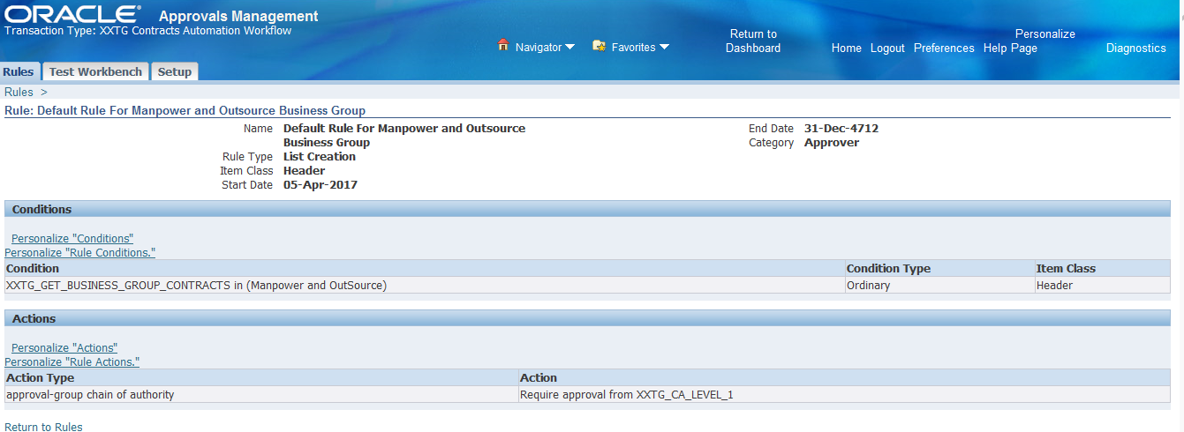

|  |  |
| --- | --- |
| Name | Default Rule For Manpower and Outsource Business Group |
| Rule Type | Default Rule For Manpower and Outsource Business Group |
| Category | Approver |
| Condition | XXTG_GET_BUSINESS_GROUP_CONTRACTS in (Manpower and OutSource) |
|  |  |
| Action Type |  |
| approval-group chain of authority | Require approval from XXTG_CA_LEVEL_1 |
|  |  |
|  |  |

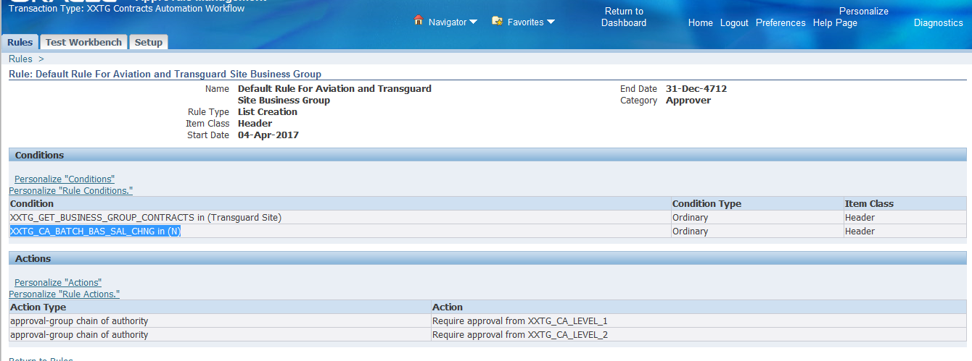

|  |  |
| --- | --- |
| Name | Default Rule For Aviation and Transguard Site Business Group http://dhoodev02v.transguard.ae:8001/OA_HTML/cabo/images/swan/t.gif |
| Rule Type | Approver |
|  |  |
| Condition | XXTG_GET_BUSINESS_GROUP_CONTRACTS in (Transguard Site) |
| Condition | XXTG_CA_BATCH_BAS_SAL_CHNG in (N) |
| Action Type |  |
| approval-group chain of authority | Require approval from XXTG_CA_LEVEL_1 |
| approval-group chain of authority | Require approval from XXTG_CA_LEVEL_2 |
|  |  |

It is not possible to upload LDT for difference in changes /Renaming of columns in DFF

For this we would need to copy the setup from Train to Production.

Following are the snapshots

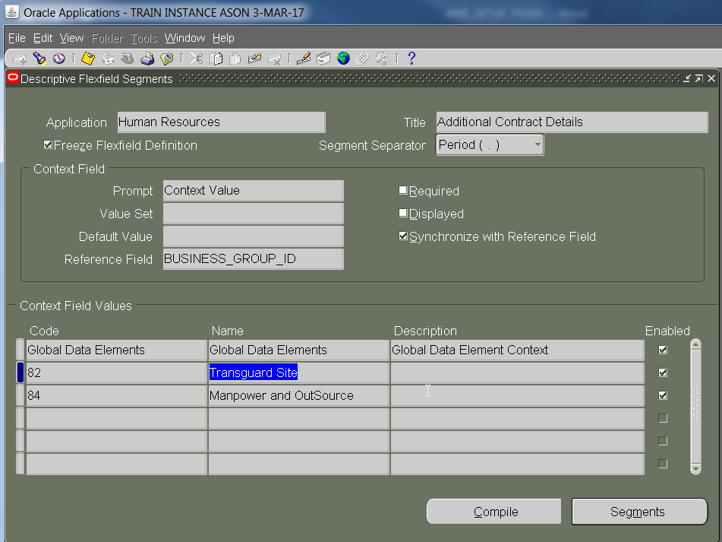

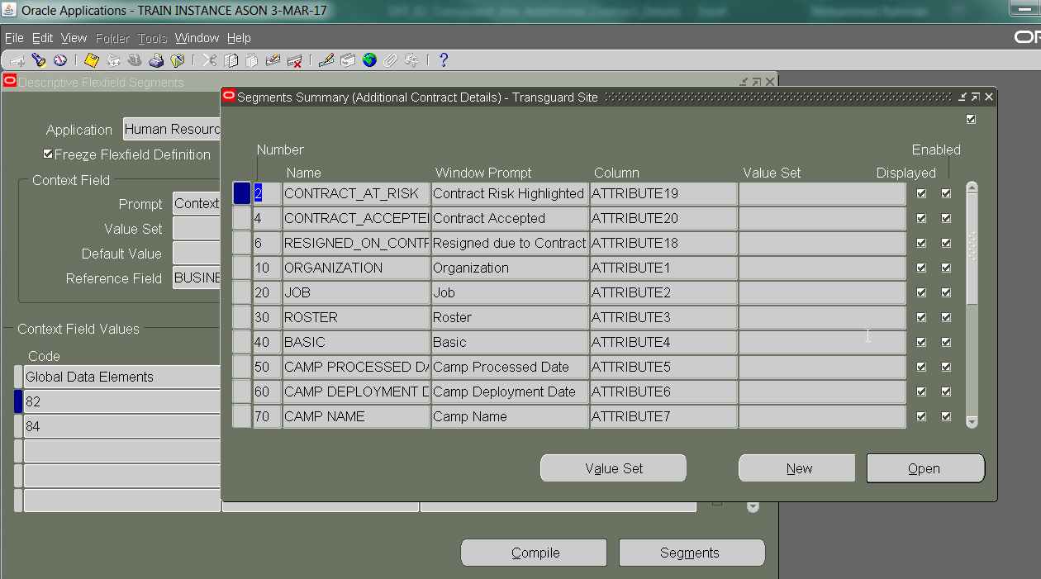

|  |  |  |  |  |  |  |
| --- | --- | --- | --- | --- | --- | --- |
| Number | Name | Window Prompt | Column | Value Set | Displayed | Enabled |
| 2 | CONTRACT_AT_RISK | Contract Risk Highlighted | ATTRIBUTE19 |  | * | * |
| 4 | CONTRACT_ACCEPTED | Contract Accepted | ATTRIBUTE20 |  | * | * |
| 6 | RESIGNED_ON_CONTRACT_RECEIPT | Resigned due to Contract | ATTRIBUTE18 |  | * | * |
| 10 | ORGANIZATION | Organization | ATTRIBUTE1 |  | * | * |
| 20 | JOB | Job | ATTRIBUTE2 |  | * | * |
| 30 | ROSTER | Roster | ATTRIBUTE3 |  | * | * |
| 40 | BASIC | Basic | ATTRIBUTE4 |  | * | * |
| 50 | CAMP PROCESSED DATE | Camp Processed Date | ATTRIBUTE5 |  | * | * |
| 60 | CAMP DEPLOYMENT DATE | Camp Deployment Date | ATTRIBUTE6 |  | * | * |
| 70 | CAMP NAME | Camp Name | ATTRIBUTE7 |  | * | * |
| 80 | CAMP ROOM NAME | Camp Room Name | ATTRIBUTE8 |  | * | * |
| 90 | Operations Manager Person ID | Operations Manager Person ID | ATTRIBUTE9 |  | * | * |
| 100 | CAMP_UPDATED_BY | Camp Updated By | ATTRIBUTE10 |  | * | * |
| 110 | HRA_FLAG | HRA Flag | ATTRIBUTE11 |  | * | * |
| 120 | ASSIGNMENT_FLAG | Assignment Flag | ATTRIBUTE12 |  | * | * |
| 130 | SAL_FLAG | Salary Flag | ATTRIBUTE13 |  | * | * |
| 140 | TRA_FLAG | TRA Flag | ATTRIBUTE14 |  | * | * |
| 150 | CONTRACT_PRINT_DATE | Contract Print Date | ATTRIBUTE15 |  | * | * |
| 160 | CONTRACT_PRINT_BY_STAFF | Contract Printed by | ATTRIBUTE16 |  | * | * |
| 170 | RECEIVED_CONTRACT_SIGNED | Contract Signed and Received Date | ATTRIBUTE17 |  | * | * |

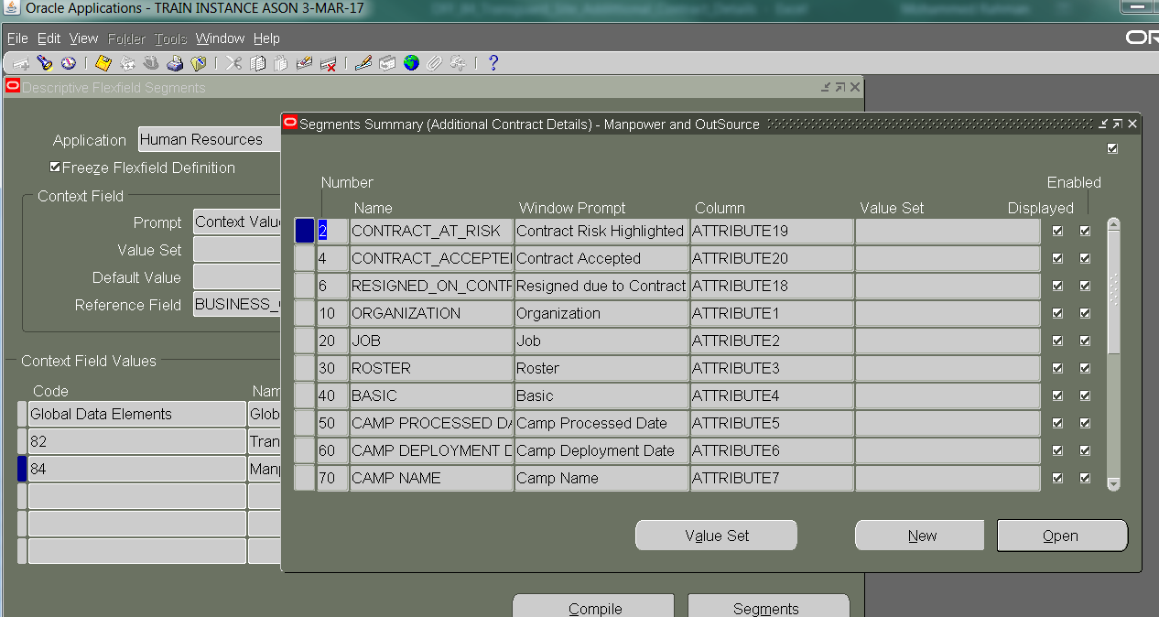

|  |  |  |  |  |  |  |
| --- | --- | --- | --- | --- | --- | --- |
| Number | Name | Window Prompt | Column | Value Set | Displayed | Enabled |
| 2 | CONTRACT_AT_RISK | Contract Risk Highlighted | ATTRIBUTE19 |  | * | * |
| 4 | CONTRACT_ACCEPTED | Contract Accepted | ATTRIBUTE20 |  | * | * |
| 6 | RESIGNED_ON_CONTRACT_RECEIPT | Resigned due to Contract | ATTRIBUTE18 |  | * | * |
| 10 | ORGANIZATION | Organization | ATTRIBUTE1 |  | * | * |
| 20 | JOB | Job | ATTRIBUTE2 |  | * | * |
| 30 | ROSTER | Roster | ATTRIBUTE3 |  | * | * |
| 40 | BASIC | Basic | ATTRIBUTE4 |  | * | * |
| 50 | CAMP PROCESSED DATE | Camp Processed Date | ATTRIBUTE5 |  | * | * |
| 60 | CAMP DEPLOYMENT DATE | Camp Deployment Date | ATTRIBUTE6 |  | * | * |
| 70 | CAMP NAME | Camp Name | ATTRIBUTE7 |  | * | * |
| 80 | CAMP ROOM NAME | Camp Room Name | ATTRIBUTE8 |  | * | * |
| 90 | Operations Manager Person Emai | Operations Manager Person Email | ATTRIBUTE9 |  | * | * |
| 100 | CAMP_UPDATED_BY | Camp Room Name | ATTRIBUTE10 |  | * | * |
| 110 | HRA_FLAG | HRA_FLAG | ATTRIBUTE11 |  | * | * |
| 120 | ASSIGNMENT_FLAG | Assignment Flag | ATTRIBUTE12 |  | * | * |
| 130 | SAL_FLAG | Salary Flag | ATTRIBUTE13 |  | * | * |
| 140 | TRA_FLAG | TRA Flag | ATTRIBUTE14 |  | * | * |
| 150 | CONTRACT_PRINT_DATE | Contract Print Date | ATTRIBUTE15 |  | * | * |
| 160 | CONTRACT_PRINT_BY_STAFF | Contract Printed by | ATTRIBUTE16 |  | * | * |
| 170 | RECEIVED_CONTRACT_SIGNED | Contract Signed and Received Date | ATTRIBUTE17 |  | * | * |

## Security Group Profile Setup

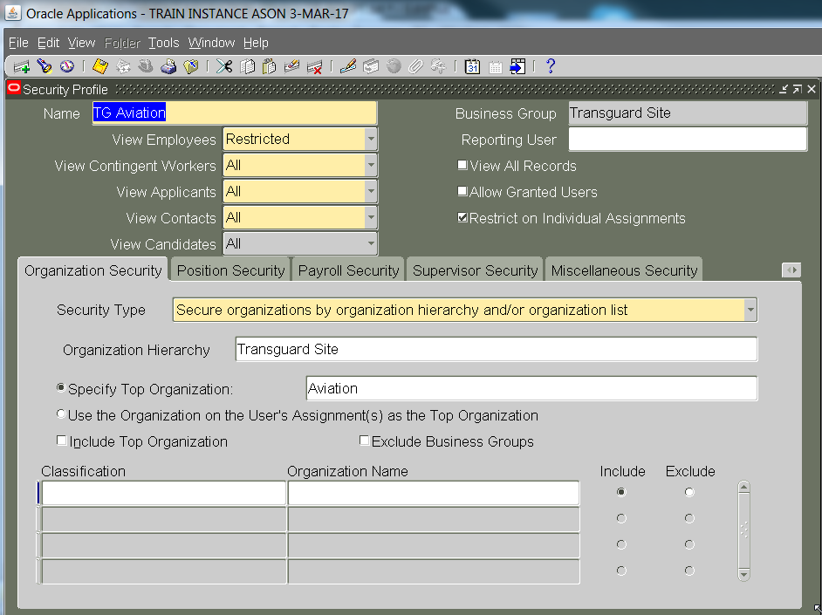

Need to Ensure all the setup of Concurrent Program **XXTG Contract Print Report** is same as TRAIN Instance

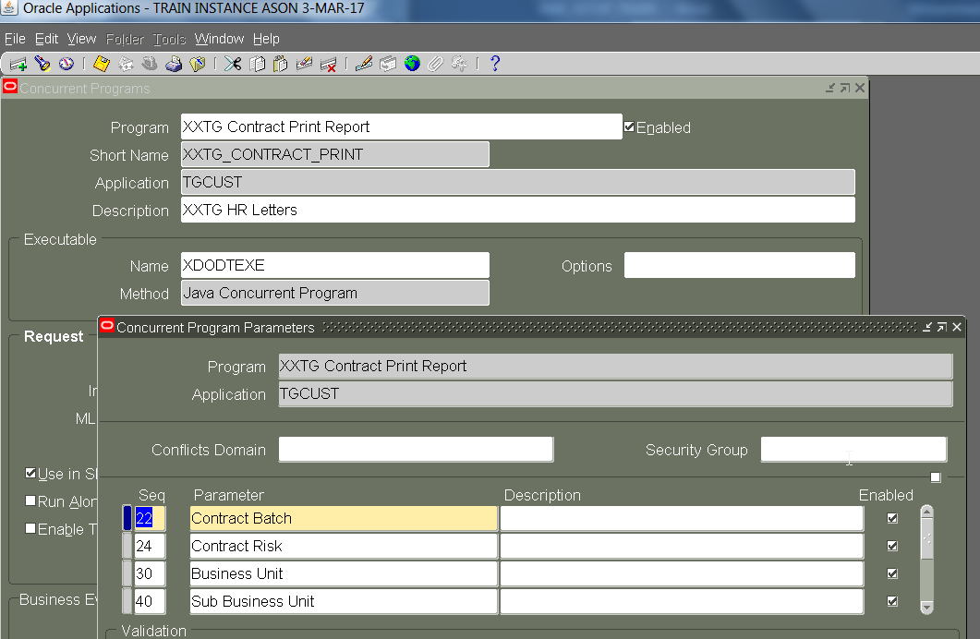

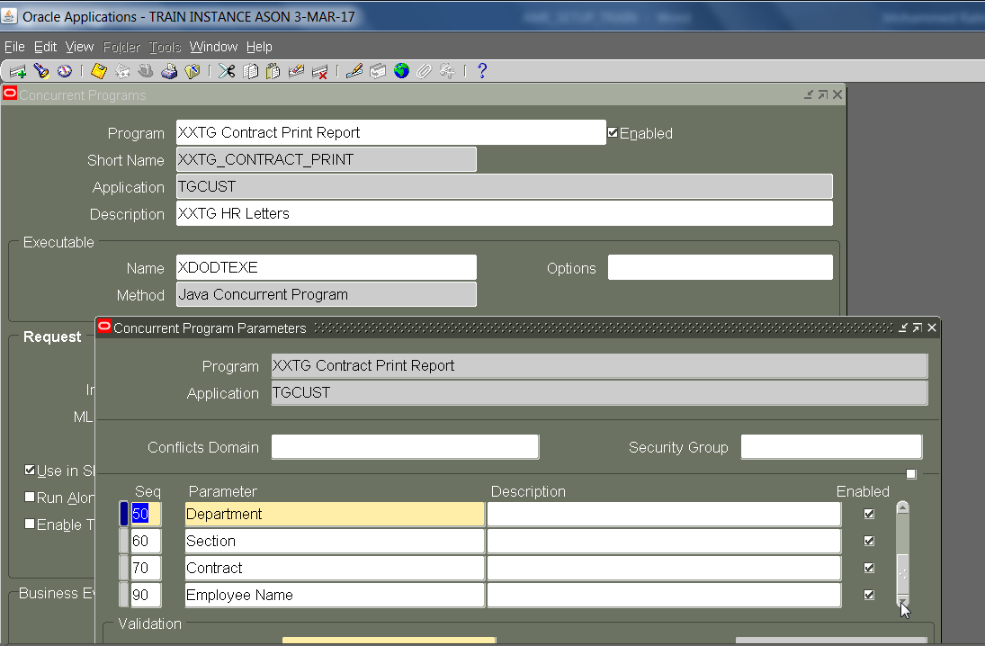

Need to Update Concurrent Program for

