

DS.140 Design Specification

Emirates Telecommunication Group Company PJSC

**Pending Transactions Report Design and Deployment**

Author: Abdulrahman Mohammed

Creation Date: September 8, 2020

Last Updated: September 8, 2020

Document Ref:

Version: V 1.0

1. **Title, Subject, Last Updated Date, Reference Number**, **and** **Version** are marked by a Word Bookmark so that they can be easily reproduced in the header and footer of documents. When you change any of these values, be careful not to accidentally delete the bookmark. **You can make bookmarks visible by selecting the Office Button>Word Options>Advanced> and checking the Show bookmarks option in the Show document content region.**

**Approvals:**

|  |  |
| --- | --- |
| Approver 1 | Buttar Gurmeet Singh |
| Approver 2 | Elias Momin |

1. To add additional approval lines, press [Tab] from the last cell in the table above.

oracle.gif

1. You can delete any elements of this cover page that you do not need for your document.

# Document Control

## Change Record

5

| Date | Author | Version | Change Reference |
| --- | --- | --- | --- |
| 26-Aug-20 | Abdulrahman Mohammed | 1.0 | No Previous Document |
|  |  |  |  |
|  |  |  |  |
|  |  |  |  |

## Reviewers

| Name | Position |
| --- | --- |
| Gurmeet Singh | Project Manager |
|  |  |
|  |  |
|  |  |

Contents

1 Document Control iii

1.1 Change Record iii

1.2 Reviewers iii

2 Technical Overview 1

3 Data Design 2

3.1 Catalog Archive of Pending Transactions Report 2

4 SQL Design 3

4.1 View SQL Scripts used in the Report data definition 3

5 Behavior Design 24

5.1 Function (Operation) Design 24

5.2 Business Rule Design 24

6 Database Design 25

6.1 Database Diagram 25

6.2 Desired Table Changes 25

6.3 Tables, Indexes, Sequences 25

6.4 Unarchiving Report 25

6.5 Creation of Report Link for HR SPOC Role/Line Manager Role 31

7 Open and Closed Issues 42

7.1 Open Issues 42

7.2 Closed Issues 42

1. To update the table of contents, put the cursor anywhere in the table and press [F9]. To change the number of levels displayed, select the menu option Insert‑>Index and Tables, make sure the Table of Contents tab is active, and change the Number of Levels to a new value.

# Technical Overview

1. The purpose of this task is to assemble all the information that is required to describe the design of a software component into a complete Design Specification. This task is not a substitute for executing the individual design tasks. This specification work product can serve as a structure for completing the design for each component by providing pointers back into the Design Tasks:   
   - DS.040 Develop Design Architecture Description  
   - DS.080 Design Software Components  
   - DS.090 Design Data  
   - DS.100 Design Behavior  
   - DS.130 Design User Interface

This document facilitates deployment of report and includes setting up of link for accessing report for various roles of Line Manager and HR SPOC Roles

Following is the report to link flow

* Unarchive the catalog to deploy the Report first
* Change the source of data model to point to correct report data definition
* Execute steps for Sandbox for developing link for report and publish in the groups

1. The intent of this section is to document the report format designs for the reports provided by the component. Reference or include the report specification from the User Interface Design (DS.130) for the component.

# Data Design

1. The intent of this section is to define the design details of each attribute – format, length, accessibility, visibility, validation rules, mandatory or optional, etc. – that is required for each entity or class within the component. If available, reference or include the class diagram (or other data design model) from the Component Data Design (DS.090) for this component. If not available, use the table below.

## Catalog Archive of Pending Transactions Report

1. The intent of this section is to identify the table, columns, and source values that are required to support the above data elements. Refer to the Physical Database Design (IM.040), to identify the existing tables where the above attributes are located.

Save following catalog file for unarchiving in later steps



# SQL Design

1. The intent of this section is to define the tables, the attributes and the SQL statements that are necessary to create, read, update, and/or delete the attributes for each use case from the database. Include applicable portions of the Software Component Design (DS.080). The focus is on creating the SQL documents for the CRUD (Create, Read, Update, Delete) processes. If the DS.080 is not available, provide the SQL for your module here.

## View SQL Scripts used in the Report data definition

SELECT A.employee_number,

A.employee_name,

A.person_id ,

A.ProcessName,

A.Requestor,

REPLACE (A.CurrentAssignee,',user',' ') CurrentAssignee,

instr(A.CurrentAssignee,',') position,

substr(A.CurrentAssignee, 0,instr(A.CurrentAssignee,',') -1) pending_with_user,

A.AssignedDate,

A.NotificationTitle,

A.TxnStatus,

A.ObjectName,

A.SUBMISSION_DATE,

ppnf.DISPLAY_name SupervisorName,

pending_with_user_dtl.person_number pending_with_user_emp_no,

pending_with_user_dtl.name pending_with_user_name,

pending_with_user_dtl.EMAIL_ADDRESS PENDING_WITH_EMAIL_ADDRESS,

per_extract_utility.get_decoded_lookup('EMP_CAT',paam.EMPLOYMENT_CATEGORY) DEPARTMENT_CATEGORY,

(SELECT hauft.NAME BusinessUnit

FROM HR_ORG_UNIT_CLASSIFICATIONS_F houcf,

HR_ALL_ORGANIZATION_UNITS_F haouf,

HR_ORGANIZATION_UNITS_F_TL hauft

WHERE haouf.ORGANIZATION_ID = houcf.ORGANIZATION_ID

AND haouf.ORGANIZATION_ID = hauft.ORGANIZATION_ID

AND haouf.EFFECTIVE_START_DATE BETWEEN houcf.EFFECTIVE_START_DATE AND houcf.EFFECTIVE_END_DATE

AND hauft.LANGUAGE = 'US'

AND hauft.EFFECTIVE_START_DATE = haouf.EFFECTIVE_START_DATE

AND hauft.EFFECTIVE_END_DATE = haouf.EFFECTIVE_END_DATE

AND houcf.CLASSIFICATION_CODE = 'FUN_BUSINESS_UNIT'

AND NVL(:P_START_DATE,SYSDATE) BETWEEN hauft.effective_start_date AND hauft.effective_end_date

AND hauft.organization_id = paam.business_unit_id

) BUSINESS_UNIT,

(SELECT hauft.NAME Department

FROM HR_ORG_UNIT_CLASSIFICATIONS_F houcf,

HR_ALL_ORGANIZATION_UNITS_F haouf,

HR_ORGANIZATION_UNITS_F_TL hauft

WHERE haouf.ORGANIZATION_ID = houcf.ORGANIZATION_ID

AND haouf.ORGANIZATION_ID = hauft.ORGANIZATION_ID

AND haouf.EFFECTIVE_START_DATE BETWEEN houcf.EFFECTIVE_START_DATE AND houcf.EFFECTIVE_END_DATE

AND hauft.LANGUAGE = 'US'

AND hauft.EFFECTIVE_START_DATE = haouf.EFFECTIVE_START_DATE

AND hauft.EFFECTIVE_END_DATE = haouf.EFFECTIVE_END_DATE

AND houcf.CLASSIFICATION_CODE = 'DEPARTMENT'

AND NVL(:P_START_DATE,SYSDATE) BETWEEN hauft.effective_start_date AND hauft.effective_end_date

AND hauft.organization_id = paam.organization_id

) Department,

(SELECT per_extract_utility.get_decoded_lookup('CONTRACT_TYPE',CONTRACTS.TYPE) AS CONTRACT_TYPE

FROM PER_CONTRACTS_F CONTRACTS

WHERE CONTRACTS.CONTRACT_ID=paam.CONTRACT_ID

AND NVL(:P_START_DATE,SYSDATE) BETWEEN CONTRACTS.EFFECTIVE_START_DATE AND NVL(CONTRACTS.EFFECTIVE_END_DATE,NVL(:P_END_DATE,SYSDATE) )

) CONTRACT,

(SELECT AGENCY.AGENCY_NAME

FROM PER_PEOPLE_GROUPS PPG,

(SELECT VS.VALUE_SET_CODE,

B.VALUE AS AGENCY_NUMBER,

T.DESCRIPTION AS AGENCY_NAME

FROM FND_VS_VALUES_B B ,

FND_VS_VALUES_TL T,

FND_VS_VALUE_SETS VS

WHERE UPPER(VS.VALUE_SET_CODE) =UPPER('ETC AGENCIES')

AND B.VALUE_SET_ID =VS.VALUE_SET_ID

AND T.VALUE_ID =B.VALUE_ID

AND ENABLED_FLAG ='Y'

) AGENCY

WHERE PPG.SEGMENT2 =AGENCY.AGENCY_NUMBER

AND paaM.PEOPLE_GROUP_ID = PPG.PEOPLE_GROUP_ID

) AGENCY

FROM

(

---HR_DOCUMENTS_OF_RECORD This query gets approved Documents of records

SELECT DISTINCT PAPF.person_number employee_number,

PPNFV.display_name employee_name,

papf.person_id,

--txnh.module_identifier

hdt.document_type ProcessName,

NULL Requestor,

NULL CurrentAssignee,

TO_CHAR(TRUNC(wft.assigneddate),'DD-Mon-YYYY', 'nls_date_language=American') AssignedDate,

wft.title NotificationTitle,

-- txnd.status TxnStatus,

-- txnh.object

'Approved' TxnStatus,

'HR_DOCUMENTS_OF_RECORD' ObjectName,

TO_CHAR(TRUNC(txnh.CREATION_DATE),'DD-Mon-YYYY', 'nls_date_language=American') SUBMISSION_DATE

FROM fusion.hrc_txn_header txnh ,

fusion.hrc_txn_data txnd ,

fa_fusion_soainfra.WFTASK wft ,

HR_DOCUMENTS_OF_RECORD HDOR ,

hr_document_types_tl hdt,

PER_ALL_PEOPLE_F PAPF,

fusion.per_person_names_f_v PPNFV

WHERE txnh.transaction_id =txnd.transaction_id(+)

AND wft.identificationkey(+) =TO_CHAR(txnh.transaction_id)

AND txnh.OBJECT_ID(+) = HDOR.documents_of_record_id

AND hdt.document_type_id = HDOR.document_type_id

AND HDOR.PERSON_ID =PAPF.PERSON_ID

AND PAPF.person_id =PPNFV.person_id

AND txnh.object(+) ='HR_DOCUMENTS_OF_RECORD'

AND hdt.language = 'US'

AND (:P_PERSON_NUMBER IS NULL

OR PAPF.PERSON_number =:P_PERSON_NUMBER)

AND TRUNC(wft.assigneddate) BETWEEN NVL(:P_START_DATE,SYSDATE) AND NVL(:P_END_DATE, SYSDATE)

-- AND HDOR.creation_date BETWEEN NVL(:P_START_DATE,SYSDATE) AND NVL(:P_END_DATE,SYSDATE)

AND (:P_STATUS IS NULL

OR txnd.status =:P_STATUS)

AND wft.workflowpattern<>'FYI'

UNION

---PER_ALLOCATED_TASKS This query gets approved checklists

SELECT DISTINCT PAPF.person_number employee_number,

PPNFV.display_name employee_name,

papf.person_id,

--txnh.module_identifier

'Tasks' ProcessName,

NULL Requestor,

NULL CurrentAssignee,

TO_CHAR(TRUNC(PAT.TARGET_START_DATE),'DD-Mon-YYYY', 'nls_date_language=American') AssignedDate,

NULL NotificationTitle,

-- 'Approved' TxnStatus,

DECODE(pat.status, 'COM','Completed', 'INI','Initiated', 'INP','In Progress', 'OUT','Outstanding', 'REJ','Rejected', 'SUS','Suspended', 'WIT','Withdrawn', 'WAI','Deferred to date', 'DEP','Dependent of other tasks to be completed' ,'Approved') TxnStatus,

-- txnh.object

'PER_ALLOCATED_TASKS' ObjectName,

TO_CHAR(TRUNC(PAT.TARGET_START_DATE),'DD-Mon-YYYY', 'nls_date_language=American') SUBMISSION_DATE

FROM

--fusion.hrc_txn_header txnh

--,fusion.hrc_txn_data txnd ,

-- fa_fusion_soainfra.WFTASK wft ,

PER_ALLOCATED_TASKS PAT ,

PER_ALL_PEOPLE_F PAPF,

fusion.per_person_names_f_v PPNFV

WHERE -- txnh.transaction_id =txnd.transaction_id(+)

--and wft.identificationkey(+) =TO_CHAR(txnh.transaction_id)

--and txnh.OBJECT_ID(+) = PAT.ALLOCATED_TASK_ID

--and

PAT.TASK_OWNER_PERSON_ID =PAPF.PERSON_ID

AND PAPF.person_id =PPNFV.person_id

--and txnh.object(+) ='PER_ALLOCATED_TASKS'

AND (:P_PERSON_NUMBER IS NULL

OR PAPF.PERSON_number =:P_PERSON_NUMBER)

AND PAT.TARGET_START_DATE BETWEEN NVL(:P_START_DATE,SYSDATE) AND NVL(:P_END_DATE,SYSDATE)

AND (:P_STATUS IS NULL

OR :P_STATUS ='APPROVED')

UNION

-- PER_PERSONS

SELECT DISTINCT PAPF.person_number employee_number,

PPNFV.display_name employee_name,

papf.person_id ,

--txnh.module_identifier

'Staff Creation Approval' ProcessName,

--wft.creator

NULL Requestor,

-- wft.assignees

NULL CurrentAssignee,

TO_CHAR(TRUNC(PAAM.start_date),'DD-Mon-YYYY', 'nls_date_language=American') AssignedDate,

NULL NotificationTitle,

-- txnd.status

'Approved' TxnStatus,

-- txnh.object

'PER_PERSONS' ObjectName,

TO_CHAR(TRUNC(PAAM.START_DATE),'DD-Mon-YYYY', 'nls_date_language=American') SUBMISSION_DATE

FROM PER_PERSONS PAAM ,

PER_ALL_PEOPLE_F PAPF,

fusion.per_person_names_f_v PPNFV

WHERE PAAM.PERSON_ID =PAPF.PERSON_ID

AND PAPF.person_id =PPNFV.person_id

AND (:P_PERSON_NUMBER IS NULL

OR PAPF.person_number =:P_PERSON_NUMBER)

AND PAAM.start_date BETWEEN NVL(:P_START_DATE,SYSDATE) AND NVL(:P_END_DATE,SYSDATE)

AND (:P_STATUS IS NULL

OR :P_STATUS ='APPROVED')

UNION

--CMP_SALARY -- All Approved Compensation Entries for Team

SELECT DISTINCT PAPF.person_number employee_number,

PPNFV.display_name employee_name,

papf.person_id ,

'Compensation' ProcessName,

--wft.creator

NULL Requestor,

-- wft.assignees

NULL CurrentAssignee,

TO_CHAR(TRUNC(CS.date_from ),'DD-Mon-YYYY', 'nls_date_language=American') AssignedDate,

NULL NotificationTitle,

'Approved' TxnStatus,

'CMP_SALARY' ObjectName,

TO_CHAR(TRUNC(CS.DATE_FROM),'DD-Mon-YYYY', 'nls_date_language=American') SUBMISSION_DATE

FROM

--fusion.hrc_txn_header txnh

--,fusion.hrc_txn_data txnd ,

-- fa_fusion_soainfra.WFTASK wft ,

CMP_SALARY CS,

PER_ALL_PEOPLE_F PAPF,

fusion.per_person_names_f_v PPNFV

WHERE

--txnh.transaction_id =txnd.transaction_id(+)

--and wft.identificationkey(+) =TO_CHAR(txnh.transaction_id)

--and txnh.OBJECT_ID(+) = cs.salary_ID

--and

CS.PERSON_ID =PAPF.PERSON_ID

AND PAPF.person_id =PPNFV.person_id

--and txnh.object(+) ='CMP_SALARY'

AND (:P_PERSON_NUMBER IS NULL

OR PAPF.person_number =:P_PERSON_NUMBER)

AND CS.date_from BETWEEN NVL(:P_START_DATE,SYSDATE) AND NVL(:P_END_DATE,SYSDATE)

AND (:P_STATUS IS NULL

OR :P_STATUS ='APPROVED')

UNION

--- All Approved Absence Entries for Team

SELECT DISTINCT PAPF.person_number employee_number,

PPNFV.display_name employee_name,

papf.person_id ,

'Leave Approval' ProcessName,

--wft.creator

NULL Requestor,

-- wft.assignees

NULL CurrentAssignee,

TO_CHAR(TRUNC(APAE.START_DATE),'DD-Mon-YYYY', 'nls_date_language=American') AssignedDate ,

NULL NotificationTitle,

'Approved' TxnStatus,

-- txnh.object

'ANC_PER_ABS_ENTRIES' ObjectName,

TO_CHAR(TRUNC(APAE.START_DATE),'DD-Mon-YYYY', 'nls_date_language=American') SUBMISSION_DATE

FROM

--fusion.hrc_txn_header txnh

--,fusion.hrc_txn_data txnd ,

-- fa_fusion_soainfra.WFTASK wft ,

ANC_PER_ABS_ENTRIES APAE,

PER_ALL_PEOPLE_F PAPF,

fusion.per_person_names_f_v PPNFV

WHERE

-- txnh.transaction_id =txnd.transaction_id(+)

--and wft.identificationkey(+) =TO_CHAR(txnh.transaction_id)

--and txnh.OBJECT_ID(+) = APAE.PER_ABSENCE_ENTRY_ID

--and

APAE.PERSON_ID =PAPF.PERSON_ID

AND PAPF.person_id =PPNFV.person_id

--and txnh.object(+) ='ANC_PER_ABS_ENTRIES'

AND (:P_PERSON_NUMBER IS NULL

OR PAPF.person_number =:P_PERSON_NUMBER)

AND APAE.START_DATE BETWEEN NVL(:P_START_DATE,SYSDATE) AND NVL(:P_END_DATE,SYSDATE)

AND (:P_STATUS IS NULL

OR :P_STATUS ='APPROVED')

UNION

-- All New Persons joined in Team

SELECT DISTINCT PAPF.person_number employee_number,

PPNFV.display_name employee_name,

papf.person_id ,

--txnh.module_identifier

'Staff Creation Approval' ProcessName,

--wft.creator

NULL Requestor,

-- wft.assignees

NULL CurrentAssignee,

TO_CHAR(TRUNC(papf.effective_START_DATE),'DD-Mon-YYYY', 'nls_date_language=American') AssignedDate,

NULL NotificationTitle,

'Approved' TxnStatus,

'PER_ALL_PEOPLE_F' ObjectName,

TO_CHAR(TRUNC(PAPF.EFFECTIVE_START_DATE),'DD-Mon-YYYY', 'nls_date_language=American') SUBMISSION_DATE

FROM PER_ALL_PEOPLE_F PAPF,

fusion.per_person_names_f_v PPNFV

WHERE PAPF.person_id =PPNFV.person_id

AND (:P_PERSON_NUMBER IS NULL

OR PAPF.person_number =:P_PERSON_NUMBER)

AND papf.effective_START_DATE BETWEEN NVL(:P_START_DATE,SYSDATE) AND NVL(:P_END_DATE,SYSDATE)

AND PPNFV.effective_START_DATE BETWEEN NVL(:P_START_DATE,SYSDATE) AND NVL(:P_END_DATE,SYSDATE)

AND (:P_STATUS IS NULL

OR :P_STATUS ='APPROVED')

UNION

---Approved Resignations

SELECT PAPF.person_number employee_number,

PPNFV.display_name employee_name,

papf.person_id ,

--txnh.module_identifier

'Annual Performance Reviews' ProcessName,

-- wft.creator

NULL Requestor,

-- wft.assignees

NULL CurrentAssignee,

TO_CHAR(TRUNC(HE.START_DATE),'DD-Mon-YYYY', 'nls_date_language=American') AssignedDate,

NULL NotificationTitle,

Initcap( he.status_code) TxnStatus,

'HRA_EVALUATIONS' ObjectName,

TO_CHAR(TRUNC(HE.START_DATE),'DD-Mon-YYYY', 'nls_date_language=American') SUBMISSION_DATE

FROM

--fusion.hrc_txn_header txnh

--,fusion.hrc_txn_data txnd ,

-- fa_fusion_soainfra.WFTASK wft ,

HRA_EVALUATIONS HE,

PER_ALL_PEOPLE_F PAPF,

fusion.per_person_names_f_v PPNFV

WHERE

--txnh.transaction_id =txnd.transaction_id(+)

--and wft.identificationkey(+) =TO_CHAR(txnh.transaction_id)

--AND txnh.OBJECT_ID(+) =HE.EVALUATION_ID

--AND

HE.WORKER_ID = PAPF.person_id

AND PAPF.person_id =PPNFV.person_id

--and txnh.object(+) ='HRA_EVALUATIONS'

AND (NVL(:P_START_DATE,SYSDATE) BETWEEN HE.START_DATE AND HE.END_DATE

OR NVL(:P_END_DATE,SYSDATE) BETWEEN HE.START_DATE AND HE.END_DATE )

AND NVL(:P_START_DATE,SYSDATE) BETWEEN PAPF.EFFECTIVE_START_DATE AND PAPF.EFFECTIVE_END_DATE

AND NVL(:P_START_DATE,SYSDATE) BETWEEN PPNFV.EFFECTIVE_START_DATE AND PPNFV.EFFECTIVE_END_DATE

AND (:P_PERSON_NUMBER IS NULL

OR PAPF.person_number =:P_PERSON_NUMBER)

AND (:P_STATUS IS NULL

OR :P_STATUS ='APPROVED')

UNION

SELECT dp.person_number employee_number,

n.display_name employee_name,

dp.person_id ,

txnh.module_identifier ProcessName,

wft.creator Requestor,

wft.assignees CurrentAssignee,

TO_CHAR(TRUNC(wft.assigneddate),'DD-Mon-YYYY', 'nls_date_language=American') AssignedDate,

wft.title NotificationTitle,

txnd.status TxnStatus,

txnh.object ObjectName,

TO_CHAR(TRUNC(txnh.CREATION_DATE),'DD-Mon-YYYY', 'nls_date_language=American') SUBMISSION_DATE

FROM fusion.per_all_people_f dp,

fusion.per_person_names_f_v n,

fusion.per_all_assignments_m asg,

fusion.hrc_txn_header txnh,

fusion.hrc_txn_data txnd,

fa_fusion_soainfra.WFTASK wft

WHERE dp.person_id =n.person_id

AND asg.person_id =n.person_id

AND LENGTH(asg.assignment_type)=1

AND asg.period_of_service_id =txnh.object_id

AND wft.identificationkey =TO_CHAR(txnh.transaction_id)

AND txnh.object ='PER_PERIODS_OF_SERVICE'

AND txnh.transaction_id =txnd.transaction_id

AND NVL(:P_START_DATE,SYSDATE) BETWEEN asg.effective_start_date AND asg.effective_end_date

AND asg.effective_latest_change='Y'

AND NVL(:P_START_DATE,SYSDATE) BETWEEN dp.effective_start_date AND dp.effective_end_date

AND NVL(:P_START_DATE,SYSDATE) BETWEEN n.effective_start_date AND n.effective_end_date

AND (:P_STATUS IS NULL

OR txnd.status =:P_STATUS)

AND (:P_PERSON_NUMBER IS NULL

OR DP.person_number =:P_PERSON_NUMBER)

AND wft.workflowpattern<>'FYI'

--UNION

--SELECT DISTINCT

-- PAPF.person_number employee_number,

-- PPNFV.display_name employee_name,

-- papf.person_id ,

--txnh.module_identifier ProcessName,

--

-- wft.creator Requestor,

--

-- wft.assignees CurrentAssignee,

--

--to_char(trunc(wft.assigneddate),'DD-Mon-YYYY', 'nls_date_language=American') AssignedDate,

--

-- wft.title NotificationTitle,

--

-- txnd.status TxnStatus ,

-- txnh.object ObjectName

--

--FROM

--fusion.hrc_txn_header txnh

--,fusion.hrc_txn_data txnd ,

-- fa_fusion_soainfra.WFTASK wft ,

--PER_ALL_PEOPLE_F PAPF,

-- fusion.per_person_names_f_v PPNFV

--where txnh.transaction_id =txnd.transaction_id

--and wft.identificationkey =TO_CHAR(txnh.transaction_id)

--and XMLTYPE(txnd.data_cache).EXTRACT('//personId/text()').getStringVal() =PAPF.PERSON_ID

--and PAPF.person_id =PPNFV.person_id

----and txnh.object ='PER_PERSONS'

--and txnd.data_cache is NOT null

--and wft.assignees is NOT null

--and (:P_STATUS is null or txnd.status =:P_STATUS)

--and (:P_PERSON_NUMBER IS NULL OR PAPF.person_number=:P_PERSON_NUMBER)

UNION

SELECT DISTINCT PAPF.person_number employee_number,

PPNFV.display_name employee_name,

papf.person_id ,

--txnh.module_identifier ProcessName,

hdt.document_type ProcessName,

--wft.creator

NULL Requestor,

-- wft.assignees

NULL CurrentAssignee,

TO_CHAR(TRUNC(HDOR.creation_date),'DD-Mon-YYYY', 'nls_date_language=American') AssignedDate,

NULL NotificationTitle,

-- txnd.status TxnStatus,

--txnh.object

'Approved' TxnStatus,

'HR_DOCUMENTS_OF_RECORD' ObjectName,

TO_CHAR(TRUNC(hdor.CREATION_DATE),'DD-Mon-YYYY', 'nls_date_language=American') SUBMISSION_DATE

FROM

--fusion.hrc_txn_header txnh

--,fusion.hrc_txn_data txnd ,

-- fa_fusion_soainfra.WFTASK wft ,

HR_DOCUMENTS_OF_RECORD HDOR ,

hr_document_types_tl hdt,

PER_ALL_PEOPLE_F PAPF,

fusion.per_person_names_f_v PPNFV

WHERE hdt.document_type_id = HDOR.document_type_id

AND HDOR.PERSON_ID =PAPF.PERSON_ID

AND PAPF.person_id =PPNFV.person_id

AND hdt.language = 'US'

AND (:P_PERSON_NUMBER IS NULL

OR PAPF.PERSON_number =:P_PERSON_NUMBER)

AND HDOR.creation_date BETWEEN NVL(:P_START_DATE,SYSDATE) AND NVL(:P_END_DATE,SYSDATE)

AND NVL(:P_START_DATE,SYSDATE) BETWEEN PAPF.effective_start_date AND PAPF.effective_end_date

AND NVL(:P_START_DATE,SYSDATE) BETWEEN PPNFV.effective_start_date AND PPNFV.effective_end_date

AND (:P_STATUS IS NULL

OR :P_STATUS ='APPROVED')

--union

--

--

--SELECT distinct PAPF.person_number employee_number,

-- PPNFV.display_name employee_name,

--papf.person_id,

--

--

--'Time Card Approval' ProcessName,

--

--

-- null Requestor,

--

--

-- null CurrentAssignee,

--

--to_char(trunc(HTRG.DATE_FROM),'DD-Mon-YYYY', 'nls_date_language=American') AssignedDate,

--

-- null NotificationTitle,

--

-- 'Approved ' TxnStatus,

--

-- 'HWM_TM_REC_GRP' ObjectName

--FROM

--HWM_TM_REC_GRP HTRG ,

--PER_ALL_PEOPLE_F PAPF,

-- fusion.per_person_names_f_v PPNFV

--where

-- HTRG.RESOURCE_ID =PAPF.PERSON_ID

--and PAPF.person_id =PPNFV.person_id

--and (:P_PERSON_NUMBER IS NULL OR PAPF.PERSON_number=:P_PERSON_NUMBER)

--and ( trunc(HTRG.DATE_FROM) BETWEEN NVL(:P_START_DATE,SYSDATE) and NVL(:P_END_DATE,SYSDATE) OR trunc(HTRG.DATE_TO) BETWEEN NVL(:P_START_DATE,SYSDATE) and NVL(:P_END_DATE,SYSDATE) )

--and ( PAPF.effective_start_date between NVL(:P_START_DATE,SYSDATE) and NVL(:P_END_DATE,SYSDATE) )

--and ( PPNFV.effective_start_date between NVL(:P_START_DATE,SYSDATE) and NVL(:P_END_DATE,SYSDATE) )

--and (:P_STATUS is null or :P_STATUS='APPROVED')

UNION

SELECT PAPF.person_number employee_number,

PPNFV.display_name employee_name,

apae.person_id ,

txnhe.module_identifier ProcessName,

wft.creator Requestor,

wft.assignees CurrentAssignee,

TO_CHAR(TRUNC(wft.assigneddate),'DD-Mon-YYYY', 'nls_date_language=American') AssignedDate,

wft.title NotificationTitle,

txndata.status TxnStatus ,

txnhe.object ObjectName,

TO_CHAR(TRUNC(txnhe.CREATION_DATE),'DD-Mon-YYYY', 'nls_date_language=American') SUBMISSION_DATE

FROM hrc_txn_data txndata,

hrc_txn_header txnhe,

fa_fusion_soainfra.WFTASK wft ,

ANC_PER_ABS_ENTRIES apae ,

PER_ALL_PEOPLE_F PAPF,

fusion.per_person_names_f_v PPNFV

WHERE txnhe.transaction_id =txndata.transaction_id

AND wft.identificationkey = TO_CHAR(txnhe.object_id)

AND apae.person_id = papf.person_id

AND papf.person_id = ppnfv.person_id

AND apae.PER_ABSENCE_ENTRY_ID = txnhe.object_id

AND (:P_STATUS IS NULL

OR txndata.status =:P_STATUS )

AND txnhe.module_identifier = 'Global Absence Recording'

AND TRUNC(wft.assigneddate) BETWEEN :P_START_DATE AND :P_END_DATE

AND (:P_PERSON_NUMBER IS NULL

OR PAPF.person_number = :P_PERSON_NUMBER)

AND wft.workflowpattern<>'FYI'

AND :P_START_DATE BETWEEN ppnfv.effective_start_date AND ppnfv.effective_end_date

AND :P_START_DATE BETWEEN papf.effective_start_date AND papf.effective_end_date

UNION

-- this is specifically for pending Transactions for Resignation

SELECT employee_number,

employee_name,

person_id ,

ProcessName,

Requestor,

(LISTAGG(CurrentAssignee, ' ') WITHIN GROUP (

ORDER BY person_id,TxnStatus,ObjectName,AssignedDate )) CurrentAssignee ,

AssignedDate,

NotificationTitle,

TxnStatus,

ObjectName,

SUBMISSION_DATE

FROM

(

SELECT PAPF.person_number employee_number,

PPNFV.display_name employee_name,

papf.person_id ,

/*

NVL(

NVL(

nvl( XMLTYPE(txnd.data_cache).EXTRACT('//personId[1]/text()').getStringVal() , XMLTYPE(txnd.data_cache).EXTRACT('//EMP_PersonId[1]/text()').getStringVal() ) ,

XMLTYPE(txnd.data_cache).EXTRACT('//WorkerId[1]/text()').getStringVal() ),

XMLTYPE(txnd.data_cache).EXTRACT('//ManageWR_PersonId[1]/text()').getStringVal() ) person_id, */

txnh.module_identifier ProcessName,

wft.creator Requestor,

wft.assignees CurrentAssignee,

TO_CHAR(TRUNC(wft.assigneddate),'DD-Mon-YYYY', 'nls_date_language=American') AssignedDate ,

wft.title NotificationTitle ,

txnd.status TxnStatus ,

txnh.object ObjectName,

TO_CHAR(TRUNC(txnh.CREATION_DATE),'DD-Mon-YYYY', 'nls_date_language=American') SUBMISSION_DATE

FROM fusion.hrc_txn_header txnh ,

fusion.hrc_txn_data txnd ,

fa_fusion_soainfra.WFTASK wft ,

PER_ALL_PEOPLE_F PAPF,

fusion.per_person_names_f_v PPNFV

WHERE txnh.transaction_id =txnd.transaction_id

AND wft.identificationkey =TO_CHAR(txnh.transaction_id)

/*--and XMLTYPE(txnd.data_cache).EXTRACT('//personId/text()').getStringVal() =PAPF.PERSON_ID*/

AND PAPF.PERSON_ID

||PAPF.PERSON_ID = NVL( NVL( NVL( NVL( XMLTYPE(txnd.data_cache).EXTRACT('//personId/text()').getStringVal() , XMLTYPE(txnd.data_cache).EXTRACT('//EMP_PersonId/text()').getStringVal() ) , XMLTYPE(txnd.data_cache).EXTRACT('//WorkerId/text()').getStringVal() ), XMLTYPE(txnd.data_cache).EXTRACT('//ManageWR_PersonId/text()').getStringVal() ), XMLTYPE(txnd.data_cache).EXTRACT('//PersonId/text()').getStringVal() )

AND PAPF.person_id =PPNFV.person_id

--and txnh.object ='HR_DOCUMENTS_OF_RECORD'

AND txnd.data_cache IS NOT NULL

AND wft.assignees IS NOT NULL

AND (:P_STATUS IS NULL

OR txnd.status =:P_STATUS)

AND TRUNC(wft.assigneddate) BETWEEN NVL(:P_START_DATE,SYSDATE) AND NVL(:P_END_DATE, SYSDATE)

AND wft.workflowpattern<>'FYI'

AND (:P_PERSON_NUMBER IS NULL

OR PAPF.person_number =:P_PERSON_NUMBER)

)

GROUP BY employee_number,

employee_name,

person_id ,

ProcessName,

Requestor,

NotificationTitle,

TxnStatus,

ObjectName,

AssignedDate,

SUBMISSION_DATE

--and (:P_PERSON_NPUMBER IS NULL OR PAPF.person_number=:P_PERSON_NUMBER)

UNION

-- This subquery gets all pending Transactions across object

SELECT employee_number,

employee_name,

person_id ,

ProcessName,

Requestor,

(LISTAGG(CurrentAssignee, ' ') WITHIN GROUP (

ORDER BY person_id,TxnStatus,ObjectName,AssignedDate )) CurrentAssignee ,

AssignedDate,

NotificationTitle,

TxnStatus,

ObjectName,

SUBMISSION_DATE

FROM

(SELECT

/* ROW_NUMBER () OVER ( PARTITION BY papf.person_id, txnd.status,txnh.object ORDER BY wft.assigneddate DESC ) rn,

COUNT (1) OVER ( PARTITION BY papf.person_id, txnd.status,txnh.object ) cnt,*/

PAPF.person_number employee_number,

PPNFV.display_name employee_name,

papf.person_id ,

txnh.module_identifier ProcessName,

wft.creator Requestor,

wft.assignees CurrentAssignee,

TO_CHAR(TRUNC(wft.assigneddate),'DD-Mon-YYYY', 'nls_date_language=American') AssignedDate ,

wft.title NotificationTitle ,

txnd.status TxnStatus ,

txnh.object ObjectName,

TO_CHAR(TRUNC(txnh.CREATION_DATE),'DD-Mon-YYYY', 'nls_date_language=American') SUBMISSION_DATE

-- COUNT (*) OVER () cnt

FROM fusion.hrc_txn_header txnh ,

fusion.hrc_txn_data txnd ,

fa_fusion_soainfra.WFTASK wft ,

PER_ALL_PEOPLE_F PAPF,

fusion.per_person_names_f_v PPNFV

WHERE txnh.transaction_id =txnd.transaction_id

AND wft.identificationkey =TO_CHAR(txnh.transaction_id)

--and XMLTYPE(txnd.data_cache).EXTRACT('//personId/text()').getStringVal() =PAPF.PERSON_ID

AND PAPF.PERSON_ID(+) = NVL( NVL( NVL( NVL( NVL( XMLTYPE(txnd.data_cache).EXTRACT('//personId/text()').getStringVal() , XMLTYPE(txnd.data_cache).EXTRACT('//EMP_PersonId/text()').getStringVal() ) , XMLTYPE(txnd.data_cache).EXTRACT('//WorkerId/text()').getStringVal() ), XMLTYPE(txnd.data_cache).EXTRACT('//ManageWR_PersonId/text()').getStringVal() ), XMLTYPE(txnd.data_cache).EXTRACT('//PersonId/text()').getStringVal() ), XMLTYPE(txnd.data_cache).EXTRACT('//AddDirectPersonId/text()').getStringVal() )

AND PAPF.person_id =PPNFV.person_id(+)

--and txnh.object ='HR_DOCUMENTS_OF_RECORD'

AND txnd.data_cache IS NOT NULL

AND wft.assignees IS NOT NULL

AND wft.workflowpattern<>'FYI'

AND (:P_STATUS IS NULL

OR txnd.status =:P_STATUS)

AND TRUNC(wft.assigneddate) BETWEEN NVL(:P_START_DATE,SYSDATE) AND NVL(:P_END_DATE, SYSDATE)

AND (:P_PERSON_NUMBER IS NULL

OR PAPF.person_number =:P_PERSON_NUMBER)

)

GROUP BY employee_number,

employee_name,

person_id ,

ProcessName,

Requestor,

NotificationTitle,

TxnStatus,

ObjectName,

AssignedDate,

submission_date

UNION

-- This subquery gets all pending Transactions for Performance Evaluations

SELECT employee_number,

employee_name,

person_id ,

ProcessName,

Requestor,

(LISTAGG(CurrentAssignee, ' ') WITHIN GROUP (

ORDER BY person_id,TxnStatus,ObjectName,AssignedDate )) CurrentAssignee ,

AssignedDate,

NotificationTitle,

TxnStatus,

ObjectName,

SUBMISSION_DATE

FROM

(

SELECT

PAPF.person_number employee_number,

PPNFV.display_name employee_name,

papf.person_id ,

txnh.module_identifier ProcessName,

wft.creator Requestor,

wft.assignees CurrentAssignee,

to_char(trunc(wft.assigneddate),'DD-Mon-YYYY', 'nls_date_language=American') AssignedDate,

wft.title NotificationTitle,

txnd.status TxnStatus,

txnh.object ObjectName ,

TO_CHAR(TRUNC(txnh.CREATION_DATE),'DD-Mon-YYYY', 'nls_date_language=American') SUBMISSION_DATE

FROM

fusion.hrc_txn_header txnh

,fusion.hrc_txn_data txnd ,

fa_fusion_soainfra.WFTASK wft ,

PER_ALL_PEOPLE_F PAPF,

fusion.per_person_names_f_v PPNFV

where txnh.transaction_id =txnd.transaction_id

-- and wft.identificationkey = TO_CHAR(txnh.transaction_id)

and wft.CORRELATIONID = TO_CHAR(txnh.transaction_id)

and PAPF.PERSON_ID(+) = NVL( NVL( NVL( NVL( NVL( XMLTYPE(txnd.data_cache).EXTRACT('//personId/text()').getStringVal() , XMLTYPE(txnd.data_cache).EXTRACT('//EMP_PersonId/text()').getStringVal() ) , XMLTYPE(txnd.data_cache).EXTRACT('//WorkerId/text()').getStringVal() ), XMLTYPE(txnd.data_cache).EXTRACT('//ManageWR_PersonId/text()').getStringVal() ), XMLTYPE(txnd.data_cache).EXTRACT('//PersonId/text()').getStringVal() ), XMLTYPE(txnd.data_cache).EXTRACT('//AddDirectPersonId/text()').getStringVal() )

and PAPF.person_id =PPNFV.person_id(+)

and txnh.object ='HRA_EVALUATIONS' --once Commented this queryer will be for all process in all status to be available

and txnd.data_cache is NOT null

and wft.assignees is NOT null

and wft.assigneddate between NVL(:P_START_DATE,SYSDATE) AND NVL(:P_END_DATE,SYSDATE)

AND NVL(:P_START_DATE,SYSDATE) BETWEEN PAPF.EFFECTIVE_START_DATE AND PAPF.EFFECTIVE_END_DATE

AND NVL(:P_START_DATE,SYSDATE) BETWEEN PPNFV.EFFECTIVE_START_DATE AND PPNFV.EFFECTIVE_END_DATE

and (:P_PERSON_NUMBER IS NULL OR PAPF.person_number=:P_PERSON_NUMBER)

and (:P_STATUS is null or txnd.status =:P_STATUS)

and wft.workflowpattern<>'FYI'

)

GROUP BY employee_number,

employee_name,

person_id ,

ProcessName,

Requestor,

NotificationTitle,

TxnStatus,

ObjectName,

AssignedDate,

submission_date

) A,

PER_PERSON_SECURED_LIST_V ppslv,

per_all_assignments_m paam,

per_assignment_supervisors_f pasf,

per_person_names_f ppnf,

( SELECT papf_mgr.person_id ,

papf_mgr.person_number person_number,

ppnf.DISPLAY_name name,

trim(upper(pu.username)) username,

EMAILS.EMAIL_ADDRESS

FROM per_all_people_f papf_mgr

, per_person_names_f ppnf,

per_users pu,

PER_EMAIL_ADDRESSES EMAILS

WHERE ppnf.person_id = papf_mgr.person_id

AND pu.person_id = papf_mgr.person_id

AND PAPF_MGR.PRIMARY_EMAIL_ID = EMAILS.EMAIL_ADDRESS_ID(+)

AND ppnf.name_type = 'GLOBAL'

and TRUNC(NVL(:P_START_DATE,SYSDATE)) between papf_mgr.effective_start_date and papf_mgr.effective_end_date

and TRUNC(NVL(:P_START_DATE,SYSDATE)) between ppnf.effective_start_date and ppnf.effective_end_date

) pending_with_user_dtl

WHERE A.person_id = ppslv.person_id

AND ppslv.person_id = paam.person_id

AND paam.person_id = pasf.person_id

AND ppnf.person_id = pasf.manager_id

AND pending_with_user_dtl.username(+) = trim(upper(substr(A.CurrentAssignee, 0,instr(A.CurrentAssignee,',') -1)))

AND paam.primary_assignment_flag = 'Y'

AND paam.assignment_type IN ( 'E','C' )

AND paam.effective_latest_change = 'Y'

AND pasf.manager_type = 'LINE_MANAGER'

AND ppnf.name_type = 'GLOBAL'

AND TRUNC(NVL(:P_START_DATE,SYSDATE)) BETWEEN ppslv.effective_start_date AND ppslv.effective_end_date

AND TRUNC(NVL(:P_START_DATE,SYSDATE)) BETWEEN pasf.effective_start_date AND pasf.effective_end_date

AND TRUNC(NVL(:P_START_DATE,SYSDATE)) BETWEEN ppnf.effective_start_date AND ppnf.effective_end_date

AND TRUNC(NVL(:P_START_DATE,SYSDATE)) BETWEEN paam.effective_start_date AND paam.effective_end_date

AND (:P_DEPARTMENT_CATEGORY IS NULL

OR per_extract_utility.get_decoded_lookup('EMP_CAT',paam.EMPLOYMENT_CATEGORY) = :P_DEPARTMENT_CATEGORY)

AND (:P_PERSON_NUMBER IS NULL

OR a.employee_number =:P_PERSON_NUMBER)

AND (:P_STATUS IS NULL

OR A.TxnStatus = :P_STATUS)

ORDER BY A.AssignedDate DESC

1. ORDER BY 1;The intent of this section is to define the design considerations necessary to achieve the data retrieval and storage requirements for performance. Include performance requirements as specified in the Supplemental Requirements (RD.055) for service level requirements (i.e., 1-minute response time, etc.)

# Behavior Design

1. The intent of this section is to define the details of each operation (to include pseudo code) required for each entity, module, or class within the component. Refer to Behavior Design (DS.100) and the Design class diagram, with a focus specifically on the Operations section for the Class. In the event that you do not have a class diagram use the table below.

## Function (Operation) Design

## Business Rule Design

1. The intent of this section is to define the implementation strategy for each business rule within this component. Refer to the DS.110 Business Rules Design to capture the Business Rules for this component.
2. The intent of this section is to define the design considerations necessary to achieve the performance requirements for each interface. Include performance supplemental requirements as specified in the Supplemental Requirements (RD.055) work product for service level requirements include the Software Component Design (DS.080) with focus on the interface performance Design.

# Database Design

1. The intent of this section is to design the physical schema of the database, or changes to the database for this component. Refer to the Logical Database Design (DS.150).

This section summarizes new and/or changing database objects and data required to support <Component Name>. However, the complete database design is documented in the Develop Database Design work product.

## Database Diagram

1. The intent of this section is to graphically depict the ER diagram that represents how the database will be designed for this component. Refer to the Logical Database Design (DS.150) with a focus only on the portion of the diagram needed to support this component.

## Desired Table Changes

1. The intent of this section is to document the design changes necessary for existing or new tables required to support this component. Refer to the Logical Database Design (DS.150).

## Tables, Indexes, Sequences

## Unarchiving Report

For unarchiving Report Navigate to Path “Shared Folder/Custom and click on highlight “HR4US” and right click.

1. The intent of this section is to document the design changes necessary to provide archiving required to support this component. Refer to the Logical Database Design (DS.150).

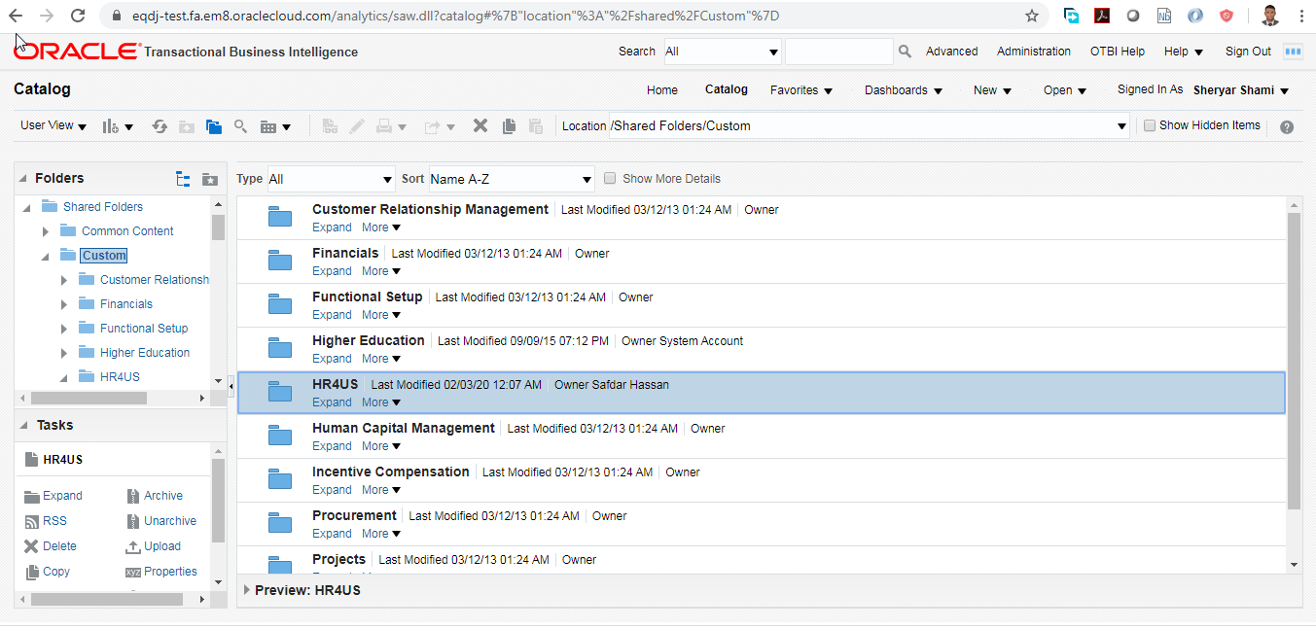

Right Click on “HR4US” Folder and choose option “Unarchive”

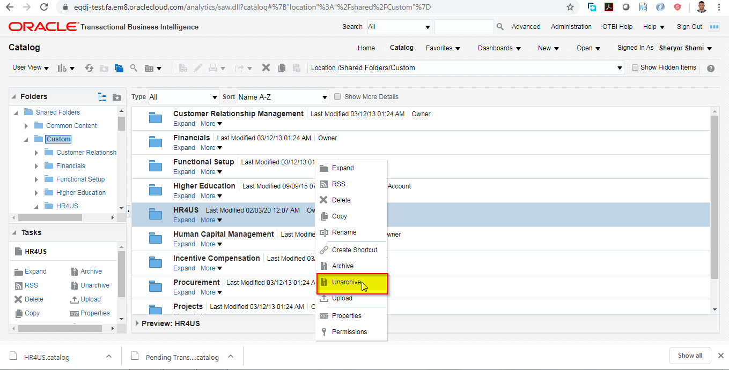

In the Dialog Box, click on Browse and select the catalog file called Pending Transactions.catalog 

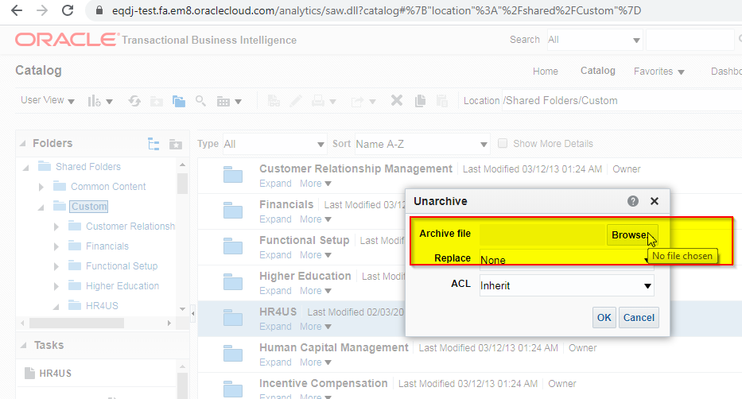

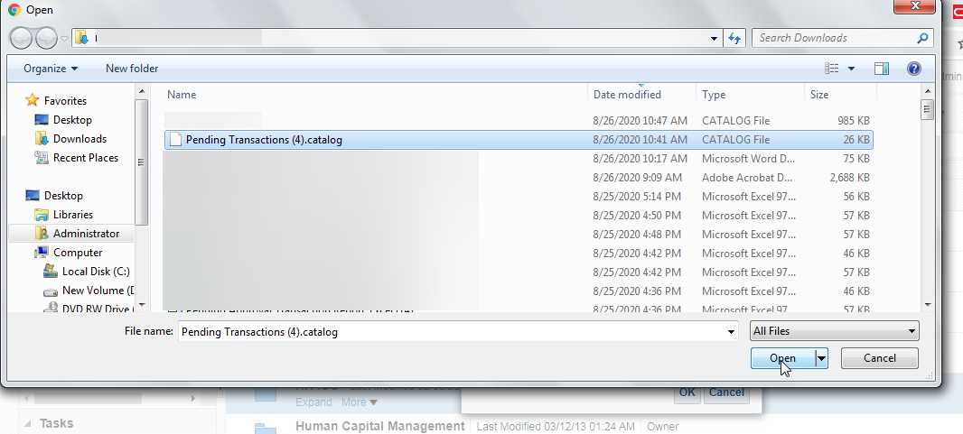

Ensure Replace” Option is “None” and “ACL” (Access Control List) Option is “Preserve”

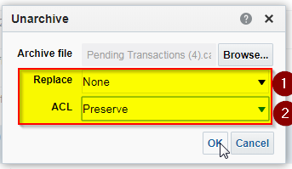

Click on OK

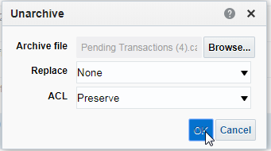

Change the Data Model to point to “Pending Transactions” Report Data Definition, go to Catalog -🡪 Shared folder/Custom/HR4US/Pending Transactions, Click on “Edit” Option of “Pending Approval Transaction Report”

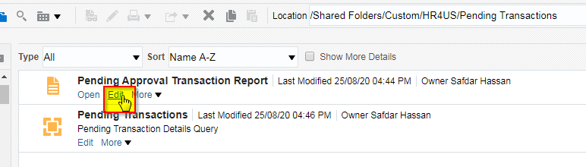

Click on Magnifying glass link to select “Pending Transactions” Data Definition from the path

Shared folder/Custom/HR4US/Pending Transactions

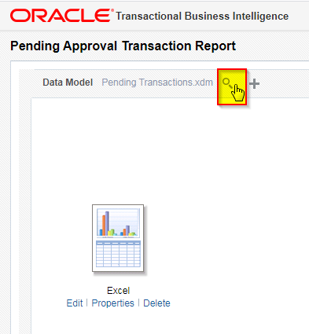

Click on Ok to close the data model selection.

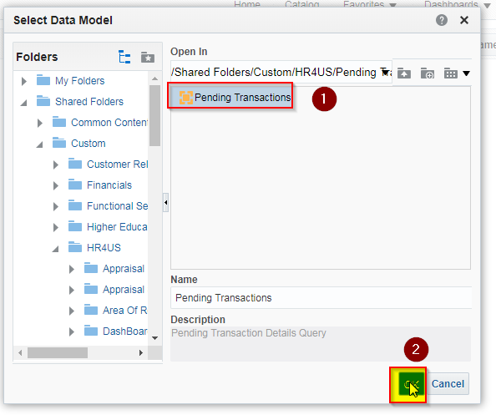

Now click on “Floppy” icon to save the definition

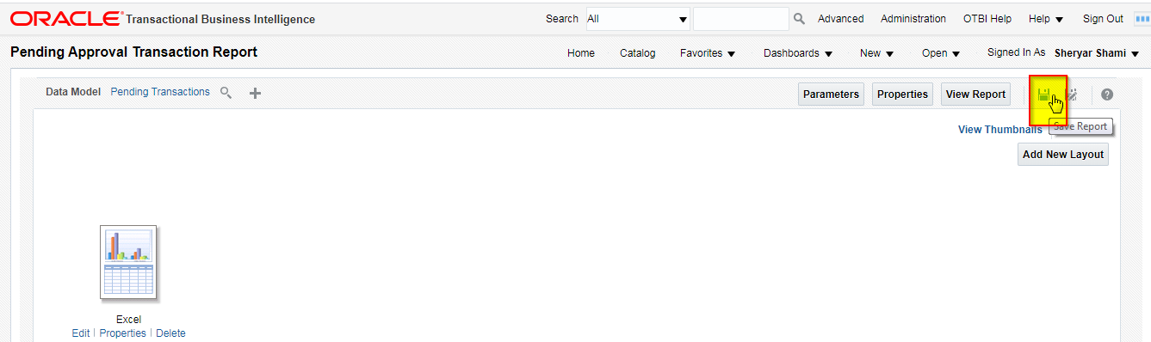

Finally click on “View Report” Button

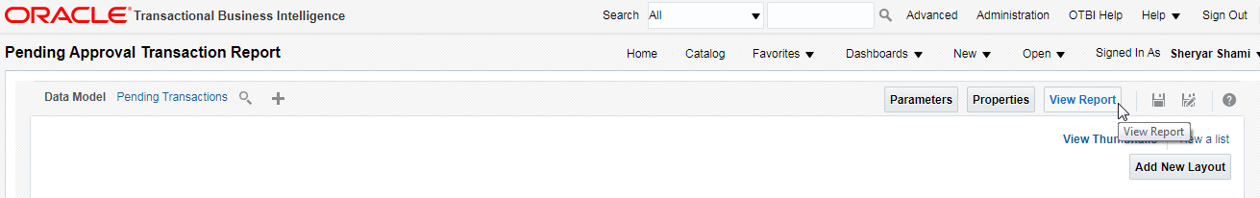

On the View Report page click on “Setting Gear Icon” 🡪 “Share Report Link”(Menu)🡪”No Header” (Option) and copy and save the link.

This link would be used for defining link for accessing report from HR SPOC Access.

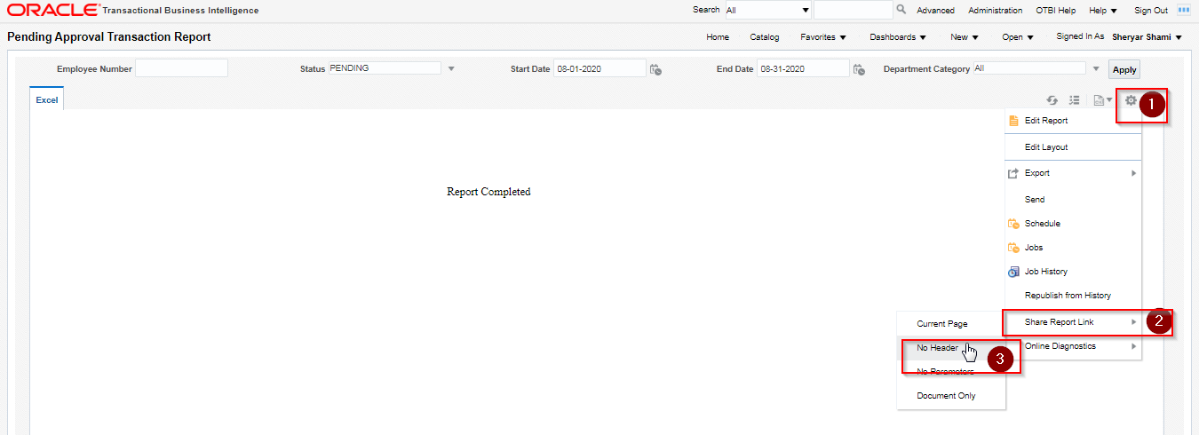

Select and Copy the URL from the next pop up form, this would be different in production instance.

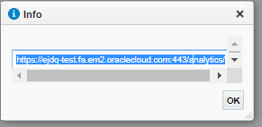

https://ejdq-test.fa.em2.oraclecloud.com:443/analytics/saw.dll?bipublisherEntry&Action=open&itemType=.xdo&bipPath=%2FCustom%2FHR4US%2FPending%20Transactions%2FPending%20Approval%20Transaction%20Report.xdo&bipParams={"_xmode":"2","_xiasynch":"","_xpf":"","_xpt":"0","_dFlag":"false","_edIndex":"0","_dIndex":"0","_rToken":"","_ranDiag":"false","_xdo":"%2FCustom%2FHR4US%2FPending%20Transactions%2FPending%20Approval%20Transaction%20Report.xdo","_paramsP_PERSON_NUMBER":"","xdo%3Axdo%3A_paramsP_STATUS_div_input":"PENDING","_paramsP_STATUS":"PENDING","_paramsP_START_DATE":"08-01-2020","_paramsP_END_DATE":"08-31-2020","xdo%3Axdo%3A_paramsP_DEPARTMENT_CATEGORY_div_input":"All","_paramsP_DEPARTMENT_CATEGORY":"*","_xt":"Excel","_xf":"excel","_xautorun":"true"}&_linkToReport=true

## Creation of Report Link for HR SPOC Role/Line Manager Role

Go to 🡪 Configuration (Menu) 🡪 Sandboxes (Option)

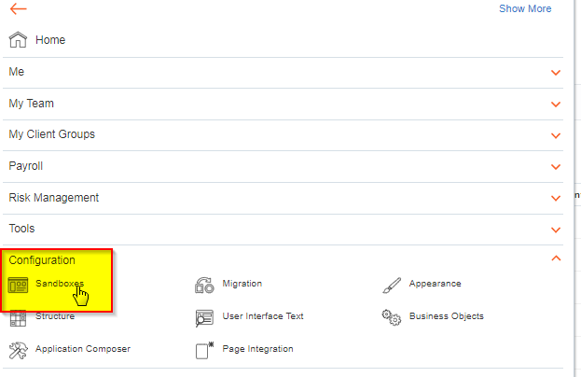

Click on “Create Sandbox” button

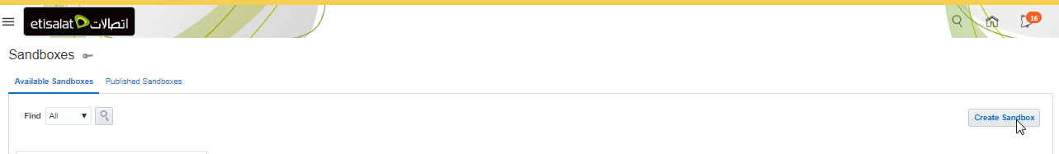

Enter Name of Sandbox as “Pending Transactions Report Deployment HR SPOC” and choose options as below

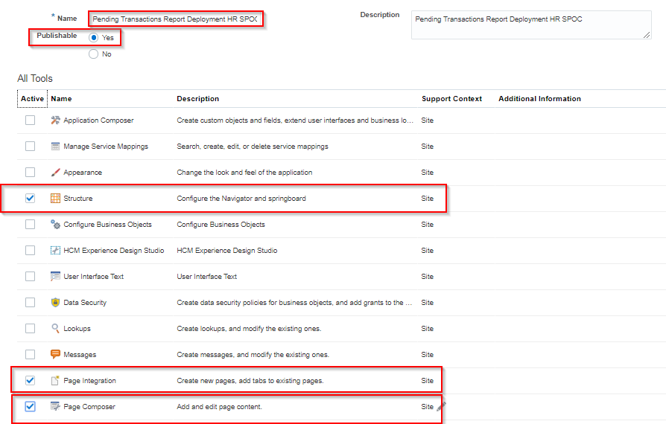

After entering all details and selecting relevant options

Click on “Create and Enter” Button



After a new page opens up, from the Bar dropdown “Tools” 🡪 Select “Page Integration” Option

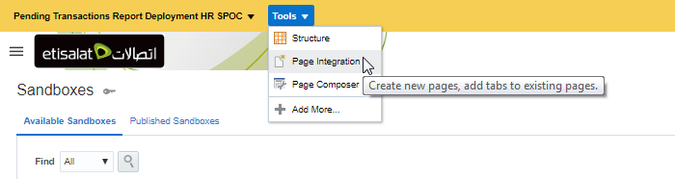

Click on Button “New Page”

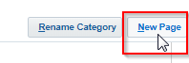

Enter following Details in New Page for ETC Line Manager Role

|  |  |
| --- | --- |
| Option | Value |
| Name | Pending Approval Transactions Report |
| Icon | Select Book Icon |
| Application Role | ETC Line Manager |
| Web Page | https://ejdq-test.fa.em2.oraclecloud.com:443/analytics/saw.dll?bipublisherEntry&Action=open&itemType=.xdo&bipPath=%2FCustom%2FHuman%20Capital%20Management%2FPending%20Transactions%2FPending%20Approval%20Transaction%20Report.xdo&bipParams={"_xmode":"2","_xiasynch":"","_xpf":"","_xpt":"","_dFlag":"false","_edIndex":"0","_dIndex":"0","_rToken":"","_ranDiag":"false","_xdo":"%2FCustom%2FHuman%20Capital%20Management%2FPending%20Transactions%2FPending%20Approval%20Transaction%20Report.xdo","_paramsP_PERSON_NUMBER":"","xdo%3Axdo%3A_paramsP_STATUS_div_input":"PENDING","_paramsP_STATUS":"PENDING","_paramsP_START_DATE":"08-01-2020","_paramsP_END_DATE":"08-31-2020","xdo%3Axdo%3A_paramsP_DEPARTMENT_CATEGORY_div_input":"All","_paramsP_DEPARTMENT_CATEGORY":"*","_xt":"Standard","_xf":"html"}&_linkToReport=true |

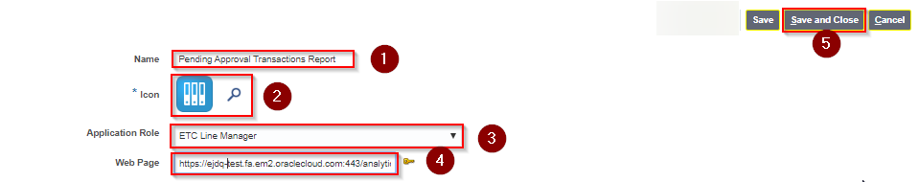

Enter following Details in New Page for HR SPOC Role

|  |  |
| --- | --- |
| Option | Value |
| Name | Pending Approval Report All Staff |
| Icon | Select Book Icon |
| Application Role | ETC HR SPOC |
| Web Page | https://ejdq-test.fa.em2.oraclecloud.com:443/analytics/saw.dll?bipublisherEntry&Action=open&itemType=.xdo&bipPath=%2FCustom%2FHR4US%2FPending%20Transactions%2FPending%20Approval%20Transaction%20Report.xdo&bipParams={"_xmode":"2","_xiasynch":"","_xpf":"","_xpt":"0","_dFlag":"false","_edIndex":"0","_dIndex":"0","_rToken":"","_ranDiag":"false","_xdo":"%2FCustom%2FHR4US%2FPending%20Transactions%2FPending%20Approval%20Transaction%20Report.xdo","_paramsP_PERSON_NUMBER":"","xdo%3Axdo%3A_paramsP_STATUS_div_input":"PENDING","_paramsP_STATUS":"PENDING","_paramsP_START_DATE":"08-01-2020","_paramsP_END_DATE":"08-31-2020","xdo%3Axdo%3A_paramsP_DEPARTMENT_CATEGORY_div_input":"All","_paramsP_DEPARTMENT_CATEGORY":"*","_xt":"Excel","_xf":"excel","_xautorun":"true"}&_linkToReport=true |

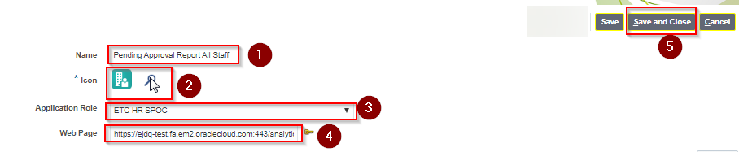

Click on dropdown “Tools”🡪 “Structure” (Option), this is to place the link on relevant region

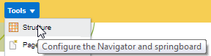

Select “Onboarding Report” Region 🡪 “Pending Approval Transactions Report” 🡪 “ > “ Option to Move the link to another Group

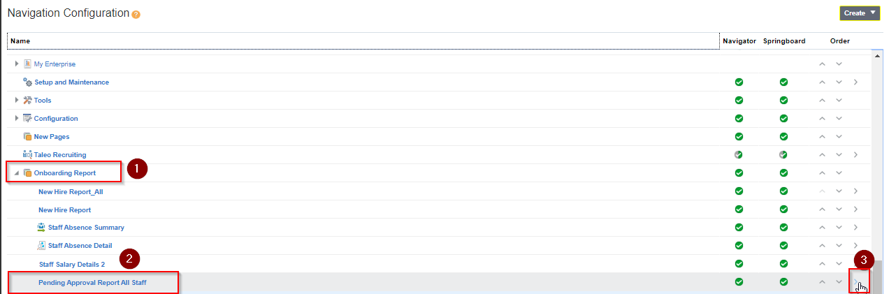

Now select “My Team” Group as in the snapshot below

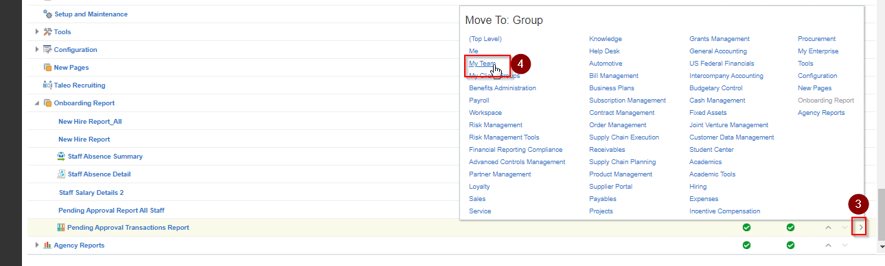

Now Pending Approval Transactions Report” Link is now in “My Team” Group and will be visible only to all Line Managers or ETC Line Manager Role.

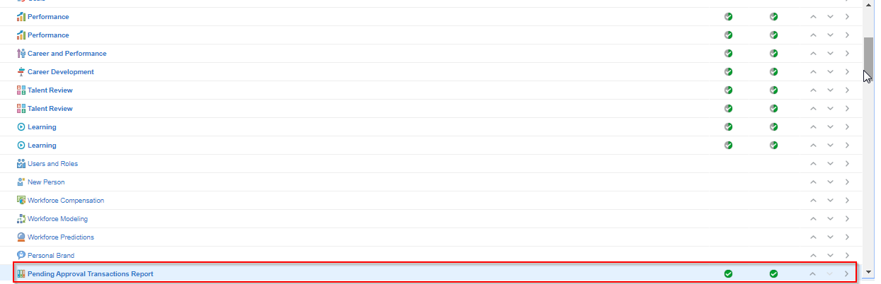

Select “Onboarding Report” Region 🡪 “Pending Approval Report All Staff” 🡪 “> “Option to Move the link to another Group “My Client Group” as in the snapshot below

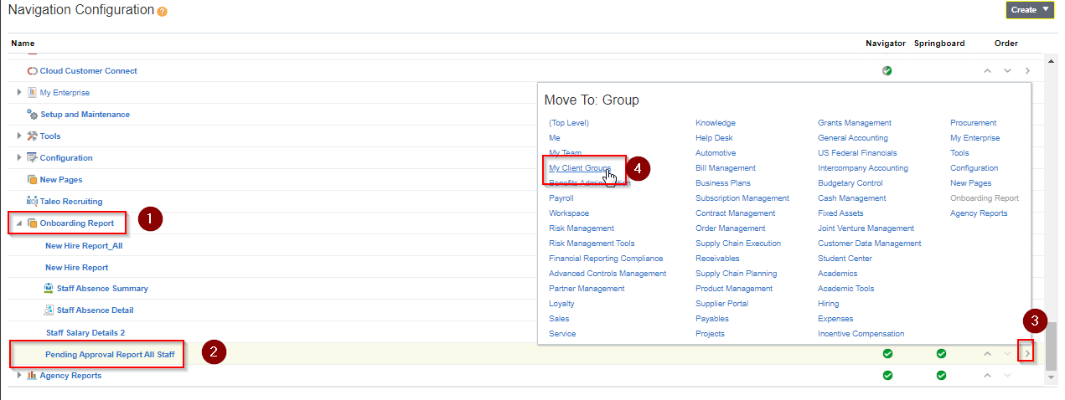

Now “Pending Approval Report All Staff” Link is now in “My Client Group” Group and will be visible only to HR SPOC Role.

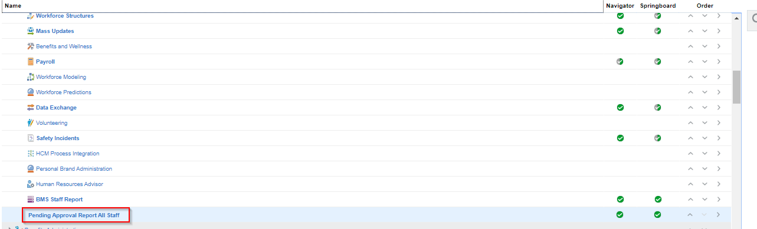

Finally we need to increase the display width of the report for this click on from dropdown “Tools” 🡪”Page Composer” Option

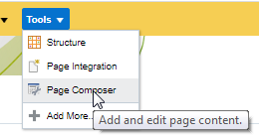

Navigate to menu 🡪 “My Team” Group 🡪 click on “Pending Approval Transactions Report” Link

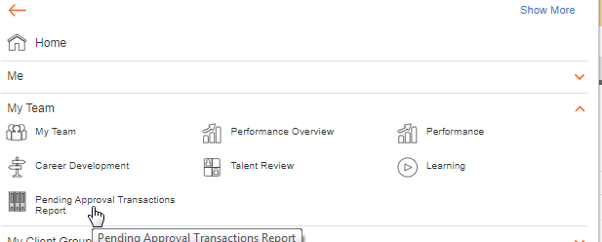

Now drag and increase the width of the window as in the snapshot below to make it wider for viewing the report output

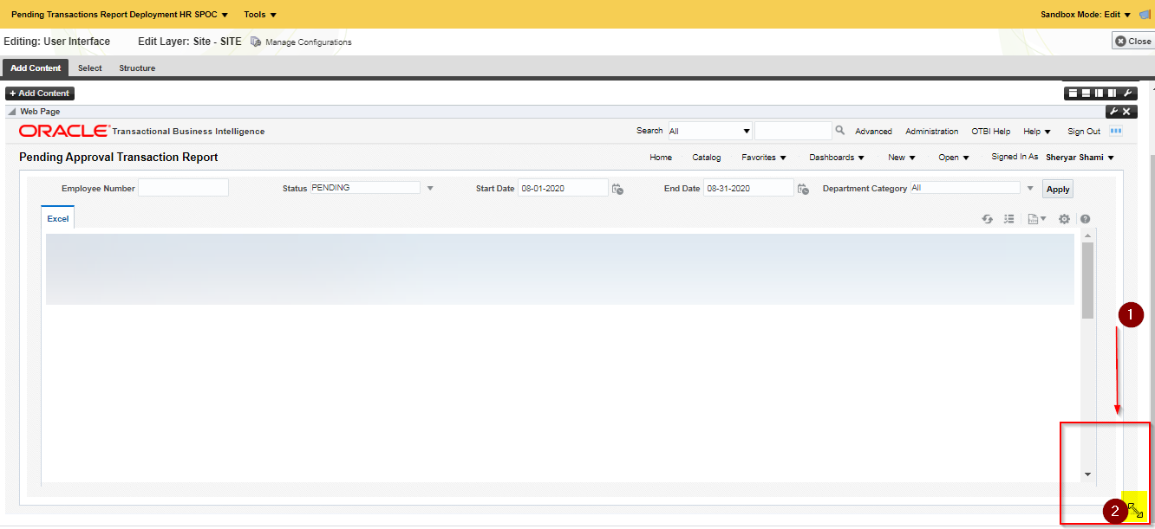

Now Increase width of another report from Menu 🡪 “My Client Groups“ Group 🡪 “Pending Approval Report All Staff”

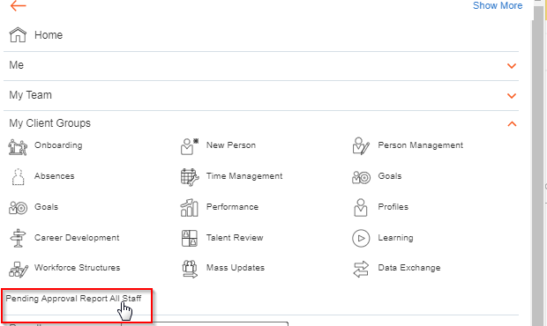

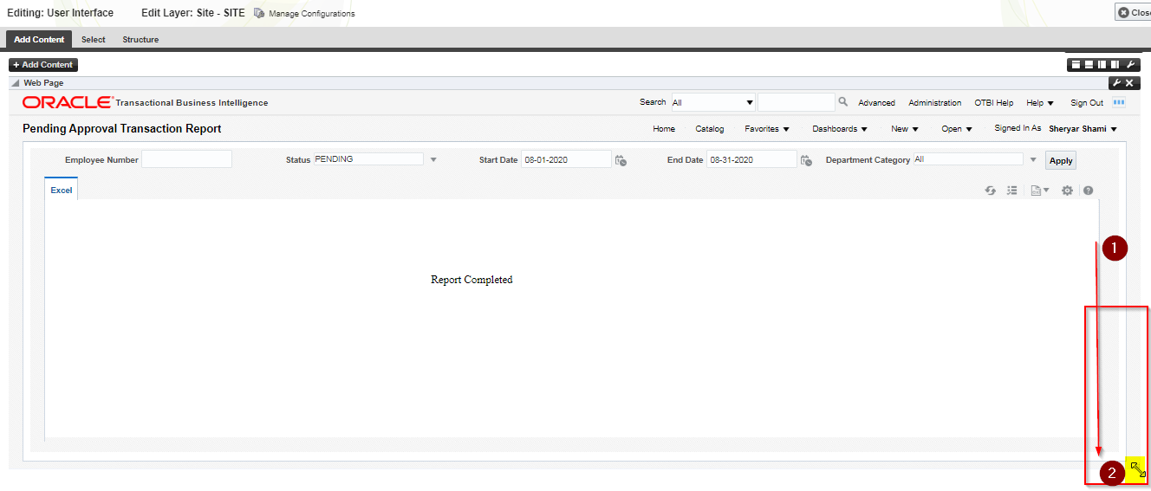

Finally deploy these changes to instance

Click on Option “Pending Transactions Report Deployment HR SPOC” and click on Option “Publish”

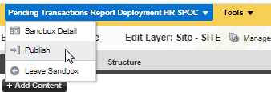

Click on “OK” option

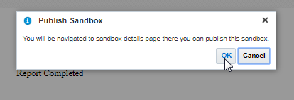

Click on “Publish” button

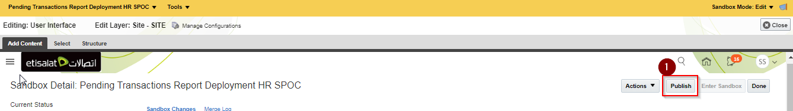

Click on “Continue to Publish” button again in the pop up window

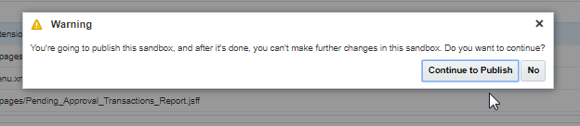

To Test, you can navigate to “My Client Group” Group and click on “Pending Approval Report All Staff” to check the report

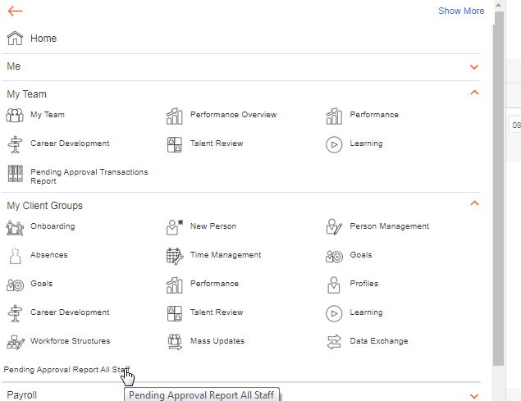

This closes the migration cycle.

# Open and Closed Issues

1. Add open issues that you identify while writing or reviewing this document to the open issues section. As you resolve issues, move them to the closed issues section and keep the issue ID the same. Include an explanation of the resolution.  
     
   When this work product is complete, any open issues should be transferred to the project- or process-level Issue Log (Manage focus area) and managed using a project level Issue Form (Manage focus area). In addition, the open items should remain in the open issues section of this work product, but flagged in the resolution column as being transferred.

## Open Issues

| ID | Issue | Resolution | Responsibility | Target Date | Impact Date |
| --- | --- | --- | --- | --- | --- |
|  |  |  |  |  |  |
|  |  |  |  |  |  |
|  |  |  |  |  |  |
|  |  |  |  |  |  |

## Closed Issues

| ID | Issue | Resolution | Responsibility | Target Date | Impact Date |
| --- | --- | --- | --- | --- | --- |
|  |  |  |  |  |  |
|  |  |  |  |  |  |
|  |  |  |  |  |  |
|  |  |  |  |  |  |