

DS.140 Design Specification

Emirates Telecommunication Group Company PJSC

**Salary Details DFF Report Design and Deployment**

Author: Abdulrahman Mohammed

Creation Date: August 30, 2020

Last Updated: August 30, 2020

Document Ref:

Version: V 1.0

1. **Title, Subject, Last Updated Date, Reference Number**, **and** **Version** are marked by a Word Bookmark so that they can be easily reproduced in the header and footer of documents. When you change any of these values, be careful not to accidentally delete the bookmark. **You can make bookmarks visible by selecting the Office Button>Word Options>Advanced> and checking the Show bookmarks option in the Show document content region.**

**Approvals:**

|  |  |
| --- | --- |
| Approver 1 | Buttar Gurmeet Singh |
| Approver 2 | Elliyas Momin |

1. To add additional approval lines, press [Tab] from the last cell in the table above.

oracle.gif

1. You can delete any elements of this cover page that you do not need for your document.

# Document Control

## Change Record

5

| Date | Author | Version | Change Reference |
| --- | --- | --- | --- |
| 30-Aug-20 | Abdulrahman Mohammed | 1.0 | No Previous Document |
|  |  |  |  |
|  |  |  |  |
|  |  |  |  |

## Reviewers

| Name | Position |
| --- | --- |
| Gurmeet Singh | Project Manager |
|  |  |
|  |  |
|  |  |

Contents

1 Document Control iii

1.1 Change Record iii

1.2 Reviewers iii

2 Technical Overview 1

3 Data Design 2

3.1 Catalog Archive of Salary Details DFF Report 2

4 SQL Design 3

4.1 View SQL Scripts used in the Report data definition 3

5 Behavior Design 13

5.1 Function (Operation) Design 13

5.2 Business Rule Design 13

6 Database Design 14

6.1 Database Diagram 14

6.2 Desired Table Changes 14

6.3 Tables, Indexes, Sequences 14

6.4 Unarchiving Report 14

7 Open and Closed Issues 20

7.1 Open Issues 20

7.2 Closed Issues 20

1. To update the table of contents, put the cursor anywhere in the table and press [F9]. To change the number of levels displayed, select the menu option Insert‑>Index and Tables, make sure the Table of Contents tab is active, and change the Number of Levels to a new value.

# Technical Overview

1. The purpose of this task is to assemble all the information that is required to describe the design of a software component into a complete Design Specification. This task is not a substitute for executing the individual design tasks. This specification work product can serve as a structure for completing the design for each component by providing pointers back into the Design Tasks:   
   - DS.040 Develop Design Architecture Description  
   - DS.080 Design Software Components  
   - DS.090 Design Data  
   - DS.100 Design Behavior  
   - DS.130 Design User Interface

This document facilitates deployment of report

Following is the flow

* Unarchive the catalog to deploy the Report first
* Change the source of data model to point to correct report data definition

1. The intent of this section is to document the report format designs for the reports provided by the component. Reference or include the report specification from the User Interface Design (DS.130) for the component.

# Data Design

1. The intent of this section is to define the design details of each attribute – format, length, accessibility, visibility, validation rules, mandatory or optional, etc. – that is required for each entity or class within the component. If available, reference or include the class diagram (or other data design model) from the Component Data Design (DS.090) for this component. If not available, use the table below.

## Catalog Archive of Salary Details DFF Report

1. The intent of this section is to identify the table, columns, and source values that are required to support the above data elements. Refer to the Physical Database Design (IM.040), to identify the existing tables where the above attributes are located.

Save following catalog file for unarchiving in later steps



# SQL Design

1. The intent of this section is to define the tables, the attributes and the SQL statements that are necessary to create, read, update, and/or delete the attributes for each use case from the database. Include applicable portions of the Software Component Design (DS.080). The focus is on creating the SQL documents for the CRUD (Create, Read, Update, Delete) processes. If the DS.080 is not available, provide the SQL for your module here.

## View SQL Scripts used in the Report data definition

SELECT DISTINCT PERSONPEO.PERSON_ID,

PERSONDETAILSPEO.PERSON_NUMBER,

PERSONPEO.BLOOD_TYPE,

PERSONNAMEPEO.DISPLAY_NAME,

PERSONNAMEPEO.FIRST_NAME,

PERSONNAMEPEO.LAST_NAME,

ASSIGNMENTPEO.ASSIGNMENT_TYPE,

ASSIGNMENTPEO.ASSIGNMENT_NUMBER,

TO_CHAR(TRUNC(PS.ACTUAL_TERMINATION_DATE),'DD-Mon-YY', 'nls_date_language=American') ACTUAL_TERMINATION_DATE,

TO_CHAR(TRUNC(PS.DATE_START),'DD-Mon-YY', 'nls_date_language=American') AS HIRE_DATE,

TO_CHAR(TRUNC(PERSONPEO.DATE_OF_BIRTH),'DD-Mon-YY', 'nls_date_language=American') DATE_OF_BIRTH,

TO_CHAR(TRUNC(ASSIGNMENTPEO.ASS_ATTRIBUTE_DATE1),'DD-Mon-YY', 'nls_date_language=American') AS SUSPENSION_DATE,

ASSIGNMENTPEO.EFFECTIVE_SEQUENCE,

ASSIGNMENTPEO.ASSIGNMENT_STATUS_TYPE,

ASSIGNMENTPEO.ASSIGNMENT_STATUS_TYPE_ID,

ASSIGNMENTPEO.HOURLY_SALARIED_CODE,

ASSIGNMENTPEO.EMPLOYEE_CATEGORY,

per_extract_utility.get_decoded_lookup('EMP_CAT',ASSIGNMENTPEO.EMPLOYMENT_CATEGORY) EMPLOYMENT_CATEGORY,

ASSIGNMENTPEO.PERMANENT_TEMPORARY_FLAG,

ASSIGNMENTPEO.PERSON_TYPE_ID,

ASSIGNMENTPEO.SOURCE_TYPE,

-- ASSIGNMENTPEO.CONTRACT_ID,

assignmentPEO.ASS_ATTRIBUTE_NUMBER3 AS Shift_Days,

-- per_extract_utility.get_decoded_lookup('CONTRACT_TYPE',CONTRACTS.TYPE) AS CONTRACT_TYPE,

-- per_extract_utility.get_decoded_lookup('HRX_AE_EMPLOYMENT_STATUS',CONTRACTS.CTR_INFORMATION1) AS EMPLOYMENT_STATUS,

-- to_char(trunc(CONTRACTS.EFFECTIVE_START_DATE),'DD-Mon-YY', 'nls_date_language=American') CONT_START_DATE,

-- to_char(trunc(CONTRACTS.EFFECTIVE_END_DATE),'DD-Mon-YY', 'nls_date_language=American') CONT_END_DATE,

DEPARTMENTS.ORGANIZATION_ID,

DEPARTMENTS.NAME AS DEPARTMENT_NAME,

ASSIGNMENTPEO.JOB_ID,

JOBS.NAME AS JOB_NAME,

JOBS.JOB_CODE AS JOB_CODE,

ASSIGNMENTPEO.POSITION_ID,

POSITIONS.NAME AS POSITION_NAME,

POSITIONS.POSITION_CODE AS POSITION_CODE,

PERSON_TYPE.SYSTEM_PERSON_TYPE,

PERSON_TYPE.USER_PERSON_TYPE,

-- EMAILS.EMAIL_ADDRESS,

-- sources.ATTENDANCE_SOURCE,

PERSONPEO.ATTRIBUTE2 AS OLD_EMLPOYEE_NUMBER,

DOR.BASIC_SALARY ,

DOR.CONSOLIDATED_ALLOWANCE,

DOR.SPECIAL_ALLOWANCE,

DOR.CHILD_SUBSISTENCE_ALLOWANCE,

DOR.HOUSING_ALLOWANCE,

DOR.TRANSPORT_ALLOWANCE,

DOR.CAR_ALLOWANCE,

DOR.UTILITY_ALLOWANCE,

DOR.OTHER_ALLOWANCE,

DOR.TELEPHONE_ALLOWANCE,

DOR.COST_OF_LIVING_ALLOWANCE,

DOR.EDUCATION_ALLOWANCE,

DOR.AIR_FARE_ANNUAL_TICKET,

DOR.INSURANCE,

DOR.PENSION,

TO_CHAR(TRUNC(DOR.date_from),'DD-Mon-YY', 'nls_date_language=American') AS DATE_FROM,

TO_CHAR(TRUNC(DOR.date_to),'DD-Mon-YY', 'nls_date_language=American') AS DATE_TO,

-- GRP.SEGMENT2 AS AGENCY_NUMBER,

-- AGENCY.AGENCY_NAME,

-- GRP.SEGMENT3 AS CONTRACT_NUMBER,

-- GRP.SEGMENT4 AS BPA1,

-- GRP.SEGMENT5 AS PAYMENT_CATEGORY,

-- USERS.USERNAME,

--

-- (

-- select per_extract_utility.get_decoded_lookup('SEX',leg.SEX) from

-- PER_PEOPLE_LEGISLATIVE_F leg

-- where PERSONPEO.PERSON_ID = leg.PERSON_ID

-- AND SYSDATE BETWEEN leg.EFFECTIVE_START_DATE AND leg.EFFECTIVE_END_DATE and rownum=1

--

-- ) as GENDER,

--

-- (

-- select per_extract_utility.get_decoded_lookup('MAR_STATUS',leg.MARITAL_STATUS) from

-- PER_PEOPLE_LEGISLATIVE_F leg

-- where PERSONPEO.PERSON_ID = leg.PERSON_ID

-- AND SYSDATE BETWEEN leg.EFFECTIVE_START_DATE AND leg.EFFECTIVE_END_DATE and rownum=1

--

-- ) as MARITAL_STATUS ,

(

SELECT SALARY.SALARY_AMOUNT

FROM CMP_ASG_SALARY_V SALARY

WHERE SALARY.ASSIGNMENT_ID = ASSIGNMENTPEO.ASSIGNMENT_ID

AND SYSDATE BETWEEN SALARY.DATE_FROM AND NVL(SALARY.DATE_TO,SYSDATE)

AND ROWNUM = 1

) GROSS_SALARY_AMOUNT,

(SELECT PERSONNAMEPEO2.DISPLAY_NAME FROM PER_ALL_PEOPLE_F PPF ,

PER_ASSIGNMENT_SUPERVISORS_F SUPERVISOR ,

PER_PERSON_NAMES_F_V PERSONNAMEPEO2

WHERE SYSDATE BETWEEN PPF.EFFECTIVE_START_DATE AND NVL(PPF.EFFECTIVE_END_DATE,SYSDATE ) AND PPF.PERSON_ID = SUPERVISOR.MANAGER_ID AND SUPERVISOR.ASSIGNMENT_ID = ASSIGNMENTPEO.ASSIGNMENT_ID

AND SYSDATE BETWEEN SUPERVISOR.EFFECTIVE_START_DATE AND NVL(SUPERVISOR.EFFECTIVE_END_DATE,SYSDATE)

AND SUPERVISOR.MANAGER_TYPE = 'LINE_MANAGER' AND PPF.PERSON_ID = PERSONNAMEPEO2.PERSON_ID

AND SYSDATE BETWEEN PERSONNAMEPEO2.EFFECTIVE_START_DATE AND NVL(PERSONNAMEPEO2.EFFECTIVE_END_DATE,SYSDATE )

AND ROWNUM = 1 ) MANAGER_NAME,

(SELECT PERSON_NUMBER FROM PER_ALL_PEOPLE_F PPF ,

PER_ASSIGNMENT_SUPERVISORS_F SUPERVISOR WHERE SYSDATE BETWEEN PPF.EFFECTIVE_START_DATE AND NVL(PPF.EFFECTIVE_END_DATE,SYSDATE ) AND PPF.PERSON_ID = SUPERVISOR.MANAGER_ID AND SUPERVISOR.ASSIGNMENT_ID = ASSIGNMENTPEO.ASSIGNMENT_ID

AND SYSDATE BETWEEN SUPERVISOR.EFFECTIVE_START_DATE AND NVL(SUPERVISOR.EFFECTIVE_END_DATE,SYSDATE)

AND SUPERVISOR.MANAGER_TYPE = 'LINE_MANAGER' AND ROWNUM = 1 ) MANAGER_NUMBER

-- (

--

-- SELECT LK.MEANING FROM PER_RELIGIONS RELIGION, HCM_LOOKUPS LK

--

-- WHERE PERSONPEO.PERSON_ID=RELIGION.PERSON_ID AND

-- PRIMARY_FLAG='Y' AND LK.LOOKUP_TYPE='PER_RELIGION'

-- AND RELIGION.RELIGION=LK.LOOKUP_CODE) AS RELIGION,

--

-- (SELECT LK.MEANING FROM PER_CITIZENSHIPS C, HCM_LOOKUPS LK

-- WHERE PERSONPEO.PERSON_ID=C.PERSON_ID AND

-- LK.LOOKUP_TYPE='NATIONALITY'

-- AND C.LEGISLATION_CODE=LK.LOOKUP_CODE AND C.CITIZENSHIP_STATUS='A' AND ROWNUM=1) AS CITIZENSHIP,

--

--

--

-- (SELECT C.PASSPORT_NUMBER FROM PER_PASSPORTS C

-- WHERE PERSONPEO.PERSON_ID=C.PERSON_ID AND ROWNUM=1) AS PASSPORT_NUMBER,

-- (SELECT to_char(trunc(C.EXPIRATION_DATE),'DD-Mon-YY', 'nls_date_language=American') FROM PER_PASSPORTS C

-- WHERE PERSONPEO.PERSON_ID=C.PERSON_ID AND ROWNUM=1) AS PASSPORT_EXPIRY_DATE,

-- (SELECT to_char(trunc(C.ISSUE_DATE),'DD-Mon-YY', 'nls_date_language=American') FROM PER_PASSPORTS C

-- WHERE PERSONPEO.PERSON_ID=C.PERSON_ID AND ROWNUM=1) AS PASSPORT_ISSUE_DATE,

--

-- (SELECT ''''||to_char(C.NATIONAL_IDENTIFIER_NUMBER) FROM PER_NATIONAL_IDENTIFIERS C

-- WHERE PERSONPEO.PERSON_ID=C.PERSON_ID AND ROWNUM=1) AS NATIONAL_IDENTIFIER_NUMBER,

-- (SELECT to_char(trunc(C.EXPIRATION_DATE),'DD-Mon-YY', 'nls_date_language=American') FROM PER_NATIONAL_IDENTIFIERS C

-- WHERE PERSONPEO.PERSON_ID=C.PERSON_ID AND ROWNUM=1) AS ID_EXPIRATION_DATE,

--

-- (SELECT to_char(C.VISA_PERMIT_NUMBER) FROM PER_VISAS_PERMITS_F C

-- WHERE PERSONPEO.PERSON_ID=C.PERSON_ID AND ROWNUM=1) AS VISA_PERMIT_NUMBER,

-- (SELECT to_char(trunc(C.ISSUE_DATE),'DD-Mon-YY', 'nls_date_language=American') FROM PER_VISAS_PERMITS_F C

-- WHERE PERSONPEO.PERSON_ID=C.PERSON_ID AND ROWNUM=1) AS VISA_ISSUE_DATE,

-- (SELECT to_char(trunc(C.EXPIRATION_DATE),'DD-Mon-YY', 'nls_date_language=American') FROM PER_VISAS_PERMITS_F C

-- WHERE PERSONPEO.PERSON_ID=C.PERSON_ID AND ROWNUM=1) AS VISA_EXPIRATION_DATE,

--

--

-- (

-- SELECT

-- PLDFT.LOCATION_NAME LOCATIONNAME

-- FROM

-- PER_LOCATION_DETAILS_F PLDF,

-- PER_LOCATION_DETAILS_F_TL PLDFT

-- WHERE ASSIGNMENTPEO.LOCATION_ID = PLDF.LOCATION_ID

-- AND TRUNC(SYSDATE) BETWEEN PLDF.EFFECTIVE_START_DATE AND PLDF.EFFECTIVE_END_DATE

-- AND PLDF.LOCATION_DETAILS_ID = PLDFT.LOCATION_DETAILS_ID and rownum=1

-- ) AS LOCATION_NAME,

--

-- (SELECT C.PHONE_NUMBER FROM PER_PHONES C

--

-- WHERE PERSONDETAILSPEO.PRIMARY_PHONE_ID=C.PHONE_ID AND

-- PERSONPEO.PERSON_ID=C.PERSON_ID AND

-- ROWNUM=1) AS PHONE_NUMBER,

--

-- orgs.attribute7 as COST_CENTER,

-- (

--

--

-- select

--

-- per_extract_utility.get_decoded_lookup('ETC_BANKS',rec.DEI_ATTRIBUTE1) Bank_name

--

--

-- from

--

--

--

-- HR_DOCUMENT_TYPES_VL v,

-- HR_DOCUMENTS_OF_RECORD rec

-- where

-- rec.DOCUMENT_TYPE_ID=v.DOCUMENT_TYPE_ID

-- and v.DOCUMENT_TYPE='Bank Details'

-- and rec.person_id=PERSONPEO.PERSON_ID and rownum=1

--

--

-- ) Bank_NAME,

-- (

--

-- select

-- rec.DEI_ATTRIBUTE3 IBAN

-- from

--

-- HR_DOCUMENT_TYPES_VL v,

-- HR_DOCUMENTS_OF_RECORD rec

-- where

-- rec.DOCUMENT_TYPE_ID=v.DOCUMENT_TYPE_ID

-- and v.DOCUMENT_TYPE='Bank Details'

-- and rec.person_id=PERSONPEO.PERSON_ID and rownum=1

--

-- ) IBAN

-- ,

-- (select

--

-- per_extract_utility.get_decoded_lookup('DISABILITY_CATEGORY',CATEGORY) DISABILITY_CATEGORY

--

--

-- from PER_DISABILITIES_F dis

--

-- where SYSDATE BETWEEN dis.EFFECTIVE_START_DATE AND NVL(dis.EFFECTIVE_END_DATE,SYSDATE)

-- and dis.person_id=PERSONPEO.PERSON_ID

-- and dis.ASSIGNMENT_ID = ASSIGNMENTPEO.ASSIGNMENT_ID

-- and rownum=1 ) DISABILITY_CATEGORY,

--decode(ASSIGNMENTPEO.REASON_CODE,'AGENCY CHANGE',to_char(trunc(ASSIGNMENTPEO.EFFECTIVE_START_DATE),'DD-Mon-YY', 'nls_date_language=American'),to_char(trunc(PS.DATE_START),'DD-Mon-YY', 'nls_date_language=American')) DOJ_WITH_AGENCY,

--initcap(ASSIGNMENTPEO.REASON_CODE) REASON_CODE,

-- (SELECT

-- H.ACTION_REASON

--FROM PER_ALL_ASSIGNMENTS_M M, PER_ACTION_OCCURRENCES AC, PER_ACTION_REASONS_VL H

--WHERE M.PERSON_ID = PERSONPEO.PERSON_ID

--AND M.ACTION_CODE ='TERMINATION'

--AND M.ASSIGNMENT_TYPE = ASSIGNMENTPEO.ASSIGNMENT_TYPE

--AND M.ACTION_OCCURRENCE_ID = AC.ACTION_OCCURRENCE_ID

--AND AC.ACTION_REASON_ID = H.ACTION_REASON_ID ) TERMINATION_REASON,

--ASSIGNMENTPEO.NORMAL_HOURS ||'-' ||per_extract_utility.get_decoded_lookup('FREQUENCY',ASSIGNMENTPEO.FREQUENCY) WORKINGHR_FREQ,

--ASSIGNMENTPEO.ASS_ATTRIBUTE7 SHIFT_CATEGORY,

--(select ORG_INFORMATION_NUMBER1 ||'-'||per_extract_utility.get_decoded_lookup('FREQUENCY',ORG_INFORMATION4) from HR_ORGANIZATION_INFORMATION_F

--where ORG_INFORMATION_CONTEXT='PER_WORK_DAY_INFO'

--AND LEGISLATION_CODE = 'AE'

--and trunc(sysdate) between effective_start_date and effective_end_date

--AND ORGANIZATION_ID IN (select n.organization_id from HR_ORGANIZATION_UNITS n

--where n.name = 'Emirates Telecommunications Corporation LE')) STANDARD_WORKING_HR

FROM PER_PERSONS PERSONPEO,

PER_PERSON_SECURED_LIST_V PERSONDETAILSPEO,

PER_PERSON_NAMES_F_V PERSONNAMEPEO,

PER_ALL_ASSIGNMENTS_M ASSIGNMENTPEO,

--PER_CONTRACTS_F CONTRACTS,

PER_DEPARTMENTS DEPARTMENTS,

PER_JOBS JOBS,

HR_ALL_POSITIONS POSITIONS,

PER_PERSON_TYPES_VL PERSON_TYPE ,

PER_EMAIL_ADDRESSES EMAILS,

PER_PERIODS_OF_SERVICE PS,

PER_PEOPLE_GROUPS GRP,

PER_USERS USERS,

(SELECT *

FROM

(SELECT DEI_ATTRIBUTE_NUMBER1 BASIC_SALARY ,

DEI_ATTRIBUTE_NUMBER2 CONSOLIDATED_ALLOWANCE,

DEI_ATTRIBUTE_NUMBER3 SPECIAL_ALLOWANCE,

DEI_ATTRIBUTE_NUMBER4 CHILD_SUBSISTENCE_ALLOWANCE,

DEI_ATTRIBUTE_NUMBER5 HOUSING_ALLOWANCE,

DEI_ATTRIBUTE_NUMBER6 TRANSPORT_ALLOWANCE,

DEI_ATTRIBUTE_NUMBER7 CAR_ALLOWANCE,

DEI_ATTRIBUTE_NUMBER8 UTILITY_ALLOWANCE,

DEI_ATTRIBUTE_NUMBER9 OTHER_ALLOWANCE,

DEI_ATTRIBUTE_NUMBER10 TELEPHONE_ALLOWANCE,

DEI_ATTRIBUTE_NUMBER11 COST_OF_LIVING_ALLOWANCE,

DEI_ATTRIBUTE_NUMBER12 EDUCATION_ALLOWANCE,

DEI_ATTRIBUTE_NUMBER13 AIR_FARE_ANNUAL_TICKET,

DEI_ATTRIBUTE_NUMBER14 INSURANCE,

DEI_ATTRIBUTE_NUMBER15 PENSION,

rec.date_from,

rec.date_to,

PERSON_ID

FROM HR_DOCUMENTS_OF_RECORD rec

WHERE rec.DEI_ATTRIBUTE_CATEGORY ='GLB_ETC_SALARY_DETAILS'

AND (:P_START_DATE BETWEEN rec.date_from AND NVL(rec.date_to, to_date('31-12-4712','DD-MM-RRRR')))

order by row_number()

over (partition by rec.PERSON_ID

order by rec.creation_date desc )

fetch first row with ties

)

) DOR

-- (SELECT VS.VALUE_SET_CODE,B.VALUE AS AGENCY_NUMBER,T.DESCRIPTION AS AGENCY_NAME FROM

-- FND_VS_VALUES_B B ,FND_VS_VALUES_TL T, FND_VS_VALUE_SETS VS

-- WHERE

-- UPPER(VS.VALUE_SET_CODE) =UPPER('ETC AGENCIES')

-- AND B.VALUE_SET_ID=VS.VALUE_SET_ID

-- AND T.VALUE_ID=B.VALUE_ID

-- AND ENABLED_FLAG='Y') AGENCY ,

--

-- (SELECT VS.VALUE_SET_CODE,B.VALUE AS ATTENDANCE_SOURCE_ID,T.DESCRIPTION AS ATTENDANCE_SOURCE FROM

-- FND_VS_VALUES_B B ,FND_VS_VALUES_TL T, FND_VS_VALUE_SETS VS

-- WHERE

-- UPPER(VS.VALUE_SET_CODE) =UPPER('Attendence Source_WFM_BMS')

-- AND B.VALUE_SET_ID=VS.VALUE_SET_ID

-- AND T.VALUE_ID=B.VALUE_ID

-- AND ENABLED_FLAG='Y') sources ,

--

-- (

-- select *

-- from PER_CONTRACTS_F c

-- where exists (

-- select 1 from PER_ALL_ASSIGNMENTS_M x

-- where x.CONTRACT_ID=c.CONTRACT_ID

-- AND SYSDATE BETWEEN x.EFFECTIVE_START_DATE AND NVL(x.EFFECTIVE_END_DATE,SYSDATE )

--

-- ) AND SYSDATE BETWEEN c.EFFECTIVE_START_DATE AND c.EFFECTIVE_END_DATE

-- )CONTRACTS,

--

-- (

--

-- select attribute7 ,ORGANIZATION_ID from HR_ALL_ORGANIZATION_UNITS_F x

-- where SYSDATE BETWEEN x.EFFECTIVE_START_DATE AND NVL(x.EFFECTIVE_END_DATE,SYSDATE )

--

--

--

-- ) orgs

WHERE PERSONPEO.PERSON_ID = PERSONDETAILSPEO.PERSON_ID

AND PERSONPEO.PERSON_ID = PERSONNAMEPEO.PERSON_ID

AND PERSONPEO.PERSON_ID = ASSIGNMENTPEO.PERSON_ID

AND PERSONPEO.PERSON_ID = PS.PERSON_ID

AND PERSONPEO.PERSON_ID = DOR.PERSON_ID(+)

AND ASSIGNMENTPEO.EFFECTIVE_LATEST_CHANGE = 'Y'

AND ASSIGNMENTPEO.ASSIGNMENT_TYPE IN( 'E' ,'C')

-- AND ASSIGNMENTPEO.CONTRACT_ID=CONTRACTS.CONTRACT_ID(+)

AND ASSIGNMENTPEO.ORGANIZATION_ID = DEPARTMENTS.ORGANIZATION_ID(+)

-- AND ASSIGNMENTPEO.ORGANIZATION_ID = orgs.ORGANIZATION_ID(+)

AND ASSIGNMENTPEO.JOB_ID = JOBS.JOB_ID(+)

AND ASSIGNMENTPEO.POSITION_ID = POSITIONS.POSITION_ID(+)

AND ASSIGNMENTPEO.PERSON_TYPE_ID =PERSON_TYPE.PERSON_TYPE_ID(+)

AND PERSONDETAILSPEO.PRIMARY_EMAIL_ID=EMAILS.EMAIL_ADDRESS_ID(+)

-- AND GRP.SEGMENT2=AGENCY.AGENCY_NUMBER(+)

AND ASSIGNMENTPEO.PEOPLE_GROUP_ID = GRP.PEOPLE_GROUP_ID(+)

--AND GRP.PEOPLE_GROUP_ID IS NOT NULL

AND PERSONPEO.PERSON_ID=USERS.PERSON_ID(+)

-- AND ASSIGNMENTPEO.ASS_ATTRIBUTE_NUMBER1=sources.ATTENDANCE_SOURCE_ID(+)

AND :P_START_DATE BETWEEN PERSONDETAILSPEO.EFFECTIVE_START_DATE AND NVL(PERSONDETAILSPEO.EFFECTIVE_END_DATE,SYSDATE )

AND :P_START_DATE BETWEEN PERSONNAMEPEO.EFFECTIVE_START_DATE AND NVL(PERSONNAMEPEO.EFFECTIVE_END_DATE,SYSDATE )

AND :P_START_DATE BETWEEN ASSIGNMENTPEO.EFFECTIVE_START_DATE AND NVL(ASSIGNMENTPEO.EFFECTIVE_END_DATE,SYSDATE )

AND PERSONDETAILSPEO.PERSON_NUMBER NOT IN ('3','2','504245','504173')

AND PERSON_TYPE.SYSTEM_PERSON_TYPE = 'CWK'

AND (:P_DEPARTMENT_CATEGORY IS NULL

OR (per_extract_utility.get_decoded_lookup('EMP_CAT',ASSIGNMENTPEO.EMPLOYMENT_CATEGORY) = :P_DEPARTMENT_CATEGORY))

and (:P_PERSON_NUMBER IS NULL OR PERSONDETAILSPEO.person_number=:P_PERSON_NUMBER)

ORDER BY PERSONNAMEPEO.DISPLAY_NAME

1. ORDER BY 1;The intent of this section is to define the design considerations necessary to achieve the data retrieval and storage requirements for performance. Include performance requirements as specified in the Supplemental Requirements (RD.055) for service level requirements (i.e., 1-minute response time, etc.)

# Behavior Design

1. The intent of this section is to define the details of each operation (to include pseudo code) required for each entity, module, or class within the component. Refer to Behavior Design (DS.100) and the Design class diagram, with a focus specifically on the Operations section for the Class. In the event that you do not have a class diagram use the table below.

## Function (Operation) Design

## Business Rule Design

1. The intent of this section is to define the implementation strategy for each business rule within this component. Refer to the DS.110 Business Rules Design to capture the Business Rules for this component.
2. The intent of this section is to define the design considerations necessary to achieve the performance requirements for each interface. Include performance supplemental requirements as specified in the Supplemental Requirements (RD.055) work product for service level requirements include the Software Component Design (DS.080) with focus on the interface performance Design.

# Database Design

1. The intent of this section is to design the physical schema of the database, or changes to the database for this component. Refer to the Logical Database Design (DS.150).

This section summarizes new and/or changing database objects and data required to support Salary Details DFF However, the complete database design is documented in the Develop Database Design work product.

## Database Diagram

1. The intent of this section is to graphically depict the ER diagram that represents how the database will be designed for this component. Refer to the Logical Database Design (DS.150) with a focus only on the portion of the diagram needed to support this component.

## Desired Table Changes

1. The intent of this section is to document the design changes necessary for existing or new tables required to support this component. Refer to the Logical Database Design (DS.150).

## Tables, Indexes, Sequences

## Unarchiving Report

For unarchiving Report Navigate to Path “Shared Folder/Custom and click on highlight “HR4US” and right click.

1. The intent of this section is to document the design changes necessary to provide archiving required to support this component. Refer to the Logical Database Design (DS.150).

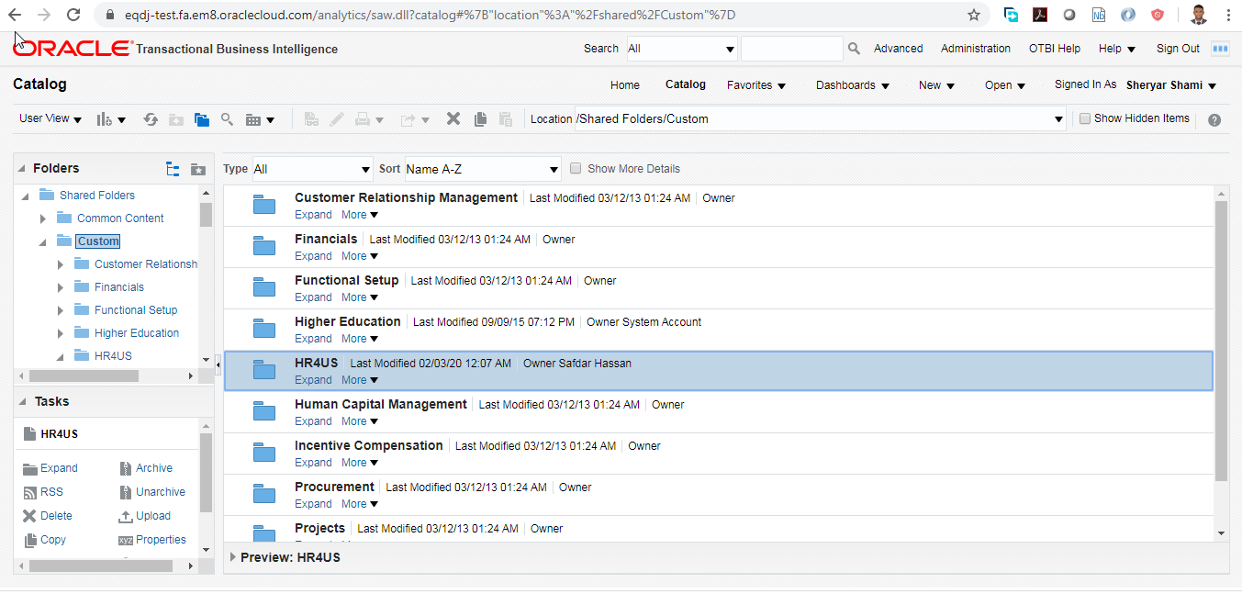

Right Click on “HR4US” Folder and choose option “Unarchive”

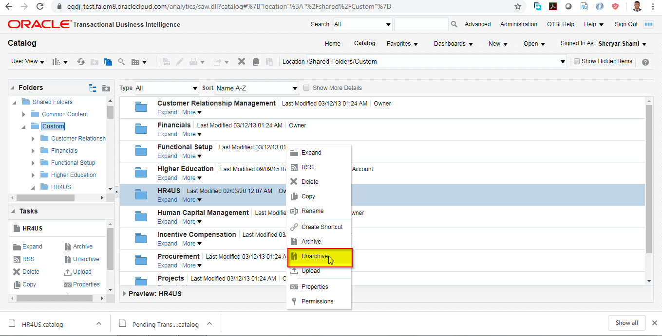

In the Dialog Box , click on Browse and select the catalog file called Master Staff Report.catalog 

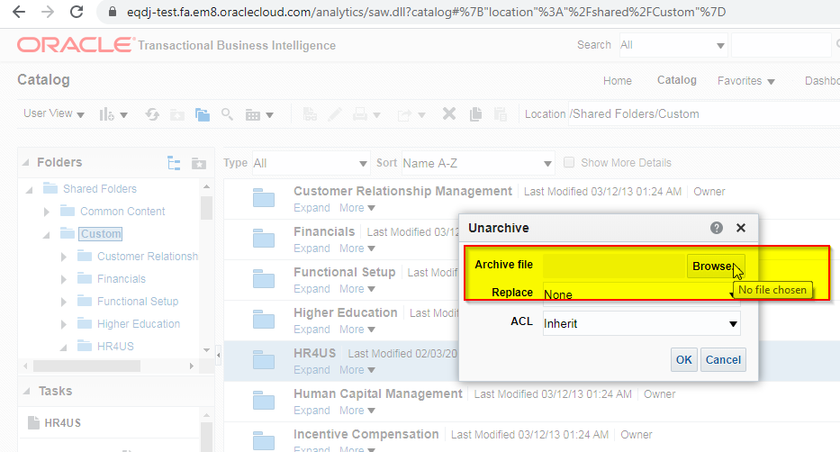

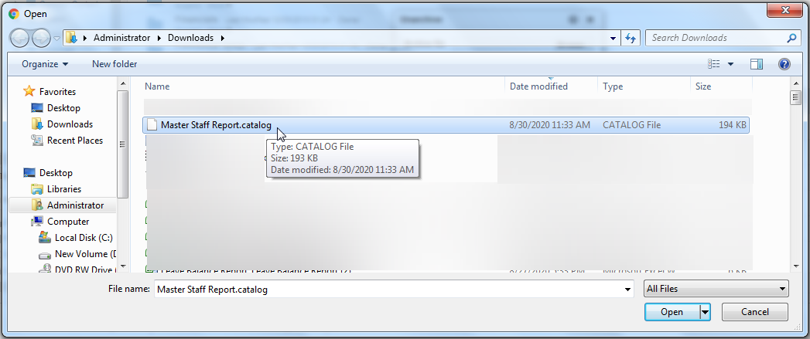

Ensure Replace” Option is “None” and “ACL” (Access Control List) Option is “Preserve”

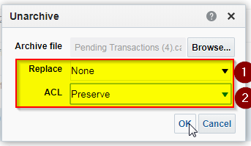

Click on OK

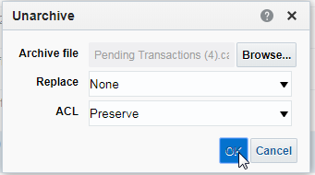

Change the Data Model to point to “ETC Staff Salary Details DM” Report Data Definition, go to Catalog -🡪 Shared folder/Custom/HR4US/Master Staff Report, Click on “Edit” Option of “Staff Salary Details Report”

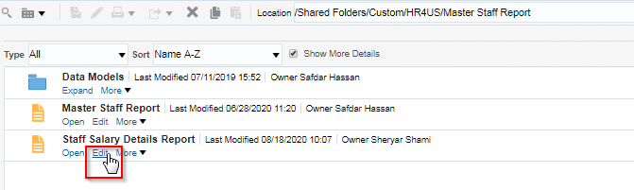

Click on Magnifying glass link to select “Pending Transactions” Data Definition from the path

Shared folder/Custom/HR4US/ Master Staff Report/Data Models and select “ETC Staff Salary Details DM” data model

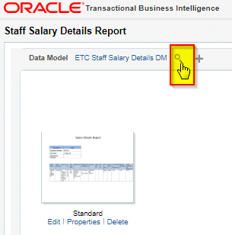

Click on Ok to close the data model selection.

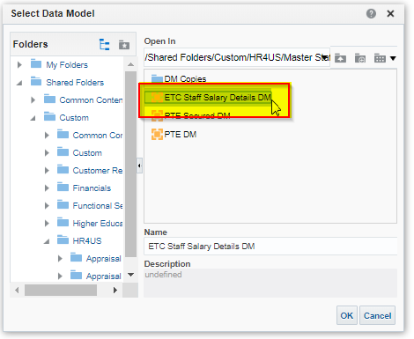

Now click on “Floppy” icon to save the definition

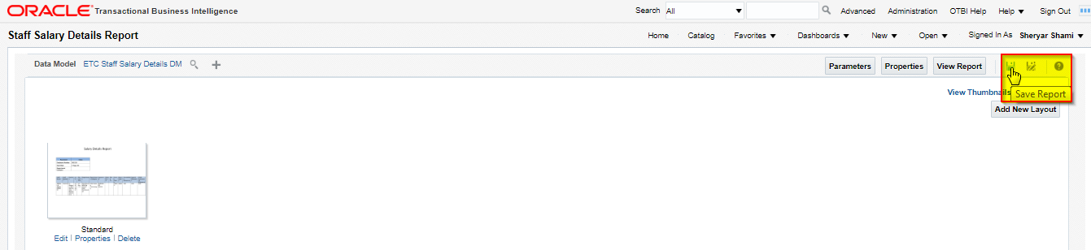

Finally click on “View Report” Button

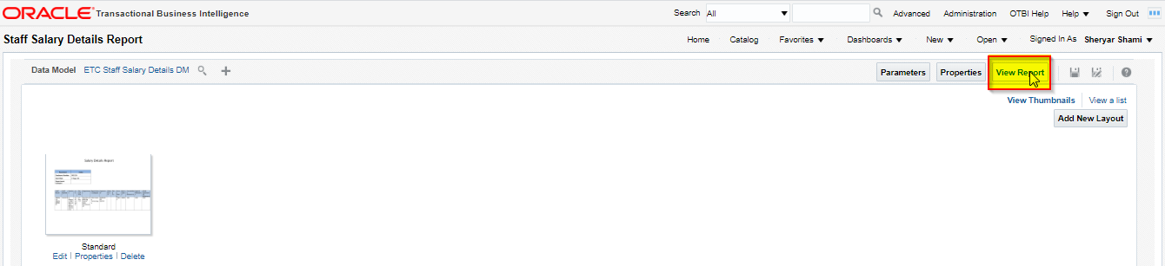

On the View Report page click on “Setting Gear Icon” 🡪 “Share Report Link”(Menu)🡪”No Header” (Option) and copy and save the link.

This link would be used for defining link for accessing report from HR SPOC Access.

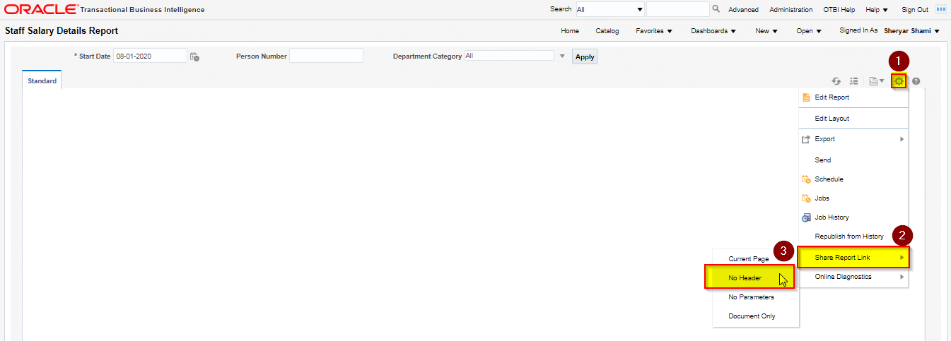

Select and Copy the URL from the next pop up form, this would be different in production instance.

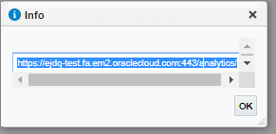

https://ejdq-test.fa.em2.oraclecloud.com:443/analytics/saw.dll?bipublisherEntry&Action=open&itemType=.xdo&bipPath=%2FCustom%2FHR4US%2FMaster%20Staff%20Report%2FStaff%20Salary%20Details%20Report.xdo&bipParams={"_xmode":"2","_xiasynch":"","_xpf":"","_xpt":"","_dFlag":"false","_edIndex":"0","_dIndex":"0","_rToken":"","_ranDiag":"false","_xdo":"%2FCustom%2FHR4US%2FMaster%20Staff%20Report%2FStaff%20Salary%20Details%20Report.xdo","_paramsP_START_DATE":"08-01-2020","_paramsP_PERSON_NUMBER":"","xdo%3Axdo%3A_paramsP_DEPARTMENT_CATEGORY_div_input":"All","_paramsP_DEPARTMENT_CATEGORY":"*","_xt":"Standard","_xf":"html"}&_linkToReport=true

This closes the migration cycle.

# Open and Closed Issues

1. Add open issues that you identify while writing or reviewing this document to the open issues section. As you resolve issues, move them to the closed issues section and keep the issue ID the same. Include an explanation of the resolution.  
     
   When this work product is complete, any open issues should be transferred to the project- or process-level Issue Log (Manage focus area) and managed using a project level Issue Form (Manage focus area). In addition, the open items should remain in the open issues section of this work product, but flagged in the resolution column as being transferred.

## Open Issues

| ID | Issue | Resolution | Responsibility | Target Date | Impact Date |
| --- | --- | --- | --- | --- | --- |
|  |  |  |  |  |  |
|  |  |  |  |  |  |
|  |  |  |  |  |  |
|  |  |  |  |  |  |

## Closed Issues

| ID | Issue | Resolution | Responsibility | Target Date | Impact Date |
| --- | --- | --- | --- | --- | --- |
|  |  |  |  |  |  |
|  |  |  |  |  |  |
|  |  |  |  |  |  |
|  |  |  |  |  |  |