Visual Teaching Methods
  - Editable editorial layout demonstration — not a factual research report
Version 3 demonstration · All statements and diagram data are schematic

Contents

Choosing the right visual
Choose visuals by the learner's task. A clear paragraph is often better than an unnecessary decoration.

One purpose per component
Use an icon for a recognizable short cue; a diagram for structure; and a table for a comparison on consistent criteria.
IMPORTANT: This file demonstrates design and implementation, not external factual evidence.

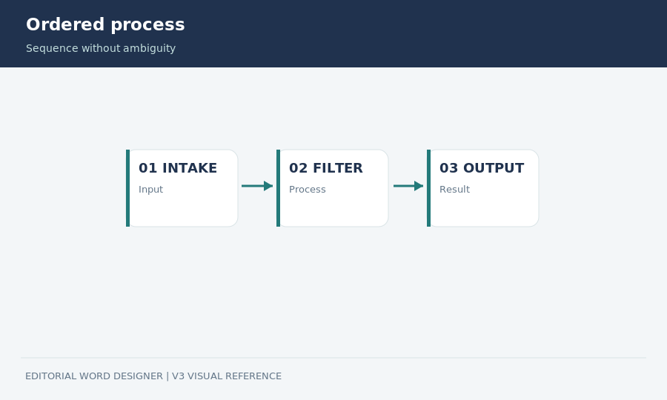
Figure — Example of the ordered-process visual grammar; illustration only.

Editable technical components
Keep real content editable whenever possible; screenshots are not a substitute for source code.
Name the function validate_visual() inside the paragraph.
def validate_visual(item):
return item['educational_gain']
Learning goal | Preferred component
Sequential stages | Process diagram
Attribute comparison | Structured table
Short caveat | Callout

