Task1

Print in terminal screen

echo " Hi, my name is Abdulrahman and I’m software robotics engineer "

open image

install player :

sudo apt install imagemagick-6.q16hdri

go to the image location :

cd Desktop

run the image that exist in the location :

display eren.jpg // display image_name

run video

install player :

mplayer video.mp4

go to the video location :

cd Desktop

run the video that exist in the location :

mplayer video.mp4 //mplayer video_name

open browser

write firefox in the terminal

open pdf

go to the PDF location :

cd Desktop/ROS

then open the pdf

evince Task1.pdf // evince pdf_name

Create a new directory called "myproject" in your home directory.

Python file

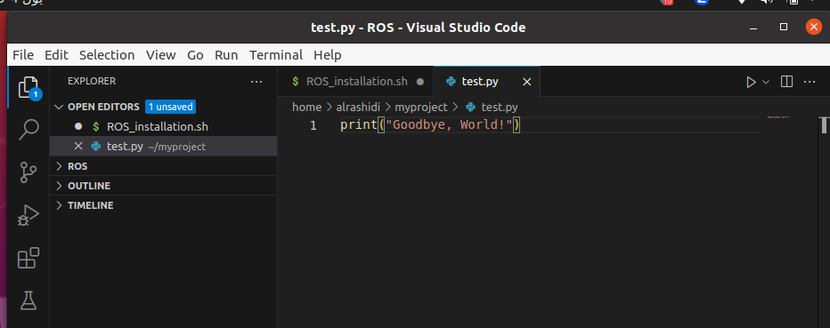
full code in the terminal

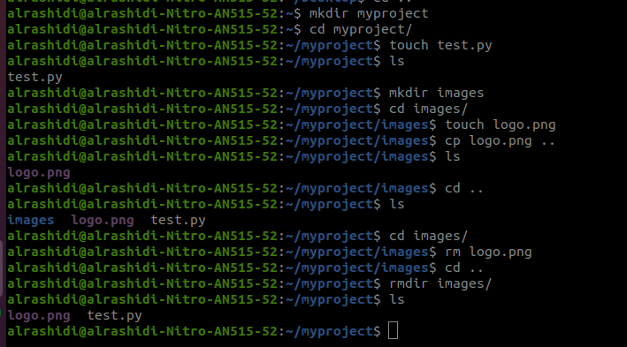
.

last task

