House Prices Dataset:

Overview:

The House Price Dataset contains variables describing (almost) every aspect of residential homes in Ames, Iowa.

Dataset size:

Initially 2919 row x 75 column.

Goal:

Predict sales price for each house based on its features.

Training and Testing:

**Training:** Used 2335 rows of 10 selected best features. (80% of samples)

**Testing:** Used 584 rows of 10 features. (20% of samples)

Description of the selected features:

OverallQual: Overall material and finish quality.

GrLivArea: Above grade (ground) living area square feet.

GarageCars: Size of garage in car capacity.

ExterQual: Exterior material quality.

GarageArea: Size of garage in square feet.

TotalBsmtSF: Total square feet of basement area.

1stFlrSF: First floor square feet.

BsmtQual: Height of the basement.

KitchenQual: Kitchen quality.

TotRmsAbvGrd: Total rooms above grade (does not include bathrooms).

Distribution of SalesPrice:

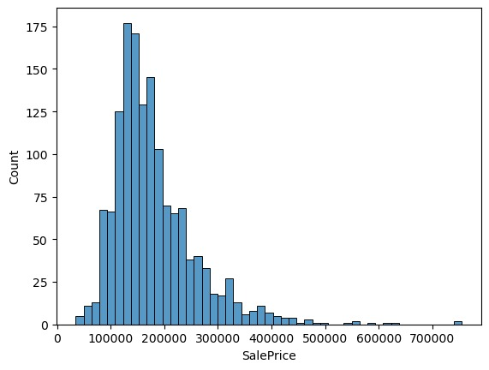

Summary:

First we handled missing values by dropping the columns with too many missing values and filling columns with moderate amount of missing values with column mean for numerical columns and mode for categorical ones. then normalized categorical values using Label Encoder. Then selected the 10 most relevant features to train the model. Then applied Linear Regression and KNN to the training data. At the end compared the performance of each model.

Performance Comparison:

|  |  |  |
| --- | --- | --- |
|  | Linear Regression | KNN |
| R2 | 0.408 | 0.318 |
| MAE | 31253.27 | 32615.22 |
| MSE | 2179459590.9 | 2512043957.0 |
| RMSE | 46684.7 | 50120.3 |

Overall:

Linear Regression performs better than KNN by 28%.

Plant Disease Dataset:

Overview:

The PlantVillage Dataset is a collection of images of healthy and diseased plant leaves, widely used for training machine learning models in plant disease classification.

Dataset description:

No. Samples: 20.6k images.

Number of Classes: 15 classes.

Image Dimensions: 256x256.

Goal:

Classify the plant disease based on the leaf image.

Classes:

Pepper__bell___Bacterial_spot

Pepper__bell___healthy

Potato___Early_blight

Potato___Late_blight

Potato___healthy

Tomato_Bacterial_spot

Tomato_Early_blight

Tomato_Late_blight

Tomato_Leaf_Mold

Tomato_Septoria_leaf_spot

Tomato_Spider_mites_Two_spotted_spider_mite

Tomato__Target_Spot

Tomato__Tomato_YellowLeaf__Curl_Virus

Tomato__Tomato_mosaic_virus

Tomato_healthy

Selected classes:

Tomato_healthy: 1591 images.

Tomato_Early_blight: 1000 images.

Tomato_Late_blight: 1909 images

Pepper__bell___healthy: 1478 images.

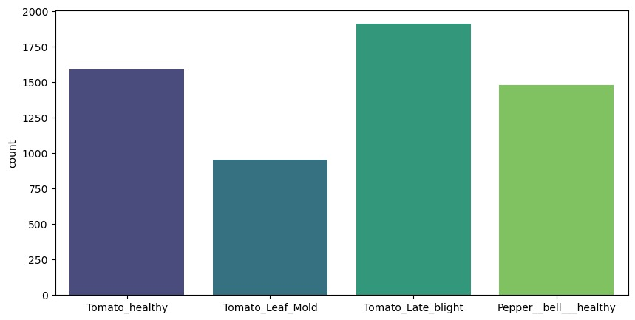

Training and Testing:

**Training:** 4782 samples. (80%)

**Testing:** 1196 samples. (20%)

Performance Comparison:

|  |  |  |
| --- | --- | --- |
|  | Logistic Regression | KNN |
| Accuracy | 0.8 | 0.68 |

Logistic Regression performs better than KNN by 18%.

Logistic Regression:

KNN:

