Assignment 2

(Shell Scripting)

Write a shell script for

**1. For Calculator uding command line arguments**

**2. To reverse the given string**

**3. To execute linux commands using case statement.**

**4. To print the pyramid of \***

**5.To write a function for factorial of a number**

**6. To sort the given elements using any sorting method.**

Name – Ajinkya Walunj

Class – SYCS

Div – A

PRN – 12110283

Roll - 05

1. To convert given binary number into decimal number

#!/bin/bash

echo "Enter a binary number: "

read binary

decimal=0

i=0

while [ $binary -ne 0 ]

do

digit=$(( binary % 10 ))

decimal=$(( decimal + digit * 2**i ))

binary=$(( binary / 10 ))

i=$(( i + 1 ))

done

echo "Decimal number is: $decimal"

OUTPUT:

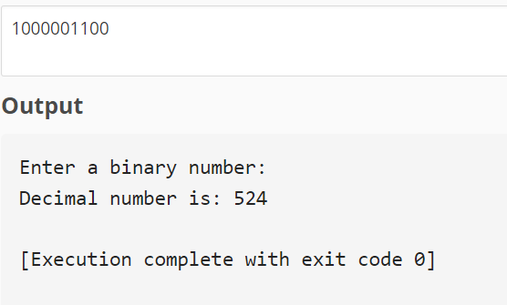

2. To accept the strings &   to reverse the string.

#!/bin/bash

# Prompt user to enter a string

echo "Please enter a string:"

read input_string

# Reverse the string using a for loop

reverse_string=""

for (( i=${#input_string}-1; i>=0; i-- )); do

reverse_string="$reverse_string${input_string:$i:1}"

done

OUTPUT:

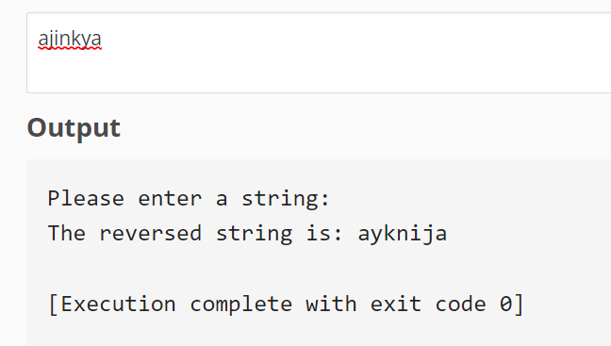

3. To design a calculator using command line arguments.

#!/bin/bash

# Check if exactly 3 arguments were provided

if [ $# -ne 3 ]; then

echo "Usage: $0 <num1> <operator> <num2>"

exit 1

fi

# Assign the arguments to variables

num1=$1

operator=$2

num2=$3

# Perform arithmetic operation based on operator

case $operator in

+)

result=$(echo "$num1 + $num2" | bc)

;;

-)

result=$(echo "$num1 - $num2" | bc)

;;

\*)

result=$(echo "$num1 * $num2" | bc)

;;

/)

result=$(echo "scale=2; $num1 / $num2"

4. To write a function to calculate the factorial of a number.

#!/bin/bash

# Define the factorial function

factorial() {

if [ $1 -eq 0 ]; then

echo 1

else

local i=$1

local result=1

while [ $i -gt 1 ]; do

result=$(echo "$result * $i" | bc)

i=$(echo "$i - 1" | bc)

done

echo $result

fi

}

# Call the factorial function with a number

num=5

factorial_of_num=$(factorial $num)

# Print the result

echo "Factorial of $num is: $factorial_of_num"

OUTPUT:

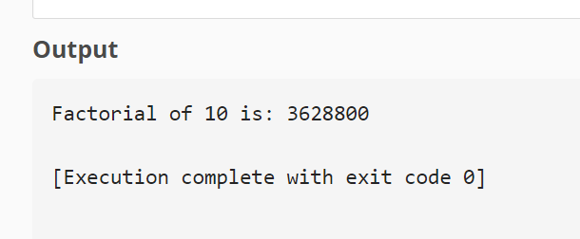

5. To print the pyramid of *.

#!/bin/bash

# Prompt user to enter the number of rows

echo "Please enter the number of rows:"

read num_rows

# Loop through the rows

for (( i=1; i<=num_rows; i++ )); do

# Print spaces for the current row

for (( j=1; j<=num_rows-i; j++ )); do

echo -n " "

done

# Print asterisks for the current row

for (( j=1; j<=2*i-1; j++ )); do

echo -n "*"

done

# Move to the next line

echo ""

done

OUTPUT:

