Lab 9 Morphological Operations
Completed answers to Lab9_Task.docx. The accompanying executed notebook contains the full comment-free code, both tasks, and all five supplied images. The results show that foreground polarity and structuring element size and shape determine the morphological changes.

Objective
Apply erosion, dilation, opening and closing to a new binary image, then compare erosion and dilation across square, cross and ellipse structuring elements at sizes 3×3, 5×5 and 7×7.

Task 1 Apply morphological operations
Selected image: Balls.png, different from the reference erosion image. Otsu thresholding at 127 is inverted so the dark rings, numbers and frame become white foreground. The full image is retained. A 5×5 square kernel is applied once for each operation, using OpenCV’s default neutral constant border.
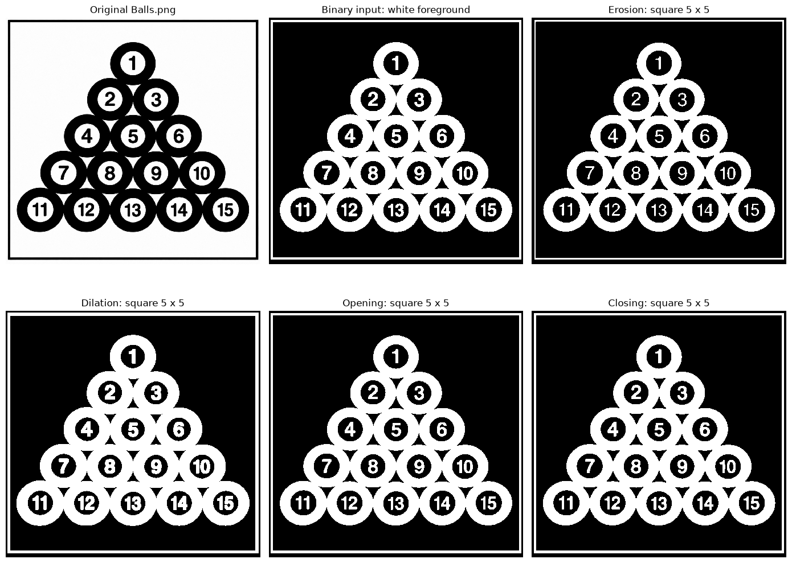
Erosion shrinks white rings and number strokes; dilation expands them and can join nearby regions. Opening is erosion followed by dilation; closing reverses that order. On this large image, opening changes only a few fine details, while closing fills small gaps. These effects are on the white foreground in the binary panels.
Operation | Foreground pixels | Change from input
Input | 500,374 | 0
Erosion | 432,293 | −68,081
Dilation | 567,126 | +66,752
Opening | 500,345 | −29
Closing | 501,666 | +1,292

Task 2 Erosion comparison
All nine combinations are applied to the same Balls binary image. Rows show square, cross and ellipse; columns show kernel sizes 3×3, 5×5 and 7×7. Each operation uses one iteration. Larger kernels shrink the rings, numbers and border more strongly.
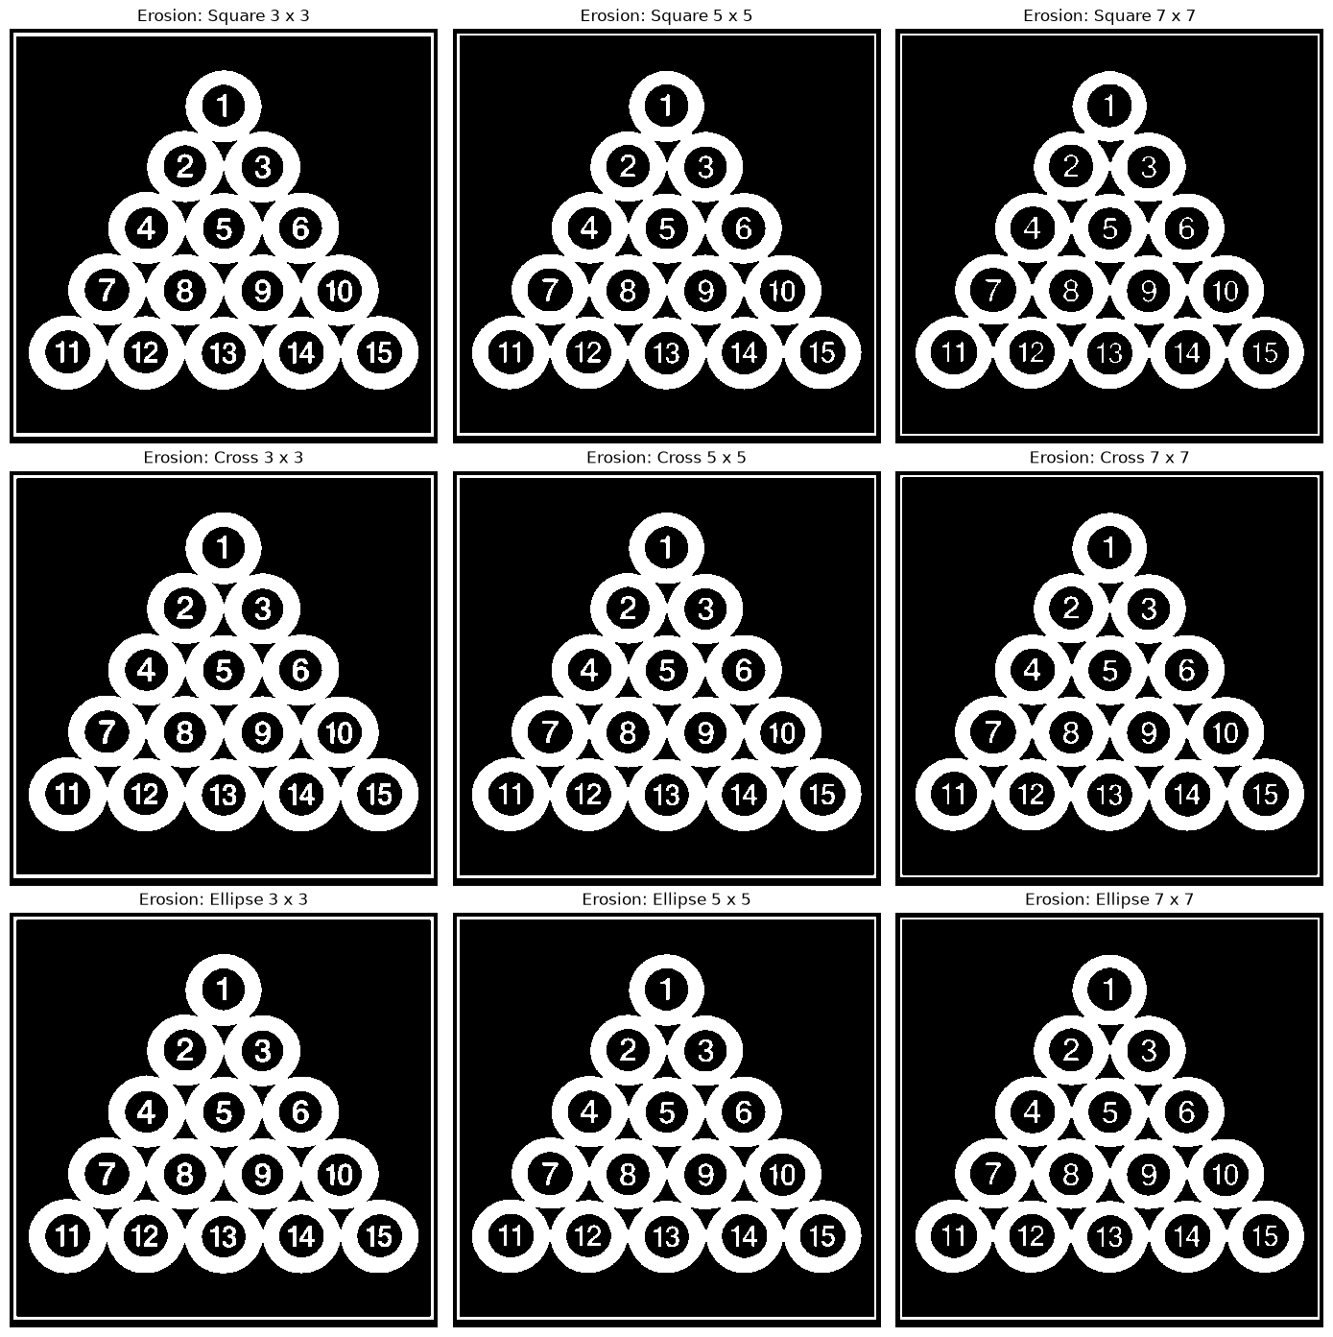
At the same size, the square removes the most foreground because it includes corner and diagonal offsets. The cross contains only horizontal and vertical arms. The ellipse approximates a disk and follows round shapes more naturally. The 3×3 cross and ellipse are identical in OpenCV, so their outputs match exactly.

Task 2 Dilation comparison
The same shape and size arrangement is used here. Dilation expands the white foreground. Increasing the kernel size thickens rings and numbers, shrinks their dark holes, and can connect nearby structures. The black original frame is foreground after inversion and is processed as well.
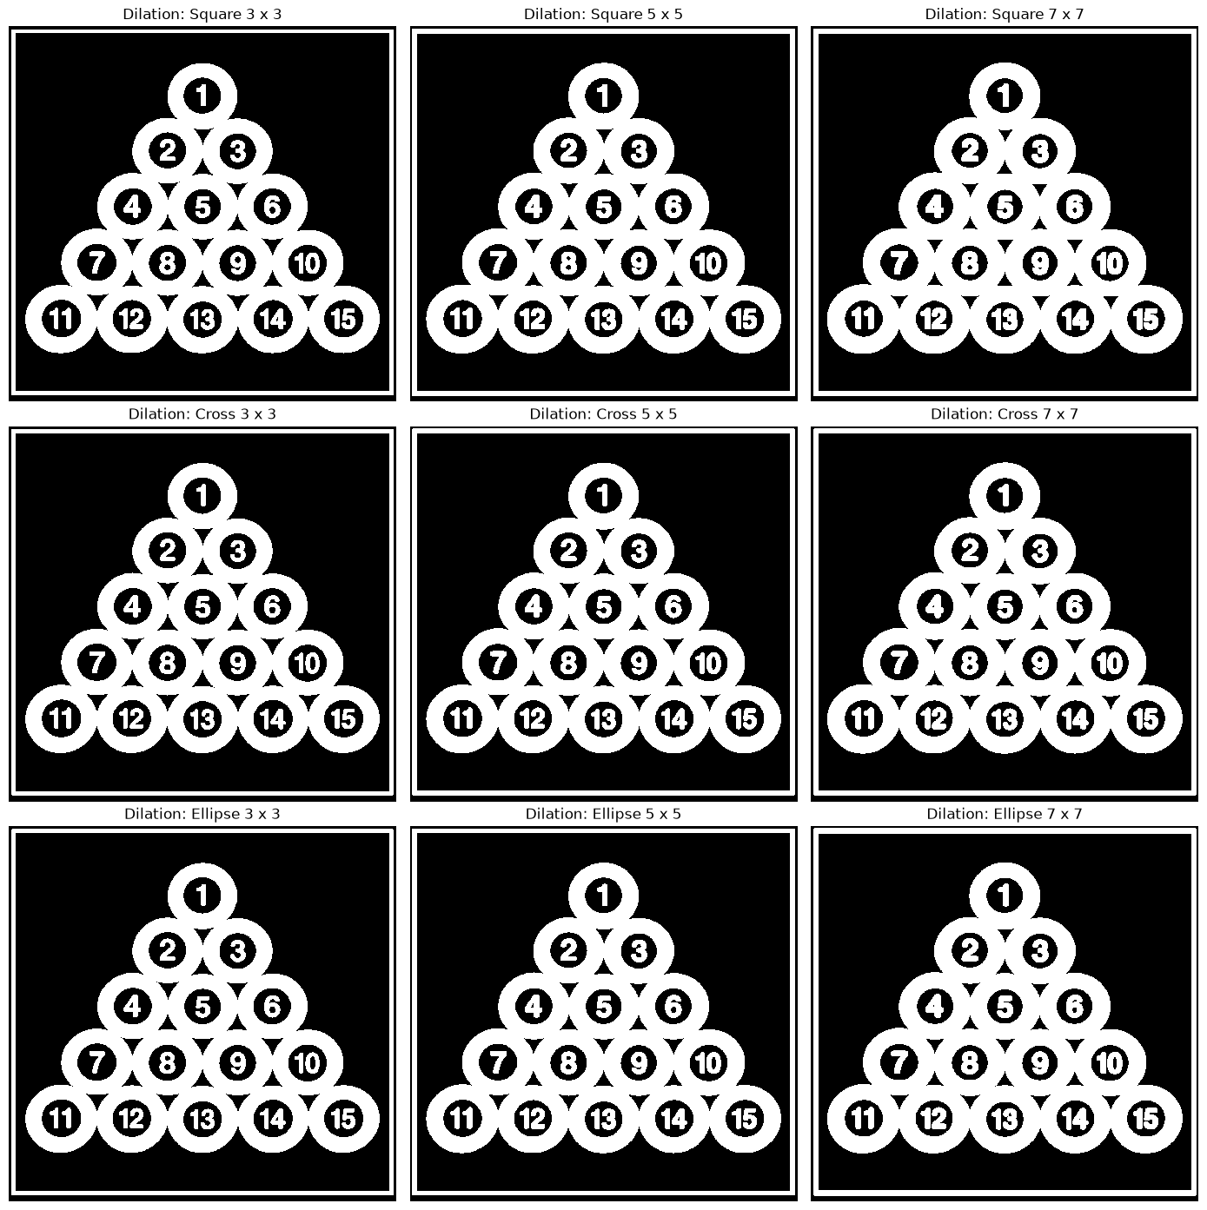
The square adds the most foreground at each size in this experiment; the cross adds the least, and the ellipse lies between them at 5×5 and 7×7. These changes are not measurements of ball count or segmentation accuracy.

Task 2 Measurements and interpretation
Shape | Size | Kernel pixels | Eroded area | Dilated area
Square | 3×3 | 9 | 466,395 | 534,094
Square | 5×5 | 25 | 432,293 | 567,126
Square | 7×7 | 49 | 398,085 | 599,496
Cross | 3×3 | 5 | 473,108 | 527,560
Cross | 5×5 | 9 | 445,935 | 554,380
Cross | 7×7 | 13 | 418,852 | 580,813
Ellipse | 3×3 | 5 | 473,108 | 527,560
Ellipse | 5×5 | 17 | 440,791 | 559,214
Ellipse | 7×7 | 33 | 413,345 | 585,692
Areas are white foreground pixel counts. For every tested shape, increasing size lowers the eroded area and raises the dilated area. The close view highlights how 7×7 kernels modify a curved ring boundary. Fine details can change even when full-image panels look very similar.
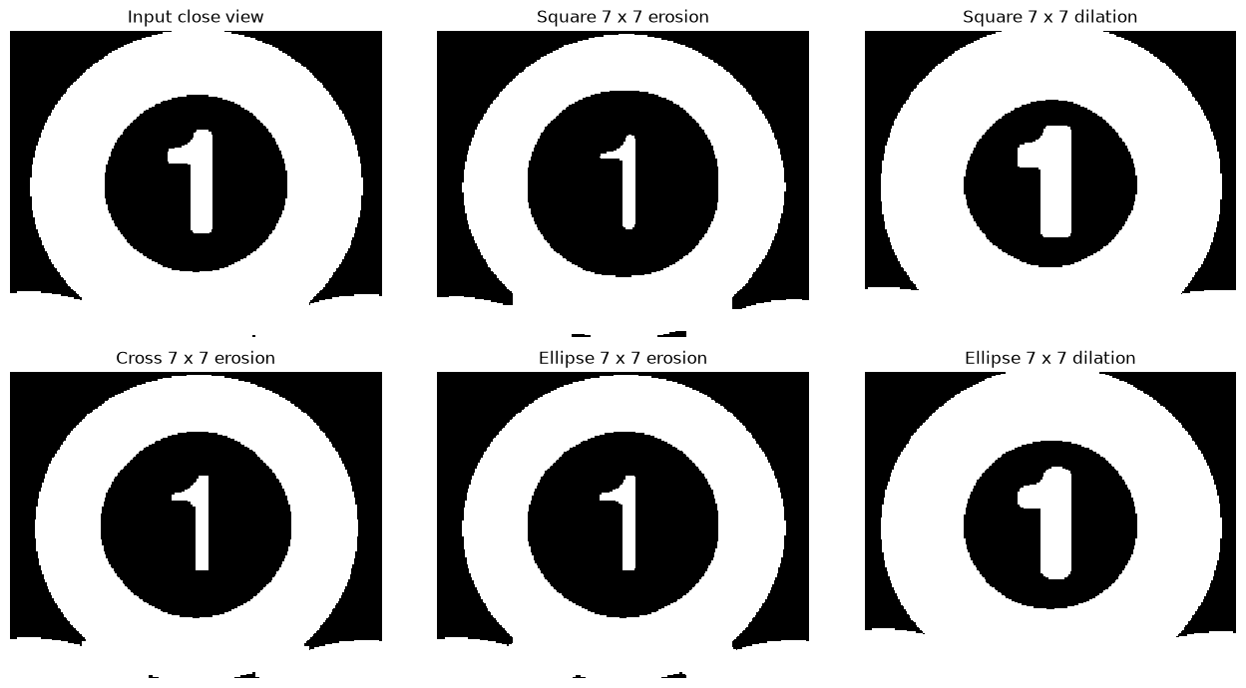

Verification and additional notebook examples
All eight code cells executed successfully and all 22 assertion statements passed. Checks cover binary values, set inclusion, composite-operation equivalence, idempotence, kernel-size trends and boundary identities. Erosion2.jpg replaces the unavailable Erosion.jpg for 3×3, 7×7 and 11×11 letter examples. Opening on Open_Closing.jpg removes 1,582 foreground pixels; closing on Opening2.jpg adds 3,570 pixels. BoundaryExtraction.jpg demonstrates the gradient and internal and external boundaries. The notebook retains all saved figures and outputs.
Submission files: Lab9_Morphological_Operations_Solved.ipynb and the PDF version of this completed report. This editable Word copy is also provided as requested. Tested with OpenCV 5.0.0 and NumPy 2.5.4.

