
First Semester 2025/2026
Faculty of Engineering and Technology
Electrical and Computer Engineering Department
ENCS3330, DIGITAL INTEGRATED CIRCUITS
Homework#1

Prepared by:

Name: Abdulrahman Atyani Id:1221808

Supervised by: Dr. Khader Mohammad

Section: 3

December-2025

Table of contents

Table of contents 2
Invertor gate 3
Schematic design 3
Layout design 3
Results 4
2-input NAND gate 5
Schematic design 5
Layout design 5
Results 6
3-input NOR gate 7
Schematic design 7
Layout design 7
Results 8

Invertor gate

Schematic design
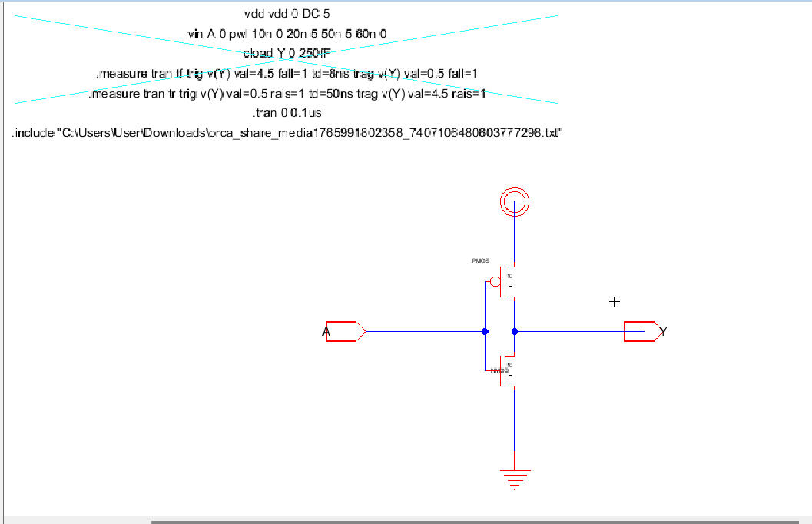

Figure 1:invertor Schematic.

Layout design
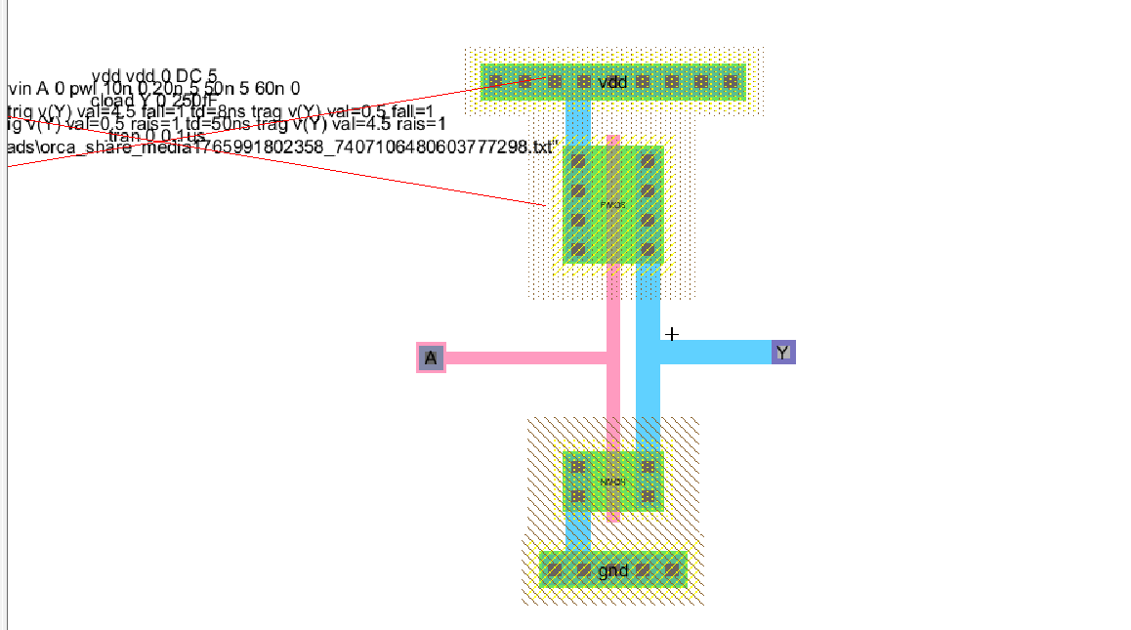
Figure 2:invertor Layout.

Results
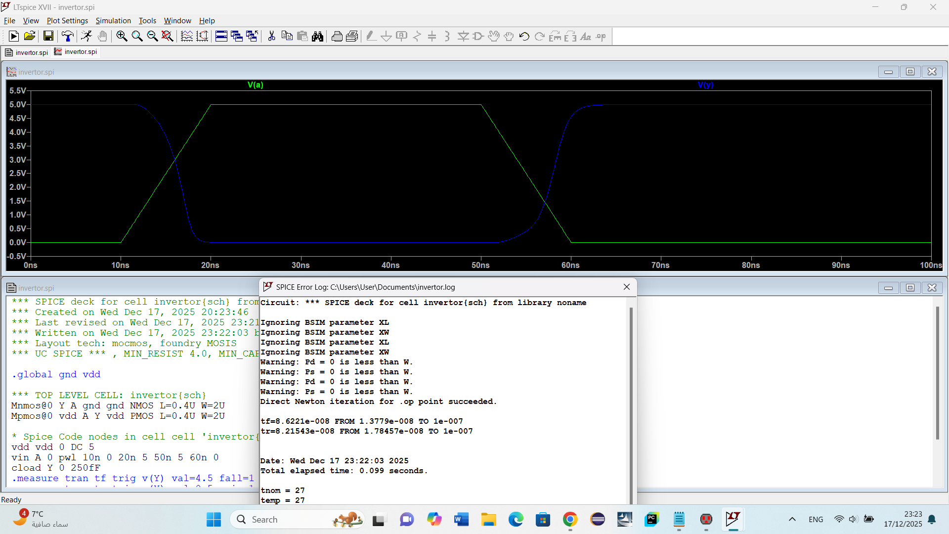

Figure 3:invertor schematic result.

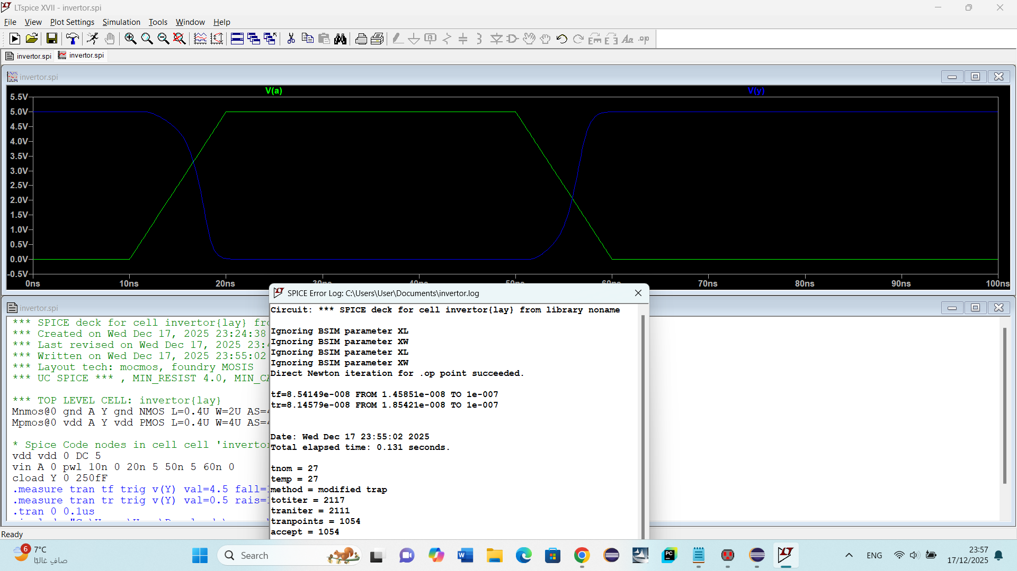

Figure 4:invertor layout result.

The schematic and layout simulations of the CMOS inverter show the same functional behaviour, where the output voltage correctly inverts the input with matching logic levels (0 ↔ VDD), confirming that the layout is electrically equivalent to the schematic. However, a small difference appears in timing: the layout inverter exhibits slightly larger rise and fall times (tr and tf) compared to the schematic. This delay is expected and comes from parasitic effects in the layout, such as diffusion capacitance, interconnect resistance, and routing capacitance, which are not present in the ideal schematic. In summary, the schematic represents an ideal and faster model, while the layout reflects a more realistic implementation with minor delays but correct and reliable operation.

2-input NAND gate

Schematic design
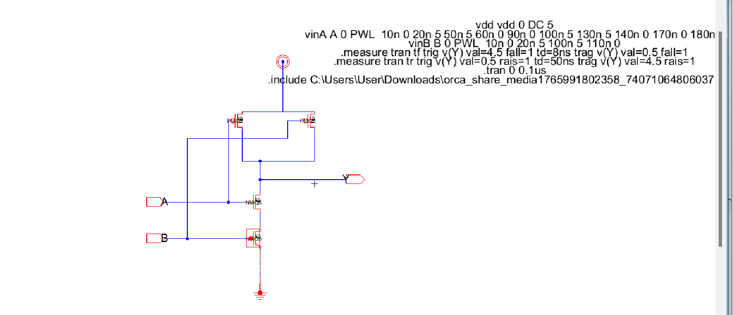
Figure 5:NAND schematic.

Layout design
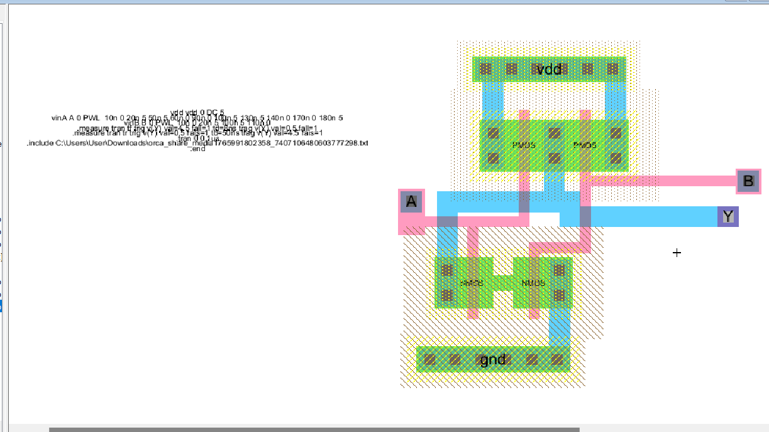

Figure 6:NAND layout.

Results

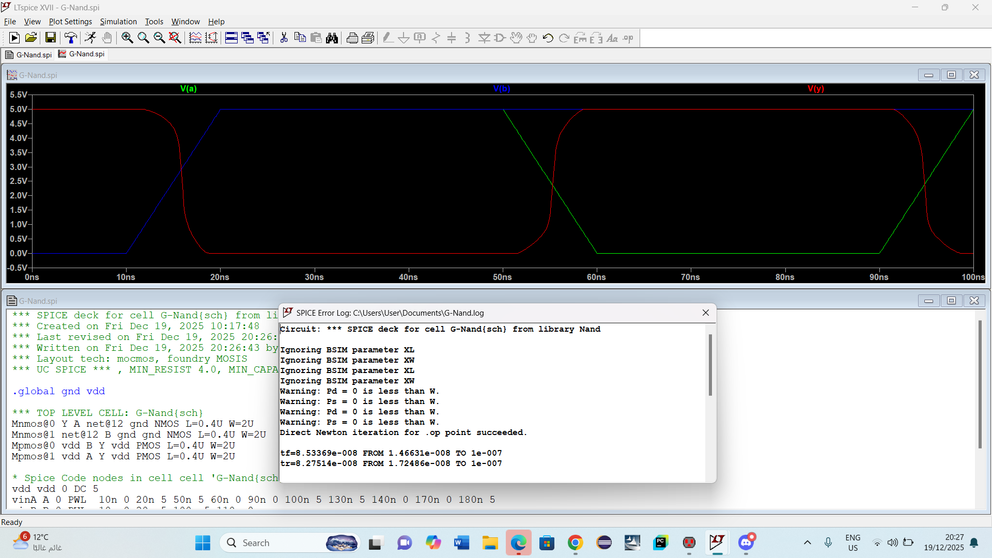
Figure 7:NAND schematic result.

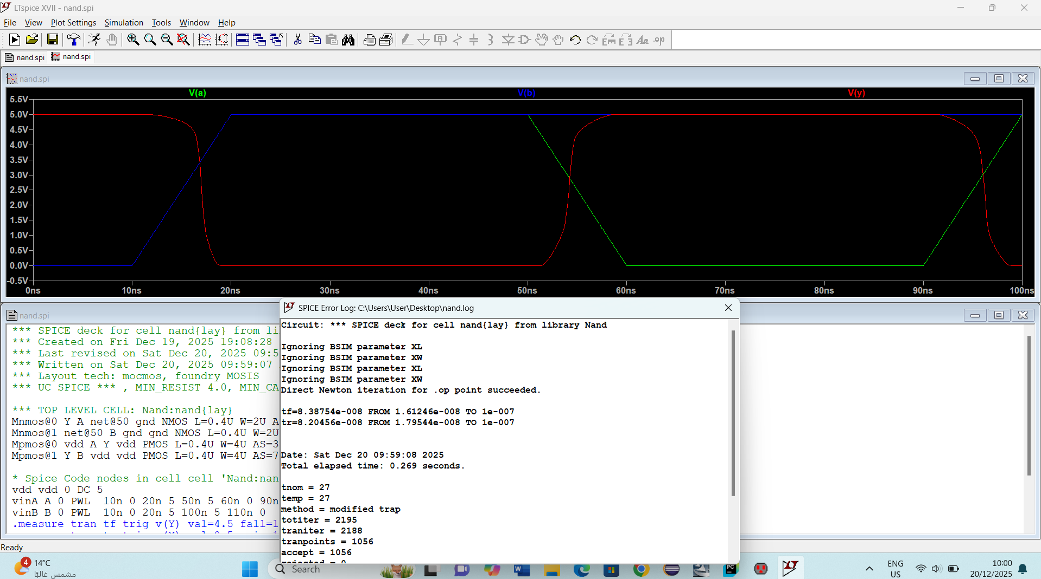
Figure 8:NAND layout result.

The simulation results for the 2-input CMOS NAND gate clearly show correct logical operation and realistic timing behavior. When either input A or B is LOW, the output Y remains HIGH, and Y only goes LOW when both A and B are HIGH, which confirms that both the schematic and layout implement the NAND truth table correctly. From the timing perspective, the output fall time (tf) occurs when both NMOS transistors turn ON in series, making the pull-down path weaker and therefore slower than in a simple inverter, while the output rise time (tr) is usually faster because the PMOS transistors are in parallel and can charge the load capacitance more easily. Comparing schematic and layout, the layout waveforms show slightly larger tr, tf, and propagation delay, which is expected due to parasitic capacitances and resistances introduced by diffusion regions, contacts, and metal interconnects. In conclusion, the schematic represents an ideal, faster behavior, while the layout provides a more accurate, real-world timing response, with correct logic functionality and slightly increased delay.

3-input NOR gate

Schematic design

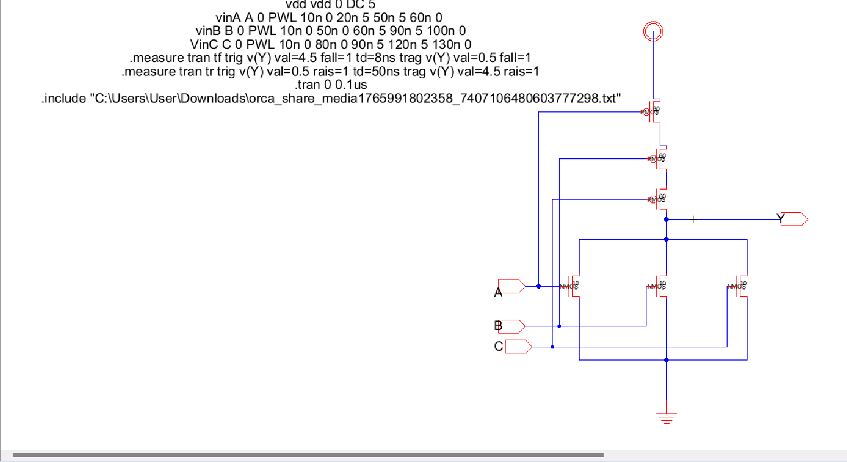
Figure 9:NOR schematic.

Layout design

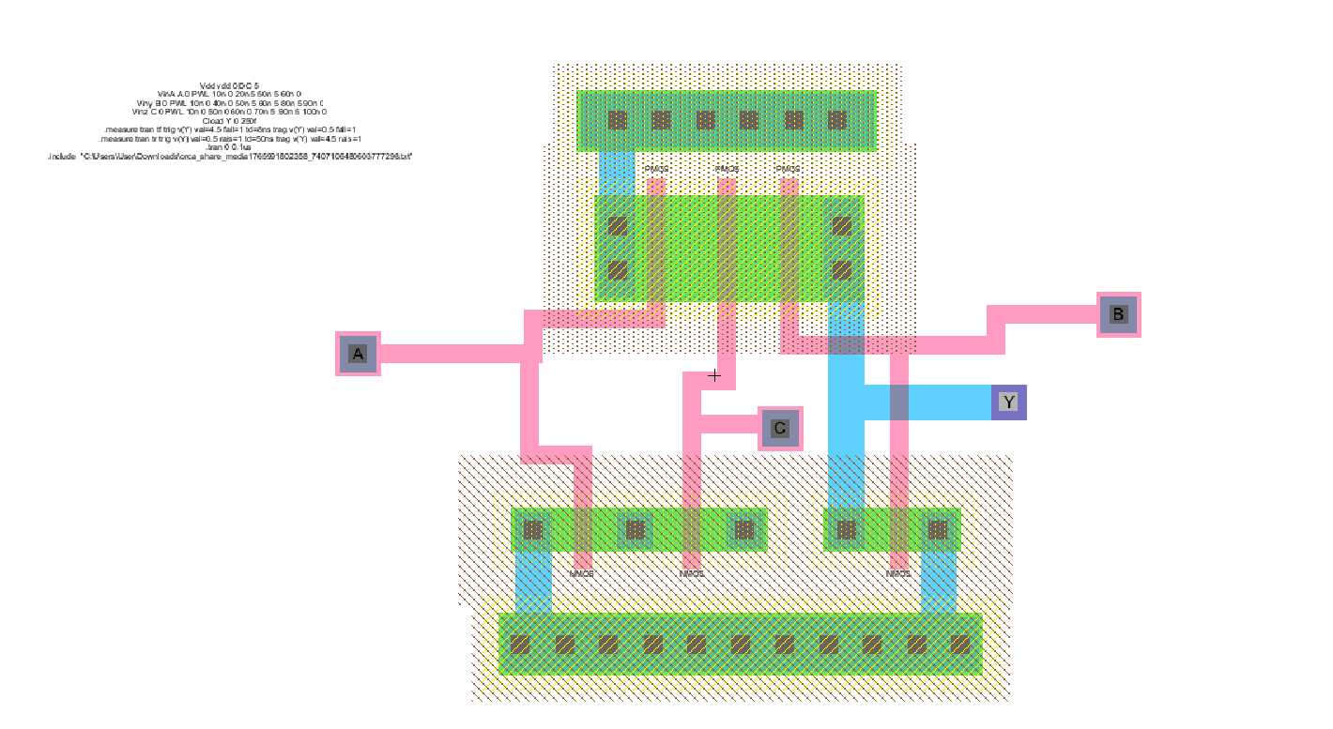
Figure 10:NOR Layout.

Results
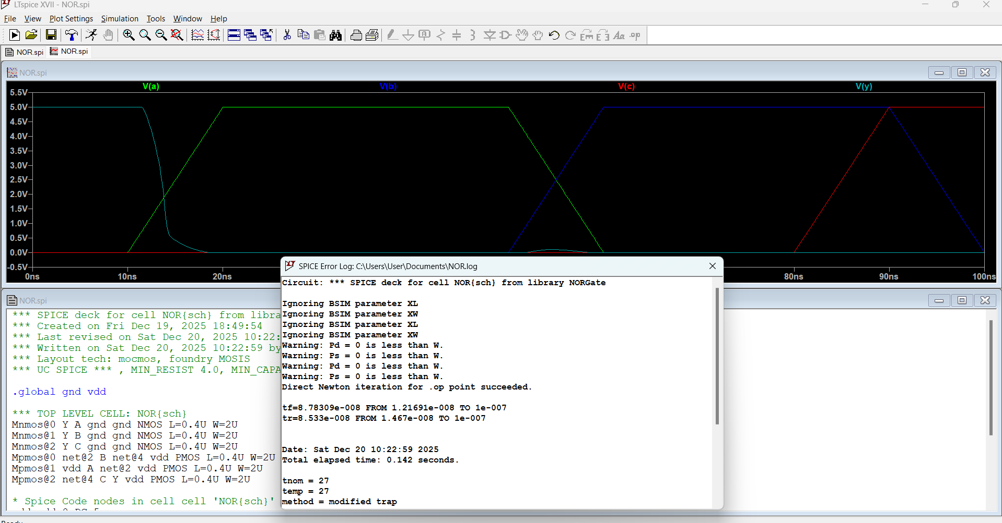
Figure 11:NOR schematic result.

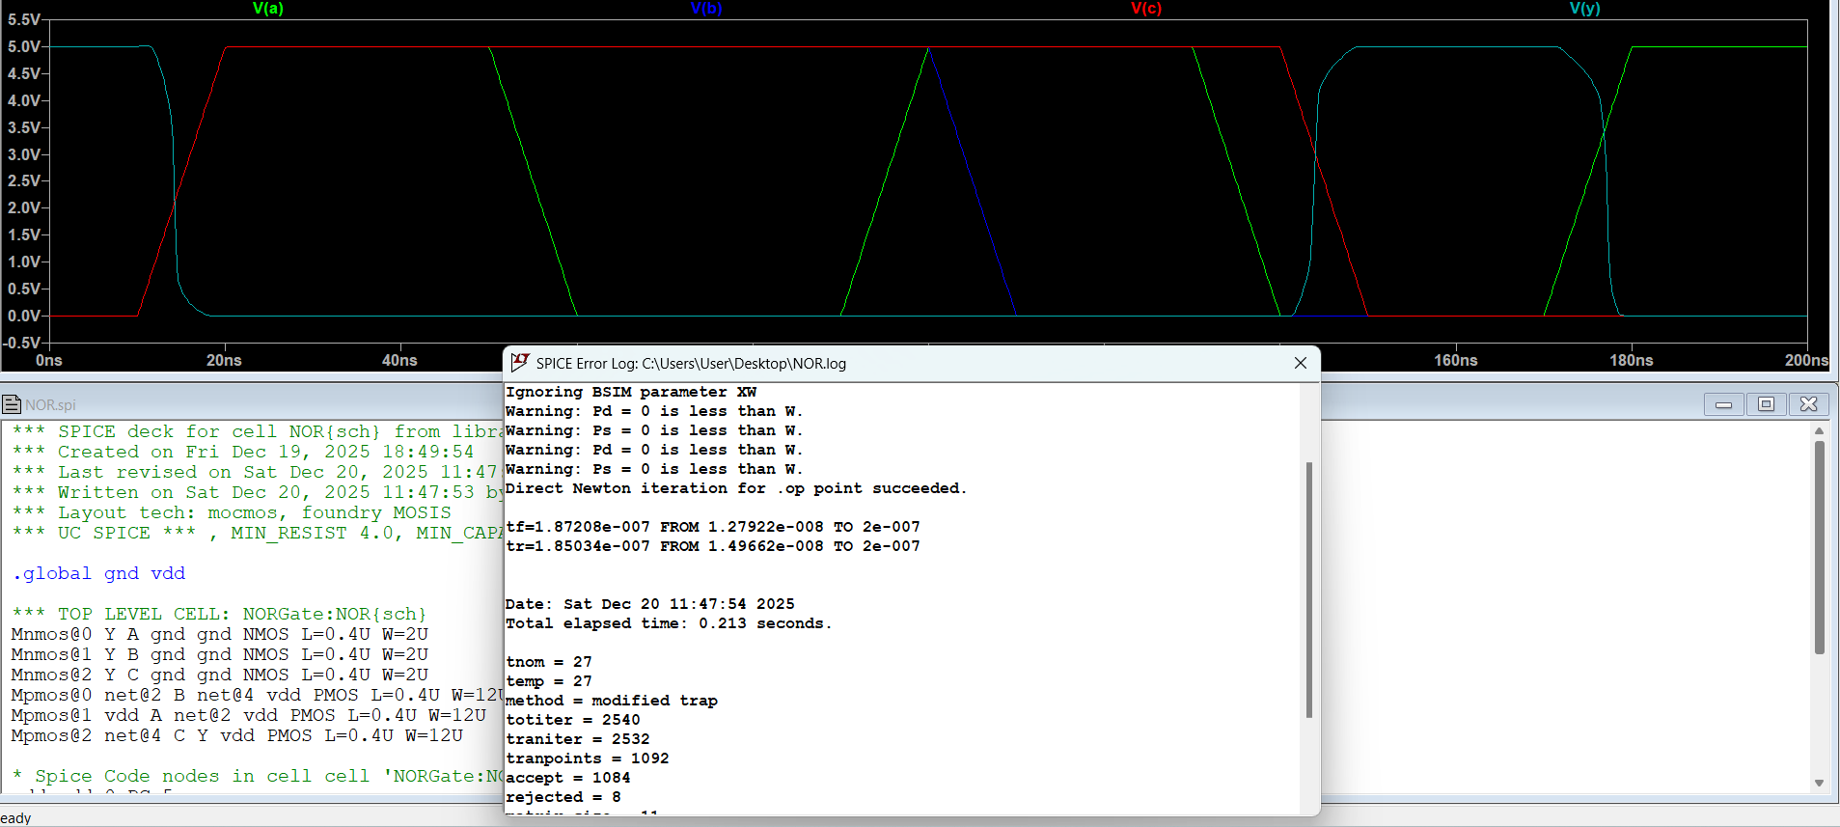
Figure 12:NOR layout result.

The 3-input NOR schematic and layout show the same correct logic behaviour, where the output Y is HIGH only when A, B, and C are all LOW and goes LOW when any input becomes HIGH, confirming functional equivalence. The schematic simulation is faster because it is ideal and does not include parasitic effects, while the layout simulation shows slightly larger rise time, fall time, and propagation delay due to parasitic resistances and capacitances from diffusion regions and metal interconnects. This effect is more noticeable in a 3-input NOR because the PMOS transistors are connected in series, making the output rise slower. Overall, the layout result is more realistic but slower, while the schematic represents an ideal, faster implementation.

