

Faculty of Engineering and Technology
Electrical and Computer Engineering Department
Summer Semester 2024 – 2025

ENCS3130, LINUX LABORATORY
Project#2

Name: Abdulrahman Atyani Id:1221808
Partner Name:Hamza Abo bakr Id:1221703

Section: 3
Supervised by: Dr. Abdullatif Abo issa
Teacher assistance: Eng.Mohammad Abo Zaina
Data: 14/9/2025

Test case#1

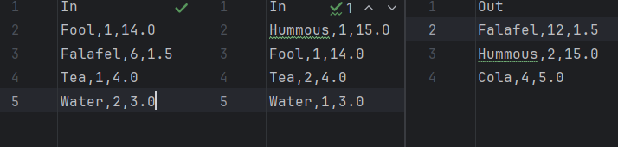

Result#1

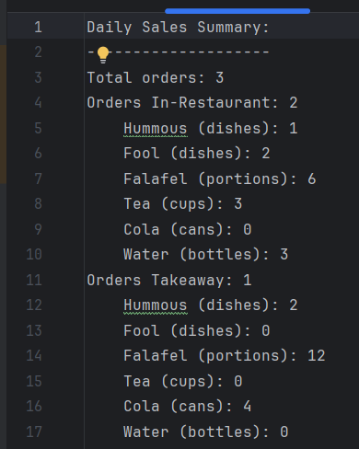

Test Case#2

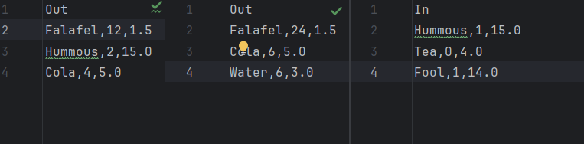

Result#2

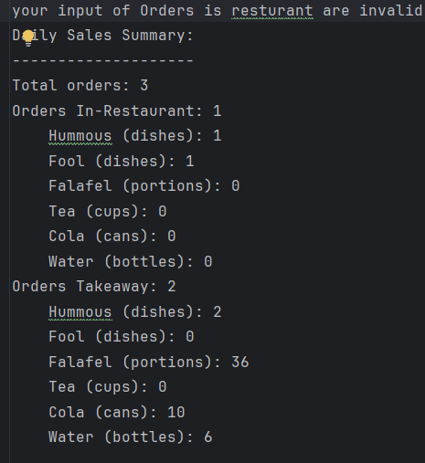

Test case#3

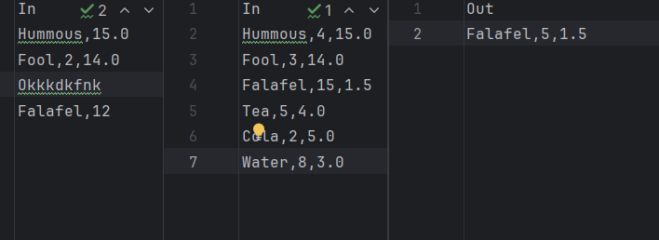

Result#3
