Task 1.5: Binary Frequency Shift Keying (BFSK)
Digital Communications, Modulation Project Part 1 (section for the combined report)

1. Overview
This section studies BFSK using the system of Figure 1 in the project description: Data bits → Mapper → AWGN channel → Demapper → BER calculator. All simulations are done on the baseband equivalent system, so no carriers are generated. We assume coherent detection: the receiver knows the two frequencies and the carrier phase.
The section answers the four questions of Section 1.5: (1) what the basis functions are, (2) what the baseband equivalent signals are and which carrier frequency is used, (3) the simulated BER versus E_{b}/N_{o} with the theoretical curve, and (4) the simulated power spectral density (PSD) of the baseband equivalent signal.

2. BFSK Signal Set and Basis Functions

2.1 Signal set
Each bit is sent as a burst of a cosine whose frequency depends on the bit:
s_{i}(t) = √(2E_{b}/T_{b}) cos(2π f_{i} t), 0 ≤ t ≤ T_{b}, i = 1, 2
where T_{b} is the bit duration, E_{b} is the energy per bit, and the transmitted frequencies are f_{i} = (n_{c} + i)/T_{b} with n_{c} an integer. Therefore f₂ − f₁ = 1/T_{b}. Each signal has energy E_{b}, because the integral of s_{i}²(t) over one bit equals (2E_{b}/T_{b})·(T_{b}/2) = E_{b}.

2.2 Basis functions
The basis functions are the "axes" of the signal space. Every signal is written as a point with coordinates along these axes. For BFSK they are:
φ_{i}(t) = √(2/T_{b}) cos(2π f_{i} t), 0 ≤ t ≤ T_{b}, i = 1, 2
They are orthonormal, which means each has unit energy and they are orthogonal to each other:
- Unit energy: cos² = ½(1 + cos 4π f_{i}t). The cosine term integrates to zero over the bit because 2f_{i}T_{b} is an integer (a whole number of periods), so the integral of φ_{i}² is 1.
- Orthogonality: φ₁(t)φ₂(t) = (1/T_{b})[cos(2π(f₂ − f₁)t) + cos(2π(f₁ + f₂)t)]. Both (f₂ − f₁)T_{b} = 1 and (f₁ + f₂)T_{b} = 2n_{c} + 3 are integers, so both cosines complete whole periods in T_{b} and integrate to zero.
The spacing 1/T_{b} is the smallest spacing that keeps the two tones orthogonal for any carrier phase. With perfectly known phase (coherent detection) a spacing of 1/(2T_{b}) would also be orthogonal, but the project uses 1/T_{b}.

2.3 Signal space and mapping
Since s_{i}(t) = √E_{b} φ_{i}(t), the signal set is a two-dimensional orthogonal constellation. We use the mapping:
bit 1 → s₁ = [√E_{b}, 0] bit 0 → s₂ = [0, √E_{b}]
The two points are at distance d = √(2E_{b}) from each other. This distance controls the BER: the larger it is compared with the noise, the fewer errors we get.

3. Baseband Equivalent Signals
A passband signal can be written as s_{i}(t) = Re{ s_{l,i}(t) e^{j2π fc t} }, where s_{l,i}(t) is the complex envelope (the baseband equivalent) and f_{c} is the carrier frequency. For our signals:
s_{l,i}(t) = √(2E_{b}/T_{b}) e^{j2π (fi − fc) t}
We choose the carrier frequency f_{c} = f₁ = (n_{c} + 1)/T_{b}. The baseband equivalent signals are then:
s_{l,1}(t) = √(2E_{b}/T_{b}) (bit 1, f₁ − f_{c} = 0)
s_{l,2}(t) = √(2E_{b}/T_{b}) e^{j2π t/Tb} (bit 0, f₂ − f_{c} = 1/T_{b})
Remarks:
- The value of n_{c} only appears in the passband expression. The baseband signals and the simulation do not depend on it.
- f_{c}T_{b} = n_{c} + 1 is an integer, so the carrier has the same phase at the start of every bit. This is why each bit can be generated in its own local time in the simulation. For a carrier whose f_{c}T_{b} is not an integer, the envelopes would change sign from bit to bit and the spectral lines would move.
- The two envelopes are orthogonal: the integral of s_{l,1}(t) s_{l,2}*(t) over one bit is proportional to the integral of e^{−j2πt/Tb}, which is zero.
- For a carrier that is a multiple of 1/T_{b}, choosing a different f_{c} only shifts the spectrum and does not change the BER.

4. Simulation Method

4.1 Why we can simulate with signal vectors
The receiver correlates the received signal with the two basis functions: r_{i} = ∫ r(t) φ_{i}(t) dt. The result is r = s + n, where s is the transmitted point and n = [n₁, n₂] is noise. Because the white noise has power spectral density N_{o}/2 and the basis functions have unit energy and are orthogonal, n₁ and n₂ are independent Gaussian variables with zero mean and variance N_{o}/2. So the BER can be simulated with two numbers per bit instead of full waveforms, with the same result.

4.2 Noise level
E_{b} is fixed to 1 and the noise is set from the ratio E_{b}/N_{o}: N_{o} = E_{b} / (E_{b}/N_{o}), and the standard deviation per dimension is σ = √(N_{o}/2). The BER depends only on the ratio E_{b}/N_{o}, not on E_{b} and N_{o} separately, so fixing E_{b} and changing N_{o} is equivalent to changing the signal power.

4.3 System blocks
- Mapper: bit 1 → [√E_{b}, 0] and bit 0 → [0, √E_{b}].
- Channel: AWGN. The noise is generated with the MATLAB command randn and added to both coordinates.
- Demapper: decides bit 1 if r₁ > r₂ and bit 0 otherwise. This is the minimum-distance (maximum-likelihood) rule: the nearest signal point is the one with the larger correlator output. It does not need to know N_{o}.
- BER calculator: BER = (number of wrong bits) / (total number of bits).

4.4 Parameters
Parameter | Value
Bit duration T_{b} | 1 (normalized)
Energy per bit E_{b} | 1 (normalized)
Bits per E_{b}/N_{o} point | 2 × 10⁶
E_{b}/N_{o} range | 0 to 12 dB, step 1 dB
Noise per dimension | Gaussian, zero mean, variance N_{o}/2, generated with randn
Random seed | rng(1) (same results at every run)
PSD: bits and samples per bit | 20 000 equiprobable bits, 16 samples per bit (sampling frequency 16/T_{b})
PSD: estimator | Averaged periodogram, 2048-point FFT blocks, Hamming window, absolute PSD

4.5 Procedure
- Generate random equiprobable data bits.
- Map every bit to its signal vector.
- For each E_{b}/N_{o} value, compute N_{o} and add Gaussian noise of standard deviation √(N_{o}/2) to each dimension.
- Demap: decide bit 1 if r₁ > r₂, otherwise bit 0.
- Compare the detected bits with the transmitted bits and compute the BER.
- Plot the BER on a logarithmic scale against E_{b}/N_{o}, with the theoretical curve Q(√(E_{b}/N_{o})) on the same graph.
- For the PSD, build the baseband equivalent waveform of a long random bit sequence from the signals of Section 3, estimate its PSD, and compare it with the theoretical PSD.

4.6 Theoretical results used for comparison
BER. For coherent detection with the minimum-distance rule, an error happens when the noise pushes the received point across the decision boundary. That boundary is at distance d/2 from each point and the noise standard deviation is √(N_{o}/2), so:
P_{b} = Q( (d/2) / √(N_{o}/2) ) = Q( √(E_{b}/N_{o}) )
where Q(x) is the Gaussian tail function. For comparison, BPSK has P_{b} = Q(√(2E_{b}/N_{o})).
PSD. For equiprobable independent bits, with G₁(f) and G₂(f) the Fourier transforms of the two bit waveforms and A = √(2E_{b}/T_{b}), the PSD has a continuous part and discrete lines:
S(f) = (1/(4T_{b})) |G₁(f) − G₂(f)|² + (1/(4T_{b}²)) Σ_{n} |G₁(n/T_{b}) + G₂(n/T_{b})|² δ(f − n/T_{b})
with G₁(f) = A T_{b} sinc(fT_{b}) e^{−jπfTb} and G₂(f) = A T_{b} sinc((f − 1/T_{b})T_{b}) e^{−jπ(f − 1/Tb)Tb}. The lines appear only at f = 0 and f = 1/T_{b}, and each has power A²/4 = E_{b}/(2T_{b}).

5. Results and Discussion

5.1 BER versus E_{b}/N_{o}
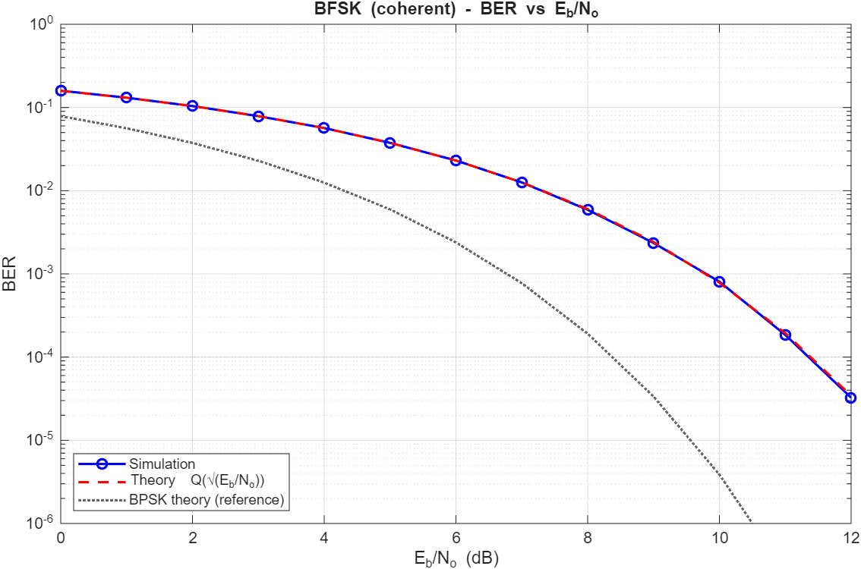
Figure B1. BER of coherent BFSK versus E_{b}/N_{o}: simulation (blue circles), theory Q(√(E_{b}/N_{o})) (red dashed line), and BPSK theory for reference (gray dotted line).
Comments:
- The simulated points lie on the theoretical curve over the whole range. For example, at 8 dB the simulated BER is about 5.9× 10⁻³ and the theory Q(√6.31) is also about 6.0 × 10⁻³.
- The BER falls from about 0.16 at 0 dB, which matches Q(1) ≈ 0.159, to about 3 × 10⁻⁵ at 12 dB.
- At 12 dB there are only about 65 errors in 2 × 10⁶ bits, so the statistical uncertainty is about 1/√65 ≈ 12%. Small differences from the theory there are statistical and not a modelling error. More bits would be needed to measure lower BER values reliably.
- BFSK needs about 3 dB more E_{b}/N_{o} than BPSK. For a BER of 10⁻³, coherent BFSK needs about 9.8 dB and BPSK about 6.8 dB. The reason is the distance between the signal points: d² = 2E_{b} for BFSK, but d² = 4E_{b} for BPSK. BFSK is less power efficient.

5.2 Received constellation
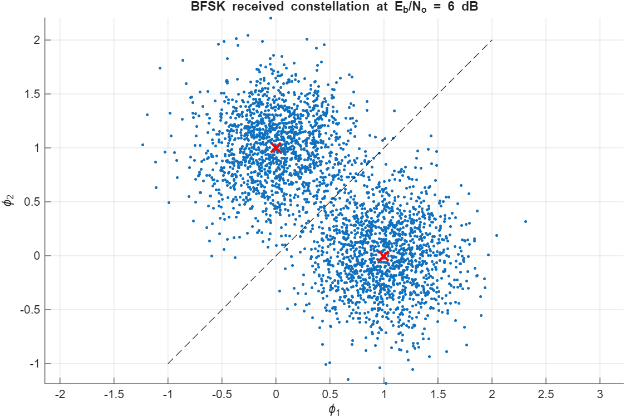
Figure B2. Received BFSK signal points at E_{b}/N_{o} = 6 dB. Red crosses mark the ideal points and the dashed line is the decision boundary r₁ = r₂.
Comments:
- The noisy points form two Gaussian clouds centered on the ideal points (1, 0) and (0, 1). The clouds have the same spread in both directions because the noise is independent in the two dimensions.
- The decision boundary r₁ = r₂ is the perpendicular bisector of the two points. A received point on the wrong side of this line is decoded wrongly.
- At 6 dB, E_{b}/N_{o} = 3.98, so the standard deviation per dimension is √(N_{o}/2) ≈ 0.35. The distance from each ideal point to the boundary is d/2 ≈ 0.71, which is two standard deviations. The error probability is therefore Q(2) ≈ 0.023, which agrees with the BER curve in Figure B1 at 6 dB.

5.3 Power spectral density

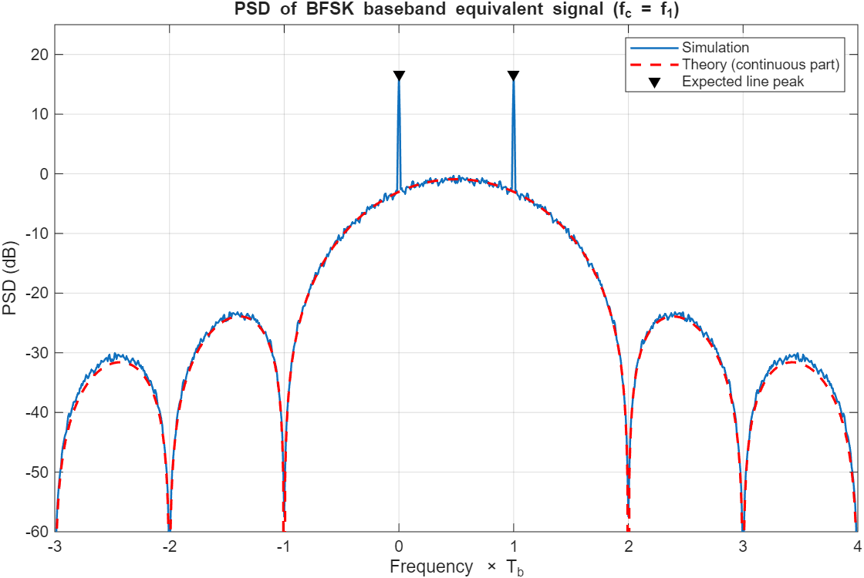
Figure B3. PSD of the BFSK baseband equivalent signal (f_{c} = f₁): simulation (blue), theory of the continuous part (red dashed), and expected height of the two lines (black triangles). The frequency axis is normalized by T_{b}.
Comments:
- Discrete lines: two sharp lines appear at f = 0 and f = 1/T_{b}. They are the two transmitted frequencies f₁ and f₂ after shifting by f_{c} = f₁. They exist because the two bit waveforms are equiprobable, so the average waveform is not zero and is periodic with period T_{b}. Each line carries power E_{b}/(2T_{b}), so together the lines carry half of the total power. The height of a line in the plot depends on the FFT length and the window, because a line is power concentrated in a single frequency bin. This is why we compare it with the expected height (black triangles), about +16.7 dB for our settings.
- Continuous part: it is a smooth hump, symmetric around f = 0.5/T_{b}, with a maximum of about −0.9 dB. At the two lines its level is about −3 dB. The simulation follows the theoretical curve closely (within about 1 dB), which confirms both the simulation and the formula.
- Bandwidth: the main lobe extends from −1/T_{b} to 2/T_{b}, a null-to-null width of 3/T_{b}. The baseband main lobe of BPSK is 2/T_{b} wide, so BFSK uses more bandwidth for the same bit rate. The passband spectrum has the same shape, shifted to the carrier, with the lines at f₁ and f₂.
- Nulls and sidelobes: nulls occur at the integer multiples of 1/T_{b} except f = 0 and f = 1/T_{b} (that is at −1, 2, 3, −2, −3, … in 1/T_{b} units). The first sidelobes are about −24 dB and the second ones about −31 dB, so they decay slowly. This is caused by the phase discontinuity at the bit boundaries, because each bit starts its tone with zero phase. A continuous-phase version of FSK would have lower sidelobes.

%% ========================================================================
% Digital Communications - Project Part 1 - Task 1.5: BFSK
% Chain (Figure 1): Data bits -> Mapper -> AWGN channel -> Demapper -> BER
% Everything is done on the BASEBAND EQUIVALENT system (no carriers).
% Run section by section (Ctrl+Enter). The helper functions are at the END
% of this file (local functions in scripts need MATLAB R2016b or newer).
% ========================================================================

%% STAGE 0 : Clean start
clear; clc; close all;
rng(1); % fixed seed -> same results every run

%% STAGE 1 : Parameters
Tb = 1; % bit duration (normalized)
Eb = 1; % energy per bit (normalized)
Nbits = 2e6; % bits per Eb/No point
EbN0_dB = 0:1:12; % Eb/No range in dB
EbN0 = 10.^(EbN0_dB/10); % linear scale
Q = @(x) 0.5*erfc(x/sqrt(2)); % Q-function (no toolbox needed)

%% STAGE 2 : Theory (answers for the report questions)
% Signal set: s_i(t) = sqrt(2Eb/Tb) cos(2*pi*f_i*t), 0<=t<=Tb, i = 1,2
% f_i = (nc+i)/Tb -> f2 - f1 = 1/Tb
%
% Basis functions: phi_i(t) = sqrt(2/Tb) cos(2*pi*f_i*t), 0<=t<=Tb
% unit energy : 2*f_i*Tb is an integer
% orthogonal : (f2-f1)*Tb = 1 and (f1+f2)*Tb = 2nc+3 are integers
% (1/Tb is the smallest spacing that keeps the tones orthogonal for ANY
% carrier phase; with perfect coherent detection 1/(2Tb) would also work.)
%
% Mapping: bit 1 -> s1 = sqrt(Eb)*phi1 = [sqrt(Eb) , 0]
% bit 0 -> s2 = sqrt(Eb)*phi2 = [0 , sqrt(Eb)] d = sqrt(2Eb)
%
% Baseband equivalent: s_i(t) = Re{ s_l,i(t) exp(j*2*pi*fc*t) }
% carrier fc = f1 = (nc+1)/Tb (a multiple of 1/Tb, so every bit can be
% generated in local time: the carrier phase is the same at each bit start)
% s_l,1(t) = sqrt(2Eb/Tb) (bit 1, f1-fc = 0)
% s_l,2(t) = sqrt(2Eb/Tb) * exp(+j*2*pi*t/Tb) (bit 0, f2-fc = 1/Tb)
%
% Theoretical BER (coherent BFSK): Pb = Q( sqrt(Eb/No) )

%% STAGE 3 : Mapper -> AWGN -> Demapper -> BER
% With an orthonormal basis the correlator outputs are r = s + n, with
% n ~ N(0, No/2) in EACH dimension, so the BER can be simulated at the
% signal-vector level.
bits = randi([0 1], 1, Nbits); % data bits
s = bfsk_mapper(bits, Eb); % 2 x Nbits

BER_sim = zeros(size(EbN0_dB));
for k = 1:numel(EbN0_dB)
r = awgn_channel(s, Eb, EbN0_dB(k));
bits_hat = bfsk_demapper(r);
BER_sim(k) = ber_calc(bits, bits_hat);
end
BER_theory = Q(sqrt(EbN0)); % BFSK theory
BER_bpsk = Q(sqrt(2*EbN0)); % BPSK reference (for the 3 dB comment)

fprintf('\n EbN0(dB) BER_sim BER_theory #errors\n');
for k = 1:numel(EbN0_dB)
fprintf(' %6.1f %.3e %.3e %d\n', EbN0_dB(k), BER_sim(k), ...
BER_theory(k), round(BER_sim(k)*Nbits));
end

%% STAGE 4 : Plot BER vs Eb/No (simulation vs theory)
figure;
semilogy(EbN0_dB, BER_sim, 'bo-', 'LineWidth', 1.5); hold on;
semilogy(EbN0_dB, BER_theory, 'r--', 'LineWidth', 1.5);
semilogy(EbN0_dB, BER_bpsk, ':', 'Color', [0.4 0.4 0.4], 'LineWidth', 1.5);
grid on; xlabel('E_b/N_o (dB)'); ylabel('BER');
title('BFSK (coherent) - BER vs E_b/N_o');
legend('Simulation', 'Theory Q(\surd(E_b/N_o))', 'BPSK theory (reference)', ...
'Location', 'southwest');
ylim([1e-6 1]);
save('BFSK_results.mat', 'EbN0_dB', 'BER_sim', 'BER_theory');

%% STAGE 5 : Received constellation at Eb/No = 6 dB
idx = 1:3000;
r6 = awgn_channel(s(:, idx), Eb, 6);
figure;
scatter(r6(1,:), r6(2,:), 6, 'filled'); hold on;
plot([sqrt(Eb) 0], [0 sqrt(Eb)], 'rx', 'MarkerSize', 12, 'LineWidth', 2);
plot([-1 2], [-1 2], 'k--'); % decision boundary r1 = r2
axis equal; grid on;
xlabel('\phi_1'); ylabel('\phi_2');
title('BFSK received constellation at E_b/N_o = 6 dB');

%% STAGE 6 : PSD of the BFSK baseband equivalent (simulation vs theory)
L = 16; % samples per bit
Fs = L/Tb; % sampling frequency
Nb_psd = 20000;
b_psd = randi([0 1], 1, Nb_psd);
x = bfsk_baseband(b_psd, Tb, Eb, L); % complex envelope (column)

% Averaged periodogram (Welch-like, no toolbox). Absolute PSD (power/Hz).
Nfft = L*128; % resolution = 1/(128*Tb)
Nblk = floor(numel(x)/Nfft);
nn = (0:Nfft-1)';
w = 0.54 - 0.46*cos(2*pi*nn/(Nfft-1)); % Hamming window (no toolbox)
Pxx = zeros(Nfft,1);
for m = 1:Nblk
seg = x((m-1)*Nfft+1 : m*Nfft) .* w;
Pxx = Pxx + abs(fft(seg)).^2;
end
Pxx = fftshift(Pxx / (Nblk*Fs*sum(w.^2)));
f = (-Nfft/2 : Nfft/2-1)' * (Fs/Nfft);

% Theory: continuous part = (1/(4Tb)) |G1(f) - G2(f)|^2,
% plus two lines (at f = 0 and f = 1/Tb), each of power A^2/4 = Eb/(2Tb)
A = sqrt(2*Eb/Tb);
sc = @(u) sin(pi*u + eps) ./ (pi*u + eps); % sinc without toolbox
G = @(ff, d) A*Tb * sc((ff - d)*Tb) .* exp(-1j*pi*(ff - d)*Tb);
Sc = abs(G(f, 0) - G(f, 1/Tb)).^2 / (4*Tb);
Pk = (A^2/4) * sum(w)^2 / (Fs*sum(w.^2)); % expected line peak with this window

figure;
plot(f*Tb, 10*log10(Pxx), 'LineWidth', 1.2); hold on;
plot(f*Tb, 10*log10(Sc), 'r--', 'LineWidth', 1.5);
plot([0 1], 10*log10([Pk Pk]), 'kv', 'MarkerFaceColor', 'k');
grid on; xlim([-3 4]); ylim([-60 25]);
xlabel('Frequency \times T_b'); ylabel('PSD (dB)');
title('PSD of BFSK baseband equivalent signal (f_c = f_1)');
legend('Simulation', 'Theory (continuous part)', 'Expected line peak', ...
'Location', 'northeast');
% Lines at f = 0 and 1/Tb = the two tones after shifting by fc = f1.
% Their height above the continuum depends on the FFT length/window.

%% ======================= LOCAL FUNCTIONS ================================
function s = bfsk_mapper(bits, Eb)
% bit 1 -> [sqrt(Eb); 0] (phi1), bit 0 -> [0; sqrt(Eb)] (phi2)
s = sqrt(Eb) * [ (bits == 1) ; (bits == 0) ];
end

function r = awgn_channel(s, Eb, EbN0_dB)
% r = s + n, n ~ N(0, No/2) per dimension, No = Eb / (Eb/No)
No = Eb / 10^(EbN0_dB/10);
r = s + sqrt(No/2) * randn(size(s));
end

function bits_hat = bfsk_demapper(r)
% Minimum distance = larger correlator output: r1 > r2 -> bit 1
bits_hat = double(r(1,:) > r(2,:));
end

function ber = ber_calc(bits, bits_hat)
ber = mean(bits ~= bits_hat);
end

function x = bfsk_baseband(bits, Tb, Eb, L)
% Complex envelope with fc = f1; each bit built in local time (fc*Tb is an integer).
t = (0:L-1)' / L * Tb;
A = sqrt(2*Eb/Tb);
seg1 = A * ones(L,1); % bit 1: f1 - fc = 0
seg0 = A * exp(1j*2*pi*t/Tb); % bit 0: f2 - fc = 1/Tb
X = zeros(L, numel(bits));
X(:, bits == 1) = repmat(seg1, 1, sum(bits == 1));
X(:, bits == 0) = repmat(seg0, 1, sum(bits == 0));
x = X(:);
end

