Data Warehousing and Predictive Analytics

COMP 309 - 003

Centennial College

Final Group Project 2:

Predictive model for Major Crimes


Prepared by:
Abdulrahman Hamid
Ethan Ayube
Munachimso Eriobuna
Ethan Micciola
Larry Yu
GitHub: Group2_repository click here
Professor: Salima Alim Amlani

Contents
1. Executive Summary 3
2. Overview of the Solution 4
3. Data Exploration and Findings 5
4. Data Cleaning and Transformation 7
5. Extra Feature 10
6. Model Building 11
7. Model Scoring and Evaluation 15
8. Model Deployment 17
9. Conclusion 18

1. Executive Summary
The objective of this project was to develop a machine learning solution capable of predicting the category of a major crime (e.g., Assault, Robbery, Auto Theft) based on temporal and spatial features. Using the Toronto Police Service’s "Major Crime Indicators" dataset, our team processed over 450,000 records to build a robust classification system. And used GitHub to maintain communication and one coding standard
Our solution involved a comprehensive data pipeline that cleaned raw police data, engineered innovative features such as TIME_OF_DAY to capture behavioral patterns, and rigorously tested multiple algorithms. We addressed significant challenges, including data leakage risks and class imbalance, by implementing strict preprocessing protocols and stratified sampling.
The final Decision Tree Classifier was selected as the production model, achieving an accuracy of 67.81% and an F1-score of 0.67, significantly outperforming the Logistic Regression baseline (48.5%). We achieved these numbers in this project because the successful implementation of SMOTE (Synthetic Minority Over-sampling Technique). This technique balanced our dataset, by increasing it from approximately 388,000 to over 1 million records, and improved the model's ability to detect rare crimes like 'Theft Over,' raising its detection rate the recall from nearly 0% to 80%. The model was successfully serialized and deployed as a RESTful Flask API, enabling real-time crime categorization to assist law enforcement agencies in resource allocation and public safety planning.

2. Overview of the Solution
Phase 1: Data loading & exploring
- Data Quality: Dropping rows with missing values (NaN)
- Removing records marked as "NSA" (Not Specified Area)
- Leakage Prevention: Identifying and removing duplicate entries based on EVENT_UNIQUE_ID
Phase 2: Feature Engineering & Selection
- Made TIME_OF_DAY instead of hours, changing the 24 hour into Morning, Afternoon, Evening, and Night.
- We applied One-Hot Encoding to categorical features (DIVISION, PREMISES_TYPE, OCC_DOW) to make them compatible with machine learning algorithms.
Phase 3: Modeling & Evaluation
In this phase we fixed the imbalanced classes because 'Assult' filled almost 87% of our dataset, by applying SMOTE to the entire dataset before splitting. This generated synthetic examples for minority classes (like Auto Theft and Robbery), ensuring perfectly equal 200,730 records for each crime type.
We then applied Min-Max Normalization to scale all features between 0 and 1. Finally, we split this balanced, normalized dataset into 80% Training and 20% Testing sets to train our Logistic Regression and Decision Tree models
Phase 4: Deployment
Used the best-performing model Decision Tree was serialized using joblib. We developed a Python Flask API (app.py) that loads this model and exposes a /predict endpoint. This allows will allow our testing application to use it and get the Json formatted data

3. Data Exploration and Findings
We started by loading the Major_Crime.csv dataset using Pandas. We checked the basic information to understand what we were working on. The dataset contains information about the occurrence date, the division (location), and the type of place (premises) where the crime happened.

Initial Findings: we used the .describe() and functions to look at the data types and statistics. We noticed that some columns had missing values and that the dataset was large over 450,000 rows initially.
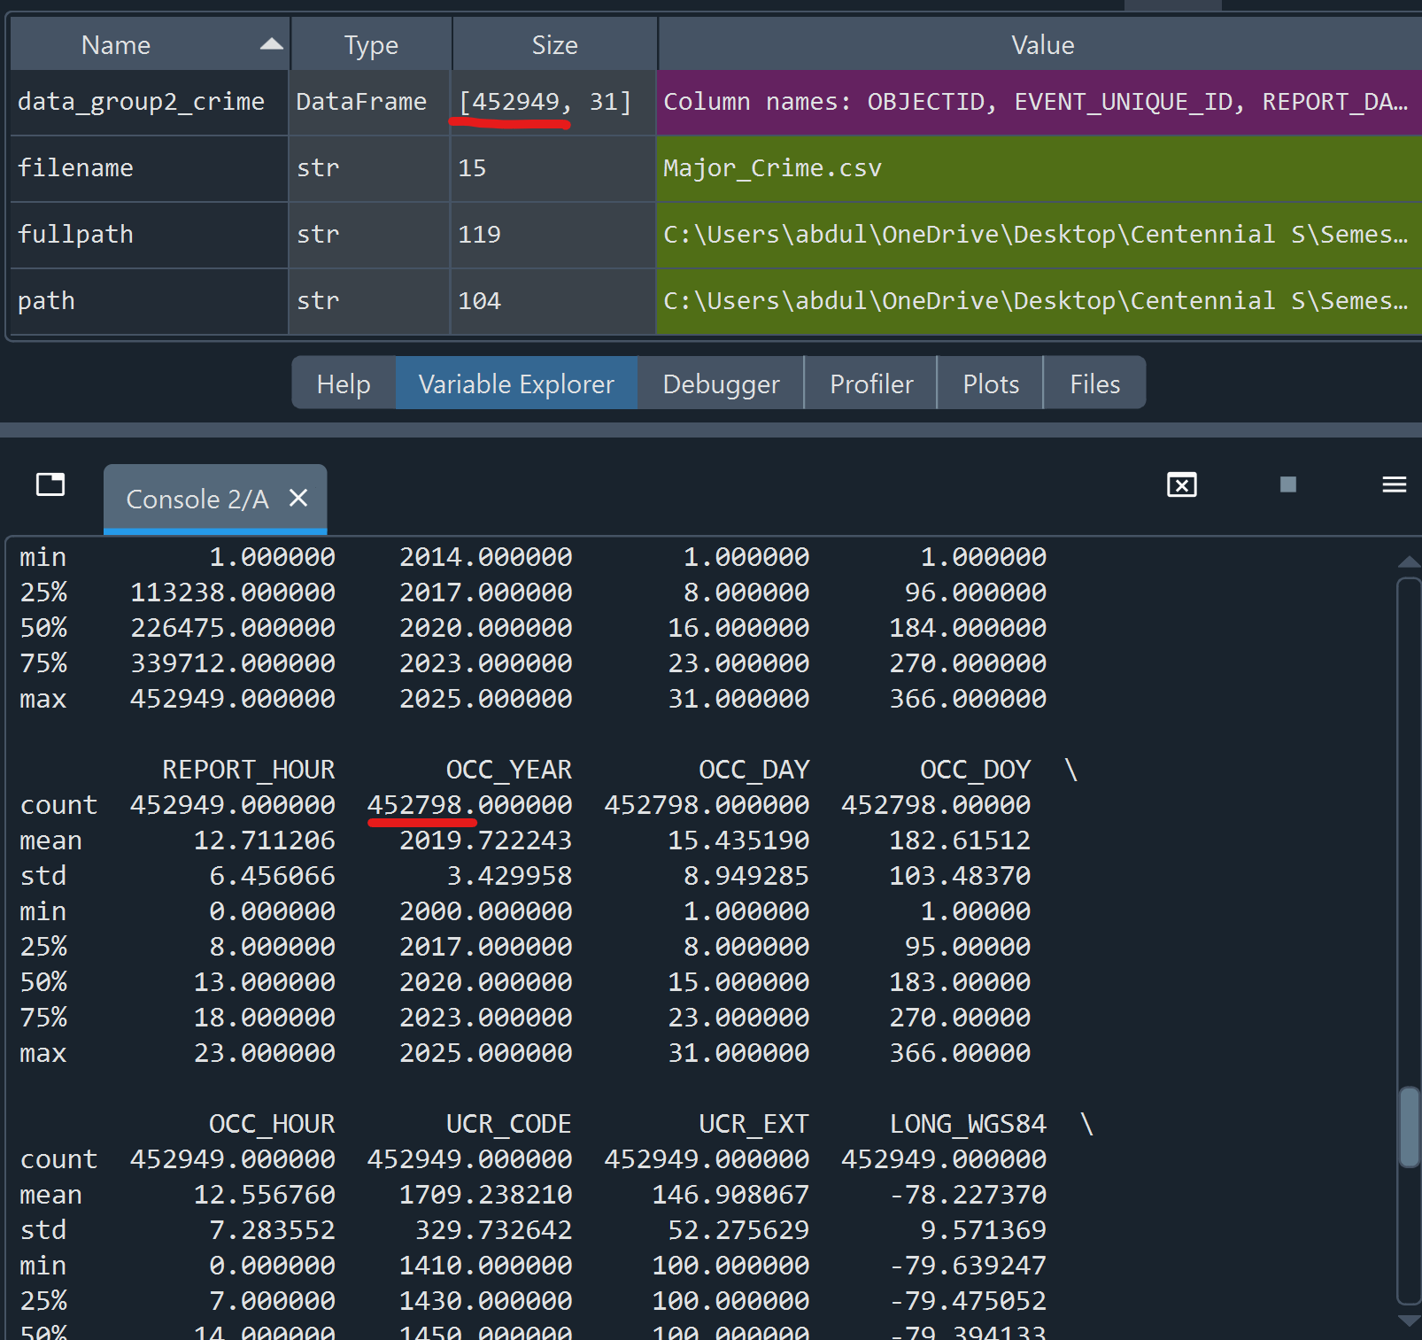
This screenshot shows we had missing values by looking at the count from some of the column had less count then our actual dataset
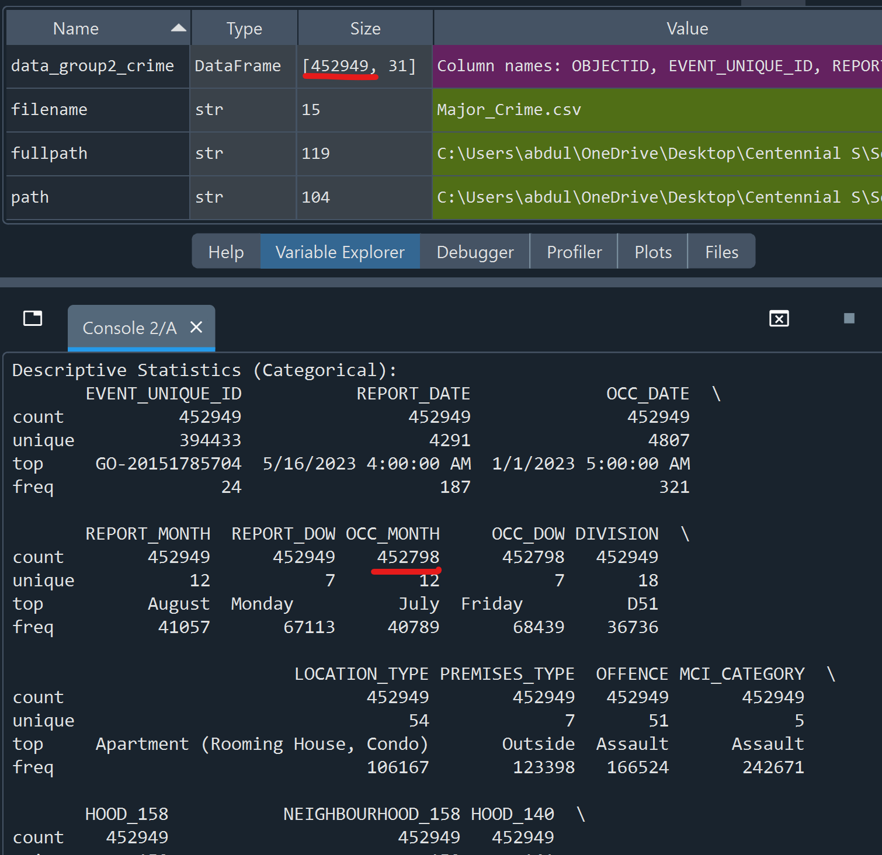
The same was for the Categorical values
we used “data_group2_crime.isnull().sum()” to get the missing values we have
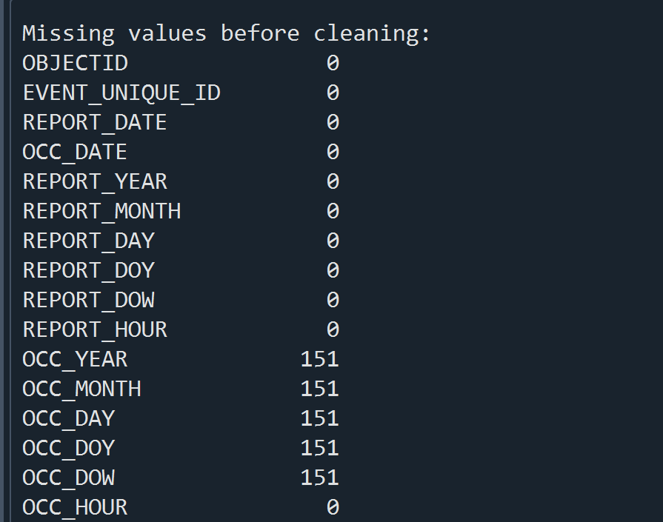

4. Data Cleaning and Transformation
To make sure our model works correctly, we had to clean the data carefully. We performed three main cleaning steps:

first before we started the cleaning process, we created a new dataframe called “data_cleaned_group2” since we do not want to alter our main df
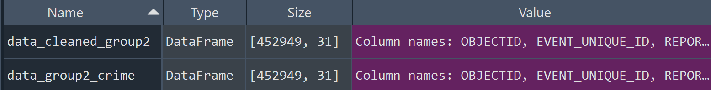

- Handling Missing Data: We found some rows with missing values for OCC_YEAR and OCC_HOUR. Instead of filling them with fake numbers which will be inaccurate especially for a crime data, we decided to just drop those rows.
using “data_cleaned_group2.dropna(inplace=True)”

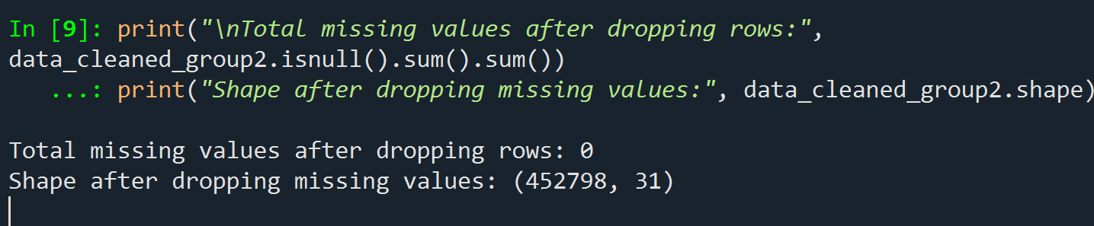
We can see here that our rows have been reduced from the original ones which was 452949

- Removing "NSA": We found the value "NSA" in the neighbourhood column. The documentation says this means "Not Specified Area" (invalid location). Since location is important for our prediction model, we had to remove these rows or accurate locations.
From the Toronto police documentation pdf
"In 2014, the Toronto Police Service changed records management systems. For occurrences prior to this date, coordinates are limited, therefore for some events with 0, 0 coordinates the neighbourhood will be identified as ‘NSA’ to indicate ‘Not Specified Area."

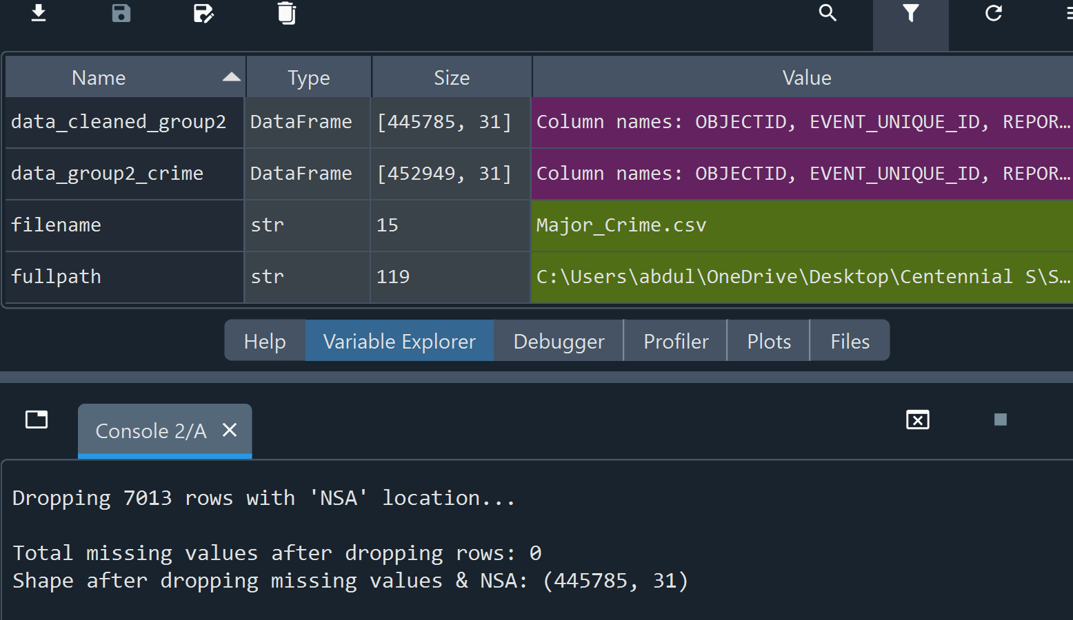
We can see here that there about 7000 (NSA) rows has been removed from the original ones which was 452949

- Removing Duplicates: We checked the EVENT_UNIQUE_ID column and found many duplicate records. We dropped these to prevent Data Leakage, making sure our model doesn't memorize the same crime twice.
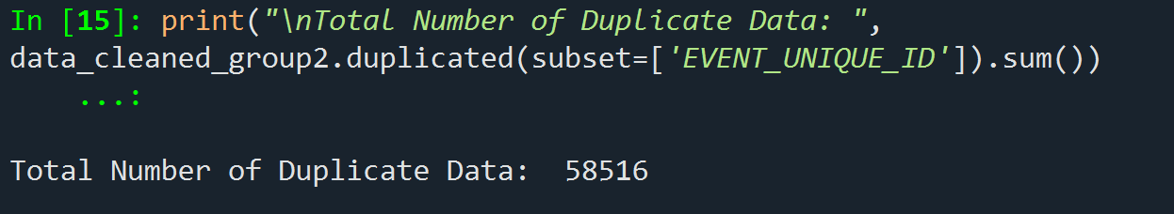
Here showing the dataset have more than 50k duplicates, which was going to cause data leakage
Using “data_cleaned_group2.drop_duplicates(subset=['EVENT_UNIQUE_ID'], inplace=True)” we dropped them.
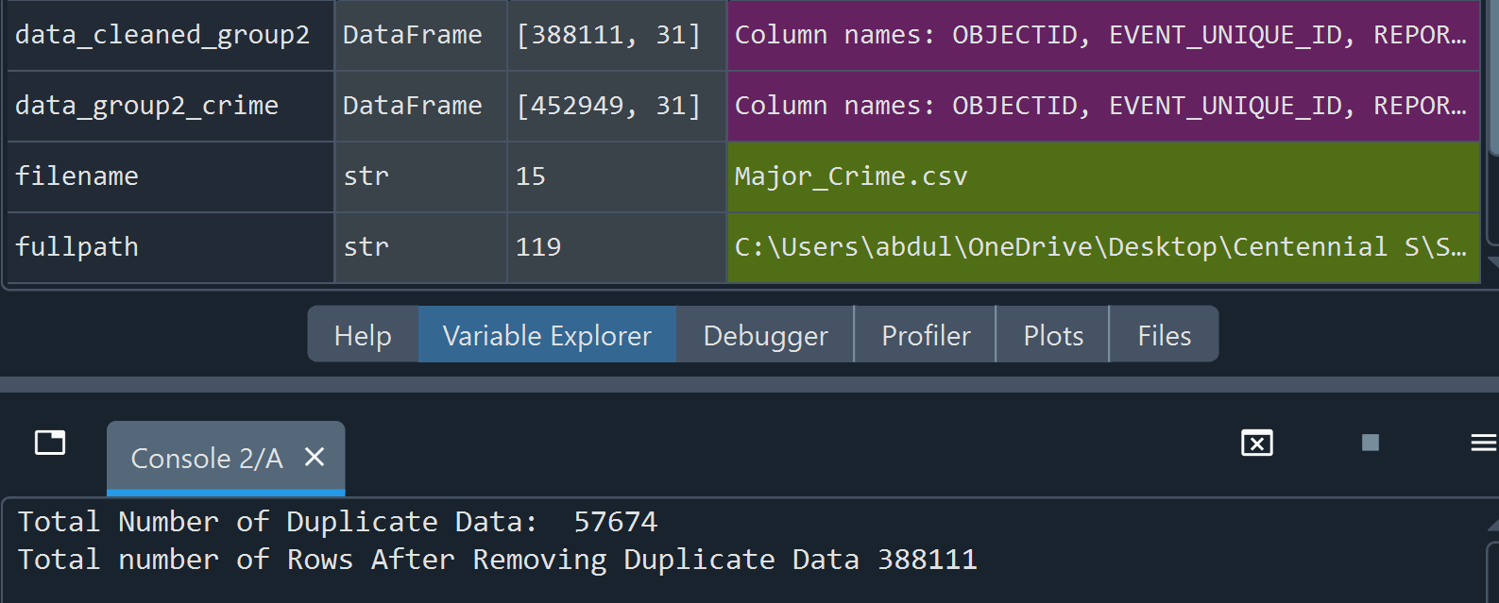
our data frame “data_cleaned_group2” after fully cleaning was left with 388111 rows

- Removing unused column: since we had a lot of columns in our dataframe so we had to deal with the ones we will not use in our models. We just dropped them
The columns we dropped and why:
a. EVENT_UNIQUE_ID / OBJECTID: random IDs will cause overfitting.
b. REPORT_ Columns: The report date happens AFTER the crime. We predict based on occurrence
c. HOOD_140 / NEIGHBOURHOOD_140: Old standards, same as 158.
d. x / y: Duplicates of LAT/LONG.
e. OFFENCE: it will cause target leakage since it is target description or crime description usually mentions the crime category

5. Extra Feature
Creating Time of Day we engineered a new feature called TIME_OF_DAY. The original data only had OCC_HOUR (0 to 23). We grouped these hours into 4 time slots: Morning, Afternoon, Evening, and Night.
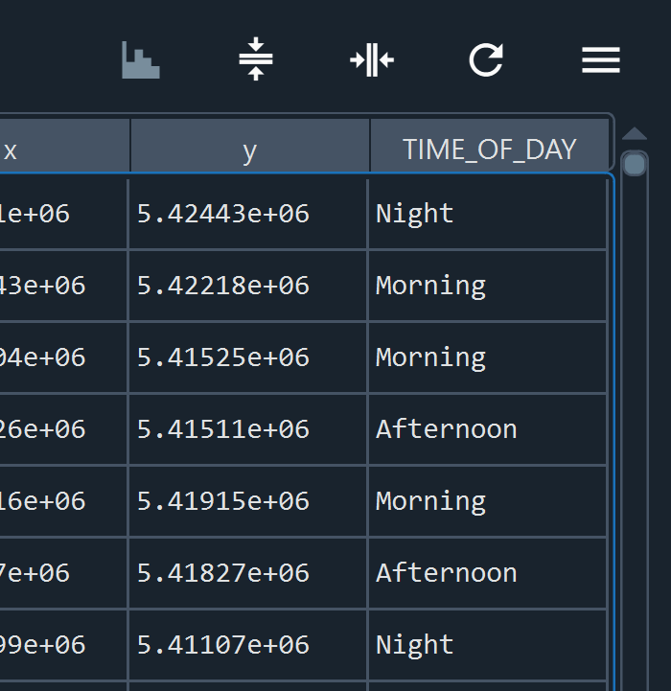

Visualizing the Data after cleaning
We created charts to see the distribution of crimes. As shown below, "Assault" is the most common crime, and certain times of day have higher crime rates.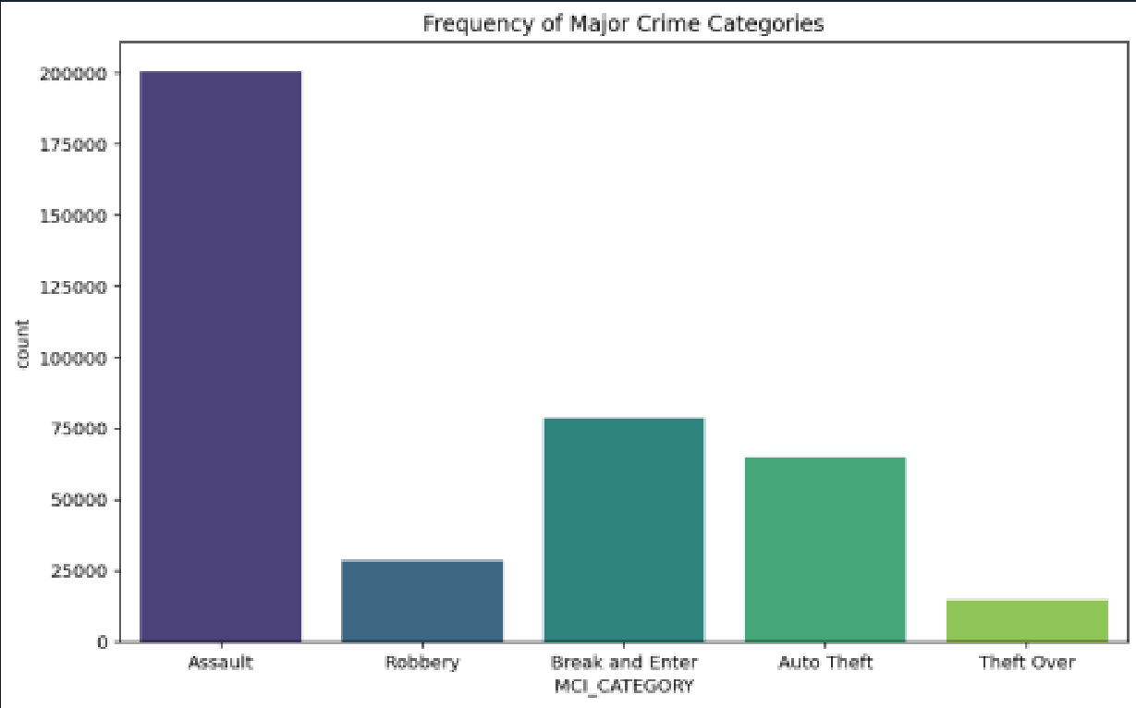

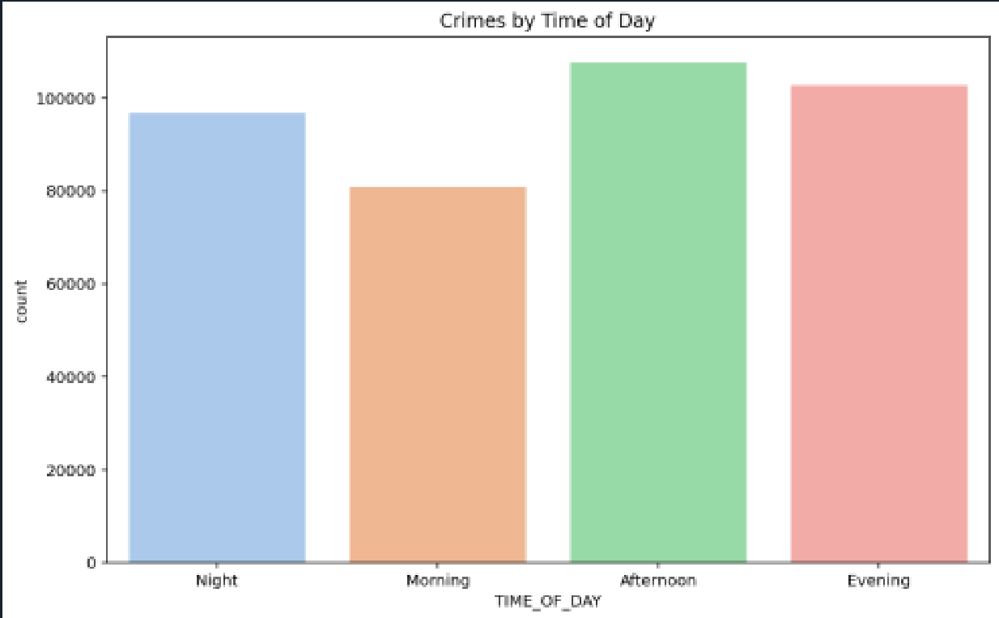

When initially skimming through the dataset, in the MCI_CATEGORIES section, Assaults took over 53%. With the next section, Break and Enter, having 18% of data.

6. Model Building
1.Feature columns:
started by choosing the featured columns ['OCC_YEAR', 'OCC_MONTH', 'OCC_DOW', 'TIME_OF_DAY', 'DIVISION', 'PREMISES_TYPE']
and the target is 'MCI_CATEGORY' in which our model will predict (What type of crime is likely to happen?)
based on three main factors:
- Time: Year, Month, Day of Week, and your new TIME_OF_DAY.
- PREMISES_TYPE” (Apartment, Outside, Commercial…).
- DIVISION: (D11, D14…).

2.Encoding:
we applied target encoder to change our target classes from texts numbers so our model can understand them. Screenshot below shows the target is coded and the count for each class
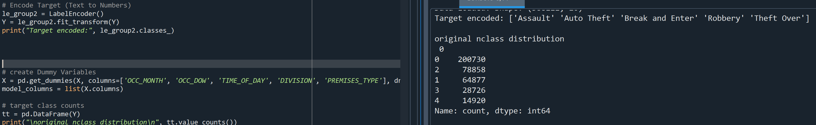
3.Balancing:
Since we noticed in the dataset the fact that Theft Over and other categories are rare crime compared to "Assault," we used SMOTE (Synthetic Minority Over-sampling Technique) to oversample our data. We applied SMOTE to our dataset
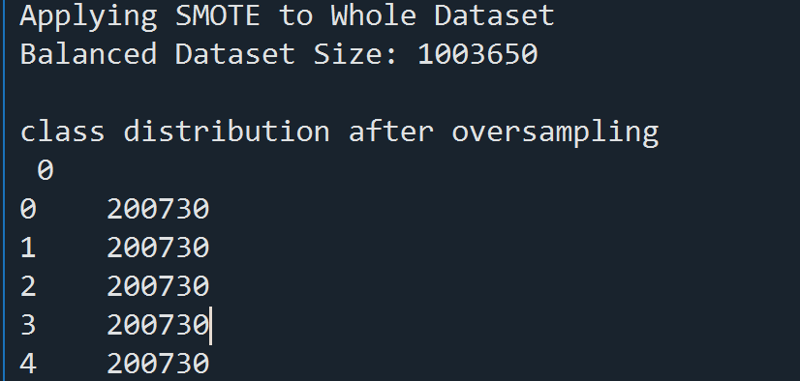
Here we can see that our dataset become over 1M records in size
and each target have 200730 record
So now we have a balanced dataset.
4.Normalization:
We had to scale OCC_YEAR because it is a huge number we used it for columns but mostly was because OCC_YEAR had values 2024 and OCC_hour was 1. There is a huge gap between the two, so will convert 2024 to something like 0.4 to keep it in smaller range for the model
also with out the scalling the Logistic Regression was taking so much time and harder for it to build
Before normalization: 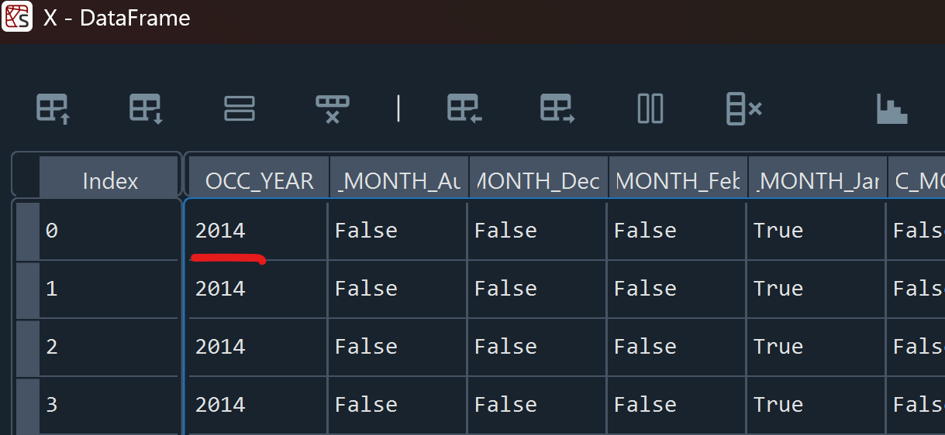

After normalization:
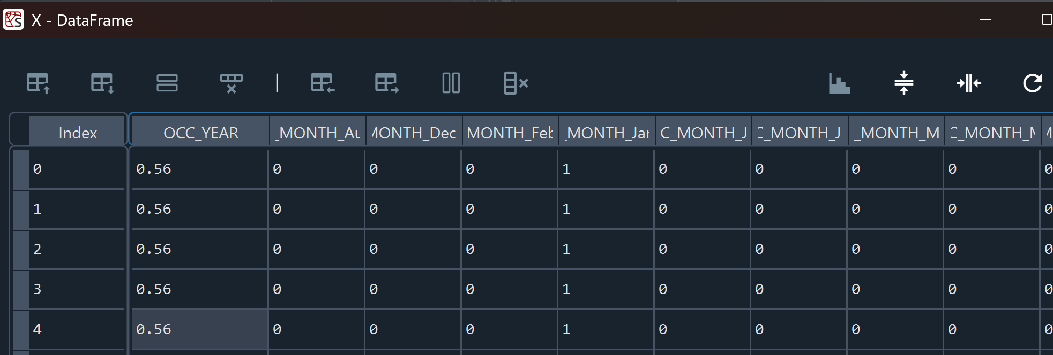

5.Splitting the Data
We split our cleaned data into 80% for Training and 20% for Testing. We used Stratified Sampling (stratify=Y) to make sure both the training and testing sets had the same percentage of each crime type. we wanted to make sure the model saw enough examples of each target. 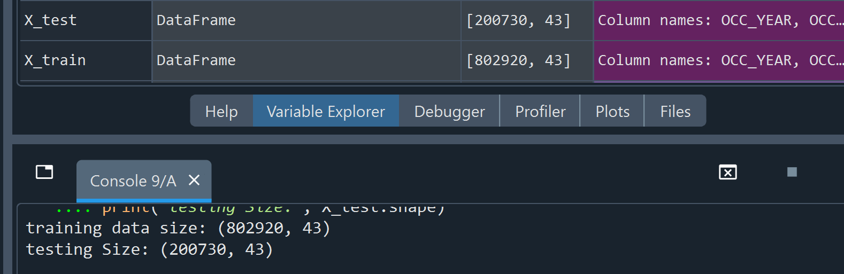

Models Used We trained and compared two algorithms:
We compared a model logistic Regression against Decision Tree on our balanced dataset.
- Logistic Regression: We used this but the since we had 5 class problem so it is too complex for it, we only got 48.51% accuracy.
- Decision Tree Classifier: After we used this and chose it for our final app.py because it can handle complex problems, and because it is good with non-linear relationships between Time, Location, and Crime Type, we achieved 67.81% accuracy.
We ended up with better numbers for Decision Tree. So, we decided to choose Decision Tree because usually it handles a lot of categories better than logistic regression. Also, usually logistic regression is used for two categories target

7. Model Scoring and Evaluation
We evaluated our models using Accuracy, Precision, Recall, and the F1-Score.
Comparison Results:
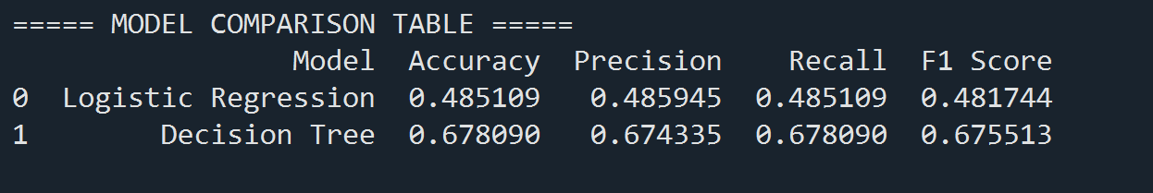
As seen in the comparison table above, the Decision Tree model performed better than Logistic Regression. It had higher accuracy and a better F1-score, so we selected it as our final model.
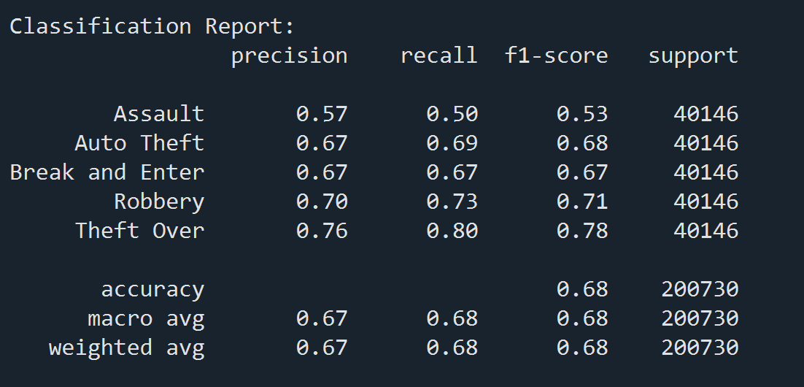
For the Decision Tree

Confusion Matrix
The Confusion Matrix below shows exactly where the model gets confused. It predicts All categories very well. However, it sometimes confuses "Break and Enter " with "Assault" because they often happen in similar locations and times.
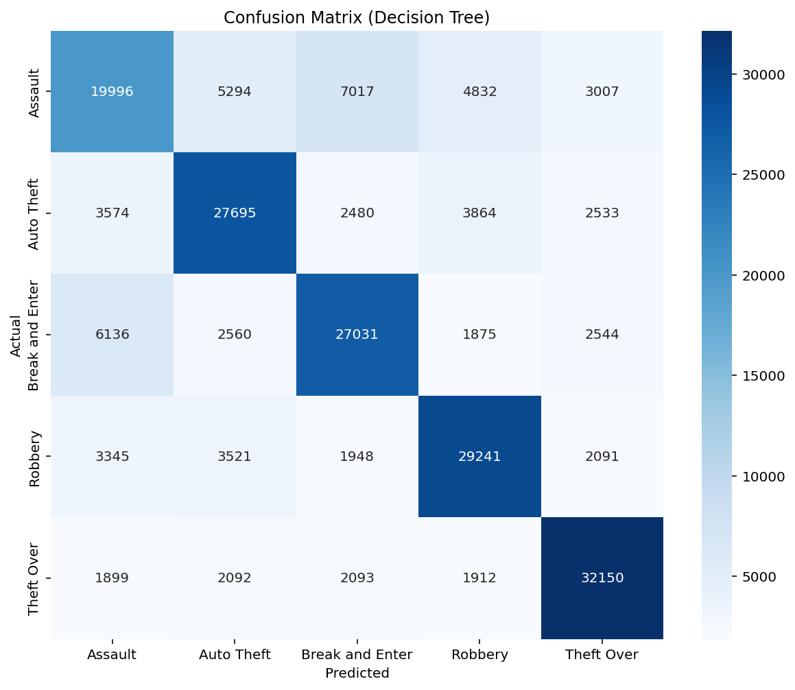

ROC Curve:
We also plotted the ROC Curve for each class. This graph helps us visualize how well the model separates the different crime categories.
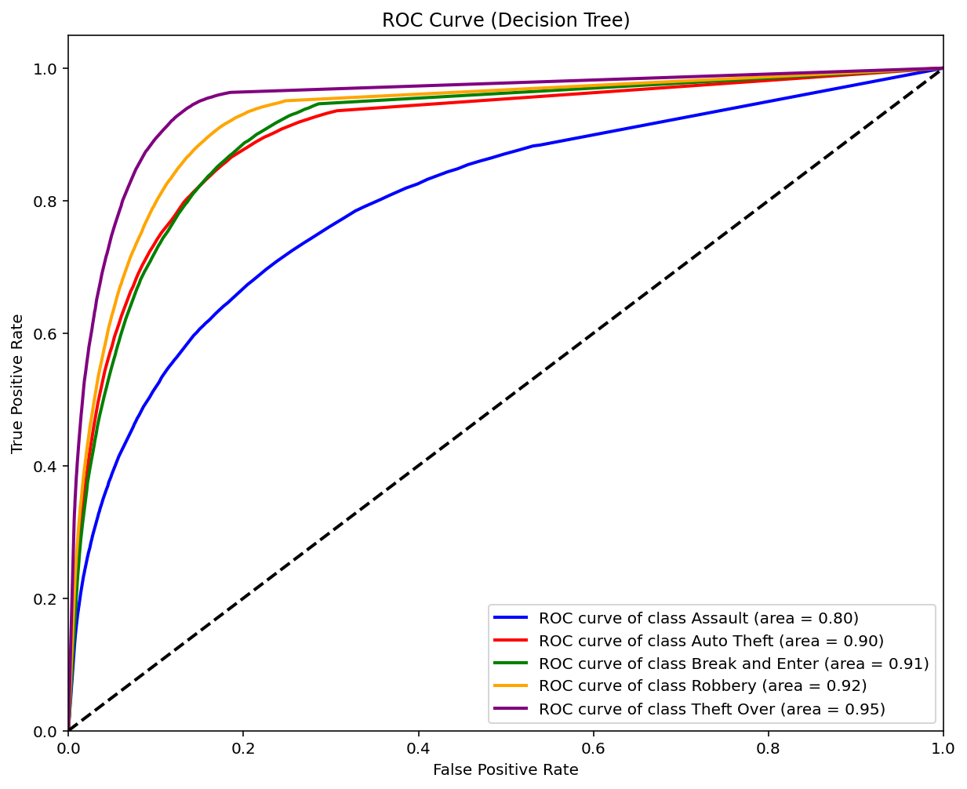
Some testing we done:
The confusion matrix if no oversampling was done:
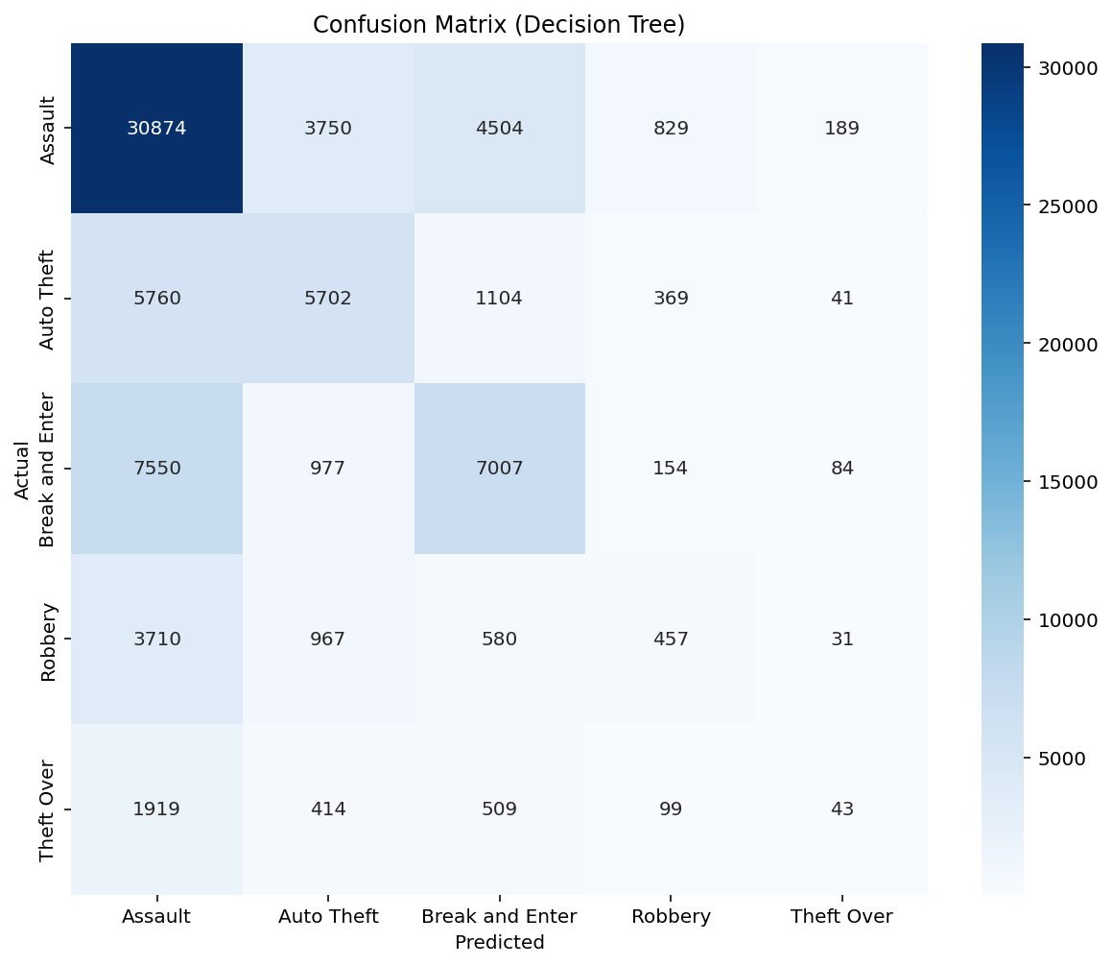

8. Model Deployment
For the final step, we deployed our best model the Decision Tree so it could be used by other applications.
We used joblib to save four pkl files, the trained model, the scaler, the categories encoder, and the list of columns.
We built a Flask API for testing. We defined endpoint that accepts JSON data. To test it, we used Postman to send details of a hypothetical crime (Date, Division, Premises), and the API correctly returned the predicted crime category.
the Json format should be like:
{
"OCC_YEAR": 2024,
"OCC_MONTH": "July",
"OCC_DOW": "Friday",
"OCC_HOUR": 22,
"DIVISION": "D14",
"PREMISES_TYPE": "Apartment"
}
and for the URL is: http://127.0.0.1:12345/predict

9. Conclusion
In this project we showed how machine learning can be used to predict major crime categories. We processed over 450000 records (over 1M after cleaning and balancing), we built a data pipeline that cleans raw data, added features, and deploys a predictive model via a Flask API.
We built a machine learning model that predicts crime categories with approximately 68% accuracy. This is significantly better than random guessing which will be (20%) 1/5. We successfully implemented SMOTE, which transformed a biased model into a balanced one that can detect rare property crimes just as well as common like assaults.

