Various Scattered sources for our documentation that we took as reference.

Functional and non-functional requirements
Software system requirements are often classified as functional or non-functional
requirements:
1. Functional requirements These are statements of services the system should
provide, how the system should react to particular inputs, and how the system
should behave in particular situations. In some cases, the functional require-
ments may also explicitly state what the system should not do.
2. Non-functional requirements These are constraints on the services or functions
offered by the system. They include timing constraints, constraints on the devel-
opment process, and constraints imposed by standards. Non-functional require-
ments often apply to the system as a whole rather than individual system features
or services.

[Sommerville, Ian. Software Engineering, Global Edition]

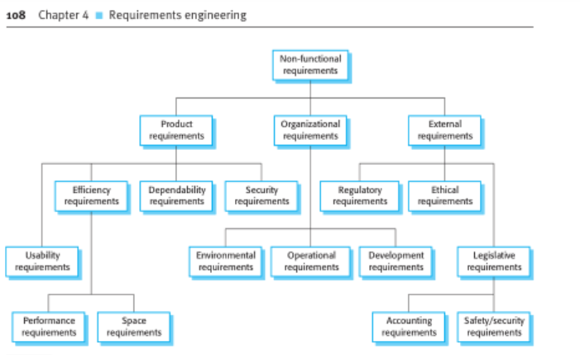

Thus we used this diagram as a reference to create our Non-functional requirements as we had issues understanding what they really are. Sometimes mislabeling them as Functional.

