

Arab Academy for Science, Technology and Maritime Transport

College of Computing and Information Technology -- Cairo

Course Name: Introduction to Software Engineering
Course Code: CSE2001

12th Week Project Documentation

Project Name: Warsha
A centralized digital platform connecting local residents with verified service providers (e.g., plumbers, tutors, electricians) to bridge the gap between community needs and local expertise.

Presented By:

Abdulrahman Ahmed  241004780 | Marino Remon  241004796
Mohamed Mahmoud  241005267 | Seif Bakry  241004799

Presented To:
Dr. Eman ElSayed Mahmoud
Eng. Anas Ahmad Ibraheem

Table of Contents

1. Introduction 1
1.1 Problem Statement 1
1.2 Purpose 1
1.3 Document Conventions 1
1.4 Intended Audience and Reading Suggestions 1
1.5 Project Scope 1
1.6 Objectives 1
1.7 Goals 1
1.8 References 2
2. Overall Description 2
2.1 Project Perspective 2
2.2 Product Functions 2
2.3 User Classes and Characteristics 2
2.4 Operating Environment 2
2.5 Design and Implementation Constraints 3
2.6 User Documentation 3
2.7 Assumptions and Dependencies 3
3. External Interface Requirements 3
3.1 User Interfaces 3
3.2 Hardware Interfaces "If Exist" 3
3.3 Software Interfaces 3
3.4 Communications Interfaces 4
4. Project Features 4
4.1 Account Management 4
4.2 Worker Profile Management 4
4.3 Service Discovery 5
4.4 Appointment Booking 5
4.5 Payment Processing 5
4.6 Reviews and Ratings 6
4.7 Admin Management 6
5. Other Nonfunctional Requirements 6
5.1 Performance Requirements 6
5.2 Safety Requirements 6
5.3 Security Requirements 6
5.4 Software Quality Attributes 6
5.5 Business Rules 6
6. UML DESIGN 7
6.1 Usecase Diagram 7
6.2 Activity Diagram 7
6.3 Sequence Diagram 7
6.4 Misuse Case Diagram 7
6.5 Class Diagram 7
6.6 State Machine Diagram "If Exist" 7
7. Implementation 8
7.1 Implemented Functions 8
7.2 Project Implementation 8
Appendix A: Glossary 8
Appendix B: Analysis Models 8
Appendix C: To Be Determined List 8

1. Introduction
1.1 Problem Statement
Many people struggle to find reliable local services due to the lack of organized platforms that connect them with qualified professionals. The key issues include:
- Scattered Service Providers: Service providers are often difficult to find because they operate across different platforms or offline sources.
- Limited Provider Information: Customers usually have little information about a provider's quality or reliability.
- Difficulty Comparing Services: Without a structured platform, comparing service providers based on price or quality is difficult.
- Inefficient Communication: Traditional communication methods make scheduling and managing services slower.
- Limited Visibility for Workers: Many skilled workers cannot easily reach potential customers without an online presence.
1.2 Purpose
The purpose of the Warsha project is to build a platform that simplifies the connection between users and service providers while improving trust, accessibility, and service management. Warsha provides centralized service access, easy service discovery, trust and transparency through ratings and reviews, an organized booking system, and support for local professionals by giving them a digital space to promote their services and reach more customers.
1.3 Document Conventions
This document follows the IEEE SRS template standard. Requirements are uniquely identified with IDs (e.g., FR1, NFR1). The following conventions are used throughout this document:
- FR#: Functional Requirement identifier
- NFR#: Non-Functional Requirement identifier
- Shall: Indicates a mandatory requirement
- Should: Indicates a recommended requirement
- TBD: To Be Determined (placeholder for information not yet available)
1.4 Intended Audience and Reading Suggestions
This document is intended for the following audiences:
- Developers: Should focus on Sections 4 (Project Features) and 5 (Nonfunctional Requirements) for implementation details.
- Project Managers: Should review Sections 1 (Introduction), 2 (Overall Description), and 6 (UML Design) for project planning.
- Testers: Should pay special attention to Sections 4 and 5 to derive test cases.
- Stakeholders: Should read Sections 1 and 2 for a high-level understanding of the project.
It is recommended to read this document sequentially, starting with the Introduction and proceeding through each section.
1.5 Project Scope
This document defines the project scope for Warsha. It establishes the clear boundaries of what the project will include and deliver, and explicitly states what falls outside of its boundaries.
1.5.1 In-Scope
The following features and functional modules will be built and delivered as part of this project:
- User: Authentication (Sign Up / Login), Service Search & Browsing, Worker Profile & Ratings Viewer, Appointment Booking / Cancellation / Rescheduling, Coupon & Discount Application, In-App Payment Processing, Refund Requests
- Worker: Authentication (Sign Up / Login), Base Pricing Configuration, Appointment Request Management (Accept / Reject), Job Completion Tracking, Earnings & Transaction History, Earnings Withdrawal
- Admin: Worker Registration Approval, User & Worker Suspension, Dispute Management, Refund Management
- Payment Gateway: Payment Processing Simulation, Refund Transaction Simulation
Integrations include: Payment Gateway API (Stripe), Email Notification Service, Sign up with Google / Apple ID, Google Analytics, and Intercom.
Platforms: Web application (Windows, Mac, Linux), Native Android & iOS Apps.
1.5.2 Out-of-Scope
The following features are explicitly NOT part of this project:
- Multi-language support
- Real-time GPS / Location tracking
- Multiple Accounts per user or worker
- In-app messaging between users and workers
- Global release (limited to local market deployment)
- Management or monitoring of third-party part prices or material costs
1.6 Objectives
To achieve the project goal, the following key milestones will be pursued:
- User-Centric Interface: Create separate, intuitive registration flows for both Customers and Service Providers. Ensure the platform is fully functional across mobile and desktop devices.
- Advanced Search & Discovery: Implement a map-based search using GPS to show the nearest available professionals. Organize services into clear categories with smart filtering for price and rating.
- Trust & Transparency: Build a robust rating and feedback mechanism to ensure service quality. Provide a backend system for admins to verify provider credentials (licenses/IDs) to build user trust.
- Communication & Booking: Integrate an in-app chat feature so users can discuss requirements without sharing personal phone numbers immediately. Allow users to book specific time slots and providers to manage their availability via a dashboard.
- Data Integrity: Ensure all financial data is handled via secure, encrypted gateways. Design the database to handle a growing number of users and service listings without performance lag.
1.7 Goals
The primary goal of this project is to develop a centralized, user-friendly digital platform that connects local residents with verified service providers (e.g., plumbers, tutors, electricians). The system aims to bridge the gap between community needs and local expertise, fostering local economic growth while simplifying the search for reliable help.
1.8 References
The following documents and resources were referenced during the creation of this SRS:
- IEEE Standard 830-1998: Recommended Practice for Software Requirements Specifications
- Warsha Project Scope Document (2025/2026)
- Stripe API Documentation: https://stripe.com/docs
- Google Analytics Documentation: https://developers.google.com/analytics
- Intercom API Documentation: https://developers.intercom.com

2. Overall Description
2.1 Project Perspective
Warsha is a new, self-contained product designed to serve as a centralized digital marketplace for local services. It is not a follow-on member of an existing product family nor a replacement for a current system. Warsha operates as a standalone platform consisting of a mobile application (Android & iOS) and a web application. The system connects three primary user classes—Customers, Service Providers (Workers), and Administrators—through a unified backend infrastructure that handles authentication, service discovery, appointment scheduling, payment processing, and dispute resolution.
2.2 Product Functions
The major functions the product must perform include:
- Account Management: Registration, authentication, and profile management for customers, workers, and admins.
- Worker Profile Management: Allow workers to enter professional details, specify services, set preferences, and configure pricing.
- Service Discovery: Enable customers to browse, search, and filter services with geolocation support.
- Appointment Booking: Facilitate scheduling, rescheduling, cancellation, and completion tracking of service appointments.
- Payment Processing: Handle in-app payments, coupon application, refund requests, and worker earnings withdrawal.
- Reviews and Ratings: Allow customers to rate workers and display aggregated ratings on worker profiles.
- Admin Management: Provide tools for worker approval, account suspension, dispute resolution, and refund processing.
2.3 User Classes and Characteristics
The following user classes are anticipated to use this product:
- Customers (Users): Local residents seeking various services. They are expected to have basic mobile device literacy and will primarily use search, booking, and payment features. This is the most important user class to satisfy.
- Service Providers (Workers): Skilled professionals offering services (e.g., plumbers, tutors, electricians). They require dashboard functionality to manage appointments, pricing, and earnings. Technical expertise may vary.
- Administrators: Platform managers responsible for verifying workers, resolving disputes, and maintaining platform integrity. They require full access to backend management tools and are expected to have higher technical proficiency.
2.4 Operating Environment
The software will operate in the following environments:
- Mobile Applications: Native Android (Kotlin/Java) and iOS (Swift) applications.
- Web Application: Cross-browser compatible web application supporting Windows, macOS, and Linux.
- Server Environment: Cloud-hosted backend (e.g., AWS, Azure, or similar) with RESTful API architecture.
- Database: Relational database management system (e.g., PostgreSQL or MySQL) for structured data storage.
- Third-Party Services: Stripe Payment Gateway, Email Notification Service, Google Sign-In / Apple ID, Google Analytics, Intercom.
2.5 Design and Implementation Constraints
The following constraints limit the options available to developers:
- Platform Limitation: The system shall not provide a web application. The platform is mobile-only (Android & iOS). [Note: This constraint is explicitly stated in the project boundaries and may be subject to revision.]
- Single Account Policy: The system shall not support multiple accounts per user or worker.
- Language: The system shall not support multi-language interfaces. English only.
- Geographic Scope: The platform is limited to local market deployment, not a global release.
- No In-App Messaging: The system shall not provide in-app messaging between users and workers.
- No Material Cost Management: The system shall not manage or monitor third-party part prices or material costs.
- Security Compliance: All payment data must be handled in compliance with PCI-DSS standards via Stripe.
- Technology Stack: Specific technologies, tools, and databases must be selected to support scalability and maintainability.
2.6 User Documentation
The following user documentation components will be delivered along with the software:
- User Manual: A comprehensive guide for customers and workers on how to use the platform.
- Onboarding Tutorials: In-app guided tutorials for first-time users.
- FAQ Section: Frequently asked questions accessible within the application.
- Admin Documentation: Technical documentation for administrators covering dispute resolution, worker verification, and refund processing.
2.7 Assumptions and Dependencies
The following assumptions and dependencies could affect the requirements stated in this SRS:
- Third-Party API Availability: The project depends on the continuous availability of Stripe, Google Sign-In, Apple ID, Google Analytics, and Intercom APIs.
- Network Connectivity: Users are assumed to have stable internet connectivity for real-time features.
- GPS Availability: Geolocation features assume devices have functional GPS capabilities.
- Regulatory Compliance: The platform assumes compliance with local data protection and financial transaction regulations.
- Device Compatibility: The mobile applications assume compatibility with modern Android and iOS devices.

3. External Interface Requirements
3.1 User Interfaces
The user interface shall follow modern mobile application design standards with intuitive navigation and responsive layouts. Key interface characteristics include:
- Separate registration flows for Customers and Workers with role-specific fields.
- Home screen with service categories, search bar, and recommended providers.
- Worker profile pages displaying ratings, services offered, pricing, and availability.
- Booking interface with calendar view for date/time selection.
- Payment interface supporting credit card input and coupon code entry.
- Worker dashboard for appointment management, earnings tracking, and pricing configuration.
- Admin panel for worker approval, account suspension, dispute management, and refund processing.
All interfaces shall adhere to platform-specific design guidelines (Material Design for Android, Human Interface Guidelines for iOS) and maintain consistency across platforms.
3.2 Hardware Interfaces "If Exist"
The system interfaces with the following hardware components:
- GPS/Location Services: Used to determine customer location and display nearest available workers. (Note: Real-time GPS tracking is out of scope; only location-based search is included.)
- Camera: May be used for profile picture uploads and document verification (licenses/IDs) during worker registration.
- Touchscreen: Primary input method for mobile applications.
- Biometric Sensors: Optional support for fingerprint or face recognition for authentication on supported devices.
3.3 Software Interfaces
The system interfaces with the following software components:
- Stripe Payment Gateway API: Handles payment processing, refunds, and transaction history. Data exchanged includes payment amounts, card tokens, transaction IDs, and refund statuses.
- Email Notification Service: Sends transactional emails (booking confirmations, password resets, promotional offers). Data includes recipient email addresses, message templates, and delivery statuses.
- Google Sign-In / Apple ID OAuth APIs: Provides single sign-on authentication. Data exchanged includes user profile information (name, email) and authentication tokens.
- Google Analytics: Tracks user behavior, session data, and platform usage metrics for business intelligence.
- Intercom: Provides customer support chat and user engagement features.
- Operating Systems: Android API Level 24+ and iOS 14+.
- Database Management System: PostgreSQL or MySQL for persistent data storage.
3.4 Communications Interfaces
The system requires the following communication functions:
- HTTPS/TLS: All client-server communication shall be encrypted using HTTPS/TLS 1.2 or higher.
- RESTful API: JSON-based REST API for communication between mobile/web clients and the backend server.
- Email Protocols: SMTP for outgoing email notifications.
- Push Notifications: Firebase Cloud Messaging (FCM) for Android and Apple Push Notification Service (APNS) for iOS.
- OAuth 2.0: Used for Google and Apple authentication flows.
- Payment Protocols: Stripe's secure payment processing protocols.

4. Project Features
4.1 Account Management
Description and Priority: This feature enables users (customers, workers, and admins) to create accounts, log in, and manage their profiles. Priority: High.
Stimulus/Response Sequences:
- User opens the app and selects 'Sign Up' -> System displays registration form with role selection.
- User enters credentials and submits -> System validates input and creates account.
- User selects 'Log In' -> System authenticates and redirects to dashboard.
- User accesses profile settings -> System displays editable profile information.
Functional Requirements:
- FR-REQ-1 (FR1): The system shall allow customers to create an account.
- FR-REQ-2 (FR2): The system shall allow blue-collar workers to create an account.
- FR-REQ-3 (FR3): The system shall allow users to log into the system using their credentials.
- FR-REQ-4 (FR4): The system shall allow users to edit and update their profile information.
4.2 Worker Profile Management
Description and Priority: This feature allows workers to set up and manage their professional profiles, services, preferences, and pricing. Priority: High.
Stimulus/Response Sequences:
- Worker navigates to profile setup -> System displays forms for personal and professional details.
- Worker selects services -> System updates available service categories on the worker's profile.
- Worker sets preferences -> System saves travel distance and availability settings.
- Worker configures pricing -> System stores and displays base pricing to customers.
Functional Requirements:
- FR-REQ-5 (FR5): The system shall allow workers to enter personal and professional details.
- FR-REQ-6 (FR6): The system shall allow workers to specify the services they offer.
- FR-REQ-7 (FR7): The system shall allow workers to define their service preferences such as travel distance and availability.
- FR-REQ-8 (FR8): The system shall allow workers to configure their base pricing for services.
4.3 Service Discovery
Description and Priority: This feature enables customers to browse, search, and discover services and workers based on various criteria including location. Priority: High.
Stimulus/Response Sequences:
- Customer opens app -> System displays available service categories.
- Customer enters search query -> System returns matching workers and services.
- Customer selects a worker -> System displays worker profile with ratings and reviews.
- Customer enables location -> System shows nearest available workers on map/list view.
Functional Requirements:
- FR-REQ-9 (FR9): The system shall allow customers to view available services.
- FR-REQ-10 (FR10): The system shall allow customers to search for services provided by workers.
- FR-REQ-11 (FR11): The system shall allow customers to view worker profiles and ratings.
- FR-REQ-12 (FR12): The system shall use GPS to show customers the nearest available workers.
4.4 Appointment Booking
Description and Priority: This feature facilitates the scheduling, management, and completion of service appointments between customers and workers. Priority: High.
Stimulus/Response Sequences:
- Customer selects service and worker -> System displays available time slots.
- Customer selects date and time -> System verifies worker availability.
- System confirms availability -> System creates appointment and notifies both parties.
- Customer requests cancellation/reschedule -> System updates appointment status and notifies worker.
- Worker receives request -> System allows worker to accept or reject appointment.
- Worker completes job -> System marks appointment as completed and enables rating.
Functional Requirements:
- FR-REQ-13 (FR13): The system shall allow customers to book service appointments.
- FR-REQ-14 (FR14): The system shall allow customers to select a preferred date and time for appointments.
- FR-REQ-15 (FR15): The system shall verify worker availability before confirming an appointment.
- FR-REQ-16 (FR16): The system shall allow customers to cancel or reschedule existing appointments.
- FR-REQ-17 (FR17): The system shall allow workers to accept or reject incoming appointment requests.
- FR-REQ-18 (FR18): The system shall allow workers to view their scheduled appointments.
- FR-REQ-19 (FR19): The system shall allow workers to mark jobs as completed.
4.5 Payment Processing
Description and Priority: This feature handles all financial transactions including payments, coupon application, refunds, and worker earnings management. Priority: High.
Stimulus/Response Sequences:
- Customer proceeds to checkout -> System displays payment options and total amount.
- Customer enters coupon code -> System validates and applies discount.
- Customer selects payment method -> System processes payment via Stripe.
- Payment succeeds -> System stores transaction record and updates booking status.
- Customer requests refund -> System submits refund request for admin review.
- Worker accesses earnings -> System displays transaction history and available balance.
- Worker requests withdrawal -> System processes withdrawal via configured payment method.
Functional Requirements:
- FR-REQ-20 (FR20): The system shall allow customers to make payments for services.
- FR-REQ-21 (FR21): The system shall allow customers to pay using either credit card or cash.
- FR-REQ-22 (FR22): The system shall allow customers to apply coupons or discounts during payment.
- FR-REQ-23 (FR23): The system shall store payment transactions for record keeping.
- FR-REQ-24 (FR24): The system shall allow customers to submit refund requests.
- FR-REQ-25 (FR25): The system shall allow workers to view their earnings and transaction history.
- FR-REQ-26 (FR26): The system shall allow workers to withdraw their earnings.
4.6 Reviews and Ratings
Description and Priority: This feature enables customers to provide feedback on completed services and allows workers to build reputation through ratings. Priority: Medium.
Stimulus/Response Sequences:
- Service completed -> System prompts customer to rate and review the worker.
- Customer submits rating -> System calculates and updates worker's average rating.
- Customer views worker profile -> System displays aggregated rating and individual reviews.
Functional Requirements:
- FR-REQ-27 (FR27): The system shall allow customers to rate workers after a completed service.
- FR-REQ-28 (FR28): The system shall display worker ratings on their profiles.
4.7 Admin Management
Description and Priority: This feature provides administrators with tools to manage worker registrations, user accounts, disputes, and refunds. Priority: High.
Stimulus/Response Sequences:
- Worker submits registration -> Admin receives notification for review.
- Admin reviews documents -> System allows approval or rejection of worker registration.
- Violation reported -> Admin can suspend or reactivate user/worker accounts.
- Dispute filed -> Admin accesses case details and resolves the dispute.
- Refund request submitted -> Admin reviews and processes refund request.
Functional Requirements:
- FR-REQ-29 (FR29): The system shall allow admins to approve or reject worker registration requests.
- FR-REQ-30 (FR30): The system shall allow admins to suspend or reactivate user and worker accounts.
- FR-REQ-31 (FR31): The system shall allow admins to manage and resolve disputes between users and workers.
- FR-REQ-32 (FR32): The system shall allow admins to review and process refund requests.

5. Other Nonfunctional Requirements
5.1 Performance Requirements
The following performance requirements must be satisfied:
- NFR-PERF-1: The system shall load pages and return search results within 3 seconds under normal network conditions.
- NFR-PERF-2: The system shall support at least 500 concurrent users without degradation in response time.
- NFR-PERF-3: Database queries for service search and worker profiles shall execute within 1 second under normal load.
- NFR-PERF-4: Payment processing transactions shall complete within 5 seconds under normal network conditions.
5.2 Safety Requirements
The following safety requirements must be satisfied:
- NFR-SAF-1: The system shall not expose users' personal contact information (phone numbers, addresses) publicly.
- NFR-SAF-2: The system shall provide clear warnings and confirmations before irreversible actions (e.g., account deletion, cancellation of paid bookings).
- NFR-SAF-3: The system shall ensure that worker verification documents are stored securely and access is restricted to authorized admins only.
- NFR-SAF-4: The system shall prevent unauthorized access to admin functions through role-based access control.
5.3 Security Requirements
The following security requirements must be satisfied:
- NFR-SEC-1: The system shall encrypt all user data and payment information in transit using HTTPS/TLS.
- NFR-SEC-2: The system shall require authentication before accessing any personal or financial data.
- NFR-SEC-3: The system shall log all admin actions for auditing purposes.
- NFR-SEC-4: The system shall implement secure password policies (minimum length, complexity requirements) and support password recovery.
- NFR-SEC-5: The system shall comply with PCI-DSS standards for all payment-related data handling.
- NFR-SEC-6: The system shall protect against common security vulnerabilities (SQL injection, XSS, CSRF).
5.4 Software Quality Attributes
The following software quality attributes are prioritized for this product:
- Usability: The system shall provide an intuitive interface that allows new users to complete registration in under 3 minutes. The system shall be fully functional and responsive on both Android and iOS mobile devices.
- Scalability: The system shall be designed to accommodate a growing number of users, workers, and service listings without requiring major architectural changes.
- Availability: The system shall maintain an uptime of at least 99% excluding scheduled maintenance windows.
- Reliability: The system shall preserve data integrity in the event of a failed transaction or unexpected error. The system shall display clear error messages to users when an operation fails, without exposing technical details.
- Maintainability: The codebase shall follow standard coding conventions and be well-documented to facilitate future updates and bug fixes.
- Portability: The system shall be designed to allow future expansion to additional platforms with minimal rework.
- Testability: The system architecture shall support unit testing, integration testing, and end-to-end testing.
5.5 Business Rules
The following business rules govern the operation of the platform:
- A worker cannot accept new appointments if they have pending verification or are suspended.
- A customer can only rate a worker after the associated appointment has been marked as completed.
- Refund requests must be submitted within 48 hours of the scheduled appointment time.
- Workers can only withdraw earnings that have been cleared (not pending or in dispute).
- Coupons and discounts cannot be combined; only one coupon may be applied per transaction.
- Admins must review and approve worker registrations before the worker can appear in search results.
- A user or worker may hold only one account; multiple accounts are prohibited.

6. UML DESIGN
6.1 Usecase Diagram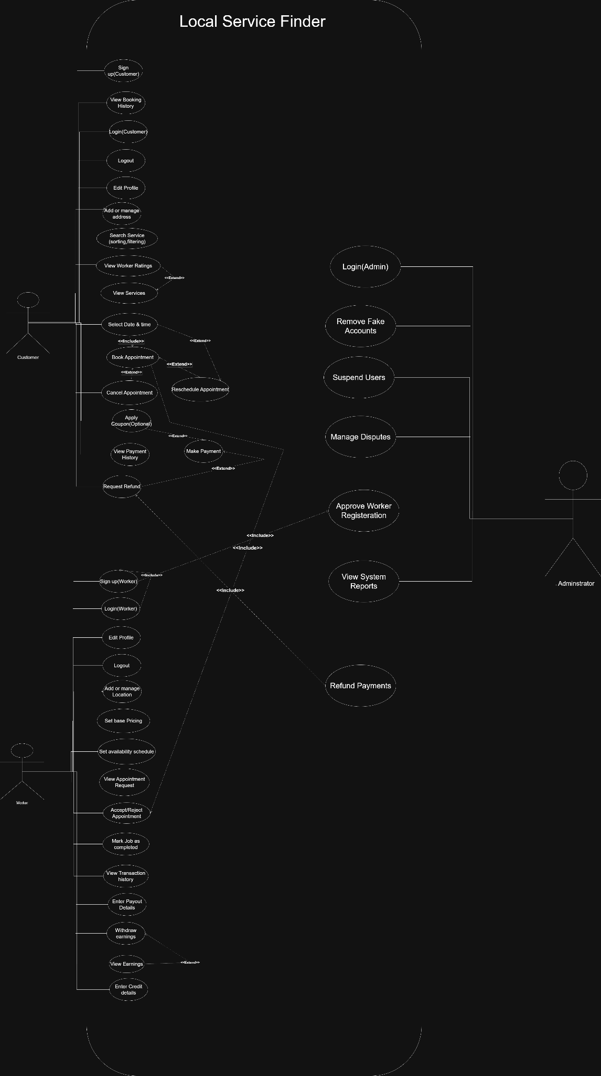

Description: The Use Case Diagram illustrates the interactions between the 2 primary actors (Customer, Worker) and the Warsha system. It captures key functionalities including authentication, service discovery, appointment management, payment processing, and administrative oversight.
6.2 Activity Diagram
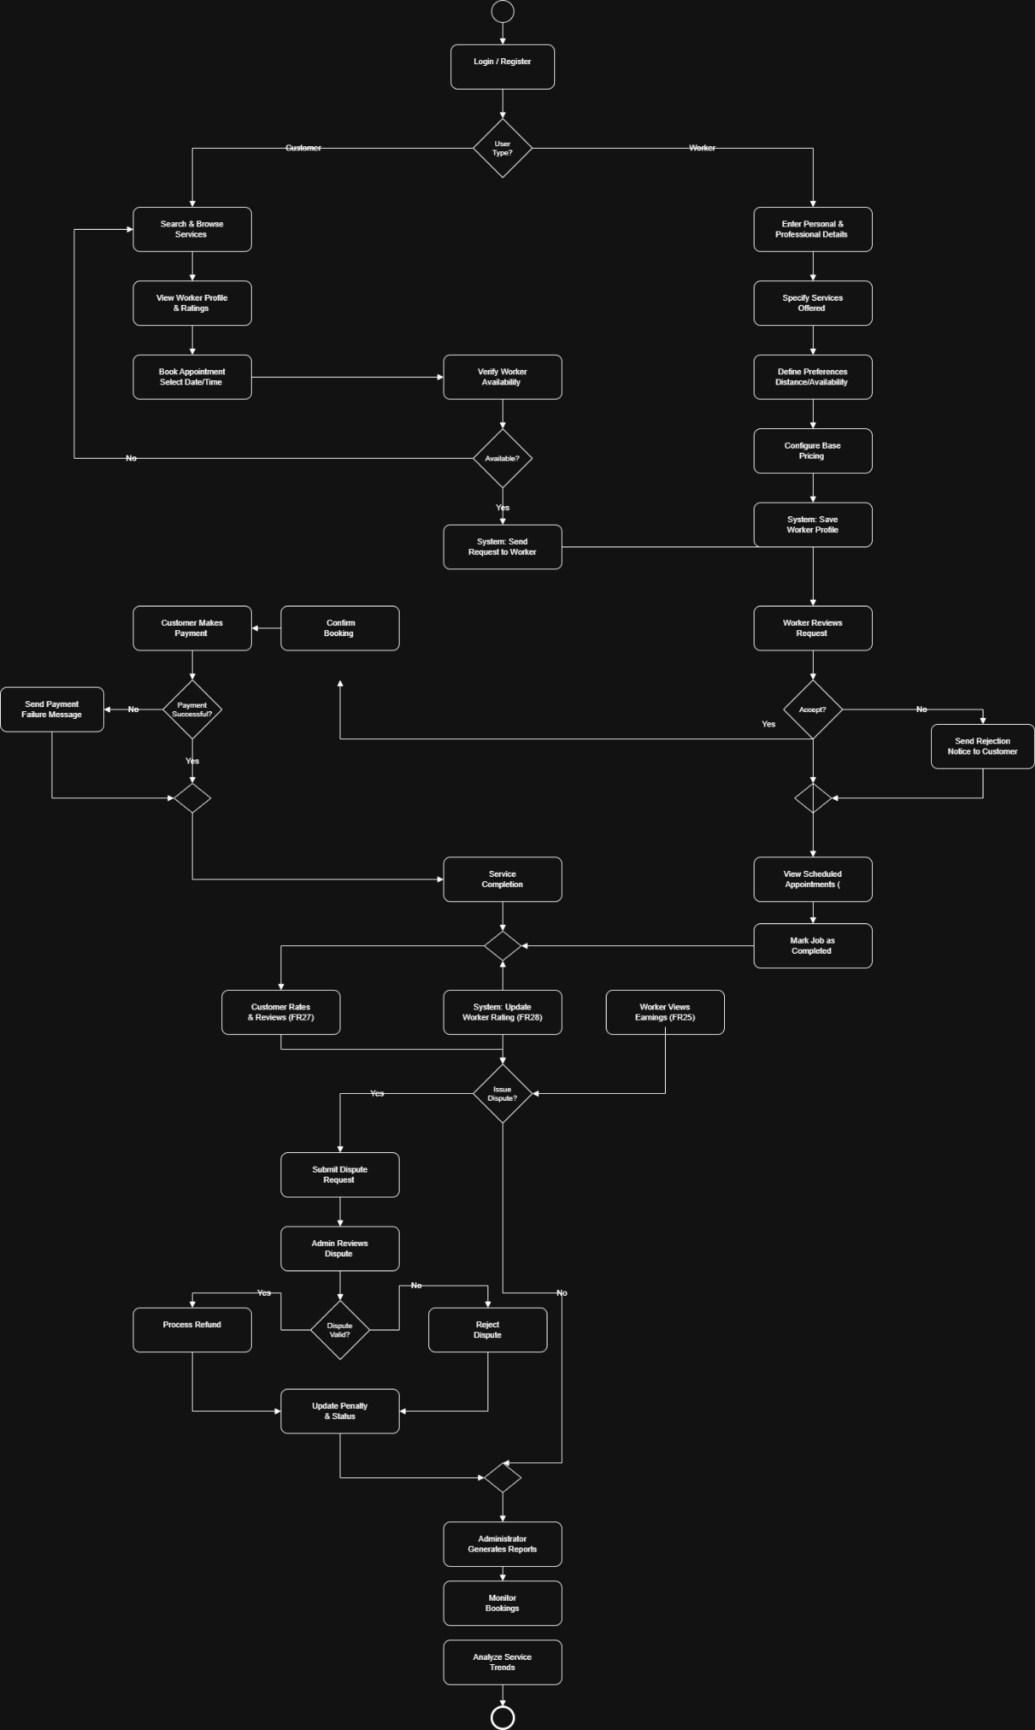
Description: The Activity Diagram models the workflow of a typical service booking process, from customer search and selection through worker acceptance, job completion, payment, and rating.
6.3 Sequence Diagram
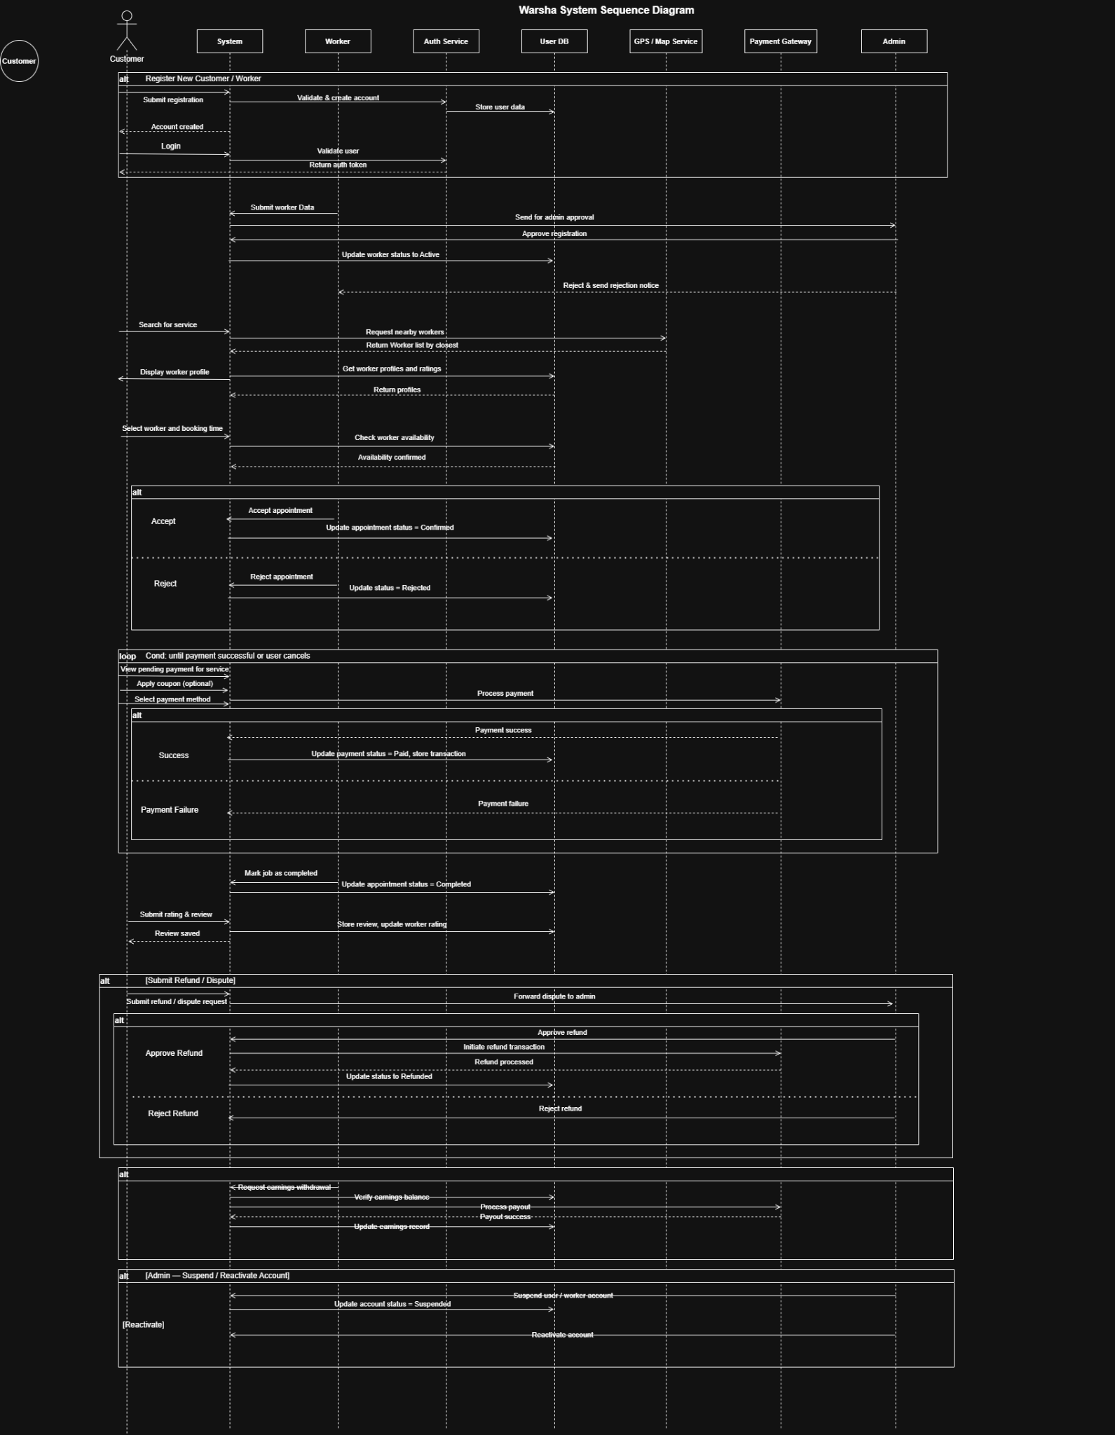

Description: The Sequence Diagram depicts the interaction sequence between the Customer, System, Worker, and Payment Gateway during the appointment booking and payment process.
6.4 Misuse Case Diagram
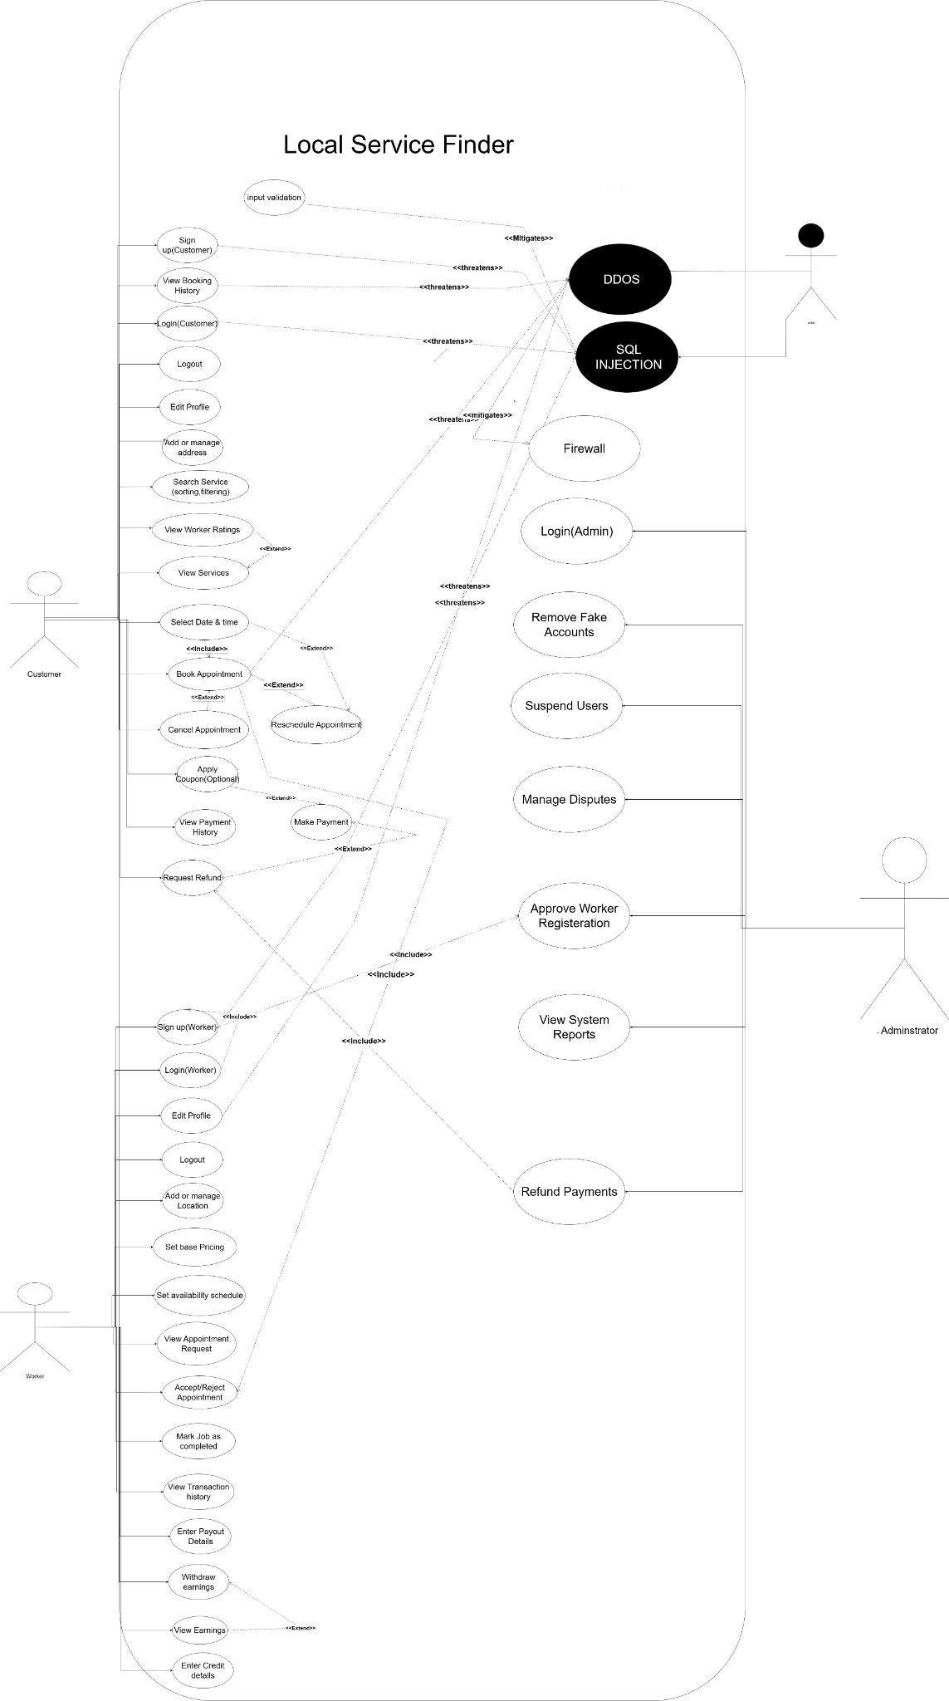

Description: The Misuse Case Diagram identifies potential security threats and malicious actor interactions with the system. THE COLORS ARE INVERTED. THIS ISSUE WILL NOT EXIST WHEN PRESENTING AND THIS ISNT HOW THE DIAGRAM IS TO BE SHOWN
6.5 Class Diagram
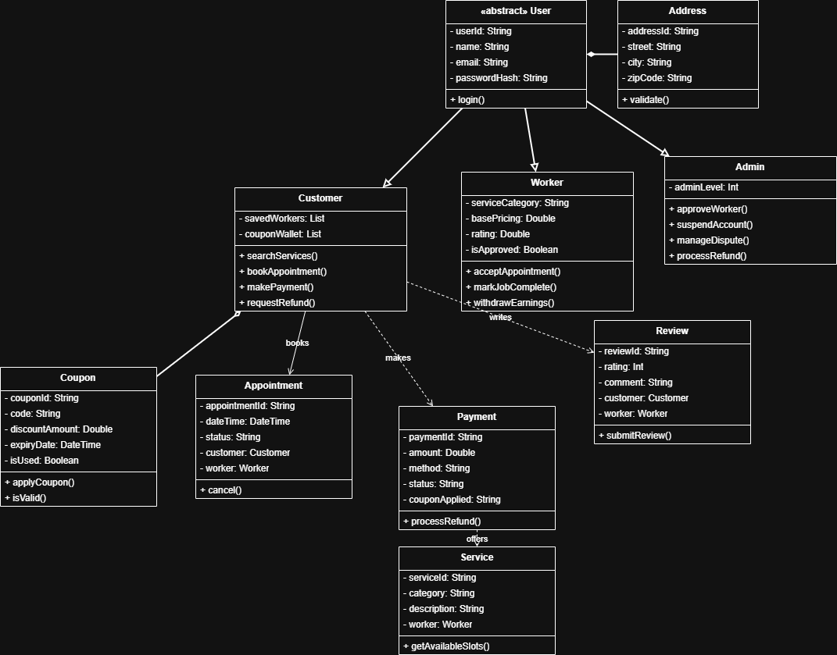

Description: The Class Diagram represents the static structure of the Warsha system, including entities such as User, Customer, Worker, Admin, Service ,coupon, Appointment, Payment, Review, and their relationships.

7. Implementation "ONLY CS6 – CS8 – CS4 – CS10"
7.1 Implemented Functions
The following functions have been implemented in the Warsha project:
- [To be completed based on actual implementation progress]
- User authentication and registration flows
- Worker profile creation and management
- Service search and discovery with filtering
- Appointment booking, acceptance, and completion workflow
- Payment processing integration
- Rating and review submission
- Admin dashboard for worker approval and account management
7.2 Project Implementation
Screenshots from the implemented project:
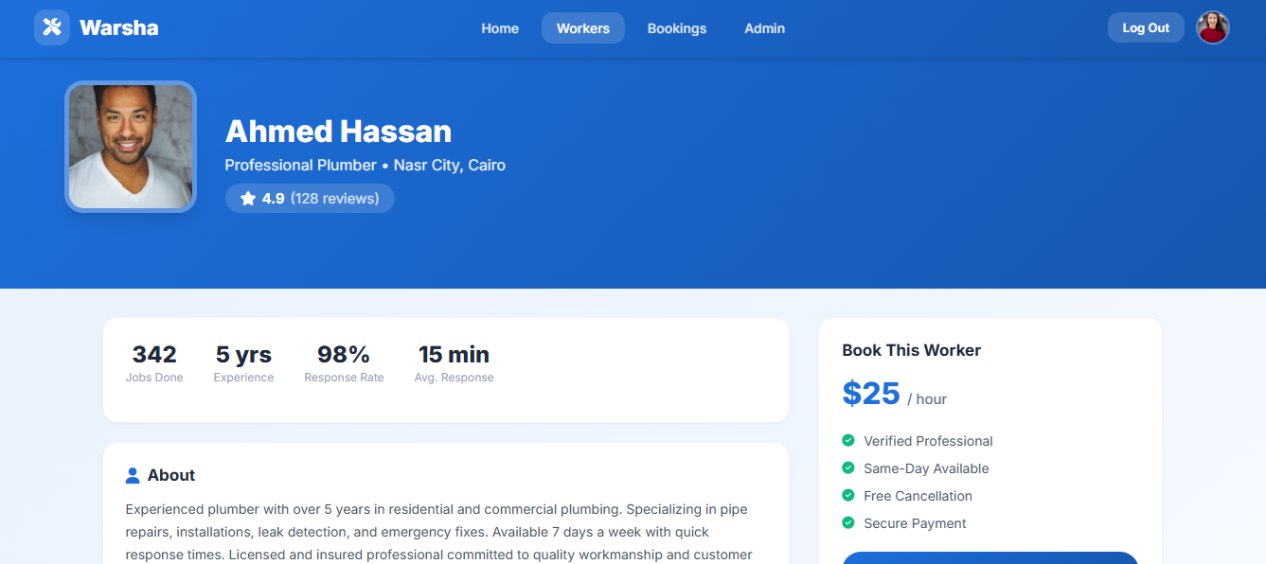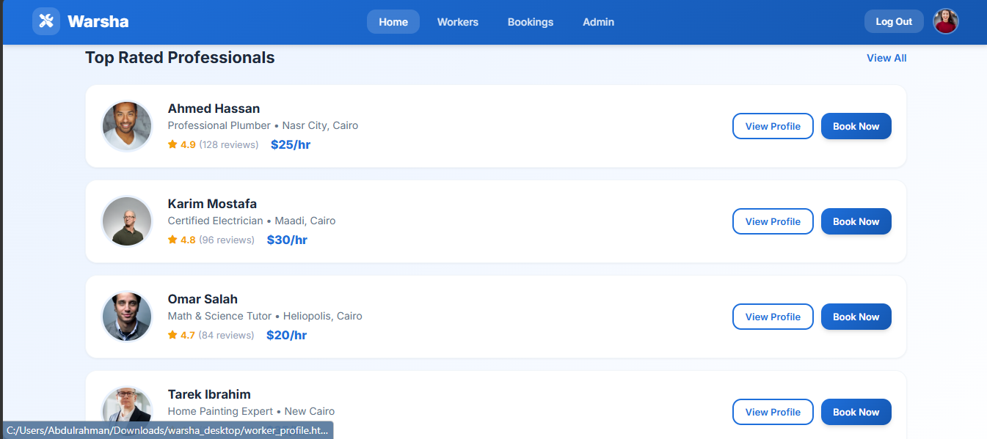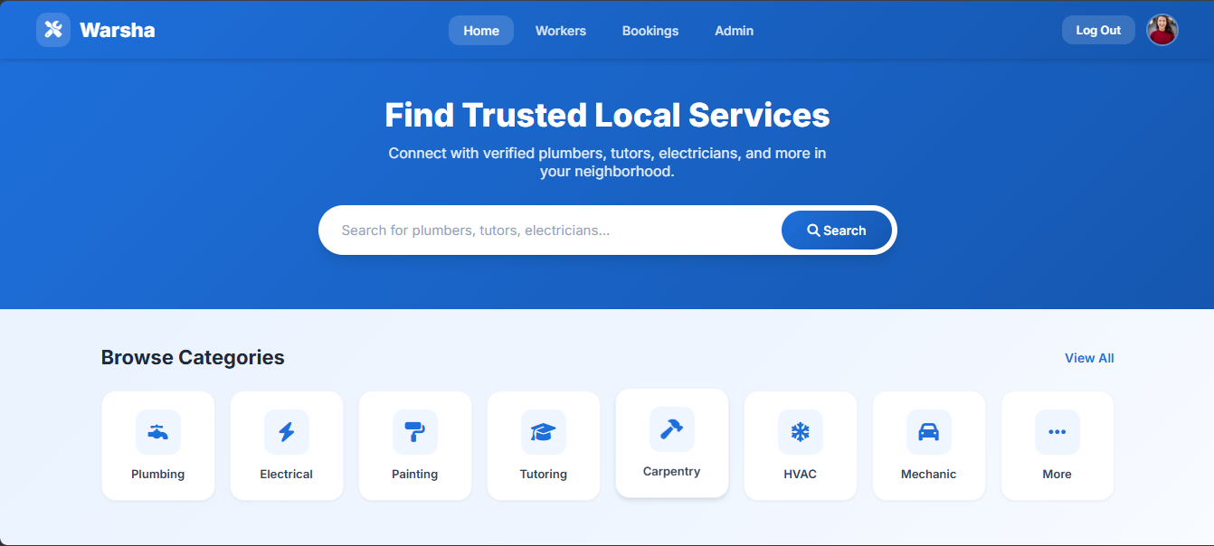
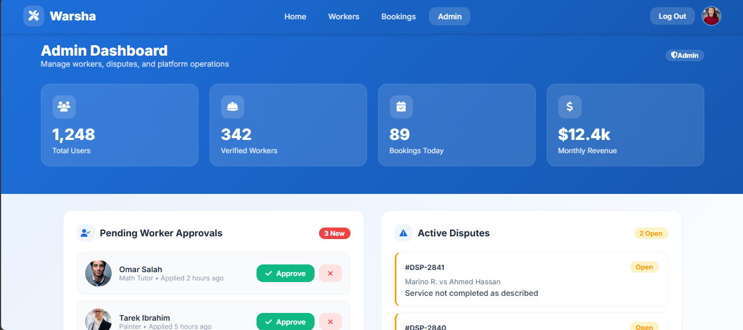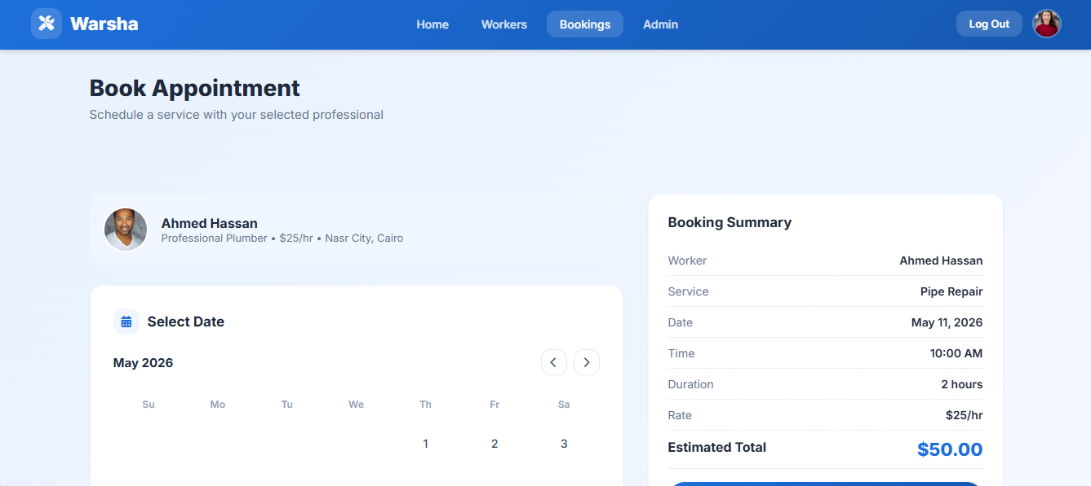
Appendix A: Glossary
The following terms are used throughout this SRS document:
Term | Definition
API | Application Programming Interface - A set of protocols for building software applications.
APNS | Apple Push Notification Service - Apple's service for sending push notifications to iOS devices.
Customer | A user of the Warsha platform who seeks to book services from workers.
FCM | Firebase Cloud Messaging - Google's service for sending push notifications to Android devices.
FR | Functional Requirement - A requirement that specifies a function the system must perform.
GPS | Global Positioning System - A satellite-based navigation system used for location services.
HTTPS/TLS | Hypertext Transfer Protocol Secure / Transport Layer Security - Protocols for secure communication over a network.
NFR | Non-Functional Requirement - A requirement that specifies criteria for system operation rather than specific behaviors.
OAuth 2.0 | An open standard for access delegation commonly used for token-based authentication.
PCI-DSS | Payment Card Industry Data Security Standard - A set of security standards for organizations that handle branded credit cards.
RESTful API | Representational State Transfer API - An architectural style for designing networked applications.
SRS | Software Requirements Specification - A document that fully defines what a software system will do.
Stripe | A technology company that builds economic infrastructure for the internet, providing payment processing services.
TBD | To Be Determined - A placeholder used when information is not yet available.
Worker | A service provider (e.g., plumber, tutor, electrician) who offers services through the Warsha platform.

Appendix B: Analysis Models
The following analysis models are included to support the understanding of the Warsha system:
- Data Flow Diagram (DFD): Illustrates the flow of data through the system, from user inputs through processing to outputs and storage.
- Entity-Relationship Diagram (ERD): Represents the database schema, showing entities (User, Worker, Service, Appointment, Payment, Review) and their relationships.
- Domain Model: A conceptual model describing the entities, their attributes, and relationships within the Warsha domain.
[Insert Data Flow Diagram Here]

[Insert Entity-Relationship Diagram Here]

Appendix C: To Be Determined List
The following items remain to be determined (TBD) in this SRS:
TBD ID | Description | Target Resolution Date
TBD-01 | Final color scheme and branding guidelines for the mobile application UI. | TBD
TBD-02 | Specific coupon and discount rules and validation logic. | TBD
TBD-03 | Exact fee structure and commission percentage for platform transactions. | TBD
TBD-04 | Third-party email service provider selection (SendGrid, AWS SES, etc.). | TBD
TBD-05 | Specific push notification content templates and triggers. | TBD
TBD-06 | Dispute resolution workflow details and escalation procedures. | TBD
Software Requirements Specification for Warsha Page [PAGE]

