Task 2

الاسم: عبدالرحمن محمد سالم

ID: 20210524

1. **What is BERT?**

**Architecture:**

* BERT is like a **smart reader** that looks at *all words in a sentence at once*.
* It uses a **bidirectional** approach:
* Imagine reading a sentence forward *and* backward to understand every word’s meaning.
* Example: For the sentence *"She went to the bank to withdraw money,"* BERT checks both "bank" (river?) and "withdraw money" (financial bank?) to decide the right meaning.

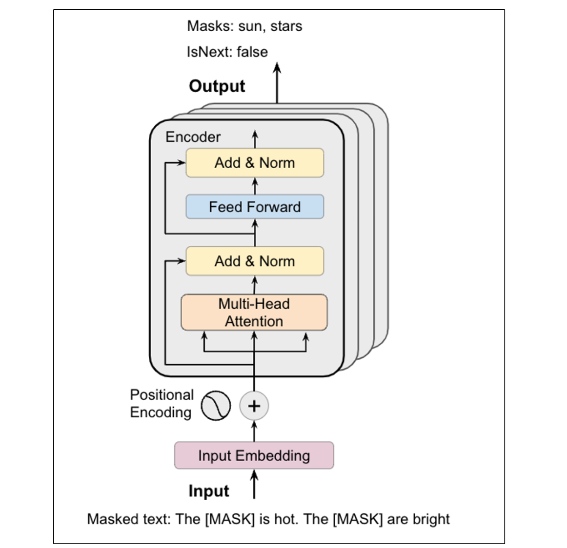

**How It Works**:

* Built as a **Transformer Encoder** (a part of the Transformer model that focuses on *understanding* text).
* Trained by guessing **masked words** (e.g., filling in blanks like "The cat sat on the ___").

**Key Features**:

* Great for tasks needing **context understanding** (e.g., answering questions, classifying text).
* Cannot **generate new text** (it only understands, doesn’t write).

**2. What is GPT-4?**

**Architecture**:

* GPT-4 is like a **creative writer** that predicts the *next word in a sentence*.
* It uses a **unidirectional** approach:
  + Reads text *left-to-right*, one word at a time.
  + Example: For the sentence *"The cat sat on the...,"* GPT-4 predicts "mat" or "roof" based on previous words.

**How It Works**:

* Built as a **Transformer Decoder** (a part of the Transformer model that focuses on *generating* text).
* Trained by predicting the **next word** in a sequence (like autocomplete).

**Key Features**:

* Excels at **text generation** (e.g., writing essays, chatbots, stories).
* Can handle many tasks without specific training (e.g., translate, summarize, code).

1. **Main Differences in Architecture**

|  |  |  |  |  |  |  |  |  |  |  |  |  |  |  |  |  |  |  |
| --- | --- | --- | --- | --- | --- | --- | --- | --- | --- | --- | --- | --- | --- | --- | --- | --- | --- | --- |
| |  |  |  | | --- | --- | --- | | Feature | BERT | GPT-4 | | Direction | **Bidirectional (reads whole sentence).** | **Unidirectional (reads left-to-right).** | | Purpose | **Understands text.** | **Generates text.** | | Training | **Guesses masked words in sentences.** | **Predicts next word in a sequence.** | | Best At | **Tasks like Q&A, sentiment analysis.** | **Tasks like writing, summarizing, chatting.** | | Limitations | **Can’t create new text.** | **May make up facts or repeat itself.** | |

**4. Simple Analogy**

* **BERT** is like a **detective**:
  + Examines all clues (words) at once to solve a mystery (understand context).
  + Example: "Is this review positive or negative?"
* **GPT-4** is like a **storyteller**:
  + Builds a story one word at a time, always looking forward.
  + Example: "Write a poem about the ocean."

**5. Which Should You Use?**

* **Choose BERT** if you need to:
  + Analyze text (e.g., classify emails, answer questions).
  + Understand context deeply (e.g., "What does 'bank' mean here?").
* **Choose GPT-4** if you need to:
  + Generate text (e.g., write articles, code, or chat).
  + Perform tasks with little to no examples (e.g., translate without training).