Part A)
Entities and Attributes
Department
- DID (Primary Key)
- DName
- Location
- PhoneNumber
Instructor
- IID (Primary Key)
- IName
- Email
- PhoneNumber
- HireDate
Student
- SID (Primary Key)
- SName
- Gender
- Email
- DOB
- ENYear
Course
- CID (Primary Key)
- CTitle
- CreditHours
Course_Section (Weak Entity)
- SCID (Partial Key)
- SCNumber
- Semester
- Year
- Schedule (Composite Attribute: Day, StartTime, EndTime)
Classroom
- RID (Primary Key)
- RNum
- Capacity
- BuildingName
Exam
- ExamType
- EDate
- MaxMarks
Relationships and Cardinalities
Department — Managed By — Instructor
- Relationship: One-to-One
- Department: Full participation
- Instructor: Full participation
Department — Has — Instructor
- Relationship: One-to-Many
- Department: Partial participation
- Instructor: Full participation
Department — Offers — Course
- Relationship: One-to-Many
- Department: Partial participation
- Course: Full participation
Department — Has — Student
- Relationship: One-to-Many
- Department: Partial participation
- Student: Full participation
Instructor — Supervises — Student
- Relationship: One-to-Many
- Instructor: Partial participation
- Student: Full participation
Course — Contains — Course_Section
- Relationship: One-to-Many
- Course: Full participation
- Course_Section: Full participation
Instructor — Teaches — Course_Section
- Relationship: One-to-Many
- Instructor: Full participation
- Course_Section: Full participation
Classroom — Assigned To — Course_Section
- Relationship: One-to-Many
- Course_Section: Full participation
- Classroom: Full participation
Student — Enrolls In — Course_Section
- Relationship: Many-to-Many
- Student: Full participation
- Course_Section: Full participation
Course_Section — Contains — Exam
- Relationship: One-to-Many
- Course_Section: Full participation
- Exam: Full participation
Student — Scored In — Exam
- Relationship: Many-to-Many
- Student: Full participation
- Exam: Full participation
Diagram
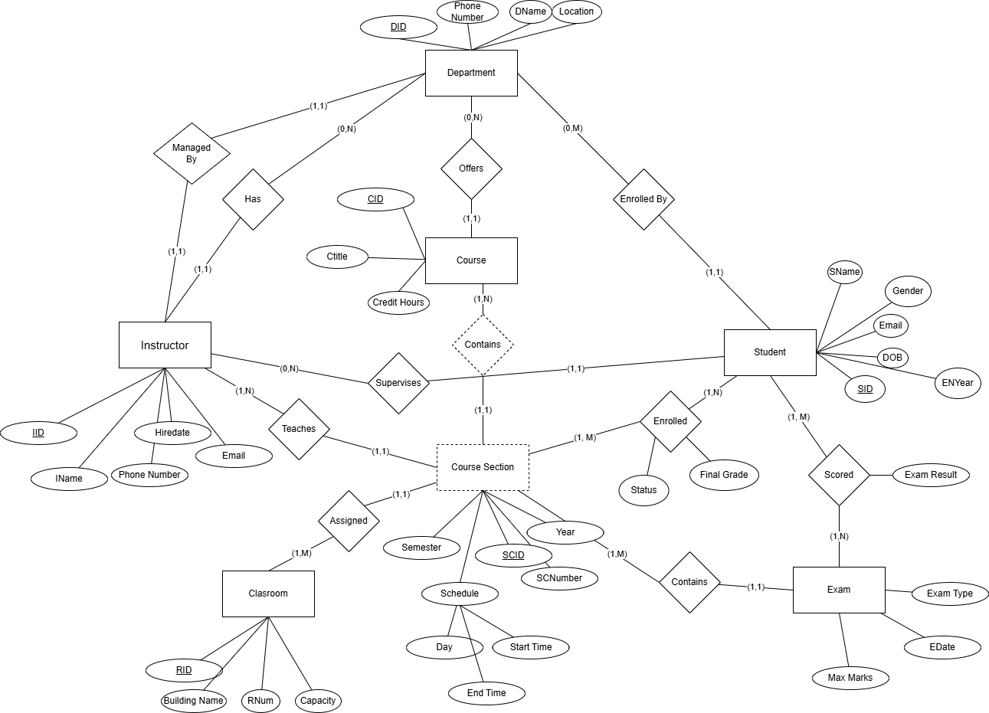

Part B)
Relational Database Schema:
