Telco Customer Churn

Business Task
Analyze Telco customer data to identify key factors that influence customer churn, with the goal of providing actionable insights to reduce churn rates, improve customer retention, and increase revenue.

Data Sources
- Dataset: Telco Customer Churn Dataset (IBM Sample Dataset)
- Source: Kaggle: Telco Customer Churn
- Licensing and Privacy: The data is publicly available for use under the Kaggle license. No personally identifiable information (PII) such as names or addresses is included in the dataset.

Data Cleaning and Processing
Tools: Excel

Steps:
- Download the Data: The dataset was downloaded as a CSV file.
- Open the Data in Excel: The CSV file was opened in Excel and saved as XLSX for easier processing.
- Convert Columns to Correct Data Types:

All columns were assigned the appropriate data types as follows: customerID, gender, Partner, Dependents, PhoneService, MultipleLines, InternetService, OnlineSecurity, OnlineBackup, DeviceProtection, TechSupport, StreamingTV, StreamingMovies, Contract, PaperlessBilling, PaymentMethod, and Churn were set as Text, while SeniorCitizen, tenure, MonthlyCharges, and TotalCharges were set as Number.

- Handle Missing Values (Blanks): The TotalCharges column had 11 blank rows for new customers (tenure = 0), which were deleted. The column is now complete and ready for analysis.
- Check for Duplicate Customer IDs: The customerID column was checked for duplicates using Data Remove Duplicates. No duplicate rows were found, ensuring each customer is unique.
- Check for Missing Values: The dataset was scanned for blanks . No missing values were found in columns like tenure or MonthlyCharges, since the previously deleted TotalCharges blanks had already been handled.
- Check for Outliers: The MonthlyCharges column was sorted from largest to smallest to identify any extreme values. All values were within the expected range of 18 to 120, so no outliers were found.
- Save Clean Dataset: A clean version of the dataset was saved as clean_telco_churn.csv in CSV format.

Data Analysis
Tools: PostgreSQL

Steps:
- Churn Overview (Churn Rate): Table: Churn_Stats_Summary, Shows total customers, churned customers, and churn percentage (Yes/No).

CREATE TABLE "CustomerData"."Churn_Stats_Summary" AS
SELECT
"Churn",
COUNT(*) AS total_customers,
ROUND(COUNT(*) * 100.0 / SUM(COUNT(*)) OVER(), 2) AS percentage
FROM "CustomerData"."CustomerData"
GROUP BY "Churn";
- Contract Analysis: Table: Summary_Contract, Churn by contract type (Month-to-month, One year, Two year) including total customers, churned customers, and churn rate.

CREATE TABLE "CustomerData"."Summary_Contract" AS
SELECT
"Contract",
COUNT(*) AS total_customers,
COUNT(*) FILTER (WHERE "Churn" = 'Yes') AS churned_customers,
ROUND(COUNT(*) FILTER (WHERE "Churn" = 'Yes') * 100.0 / COUNT(*), 2) AS churn_rate
FROM "CustomerData"."CustomerData"
GROUP BY "Contract";

- Internet Service Analysis: Table: Summary_Internet, Churn by Internet service type (DSL, Fiber optic, No).

CREATE TABLE "CustomerData"."Summary_Internet" AS
SELECT
"InternetService",
COUNT(*) AS total_customers,
COUNT(*) FILTER (WHERE "Churn" = 'Yes') AS churned_customers,
ROUND(COUNT(*) FILTER (WHERE "Churn" = 'Yes') * 100.0 / COUNT(*), 2) AS churn_rate
FROM "CustomerData"."CustomerData"
GROUP BY "InternetService";

- Payment Method Analysis: Table: Summary_Payment, Churn by payment method including total customers, churned customers, and churn rate.

CREATE TABLE "CustomerData"."Summary_Payment" AS
SELECT
"PaymentMethod",
COUNT(*) AS total_customers,
COUNT(*) FILTER (WHERE "Churn" = 'Yes') AS churned_customers,
ROUND(COUNT(*) FILTER (WHERE "Churn" = 'Yes') * 100.0 / COUNT(*), 2) AS churn_rate
FROM "CustomerData"."CustomerData"
GROUP BY "PaymentMethod";

- Demographics Analysis: Table: Summary_Demographics, Churn by gender, SeniorCitizen, Partner, Dependents.
CREATE TABLE "CustomerData"."Summary_Demographics" AS
SELECT
"gender",
"SeniorCitizen",
"Partner",
"Dependents",
COUNT(*) AS total_customers,
COUNT(*) FILTER (WHERE "Churn" = 'Yes') AS churned_count,
ROUND(COUNT(*) FILTER (WHERE "Churn" = 'Yes') * 100.0 / COUNT(*), 2) AS churn_rate
FROM "CustomerData"."CustomerData"
GROUP BY "gender", "SeniorCitizen", "Partner", "Dependents";
- Charges & Tenure Analysis: Avg MonthlyCharges and Avg Tenure by InternetService.
SELECT
"InternetService",
ROUND(AVG("MonthlyCharges"), 2) AS avg_monthly_bill,
ROUND(AVG("tenure"), 2) AS avg_tenure_months
FROM "CustomerData"."CustomerData"
GROUP BY "InternetService";

Dashboard
Tools: Power BI
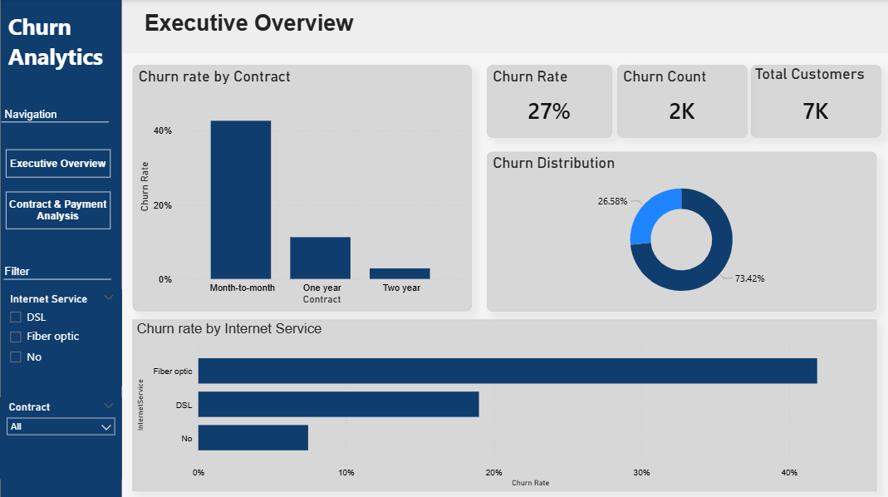

Insight
Payment Method Optimization:
- Insight: Customers using Electronic Check exhibit the highest churn rate at 45%.
- Recommendation: Incentivize the transition to Credit Card (Automatic) or Bank Transfer by offering a small one-time discount or loyalty points, as these methods show significantly higher stability.

Contractual Conversion Strategy:
- Insight: Month-to-month contracts are the most volatile, contributing the largest share to the churn count compared to long-term commitments.
- Recommendation: Launch a targeted campaign to convert short-term users into One-year or Two-year contracts by bundling value-added services (e.g., free streaming or increased data) to increase the "switching cost" for the customer.

Service & Support Synergy:
- Insight: Churn is notably high among Fiber optic users, but it decreases significantly when Technical Support is active.
- Recommendation: Implement a "Proactive Support" model for Fiber optic subscribers. Ensuring they are enrolled in or aware of Tech Support services can act as a crucial retention tool for this high-value segment.

