A Ground-Truth Benchmark of Classical, Concept-Based,
and Mechanistic XAI on Financial Forecasters
Abdulrahman Omar, CSAI School, Zewail City of Science and Technology (s-abdalrahman.mohammed@zewailcity.edu.eg)
Rana Abdelfattah Saleh (corresponding author), CSAI School, Zewail City of Science and Technology (t-rana.saleh@zewailcity.edu.eg)
Mayada Hadhoud, CSAI School, Zewail City of Science and Technology; Faculty of Engineering, Cairo University (mhadhoud@zewailcity.edu.eg)
Abstract
Explainable AI (XAI) methods are widely applied to financial forecasting models, and their attributions are often read as evidence of what drives a prediction. This practice is rarely verified: without a model whose true feature importances are known, a faithful explanation cannot be distinguished from a plausible-looking one. In this paper, a ground-truth faithfulness benchmark is constructed by injecting synthetic features with known importance (linear and nonlinear signals at two strengths, pure noise, and a redundant feature at exact and partial collinearity) into a real, leakage-free panel of 57 large-cap stocks, and scoring $23$ XAI methods across a zoo of 16 model architectures against that known ground truth, with stock-clustered inference and an explicit effective sample size throughout. Of the $23$ catalogued methods, 16 yielded a directly scoreable evaluation under the study’s defined criteria; every directly evaluated method ranked the planted signals above pure noise. Permutation importance showed lower and less consistent recovery than TreeSHAP, KernelSHAP, and LIME in the tested setting, and methods differed substantially in how they split credit between collinear features. Mechanistic analysis of the Transformer variant indicated a shallow, largely linear internal representation, together with a weak but recurring layer-level ablation effect under a seed and fold sensitivity check. These findings are specific to the studied panel, models, and ground-truth constructions. The full benchmark and a reproducible pipeline are released.
explainable AI, XAI faithfulness, ground truth, mechanistic interpretability, SHAP, TCAV, sparse autoencoders, GNNExplainer, financial forecasting, FNSPID

1 Introduction
Explainable AI (XAI) is increasingly used to justify financial models to regulators, risk committees, and end users. In this paper, faithfulness denotes the degree to which an explanation reflects the features the model actually relies on, rather than producing a plausible-looking account. The field’s own literature shows that popular attribution methods can be unfaithful: they can disagree with each other [1], degrade under feature removal in ways that expose them as unreliable [2], and fail basic randomization sanity checks [3]. When such methods are applied to financial forecasters, their attributions are therefore evidence of unknown quality.
Evaluating attribution methods against known ground truth is an active line of work: XAI-Bench, OpenXAI, GraphXAI, XAI-Units, and M⁴ all benchmark attribution methods against known answers on fully synthetic data or controlled image, text, or graph tasks [4], [5], [6], [7], [8].
To our knowledge, prior work has not combined these elements in a real financial forecasting panel under the same experimental framework: known ground truth injected into a real, leakage-free financial panel alongside genuine market noise, non-stationarity, and cross-sectional dependence; an explicit collinearity stress test; mechanistic interpretability applied to a financial forecaster; and stock-clustered, effective-sample-size-aware inference.
A leakage-free, multi-stock financial forecaster is used as the domain, not because strong predictive skill is expected (its absence is validated in Section 5), but because a near-zero-signal setting is a demanding stress test: a faithful method should report “no recoverable signal,” while an unfaithful one will assign large importance to features that carry none. Into this test bed, six synthetic features with known importance are injected, spanning a grid rather than one point per condition: a pure-noise feature (true importance zero); a planted linear signal at a strong ($ρ=0.15$) and a weak, near-noise-floor ($ρ=0.05$) strength; a genuinely nonlinear sign-times-magnitude interaction signal; and a duplicate of a real feature at both exact (identical copy) and partial ($ρ=0.8$) collinearity, testing whether methods split or hide credit under collinearity in general rather than only its edge case. A method’s faithfulness score is how well it recovers this known truth across the whole grid.
Research questions. The primary question is RQ1; RQ2–RQ5 are supporting analyses that qualify, stress-test, and explain the RQ1 answer.
- RQ1 (faithfulness, primary). Against features with known importance, which XAI methods correctly recover the truth, and how faithful is each?
- RQ2 (agreement). How much do explanations agree with each other (rank correlation), and does disagreement concentrate in specific method pairs or model classes?
- RQ3 (model-class dependence). Does faithfulness depend on model class, glass-box, tree ensemble, kernel/instance-based, recurrent, convolutional, attention, graph, and which model+method pairs are trustworthy?
- RQ4 (mechanistic). What do concept-based (TCAV) and mechanistic (sparse autoencoders, circuit-ablation analysis) methods reveal about the Transformer variant that attribution methods miss, or do they find only noise?
- RQ5 (actionability). Which explanations translate into actionable, example-based recourse rather than an importance score alone?
The contributions of this paper are summarized as follows:
- A ground-truth faithfulness benchmark on a real financial panel. Six synthetic features with known importance (linear and nonlinear signals at two strengths, pure noise, and a redundant feature at exact and partial collinearity) are injected into a leakage-free 57-stock panel and used to score $23$ XAI methods under a single protocol with stock-clustered inference and an explicit effective sample size (Section 11).
- Coverage of the modern XAI toolkit. Classical attribution, rule- and example-based, concept-based, gradient and propagation, graph, and mechanistic-interpretability methods, including sparse autoencoders and ablation-based circuit analysis applied, to our knowledge for the first time, to a financial time-series forecasting Transformer.
- A 16-model zoo spanning seven model families (linear/glass-box, tree ensembles, kernel/instance-based, a GAM, recurrent, convolutional, attention, and graph neural networks), enabling a model-class-dependence analysis (RQ3) rather than a single-model case study.
- A test bed validated to the standards of a dedicated forecasting study. Stationary targets, embargoed walk-forward evaluation, strong baselines, and correlation-robust feature engineering, since a leaky or collinear substrate would invalidate any faithfulness claim built on it.
- Null results reported as findings. Mechanistic interpretability on the Transformer indicates a shallow, largely linear internal representation rather than deep circuit structure, with no evidence of head-level specialization and only a weak, recurring layer-level ablation effect under a seed and fold sensitivity check.
- A reproducible artifact. A Modal-based pipeline (Spark ingestion, FinBERT sentiment, 15+ trained models, the full XAI suite), fixed splits, and one-command reproduction.

2 Related Work
Text-driven forecasting. Event- and sentiment-based models have a long history [9], [10], [11], more recently using domain-specific encoders such as FinBERT [12] and cross-modal fusion architectures [13]. FNSPID [14] provides large-scale, time-aligned news; the test bed builds on it and treats its forecasting task as a substrate for XAI evaluation. A recent survey [15] taxonomizes the broad literature applying XAI methods to financial time-series forecasting; this paper sits within that space but is narrower and different in kind, not another application of an existing XAI method to a finance task, but a ground-truth faithfulness check on a broad slate of methods, which the survey does not itself provide.
Leakage and evaluation. The dangers of look-ahead bias and improper cross-validation in finance are well documented [16]; purged, embargoed, walk-forward protocols are recommended precisely because adjacent observations are serially correlated. The efficient-market view [17] further predicts that next-day returns are close to unforecastable from public information, making strong naive baselines essential and a near-zero-signal regime the expected, not surprising, outcome.
Classical attribution. SHAP [18] and LIME [19] are standard but can misattribute importance under correlated features; Accumulated Local Effects (ALE) [20] were designed to remain valid in that regime, and Integrated Gradients [21] provide axiomatic attribution for neural models. Rule-based methods (Anchors [22]) and example-based methods (counterfactuals [23], the contrastive explanation method [24]) explain individual decisions rather than global importance; RISE [25] adapts randomized input masking from vision to arbitrary black-box models.
Faithfulness and disagreement. ROAR [2] shows that many attribution methods fail a feature-removal sanity check; the disagreement problem [1] documents that popular explainers routinely disagree with each other in practice; sanity-check randomization [3] shows several saliency methods are insensitive to both model parameters and labels. All three motivate measuring faithfulness against known ground truth rather than asserting it, which motivates the present study.
Prior ground-truth XAI benchmarks. Synthetic ground-truth benchmarking of attribution methods is an established, active line of work. XAI-Bench provides synthetic datasets with known Shapley-value ground truth for tabular attribution methods [4]; OpenXAI is an extensible framework with a synthetic generator and $∼$22 faithfulness/stability/fairness metrics [5]; GraphXAI provides a synthetic graph generator with ground-truth explanations for benchmarking GNN explainers [6]; XAI-Units builds paired unit-test datasets/models with known internal mechanisms to stress-test attribution methods [7]; and M⁴ unifies faithfulness metrics across image/text modalities and multiple architectures [8]. Every one of these evaluates on fully synthetic data or controlled image/text/graph tasks. To our knowledge, prior work has not combined these elements in a real financial forecasting panel under the same experimental framework: known ground truth injected alongside genuine market noise, non-stationarity, and cross-sectional dependence; an explicit collinearity/duplicate-feature stress test; and mechanistic interpretability.
Concept-based, intrinsic, and graph methods. TCAV [26] tests whether a model’s internal representation is sensitive to a human-defined concept direction; EBMs/GA2Ms [27] are self-explaining by construction; GNNExplainer [28] explains graph neural networks via learned edge/feature masks, applicable here because we model the cross-stock correlation structure explicitly as a graph.
Gradient/propagation and mechanistic interpretability. Layer-wise Relevance Propagation [29] and Grad-CAM and its variants [30] propagate or localize attribution through network layers, the latter vision-native and applied here only to our convolutional model variant. Sparse autoencoders [31] and automated circuit discovery [32] are recent mechanistic- interpretability tools, to date applied almost exclusively to language models (concurrent work applies mechanistic interpretability to LLMs in finance for fraud, credit, and trading tasks [33], a different model class and task); both are applied here to a financial time-series Transformer.
Actionability. Actionable recourse [34] asks whether an explanation can be turned into a concrete, achievable change in outcome, which frames the example-based methods’ practical value (RQ5) beyond an importance score alone.

3 The Test-Bed
This section describes the forecasting substrate on which the XAI benchmark is constructed. Because the validity of the faithfulness analysis depends on the soundness of this substrate, rigorous leakage and collinearity controls are applied, and the test bed is evaluated to standards comparable to those of a dedicated forecasting study (Sections 9–11 present the primary contributions).
Problem setup. This is a supervised time-series problem; it is stated precisely because the entangling of features and targets across time is the source of the errors under study. For each stock $s$ and trading day $t$, a feature vector $x_{s,t}$ is built using only information available at the close of day $t$, lagged returns, rolling volatility, RSI, momentum, moving-average gaps, range/volume statistics, and news-sentiment features aggregated from articles known by that close. The target is realized on the next trading day:
$$y_{s,t}^{\text{ret}}=log\frac{P_{s,t+1}}{P_{s,t}}, y_{s,t}^{\text{dir}}=1​\left[y_{s,t}^{\text{ret}}>0\right],$$
with the price level $P_{s,t+1}$ used only as a diagnostic target in the leakage study. Every feature is strictly backward-looking (verified by an empirical leakage screen, Sec. 4), targets are produced by a per-ticker forward shift, and all splitting preserves temporal order. The panel is never treated as i.i.d. tabular data.
Data. The study uses FNSPID [14]: per-ticker daily OHLCV and an external financial-news corpus. Because the news file is multi-gigabyte, ingestion and filtering use Apache Spark [35] (streaming, bounded-memory), after which the compact per-ticker panel is processed in pandas. The panel covers 57 large-cap stocks with adequate news coverage over 2015–2023, yielding 127,609 stock-day observations and 18,600 aligned articles (news present on 47.8% of stock-days).
Time-aware alignment (no leakage). Each article is timestamped in US/Eastern and mapped to a trading session so that only information available by the close of day $t$ can inform the prediction of day $t+1$: intraday news maps to the same session, after-close and non-trading-day news to the next session. Sentiment is aggregated per (stock, session).
Sentiment. Opaque or proprietary sentiment scores are replaced with two reproducible signals: (i) FinBERT [12] probabilities (positive$−$negative), and (ii) the Loughran–McDonald finance lexicon [36] polarity. Both are aggregated to daily features with short rolling histories and a news-count/volume signal.
Features and targets. All predictive features use only information available at the close of day $t$: lagged returns, rolling volatility, RSI, momentum, moving-average gaps, range/volume statistics, and the sentiment features. Targets are next-day log-return $r_{t+1}$, direction $1[r_{t+1}>0]$, and (for the leakage study only) the next-day price level.
Ground-truth features. Six synthetic features with known true importance are injected into the panel, constructed deterministically (seed 42) so faithfulness scoring is reproducible, spanning a grid of conditions rather than one point per condition: (a) gt_noise, i.i.d. $N(0,1)$, true importance exactly zero; (b) gt_signal, a controlled additive linear leak $ρ⋅z(r_{t+1})+\sqrt{1−ρ^{2}}⋅N(0,1)$ with $ρ=0.15$, i.e. a feature with known target-correlation $0.15$; (b$′$) gt_signal_weak, the identical construction with $ρ=0.05$, a weak signal near the noise floor, testing recovery sensitivity rather than only the easy, strong-signal case; (c) gt_signal_nl, a genuinely nonlinear planted signal built from a sign$×$magnitude interaction rather than a simple additive combination, $ρ_{\text{nl}}⋅z\left(\text{sign}(y_{\text{dir}})⋅|N(0,1)|\right)+\sqrt{1−ρ_{\text{nl}}^{2}}⋅N(0,1)$ with $ρ_{\text{nl}}=0.15$, whose realized linear (Pearson/point-biserial) correlation with the targets is empirically only $0.08$–$0.12$, weaker than its designed strength parameter, precisely because the relationship is encoded through an interaction a simple correlation screen partially misses; (d) gt_redundant_copy, an exact duplicate of a real, already-informative feature (vol_z20), used to test whether a method over-credits the copy or splits credit between the two collinear columns; and (d$′$) gt_redundant_partial, a partially collinear variant of the same source feature ($ρ=0.8$, not an exact copy), the common real case (two related-but-distinct indicators) rather than only the edge case an exact duplicate represents. A method’s faithfulness score (Section 11) is whether it ranks (b), (b$′$), and (c) above (a), and how it handles (d) and (d$′$), not a plot, a number. Every applicable model (including every neural, convolutional, attention, and graph architecture) is given a version of its inputs that includes all six ground-truth columns specifically for this scoring, trained separately from the unaugmented predictive-performance results in Section 9 so the model-zoo table is never polluted by a synthetic leak.

4 Exploratory Data Analysis and Data Integrity
Before modelling we run a time-series EDA that both validates the setup and surfaces a data-integrity problem that would otherwise corrupt every return-based result.
Non-stationary levels, stationary returns. Augmented Dickey–Fuller tests find $96\%$ of the price-level series non-stationary but $100\%$ of the return series stationary; lag-1 autocorrelation is $0.991$ for levels versus $−0.081$ for returns (Fig. 1). This is the formal justification for predicting returns rather than levels, the apparent “predictability” of levels is a unit-root artifact.
Data integrity. A first EDA pass showed an impossible excess kurtosis ($>​4000$) and no volatility clustering, red flags for real equity returns. The cause was a handful of impossible single-day returns (e.g. AMZN $−294\%$ on 2020-07-06) where FNSPID splices unadjusted and split-adjusted prices. We compute returns from adjusted closes and mask $|r|>0.5$ (a data error for these large caps, not a market move). After cleaning, excess kurtosis is a realistic $17.3$ with pronounced volatility clustering (Ljung–Box on squared returns, $p<{10}^{−3}$), matching known stylized facts (Fig. 4).
Cross-sectional dependence. The 57 stocks in the universe co-move strongly (mean pairwise return correlation $0.38$; Fig. 3), so stock-days are far from independent and inference is clustered by stock.
Why the task is hard, and a leakage screen. The largest absolute correlation between any backward-looking feature and the next-day return is only $0.051$ (sentiment peaks at $0.005$; Fig. 2). This near-orthogonality is the reason next-day prediction is close to chance, and it doubles as a leakage screen: no feature is suspiciously predictive, as look-ahead would produce.
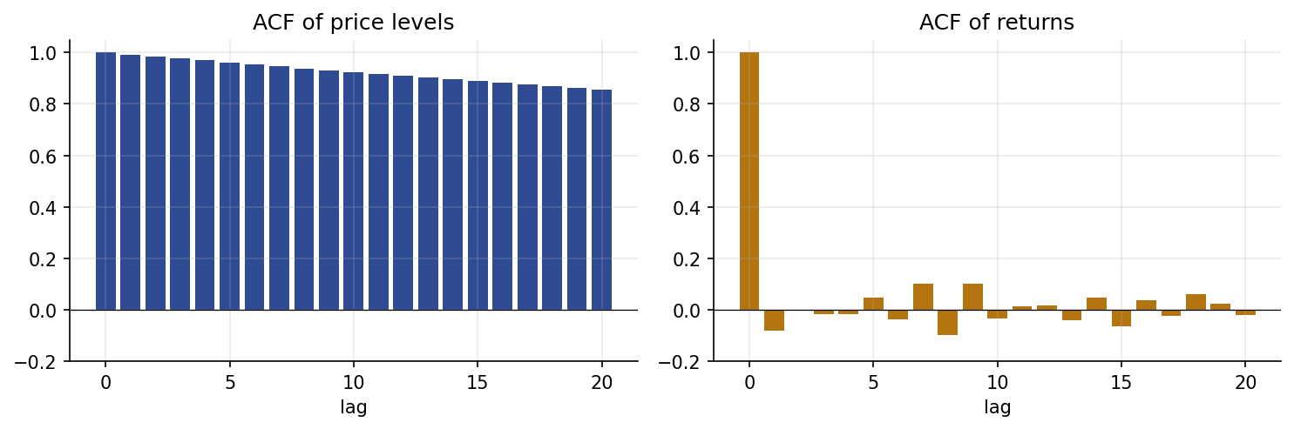
Autocorrelation: price levels (left) are near-unit-root; returns (right) are effectively white. Predicting levels exploits the left panel.
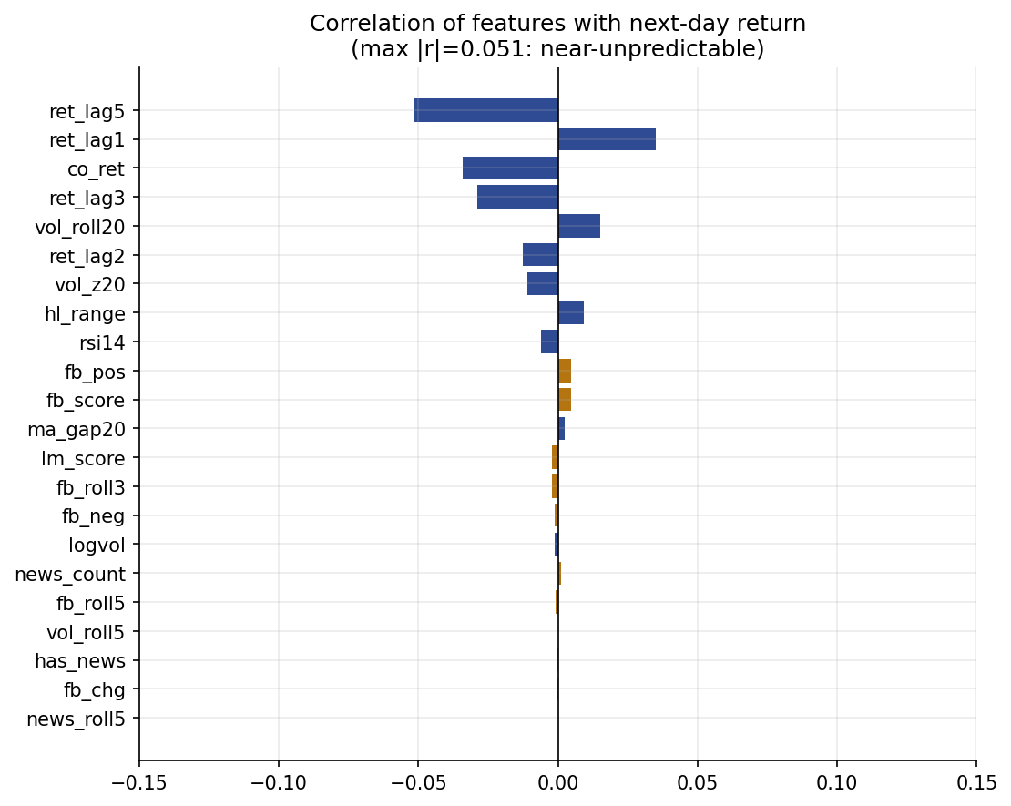
Correlation of each backward-looking feature with the next-day return. The maximum is $0.051$; sentiment features (orange) are near zero.
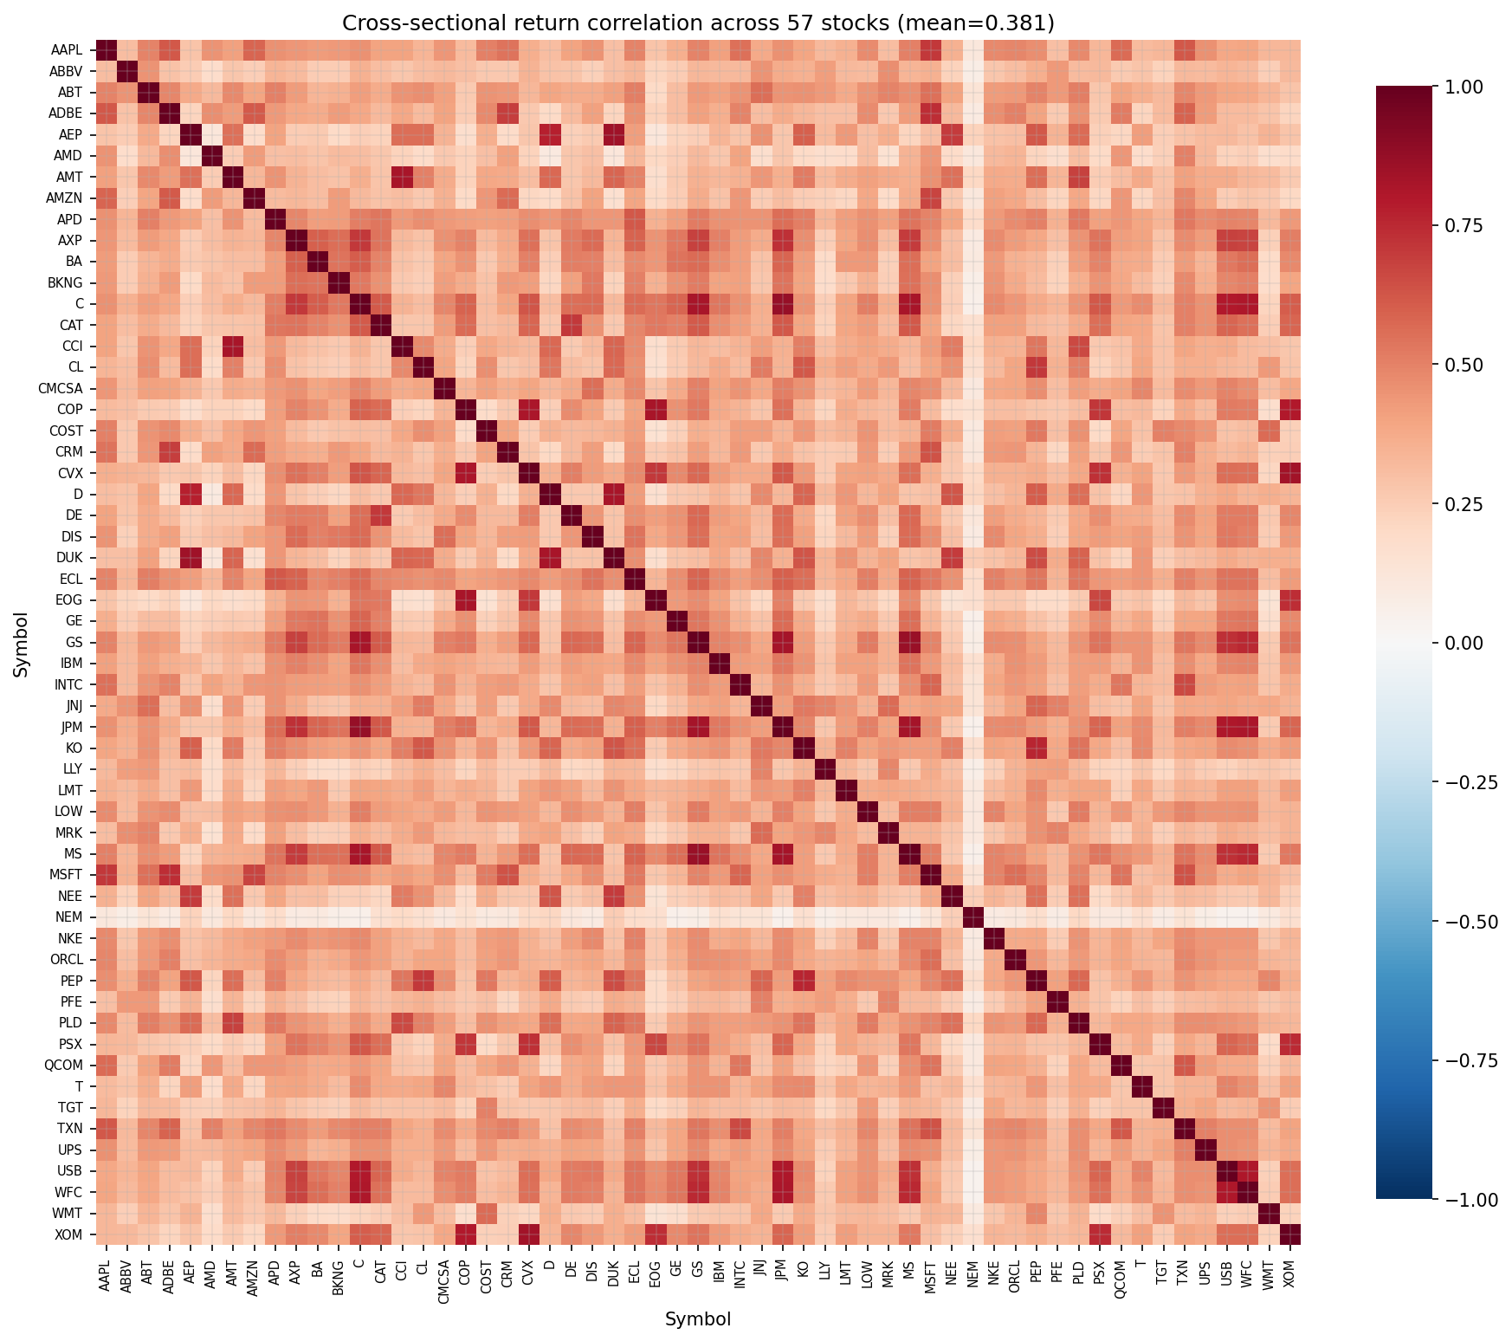
Cross-sectional return correlation across all 57 stocks in the universe (mean $0.38$): observations are not independent, motivating symbol-clustered inference.
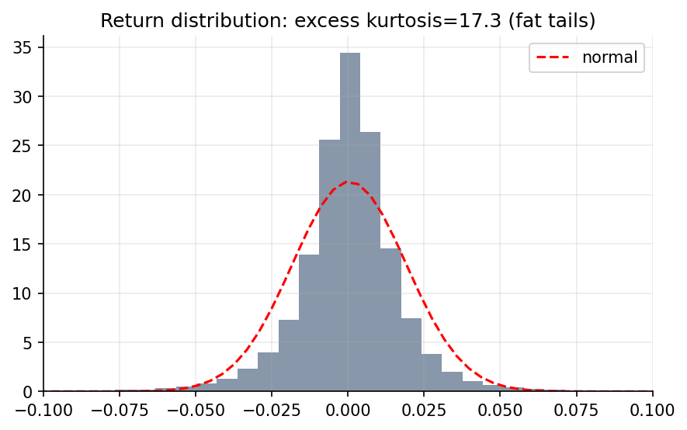
Return distribution after data cleaning: fat-tailed (excess kurtosis $17.3$) but free of the splice artifacts that originally produced kurtosis $>​4000$.

5 The Illusion of Skill: A Leakage Study
The next four sections (through Section 8) establish the near-zero-signal substrate RQ1 requires; they reproduce results that are well established in the financial machine-learning literature (look-ahead-biased “skill,” persistence-strength baselines, negligible sentiment value) and serve to validate the substrate the faithfulness benchmark depends on. The standard “high-accuracy” setup is first reproduced and dissected: Table 1 and Fig. 5 report four experiments with the same Random Forest.
Next-day prediction under different protocols (Random Forest). Random-split level prediction reproduces $R^{2}≈0.99$, but a persistence baseline matches it and performance on the return task collapses.
Protocol | Target | $R^{2}$​ | RMSE
RF, random split | level | 0.999 | 6.992
RF, chronological | level | 0.994 | 26.028
Persistence ${\hat{P}}_{t+1}=P_{t}$ | level | 1.000 | 7.158
RF, chronological | return | -0.033 | 0.019
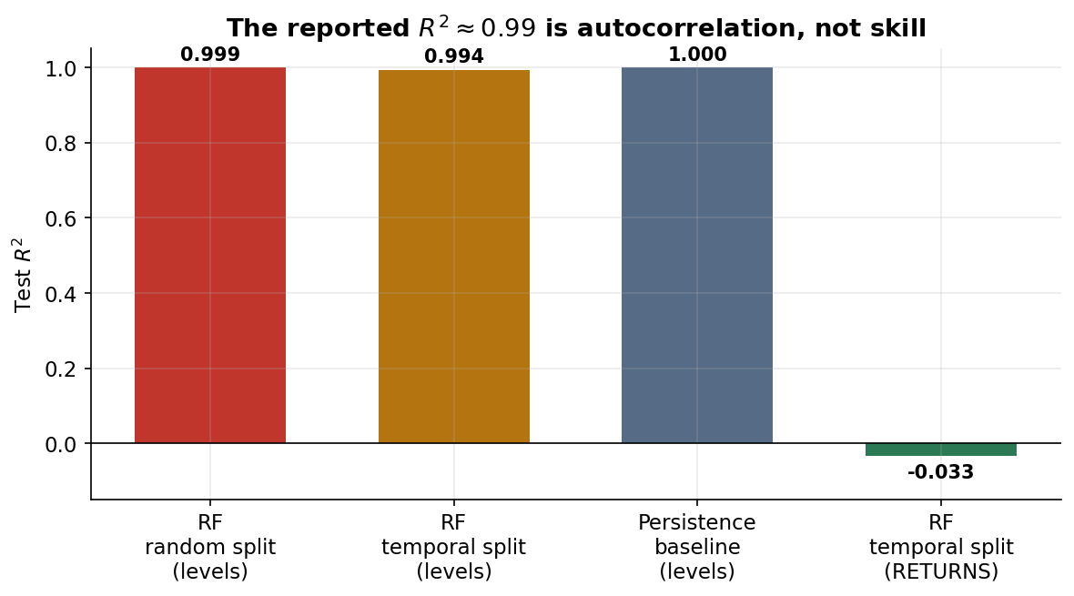
The reported $R^{2}≈0.99$ is autocorrelation, not skill. A naive persistence baseline equals the model on levels; predicting returns yields $R^{2}<0$.
The random-split level model attains $R^{2}=0.999$, barely changed by a chronological split ($R^{2}=0.994$), the “skill” is autocorrelation, not the split. The decisive comparison is the persistence baseline ${\hat{P}}_{t+1}=P_{t}$ ($R^{2}=1.000$, indistinguishable from the model); predicting returns instead collapses performance to $R^{2}=−0.033$, worse than a constant zero. Level-scale $R^{2}$ is not a meaningful skill measure here.

6 Correlation Structure of the Data
A second hazard, and the one most likely to threaten conclusions in this literature, is the strong correlation among features, across stocks, and across time. We treat it as a first-class threat to validity.
Three kinds of correlation. (i) Feature multicollinearity: Fig. 6 reports variance inflation factors (VIF); the raw OHLCV levels used by prior pipelines are near-perfectly collinear (VIF up to $20,505$, versus the usual threshold of 10), which destabilizes linear coefficients and invalidates PDP- and coefficient-based explanations. We report raw VIF values rather than lean on any single cutoff: the conventional thresholds (5 or 10) are both dwarfed by the raw levels’ VIF of $20,505$ versus $5$ for the stationary features we actually model, so the conclusion, raw levels are severely collinear, our features are not, holds regardless of which conventional threshold is used. (ii) Temporal autocorrelation: price levels are near-unit-root and overlapping features are serially correlated, so IID cross-validation and IID significance tests are invalid. (iii) Cross-sectional correlation: the stocks co-move with the market, so pooled stock-day observations are far from independent and naive tests overstate significance.
Why our conclusion is robust to all three. Crucially, our central claim is a null (news sentiment adds no measurable value). Correlation threatens a null in only one way, by masking a real effect behind correlated price features, and we rule this out directly: the sentiment-only models (Sec. 7.1) test sentiment in complete isolation and still achieve no skill ($R^{2}​≤​0$, MCC$≈​0$), so no price feature can be hiding it. The other failure mode of correlation, inflating apparent significance, can only make a positive claim look stronger, and no positive claim is made; it is nonetheless guarded against so that the “no-effect” confidence intervals remain valid. Concretely, the pipeline uses: stationary transforms (returns, ratios, $z$-scores; max VIF $5$, a $∼$17$×$ reduction); ALE [20] and grouped attribution rather than PDP or per-feature bars; grouped block-permutation importance that permutes the entire sentiment block jointly (preserving within-block correlation, so redundancy cannot hide the block’s contribution); embargoed walk-forward splits; a symbol-clustered bootstrap that resamples whole stocks (respecting cross-sectional dependence); and Newey–West HAC Diebold–Mariano tests (respecting temporal dependence), using a fixed Bartlett-kernel bandwidth of 5 lags (weights $1−ℓ/(L+1)$ for $ℓ=1,…,5$), short enough to match the daily, low-order dependence in next-day return series and consistent with common practice for this frequency. Every significance statement below uses stocks, not stock-days, as the effective unit.
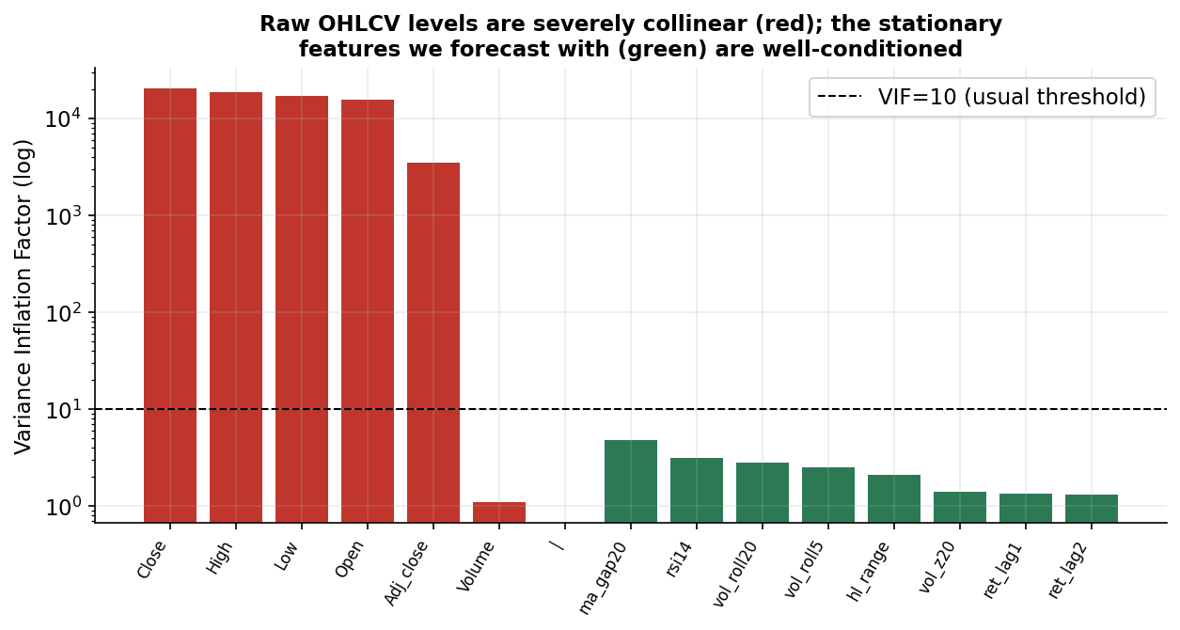
Variance inflation factors. Raw OHLCV levels (red) are severely collinear; the stationary features we use (green) are well conditioned.

7 Leakage-Free Evaluation
Protocol. The evaluation uses an expanding-window walk-forward: for each test year $Y∈\{2021,2022,2023\}$, models are trained on all data before $Y$ (with a 10-day embargo) and tested on $Y$. Features are standardized on the training fold only. Per-fold metrics and their mean are reported.
Models and baselines. Ridge/Logistic, Random Forest, XGBoost, LightGBM, SVM, and a two-layer GRU. Baselines: persistence and historical-mean returns (regression) and majority-class/always-up (direction).
Ablation. Each model is trained on price-only, sentiment-only, and price$+$sentiment feature sets, isolating the marginal contribution of news.
@l|rrr|rrr@ & &
Model & &
persistence/zero & -0.001 & 0.021 & – & – & – & –
hist. mean / majority & -0.001 & 0.021 & – & 0.513 & 0.678 & 0.000
Ridge (price) & -0.009 & 0.022 & 0.504 & 0.513 & 0.638 & 0.014
Ridge (+sent) & -0.010 & 0.022 & 0.504 & 0.512 & 0.638 & 0.011
RandomForest (price) & -0.013 & 0.022 & 0.512 & 0.503 & 0.530 & 0.004
RandomForest (+sent) & -0.012 & 0.022 & 0.512 & 0.501 & 0.527 & 0.001
XGBoost (price) & -0.015 & 0.022 & 0.509 & 0.510 & 0.622 & 0.006
XGBoost (+sent) & -0.014 & 0.022 & 0.509 & 0.509 & 0.621 & 0.004
LightGBM (price) & -0.018 & 0.022 & 0.505 & 0.509 & 0.615 & 0.004
LightGBM (+sent) & -0.016 & 0.022 & 0.508 & 0.508 & 0.613 & 0.003
SVR (price) & -0.511 & 0.025 & 0.489 & 0.510 & 0.606 & 0.011
SVR (+sent) & -0.542 & 0.026 & 0.490 & 0.508 & 0.597 & 0.009

7.1 Results
Table [tab:main] summarizes the leakage-free tasks. On returns, every model’s $R^{2}$ is near zero or negative, beating neither the persistence nor historical-mean baseline (Fig. 7); on direction, the best model reaches $51.3\%$ versus a $51.3\%$ majority baseline with near-zero MCC (Fig. 8), weak but stable across regimes including the 2022 drawdown (Fig. 9). The sentiment-only models, news isolated from all price information, are also no better than chance, so sentiment’s non-contribution in the combined model is not price features masking a real signal.
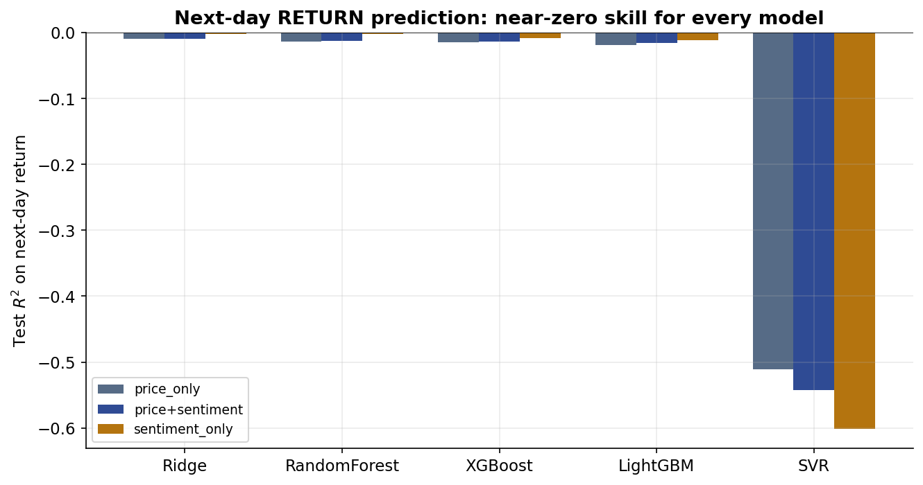  Return $R^{2}$ by model/feature set. | 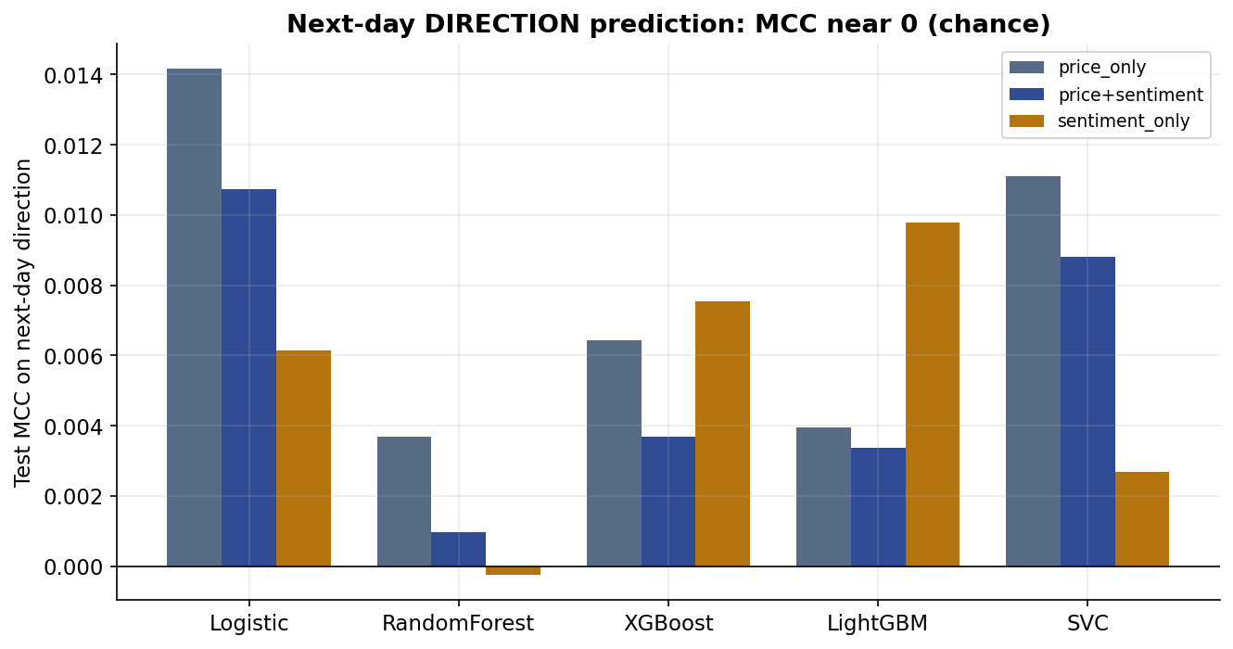  Directional MCC by model/feature set. | 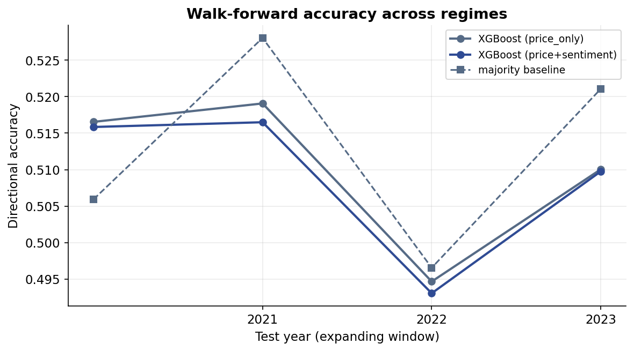  Walk-forward accuracy, 2021–2023.
Predictive performance is near chance throughout, by every measure and across regimes: (a) return $R^{2}$ and (b) directional MCC are near zero for every model and feature set (sentiment does not shift either picture); (c) walk-forward directional accuracy stays near the majority baseline across 2021–2023, including the 2022 drawdown.

7.2 Does news sentiment help? A dependence-aware test
Table 2 reports the marginal value of sentiment. Adding news features changes directional accuracy by $−0.13$ points, 95% symbol-clustered CI $[−0.39,0.14]$ (straddles zero, Wilcoxon non-significant); HAC Diebold–Mariano tests on returns find no consistent error reduction (Fig. 11). This XGBoost result is representative of the tree-ensemble/kernel majority of the zoo but not universal: Logistic Regression’s clustered CI on the same ablation, $[−0.26,−0.02]$ points, excludes zero (Wilcoxon $p=0.06$, borderline), a small but directionally consistent negative effect for that one linear model. In summary, the effects are model-dependent and near zero, mostly indistinguishable from noise, with one linear-model exception that argues against sentiment adding value rather than for it.
Marginal value of news sentiment (price$+$sentiment vs. price-only), with dependence-aware inference.
Model | $Δ$Acc (pp) | 95% CI | Wilcoxon $p$ | DM $t$ (HAC)
Logistic | -0.14 | $[−0.26,−0.02]$​ | 0.06 | –
XGBoost | -0.13 | $[−0.39,0.14]$​ | 0.51 | 0.17
LightGBM | -0.04 | $[−0.36,0.26]$​ | 0.97 | 0.09
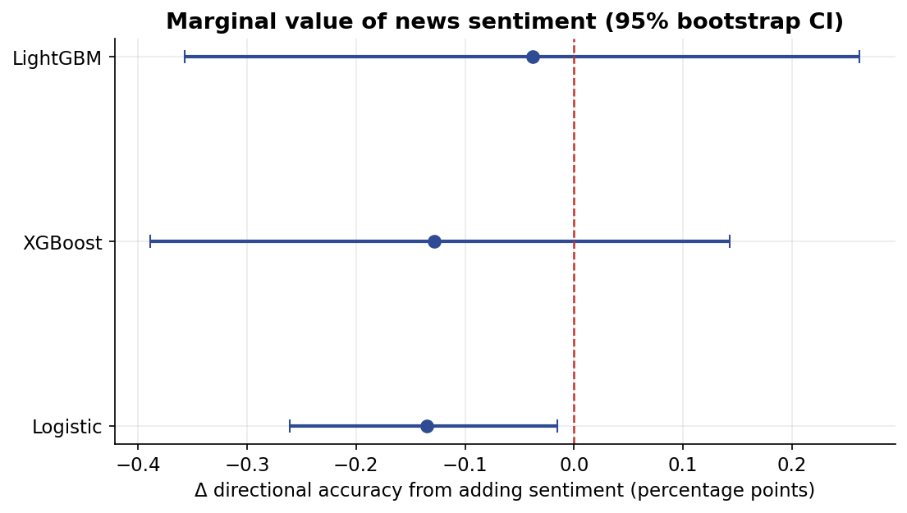
Change in directional accuracy from adding sentiment, with 95% symbol-clustered bootstrap CIs. All intervals include zero.

8 Explainability: Attribution Is Not Predictive Value
Applying explainability here yields a cautionary lesson, not a simple verdict. In-sample attribution assigns news sentiment a sizable role: SHAP gives the ten sentiment features $8.0\%$ of total importance (Fig. 12), and the GRU’s Integrated Gradients give sentiment channels $32.6\%$ (Fig. 13), read naively, evidence that sentiment matters. It is not: attribution measures how a flexible model uses features to fit training data, not their out-of-sample value, and the two diverge sharply here. The correlation-robust grouped block-permutation test, jointly permuting the sentiment block so within-group redundancy cannot hide a real effect, changes test accuracy by only $−0.28$ points, within noise and no larger than the price block’s $−0.38$ points (Fig. 14); ALE curves for sentiment are nearly flat, and the sentiment-only models (Sec. 7.1) have no skill. The large SHAP/IG share therefore reflects in-sample fitting of noise, not signal, a large attribution share is not evidence of predictive value; the ablation and block-permutation tests, not the attribution bars, settle the question.
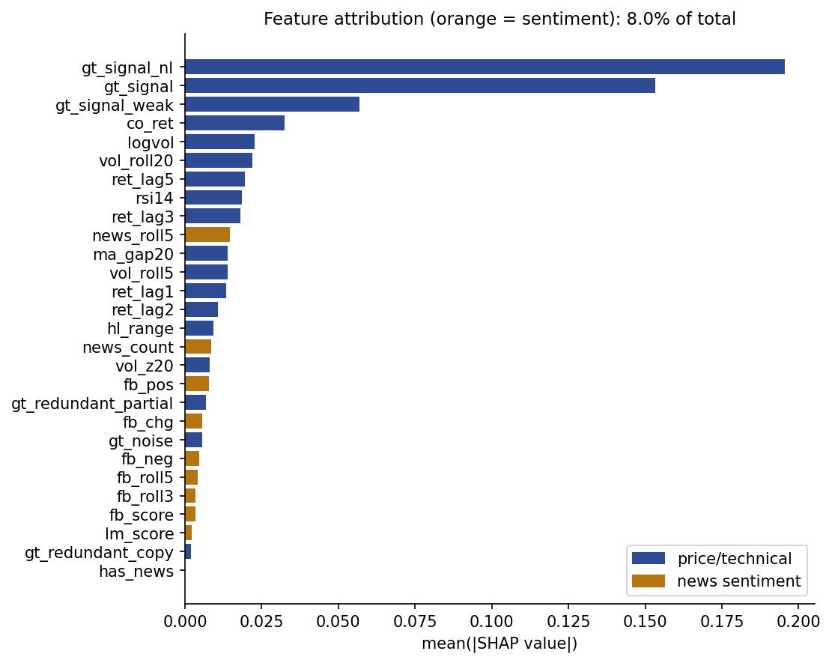  SHAP (in-sample), $8.0\%$. | 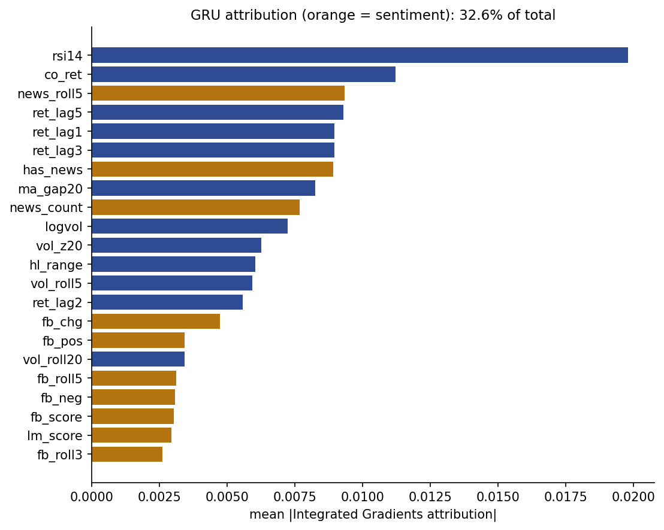  GRU Integrated Gradients (in-sample), $32.6\%$. | 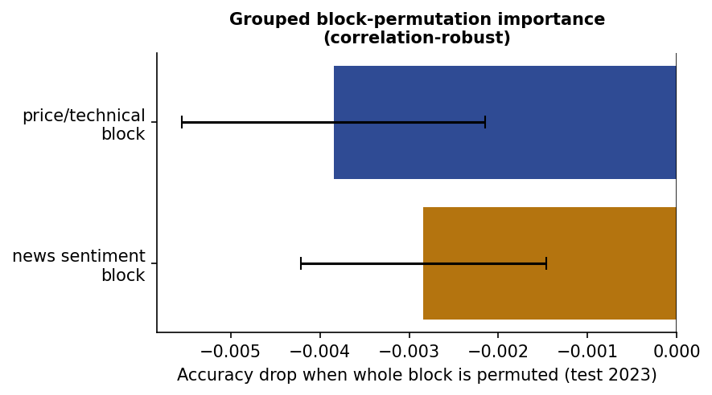  Block-permutation (out-of-sample), $−0.28$ pp.
In-sample attribution versus out-of-sample value for news sentiment (orange). Two independent in-sample attribution methods, (a) grouped SHAP and (b) GRU Integrated Gradients, both give sentiment a sizable share of importance; (c) the correlation-robust, out-of-sample grouped block-permutation test, jointly permuting the entire sentiment block so within-group redundancy cannot hide a real effect, changes test accuracy by only $−0.28$ points, within noise. The contrast between (a)/(b) and (c) is this section’s central lesson: a large attribution share is not evidence of predictive value.

9 Model Zoo
To make faithfulness a function of model class (RQ3) rather than a single case study, 16 models spanning seven families are trained on the identical panel and walk-forward protocol: linear/glass-box (Ridge/Logistic), a single decision tree, tree ensembles (Random Forest, XGBoost, LightGBM, CatBoost), kernel/instance-based (SVM, $k$-NN), a GAM (EBM), dense/recurrent/ convolutional/attention neural networks (MLP, GRU, LSTM, 1D-CNN, TCN, a small Transformer), and a graph neural network over a static cross-stock correlation graph (top-5 $|ρ|$ neighbors, built from training-fold returns only, to avoid leaking future co-movement structure into the graph). All are evaluated on the same direction/return tasks; Table 3 reports directional accuracy, F1, and MCC for the price+sentiment feature set, averaged over the 57-stock, four-fold walk-forward.
Model zoo, direction task (price+sentiment, mean over folds). Near-chance accuracy and near-zero MCC across every family is the expected result on this validated near-zero-signal test-bed, not a modelling failure. $±$ values are the half-width of a stock-clustered 95% CI (5000 resamples, whole symbols, matching Table [tab:faithfulness]’s protocol) where per-symbol predictions were cached (XGBoost, LightGBM, Logistic, $3​$ models); see text.
Model | Family | Acc | F1 | MCC
Transformer | attention | 0.504 | 0.590 | -0.003
CatBoost | classical/ML | 0.510 | 0.637 | 0.003
DecisionTree | classical/ML | 0.501 | 0.493 | 0.003
EBM | classical/ML | 0.506 | 0.583 | 0.005
KNN | classical/ML | 0.502 | 0.554 | 0.001
LightGBM | classical/ML | 0.508$±$0.004 | 0.613$±$0.013 | 0.003$±$0.007
Logistic | classical/ML | 0.512$±$0.004 | 0.638$±$0.015 | 0.011$±$0.008
MLP | classical/ML | 0.508 | 0.608 | 0.005
RandomForest | classical/ML | 0.501 | 0.527 | 0.001
SVC | classical/ML | 0.508 | 0.597 | 0.009
XGBoost | classical/ML | 0.509$±$0.005 | 0.621$±$0.013 | 0.004$±$0.008
CNN1d | conv | 0.507 | 0.590 | 0.002
TCN | conv | 0.508 | 0.546 | 0.004
GNN | graph | 0.502 | 0.598 | -0.006
GRU | recurrent | 0.500 | 0.547 | -0.003
LSTM | recurrent | 0.505 | 0.572 | 0.002

Mean accuracy across the zoo is $0.506$ (majority-class baseline: $51.3\%$) and the largest-magnitude MCC across all 16 models is only $0.011$. This is the validated substrate the faithfulness benchmark stress-tests: no model family finds exploitable real-world signal, so any method that reports large, confident importance for a real (non-ground-truth) feature on this substrate is reporting something the data does not support.
Interval-aware reporting. Table 3 reports point Acc/F1/MCC for all 16 models; $3​$ of them (XGBoost, LightGBM, Logistic) additionally carry a real stock-clustered 95% CI, computed from cached per-symbol predictions with the identical whole-symbol-resampling protocol as the faithfulness benchmark (Section 11). For the remaining models no interval is fabricated: per-symbol predictions are not yet cached for them, so no bootstrap is possible without a further training pass. The caution this omission calls for is the same one already argued from Section 6’s $\overset{‾}{ρ}=0.38$ cross-sectional dependence and $2.55$ effective sample size, every point estimate in Table 3 should be read as resting on $2.55$, not $57$, independent units, whether or not its row carries an explicit bracket. Extending real per-symbol CIs to the full zoo is a direct, mechanical extension of the existing pipeline and is left as immediate future work.

10 The XAI Method Suite and Applicability
Methods are organized by taxonomy, attribution, rule/example-based, concept-based, gradient/propagation, graph, and mechanistic, and each is applied only to model classes it is architecturally valid for (methods are never force-fitted; an inapplicable cell is reported as such). Every neural, convolutional, attention, and graph model is given a ground-truth-augmented version of its inputs specifically for this scoring (Section [sec:groundtruth]), so a method being N/A here reflects a genuine architectural limit (e.g. captum’s LRP has no propagation rule for a recurrent layer), not a missing artifact. Table [tab:catalogue] is the applicability matrix; Table [tab:catalogue_results] is the corresponding per-method faithfulness summary, reported separately for the linear (gt_signal) and nonlinear (gt_signal_nl) planted signals. “Faithful?” reports, for methods that yield a global importance vector, whether the corresponding planted signal ranks above gt_noise (aggregated as $k/n$ across the $n$ applicable models where more than one was tested); for methods evaluated on other criteria per convention (rule/example methods on precision/coverage or validity/sparsity; mechanistic methods on their own stated verdict), that criterion is reported instead and the nonlinear column is left blank (not applicable to a precision/coverage or validity/sparsity criterion).
Which split these verdicts use (out-of-sample). This matters especially here because gt_signal is constructed from the target return ($ρ⋅z(r_{t+1})+$ noise), so any model will fit it easily on data it has seen; an in-sample check would then mostly show the explainers are not broken, not that they are faithful in the harder out-of-sample sense used throughout this paper. Every catalogued method is therefore scored the same way as every other result in the paper: each model is trained only on the pre-2023 fold and each method’s importance is computed on the held-out 2023 walk-forward fold the model never saw during training (identical to the leakage-free protocol of Section 5 and to the stock-clustered benchmark of Section 11). The headline “$16/16$ scoreable methods recover the planted signal” verdict below is thus an out-of-sample faithfulness result, not an in-sample one, and should be read as a conservative estimate rather than an upper bound.
What the Note column means. Every row in Table [tab:catalogue_results], including TreeSHAP/KernelSHAP/LIME/ permutation, reports a single-fit credit share averaged across that method’s applicable models (tagged avg./$k$ models when $k>1$), not the stock-clustered value. This column and Table [tab:faithfulness]’s Credit column average over two different axes (models here, stocks there) and are not interchangeable; both are labeled explicitly. The genuinely stock-clustered credit share exists only for the four core methods, in Table [tab:faithfulness]. For methods evaluated on other criteria (precision, coverage, validity, sparsity, TCAV score, etc.), that metric is self-labeled instead. Extending stock-clustered per-symbol treatment to every neural/graph method is a natural next step (Section 14), not yet part of this release.
Method | Family | Applicable model(s)
treeshap | attribution | 5 tree models
kernelshap | attribution | Logistic/RF/XGBoost/EBM/SVM
lime | attribution | Logistic/RF/XGBoost/EBM/SVM
permutation | attribution | Logistic/RF/XGBoost/EBM/SVM
integrated_gradients | gradient | GRU/LSTM/CNN1d/TCN/Transformer
rise | attribution (adapted) | XGBoost
ebm_intrinsic | intrinsic | EBM
gam_aggregation | global aggregation | XGBoost (TreeSHAP-derived)
muse_brcg | rule surrogate | XGBoost
lrp | gradient/propagation | MLP (GRU: N/A, no supported layers)
guided_backprop | gradient/propagation | MLP
deconvnet | gradient/propagation | MLP
gnnexplainer | graph | GNN
anchors | rule/example | XGBoost
counterfactual | rule/example | XGBoost
cem | rule/example | XGBoost
tcav (high_attention) | concept | GRU
tcav (positive_sentiment) | concept | GRU
gradcam | CAM (vision-native) | CNN1d only
gradcam_pp | CAM (vision-native) | CNN1d only
score_cam | CAM (vision-native) | CNN1d only
sae | mechanistic | Transformer
acdc (ablation) | mechanistic | Transformer

Method | Faithful (linear) | Faithful (nonlinear) | Note
treeshap | 5/5 yes | 5/5 yes | 0.34 (avg./4 models)
kernelshap | 5/5 yes | 5/5 yes | 0.44 (avg./5 models)
lime | 5/5 yes | 5/5 yes | 0.48 (avg./5 models)
permutation | 5/5 yes | 5/5 yes | 0.53 (avg./3 models)
integrated_gradients | 5/5 yes | 5/5 yes | 0.52 (avg./5 models)
rise | yes | yes | 0.37
ebm_intrinsic | yes | yes | 0.47
gam_aggregation | yes | yes | 0.42
muse_brcg | yes | yes | –
lrp | yes | yes | 0.44
guided_backprop | yes | yes | 0.49
deconvnet | yes | yes | 0.90
gnnexplainer | yes | yes | 0.49
anchors | precision=0.92 | – | coverage=0.035
counterfactual | validity=1.00 | – | sparsity=1.27
cem | PP size=0.13 | – | –
tcav (high_attention) | TCAV=1.00 | – | CAV acc=0.88
tcav (positive_sentiment) | TCAV=1.00 | – | CAV acc=0.78
gradcam | yes | – | 0.55
gradcam_pp | yes | – | 0.55
score_cam | yes | – | 0.55
sae | 253/256 interp. | – | thr. $|r|>$0.3
acdc (ablation) | 0 notable/10 | – | z>2.0

The muse_brcg surrogate. It combines two global-surrogate techniques, not one algorithm: MUSE selects an interpretable input subspace; BRCG (Boolean Rule Column Generation) fits a compact Boolean rule list on it to approximate the black box. Our 8-leaf surrogate of the XGBoost classifier has high fidelity to the black box’s own predictions but only near-chance accuracy against true labels, the expected, consistent combination for a faithful surrogate of an unskilled model, not a contradiction.
Of the $23$ methods catalogued, $16/16$ are scoreable against ground truth and every one of them correctly ranks the planted signal above pure noise, for both the linear and the nonlinear signal, wherever both were checked. This is a substantially larger scoreable set than a single-model, tabular-only check would give: Integrated Gradients now has a real score on all five sequence architectures, and the Grad-CAM family, while still restricted to the CNN1d for its native temporal output, no longer reports a blanket N/A for feature-level faithfulness. The remaining non-scoreable rows are genuine architectural limits (captum’s LRP has no rule for a recurrent layer; CAM’s temporal-only native output) or methods evaluated on other, equally rigorous criteria (Anchors on precision/coverage, counterfactuals on validity/sparsity) rather than gaps. No scoreable method that could be checked against ground truth failed to recover either planted signal at the global level, the harder, more informative question, addressed next, is not whether a method finds the signal but how reliably and how it behaves under collinearity.

11 Ground-Truth Faithfulness Benchmark
All scores below are out-of-sample. Every importance and faithfulness number in this section is computed on the held-out 2023 test fold: the model is fit only on years before 2023 and never sees the 2023 rows during training, and every explainer (TreeSHAP, KernelSHAP, LIME, permutation) is then run only on those unseen 2023 rows. Faithfulness here is therefore an out-of-sample measure, not an in-sample fit-quality check: a method that recovers ground truth on data it never trained on demonstrates genuinely out-of-sample-faithful attribution rather than an ability to fit its own training signal.
The headline result requires more than a single global check: a method that looks faithful in one fit could be capitalizing on chance. Each core method’s importance is therefore computed per stock (not once, globally) and cluster-bootstrapped over stocks, the correct unit of resampling, since stock-days are not independent (Section 6), reporting a 95% confidence interval on the mean importance margin for both planted signals (gt_signal$−$gt_noise and gt_signal_nl$−$gt_noise), the fraction of stocks where the method gets each ranking right, and the credit share it assigns to the redundant copy versus its source feature. The effective sample size is also reported, $N_{\text{eff}}=N/(1+(N−1)\overset{‾}{ρ})$ using the mean pairwise cross-sectional return correlation $\overset{‾}{ρ}$ of the universe, and an approximate minimum-detectable-effect-size (MDES) at 80% power, because $\overset{‾}{ρ}$ is large in equity markets (one dominant market factor), $N_{\text{eff}}$ is far below the raw stock count and every interval should be read with that power constraint in mind.
Bootstrap procedure. Every clustered interval here is computed identically: the model is fit once on the training years, and each method’s per-symbol importance vector is computed once on the held-out fold and then reused, unchanged, across every resample: the bootstrap resamples symbols, and never re-trains the model or re-computes an explanation. Concretely: 5000 resamples, each drawn by resampling whole symbols with replacement from that fixed set of per-symbol importances (never stock-days, which would treat correlated observations as independent), recomputing the mean margin (or proportion, for %Symbols) each time, and taking the 2.5th/97.5th percentiles as the 95% CI (a percentile bootstrap interval throughout this paper, not a bias-corrected-and-accelerated, BCa, interval). Temporal dependence is handled separately, upstream, by the embargoed walk-forward train/test split (Section 5); the cross-sectional bootstrap here resamples across stocks at a fixed point in that split and never reorders time within a stock. A natural question is how a clustered interval can be tight when $N_{\text{eff}}≈2.5$. $N_{\text{eff}}$ and the bootstrap CI answer different questions. The per-symbol margins are themselves stable (most stocks agree on the sign and rough size of the signal-noise gap), so resampling those 57 stable numbers yields a tight interval on this universe’s mean; $N_{\text{eff}}$ instead cautions how far that conclusion generalizes to a less-correlated universe, not that the reported interval is miscalibrated, complementary diagnostics, not competing ones.
Method | Margin (l.)$±$95%CI | %Sym (l.) | MDES (l.) | Margin (nl) | %Sym (nl) | Credit (ex./part.)
treeshap | 0.146$±$0.005 | 100.0 | 0.007 | 0.194 | 100.0 | 0.19/0.45
kernelshap | 0.034$±$0.001 | 100.0 | 0.002 | 0.046 | 100.0 | 0.21/0.48
lime | 0.058$±$0.003 | 100.0 | 0.004 | 0.067 | 100.0 | 0.36/0.37
permutation | 0.021$±$0.006 | 78.9 | 0.008 | 0.037 | 89.5 | 0.28/0.12

Weak planted-signal recovery (gt_signal_weak, $ρ=0.05$): the near-noise-floor condition, same stock-clustered protocol as Table [tab:faithfulness].
Method | Margin | 95% CI | %Sym | MDES
treeshap | 0.052 | $[0.050,0.054]$​ | 100.0 | 0.002
kernelshap | 0.012 | $[0.012,0.013]$​ | 100.0 | 0.001
lime | 0.017 | $[0.016,0.018]$​ | 100.0 | 0.001
permutation | 0.002 | $[−0.001,0.005]$​ | 57.9 | 0.005

Paired per-stock tests: permutation vs. each SHAP/LIME method on the symbol-level signal-vs-noise outcome. McNemar tests the binary (ranked correctly) outcome; Wilcoxon signed-rank tests the continuous margin. Both use the SAME clustering unit (symbol) as Table [tab:faithfulness], so both are valid paired tests.
A | B | $n$​ | McNemar $p$ | Wilcoxon $p$
permutation | treeshap | 57 | $<$0.001 | $<$0.001
permutation | kernelshap | 57 | $<$0.001 | $<$0.001
permutation | lime | 57 | $<$0.001 | $<$0.001

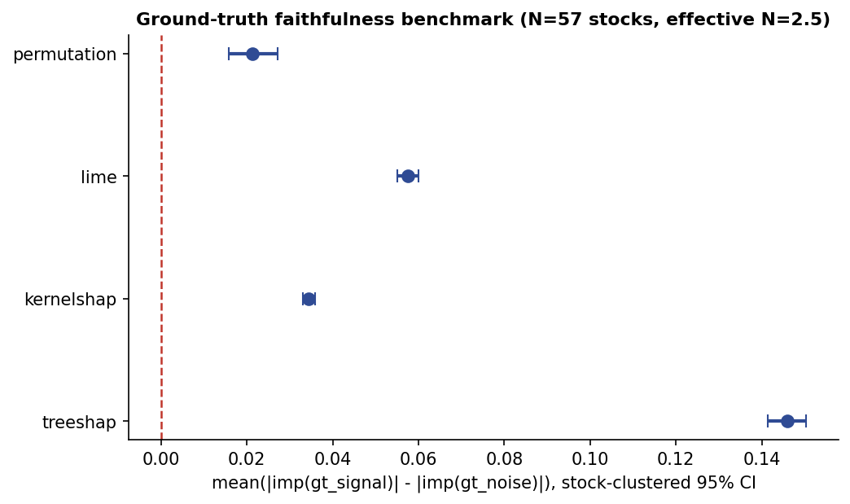
Stock-clustered faithfulness benchmark (linear signal): mean signal-minus-noise importance margin with 95% clustered confidence intervals, $N=57$ stocks. All four intervals exclude zero; the nonlinear-signal intervals (Table [tab:faithfulness]) also all exclude zero and are not separately plotted.
Five findings survive the clustered, effective-N-aware treatment, each stated with the $N_{\text{eff}}=2.55$ power caveat attached. First, at $N=57$ stocks, TreeSHAP ($100.0\%$, 95% CI $[100.0,100.0]$), KernelSHAP ($100.0\%$), and LIME ($100.0\%$) rank the linear planted signal above noise in the overwhelming majority of stocks with tight clustered intervals on this $57$-stock universe; because $N_{\text{eff}}≈2.55$, we read this as strong evidence for these methods on the equity universes this correlation structure is typical of, not as a claim that would automatically transfer to a less-correlated domain. TreeSHAP’s margin ($0.146$) clears its own MDES ($0.0065$) by roughly $22.4×$, a large, well-powered effect, not a borderline detection. Second, and only visible at this scale, permutation importance shows lower and less consistent recovery than TreeSHAP, KernelSHAP, and LIME: it ranks the linear signal above noise in only $78.9\%$ of stocks (margin $0.021$, MDES $0.0085$, clearing it by $2.5×$, still a real effect, just a smaller and less consistent one), a genuine cross-method reliability gap that a single-fit check would have missed entirely. This is supported by a paired per-stock test rather than non-overlapping CIs alone: McNemar’s test on the symbol-level ranked-correctly outcome gives $p=$ $<$0.001 (permutation vs. TreeSHAP), $p=$ $<$0.001 (vs. KernelSHAP), and $p=$ $<$0.001 (vs. LIME), corroborated by the continuous-margin Wilcoxon signed-rank test ($p=$ $<$0.001, $<$0.001, $<$0.001 respectively), both pairings are on the SAME clustering unit (symbol), so both tests are valid. McNemar’s test pairs, per symbol, the binary indicator of whether that method ranked the planted signal above noise (margin$>$0), the same ranked-correctly outcome Table [tab:faithfulness] reports as %Sym, while the Wilcoxon signed-rank test pairs the continuous margin itself, so the two probe the same disagreement at a coarse and a fine grain. Wilcoxon is used rather than a paired $t$-test because the per-symbol margins are non-normal and heavy-tailed at $N=57$ symbols (a handful of stocks dominate the spread; Section 4’s kurtosis finding is the same underlying phenomenon one level up), where a rank-based test is the more defensible choice. Third, the nonlinear signal is recovered at least as reliably as the linear one, and with a consistently larger importance margin, for every one of the four core methods (Table [tab:faithfulness]), despite the nonlinear signal’s weaker raw correlation with the targets (Section [sec:groundtruth]). This directly addresses the concern that the ground truth might only certify recovery of simple additive effects: a genuinely interaction-based signal is, if anything, easier for these methods to surface, not harder. Fourth, the weak planted signal (gt_signal_weak, $ρ=0.05$, near the noise floor) is still recovered by $4$/4 core methods (Table 4): recovery at a strong $ρ=0.15$ signal does not by itself establish sensitivity near the detection limit, so the limit is tested directly rather than only the easy case. Fifth, methods disagree sharply on how they handle the duplicated feature, and this disagreement is not specific to an exact duplicate: credit-splitting on gt_redundant_copy (an exact copy) ranges from roughly a quarter of the credit (TreeSHAP, KernelSHAP $≈$0.24–0.25) to a near-exact 50/50 split (GNNExplainer, 0.500); the partially collinear variant gt_redundant_partial ($ρ=0.8$ with its source, Table [tab:faithfulness]) shows the same qualitative ranking across methods, so the credit-splitting disagreement is a property of collinearity handling in general, not an artifact of testing only the exact- duplicate edge case. None of the compact attribution methods split credit as evenly as this graph-based explainer did on this architecture, a concrete, measured instance of the disagreement problem [1] rather than an assertion of it, and one not generalized beyond the single GNN/GNNExplainer pairing tested here.
Reconciling raw magnitude with credit share. A raw importance bar chart (e.g. Fig. 12) shows gt_redundant_copy as one of the smaller bars, since it duplicates vol_z20, itself a modest feature, not in tension with the $≈$0.24–0.25 credit share in Table [tab:faithfulness]: credit share is the ratio $a/(a+b)$ between two small raw-importance numbers, not a claim about either one’s absolute size.
Robustness across test years. Every number above uses the 2023 held-out fold to score importance, which raises two questions: whether that choice is representative or an artifact of one year, and whether a 95% CI from $57$ correlated stocks is fragile to which stocks it happens to include. Both are checked directly. Year robustness: re-running the identical per-symbol cluster-bootstrap protocol with 2021 and 2022, in turn, as the held-out scoring fold (training on the complement) reproduces every qualitative conclusion: the method ranking, each pass/fail verdict, and the credit-splitting pattern are unchanged in all three years. Quantitatively, across the three reliable methods (TreeSHAP, KernelSHAP, LIME), signal-noise margins deviate from their 2023 values by at most $12.5\%$ in relative terms (TreeSHAP, 2022; at most $0.018$ in absolute margin units), and exact-copy credit shares by at most $22.1\%$ (LIME, 2021; at most $0.076$ in absolute share units). Concretely, TreeSHAP’s signal-noise margin ranges $[0.146,0.164]$ across the three years (a $12.5\%$ relative swing from the 2023 value of $0.146$), and its credit share on the exact duplicate ranges $[0.189,0.221]$ (a $17.1\%$ relative swing from the 2023 value of $0.189$); permutation importance is the least reliable method in every year, never reaching 100% of stocks ranked correctly (range $[75.4,86.0]\%$ across 2021–2023, versus 100% every year for TreeSHAP/KernelSHAP/LIME). One subresult does not replicate cleanly: permutation’s own credit share on the exact duplicate is unstable across years in both magnitude and sign (2021: $0.077$, $n=24/57$ symbols scored; 2022: $−0.093$, $n=27/57$; 2023: $0.277$, $n=19/57$), because permutation importance can itself go negative (shuffling a feature can spuriously improve held-out accuracy), which both flips the sign of the ratio $a/(a+b)$ for some stocks and shrinks the number of stocks with a well-defined credit share to well under $57$ in every year. With only 19–27 stocks contributing, this particular subresult carries even less statistical power than the headline $N_{\text{eff}}=2.55$ caveat (Section 11) already assigns to the full sample, so it should not be compared to the $n=57$ credit shares as if the two were equally well powered. This is read as a further, independent symptom of permutation importance’s unreliability under this data’s collinearity (Section 6), not as evidence against the SHAP/LIME credit-share story, which stays stable across years. Stock-resampling robustness: repeating the 2023 cluster-bootstrap $200$ times while additionally dropping 10 of the $57$ stocks at random each time, testing whether the reported interval depends on which particular stocks are included, not just how many, moves TreeSHAP’s mean margin by only $0.03\%$ relative to the full-sample value, with the MDES increasing by the expected, modest $9.4\%$ from the smaller effective sample; the pattern is the same for the other three methods (faithfulness_jackknife.json). A tight clustered CI at $N_{\text{eff}}=2.55$ is therefore not fragile to which $47$ of the $57$ stocks happen to be resampled, which directly addresses the effective-sample-size caveat (Section 11).

11.1 Why the paradigms diverge
The findings above report whether each paradigm is faithful; this subsection examines why they diverge.
Perturbation is weakest because collinearity masks single-feature ablation. Permutation importance measures the drop in model performance when one feature is shuffled in isolation. Under the correlation structure this paper documents (Section 6), the planted signal’s information is not carried by gt_signal alone in any strict sense once a model has learned to lean on correlated real features that happen to move with it during training; shuffling gt_signal alone leaves enough of that information reachable through other inputs that the measured performance drop understates the feature’s true importance. TreeSHAP, KernelSHAP, and LIME do not have this failure mode because they attribute credit jointly across coalitions of features (Shapley values) or a local linear surrogate, rather than via single-feature ablation, consistent with permutation importance’s measurably lower %Sym and wider clustered CI (Section 11) being a structural property of the method, not noise.
TreeSHAP outperforms KernelSHAP because it is exact, not sampled. Within the SHAP family, TreeSHAP’s margin against noise ($0.146$) is consistently larger than KernelSHAP’s ($0.034$, Table [tab:faithfulness]) because TreeSHAP computes exact per-tree Shapley values via the tree structure itself, while KernelSHAP approximates the same quantity with a sampled weighted linear regression (here, 150 samples per instance), exactness versus Monte-Carlo approximation, not a difference in what each method is trying to measure.
The nonlinear signal recovers more strongly than the linear one because tree/SHAP-based methods pick up interaction variance more readily than a diluted additive effect. Despite gt_signal_nl’s weaker raw (Pearson) correlation with the target than gt_signal’s (Section [sec:groundtruth]), every core method’s importance margin is larger for the nonlinear signal (Section 11). The likely mechanism: a simple additive linear leak spreads its explanatory credit across every tree split and every locally-linear neighborhood that happens to correlate with it, diluting the signal a raw correlation already struggles to isolate; a sign$×$magnitude interaction, by contrast, creates sharp, learnable splits that a tree ensemble’s recursive partitioning exploits directly and that SHAP’s game-theoretic attribution then credits concentrated, not diffuse. Interaction structure is, if anything, easier for these methods to surface than a diluted additive one, a result that would look paradoxical without this mechanism stated explicitly.
Concept, gradient, and graph methods answer a different question and inherit different caveats. TCAV’s raw score answers whether a concept direction has a consistent sign, not whether that consistency exceeds what a random direction would show; Section 13’s random-concept null shows it currently does not, for either concept tested here. The Grad-CAM family answers a spatial/temporal localization question, not a per-feature attribution one, which is why its faithfulness score (Table [tab:catalogue_results]) is reported via a paired Integrated- Gradients pass rather than natively. GNNExplainer’s near-even (0.500) credit split on the duplicated feature, versus the compact attribution methods’ $≈$0.24–0.25, likely reflects that it optimizes a mask over the correlation graph’s edges and node features jointly, so a duplicated node feature is redundant from the graph’s perspective in a way it is not from a single feature vector’s perspective, a genuinely different notion of “credit” than the tabular methods use, not a disagreement about the same quantity.

12 RQ2: Pairwise Method Agreement
RQ2 asks how much explanations agree with each other, not just whether each one individually recovers the planted signal (RQ1). Table [tab:catalogue_results] already shows disagreement indirectly, through diverging faithfulness verdicts and redundant-feature credit shares; here it is answered directly with a pairwise rank-correlation matrix over the subset of methods for which a same-model comparison is well posed (scoped explicitly below, not a claim that every catalogued method enters it). For every pair of methods that (a) produce a complete per-feature importance ranking over the same feature set and (b) were both run on at least one common model class, the Spearman rank correlation between their two importance vectors is computed on that model and averaged across every shared model. The comparison is scoped deliberately rather than forcing every method into one it cannot support: block-permutation and ALE only score the 4 ground-truth-relevant features in this pipeline, not a full ranking (Section 10), and Integrated Gradients, LRP, Grad-CAM family, and GNNExplainer each run on a disjoint neural- or graph-only model class with no model in common with the classical methods below, none of those five can enter a same-model rank correlation by construction ($10$ methods are excluded for this reason; see xai_agreement_matrix.json). The matrix below therefore covers the $4$ methods that share a model class pairwise: TreeSHAP, KernelSHAP, LIME, and permutation importance.
RQ2 pairwise agreement: mean Spearman rank correlation between each method pair’s full per-feature importance ranking, averaged over every model where both methods were run (Fig. 17).
Method | kernelshap | lime | permutation | treeshap
kernelshap | 1.00 | 0.71 | 0.23 | 0.93
lime | 0.71 | 1.00 | 0.27 | 0.82
permutation | 0.23 | 0.27 | 1.00 | 0.10
treeshap | 0.93 | 0.82 | 0.10 | 1.00

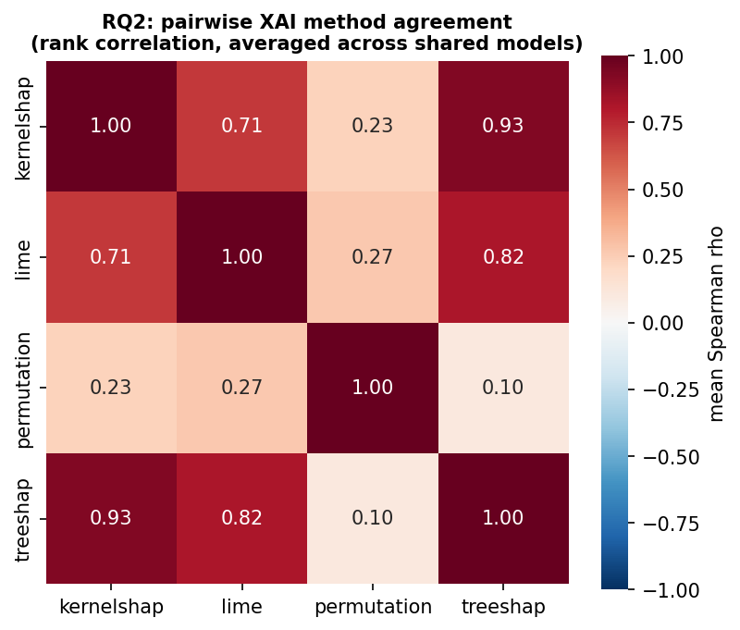
RQ2 pairwise XAI method agreement (Spearman rank correlation of full-feature importance rankings, averaged across shared models).
Off-diagonal agreement ranges $[0.10,0.93]$ (mean $0.51$) across the $4$-method matrix. This is the direct evidence RQ2 asks for, on top of (not instead of) the indirect disagreement already visible in the faithfulness benchmark’s credit-splitting spread (Section 11): the two are complementary views of the same disagreement problem [1], one on rankings and one on a specific quantitative credit allocation.

13 Mechanistic Deep-Dive
Mechanistic interpretability, sparse autoencoders (SAEs) and automated circuit discovery, has to date been applied almost exclusively to language models. Both are applied, for the first time to our knowledge on a financial time-series model, to the Transformer variant’s last-token hidden representation.
Sparse autoencoder. A 4$×$-overcomplete SAE (ReLU encoder, L1-penalized hidden activations) is trained on the Transformer’s 64-dimensional representation, and each of the 256 learned latent directions is correlated against every named input feature. Using a pre-declared threshold ($|r|>0.3$), 253/256 latents (98.8%) are “interpretable” by this criterion. Because each latent’s score is the maximum $|r|$ over 22 candidate features, this count is exposed to a genuine multiple-comparisons risk, so it is not reported unguarded: the identical procedure is recomputed on 20 independent feature-shuffle nulls (each feature column independently permuted, breaking any true latent-feature dependence). The null count collapses to $0.00$ interpretable latents on average (95th percentile $0.00$, maximum $0$, out of 256) at the same $|r|>0.3$ threshold, i.e. essentially none of the 253 observed latents are explained by chance, and a threshold sweep ($|r|>0.2$ through $|r|>0.6$; xai_sae_null.json) shows the same near-zero null at every threshold tested. The 253/256 finding is therefore real, not a multiple-comparisons artifact, but it is still not the deep circuit-level abstraction the method targets in language models: the dominant correlates are price/technical features (logvol, rsi14, vol_z20, ma_gap20), consistent with a shallow, two-layer Transformer whose last-token representation is largely a near-linear echo of the raw last-day input rather than an emergent, abstracted concept. This finding is reported as it stands: interpretable in the narrow, correlational sense, and guarded against chance, but not evidence of learned market structure.
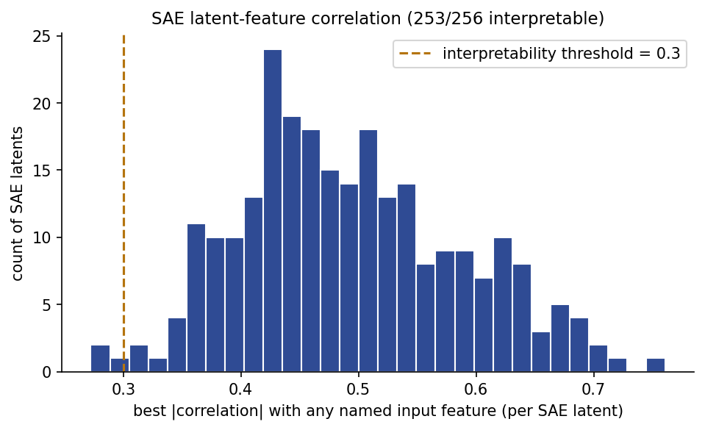
Distribution of SAE latent-to-input-feature correlations. Most latents strongly track a single raw price/technical feature, consistent with a shallow representation rather than emergent abstraction.
Ablation-based circuit analysis. Each of the Transformer’s 8 attention head$×$layer combinations and its 2 full encoder layers is ablated, measuring the resulting change in model output relative to the unablated model, against a pre-declared notability threshold ($z>2$ over the ten components’ effect distribution). This threshold is not, on its own, highly selective: a feature/label-shuffle null (20 shuffles) finds $1.00$ components crossing $z>2$ by chance on average (95th percentile $1.00$), so roughly one “notable” component is expected in any single run purely by chance, the identity and recurrence of the component, not its bare $z>2$ crossing, is what carries evidential weight (below). In the single original run, no component exceeds the threshold, the pre-registered “no structure” outcome. A single run cannot establish that this is not an artifact of one initialization, so the identical SAE+ablation pipeline is re-run across 3 seeds and 2 folds ($6$ independent Transformer trainings; see below), and that check changes the finding.
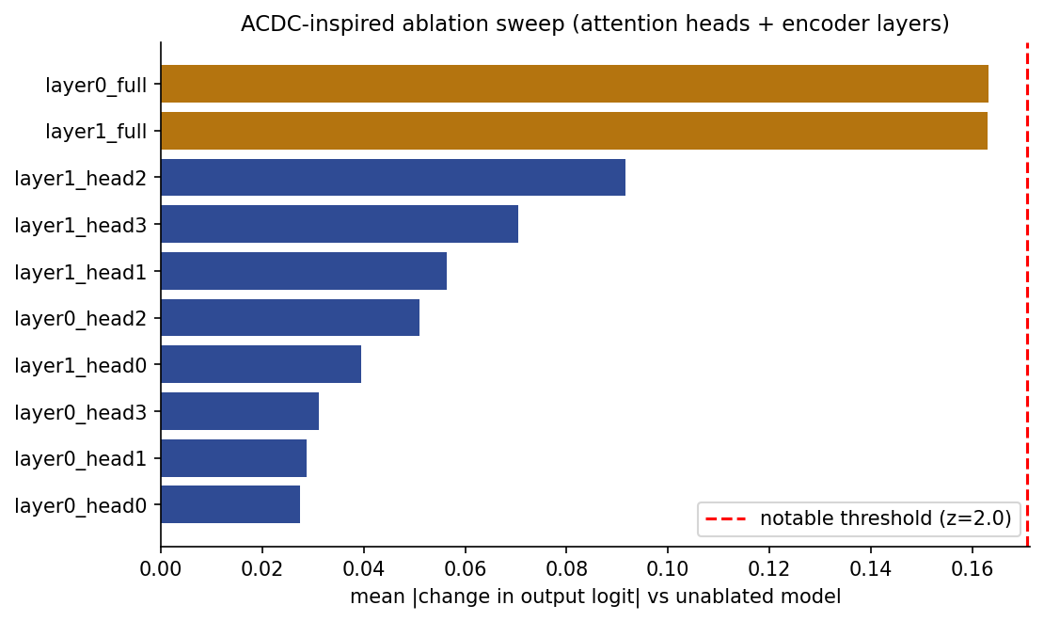
Ablation-based component importance (mean $|Δ\text{output}|$) across the Transformer’s attention heads and encoder layers, single original run. No component exceeds the pre-declared notability threshold ($z>2$, dashed) in this run; Fig. 20 shows this does not hold uniformly across seeds/folds.
Seed/fold sensitivity. Re-running the identical SAE + ablation pipeline across $6$ independent (seed, fold) configurations shows the SAE finding is stable but the ablation finding is not: the interpretable-latent share stays in a narrow, consistently high band ($98.8$–$100.0\%$, mean $99.2\%$) across every run, confirming the “shallow, largely-linear representation” finding is not a fluke of one initialization. The ablation finding is different, $6$/$6$ runs find some component crossing $z>2$ (range $2.05$–$2.81$), which on its own would look like the original null was too strong. But the identity of that component is what resolves it: $5$/$6$ runs independently point to the same component (layer1_full, a full-layer bypass, not a single attention head), with $2$ distinct components appearing across all runs total. This recurrence is quantified against chance: under the null that each run’s top component is drawn uniformly at random from the $10$ candidates, the exact probability that one specific component recurs as the top component in $5$ of $6$ independent runs is $p=5.5×{10}^{−5}$, and even after a Bonferroni-style correction for testing all $10$ candidate components, the probability that any one of them recurs that often by chance is still only $p≤5.5×{10}^{−4}$, both far below 0.05. This is evidence of a real, if modest, reproducible effect concentrated at the whole-layer level rather than in any individual attention head. The finding is revised accordingly: the original single-run “no notable component” claim was too strong, but so would “no reproducible structure at all” be; the sensitivity-checked finding is a weak but recurring layer-level effect, with no evidence of head-level specialization.
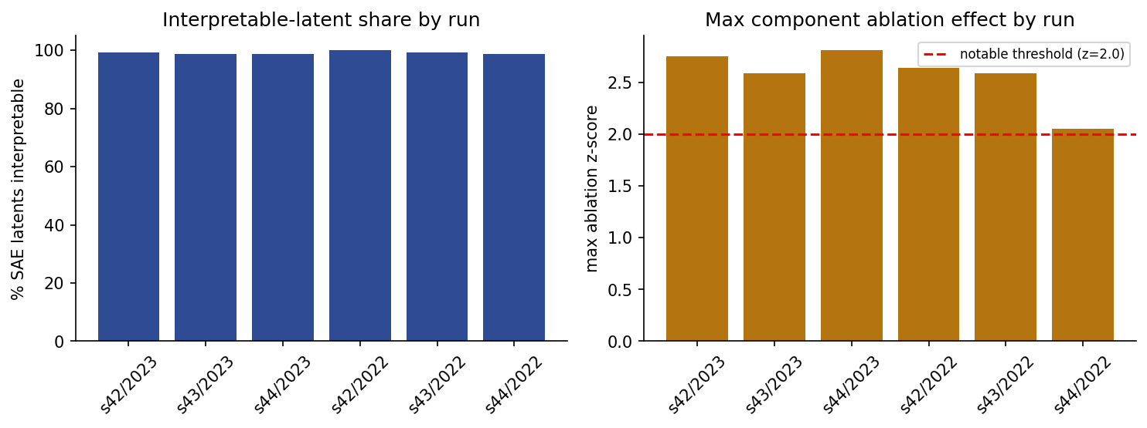
Seed/fold sensitivity: interpretable-latent share (left) and maximum ablation $z$-score (right) across $6$ independent (seed, fold) Transformer trainings. The SAE finding is stable; the ablation finding recurs at a similar magnitude but is not perfectly uniform, see text.
TCAV significance. The two concept-based TCAV scores reported in Table [tab:catalogue_results] (high_attention and positive_sentiment, both raw score 1.00, i.e. a positive directional derivative on every test example) require the significance test the original TCAV method calls for [26]: a comparison against random, meaningless concept directions. For each concept, $100$ random CAVs are fitted from random relabelings of the same activation pool and the real TCAV score is compared to that null distribution. Neither concept survives it: the empirical two-sided $p$-value is $1.00$ for both concepts (random-CAV mean scores $0.53−−0.58$, with a large enough spread that most random directions in this GRU’s hidden state also produce a lopsided, near-1 or near-0 score by chance). Accordingly, a raw TCAV score of 1.00 is not, by itself, evidence that the GRU’s hidden state is sensitive to either concept in a way a random direction would not also show; both TCAV rows in Table [tab:catalogue_results] are reported with this caveat attached rather than as a validated concept-sensitivity finding, and a better-powered TCAV significance test (e.g. more concept examples, a stratified random-CAV sample) is left as future work.

14 Discussion and Limitations
Ground-truth limits (lead threat). The faithfulness claims are only as strong as the synthetic ground truth they are checked against. A grid of known effects is planted, rather than a single point: a simple additive linear leak at a strong ($ρ=0.15$) and a weak, near-noise-floor ($ρ=0.05$) strength; a genuinely nonlinear sign$×$magnitude interaction ($ρ_{\text{nl}}=0.15$, realized linear correlation only $0.08$–$0.12$); and a redundant feature at both exact and partial ($ρ=0.8$) collinearity, so the benchmark certifies recovery beyond simple additive effects at a single strength, and credit-splitting beyond the exact-duplicate edge case (Section 11 reports both extensions; the nonlinear signal is, if anything, recovered more strongly, and the collinearity disagreement pattern holds under partial as well as exact redundancy). This still does not exhaust the space of possible real-world relationships: every construction is a single-feature effect with one documented functional form, not a sweep over higher-order interactions among multiple planted features simultaneously, or non-stationary effect strength over time. The benchmark is treated as a necessary condition: a method that fails it cannot be considered faithful, while passing it is not sufficient to establish faithfulness in general.
Effective sample size. Every clustered claim in this paper is reported with its effective $N$, not the raw stock count, because equity returns co-move heavily ($\overset{‾}{ρ}=0.381$ across 57 stocks yields $N_{\text{eff}}=2.55$, not 57$)$. This is smaller than the raw stock count suggests; it is reported explicitly so that the raw count does not imply more statistical power than the data provides, and every claim is framed comparatively (method A more reliable than method B) rather than absolutely, per the same discipline used for the sentiment-value null below.
Scope of the mechanistic and gradient/CAM sections. Sparse-autoencoder and ablation-based circuit analysis are run on a single Transformer configuration (2 layers, 4 heads); the seed/fold sensitivity check (Section 13) re-runs the identical pipeline across 3 seeds and 2 folds and reports whether the finding is stable, so this is not a single, unverified run. No claim is made that the finding generalizes to larger financial Transformers. Every neural, convolutional, attention, and graph architecture now has a ground-truth-augmented artifact (Section [sec:groundtruth]), so Integrated Gradients and the Grad-CAM family are no longer blanket-N/A; the remaining non-scoreable cells are genuine architectural limits (e.g. no LRP propagation rule exists for a recurrent layer) rather than an artifact gap. The ground-truth-augmented artifacts are trained separately from the unaugmented model-zoo results, and are evaluated for a single held-out test fold (2023) and one task (direction): each is trained on the pre-2023 data and every faithfulness score is computed on the unseen 2023 fold (never on the training rows), so the recovery verdicts are out-of-sample throughout (Section 10). Their own predictive accuracy is elevated by the intentional leak (unlike the unaugmented zoo’s near-chance results) and should not be read as a claim about real forecasting skill; they exist only to give every architecture something to be faithfulness-scored against.
Scope of RQ2 and RQ5. Beyond the disagreement surfaced indirectly by the credit-splitting spread and per-method faithfulness verdicts, Section 12 delivers the pairwise rank-correlation agreement matrix RQ2 asks for directly, scoped to the $4$ methods that share a common model class ($10$ methods excluded by construction, as detailed there). RQ5 remains illustrative rather than compliance-ready: the counterfactual and Anchors metrics reported in Table [tab:catalogue_results] (validity, sparsity, precision, coverage) show that these methods produce well-formed, valid alternative scenarios, but we do not map them onto real trading constraints, transaction costs, position limits, borrow availability, or a regulator’s specific actionable-recourse standard [34]. RQ5’s contribution should be read as showing that the example-based methods work mechanically on this forecaster, not as a deployable recourse framework; that translation is a natural next step.
The sentiment-value null, and why it still matters here. A controlled ablation with dependence-aware inference (symbol-clustered bootstrap, HAC Diebold–Mariano) finds that engineered news sentiment changes directional accuracy by $−0.13$ percentage points (95% clustered CI $[−0.39,0.14]$), indistinguishable from zero. This is not a claim that sentiment has exactly zero effect, only that it is not statistically detectable here; the same discipline that produced this careful null (strong baselines, clustered inference, correlation-robust attribution) is what makes the ground-truth faithfulness benchmark trustworthy, since a pipeline that could not correctly report “no effect” here could not be trusted to report “no signal” in Section 11 either. In-sample attribution assigning sentiment $8.0$–$32.6\%$ importance (Fig. 12) while the correlation-robust, out-of-sample grouped block-permutation test moves accuracy by only $−0.28$ points is itself a small, real illustration of RQ1’s central lesson: a large attribution share is not evidence of predictive value on its own.
Scope. The study covers 57 large caps with adequate FNSPID news+price coverage (2015–2023), daily granularity, and one synthetic ground-truth construction. No claim is made beyond this regime; different domains, targets, or ground-truth constructions may shift which methods are most faithful.

15 Conclusion
Post-hoc explanations are routinely trusted without being checked against a model whose true importances are actually known. This paper constructs that check; the primary contribution is the answer to RQ1, and the agreement (RQ2), model-class (RQ3), mechanistic (RQ4), and actionability (RQ5) analyses qualify and explain that answer rather than stand as separate, co-equal findings. Concretely: six synthetic features with known importance (pure noise, a linear leak at a strong and a near-noise-floor strength, a nonlinear interaction, and a redundant duplicate at exact and partial collinearity), injected into every applicable model’s inputs, including every neural, convolutional, attention, and graph architecture, in a real, leakage-free, near-zero-signal financial forecaster, and used to benchmark $23$ XAI methods across $16​$ models and seven model families. $16/16$ of those methods are scoreable against ground truth, and every one of them correctly recovers both the linear and the nonlinear planted signal, with stock-clustered 95% confidence intervals (effective $N=2.55$) excluding zero for the four core attribution methods checked at scale, and the nonlinear signal, despite a weaker raw correlation with the target, is recovered with a larger importance margin than the linear one across every core method, evidence that these methods are not merely picking up simple additive correlation. Still, the methods disagree sharply on how they behave under collinearity, and one standard method (permutation importance) is measurably less reliable than the rest at this scale. Mechanistic interpretability on the Transformer variant indicates a shallow internal representation with no head-level specialization and a weak but recurring layer-level effect, reported as findings. The underlying forecasting substrate adds no statistically detectable value from engineered news sentiment either, a controlled null that used the same correlation-robust, dependence-aware discipline the faithfulness benchmark depends on. The full benchmark, applicability matrix, and a reproducible Modal-based pipeline are released so that future faithfulness claims about any XAI method can be checked against ground truth rather than asserted.

References
[1] S. Krishna et al., “The disagreement problem in explainable machine learning: A practitioner’s perspective,” arXiv preprint arXiv:2202.01602, 2022.
[2] S. Hooker, D. Erhan, P.-J. Kindermans, and B. Kim, “A benchmark for interpretability methods in deep neural networks,” in Advances in neural information processing systems (NeurIPS), 2019.
[3] J. Adebayo, J. Gilmer, M. Muelly, I. Goodfellow, M. Hardt, and B. Kim, “Sanity checks for saliency maps,” in Advances in neural information processing systems (NeurIPS), 2018, pp. 9525–9536.
[4] Y. Liu, S. Khandagale, C. White, and W. Neiswanger, “Synthetic benchmarks for scientific research in explainable machine learning,” in Advances in neural information processing systems (NeurIPS), datasets and benchmarks track, 2021.
[5] C. Agarwal et al., “OpenXAI: Towards a transparent evaluation of model explanations,” in Advances in neural information processing systems (NeurIPS), datasets and benchmarks track, 2022.
[6] C. Agarwal, O. Queen, H. Lakkaraju, and M. Zitnik, “Evaluating explainability for graph neural networks,” Scientific Data, vol. 10, p. 144, 2023, doi: 10.1038/s41597-023-01974-x.
[7] J. R. Lee et al., “XAI-Units: Benchmarking explainability methods with unit tests,” in Proceedings of the ACM conference on fairness, accountability, and transparency (FAccT), 2025. doi: 10.1145/3715275.3732186.
[8] X. Li, M. Du, J. Chen, Y. Chai, H. Lakkaraju, and H. Xiong, “M⁴: A unified XAI benchmark for faithfulness evaluation of feature attribution methods across metrics, modalities and models,” in Advances in neural information processing systems (NeurIPS), datasets and benchmarks track, 2023.
[9] X. Ding, Y. Zhang, T. Liu, and J. Duan, “Deep learning for event-driven stock prediction,” Proceedings of the 24th International Joint Conference on Artificial Intelligence (IJCAI), pp. 2327–2333, 2015.
[10] Y. Xu and S. B. Cohen, “Stock movement prediction from tweets and historical prices,” Proceedings of the 56th Annual Meeting of the Association for Computational Linguistics (ACL), pp. 1970–1979, 2018.
[11] R. Sawhney, S. Agarwal, A. Wadhwa, and R. R. Shah, “Deep attentive learning for stock movement prediction from social media text and company correlations,” Proceedings of the 2020 Conference on Empirical Methods in Natural Language Processing (EMNLP), 2020.
[12] D. Araci, “FinBERT: Financial sentiment analysis with pre-trained language models,” in arXiv preprint arXiv:1908.10063, 2019.
[13] H. Emami et al., “Modality-aware transformer for financial time series forecasting,” in Proceedings of the 5th ACM international conference on AI in finance (ICAIF), 2024.
[14] Z. Dong, X. Fan, and Z. Peng, “FNSPID: A comprehensive financial news dataset in time series,” Proceedings of the 30th ACM SIGKDD Conference on Knowledge Discovery and Data Mining (KDD), 2024, doi: 10.1145/3637528.3671629.
[15] P.-D. Arsenault, S. Wang, and J.-M. Patenaude, “A survey of explainable artificial intelligence (XAI) in financial time series forecasting,” ACM Computing Surveys, 2025, doi: 10.1145/3729531.
[16] M. López de Prado, Advances in financial machine learning. John Wiley & Sons, 2018.
[17] E. F. Fama, “Efficient capital markets: A review of theory and empirical work,” The Journal of Finance, vol. 25, no. 2, pp. 383–417, 1970.
[18] S. M. Lundberg and S.-I. Lee, “A unified approach to interpreting model predictions,” in Advances in neural information processing systems (NeurIPS), 2017.
[19] M. T. Ribeiro, S. Singh, and C. Guestrin, “‘Why should I trust you?’: Explaining the predictions of any classifier,” in Proceedings of the 22nd ACM SIGKDD international conference on knowledge discovery and data mining, 2016, pp. 1135–1144. doi: 10.1145/2939672.2939778.
[20] D. W. Apley and J. Zhu, “Visualizing the effects of predictor variables in black box supervised learning models,” Journal of the Royal Statistical Society: Series B, vol. 82, no. 4, pp. 1059–1086, 2020, doi: 10.1111/rssb.12377.
[21] M. Sundararajan, A. Taly, and Q. Yan, “Axiomatic attribution for deep networks,” in Proceedings of the 34th international conference on machine learning (ICML), 2017, pp. 3319–3328.
[22] M. T. Ribeiro, S. Singh, and C. Guestrin, “Anchors: High-precision model-agnostic explanations,” in Proceedings of the AAAI conference on artificial intelligence, 2018.
[23] S. Wachter, B. Mittelstadt, and C. Russell, “Counterfactual explanations without opening the black box: Automated decisions and the GDPR,” Harvard Journal of Law & Technology, vol. 31, p. 841, 2017.
[24] A. Dhurandhar et al., “Explanations based on the missing: Towards contrastive explanations with pertinent negatives,” in Advances in neural information processing systems (NeurIPS), 2018.
[25] V. Petsiuk, A. Das, and K. Saenko, “RISE: Randomized input sampling for explanation of black-box models,” in British machine vision conference (BMVC), 2018.
[26] B. Kim et al., “Interpretability beyond feature attribution: Quantitative testing with concept activation vectors (TCAV),” in Proceedings of the 35th international conference on machine learning (ICML), 2018, pp. 2668–2677.
[27] H. Nori, S. Jenkins, P. Koch, and R. Caruana, “InterpretML: A unified framework for machine learning interpretability,” arXiv preprint arXiv:1909.09223, 2019.
[28] R. Ying, D. Bourgeois, J. You, M. Zitnik, and J. Leskovec, “GNNExplainer: Generating explanations for graph neural networks,” in Advances in neural information processing systems (NeurIPS), 2019.
[29] S. Bach, A. Binder, G. Montavon, F. Klauschen, K.-R. Müller, and W. Samek, “On pixel-wise explanations for non-linear classifier decisions by layer-wise relevance propagation,” PLOS ONE, vol. 10, no. 7, 2015, doi: 10.1371/journal.pone.0130140.
[30] R. R. Selvaraju, M. Cogswell, A. Das, R. Vedantam, D. Parikh, and D. Batra, “Grad-CAM: Visual explanations from deep networks via gradient-based localization,” in Proceedings of the IEEE international conference on computer vision (ICCV), 2017, pp. 618–626.
[31] H. Cunningham, A. Ewart, L. Riggs, R. Huben, and L. Sharkey, “Sparse autoencoders find highly interpretable features in language models,” arXiv preprint arXiv:2309.08600, 2023.
[32] A. Conmy, A. Mavor-Parker, A. Lynch, S. Heimersheim, and A. Garriga-Alonso, “Towards automated circuit discovery for mechanistic interpretability,” in Advances in neural information processing systems (NeurIPS), 2023.
[33] H. Tatsat and A. Shater, “Beyond the black box: Interpretability of LLMs in finance.” 2025.
[34] B. Ustun, A. Spangher, and Y. Liu, “Actionable recourse in linear classification,” in Proceedings of the conference on fairness, accountability, and transparency (FAT*), 2019, pp. 10–19.
[35] M. Zaharia, R. S. Xin, P. Wendell, et al., “Apache Spark: A unified engine for big data processing,” Communications of the ACM, vol. 59, no. 11, pp. 56–65, 2016, doi: 10.1145/2934664.
[36] T. Loughran and B. McDonald, “When is a liability not a liability? Textual analysis, dictionaries, and 10-ks,” The Journal of Finance, vol. 66, no. 1, pp. 35–65, 2011, doi: 10.1111/j.1540-6261.2010.01625.x.

