**Preface**

The term "E-library program" refers to a computer-based system that controls a library's catalog. The primary objective of this system is to deal effectively with the day-to-day library operations whose stakeholders are the library administrators and library customers.

**Introduction**

The world is rapidly shifting towards E-shopping. The idea of buying your stuff without the need to physically go to the store has revolutionized our reality and the creation of this program is a step in the same direction.

This E-library program is intended to be an easier, less time-consuming and a more fun way of buying your books than going to the library in person. It allows clients to search for books from a range of E-books that are available in the system or search by category according to the user’s preference then allows him to download the book.

**Glossary**

**Dashboard**: The main user interface, where the user’s activity is summarized, and the categories are listed. It is the first user lands exactly after signing in.

**Database:** it is the virtual structure that holds our users’ data in a well-organized way

**Functional requirements:**

-the system does not allow those who do not have an account already registered within the database to login instead it gives them the option to sign up.

-the system puts each book within its category, categorizing them by subject names.s

-the system allows users to search for each category by typing its name in the search bar then it allows them to choose whatever book they need.

-the system does not proceed to the download procedure unless the user has paid for the book.

**Non-functional requirements:**

-the system should be secure from unauthorized access and misuse to protect the user’s information as well as the licensed books.

-the system should be efficient serving the purpose of its customers and reaches peak level of performance to satisfy their needs.

-the system should be reliable meeting the standards of which are expected putting out correct data.

-the system reusable in the sense that it can be enhanced when needed and easy to add or remove features from it.

-the system should be organized in a way that makes customers feel at ease and they shall not find any troubles interacting with the system.

**System Modules**

**Index**

**Snapshots**

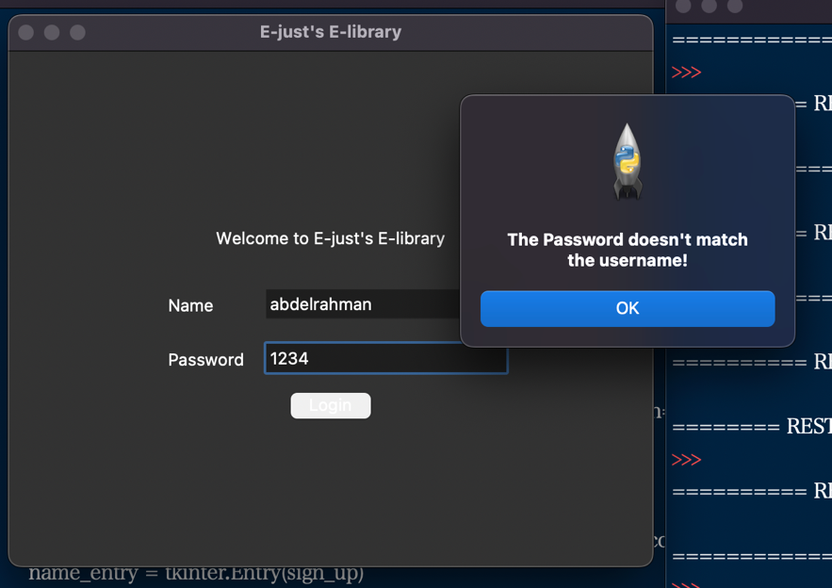Figure 1 The login page, which is the first page

Figure 3 When the user enters a valid name but with the wrong password

Figure 2 When the user inputs a name and password that are not in the database

Figure 5 The dashboard opens up with the book categories for the user to choose from

Figure 4 When the user presses the signup button, A signup menu appears with the following text fields

Figure 7 When the user presses a book button it immediately loads the payment page asking for the user's credit card info.

Figure 6 Once the user has typed a category that he wants, all the books in that category appears as buttons to choose from

**System architecture:**

It is a conceptual model that describes the structure and behavior of multiple components and subsystems like multiple software applications, network devices, hardware, and even other machinery of a system.

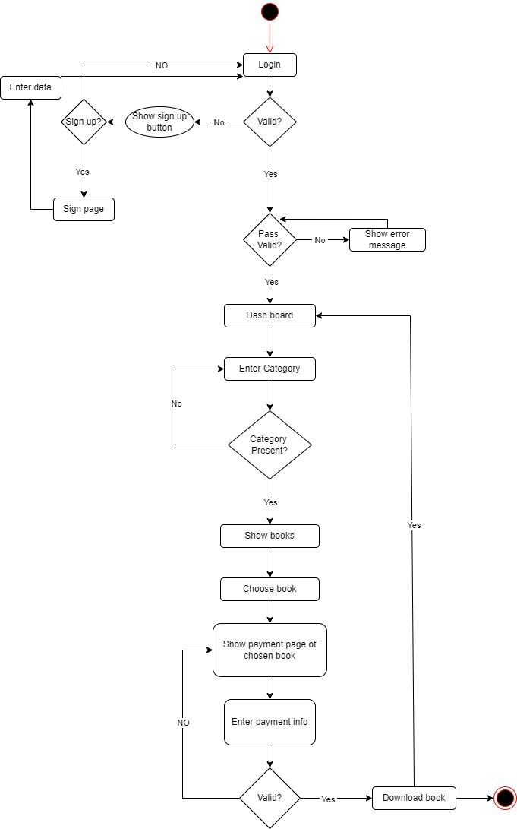**Activity Diagram**

**Use case Diagram**

Use case diagram description(scenario):

The user opens the system and it displays the login page as shown in the snapshots , the user should put in his information and the system will verify if it’s the right credentials or not, in case the user is not registered system will show the sign-up page which will allow the user to register in the system, sending his credentials to the database then directing him to the login page again which if he then logs in with the right credentials it should direct him to the front page of the application which will have a dashboard for the user showing how many books the user has bought and the username and the number of categories and what categories there are in addition to a search bar allowing the user to search for the category he wants and after choosing the category the user needs it will direct him to a page that has all books related to this category allowing him to choose the desired book, after choosing the book she/he wants the system then direct the user to the payment page which he will need to put in his card info before being able to download the book if the info was wrong the system will return the user to the payment page to fill his information again, if it’s right the system should allow the user to download the book he chose and then the system should direct the user to the front page again so he will be able to buy another book.

**Class Diagram**