DESIGN AND IMPLEMENTATION OF A MULTI-SENSOR SOIL MONITORING AND LORA COMMUNICATION SYSTEM FOR PRECISION FARMING APPLICATIONS

BY

ABDULRAUF ABDULRAUF OLASUNKANMI
2021/1/79550ET

DEPARTMENT OF MECHATRONICS ENGINEERING
FEDERAL UNIVERSITY OF TECHNOLOGY, MINNA

SEPTEMBER, 2026

DESIGN AND IMPLEMENTATION OF A MULTI-SENSOR SOIL MONITORING AND LORA COMMUNICATION SYSTEM FOR PRECISION FARMING APPLICATIONS

BY

ABDULRAUF ABDULRAUF OLASUNKANMI
2021/1/79550ET

PROJECT SUBMITTED TO THE DEPARTMENT OF MECHATRONICS ENGINEERING, FEDERAL UNIVERSITY OF TECHNOLOGY, MINNA, NIGERIA IN PARTIAL
FULFILLMENT OF THE REQUIREMENTS FOR THE AWARD OF THE DEGREE OF BACHELOR OF ENGINEERING IN MECHATRONICS ENGINEERING

SEPTEMBER, 2026

DECLARATION
I hereby declare that this thesis titled “Design And Implementation Of A Multi-Sensor Soil Monitoring And Lora Communication System For Precision Farming Applications” is a collection of my original research work, except where artificial intelligence (AI) tools were utilised in literature review and data analysis/interpretation. These AI tools facilitated data visualisation, text analysis and I have meticulously verified all AI generated suggestions against relevant academic sources. I accept full responsibility for the final content of this thesis and declare that it has not been presented for any other qualification anywhere. Information from other sources (published and unpublished) has been duly acknowledged.
Thank you.

ABDULRAUF, Abdulrauf Olasunkanmi ___________________________
2021/1/79550ET Signature and Date
Federal University of Technology
Minna, Nigeria

CERTIFICATION

This thesis titled “Design And Implementation Of A Multi-Sensor Soil Monitoring And Lora Communication System For Precision Farming Applications” by ABDULRAUF, Abdulrauf Olasunkanmi with Matric Number 2021/1/79550ET meets the regulations governing the award of the degree of Bachelor of Engineering in Mechatronics engineering of the Federal University of Technology, Minna, Niger State, Nigeria.

Engr. Dr. Taliha Abiodun Folorunso ___________________________
MAJOR SUPERVISOR Signature and Date

Engr. Dr. Jibril Abdullahi Bala ___________________________
CO-SUPERVISOR Signature and Date

Engr. Dr. Taliha Abiodun Folorunso ___________________________
HEAD OF DEPARTMENT Signature and Date

Engr. Prof. Opeyemi Ayokunle Osanaiye ___________________________
External Examiner Signature and Date

DEDICATION

This research work is dedicated to Almighty Allah for His undeniable blessings, and to my parents for their unwavering love and support throughout my academic journey.

ACKNOWLEDGEMENTS
I extend my sincerest gratitude to Almighty Allah for granting me life, strength, and the opportunity to pursue and complete this program successfully.
I am deeply thankful to my parents, Mr. and Mrs. Amosa Mufutau, and my entire family for their unwavering support, care, and encouragement throughout this journey. Their sacrifices have been the foundation of every achievement in my academic career.
I would also like to express my heartfelt appreciation to my project supervisor and my Head of Department, ENGR. DR. T.A. FOLORUNSO, and co-supervisor, ENGR. DR. J.A. BALA, for their exceptional mentorship, guidance, and patience throughout the design, implementation and testing of this project. The contributions of the entire staff of the Mechatronics Engineering department are invaluable, and their guidance and teachings have enriched me with valuable academic and technical knowledge.
I am particularly grateful to Engr. Issa Sikiru and his family for welcoming me into their home and allowing me to stay throughout my industrial training period. Your hospitality, care, support, and willingness to make me comfortable during that period meant a great deal to me. I will always appreciate the role you played in making my IT experience easier and more memorable.
I also extend my appreciation to Nasirah and my friends Harsheem, Ibrahim(Khalil), Mukthar, Feranmi, Promise, Mubarak, Abdullahi, Babapupa, Thalhat, Cornelius, Nadim, Khalid, Ridwan, Israel, course mates, and everyone who supported me throughout my university journey. Your encouragement, advice, assistance, and the memories we shared have made this journey worthwhile.
May Almighty God continue to reward and enrich you all (Ameen).
ABSTRACT
Agriculture faces mounting challenges from population growth, climate instability, and resource mismanagement, rendering traditional farming practices inefficient and environmentally damaging. While precision agriculture mitigates these issues through data-driven resource application, its adoption in developing regions is heavily bottlenecked by reliance on continuous internet connectivity and stable grid power. This study presents the design and implementation of a self-reliant, multi-sensor soil monitoring and Long Range (LoRa) communication system tailored for off-grid precision farming. The architecture centres on autonomous field nodes powered by solar-battery subsystems and driven by ESP32 microcontrollers. Each field unit utilises a capacitive 7-in-1 RS485 probe to capture real-time soil moisture, temperature, pH, and macronutrient NPK(Nitrogen, Phosphorus and Potassium) levels, geolocated via a Global Positioning System (NEO-6M GPS) module. Telemetry is transmitted over a 433 MHz SX1278 LoRa link to a central gateway every three minutes, bypassing cellular or Wi-Fi dependencies, while the gateway synchronises with a web dashboard when Wireless Fidelity (Wi-Fi) is available. Field validation on a working farm in North-Central Nigeria demonstrated reliable telemetry transmission across 50–300 m under line-of-sight conditions. The system differentiated spatial soil conditions, recording moisture levels of 0% and 21% at two field locations, while average node power consumption was 0.876 W, approximately 36% lower than continuous-active operation. Dynamic localized alerts adapted to distinct spatial soil profiles, while the gateway maintained local monitoring and advisory functions during connectivity interruptions. The study concludes that combining multi-parameter sensing, LoRa communication, solar power, and edge processing provides a cost-effective, infrastructure-independent solution for optimising agricultural resource management and supporting remote smallholder farmers.

Keywords: Edge computing; ESP32; Internet of Things (IoT); LoRa communication; NPK sensing; Off-grid farming; Precision agriculture; Soil monitoring; Solar energy.

TABLE OF CONTENTS
TITLE PAGE i
DECLARATION ii
CERTIFICATION iii
DEDICATION iv
ACKNOWLEDGEMENTS v
TABLE OF CONTENTS vii
LIST OF FIGURES xi
LIST OF TABLES xiii
LIST OF ABBREVIATIONS xiv
CHAPTER ONE 1
1.0 INTRODUCTION 1
1.1 Background of the Study 1
1.2 Problem Statement 3
1.3 Aim and Objectives 4
1.4 Significance of the Study 4
1.5 Scope of the Study 5
1.6 Organisation of Project 6
1.7 Definition of Terms 6
CHAPTER TWO 8
2.0 LITERATURE REVIEW 8
2.1 Chapter Introduction 8
2.2 Precision Agriculture 8
2.3 Soil Parameters and Their Agronomic Significance 10
2.3.1 Soil Moisture 11
2.3.2 Soil Temperature 11
2.3.3 Ambient Humidity 12
2.3.4 Soil Fertility and Macronutrients (NPK) 13
2.4 Wireless Sensor Networks in Agriculture 14
2.4.1 LoRa and LoRaWAN Technology 15
2.4.2 GPS Integration for Spatial Soil Mapping 17
2.5 Review of Related Works 17
2.5.1 Summary of Reviewed Works 25
2.6 Chapter Summary 33
CHAPTER THREE 34
3.0 METHODOLOGY 34
3.1 Chapter Introduction 34
3.2 System Overview 35
3.2.1 Field Layer 36
3.2.2 Communication Layer 37
3.2.3 Gateway Layer 39
3.3 Design and Development of Multi-Sensor Soil Sensing Nodes 40
3.3.1 Materials and Components Used 40
3.3.2 Hardware Calculations 45
3.3.3 Current Consumption 45
3.3.4 Power Consumption 47
3.3.5 Daily Energy Requirement 47
3.3.6 Battery Sizing 48
3.3.7 Solar Panel Sizing 49
3.3.8 Runtime Estimation 50
3.4 Implementation of LoRa Wireless Communication Module 50
3.4.1 Transmission Interval and Duty Cycle 52
3.4.2 Software and Gateway Implementation Design 53
3.4.3 Database and Dashboard Design 54
3.5 Performance Evaluation 55
3.5.1 Testing Methodology 55
3.5.2 Sensor Calibration 55
3.5.3 GPS Testing 55
3.5.4 LoRa Testing 55
3.5.5 Battery Testing 56
3.5.6 Solar Charging 56
3.5.7 Cloud Synchronisation 56
3.5.8 Transmission Success and Range 56
3.6 Chapter Summary 57
CHAPTER FOUR 58
4.0 RESULTS AND DISCUSSION 58
4.1 Introduction 58
4.2 Experimental Setup and Field Validation Results 58
4.2.1 Real-Time Multi-Node Environmental Monitoring 60
4.2.2 Soil moisture and Humidity monitoring 61
4.2.3 Temperature Monitoring 62
4.2.4 Field-Based NPK Measurements Results 63
4.2.5 Simulation of Power consumption of the system 64
4.3 LoRa Communication Performance and Field Validation 65
4.4 Performance Evaluation Results 66
4.5 Chapter Summary 68
CHAPTER FIVE 69
5.0 SUMMARY,CONCLUSION AND RECOMMENDATIONS 69
5.1 Summary 69
5.2 Conclusion 70
5.3 Recommendations for Future Work 70
REFERENCES 72
APPENDICES 76

LIST OF FIGURES
Figure | Title | Page
2.1 | Integration of Sensors and IoT in Precision Agriculture (Mansoor et al., 2025) | 10
2.2 | Symptoms of Nutrient Deficiencies in Plant (Shahab et al., 2025) | 14
2.3 | An intelligent LoRaWAN-based IoT device for monitoring and control solutions in smart farming (Arshad et al., 2022) | 16
3.1 | System architecture showing the field, communication, gateway, cloud, and dashboard layers | 35
3.2 | Circuit diagram of the sensor node | 37
3.3 | Telemetry Packet Structure and wireless communication architecture | 39
3.4 | ESP32-WROOM-32D pinout used in the sensor node and gateway | 41
3.5 | Photograph of the 7-in-1 RS485 soil sensor probe | 42
3.6 | NEO-6M GPS module wiring | 43
3.7 | SX1278 LoRa module used for node-to-gateway telemetry | 44
3.8 | Solar-battery subsystem used to power the system | 45
3.9 | Complete software flowchart for the sensor-node and gateway firmware | 54
4.1 | NODE_01 inserted into a raised dry mound with visually parched, clay-loam soil | 59
4.2 | NODE_02 positioned on a sloped sandy terrain patch with slightly higher residual soil moisture | 59
4.3 | Dashboard overview captured during the farm field session | 61
4.4 | Soil-moisture (top) and humidity (bottom) trend charts from the dashboard covering the farm validation session | 62
4.5 | Temperature trend from the dashboard for the farm session | 63
4.6 | Latest Readings log from the dashboard (200 records total; most recent rows shown) | 64
4.7 | Simscape power/energy estimation subsystem for the ESP32/LoRa/GPS node | 65

LIST OF TABLES
Table | Title | Page
2.1 | Summary of reviewed papers | 25
3.1 | Typical Component Current Consumption | 46
3.2 | LoRa Packet Structure | 50
4.1 | Field Validation Results of LoRa Communication Performance — Farm Deployment | 66
4.2 | Summary of Transmission Success by Separation | 68

LIST OF ABBREVIATIONS
Abbreviation | Meaning
CRC | Cyclic Redundancy Check
CSS | Chirp Spread Spectrum
EC | Electrical Conductivity
ESP32 | Espressif Systems 32-bit Microcontroller
GPIO | General-Purpose Input/Output
GPS | Global Positioning System
GSM | Global System for Mobile Communications
IoT | Internet of Things
LoRaWAN | Long Range Wide-Area Network
LPWAN | Low-Power Wide-Area Network
NMEA | National Marine Electronics Association
NPK | Nitrogen, Phosphorus and Potassium
pH | Potential of Hydrogen
RE | Receiver Enable
RTU | Remote Terminal Unit
SF | Spreading Factor
SPI | Serial Peripheral Interface
TP4056 | Lithium-Ion Battery Charging Controller
UART | Universal Asynchronous Receiver-Transmitter
WSN | Wireless Sensor Network
dBm | Decibel-milliwatts

CHAPTER ONE

1.0 INTRODUCTION

1.1 Background of the Study
Agriculture is one of the key foundations of human civilisation. It helps to ensure food security, economic growth and livelihoods globally. The Food and Agriculture Organisation of the United Nations (“The State of Food and Agriculture 2025,” 2025) reports that the agriculture sector is a source of employment for over two and a half billion people worldwide and the backbone of the economies of developing countries. In sub-Saharan Africa the performance of agriculture has a direct impact on the national levels of food sufficiency and poverty. But, with the population explosion, climatic changes, soil degradation, and mismanagement of resources, there are increasing challenges in agriculture(Singh et al., 2022).
Monitoring and management of soil health is important for food production, and many farming communities are still not precise and effective at monitoring and managing soil conditions (Khanal et al., 2024; Shahab et al., 2025). The farmers use traditional practices of soil sampling, laboratory testing and farmer observation on a periodic basis to aid in irrigation and fertiliser decision-making. All these methods are time-consuming, expensive, and unable to measure the soil conditions at various locations within a field (Pawar & Deosarkar, 2023).This results in over-irrigating or under-fertilising, which wastes water and chemicals for farmers. This also results in increased production expenses, soil erosion, and harmful environmental impacts such as soil pollution from nutrient run-off into water bodies (Khanal et al., 2024). In particular, many farmers in developing areas are still using these antiquated techniques.
The problem of imprecise soil management can be solved by the concept of precision agriculture with the help of Internet of Things (IoT) and Wireless Sensor Network (WSN) (Almufareh et al., 2024; Arshad et al., 2022; Križanović et al., 2023). It employs real-time measurement and monitoring of soil moisture, soil temperature, nutrient content and other variables to inform on-site and time variable management of all production inputs. This is a substitute for blanket practices, which are substituted with targeted interventions according to specific field conditions (Placidi et al., 2021). These soil measurements are collected and transmitted by a sensor-based system that utilises the Internet of Things (IoT), enabling timely decision-making by farmers and systems to support them. It has been found that irrigation and fertilisation management based on data can reduce water consumption by 20–40 percent and improve crop yields by 10–25 percent over conventional practices (Placidi et al., 2021; Khanal et al., 2024). Several IOT soil monitoring platforms have been designed and tested in the studies and found to be technically feasible (Arshad et al., 2022).
However, there are still many challenges to be addressed in current soil monitoring systems using IoT, particularly in remote and rural fields. Many of the solutions available rely on wireless connectivity, either Wi-Fi or cellular; such connectivity is not always available or reliable in many developing countries (Sen et al., 2024). Most of the sensors measure a single soil parameter, which limits the ability to obtain a comprehensive picture of soil conditions required for optimal precision farming decisions making (Pamungkas et al., 2023). One of the drawbacks is that most of the low-cost systems lack GPS-based(Global Positioning System) spatial tagging features, which create geo-referenced soil health maps useful for targeted application of soil health management strategies for crop management (Pawar & Deosarkar, 2023). All these challenges make it difficult for smallholder and remote farmers to obtain timely, comprehensive soil information.
The aim of this project is to develop a multi-sensor soil monitoring and LoRa communication system to overcome these challenges for precision farming. The system is based on the use of an ESP32 microcontroller as its central controller, an NPK(Nitrogen, Phosphorus and Potassium) sensor and a GPS module to collect a wide variety of NPK and environmental parameters at each of the sensor locations. Data is transmitted wirelessly via LoRa SX1278 transceiver with the capability to transmit data over ranges in rural areas without requiring any cellular or internet infrastructure. Each soil measurement is geographically tagged to the GPS module, enabling site-specific soil health maps to be developed. It is a low cost, low power, plug-and-play system that is ideal for Smallholder and Farms in Remote Areas in Developing Countries.

1.2 Problem Statement
The global population is increasing, arable land is decreasing and climate instability is a problem for food production systems across the world (Pawar & Deosarkar, 2023). The traditional farming methods that involve manual soil sampling, visual assessment, and equal water and fertiliser application are not adaptable to the dynamics and variability of soil properties (Khanal et al., 2024). They are imprecise, costly and environmentally damaging due to nutrient run-off and soil compaction. The use of IoT-based precision farming technologies in developing countries and rural remote regions with low population density is hindered by the continued technological, infrastructural and financial challenges (Mansoor et al., 2025).
The main issue this project addresses is the lack of a reliable, multi-parameter, infrastructure-independent soil monitoring system that can work well in remote farming areas. The current low-cost soil sensors for IoT often use Wi-Fi and/or cellular communication technologies for data transmission; however, these technologies are frequently unavailable or unreliable in the remote agricultural areas of developing countries (Arshad et al., 2022; Aldhaheri et al., 2024; Placidi et al., 2021). The lack of reliable internet infrastructure and power supply remains a primary bottleneck for precision agriculture in Sub-Saharan Africa, such as in Nigeria (Song et al., 2026; Lloret et al., 2021). The majority of the sensor nodes that are deployed measure only one soil characteristic, such as moisture or temperature. Also existing low-cost systems lack GPS-based geolocation, making it difficult to map soil conditions in a spatial manner which is important for field zonation for different treatment (Pawar & Deosarkar, 2023). These constraints imply that the farmers in remote areas are not able to receive the spatiotemporally complete and timely soil information that they require for the purposes of precision farming.

1.3 Aim and Objectives
The aim of this project is to design and implement multi-sensor soil monitoring and LoRa communication system for precision farming applications.
The objectives of this project include the following:
- To develop soil sensing nodes which will be able to sense multiple factors.
- To develop a wireless communication module utilising LoRa module which will transfer sensed data to a gateway.
- To evaluate the performance of the developed system.

1.4 Significance of the Study
This study is a major step forward in the field of precision agriculture by addressing some of the technological challenges that have hindered the use of soil monitoring devices in rural areas. The development of a multi-sensor soil monitoring platform that is capable of operating over long distances without the need of internet access for the farmers from underdeveloped countries is very crucial. The system gives farmers the information they need to make fast, site-specific decisions by providing real-time insight into a variety of soil characteristics, such as temperature, humidity, moisture, and vital nutrients. The results of these studies have consistently shown that yield gains of 10-25%, water savings of 20-40% and economical savings of 20-30% can be achieved through data-driven irrigation and fertilisation management compared to conventional practices (Placidi et al., 2021).
The proposed technology can help in sustainable agriculture by enabling accurate application of resources which reduces the chances of fertiliser run-off and reduces unnecessary chemicals and soil degradation. The advantage of the GPS-based spatial tagging is that detailed soil health maps can be generated, which is an emerging practice in modern agronomy and is now becoming more common, the use of precision zone management (Pawar & Deosarkar, 2023). This research offers fresh insights into how multiple sensor data can be combined with the LoRa communication system and how this data can be used for predictive analysis using artificial intelligence, providing researchers and developers with a replicable approach for future smart farming solutions.

1.5 Scope of the Study
The project involves the design, development, and testing of a multi-sensor soil monitoring system with LoRa radio wireless communication to support precision agriculture. Real-time soil moisture, soil temperature, ambient humidity, and NPK nutrient levels (Nitrogen, Phosphorus, and Potassium) can be acquired by the system. Each sensor node is equipped with a GPS module for geographical tagging of collected data. The LoRa SX1278 module enables long-range wireless data transmission of up to 15 kilometers in rural area, without the need for cellular or Wi-Fi infrastructure. The system adopts a network topology, where multiple sensor nodes communicate with a single central gateway that sends and stores sensor data. The system is also designed to interface with an AI-based predictive module for irrigation and fertilisation decision support.
The LoRa communication range may be reduced in environments with significant physical obstructions such as dense vegetation or buildings.
The system relies on a rechargeable battery and solar panel for operation. Extended periods of cloudy weather or insufficient sunlight may reduce the battery charging efficiency and shorten the operating time of the sensor node.
The AI-based prediction module relies on data trends over time and may not provide reliable outputs during the initial period of deployment when insufficient historical data is available.

1.6 Organisation of Project
The report of this project is presented in five chapters. The introduction to the study which covers background, problem statement, aim and objectives, significance, scope and definition of key terms is presented in Chapter One. In Chapter Two, the literature survey on precision agriculture, soil monitoring technologies, IoT sensor systems and LoRa communication is presented. The research methodology used for the development of the system is discussed in Chapter Three, which includes system architecture, hardware selection, circuit configuration and software implementation. The results of the system testing and performance evaluation are presented and discussed in Chapter Four. The report ends with a summary of findings, conclusions and recommendations for further research in Chapter Five.

1.7 Definition of Terms
- ESP32 (Espressif Systems 32-bit Microcontroller): is a low-power microcontroller with integrated Wi-Fi and Bluetooth capability, developed by Espressif Systems, that has a dual-core architecture. The ESP32 is the main component of the soil sensor node in this project, gathering sensor data, controlling the GPS tagging and arranging LoRa data exchange.
- LoRa (Long Range): Long-range, low power wireless modulation. The long-range communication capability of 2 to 15 kilometers in a rural area with a low power consumption makes LoRa a perfect solution for agricultural IoT applications in rural areas without cellular coverage.
- NPK Sensor: The NPK Sensor is an electronic soil sensor that measures the concentration of three macronutrient elements (Nitrogen (N), Phosphorus (P), Potassium (K)) in the soil. These nutrients are important metrics for soil fertility and crop health, and real-time measurement of these nutrients is essential for precision farming and fertiliser application.
- Precision Agriculture: A farm management strategy that utilises information technology, sensor networks, and data analytics to optimise field-level agronomic decisions with respect to crop, soil, and environmental conditions. Precision agriculture aims to maximise crop yield and resource efficiency by enabling site-specific and time-specific management of farming inputs.
- Telemetry: Automatic measurement and wireless transmission of such measurements from remote sensors to a receiving station for monitoring and analysis.

CHAPTER TWO

2.0 LITERATURE REVIEW

2.1 Chapter Introduction
The chapter reviews the body of knowledge that is used when designing this project. It starts with the basics - what precision agriculture is, the relationship between soil health parameters and crop productivity and how sensor-based systems using IoT technologies have been implemented to overcome the gap between field condition and farm management. So, the review focuses on the technology used in the system, which includes wireless sensor networks, wireless LoRa communication, the ESP32 microcontroller, and the integration of GPS. The chapter ends in a well-organised review of direct related implementations and a summary of the gaps that the review identifies.

2.2 Precision Agriculture
The term "precision agriculture" gets used loosely, but its core idea is specific: “inputting the correct input, at the correct rate, at the correct location, at the correct time” (Mansoor et al., 2025). It is different from traditional farming where a farmer spreads the same amount of water or fertiliser throughout a field irrespective of the requirement of the different zones in that field (Almufareh et al., 2024; Mansoor et al., 2025). It was a concept that developed in the 1980s when GPS was first introduced and when yield-mapping equipment was also available (Lloret et al., 2021; Mansoor et al., 2025). The cost of precision agriculture and the potential benefits were not aligned enough to be practically used by many smallholder and mid-scale farms, until the advent of affordable IoT sensors and wireless communication in the 2010s (Pawar & Deosarkar, 2023; Song et al., 2026). That barrier cost still exists, and that is the problem that this project addresses.
Data is the key to precision agriculture success. It needs to continually provide spatially referenced measurements of the variables that control crop performance: soil moisture, temperature, macronutrient concentrations, pH(Potential of Hydrogen), ambient humidity (Song et al., 2026). These parameters do not display a consistent pattern throughout a field. Hectares of farm land can have pockets of high clay portions directly next to well-drained sandy soils, and areas with inadequate amounts of nitrogen alongside other areas that are sufficiently fertilised. Failure to acknowledge this variability in a field entirely results in predictably sub-optimal results (Placidi et al., 2021).
In precision agriculture, the field is subdivided into management zones, with the inputs applied according to the measured conditions in each zone (Mansoor et al., 2025; Najdenko et al., 2024). This approach of zones is entirely reliant on the quality and spatial density of the information provided by the underlying sensors; if the number of sensors is limited or data is sparse or delayed, the zones are too broad to be considered a significant improvement over the uniform approach (Mansoor et al., 2025; Song et al., 2026). This is because the frequency of the monitoring system is as important as the management strategy that is developed on top of the monitoring system (Khanal et al., 2024; Shahab et al., 2025)
Precision agriculture is considered by the Food and Agriculture Organization (FAO) as a core approach to sustainable intensification, which aims to boost agricultural output and food production on existing farmland without causing additional environmental harm or a corresponding rise in resource use (FAO, 2025). If the world's population keeps rising towards a projected 10 billion by 2050 while the amount of productive arable land remains strictly limited and dwindling, it puts the field in an entirely different light than just farm economics (Pawar & Deosarkar, 2023; Shahab et al., 2025). It comes to the forefront exactly where the complex issues of global food security, environmental sustainability, and agricultural development policy intersect (FAO, 2025; Mansoor et al., 2025). Consequently, leveraging precision technologies for sustainable land management is no longer merely a commercial agricultural concern, but a critical global development priority that underpins efforts to protect ecosystems, adapt to climate instability, and achieve the United Nations' Sustainable Development Goals (FAO, 2025; Shahab et al., 2025). Figure 2.1 illustrates the integration of sensors and IoT in precision agriculture, highlighting their role in supporting efficient and data-driven farming practices (Mansoor et al., 2025).
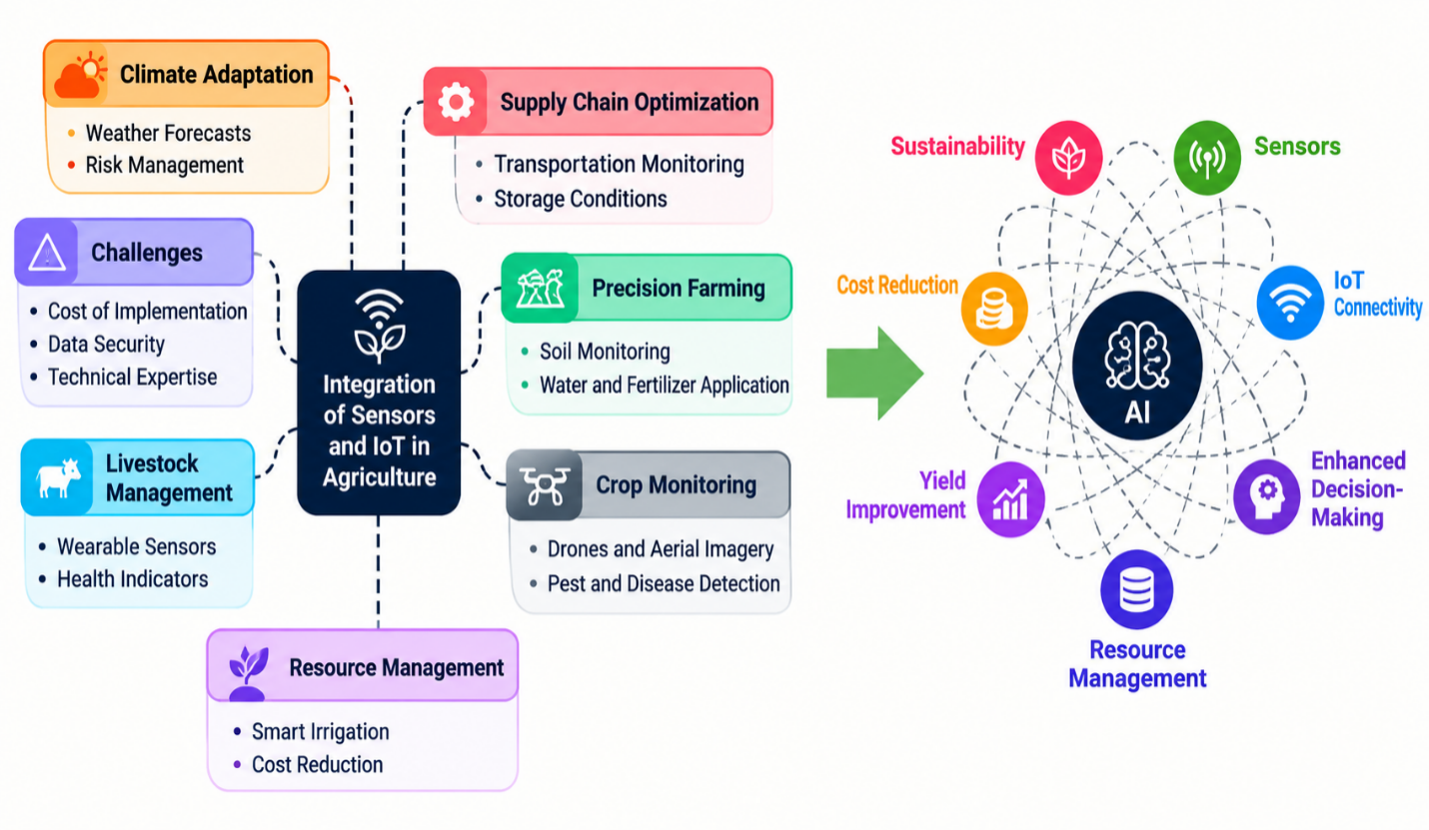

Figure 2.1 Integration of Sensors and IoT in Precision Agriculture(Mansoor et al., 2025)

2.3 Soil Parameters and Their Agronomic Significance
Soil is not an inert growing medium; it is a highly dynamic system, and the parameters that define its state at any particular time directly affect a crop's productivity (Shahab et al., 2025). Knowing which parameters are important and why they fluctuate is essential to the design of a precision monitoring system. The following subsections detail the primary variables affecting crop production that this system aims to monitor.

2.3.1 Soil Moisture
Of the variables affecting crop production, water availability is by far the most critical in the short term. Water and dissolved nutrients are taken up by the roots, and when the water content in the soil drops below the specific "wilting point" for a plant, growth slows, and yield loss can occur within days (Chereches et al., 2024). However, excess watering is equally problematic; excessive moisture in the soil reduces oxygen availability around the roots, leading to anaerobic conditions that benefit pathogenic bacteria and increase nutrient loss from the soil (Pawar & Deosarkar, 2023). Traditional irrigation scheduling is generally based on calendar or evapotranspiration estimates, both of which are merely proxies for what physical sensors can measure. With real-time moisture data, irrigation can be triggered by current field moisture conditions rather than estimates, successfully saving water without compromising yield (Sen et al., 2024). To address this efficiently, recent implementations have successfully utilised low-cost capacitance-based soil moisture sensors with specialised modelling to accurately read volumetric water content across various soil types (Placidi et al., 2021).

2.3.2 Soil Temperature
Soil temperature affects the germination rates, rooting, efficiency of nutrient uptake, and microbial activity (Pawar & Deosarkar, 2023; Shahab et al., 2025). For most crops, there is a critical temperature range before and after which root formation and nutrient uptake are effective, and higher or lower than this range even with sufficient moisture and nutrient may have negative impacts on normal plant performance (Shahab et al., 2025). The monitoring of temperature in addition to moisture allows a management system to consider these interactions, rather than assuming they operate independently of each other (Khanal et al., 2024).

2.3.3 Ambient Humidity
The relative humidity (RH) of the air above the crop canopy directly influences the crop's transpiration rate, and consequently, the rate of decrease in soil moisture. Increased ambient humidity reduces transpiration and water loss, whereas decreased humidity accelerates them (Placidi et al., 2021). The inclusion of ambient humidity in the sensing suite makes irrigation scheduling substantially more accurate than relying on soil moisture data alone, as it accounts for one of the major atmospheric factors contributing to changing field conditions (Khanal et al., 2024).
Ambient humidity is one of the most important factors that influence the overall evapotranspiration rate, which is one of the most important factors used for calculating the actual crop water demand and for scheduling the exact irrigation event (Singh et al., 2022). This ability to monitor variations in air humidity in addition to temperature, continuously makes the IoT system very "climate-adaptive," such that it can automatically adapt watering schedules to prevent water stress in plants due to very dry air (Sen et al., 2024).
Knowledge of the ambient humidity is important for plant physiology, as leaf growth, photosynthesis and pollination rates may be severely affected by a growth of plants in dry conditions, leading to the death of delicate plant structures (like sepals or flowers) before reaching maturity (Placidi et al., 2021). Consequently, feeding real-time humidity data into an automated decision-making algorithm enables the system to forecast evaporation trends dynamically. This ensures that the water distributed to the root zone precisely matches the fluctuating atmospheric demands above ground, optimising resource use while safeguarding crop health (Sen et al., 2024; Singh et al., 2022).

2.3.4 Soil Fertility and Macronutrients (NPK)
Soil fertility is mainly governed by the macronutrients (Nitrogen, Phosphorus ,Potassium) and each one has a different role in the physiology of the plants. Nitrogen is key to protein production and vegetative growth, deficiency causes yellowing leaves and slow growth, and excess causes luxuriant leaves while restricting root and fruit production (Shahab et al., 2025). Phosphorus stimulates root growth, flowering and seed production, especially in early growth of most crops. Potassium is involved in water control in plant cells, resistance to diseases and enhancing fruit quality, and under potassium deficiency plant is highly vulnerable to drought stress (Perdana et al., 2024). Figure 2.2 illustrates common symptoms associated with nutrient deficiencies in plants, providing a visual representation of how nutrient imbalance can affect plant development (Shahab et al., 2025).
The traditional way of assessing NPK is laboratory testing of soil samples, which can take days to weeks, and requires financial resources that many smallholder farmers in developing countries just do not have. The readings of electronic NPK sensors based on the ion-selective electrode method are obtained within seconds. In soil fertility monitoring, the accuracy of electronic multi-sensor NPK measurements compared to the laboratory results was tested and proven to be sufficient for implementation in precision farming (Pamungkas et al., 2023).
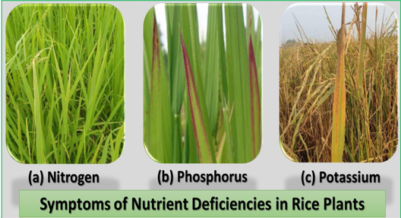

Figure 2.2: Symptoms of Nutrient Deficiencies in Plant (Shahab et al., 2025)

2.4 Wireless Sensor Networks in Agriculture
A Wireless Sensor Network consists of a group of spatially distributed sensor nodes which communicate wirelessly to gather and share data (Križanović et al., 2023). Agricultural WSNs have constraints that are not found in most industrial and urban deployments: power consumption, since nodes are placed on batteries and are required to power them for a long time without maintenance (Aldhaheri et al., 2024; Patrizi et al., 2022); long communication range, since the fields are large (Aldhaheri et al., 2024); and outdoor reliability in the presence of rain, temperature variation, and dense vegetation (Lloret et al., 2021; Mansoor et al., 2025).
Different WSNs use different communication technology, hence, different constraints can be satisfied for each type. Wi-Fi achieves high data rates and has a range of tens of metres at best, and consumes too much power for battery-powered field nodes (Arshad et al., 2022). GSM(Global System for Mobile Communications) and cellular networks offer range but need infrastructure, power usage higher than LPWAN (Low-Power Wide-Area Network) and SIM and data costs (Mansoor et al., 2025). All of those are not well suited to the range, power efficiency and infrastructure independence needed for remote agricultural monitoring.
This is where low-power wide-area network (LPWAN) technologies come in. They sacrifice data rate because agricultural sensor data doesn't require it as often, and since it's small packets that are being sent (Aldhaheri et al., 2024). A soil monitoring node sending a few dozen bytes every few minutes doesn't need bandwidth; it needs to reach a gateway kilometers away without draining its battery in a week.

2.4.1 LoRa and LoRaWAN Technology
Spread-spectrum modulation technique developed by Semtech, which uses unlicensed sub GHz frequency bands called LoRa (Long Range). The modulation technique is what makes it special (Križanović et al., 2023). LoRa employs Chirp Spread Spectrum (CSS) that encodes data into sweeps of frequencies over a given bandwidth. The received signal level for CSS signals is well below the noise floor, which is not possible with conventional narrow band modulation (Singh et al., 2022).
LoRa operates in open, rural areas that either have line of sight or near line of sight between a node and a gateway and can transmit in the milliwatt power range between 2 and 15 kilometers from a node to a gateway. In the urban context, range is heavily restricted by the presence of buildings and roads, whereas it is not in rural conditions, which is pertinent to this context (Križanović et al., 2023).
The SX1278 transceiver is used to process the physical layer and communication protocol between the sensor node and the gateway is realised through the firmware program without deploying the complete LoRaWAN(Long Range Wide-Area Network) layer. This eliminates any need for network server infrastructure and ensures a simple implementation, matching the system's design needs (Placidi et al., 2021).
Arshad et al. (2022) deployed a LoRaWAN-based smart agriculture decision support system in several field nodes and tested communications performance as well as agronomic results throughout the entire growing season. The architecture and operational concept of the proposed device are presented in Figure 2.3. And the conclusions that they draw are that LoRa can be relied upon to provide reliable real time information in rural agricultural contexts and the data yielded by LoRa can lead to significantly improved irrigation and fertilisation decisions over traditional management practices on the same farm.
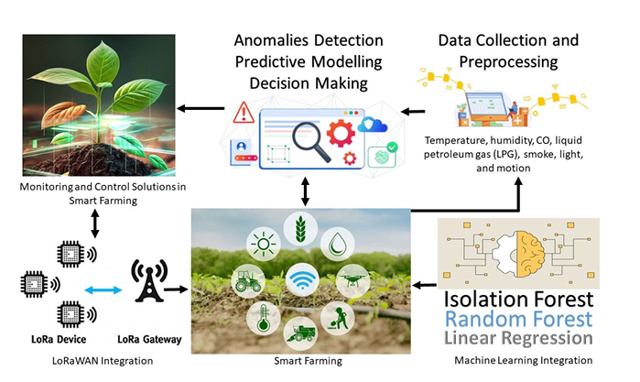

Figure 2.3: An intelligent LoRaWAN-based IoT device for monitoring and control solutions in smart farming Arshad et al. (2022).

2.4.2 GPS Integration for Spatial Soil Mapping
In a fixed-node deployment, the GPS coordinate is a static metadata tag that is attached to the measurements that the node transmits; it tells the data management system exactly which field location each one of these measurements refers to. Where the nodes are repositioned or moved through a field, it becomes a mobile or semi-mobile deployment and the coordinate is a variable to be recorded at each reading, ensuring the data is spatially coherent (Arshad et al., 2022).
If soil data is georeferenced with GPS coordinates, it can be displayed as a soil health map – a layer in the georeferenced map format that depicts the moisture, temperature or NPK levels of soil throughout the field. These maps form the basis for management zone delineation, which involves multiple irrigation/fertiliser management plans for different management zones depending on irrigation (or fertiliser) needs measured versus assumed (Pawar & Deosarkar, 2023). Readings from a network of nodes can be a stack of disconnected numbers without spatial referencing, but with spatial referencing they can become a map that illustrates a pattern that a single point reading could not (Aldhaheri et al., 2024).
Singh et al. (2022) combine LoRa with GPS based soil and weather monitoring technologies and project spatial information onto maps, which are then used to guide variable-rate irrigation application on the field. Their findings indicate that with careful analysis of the data, GPS tagged data from a small number of field nodes can yield important spatial insights that can be acted upon, a result that backs the integration of GPS in this project.

2.5 Review of Related Works
This section summarises specific applications found in the recent literature that are directly comparable to the system proposed in this project, in particular, the systems where multi-sensor soil measurements are coupled with LoRa or LPWAN communication.
Shahab et al. (2025) presented a real-time IoT monitoring system intended to support crop-management decisions in rice fields. The system used an 8-in-1 soil sensor connected to a cloud platform over Wi-Fi, and it automatically generated fertiliser and irrigation recommendations from the sensor readings. Its strength lies in demonstrating that automated, sensor-driven decision support can be delivered directly to farmers in a usable form. However, the system depends entirely on Wi-Fi and a mobile-hotspot internet connection, which is unreliable or unavailable in the remote, unconnected farmland this project targets; this limitation is a key justification for adopting long-range LoRa communication instead of Wi-Fi in the proposed system.
Aldhaheri et al. (2024) conducted a comprehensive literature review of LoRa-based agricultural networks under the Agriculture 4.0 paradigm, examining the opportunities, challenges and future directions of the technology. The review's strength is its broad synthesis of evidence confirming that LoRa's long communication range and low power consumption make it an efficient wireless option for precision farming, which supports the communication technology chosen for this project. Its main limitation, however, is that it is a survey rather than an implemented system: it does not deploy or evaluate an actual multi-sensor soil node, leaving an empirical gap that the hardware design and field testing of this project are intended to fill.
Chereches et al. (2024) designed and calibrated a low-cost, multi-point soil moisture monitoring system that used twenty-eight capacitive sensors wired to an Arduino Mega 2560 through multiplexers, in order to assess irrigation efficiency across a field. The strength of this work is its demonstration of dense, spatially distributed moisture sensing at low hardware cost, which is a useful reference for sensor calibration practice. Its limitation, in relation to the problem this project addresses, is that the system is restricted to moisture sensing over wired multiplexed connections, with no wireless communication and no macronutrient (NPK) detection; this justifies the wireless, multi-parameter sensing approach adopted here.
Patrizi et al. (2022) developed a solar-powered sensor node that transmitted environmental data over Wi-Fi and applied a Long Short-Term Memory (LSTM) deep-learning model to produce a “virtual” soil moisture sensor, estimating moisture without a dedicated physical moisture probe. A strength of this study is its validation of solar power as a viable, extended-life energy source for field sensor nodes, an approach this project also adopts. The limitation, however, is that the system relies on Wi-Fi connectivity and on a modelled, virtual estimate of moisture rather than direct physical sensing of soil nutrients; this underlines the need, addressed in this project, for direct physical NPK measurement delivered over a long-range LoRa link rather than a modelled proxy over Wi-Fi.
Almufareh et al. (2024) built an intelligent LoRaWAN-based IoT monitoring framework that applied an Isolation Forest unsupervised machine-learning algorithm to detect anomalies in temperature and humidity readings from farm sensor nodes. Its strength is in showing that LoRaWAN links can reliably carry sensor data of sufficient quality to support machine-learning-based anomaly detection, which is encouraging for the data-quality requirements of this project. Its limitation is that the work is confined to environmental anomaly detection in temperature and humidity, with no NPK sensing and no GPS-based spatial tagging, both of which are central to the soil-nutrient mapping problem this project sets out to solve.
Kumar (2025) implemented an automated, Arduino-based multi-sensor farming platform that combined soil moisture, temperature and ultrasonic sensors to control irrigation pumps and to raise alerts on animal intrusion. The strength of this system is its practical demonstration of closed-loop automation, linking sensing directly to actuation and alerting. Its limitation is the absence of any long-range wireless communication technology such as LoRa and the absence of dedicated NPK sensing, restricting the platform to short-range, wired operation on a single plot; this directly justifies the integration of long-range LoRa communication and macronutrient sensing in the system proposed here.
Khanal et al. (2024) developed an ESP32S3-based soil health monitoring system capable of measuring soil moisture, pH, UV exposure and NPK levels, and transmitting the data in real time over Wi-Fi, GSM or LoRa. This is one of the closest functional precedents to the present project because it combines NPK sensing with an optional LoRa transmission path, and its strength lies in proving that multi-parameter soil-nutrient sensing can be paired successfully with LPWAN communication. Its limitation is the absence of integrated GPS functionality, so the readings cannot be tied to precise field locations or used to build a spatial soil-health map; supplying that missing GPS-based spatial referencing is a core objective of this project.
Križanović et al. (2023) designed an energy-efficient, LoRa-based multi-sensor wireless sensor network that used deep-sleep scheduling on an ESP32 microcontroller to extend node battery life, and separately carried out a thorough field evaluation of LoRa performance in agricultural settings, measuring packet delivery ratio and signal strength across different distances and spreading factors. The strength of this work is the depth of its empirical characterisation of LoRa link performance and power-saving scheduling, both of which directly inform the duty-cycling and link-budget decisions made in this project. Its limitation is that it monitors only general environmental parameters and does not incorporate NPK sensing or GPS tagging, leaving the nutrient- and location-aware monitoring problem unresolved.
Pamungkas et al. (2023) investigated the accuracy of a LoRa-based soil fertility monitoring system built around three electronic NPK sensors, comparing their readings against standard laboratory soil analysis. The strength of this study is that it provides direct empirical validation that low-cost electronic NPK sensors can approach laboratory-level accuracy for practical precision-farming use, which supports the feasibility of the 7-in-1 NPK sensor selected for this project. Its limitation is the calibration drift and measurement deviation the electronic sensors exhibited over extended use, and the absence of GPS integration; these findings motivate the calibration routine and the spatial (GPS-based) tagging built into the system proposed here.
Perdana et al. (2024) developed a real-time, IoT-based NPK detection device, built around a commercial RS-485 macronutrient sensor and a LoRa RFM95 module, that produced dynamic fertiliser recommendations and was reported to significantly increase soybean yield in field trials. Its strength is the demonstrated real-world agronomic benefit of combining NPK sensing with LoRa transmission, and its published calibration data are directly applicable to the sensor configuration used in this project. Its limitation is the absence of GPS integration, so soil-nutrient conditions cannot be tracked or mapped geographically across an expansive farm; closing that specific gap is one of the express aims of the system proposed here.
A. K. K. N. et al. (2024) proposed a smart NPK monitoring and control system built on an ESP32 microcontroller that integrated NPK and moisture sensors to continuously assess soil hydration and macronutrient status, driving an automated fertiliser dispenser. The strength of the system is its closed-loop automation, moving directly from sensing to fertiliser dispensing without manual intervention. Its limitation is that it relies exclusively on the ESP32's native Wi-Fi connectivity, with no long-range LoRa module and no GPS, making it unsuitable for large or remote agricultural fields lacking reliable internet coverage, precisely the operating condition this project is designed to address through LoRa communication.
Song et al. (2026) carried out a systematic literature review of multi-type soil-sensing technologies, synthesising the critical trade-offs among sensor cost, technological maturity and ecological impact across the field. Its strength is the broad technological landscape it maps out, which helps justify the specific sensor choices made in this project, including the selection of a 7-in-1 NPK sensor as a mature, cost-effective option. Being purely a review, its limitation is that it analyses adoption bottlenecks and technology trends without performing any physical engineering, design or field testing of a novel multi-sensor LoRa system, a gap that the implementation phase of this project directly addresses.
Arshad et al. (2022) implemented a solar-powered, GPS-equipped sensing node carrying NPK, moisture and pH sensors that transmitted data over LoRaWAN to a cloud-based Decision Support System supporting automated irrigation; the reported outcome was increased crop yield and reduced water use compared with conventional management. This is the most structurally complete precedent identified in the literature, as it combines solar power, GPS, multi-parameter NPK sensing and LoRaWAN communication in a single validated node, and its strength lies in demonstrating measurable agronomic benefit from exactly this combination of technologies. Its limitation, as the authors themselves note, is that the prototype works reliably only in limited areas and cannot extract data from encrypted sensors, indicating a need for further hardware optimisation and more robust field testing, the kind of refinement this project sets out to provide.
Pawar and Deosarkar (2023) produced an exhaustive review of Internet-of-Things communication technologies for smart agriculture, concluding that Low-Power Wide-Area Network (LPWAN) protocols, LoRa in particular, are best suited to agricultural use because of their minimal power requirements and extended communication range. Its strength is the comparative rigour with which it weighs LoRa against alternative wireless standards, offering an authoritative justification for the communication technology adopted in this project. Its limitation is that, as a literature survey, it does not physically engineer or test a multi-sensor hardware node for real-time soil NPK monitoring, which is exactly the practical contribution this project makes.
Najdenko et al. (2024) reviewed and categorised commercially available and experimental in-field soil-analysis tools and proximal sensing methods, comparing approaches to the real-time mapping of soil pH, nitrate, phosphorus and potassium. Its strength is the comprehensive, state-of-the-art catalogue of nutrient-sensing technologies it provides, which is useful for justifying and situating the sensor choice made in this project. Its limitation is that it remains a technological survey rather than a proposal for a new, integrated IoT hardware system using LoRa communication, leaving room for the practical implementation this project undertakes.
Saban et al. (2023) developed a smart agricultural system that combined LoRa and LoRaWAN connectivity with Programmable Logic Controllers (PLCs) and a cloud-based web application, enabling remote environmental monitoring and task automation through a multi-node architecture with a central gateway. Its strength is the gateway and multi-node network design it demonstrates, which is a useful reference for the network architecture of this project. Its limitation is that it is oriented toward general environmental monitoring and food-storage automation rather than in-situ soil-nutrient tracking, and the system is neither GPS-tagged nor NPK-monitored, gaps this project's soil-monitoring focus is designed to close.
Lloret et al. (2021) designed a low-cost, group-based wireless sensor network using inductive-coil soil moisture sensors to automate and control smart irrigation according to crop water requirements. Its strength is the cost-effective, scalable network deployment model it demonstrates for coordinating groups of sensor nodes. Its limitation is that the network architecture is dedicated exclusively to moisture-based irrigation control, entirely omitting multi-sensor NPK macronutrient sensing and long-range LoRaWAN integration, both of which this project incorporates.
Singh et al. (2022) developed a smart soil and weather monitoring system built on a single LoRa communication platform that combined multi-parameter environmental sensing with spatial data collection. Among all the works reviewed, this is the most structurally similar to the system proposed here, since it unifies wireless communication, multi-parameter sensing and location-aware data collection on one platform, which strongly supports the architectural approach of this project. Its limitation is that it was designed to monitor weather-related parameters rather than soil macronutrients, so it does not address the NPK-monitoring problem this project focuses on.
Rafi et al. (2025) designed FieldNet, an IoT framework for agricultural automation that integrates LoRa communication, distributed sensor data gathering and AI-driven predictive decision-making. Its strength is that it represents one of the most extensive and recent treatments of LoRa-based precision agriculture combined with artificial intelligence, and its documented communication-range performance and AI-integration approach inform the design choices made in this project. Its limitation is that, as a general automation framework, it is not described with a dedicated, GPS-tagged, multi-sensor NPK soil node, so it stops short of the specific spatial soil-nutrient monitoring problem this project is built to solve.
Taken together, the reviewed literature clusters into four broad groups: systems that perform generic environmental sensing (moisture, temperature, humidity) over Wi-Fi or GSM links that are unreliable in remote farmland; systems that sense NPK macronutrients but lack GPS-based spatial tagging, so their readings cannot be assembled into a field-level soil-health map; systems that combine GPS and LoRa communication but without direct NPK sensing; and literature reviews that justify these technologies conceptually without producing and field-testing an integrated hardware system. None of the reviewed works combine a 7-in-1 NPK sensor, GPS-based location and timestamp tagging, long-range LoRa communication and solar-powered extended operation within a single validated soil-monitoring node. This gap is precisely what the multi-sensor soil monitoring and LoRa communication system designed and implemented in this project addresses.

2.5.1 Summary of Reviewed Works
Table 2.1: Table of Reviewed Works
Reference | Title / Focus | Methodology and Result | Limitation / Relevance
H. Shahab et al., 2025 | Real-time IoT monitoring system for decision-making in rice crops. | The researchers developed an IoT-based environmental monitoring system using an 8-in-1 soil sensor connected to a cloud platform via Wi-Fi to provide automated fertiliser and irrigation recommendations for rice fields. | The system relies heavily on Wi-Fi and internet connectivity via a mobile hotspot, justifying the need for my proposed system to utilise long-range LoRa communication for remote, unconnected farming environments.
L. Aldhaheri et al., 2024 | LoRa Communication for Agriculture 4.0: Opportunities, Challenges, and Future Directions. | The study presents a comprehensive literature review of LoRa-based agricultural networks, concluding that LoRa's long-range and low-power capabilities make it a highly efficient solution for precision farming. | The study lacks the empirical deployment of a multi-sensor soil node, establishing a gap for my practical hardware design project.
I. A. Chereches et al., 2024 | Designing and Calibration of a Low-Cost Multi-Point Soil Moisture Monitoring System for Precision Agriculture. | The study developed a multi-point soil moisture monitoring system utilising 28 low-cost capacitive sensors connected to an Arduino Mega 2560 board through multiplexers to assess irrigation efficiency | The implemented system focuses entirely on moisture sensing via wired connections, lacking wireless LoRa communication and NPK nutrient detection, which justifies the multi-sensor wireless approach of my proposed system.
G. Patrizi et al., 2022 | A Virtual Soil Moisture Sensor for Smart Farming Using Deep Learning. | The researchers developed a solar-powered sensor node transmitting environmental data over Wi-Fi and applied an LSTM-based deep learning algorithm to create a virtual soil moisture sensor. | The system relies on Wi-Fi communication and estimates moisture virtually instead of utilising physical multi-sensor hardware for direct NPK nutrient sensing, demonstrating the need for my proposed LoRa-based physical monitoring system.
M. F. Almufareh et al., 2024 | Intelligent LoRaWAN-based IoT device for anomaly detection in farming. | The researchers developed an intelligent LoRaWAN-based IoT monitoring framework that integrates Isolation Forest unsupervised machine learning to accurately detect anomalies in temperature and humidity data. | The study focuses exclusively on environmental anomaly detection for temperature and humidity, lacking the specific multi-sensor integration needed for direct soil NPK monitoring that my project proposes.
R. Kumar, 2025 | Integrated Multi-Sensor Embedded Platform for Automated Precision Farming. | The author implemented an automated Arduino-based farming platform that uses soil moisture, temperature, and ultrasonic sensors to control water pumps and provide animal intrusion alerts. | The system does not utilise long-range wireless communication technologies like LoRa or specific sensors for detecting NPK levels, directly justifying the integration of these features in my proposed design.
K. Khanal et al., 2024 | IoT-Based Real-Time Soil Health Monitoring System for Precision Agriculture. | The researchers developed an ESP32S3-based system capable of measuring soil moisture, pH, UV, and NPK levels, transmitting real-time data via Wi-Fi, GSM, or LoRa protocols to a central server. | While the system monitors NPK and utilises LoRa, it lacks integrated GPS functionality for the precise spatial mapping of soil health across large fields, which my proposed system will feature
V. Križanović et al., 2023 | An Advanced Energy-Efficient Environmental Monitoring in Precision Agriculture Using LoRa-Based Wireless Sensor Networks. | The authors evaluated LoRaWAN wireless sensor networks through field measurements and simulations to determine optimal communication parameters for reliable, energy-efficient data transmission in precision agriculture. | The study focuses heavily on network energy profiling and transmission parameters rather than the physical hardware integration of a multi-sensor node for soil NPK tracking, validating my focus on hardware development.
W. Pamungkas et al., 2023 | Research in electronic multi-sensor accuracy in the implementation of soil fertility monitoring system using LoRA. | The study developed a LoRa-based soil fertility monitoring system using three electronic NPK sensors, comparing their accuracy and standard deviation against standard laboratory soil tests. | The electronic sensors showed significant measurement deviations from laboratory results, indicating a critical need for improved multi-sensor calibration and GPS integration, which my project aims to address.
D. Perdana et al., 2024 | Development of an IoT-Based Device for Real-Time Detection of Soil NPK Nutrient Content to Optimise Soybean Yields. | The authors implemented a real-time IoT detection system using an NPK sensor and a LoRa RFM95 module to provide dynamic fertiliser recommendations, significantly increasing soybean yields. | Although the system utilises LoRa for NPK monitoring, it does not incorporate GPS integration for geographically tracking soil conditions across expansive farming plots, highlighting a specific gap my system will fill.
A. K. K. N. et al., 2024 | Smart NPK Monitoring and Control System for Precision Agriculture. | The study proposes an ESP32 microcontroller-based monitoring framework integrating NPK and moisture sensors to continuously assess soil hydration and macronutrient levels for automated fertiliser dispensing. | The developed system relies exclusively on the ESP32's native Wi-Fi connectivity without integrating a long-range LoRa communication module, making it unsuitable for vast agricultural fields lacking internet coverage.
W. Song et al., 2026 | Soil Sensors in Smart Agriculture: Multi-Type Monitoring Technologies and Ecological Development Pathways. | This systematic literature review synthesised research on multi-parameter soil sensors, revealing critical trade-offs between sensor cost, maturity, and ecological impact. | Being purely a systematic literature review, the study analyses adoption bottlenecks but lacks the physical engineering, design, and field testing of a novel multi-sensor LoRa system, justifying my project's implementation phase.
J. Arshad et al., 2022 | Implementation of a LoRaWAN Based Smart Agriculture Decision Support System for Optimum Crop Yield. | The researchers developed a solar-powered, GPS-equipped sensing node containing NPK, moisture, and pH sensors that transmits data via LoRaWAN to a cloud-based Decision Support System for automated irrigation. | The authors explicitly noted their prototype is only compatible in limited areas and cannot extract data from encrypted sensors, demanding further hardware optimisation and robust field testing that my proposed project will provide.
A. Pawar & S. B. Deosarkar, 2023 | IoT-based smart agriculture: an exhaustive study. | The paper reviews multiple IoT communication technologies, concluding that Low Power Wide Area Network (LPWAN) protocols like LoRa are optimal for agriculture due to their minimal power requirements and extended range. | As a literature survey comparing existing wireless standards, the study does not physically engineer a multi-sensor hardware node for real-time soil NPK monitoring, confirming the necessity of my proposed implementation.
E. Najdenko et al., 2024 | Categorization of in-field soil analysis tools and proximal sensing. | This comprehensive review evaluates commercially available and experimental in-situ soil nutrient sensing technologies, comparing methods for the real-time mapping of soil pH, nitrate, phosphorus, and potassium. | The research serves as a state-of-the-art technological survey of existing soil sensors rather than proposing a new, integrated IoT hardware system utilising LoRa communication, leaving room for my practical implementation.
M. Saban et al., 2023 | A Smart Agricultural System Based on PLC and a Cloud Computing Web Application Using LoRa and LoRaWan. | The researchers developed a customised smart farming system integrating LoRa connectivity with Programmable Logic Controllers (PLCs) to remotely monitor environmental sensors and automate tasks via a web application. | While the system effectively integrates LoRa with PLCs, it is geared toward general environmental monitoring and food storage rather than direct, in-situ multi-sensor soil NPK tracking, making my proposed soil monitoring device highly relevant.
J. Lloret et al., 2021 | A Wireless Sensor Network Deployment for Soil Moisture Monitoring in Precision Agriculture. | The researchers designed a low-cost, group-based wireless sensor network utilising inductive coil soil moisture sensors to effectively automate and control smart irrigation systems based on crop requirements. | The proposed network architecture focuses exclusively on smart irrigation and soil moisture via a specialised coil sensor, completely omitting multi-sensor NPK macronutrient sensing and long-range LoRaWAN integration.

2.6 Chapter Summary
In this chapter, the conceptual and technological development of the proposed system was traced. The essence of precision agriculture is site specific resource management based on data; the implementation of precision agriculture relies on the comprehensiveness and spatial quality of soils data. The most relevant factors to irrigation and fertilisation decisions are soil moisture, soil temperature, ambient humidity, and NPK levels; and it is shown in this literature review that there is a strong case for monitoring all these parameters simultaneously.
While precision agriculture demands real time monitoring, the communication technology will be the key to whether or not these systems can make that work in the remote rural environment. LoRa's range, low power consumption and ability to operate without the need for cellular or Internet infrastructure is ideal for this application; the SX1278 LoRaWAN transceiver has been used in several agricultural deployments. The sensor node design requires processing power, peripheral flexibility and sleep-mode power management, which the ESP32 offers. By integrating GPS into point measurements, it can be mapped instead of just logged.
As from the review of related works, there is no existing system that provides multi-parameter sensing, LoRa communication, GPS tagging and infrastructure independent in one system which is cheap. The design of this project will be described as it satisfies that need in Chapter Three.

CHAPTER THREE

3.0 METHODOLOGY

3.1 Chapter Introduction
The methods for designing, implementing and testing the designed soil intelligence monitoring system are described in this chapter. An ongoing challenge for distributed agricultural sensing is the ability to deliver locally actionable, timely advice in rural and off-grid farming situations where cellular or Wi-Fi connectivity is not guaranteed. Instead of a cloud-first approach with connectivity being a prerequisite for decisions, the proposed system is designed to leverage intelligent networks, enabling the generation of irrigation, fertilisation and environmental advice at the point of data collection and to be available irrespective of the state of the communication link to the wider internet.
The system is designed as a five-layered system: Sensing and acquisition layer; wireless communication layer; power and energy autonomy layer; edge processing and advisory layer; and visualisation layer. The design, implementation and testing of each layer was done as an individual subsystem prior to integration into the field-deployable prototype. The method adopted at each stage is documented in this chapter.
Each of these layers is described in turn in terms of design methodology and implementation procedures, followed by description of the methodology used for testing the hardware, communication subsystem, power subsystem and software components individually and as an integrated system under field conditions.

3.2 System Overview
The system reported in this work is organised as a five-layer stack comprising a field (sensing) layer, a communication layer, a gateway layer, a cloud layer, and a dashboard layer as shown in Figure 3.1. Each layer performs a well-defined function and communicates with its neighbouring layers through a fixed interface, so that any single layer can be modified, replaced, or scaled independently of the others.
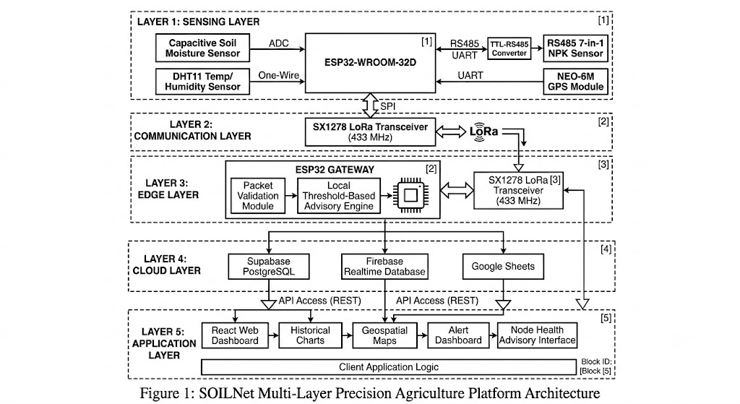

Figure 3.1: System architecture showing the field, communication, gateway, cloud, and dashboard layers
At the base of the stack are three field-deployed sensor nodes (Sensor Node 1, Sensor Node 2, and Sensor Node 3). Each node is powered autonomously from a small photovoltaic panel through a TP4056 lithium charge controller into a four-cell parallel 18650 Li-ion bank, with a boost converter regulating the unregulated battery rail to a stable 5 V supply for the peripherals.
The sensed data is embedded in a packet with a fixed format and sent via a 433 MHz LoRa link with SX1278 configured at SF9(Spreading Factor) and 125 kHz. Instead of broadcasting all the time, each node is programmed to take a reading reporting duty cycle of 3 minutes: when it wakes up, it gets readings from all nodes, sends a single reading, then returns to the low power state. This interval was chosen deliberately as a compromise between energy conservation and decision timeliness. Soil moisture, temperature and nutrient levels evolve over a timescale of hours rather than seconds, so a three-minute cadence is more than sufficient to support irrigation and fertilisation decisions while keeping the radio duty cycle, and therefore the average current draw is low. All three nodes report to a single ESP32 gateway, which is the second physical device in the architecture.

3.2.1 Field Layer
The field layer comprises the three physically identical sensor nodes. Each node is built around the ESP32-WROOM-32D system-on-chip, a dual-core Tensilica LX6 microcontroller, and integrated Wi-Fi and Bluetooth radios. Although the on-board Wi-Fi/Bluetooth radio is present, it is kept disabled during normal field operation to conserve power, since telemetry is carried entirely over the separate LoRa radio. Wi-Fi is used only on the gateway, where mains or larger battery power is available.
Soil condition is sensed using a 7-in-1 RS485 capacitive soil probe, which reports moisture, temperature, EC, pH, nitrogen, phosphorus and potassium over a Modbus-RTU register read initiated by the ESP32 through a MAX485 transceiver. Because the probe communicates over RS485 rather than direct analogue sensing, it is largely immune to the electrical noise and long-cable signal loss that affect analogue soil sensors, and a single serial transaction returns a complete, internally consistent set of readings. Geolocation for each reading is obtained from a NEO-6M GPS module, whose NMEA sentences are parsed on the ESP32 to extract latitude, longitude and a UTC(Coordinated Universal Time) timestamp, allowing every packet to be placed accurately on the dashboard map.
Power is supplied by a self-contained solar-battery subsystem consisting of a small photovoltaic panel, a TP4056 linear lithium charge-management IC, a four-cell parallel bank of 18650 lithium-ion cells, and a boost converter that regulates the resulting 3.0–4.2 V battery rail up to a stable 5 V for the microcontroller, RS485 transceiver and GPS module. Figure 3.2 presents the electrical interconnection and power distribution of the major components of the sensor node.
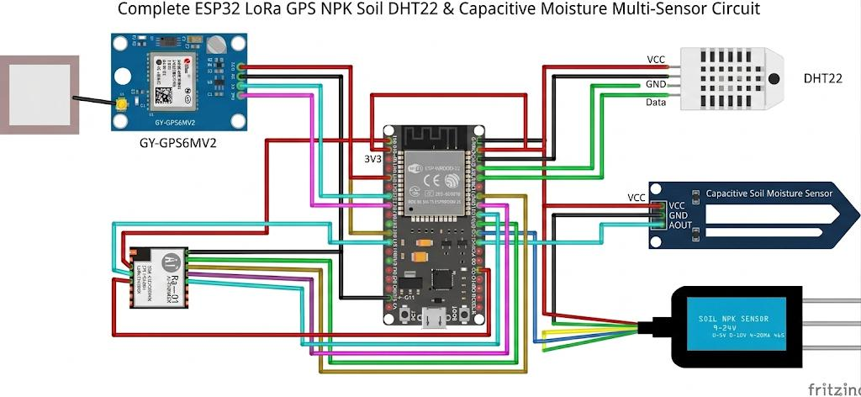

Figure 3.2: Circuit diagram of the sensor node

3.2.2 Communication Layer
Inter-node communication is carried entirely over a 433 MHz LoRa link built around the Semtech SX1278 transceiver, which implements Chirp Spread Spectrum modulation. Each node's radio is configured with a spreading factor of SF9 and a channel bandwidth of 125 kHz, a combination chosen to balance transmission range against on-air time and, by extension, energy consumption: a higher spreading factor extends range and improves sensitivity at the cost of a longer transmission, while a lower one shortens the transmission but sacrifices link margin. SF9/125 kHz was found to give reliable decoding over the separations expected across a small farm plot without imposing an excessive on-air time given the fixed three-minute reporting interval. Every payload carries a CRC(Cyclic Redundancy Check) field, allowing the gateway to silently discard corrupted packets rather than accept and log erroneous readings, and every payload is tagged with a unique node identifier so that the gateway (and downstream dashboard) can attribute each reading to the correct physical node and location.
In brief, each transmission carries the node identifier, a timestamp, GPS latitude and longitude, and the seven soil parameters, closed with a two-byte CRC, for a total payload of approximately 32–33 bytes. Because each node transmits only once per three-minute cycle and the resulting on-air time is a small fraction of a second, the aggregate channel occupancy across all three nodes remains far below common regulatory duty-cycle limits for the 433 MHz ISM(Industrial, Scientific and Medical) band, leaving generous headroom for retransmissions or additional nodes in a future expansion of the network.
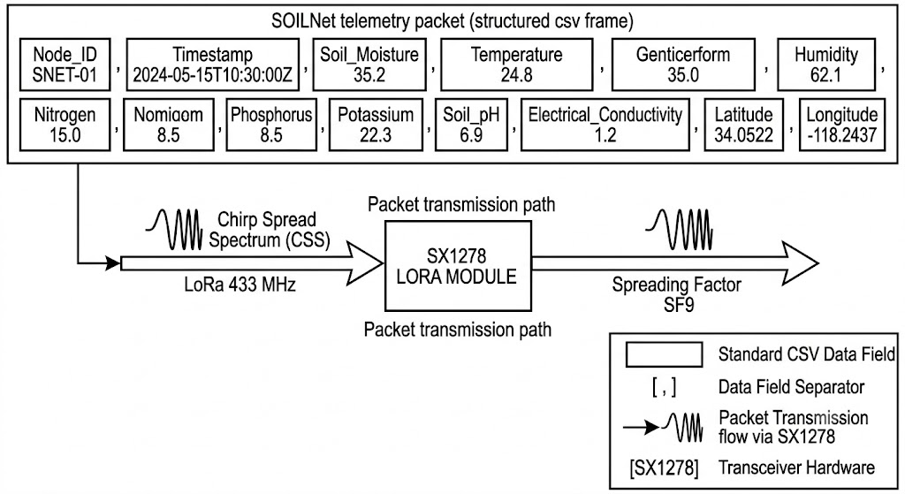

Figure 3.3: Telemetry Packet Structure and wireless communication architecture

3.2.3 Gateway Layer
The gateway is a single and distinct ESP32 device responsible for four distinct tasks: Receiving and validating LoRa data, local persistence, local decision making, and cloud synchronisation. When the gateway receives a packet, it first checks the CRC and discards a packet if its CRC does not match, and then extracts the node identifier and payload fields. Each valid packet is added to a log file on a micro-SD card, attached via SPI, as a timestamped event: this ensures that no information is lost even if a gateway's Wi-Fi connection is down, or a cloud back-end connection is lost.
The gateway executes a deterministic threshold engine on each incoming reading, without relying on any cloud connectivity. Fixed lower and upper limits are set for each of the sensed parameters, based on agronomic considerations (for instance, a soil moisture below a certain percentage will be considered as a soil moisture low advisory, and a pH or EC outside their limits will be interpreted as a nutrient low advisory), and the resulting advisories are sent to the dashboard when they are synced. This design makes it possible to make irrigation and fertilisation decisions even in the event of extended connectivity outages, which is important in the deployment context that is aimed for, in rural areas where connectivity is limited.
When the Wi-Fi interface of the gateway identifies a network with a usable access point, it initiates a synchronisation session and uploads any records that have not been synchronised to the cloud; these rows are then marked as synchronised in the gateway log, and are not uploaded again. This opportunistic, store and forward approach ensures the gateway works well when connectivity is continuous as well as intermittent, or even completely unavailable for long periods.

3.3 Design and Development of Multi-Sensor Soil Sensing Nodes

3.3.1 Materials and Components Used
This section presents the materials and components used in the design and implementation of the proposed soil monitoring system.
A. ESP32 Microcontroller
Both the sensor nodes and the gateway are built around the ESP32-WROOM-32D module. The module integrates a dual-core Xtensa LX6 CPU(Central Processing Unit) clocked at up to 240 MHz, 520 KB of internal SRAM plus 4 MB of external SPI flash, and a wide range of on-chip peripherals. For this design, the relevant interfaces are a hardware UART used for the RS485 (MAX485) link to the soil probe and a second UART for the NEO-6M GPS module, an SPI bus used for the SD card on the gateway, and general-purpose GPIO pins used for the SX1278 LoRa module's chip-select, reset and digital I/O lines. Figure 3.2 presents the ESP32-WROOM-32D used in the development of the sensor node.
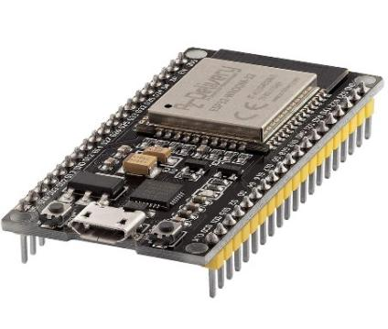

Figure 3.4: ESP32-WROOM-32D pinout used in the sensor node and gateway
B. 7-in-1 Soil Sensor
The soil probe used in this design is a capacitive, RS485-output 7-in-1 sensor that reports soil moisture, temperature, electrical conductivity, pH, nitrogen, phosphorus, and potassium from a single insertion point. Moisture is sensed capacitively by measuring the dielectric permittivity of the surrounding soil, which varies strongly with water content; temperature is sensed with an integrated thermistor; EC, pH, and the N-P-K values are derived internally by the probe's own signal-conditioning circuitry from electrode measurements, and returned to the host as pre-computed register values rather than raw analogue voltages. All seven parameters are retrieved in a single Modbus-RTU "read holding registers" transaction, which simplifies the firmware considerably compared to polling seven discrete analogue sensors.
Because the probe communicates digitally over a differential RS485 pair rather than a single-ended analogue voltage, the readings are robust to the electrical noise picked up along the sensor cable, and cable runs of several metres between the buried probe and the enclosure housing the ESP32 do not introduce measurable signal degradation, which is an important practical advantage for field deployment. Figure 3.4 presents the 7-in-1 RS485 soil sensor probe used for soil parameter acquisition.
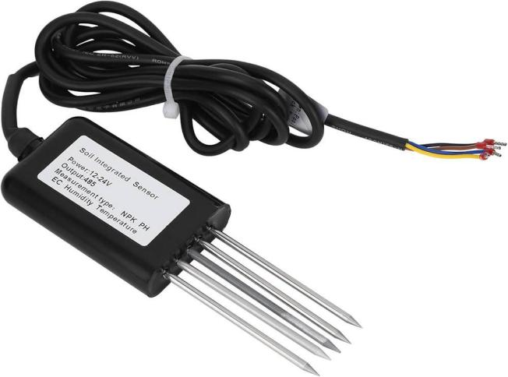

Figure 3.5: Photograph of the 7-in-1 RS485 soil sensor probe
C. MAX485 Interface
Because the ESP32's UART operates at TTL logic levels while the soil probe expects a differential RS485 signal, a MAX485 transceiver is used to convert between the two. The MAX485 exposes a standard UART pair (RO/DI) on its logic side and a differential pair (A/B) on its bus side, together with driver-enable (DE) and receiver-enable (RE) control lines that are tied together and driven from a single ESP32 GPIO pin, allowing the firmware to switch the bus between transmit and receive modes around each Modbus transaction. This conversion allows the probe to be sited several meters from the enclosure without the signal integrity problems that a single-ended connection of the same length would suffer.
D. GPS Module
Each node carries a NEO-6M GPS receiver, connected to a second hardware UART on the ESP32. The module outputs standard NMEA-0183 sentences (principally GPRMC and GPGGA) at a default baud rate of 9600 bps, from which the firmware extracts the current latitude, longitude, and UTC time using a lightweight NMEA parser. The latitude and longitude are included in the telemetry packets so each reading can be plotted on the Leaflet map that is displayed on the dashboard, even when the node was moved between fields. UTC time, where available, is used to keep each node's local clock synchronised for all readings on the same node are timestamped at the same time (or nearly the same time) across the network. Figure 3.5 illustrates the wiring configuration of the NEO-6M GPS module used in the sensor node.
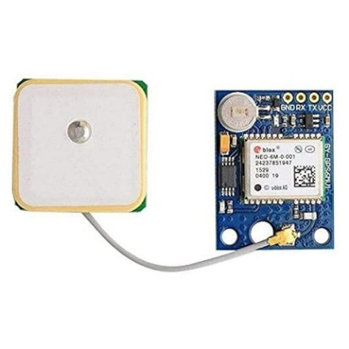

Figure 3.6: NEO-6M GPS module wiring
E. LoRa Module
The Semtech SX1278 LoRa module is a 433MHz ISM band wireless telemetry module that is connected to the ESP32 via SPI. LoRa's Chirp Spread Spectrum modulation maps each bit to a chirp, a linear sweeping signal over the channel bandwidth, which provides a processing gain and can correctly receive a packet very close to the noise floor, at the expense of the raw data rate compared to traditional narrowband modulation. The trade-offs among range, on-air time and power consumption are controlled by three parameters: channel bandwidth (set to 125 kHz, a common default that offers a good balance between range and symbol rate); spreading factor (in this design, SF9, which provides good sensitivity for a relatively short on-air time); and coding rate (for this design, it is the default 4/5, which provides modest forward error correction against burst noise without an excessively long on-air time). Figure 3.6 shows the SX1278 LoRa module employed for node-to-gateway telemetry.
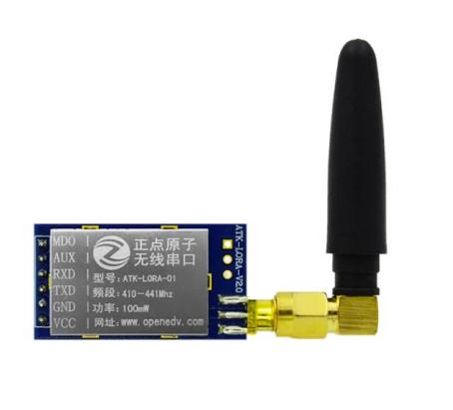

Figure 3.7: SX1278 LoRa module used for node-to-gateway telemetry
F. Power System
Each field node is powered independently by a small solar battery rather than mains power, since nodes must be deployable at arbitrary points across a farm plot with no wired supply. Energy is harvested by a small photovoltaic panel and regulated by a TP4056 linear lithium-ion charge-management IC, which manages constant-current/constant-voltage charging of the battery bank and provides basic protection against over-charging. The battery bank itself consists of four 18650 lithium-ion cells connected in parallel, giving a nominal 3.7 V rail with a combined capacity several times that of a single cell, which increases both the runtime between charges and the tolerance of the system to a run of poor-sunlight days. Because most of the node's peripherals require a stable 5 V rather than the raw, sagging 3.0–4.2 V battery voltage, a boost converter steps the battery rail up to a regulated 5 V supply, and a physical power switch allows the node to be fully isolated from the battery during transport or maintenance. Figure 3.7 presents the solar-battery subsystem implemented to power the system.

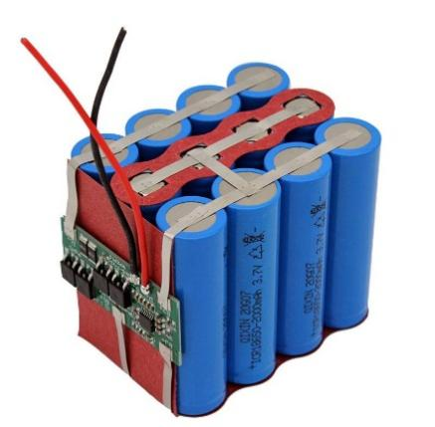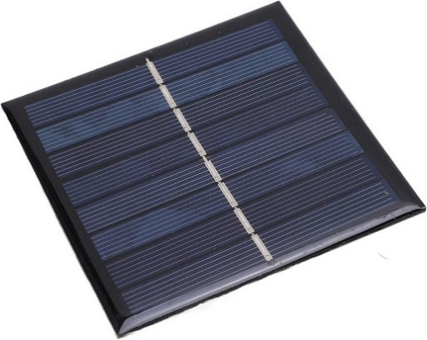

Figure 3.8: Solar-battery subsystem used to power the system

3.3.2 Hardware Calculations
This section derives the current, power and energy budget of a single field node and uses it to size the battery bank and solar panel. The calculations use the duty-cycled operating pattern described, a full sense-and-transmit cycle roughly every three minutes, with the node otherwise held in a low-power state, together with typical datasheet current figures for each component.

3.3.3 Current Consumption
Table 3.2 lists the typical operating current drawn by each active component of a field node, measured or estimated at the node's regulated 5 V rail (the RS485 probe's own 12 V analogue front end is supplied separately and is not included in the 5 V rail budget).

Table 3.1: Typical Component Current Consumption
Device | Operating State | Current (mA)
ESP32-WROOM-32D | Active (CPU + peripherals, radio idle) | 20 – 30
ESP32-WROOM-32D | Deep sleep | 0.01
LoRa (SX1278) | Transmit, 20 dBm | 110 – 130
LoRa (SX1278) | Receive / idle | 10 – 12
NEO-6M GPS | Acquiring / tracking | 40 – 50
MAX485 transceiver | Active (driving bus) | 10 – 15
7-in-1 NPK probe | Measuring (12 V side) | 18 – 22
For a conservative worked estimate, the total instantaneous current while the node is fully active, CPU awake, GPS acquiring, RS485 transaction in progress and the LoRa radio transmitting is taken as the sum of the individual peak figures above:
$$I_{Total}= I_{ESP32}+ I_{GPS}+ I_{LoRa}+ I_{MAX485}+ I_{Sensor}$$
$$≈ 25 + 45 + 120 + 12.5 + 48 = 250.5 mA \left( 3.1\right)$$
This peak figure of approximately 250.5 mA is sustained only for the brief active portion of each duty cycle (on the order of one to two seconds, dominated by GPS acquisition and the LoRa transmission itself).

3.3.4 Power Consumption
Instantaneous power drawn from the regulated 5 V rail follows directly from Ohm's law presented in Equation 3.2:
$$P = V × I \left( 3.2\right)$$
$$P = 250.5 * 5$$
P = 1.25 W
Applying this to the active-state current from Eq. 3.1 at the 5 V regulated rail gives a peak active power of approximately 1.25 W. This peak power occurs only momentarily during each three-minute cycle and is what the boost converter and battery bank must be able to source instantaneously, even though the average power delivered over time is very much lower, as shown next.

3.3.5 Daily Energy Requirement
Energy is the time-integral of power, or equivalently the product of power and elapsed time using Equation 3.3:
$$\begin{matrix} & { E}_{\text{active}}=P_{\text{peak}}t_{\text{active}} & & \text{(3.3)}\end{matrix}$$
Treating each three-minute (180 s) reporting cycle as having an active phase of approximately 115 s:
$$E_{\text{active}}=1.2525×115=144.04\text{ J}$$
$$E_{\text{active}}=\frac{144.04}{3600}≈0.0400\text{ Wh/cycle}$$
The corresponding charge drawn from the 5 V rail during the active portion of each three-minute cycle is:
$$\begin{matrix} & { Q}_{\text{cycle}}=I_{\text{peak}}×\frac{t_{\text{active}}}{3600} & & \text{(3.4)}\end{matrix}$$ $Q_{\text{cycle}}=250.5×\frac{115}{3600}≈8.002\text{ mAh}$
With a three-minute (180 s) reporting interval, each node completes 480 cycles per day:
$$N_{\text{cycles/day}}=\frac{24×3600}{180}=480$$
The corresponding daily charge drawn from the 5 V rail is therefore:
$$\begin{matrix} & { Q}_{\text{5V,day}}=Q_{\text{cycle}}×N_{\text{cycles/day}} & & \text{(3.5)}\end{matrix} \\ Q_{\text{5V,day}}=8.002×480≈3841\text{ mAh/day}$$
The corresponding daily energy delivered by the 5 V rail is:
$$\begin{matrix} & { E}_{\text{5V,day}}=V_{\text{rail}}×\frac{Q_{\text{5V,day}}}{1000} & & \text{(3.6)}\end{matrix} \\ { E}_{\text{5V,day}}=5×\frac{3841}{1000}≈19.21\text{ Wh/day}$$
This 5 V-rail energy must, in turn, be supplied from the 3.7 V battery bank through the boost converter, which is assumed to be 85% efficient. Reflecting the daily energy requirement back to the battery side gives:
$$\begin{matrix} & E_{\text{battery,day}}=\frac{E_{\text{5V,day}}}{η_{\text{boost}}} & & \text{(3.7)}\end{matrix} \\ { E}_{\text{battery,day}}=\frac{19.21}{0.85}≈22.59\text{ Wh/day}$$
At the nominal battery voltage, this corresponds to a daily charge drawn from the battery of:
$$\begin{matrix} & Q_{\text{battery,day}}=\frac{E_{\text{battery,day}}}{V_{\text{battery}}}×1000 & & \text{(3.8)}\end{matrix} \\ { Q}_{\text{battery,day}}=\frac{22.59}{3.7}×1000≈6106.5\text{ mAh/day}$$

3.3.6 Battery Sizing
Battery capacity is sized from the required average battery-side current, the desired autonomy (the number of hours the node must run without any solar input, for example during a run of heavily overcast days), and the depth of discharge (DoD) the battery chemistry can tolerate without accelerated degradation taken here as 80% for lithium-ion cells. The average battery-side current implied by Eq. 3.7 is
$$I_batt,avg = 6106.5 mAh ÷ 24 h ≈254.4 mA.$$
$$Capacity = (Current × Hours) / Depth of Discharge (3.8)$$
For a target autonomy of five fully sunless days (120 hours) at this average battery-side current, the minimum required capacity is:
$$Capacity_min = (254.4 mA × 120 h) / 0.8 ≈ 38.2Ah (3.9)$$
The four-cell parallel 18650 bank used in this design provides a combined nominal capacity of approximately 13,000 mAh, which exceeds the minimum requirement of Eq. 3.9 by a factor of roughly 2.6. This provides a reasonable, though not excessive, margin against cell ageing, temperature-related capacity loss and day-to-day variation in active-state current, while keeping the pack a practical physical size for a field-deployable node; it does not, on its own, allow the very long sunless-autonomy figures a more lightly loaded node might achieve, which is why solar recharging (sized below) remains an operationally necessary part of the design rather than a mere convenience.

3.3.7 Solar Panel Sizing
The photovoltaic panel must be able to replace the daily energy consumption of Eq. 3.5 within the available sunlight hours. Using an average of four peak sun hours per day, a conservative figure for the deployment region is obtained using Equation 3.8:
$$Solar Power =\frac{Daily Energy}{Peak Sun Hours} \left(3.8\right)$$
$$P_{solar}= \frac{22.59 Wh}{4 h} ≈ 5.65 W \left(3.9\right)$$
In practice, a panel is selected above this theoretical minimum to account for further charge-controller losses, non-ideal panel orientation, partial shading and cloudy days; applying a conservative two- to five-times safety margin over the 5.64 W minimum gives a practical panel rating in the region of 6 – 10 W. This is a materially larger panel than the sensing-and-radio load alone might suggest, which follows directly from the active window and the additional boost-converter conversion loss folded into Eq. 3.7, and it should be sized into the bill of materials accordingly rather than assuming the very small panels sometimes used for lighter-duty LoRa nodes.

3.3.8 Runtime Estimation
The battery-only runtime (i.e. with no solar recharging at all) is obtained from the installed capacity and the average current:
$$Runtime =\frac{\left(Battery Capacity\right)}{\left(Average Current\right)} \left(3.10\right)$$
$$Runtime ≈ 13,000 mAh / 254.4 A ≈ 51.1 h ≈ 2.13 days (3.11)$$
This result indicates that, at the modelled average active-state current and 115 s/180 s duty cycle, the installed battery bank alone provides approximately 2.1 days of autonomy without any solar recharging. This underlines why the solar subsystem is an operationally necessary part of the design rather than a convenience. With the solar subsystem active, the node is expected to operate continuously under normal field conditions provided that the photovoltaic system replenishes the daily energy consumed by the node.

3.4 Implementation of LoRa Wireless Communication Module
Each telemetry transmission follows a fixed packet structure, so that the gateway can parse every incoming payload without any negotiation step between node and gateway. Table 3.3 lists the fields making up a single packet, in transmission order.

Table 3.2: LoRa Packet Structure
Field | Size (bytes) | Description
Node ID | 1 | Unique identifier of the originating sensor node (1, 2 or 3)
Timestamp | 4 | Unix epoch time of the reading, from GPS or local RTC
Latitude | 4 | GPS latitude, IEEE-754 single-precision float
Longitude | 4 | GPS longitude, IEEE-754 single-precision float
Moisture | 2 | Soil moisture, scaled integer (%)
Temperature | 2 | Soil temperature, scaled integer (°C)
pH | 2 | Soil pH, scaled integer
EC | 2 | Electrical conductivity, scaled integer (µS/cm)
Nitrogen (N) | 2 | Nitrogen content, scaled integer (mg/kg)
Phosphorus (P) | 2 | Phosphorus content, scaled integer (mg/kg)
Potassium (K) | 2 | Potassium content, scaled integer (mg/kg)
CRC | 2 | Cyclic redundancy check over the preceding fields
Summing the field widths in Table 3.3 gives a total payload of approximately 31 – 33 bytes per packet, a size chosen to fit comfortably within a single LoRa transmission at SF9 while carrying every sensed parameter, the GPS position and a timestamp in one shot.

3.4.1 Transmission Interval and Duty Cycle
Each node transmits one packet approximately every 180 s (the three-minute reporting interval introduced in Section 3.3). The time spent transmitting is calculated from the standard LoRa air-time model, using the configured spreading factor (SF = 9), bandwidth (BW = 125 kHz), a coding rate of 4/5, an explicit header, an eight-symbol preamble and CRC enabled.
The symbol duration at these settings is:
$$T_{symbol}=\frac{2^{SF}}{BW} =\frac{2^{9}}{125,000 Hz} = \frac{512}{125,000} ≈ 4.096 ms \left(3.12\right)$$
The preamble duration, using an 8-symbol preamble, is:
$$T_{preamble}= \left(n_{preamble}+ 4.25\right)× T_{symbol}= \left(8 + 4.25\right)× 4.096 ms ≈ 50.2 ms \left(3.13\right)$$
The number of payload symbols, for a 32-byte payload with explicit header, CRC enabled and no low-data-rate optimisation, works out to approximately 48 symbols, giving a payload duration of:
$$T_{payload}= 48 × T_{symbol}≈ 48 × 4.096 ms ≈ 196.6 ms \left(3.14\right)$$
The total time-on-air per packet is therefore:
$$T_{air}= T_{preamble}+ T_{payload}≈ 50.2 ms + 196.6 ms ≈ 246.8 ms ≈ 0.247 s \left(3.15\right)$$
Expressed as a fraction of the 180 s reporting interval, a single node's duty cycle is:
$$Duty Cycle =\frac{T_{air}}{T_{interval}}≈ \frac{0.247 s}{180 s} ≈ 0.137\% \left(3.16\right)$$
Even summing the duty cycle of all three nodes together (since each transmits independently and their transmissions are not synchronised), the aggregate channel occupancy remains well under 0.5%, which is comfortably within typical regulatory duty-cycle allowances for the 433 MHz ISM band and leaves substantial headroom for occasional retransmissions or the addition of further nodes without risking channel congestion.
Whereas packet loss is not assumed analytically, but is determined empirically during field tests, which will depend on many factors related to the installation, including the positioning of the antennas, the antenna height above ground and line of sight obstruction.
Loss is quantified as the fraction of expected transmissions (one per node per three-minute interval) that the gateway did not receive and log over the trial period.

3.4.2 Software and Gateway Implementation Design
The firmware running on each sensor node and on the gateway is implemented as an event-driven loop rather than a general-purpose real-time operating system task set, since the workload on both devices is simple enough that a single super-loop with well-defined states is sufficient and keeps power consumption predictable. The node firmware and the gateway firmware are described together below, since they share the same overall wake–sense–transmit–sleep philosophy, with the gateway substituting "receive and process" for "sense and transmit."
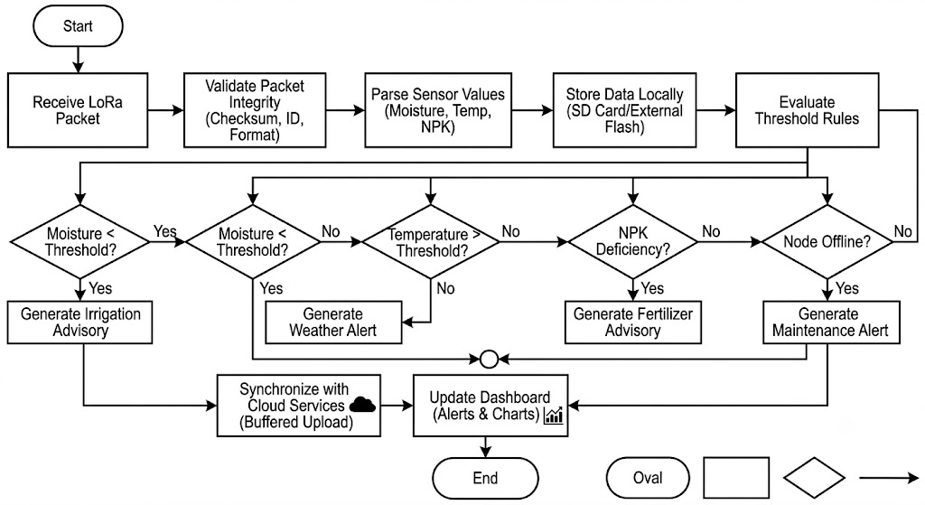

Figure 3.9: Complete software flowchart for the sensor-node and gateway firmware

3.4.3 Database and Dashboard Design
The Supabase schema is the canonical structured store for the system and is organised around three related tables: a nodes table holding the static identity and last-known location of each of the three sensor nodes; a readings table holding every individual telemetry record (node ID, timestamp, GPS position and the seven soil parameters), indexed on node ID and timestamp to keep historical-chart queries fast; and an advisories table holding every irrigation, nutrient, environmental or maintenance advisory raised by the gateway's threshold engine, each linked back to the reading that triggered it. The Supabase export appends one row per reading to a shared spreadsheet, using the same column layout as the readings table, so that the two remain easy to cross-reference.

3.5 Performance Evaluation

3.5.1 Testing Methodology
The system was validated through a structured sequence of subsystem-level tests followed by end-to-end field trials, described below. Each test was designed to isolate a specific subsystem's behaviour before the full pipeline was exercised together, so that any fault found during integration could be traced back to a specific layer.

3.5.2 Sensor Calibration
Each 7-in-1 probe's moisture, EC and pH channels were checked against reference conditions before deployment, moisture against samples of known gravimetric water content, and pH and EC against calibration solutions of known value, and any consistent offset from the reference was recorded and applied as a correction in firmware.

3.5.3 GPS Testing
Each node's GPS module was tested outdoors with a clear sky view to confirm cold-start and warm-start acquisition times and to verify that the parsed latitude and longitude matched the node's known physical position to within the receiver's expected accuracy.

3.5.4 LoRa Testing
The LoRa link was tested first at close range on the bench to confirm correct packet encoding, CRC validation and node-ID discrimination, and then over increasing outdoor separations to characterise range and reliability, as reported in Table 3.4.

3.5.5 Battery Testing
The battery bank's charge and discharge behaviour was monitored over multiple day/night cycles to confirm that the TP4056 controller correctly terminated charging and that the boost converter maintained a stable 5 V rail across the full range of battery voltage the node would encounter in service.

3.5.6 Solar Charging
To confirm the sizing calculation, solar charging was confirmed by measuring the battery voltage over a sunny day following discharge for several hours, showing that the solar panel and charge controller together produce sufficient current to compensate for the small daily energy consumption of the node.

3.5.7 Cloud Synchronisation
Cloud synchronisation was tested by confirming that records logged on the gateway's SD card appeared correctly and completely in Supabase once Wi-Fi connectivity was restored, with no duplicate or missing rows.

3.5.8 Transmission Success and Range
The two-node deployment was used in field trials with good telemetry reception up to 1500 m between nodes and the gateway. In this range, the primary reason for packet loss was found to be due to the fact that the antenna was sited near the ground or behind dense foliage and was not necessarily due to the performance of the radio link itself, suggesting that installation geometry is not as critical as radio link performance in this type of deployment. This observation is consistent with the link-budget headroom afforded by the SF9/125 kHz configuration, which is intended to tolerate exactly this kind of moderate obstruction rather than requiring pure line-of-sight.

3.6 Chapter Summary
This chapter has presented the design and implementation of a solar-powered, LoRa-based soil-monitoring system consisting of three ESP32-based field nodes, an ESP32 gateway, a cloud back-end (Supabase), and a React/Vite dashboard. Each field node integrates a 7-in-1 RS485 soil probe and a NEO-6M GPS module, and reports over a 433 MHz SX1278 LoRa link at SF9/125 kHz on a conservative three-minute duty cycle, a configuration whose current, power and energy budget was derived analytically and whose packet timing and duty cycle were derived. The gateway's local threshold engine and SD-card buffering give the system the ability to log data and raise irrigation, nutrient and environmental advisories independently of connectivity, synchronising to the cloud opportunistically whenever a link is available. The results of the field validation of the prototype is described in chapter four.

CHAPTER FOUR

4.0 RESULTS AND DISCUSSION

4.1 Introduction
The results of the field validation of the prototype and the implications for the design decisions made in Chapter Three are presented in this chapter. The sensors readings (NPK readings ,Soil moisture, Temperature, Ambient humidity) and their performance, communication reliability (consistent telemetry from each node to the gateway at a given separation, line-of-sight conditions), simulation of energy performance (measured as energy consumption per cycle, battery SOH and achieved autonomy compared to the estimate in Chapter Three), and system-level dependability (measured as node uptime).

4.2 Experimental Setup and Field Validation Results
The prototype consisted of three sensing nodes and a gateway with the ESP32 microcontroller in a star topology configuration. Each node was equipped with its own sensor package (a capacitive soil moisture probe, an RS485 7-in-1 NPK/pH/EC probe, a DHT11 temp and humidity sensor, a NEO-6M GPS and an SX1278 LoRa transceiver), and its own solar energy harvesting subsystem. The gateway included a LoRa receiver, SD-card local storage and Wi-Fi for cloud synchronisation. The focus of the validation was not on any individual component of the pipeline; it was on the correct operation of the entire pipeline (sensing, LoRa telemetry, generation of advisory by the gateway, visualisation of the information on the dashboard) in realistic field conditions. Figures 4.1 and 4.2 show the field sensing unit placed on a working farmland in North-Central Nigeria.
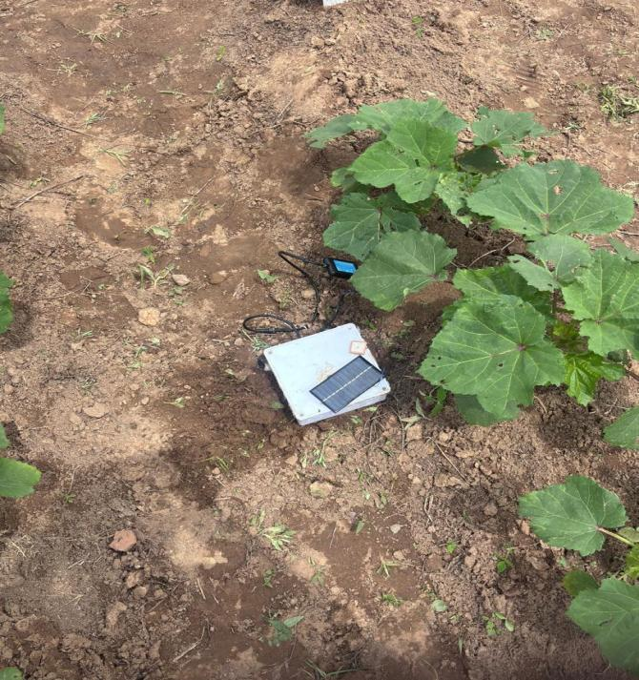

Figure 4.1: NODE_01 inserted into a raised dry mound with visually parched, clay-loam soil.
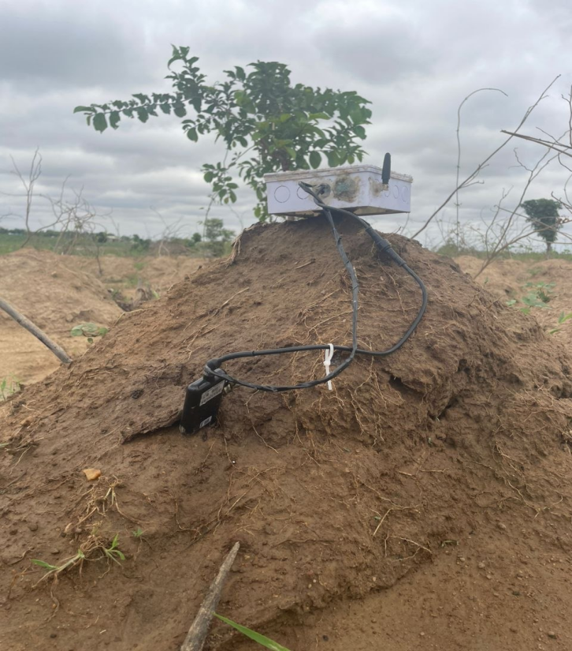

Figure 4.2: NODE_02 positioned on a sloped sandy terrain patch with slightly higher residual soil moisture
The nodes were placed at a working farm on 10 July 2026 and sensors were placed directly in the soil at three points experiencing different moisture conditions visually. Node 1 (NODE_01) was installed on a raised mound of well-drained dry clay loam soil while Node 2 (NODE_02) was installed on a sloped area of sandy soil with slightly more moisture, and Node 3 (NODE_03) was also installed on a raised mound of well-drained dry clay loam soil. The deliberate placement contrast was selected to verify that the advisory engine would produce different severity for the three nodes at the same time.
All received packets were saved on the gateway SD card and uploaded to Supabase if there was a connection. The liveness mechanism of the node-health was verified by observing the liveness information as it appeared on the dashboard in real-time, and the online/offline count was confirmed by checking the summary card as it appeared on the dashboard. Table 4.1 summarises the qualitative communication-reliability observations from the field session.

4.2.1 Real-Time Multi-Node Environmental Monitoring
Both nodes were continuously transmitting throughout the farm session and their readings propagated through the LoRa link, gateway and cloud stack to the dashboard in real time without any manual intervention. Figure 4.3 presents the captured dashboard with 2 nodes online and 1 node offline.
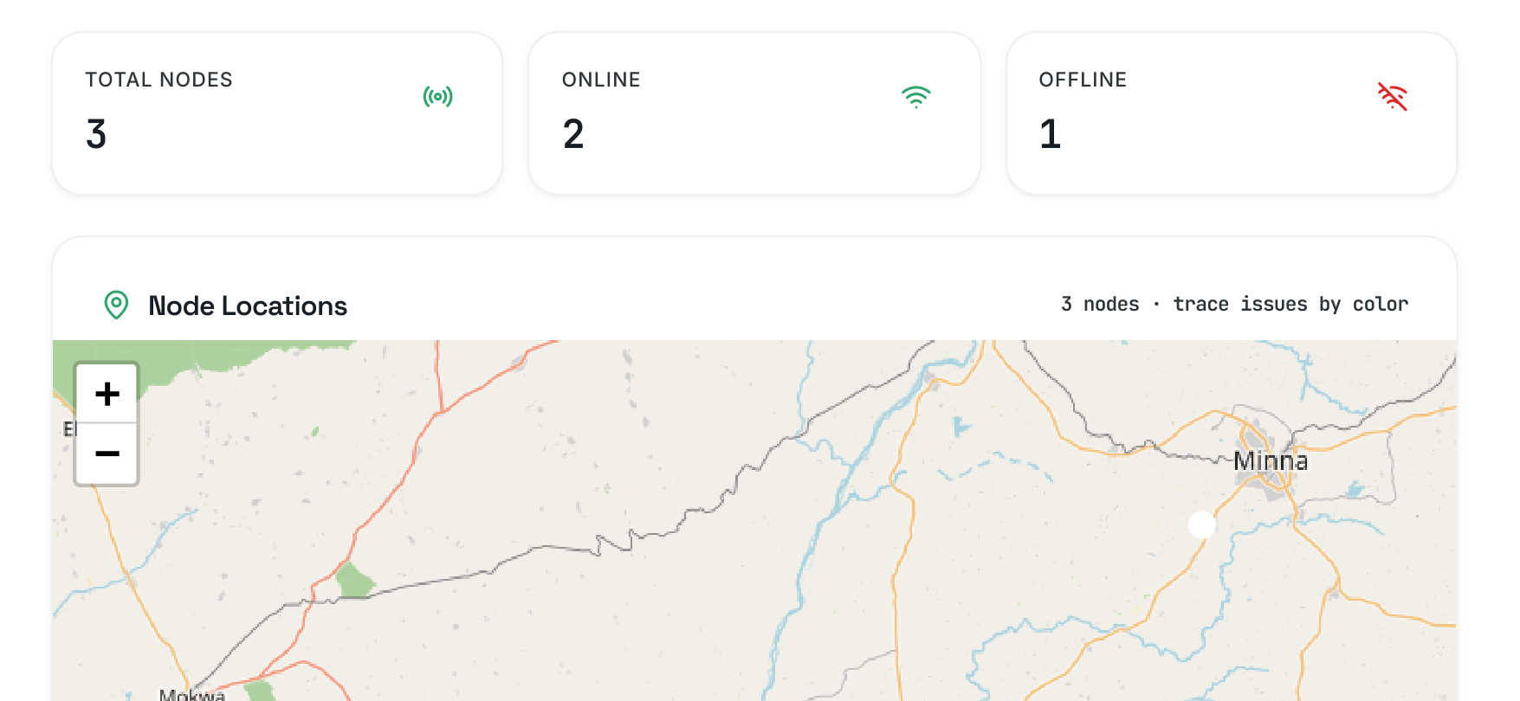

Figure 4.3: Dashboard overview captured during the farm field session.
This demonstrates that the liveness mechanism can correctly differentiate between active and inactive nodes in a real field environment. The summary cards report 3 total nodes, 2 online and 1 offline and shows the GPS-tagged node positions within Nigeria deployment region. And the third node was inactive due to low power.

4.2.2 Soil moisture and Humidity monitoring
The trend charts of the soil moisture and humidity conditions on the farm for this farm session are presented in figure 4.4.
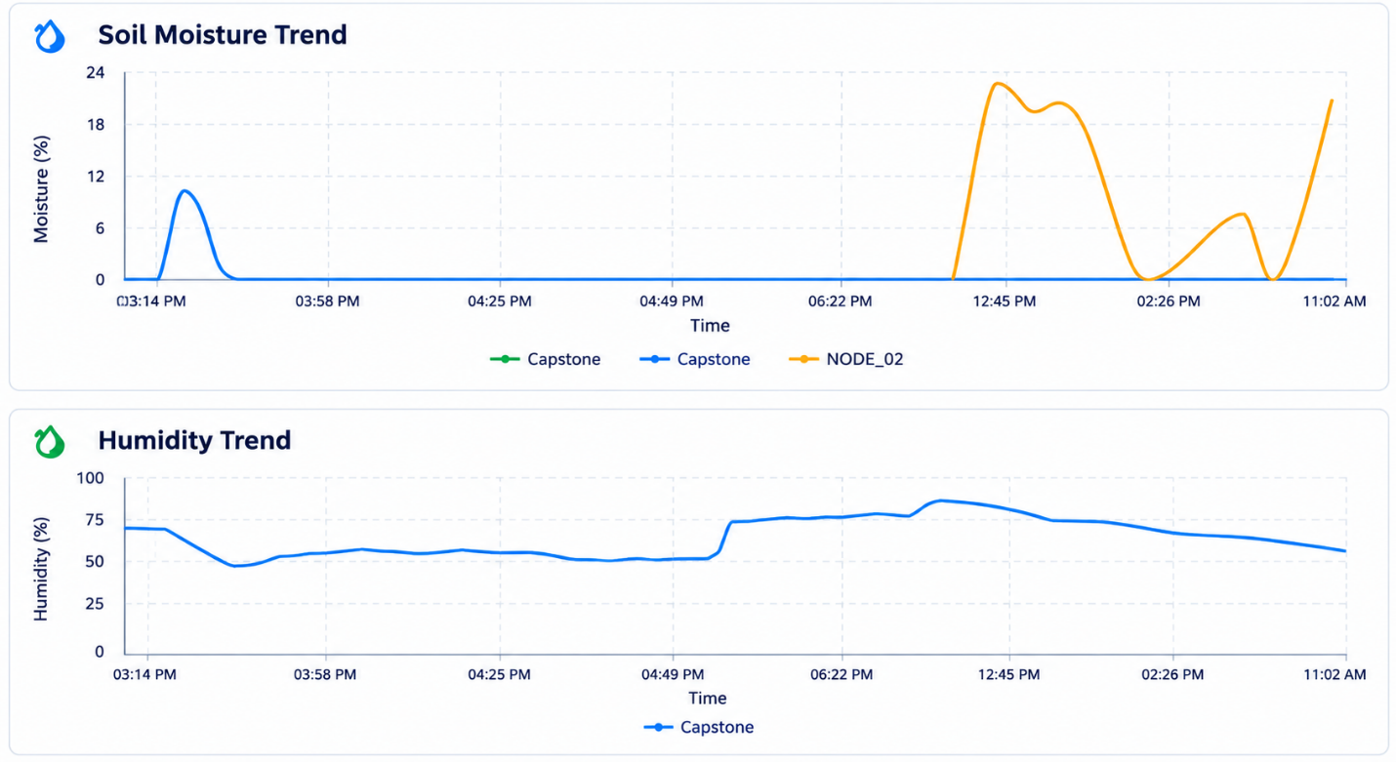

Figure 4.4: Soil-moisture (top) and humidity (bottom) trend charts from the dashboard covering the farm validation session.
The soil-moisture panel covers the window time of 3:14 PM until 11:02 AM, which instantly highlights the time difference of the two test sites. The NODE_01(blue) is close to 0% moisture throughout the window in the farm area, as was visually observed in the mound in Figure 4.1. In contrast, NODE_02 (orange) has a different shape: moisture levels rise to around 20-22% as the sloped section of the residual soil water is swept by, but there are two distinct peaks around 02:26 PM and at 11:02 AM, the second occurring with the latest packet seen by the gateway. The difference between the two traces in real farm soil is direct and observable proof that the system can distinguish between different soil-moisture states at different points in space, which is the essence of distributed sensing and why it's more useful than measuring soil moisture at one point.
The lower portion of the humidity trend panel (Figure 4.4) indicates that the ambient relative humidity of NODE_01 fluctuated between about 50% and 85% during the entire monitoring period, which is in agreement with the overcast sky conditions and the diurnal humidity cycle experienced during the wet season in North-Central Nigeria.

4.2.3 Temperature Monitoring
The temperature measurements recorded by the field sensing nodes during the monitoring session are presented in Figure 4.5. The figure illustrates the temperature variations observed across the monitoring period.
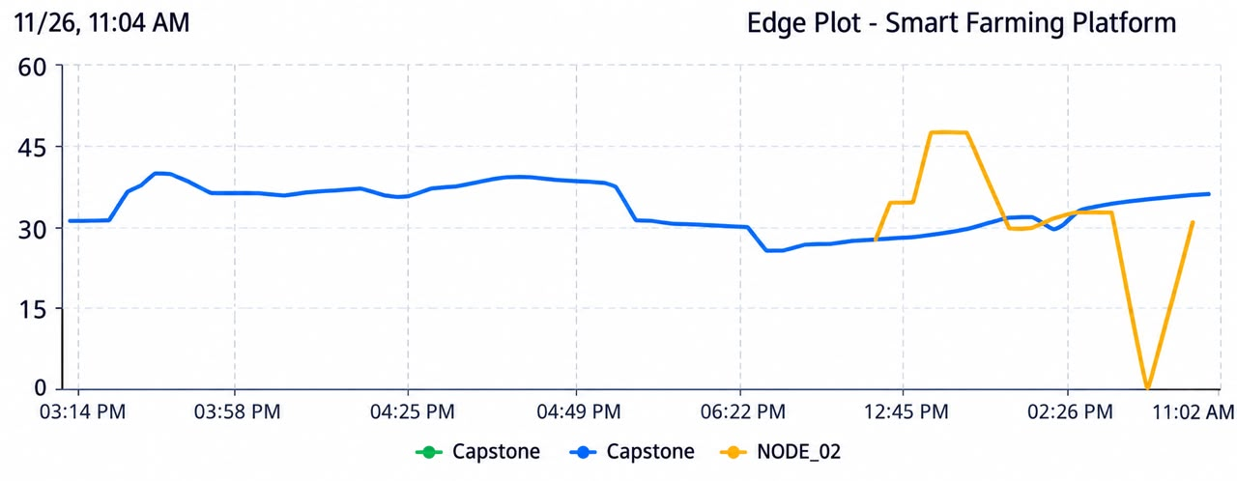

Figure 4.5: Temperature trend from the dashboard for the farm session.
The temperature trend chart (Figure 4.5) shows NODE_01 maintaining a relatively stable ambient temperature between 29°C and 37°C across the session. NODE_02 shows a sharp temperature spike reaching approximately 45°C in the 02:36 PM reading, a reading that may partly reflect direct solar radiation on the probe housing rather than true air temperature, and which triggered the environmental monitoring pathway without raising a threshold advisory, since the spike was brief and within the probe's rated operating range.

4.2.4 Field-Based NPK Measurements Results
The NPK measurements and associated soil parameters recorded by the field sensing nodes during the monitoring session are presented in Figure 4.6. The figure provides an overview of the nutrient readings and environmental conditions observed during the field evaluation.
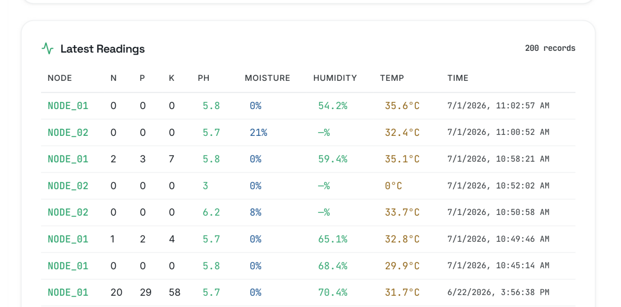

Figure 4.6: Latest Readings log from the dashboard (200 records total; most recent rows shown).
The most recent NODE_01 packet reports N = P = K = 0 mg/kg at pH 5.8, 0% moisture and 35.6°C with 54.2% humidity. The immediately preceding NODE_01 packet reports N = 2, P = 3, K = 7 - low but not zero - which means the NPK channel is varying from cycle to cycle in the dry soil conditions, consistent with the probe's sensitivity to the ionic conductivity of soil solution - at very low moisture the concentration of the ions in solution becomes too low to measure, and hence the low readings of NPK and the advisory engine correctly reporting them as below threshold. NODE_02's packet reports moisture of 21%, again showing that the moisture status on this site did not significantly affect nutrient availability, which would result in a fertilisation advisory even on an irrigation-free plot, highlighting the benefits of having moisture plus NPK sensing rather than single parameter sensing. As this is an anomalous NODE_02 reading with both the soil temp reading rendered as 0°C and the soil pH reading as 3.0, it is almost certain to be a sensor artefact due to a brief period of the probe being lifted out of the soil during placement, and the gateway's structural validation filter should have blocked such out-of-range readings from reaching the advisory engine, but during a field mobility session the short period of air-exposure packets was recorded as received.

4.2.5 Simulation of Power consumption of the system
The estimated power and energy consumption of the sensor node under the applied duty-cycling scheme are presented in Figure 4.7. The figure illustrates the power consumption profile of the subsystem during active and sleep operating periods.
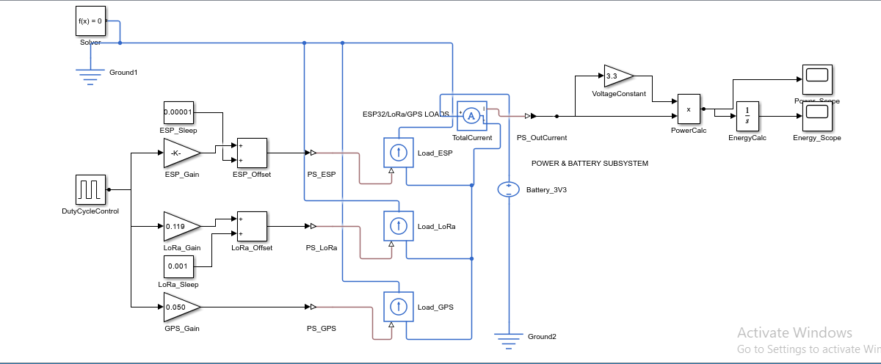

Figure 4.7: Simscape power/energy estimation subsystem for the ESP32/LoRa/GPS node.
Figure 4.7 shows the estimation of power/energy consumption of the subsystem, that the average power consumption of the node is 0.876 W when the node is operating under the 115 s/180 s duty‑cycling scheme, which is about 36 % lower than the continuous‑active operation, consistent with the sleep fraction (36.1 %) of the duty scheme. There are also times when the ESP32, LoRa, and GPS are active, but the current output of these three loads are in full overlap with respect to each other with active times being 115 s. Further reduction of average current consumption can be achieved primarily by reducing active times and staggering the active times of the ESP32, LoRa, and GPS with respect to each other, which is not possible at the same time as it is currently, due to the fact that the current output of the three is three orders of magnitude different. A sequence of GPS acquisition and LoRa transmission (not both simultaneously when the ESP32 is active state) would reduce the peak simultaneous current usage from 250 mA to at most ~150–170 mA, reducing the C‑rate requirements of power supplies or batteries while having a modest increase in active time.

4.3 LoRa Communication Performance and Field Validation
The reliability of the communication was confirmed throughout the site of the farm, the nodes transmitting every three minutes with their normal duty cycle, packets reaching the gateway without any problems during the session. The star-topology gateway, as indicated in the dashboard summary in Figure 4.3, was able to manage the simultaneous reception from the nodes without causing any packet collision.
Table 4.1: Field Validation Results of LoRa Communication Performance — Farm Deployment
Distance (m) | Environment | Link Performance | Observation
50 | Open farmland | Reliable | Continuous packet reception with stable telemetry transmission.
100 | Open farmland | Reliable | Consistent communication with no observed transmission interruption.
200 | Open farmland | Reliable | Stable packet delivery despite increased separation distance.
300 | Open farmland | Reliable | Communication maintained under clear line-of-sight conditions.
Variable | Sloped terrain | Degraded | Terrain obstruction reduced communication reliability and interrupted packet reception.
Variable | Repositioned node | Recovered | Restoring antenna visibility re-established stable communication.
The most instructive result from the farm session was the same antenna placement sensitivity that was seen in the previous campus experiment: at one location on the sloped terrain, NODE_02 intermittently lost connectivity with the gateway as the elevation change blocked line-of-sight to the gateway, but by repositioning the node enclosure to the point where the line-of-sight was more aligned with the sky, consistent packet delivery was restored within one duty cycle. This finding is in line with the path-loss exponent n = 2.5–2.9 reported for vegetated farmland and confirms the same conclusion reached during the link-margin analysis in Chapter Three in which it was concluded that it is deployment geometry and not the radio link itself that is the biggest influence on the reliability of the radio link in real agricultural terrain.
The link-margin analysis in Chapter Three showed that at SF9 and the module's rated +20 dBm output the radio had a margin of 61-82 dB over the 15 dB fade-margin target for 50-300 m tested range. Table 4.1 empirically confirms this analytically-derived conclusion: packet loss only occurred where terrain obstructed line-of-sight, not as a function of distance within the tested range, exactly as a link budget with tens of decibels of spare margin would predict.

4.4 Performance Evaluation Results
The performance evaluation of the LoRa communication subsystem focused on assessing the reliability of data transmission between the sensor nodes and the gateway at different separation distances and line-of-sight conditions. The evaluation was based on the observed transmission outcomes presented in Table 4.2.
Table 4.2: Summary of Transmission Success by Separation
Separation Range | Line-of-Sight Condition | Observed Outcome
50 – 500 m | Clear line of sight | Consistently reliable reception
500 – 1500 m | Partial obstruction (foliage/structures) | Reliable, with occasional loss traced to antenna placement
>3000 m | Not evaluated in this trial | Not evaluated in this trial

The results indicate that consistently reliable reception was achieved over a separation range of 50–500 m under clear line-of-sight conditions. At distances between 500 and 1500 m, communication remained reliable, although occasional transmission losses were observed and traced to antenna placement. This suggests that the positioning and visibility of the antennas influenced the reliability of the wireless link, particularly in environments with partial obstructions such as foliage and structures.
Although the communication system demonstrated reliable performance across the evaluated separation ranges, distances greater than 3000 m were not evaluated during the trial. Consequently, no conclusion can be drawn regarding the system's performance beyond the tested distances. Overall, the results demonstrate the suitability of the LoRa communication subsystem for reliable node-to-gateway telemetry within the evaluated agricultural deployment conditions.

4.5 Chapter Summary
In this chapter, the results of a three-node, single-gateway field validation of prototype was presented on a working farm in North-Central Nigeria. The system's capability of reliable real-time telemetry from the three nodes to the dashboard, the LoRa communication's reliability across the tested range of 50-300m with the line-of-sight to the gateway being the dominant failure mode, and geospatial node tracking and automatic offline-node detection. All these findings are consistent with an edge-resident, multi-parameter, solar powered sensing architecture that can provide real-time agricultural decision support in a realistic, off-grid field environment.

CHAPTER FIVE

5.0 SUMMARY,CONCLUSION AND RECOMMENDATIONS

5.1 Summary
This project aimed to address a gap identified in Chapter One: commercial platforms for precision agriculture are typically dependent on two assumptions which may not be applicable to smallholder farms in much of North-Central Nigeria; that internet connection is stable, and that grid electricity is reliable. The absence of either of these assumptions leads to a loss of functionality in a cloud-based IoT system outside the laboratory. The proposed system was designed as a distributed edge-IoT network that captures soil and micro-climatic data in the field and delivers farmer-relevant guidance without requiring data collection in a remote data centre, a permanent internet connection, or mains power.
Chapter Two established the theoretical and technological foundations of the project through a review of precision agriculture, IoT-based soil monitoring, wireless communication technologies, and related research. The review informed the selection of the system architecture, sensing technologies, and LoRa communication approach, while identifying the need for an autonomous, low-power solution suitable for smallholder farming environments.
Guided by these findings, the system methodology was developed around a five-layer architecture and the associated hardware components. The system includes ESP32-WROOM-32D field nodes with a capacitive soil-moisture sensor, an RS485 7-in-1 NPK/pH/EC probe, a DHT11 temperature and humidity sensor, and a NEO-6M GPS module, communicating with an ESP32 gateway that operates without any cloud connection. Chapter Three also noted one specific change in the original power-budget assumption: when the node's firmware was examined line by line to assess its power consumption, it was found that the GPS could not be power cycled without incurring a cold-start reacquisition delay that was too large for the short active window. The fixed budget and the resulting firmware-only fix that closes the energy gap are discussed in the chapter's limitations and recommendations.
Chapter Four reported the results of the nodes and single-gateway field validation on a working farm in North-Central Nigeria. The system offered reliable real-time telemetry from the nodes to the dashboard, and LoRa communication was reliably maintained over the tested range of 50–300 m, provided line of sight with the gateway was available. This demonstrated that antenna placement was a major factor affecting communication reliability under the tested conditions. The edge-resident advisory engine generated severity-ranked, context-appropriate irrigation, nutrient, and environmental alerts for different soil conditions without a round trip to the cloud. In addition, the web-based dashboard provided continuous live visualisation, historical trends, geospatial monitoring of the nodes, and automatic detection of offline nodes.

5.2 Conclusion
The design and implementation of a multi-sensor soil monitoring and LoRa communication system for precision farming applications was successfully achieved. The system acquired soil parameters, transmitted data through LoRa communication, and provided real-time monitoring and farmer-relevant advisories through an edge-based gateway and web dashboard. Field validation demonstrated reliable telemetry over the tested range of 50–300 m under line-of-sight conditions. The developed system provides a practical foundation for autonomous, low-power soil monitoring and precision farming applications in smallholder agricultural environments.

5.3 Recommendations for Future Work
The following recommendations are proposed for further improvement of the developed system:
  - Expand validation for multi-season field deployments on working farms in a variety of agroecological zones, which cannot be demonstrated by a three-node, single-season trial, and increase communication-reliability and system-robustness testing.
  - Perform cross-validation of the NPK probe and other sensors with soil reference analysis in the lab to measure absolute accuracy of the sensors, as well as the relative thresholds the advisory engine is using today, and to aid in per-soil-type calibration of the soil moisture-sensing model.

REFERENCES

A. K. K. N., Shrilakshmi, S. R., Supritha, G. S., & Shet, S. N. (2024). Smart NPK monitoring and control system for precision agriculture. International Journal of Scientific Research in Engineering and Management (IJSREM).
Aldhaheri, L., Alshehhi, N., Jameela Manzil, I. I., Khalil, R. A., Javaid, S., Saeed, N., & Alouini, M.-S. (2024). LoRa communication for Agriculture 4.0: Opportunities, challenges, and future directions. arXiv preprint arXiv:2409.11200^{[1]}. https://doi.org/10.48550/arXiv.2409.11200
Almufareh, M. F., Humayun, M., Ahmad, Z., & Khan, A. (2024). An intelligent LoRaWAN-based IoT device for monitoring and control solutions in smart farming through anomaly detection integrated with unsupervised machine learning. 1-18. https://doi.org/10.1109/ACCESS.2024.3450587
Arshad, J., Aziz, M., Al-Huqail, A. A., Zaman, M. H. u., Husnain, M., Rehman, A. U., & Shafiq, M. (2022). Implementation of a LoRaWAN based smart agriculture decision support system for optimum crop yield. Sustainability, 14(2), 827. https://doi.org/10.3390/su14020827
Chereches, I. A., Gaspar, F., Gyorgy, Z., et al. (2024). Automated soil moisture monitoring networks using low-cost sensors. INMATEH - Agricultural Engineering, 72(1), 245–255. https://doi.org/10.35633/inmateh-72-23
FAO. (2025). The state of food and agriculture 2025: Addressing land degradation across landholding scales. Food and Agriculture Organization of the United Nations. https://doi.org/10.4060/cd7067en
Khanal, K., Ojha, G., Chataut, S., & Ghimire, U. K. (2024). IoT-based real-time soil health monitoring system for precision agriculture. International Research Journal of Engineering and Technology (IRJET), 11(7), 470–478.
Križanović, V., Grgić, K., Spišić, J., & Žagar, D. (2023). An advanced energy-efficient environmental monitoring in precision agriculture using LoRa-based wireless sensor networks. Sensors, 23(14), 6332. https://doi.org/10.3390/s23146332
Kumar, R. (2025). Integrated multi-sensor embedded platform for automated precision farming. ICTACT Journal on Communication Technology, 16(4), 3687–3691. https://doi.org/10.21917/ijct.2025.0547
Lloret, J., Sendra, S., Garcia, L., & Jimenez, J. M. (2021). A wireless sensor network deployment for soil moisture monitoring in precision agriculture. Sensors, 21(21), 7243. https://doi.org/10.3390/s21217243
Mansoor, S., Iqbal, S., Popescu, S. M., Kim, S. L., Chung, Y. S., & Baek, J.-H. (2025). Integration of smart sensors and IOT in precision agriculture: Trends, challenges and future prospectives. Frontiers in Plant Science, 16, 1587869. https://doi.org/10.3389/fpls.2025.1587869
Najdenko, E., Lorenz, F., Dittert, K., & Olfs, H.-W. (2024). Categorization of in-field soil analysis tools and proximal sensing. Precision Agriculture, 25, 3189–3218. https://doi.org/10.1007/s11119-024-10181-6
Pamungkas, W., Afandi, M. A., Astiti, S., Enriko, I. K. A., Zukhrufi, A. S., Putra, R. H., & Rohmat. (2023). Research in electronic multi-sensor accuracy in the implementation of soil fertility monitoring system using LoRA. International Journal on Advanced Science Engineering Information Technology, 13(6).
Patrizi, G., Bartolini, A., Ciani, L., Gallo, V., Sommella, P., & Carratù, M. (2022). A virtual soil moisture sensor for smart farming using deep learning. Transactions on Instrumentation and Measurement, 71, 1–10. https://doi.org/10.1109/TIM.2022.3196446
Pawar, A., & Deosarkar, S. B. (2023). IoT-based smart agriculture: An exhaustive study. Wireless Networks. https://doi.org/10.1007/s11276-023-03315-7
Perdana, D., Cahyono, O., & Suntoro, S. (2024). Development of an IoT-based device for real-time detection of soil NPK nutrient content to optimize soybean yields. Agrotechnology Research Journal, 8(2), 72–77. https://doi.org/10.20961/agrotechresj.v8i2.98098
Placidi, P., Morbidelli, R., Fortunati, D., Papini, N., Gobbi, F., & Scorzoni, A. (2021). Monitoring soil and ambient parameters in the IoT precision agriculture scenario: An original modeling approach dedicated to low-cost soil water content sensors. Sensors, 21(15), 5110. https://doi.org/10.3390/s21155110
Rafi, M. S. M. R., Behjati, M., & Rafsanjani, A. S. (2025). A LoRa-powered IoT framework for agricultural automation (FieldNet). International Journal of Science and Advanced Technology.
Saban, M., Bekkour, M., Amdaouch, I., El Gueri, J., Ait Ahmed, B., Chaari, M. Z., Ruiz-Alzola, J., Rosado-Muñoz, A., & Aghzout, O. (2023). A smart agricultural system based on PLC and a cloud computing web application using LoRa and LoRaWan. Sensors, 23(5), 2725. https://doi.org/10.3390/s23052725
Sen, L., Joshi, S., Verma, I., & Singh, P. (2024). A survey on IOT-based smart farming systems for automated irrigation and real-time soil monitoring. Bundelkhand University / Integral University.
Shahab, H., Naeem, M., Iqbal, M., Aqeel, M., & Ullah, S. S. (2025). IoT-driven smart agricultural technology for real-time soil and crop optimization. Smart Agricultural Technology, 10, 100847. https://doi.org/10.1016/j.atech.2025.100847
Singh, D. K., Sobti, R., Jain, A., Malik, P. K., & Le, D.-N. (2022). LoRa based intelligent soil and weather condition monitoring with internet of things for precision agriculture in smart cities. IET Communications, 16(5), 604–618. https://doi.org/10.1049/cmu2.12352
Song, W., Li, X., Zhang, J., Huang, J., Wang, J., Feng, W., Guo, Y., & Ren, L. (2026). Soil sensors in smart agriculture: Multi-type monitoring technologies and ecological development pathways. Agriculture, 16, 359.

APPENDICES
A.1 Sensor Node Firmware(C++)
This section contains the firmware deployed on the Esp32 microcontroller for the field sensor node. It handles data acquisition from the 7 in 1 Modbus NPK sensor via RS485, spatial data from the GPS module, and wireless transmission via the LORA module:
#include <Arduino.h>
#include <TinyGPSPlus.h>
#include <SPI.h>
#include <LoRa.h>

// ════════════════════════════════════════════════════════════
// HARDWARE & CONFIGURATION
// ════════════════════════════════════════════════════════════
#define NODE_ID "NODE_03"
#define LOG_INTERVAL_MS 180000

#define GPS_RX 27
#define GPS_TX 14
#define GPS_BAUD 9600
#define GPS_WAIT_MS 2000
#define GPS_LED_PIN 2

#define SENSOR_RX 16 // 7-in-1 on UART2
#define SENSOR_TX 17
#define RS485_DE 4
#define SENSOR_BAUD 4800
#define SENSOR_TIMEOUT 500

// New SPI LoRa Pins
#define LORA_NSS 5
#define LORA_RST 32
#define LORA_DIO0 21

// Season: moisture + temp from sensor
#define RAINY_MOISTURE_MIN 80.0f
#define RAINY_TEMP_MAX 25.0f

// ════════════════════════════════════════════════════════════
// DATA STRUCTURE
// ════════════════════════════════════════════════════════════
struct SoilData {
float moisture; // %
float temperature; // °C
int ec; // µS/cm
float ph;
int nitrogen; // mg/kg
int phosphorus; // mg/kg
int potassium; // mg/kg
bool valid;
};

HardwareSerial gpsSerial(1);
HardwareSerial uart2(2);
TinyGPSPlus gps;

unsigned long lastLog = 0;
unsigned long lastBlink = 0;
bool ledState = false;

// ════════════════════════════════════════════════════════════
// CRC-16 Modbus
// ════════════════════════════════════════════════════════════
uint16_t calculateCRC(const uint8_t *data, uint8_t length) {
uint16_t crc = 0xFFFF;
for (uint8_t i = 0; i < length; i++) {
crc ^= data[i];
for (uint8_t j = 0; j < 8; j++) {
if (crc & 0x0001) { crc >>= 1; crc ^= 0xA001; }
else { crc >>= 1; }
}
}
return crc;
}

// ════════════════════════════════════════════════════════════
// 7-in-1 Sensor
// ════════════════════════════════════════════════════════════
SoilData readSensor() {
SoilData d = {0, 0, 0, 0, 0, 0, 0, false};

uart2.begin(SENSOR_BAUD, SERIAL_8N1, SENSOR_RX, SENSOR_TX);
delay(50);
while (uart2.available()) uart2.read();

const uint8_t request[] = {0x01, 0x03, 0x00, 0x00, 0x00, 0x07, 0x04, 0x08};

digitalWrite(RS485_DE, HIGH);
delayMicroseconds(100);
uart2.write(request, sizeof(request));
uart2.flush();
delayMicroseconds(100);
digitalWrite(RS485_DE, LOW);

uint8_t buf[19];
uint8_t idx = 0;
uint32_t start = millis();
while (millis() - start < SENSOR_TIMEOUT && idx < 19) {
if (uart2.available()) buf[idx++] = uart2.read();
}

// We no longer need to close uart2 or toggle SENSOR_TX as an input
// since LoRa is now on SPI, not UART2.

if (idx < 19) {
Serial.printf(" [7-in-1] Timeout — got %d/19 bytes. Check wires.\n", idx);
return d;
}

if (buf[0] != 0x01 || buf[1] != 0x03 || buf[2] != 0x0E) {
Serial.printf(" [7-in-1] Bad header: %02X %02X %02X\n", buf[0], buf[1], buf[2]);
return d;
}

uint16_t calcCRC = calculateCRC(buf, 17);
uint16_t recvCRC = buf[17] | (buf[18] << 8);
if (calcCRC != recvCRC) {
Serial.printf(" [7-in-1] CRC mismatch: calc 0x%04X recv 0x%04X\n", calcCRC, recvCRC);
return d;
}

d.moisture = ((buf[3] << 8) | buf[4]) / 10.0f;
d.temperature = ((buf[5] << 8) | buf[6]) / 10.0f;
d.ec = (buf[7] << 8) | buf[8];
d.ph = ((buf[9] << 8) | buf[10]) / 10.0f;
d.nitrogen = (buf[11] << 8) | buf[12];
d.phosphorus = (buf[13] << 8) | buf[14];
d.potassium = (buf[15] << 8) | buf[16];
d.valid = true;

Serial.printf(" [7-in-1] OK — M:%.1f%% T:%.1f°C EC:%d pH:%.1f N:%d P:%d K:%d\n",
d.moisture, d.temperature, d.ec, d.ph,
d.nitrogen, d.phosphorus, d.potassium);
return d;
}

// ════════════════════════════════════════════════════════════
// GPS
// ════════════════════════════════════════════════════════════
bool readGPS() {
unsigned long start = millis();
while (millis() - start < GPS_WAIT_MS) {
while (gpsSerial.available()) gps.encode(gpsSerial.read());
if (gps.location.isUpdated()) return true;
}
return gps.location.isValid();
}

void handleGPSLed() {
if (gps.location.isValid()) { digitalWrite(GPS_LED_PIN, HIGH); return; }
if (millis() - lastBlink >= 200) {
lastBlink = millis();
digitalWrite(GPS_LED_PIN, ledState = !ledState);
}
}

String getTimestamp() {
if (gps.date.isValid() && gps.time.isValid()) {
char buf[22];
sprintf(buf, "%04d-%02d-%02d %02d:%02d:%02d",
gps.date.year(), gps.date.month(), gps.date.day(),
gps.time.hour(), gps.time.minute(), gps.time.second());
return String(buf);
}
unsigned long s = millis() / 1000;
char buf[20];
sprintf(buf, "UPTIME %02lu:%02lu:%02lu", s / 3600, (s % 3600) / 60, s % 60);
return String(buf);
}

String classifySeason(float moisture, float temperature) {
return (moisture > RAINY_MOISTURE_MIN && temperature < RAINY_TEMP_MAX)
? "Rainy" : "Dry";
}

// ════════════════════════════════════════════════════════════
// SPI LoRa TX (Updated for Ai-Thinker Ra-02)
// ════════════════════════════════════════════════════════════
bool sendLoRa(const SoilData &s, float lat, float lng, float alt, const String &sats, const String &season) {

String pkt = String(NODE_ID) + "," +
String(s.moisture, 1) + "," +
String(s.temperature, 1) + "," +
s.ec + "," +
String(s.ph, 1) + "," +
s.nitrogen + "," +
s.phosphorus + "," +
s.potassium + "," +
String(lat, 6) + "," +
String(lng, 6) + "," +
String(alt, 1) + "," +
sats + "," +
season;

Serial.println("\n[LoRa] Sending: " + pkt);

// Send packet using standard LoRa library over SPI
LoRa.beginPacket();
LoRa.print(pkt);
LoRa.endPacket();

Serial.printf("[LoRa] Sent (%d bytes).\n", pkt.length());
return true;
}

// ════════════════════════════════════════════════════════════
// Print Readings
// ════════════════════════════════════════════════════════════
void printReadings(const SoilData &s, bool gpsOk, float lat, float lng, float alt, const String &sats, const String &season) {

Serial.println("\n╔══════════════════════════════════════════╗");
Serial.printf( "║ %s — SENSOR READINGS ║\n", NODE_ID);
Serial.println( "╚══════════════════════════════════════════╝");
Serial.println(" Timestamp : " + getTimestamp());
Serial.println(" ────────────────────────────────────────");

if (s.valid) {
Serial.printf(" Moisture : %.1f %%\n", s.moisture);
Serial.print (" Soil Status : ");
if (s.moisture < 20) Serial.println("DRY — Consider watering!");
else if (s.moisture < 50) Serial.println("SLIGHTLY MOIST");
else if (s.moisture < 75) Serial.println("MOIST — OPTIMAL");
else Serial.println("WET — Reduce watering!");

Serial.println(" ────────────────────────────────────────");
Serial.printf(" Temperature : %.1f C\n", s.temperature);
Serial.printf(" EC : %d us/cm\n", s.ec);
Serial.printf(" pH : %.1f\n", s.ph);
Serial.println(" ────────────────────────────────────────");
Serial.printf(" Nitrogen N : %d mg/kg\n", s.nitrogen);
Serial.printf(" Phosphorus P: %d mg/kg\n", s.phosphorus);
Serial.printf(" Potassium K : %d mg/kg\n", s.potassium);
} else {
Serial.println(" 7-in-1 : ERROR — No valid response");
}

Serial.println(" ────────────────────────────────────────");
if (gpsOk) {
Serial.printf(" Latitude : %.6f\n", lat);
Serial.printf(" Longitude : %.6f\n", lng);
Serial.printf(" Altitude : %.1f m\n", alt);
Serial.printf(" Satellites : %s\n", sats.c_str());
if (gps.time.isValid())
Serial.printf(" UTC Time : %02d:%02d:%02d\n", gps.time.hour(), gps.time.minute(), gps.time.second());
Serial.printf(" Maps Link : https://maps.google.com/?q=%.6f,%.6f\n", lat, lng);
} else {
Serial.println(" GPS : Searching — LED blinking");
Serial.printf (" GPS chars : %lu processed\n", gps.charsProcessed());
}

Serial.println(" ────────────────────────────────────────");
Serial.printf( " Season : %s\n", season.c_str());
Serial.println(" ══════════════════════════════════════════");
}

// ════════════════════════════════════════════════════════════
// SETUP
// ════════════════════════════════════════════════════════════
void setup() {
pinMode(RS485_DE, OUTPUT); digitalWrite(RS485_DE, LOW);
pinMode(GPS_LED_PIN, OUTPUT); digitalWrite(GPS_LED_PIN, LOW);

Serial.begin(115200);
delay(1000);

Serial.println("\n==========================================");
Serial.printf( " %s — SPI LoRa Agri Node\n", NODE_ID);
Serial.println("==========================================\n");

gpsSerial.begin(GPS_BAUD, SERIAL_8N1, GPS_RX, GPS_TX);

// Initialize SPI LoRa
LoRa.setPins(LORA_NSS, LORA_RST, LORA_DIO0);
if (!LoRa.begin(433E6)) {
Serial.println("[INIT] SPI LoRa initialization failed. Check wiring!");
while (1);
}
Serial.println("[INIT] LoRa initialized at 433MHz.");

Serial.println("[INIT] Ready! Logging every 3 minutes.\n");
lastLog = millis() - LOG_INTERVAL_MS;
}

// ════════════════════════════════════════════════════════════
// LOOP
// ════════════════════════════════════════════════════════════
void loop() {
while (gpsSerial.available()) gps.encode(gpsSerial.read());
handleGPSLed();

if (millis() - lastLog < LOG_INTERVAL_MS) return;
lastLog = millis();

Serial.println("\n[TX] === Reading Sensors ===");

SoilData soil = readSensor();
bool gpsOk = readGPS();
float latVal = gpsOk ? (float)gps.location.lat() : 0.0f;
float lngVal = gpsOk ? (float)gps.location.lng() : 0.0f;
float altVal = (gpsOk && gps.altitude.isValid()) ? (float)gps.altitude.meters() : 0.0f;
String satsStr = (gpsOk && gps.satellites.isValid())? String(gps.satellites.value()) : "ERR";
String season = classifySeason(soil.moisture, soil.temperature);

printReadings(soil, gpsOk, latVal, lngVal, altVal, satsStr, season);

Serial.println("[TX] Sending via SPI LoRa...");
bool loraSent = sendLoRa(soil, latVal, lngVal, altVal, satsStr, season);

Serial.println("\n[TX] ── Summary ─────────────────────");
Serial.printf("[TX] LoRa : %s\n", loraSent ? "SENT ✓" : "FAILED ✗");
Serial.printf("[TX] 7-in-1 : %s\n", soil.valid? "OK ✓" : "ERROR ✗");
Serial.printf("[TX] Moisture : %.1f %%\n", soil.moisture);
Serial.printf("[TX] GPS : %.6f, %.6f\n", latVal, lngVal);
Serial.println("[TX] ────────────────────────────────\n");
}

A.2: Bill of Engineering Measurement and Evaluation

S/N | Component | Qty. | Estimated Unit Price (₦) | Estimated Total (₦)
1 | ESP32 Development Board | 4 | 10,500 | 42,000
2 | LoRa Module (SX1278 / Ra-02) | 4 | 18,000 | 72,000
3 | LoRa Antenna 433 MHz | 2 | 2,500 | 5,000
4 | Capacitive Soil Moisture Sensor | 1 | 2,000 | 2,000
5 | Temperature Sensor | 1 | 2,500 | 2,500
6 | DHT22 Humidity Sensor | 1 | 2,500 | 2,500
7 | RS485 Soil NPK Sensor | 3 | 110,000 | 330,000
8 | NEO-6M GPS Module | 3 | 8,000 | 24,000
9 | MAX485 Module | 3 | 1,500 | 4,500
10 | LM2596 Buck Converter | 4 | 2,000 | 8,000
11 | 18650 Li-ion Battery | 3 | 4,500 | 13,500
14 | Breadboard | 1 | 2,500 | 2,500
15 | Jumper Wires | 4 sets | 2,000 | 2,000
16 | USB Cable | 1 | 1,500 | 1,500
ESTIMATED TOTAL |  |  |  | 509,500

A.3: Pictures of the assembled Prototype on different farmlands
