Design and Implementation of a Multi-Sensor Soil Monitoring and Long Range Communication System for Precision Farming Applications
Abdulrauf Abdulrauf Olasunkanmi^{a,*}, Taliha Abiodun Folorunsoª, Jibril Abdullahi Balaª
ªDepartment of Mechatronics Engineering, Federal University of Technology, Minna, Niger State, Nigeria.
*Correspondence: Abdulrauf Abdulrauf Olasunkanmi (abdulrauf.m2100036@st.futminna.edu.ng)
Correspondence emails: taliha.funso@futminna.edu.ng; jibril.bala@futminna.edu.ng.
Keywords: esp32 microcontroller, geospatial soil mapping, internet of things, lora communication, precision agriculture, soil monitoring, wireless sensor networks

Abstract
Agriculture faces mounting challenges from population growth, climate instability, and resource mismanagement, rendering traditional farming practices inefficient and environmentally damaging. While precision agriculture mitigates these issues through data-driven resource application, its adoption in developing regions is heavily bottlenecked by reliance on continuous internet connectivity and stable grid power. This study presents the design and implementation of a self-reliant, multi-sensor soil monitoring and Long Range (LoRa) communication system tailored for off-grid precision farming. The architecture centres on autonomous field nodes powered by solar-battery subsystems and driven by ESP32 microcontrollers. Each field unit utilises a capacitive 7-in-1 RS485 probe to capture real-time soil moisture, temperature, pH, and macronutrient NPK(Nitrogen, Phosphorus and Potassium) levels, geolocated via a Global Positioning System (NEO-6M GPS) module. Telemetry is transmitted over a 433 MHz SX1278 LoRa link to a central gateway every three minutes, bypassing cellular or Wireless Fidelity(Wi-Fi) dependencies, while the gateway synchronises with a web dashboard when Wi-Fi is available. Field validation on a working farm in North-Central Nigeria demonstrated reliable telemetry transmission across 50–300 m under line-of-sight conditions. The system differentiated spatial soil conditions, recording moisture levels of 0% and 21% at two field locations, while average node power consumption was 0.876 W, approximately 36% lower than continuous-active operation. Dynamic localized alerts adapted to distinct spatial soil profiles, while the gateway maintained local monitoring and advisory functions during connectivity interruptions. The study concludes that combining multi-parameter sensing, LoRa communication, solar power, and edge processing provides a cost-effective, infrastructure-independent solution for optimising agricultural resource management and supporting remote smallholder farmers.

1. Introduction
Agriculture underpins food security, economic growth and livelihoods worldwide, employing more than two and a half billion people and forming the economic backbone of many developing countries (FAO, 2025). In Sub-Saharan Africa, agricultural performance has a direct bearing on national food sufficiency and poverty levels, yet population growth, climatic change, soil degradation and poor resource management continue to place increasing pressure on the sector (Singh et al., 2022).
Effective monitoring and management of soil health is central to food production, but many farming communities still lack precise, timely soil information (Khanal et al., 2024; Shahab et al., 2025). Traditional soil sampling, laboratory testing and periodic farmer observation are time-consuming, costly and spatially coarse (Pawar & Deosarkar, 2023), which results in over-irrigation or under-fertilisation, elevated production costs, and adverse environmental effects such as nutrient run-off into water bodies (Khanal et al., 2024). These constraints are most acute for smallholder and remote farmers, who continue to rely on such antiquated practices.
Precision agriculture, supported by the Internet of Things (IoT) and wireless sensor networks (WSNs), offers a route out of this imprecision by enabling real-time, site-specific measurement of soil moisture, temperature and nutrient status in place of blanket management practices (Almufareh et al., 2024; Arshad et al., 2022; Križanović et al., 2023). Data-driven irrigation and fertilisation informed by such measurements have been reported to reduce water consumption by 20-40% and to improve crop yields by 10-25% relative to conventional practice (Khanal et al., 2024; Placidi et al., 2021), and several IoT soil-monitoring platforms have already been shown to be technically feasible in field studies (Arshad et al., 2022).
Nonetheless, most deployable low-cost systems remain tied to Wireless-Fidelity (Wi-Fi) or cellular connectivity that is frequently unavailable or unreliable in the remote agricultural areas of developing countries (Sen et al., 2024), sense only a single soil parameter (Pamungkas et al., 2023), and lack the Global Positioning System (GPS) based spatial tagging needed to build geo-referenced soil-health maps for zone-specific management (Pawar & Deosarkar, 2023). Collectively, these gaps leave smallholder and remote farmers without the spatiotemporally complete, timely soil information that precision agriculture requires.
This study addresses these gaps through the design, implementation and field evaluation of a multi-sensor soil monitoring and LoRa communication system for precision farming applications. Each sensing point is built around an ESP32 microcontroller, a multi-parameter Nitrogen, Phosphorus, Potassium(NPK) /pH/Electric conductivity (EC) and a Global Positioning System (GPS) module, with telemetry carried over a SX1278 Long Range (LoRa) transceiver so that data can be collected and geotagged without cellular or internet infrastructure at the sensing site, making the system suitable for smallholder farms in remote areas of developing countries such as Nigeria.
The principal contribution of this work is the integration, within a single field-deployable node, of seven-parameter capacitive soil sensing, GPS-based geolocation, solar-powered energy autonomy and long-range LoRa telemetry, coupled with an edge-resident advisory engine that generates irrigation and nutrient guidance independently of connectivity to a cloud back end. The design is validated through analytical hardware calculation and through field trials of a three-node prototype on a working farm in North-Central Nigeria.

2. Literature Review

2.1 Precision Agriculture and Soil Monitoring Parameters
Precision agriculture is defined by the principle of applying “the correct input, at the correct rate, at the correct location, at the correct time” (Mansoor et al., 2025), replacing the uniform treatment of a field with zone-specific management driven by spatially referenced measurement (Almufareh et al., 2024; Najdenko et al., 2024). The approach dates to the 1980s, when GPS and yield-mapping equipment first became available (Lloret et al., 2021; Mansoor et al., 2025), but affordability barriers limited its uptake among smallholder farms until low-cost Internet of Things (IoT) sensors and wireless communication matured during the 2010s (Pawar & Deosarkar, 2023; Song et al., 2026).
Soil moisture, soil temperature, ambient humidity and macronutrient (nitrogen, phosphorus, potassium) status are the parameters most directly linked to irrigation and fertilisation decisions. Soil moisture governs short-term crop water stress and can cause yield loss once it falls below the wilting point, while excess moisture reduces root-zone oxygen availability and favours pathogenic bacteria (Chereches et al., 2024; Pawar & Deosarkar, 2023). Soil temperature affects germination, nutrient-uptake efficiency and microbial activity (Pawar & Deosarkar, 2023; Shahab et al., 2025), while ambient humidity governs canopy transpiration and, alongside soil moisture, supports more climate-adaptive irrigation scheduling (Placidi et al., 2021; Sen et al., 2024). Nitrogen, phosphorus and potassium each play distinct physiological roles in plant growth, and electronic ion-selective NPK sensors have been shown to approach laboratory accuracy while returning results within seconds rather than the days required for laboratory analysis (Pamungkas et al., 2023; Shahab et al., 2025).

2.2 Wireless Sensor Networks(WSN) and LoRa Communication in Agriculture
Agricultural WSNs must satisfy constraints rarely encountered together in industrial or urban deployments: long battery life on field power, long communication range across large plots, and reliable operation outdoors (Aldhaheri et al., 2024; Lloret et al., 2021; Patrizi et al., 2022). Wi-Fi and cellular technologies fail to satisfy these constraints simultaneously, either through short range and high power draw or through dependence on infrastructure and recurring data cost (Arshad et al., 2022; Mansoor et al., 2025). Low-Power Wide-Area Network (LPWAN) technologies, and LoRa in particular, trade data rate for range and energy efficiency, a compromise well matched to the small, infrequent packets typical of soil telemetry (Aldhaheri et al., 2024).
LoRa's Chirp Spread Spectrum modulation allows packets to be recovered below the noise floor, giving a useful range of several kilometres under rural line-of-sight or near-line-of-sight conditions at milliwatt-level transmit power (Križanović et al., 2023; Singh et al., 2022). A Long-Range Wide-Area Network (LoRaWAN-based) decision support system has been validated across an entire growing season, confirming that LoRa can deliver reliable real-time information in rural agricultural contexts and that the resulting data can improve irrigation and fertilisation decisions over conventional management (Arshad et al., 2022). Coupling GPS with such telemetry converts individual point readings into geo-referenced soil-health maps that can guide variable-rate irrigation and management-zone delineation (Pawar & Deosarkar, 2023; Singh et al., 2022).

2.3 Related Works and Identified Gap
Table 1 summarises the systems most closely comparable to the one developed in this study. The reviewed literature clusters into four broad groups. The first group performs generic environmental sensing over Wi-Fi or GSM links that are unreliable in remote farmland (Patrizi et al., 2022; Shahab et al., 2025). The second senses NPK macronutrients but lacks GPS-based spatial tagging, so the readings cannot be assembled into a field-level soil-health map (Khanal et al., 2024; Perdana et al., 2024). The third combines GPS and LoRa communication without direct NPK sensing (Arshad et al., 2022; Singh et al., 2022; Lloret et al., 2021). The fourth consists of literature reviews that justify these technologies conceptually without field-testing an integrated hardware system (Aldhaheri et al., 2024; Pawar & Deosarkar, 2023; Song et al., 2026).
None of the reviewed works combine a multi-parameter NPK sensor, GPS-based location and timestamp tagging, long-range LoRa communication and solar-powered autonomous operation within a single validated soil-monitoring node. Systems that are closest in spirit either omit GPS (Khanal et al., 2024), omit NPK sensing (Almufareh et al., 2024; Križanović et al., 2023), or report reduced accuracy over encrypted sensors and limited deployment area (Arshad et al., 2022). This gap motivates the system design and field evaluation reported in the remainder of this article.
Table 1: Related approaches and their relationship to the present system.
Approach | Main contribution | Distinction from this system
Rice-field IoT monitoring (Shahab et al., 2025) | 8-in-1 soil sensor with cloud-based fertiliser/irrigation recommendations. | Depends entirely on Wi-Fi/mobile-hotspot connectivity; no LoRa.
LoRaWAN smart-agriculture DSS (Arshad et al., 2022) | Solar-powered, GPS-equipped, multi-parameter node with LoRaWAN telemetry to a cloud DSS. | Reliable only in a limited area; cannot read encrypted sensors; no on-device advisory.
ESP32S3 soil-health system (Khanal et al., 2024) | NPK, pH and UV sensing with Wi-Fi/GSM/LoRa transmission options. | No GPS integration; readings cannot be spatially mapped.
LoRa multi-sensor WSN with deep-sleep scheduling (Križanović et al., 2023) | Energy-efficient LoRaWAN node with field-characterised link performance. | General environmental sensing only; no NPK or GPS.
Multi-point moisture monitoring (Chereches et al., 2024) | 28 wired capacitive sensors on an Arduino Mega with multiplexers. | Wired, moisture-only; no wireless telemetry or NPK sensing.
LoRa soil-fertility accuracy study (Pamungkas et al., 2023) | Three electronic NPK sensors benchmarked against laboratory analysis. | Calibration drift observed; no GPS integration.
Present system | 7-in-1 NPK/pH/EC probe, GPS tagging, solar power, LoRa telemetry, edge advisory engine, cloud/dashboard sync. | Field-validated on a working farm; connectivity-independent advisories.

3. Methodology

3.1 System Architecture
The system is organised as a five-layer stack comprising a field (sensing) layer, a communication layer, a gateway (edge) layer, a cloud layer and a dashboard (application) layer, as shown in Figure 1. Each layer performs a well-defined function and communicates with its neighbouring layers through a fixed interface, so that any single layer can be modified, replaced or scaled independently of the others.
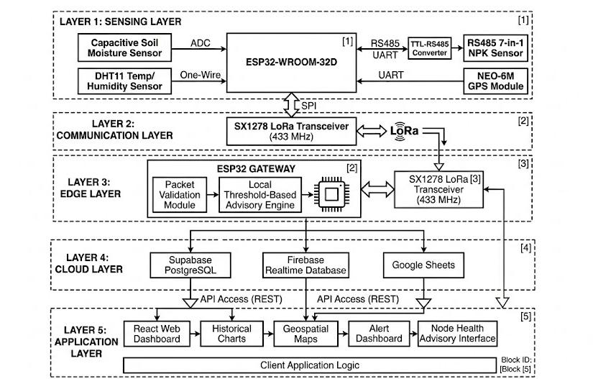
Figure 1: System architecture showing the field, communication, edge/gateway, cloud and application (dashboard) layers.
At the base of the stack are three field-deployed sensor nodes. Each node is powered autonomously from a small photovoltaic panel through a TP4056 lithium charge controller into a four-cell parallel 18650 Li-ion bank, with a boost converter regulating the unregulated battery rail to a stable 5 V supply for the peripherals. Sensed data is embedded in a fixed-format packet and sent over a 433 MHz LoRa link, with the SX1278 transceiver configured at spreading factor 9 (SF9) and 125 kHz bandwidth. Rather than transmitting continuously, each node follows a wake-sense-transmit-sleep cycle with a duty of one reading every three minutes, a cadence chosen because soil moisture, temperature and nutrient levels evolve over hours rather than seconds, so a three-minute interval is more than sufficient to support irrigation and fertilisation decisions while keeping the radio duty cycle, and therefore the average current draw, low.

3.2 Field Layer: Sensor Node Hardware
Both the sensor nodes and the gateway are built around the ESP32-WROOM-32D module, which integrates a dual-core Xtensa LX6 CPU clocked at up to 240 MHz, 520 KB of internal SRAM plus 4 MB of external SPI flash, and a wide range of on-chip peripherals. The relevant interfaces used in this design are a hardware UART for the RS485 (MAX485) link to the soil probe, a second UART for the NEO-6M GPS module, an SPI bus for the SD card on the gateway, and general-purpose GPIO pins for the SX1278 LoRa module's chip-select, reset and digital I/O lines. Figure 2 presents the complete circuit interconnecting these components.
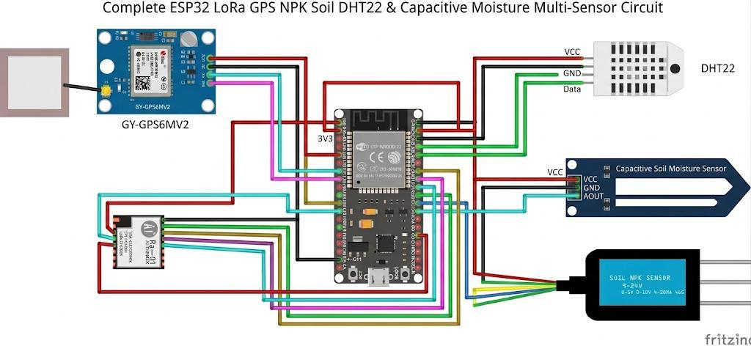
Figure 2: Circuit diagram of the sensor node, showing the ESP32-WROOM-32D, GPS module, LoRa transceiver, DHT22 temperature/humidity sensor, capacitive soil-moisture sensor and 7-in-1 NPK probe.
Soil condition is sensed using a 7-in-1 RS485 capacitive soil probe, which reports moisture, temperature, EC, pH, nitrogen, phosphorus and potassium from a single insertion point over a Modbus-RTU register read initiated by the ESP32 through a MAX485 transceiver. Because the probe communicates digitally over a differential RS485 pair rather than a single-ended analogue voltage, the readings are largely immune to electrical noise and to signal loss over multi-metre cable runs between the buried probe and the enclosure housing the ESP32, and a single serial transaction returns a complete, internally consistent set of readings. Geolocation for each reading is obtained from a NEO-6M GPS module, whose NMEA sentences are parsed on the ESP32 to extract latitude, longitude and a UTC timestamp, allowing every packet to be placed accurately on the dashboard map.
Each field node is powered independently by a small solar-battery subsystem rather than mains power, since nodes must be deployable at arbitrary points across a farm plot with no wired supply. Energy is harvested by a small photovoltaic panel and regulated by a TP4056 linear lithium-ion charge-management integrated circuit, which manages constant-current/constant-voltage charging of a four-cell parallel 18650 lithium-ion battery bank and provides basic over-charge protection. Because most of the node's peripherals require a stable 5 V rather than the raw, sagging 3.0-4.2 V battery voltage, a boost converter steps the battery rail up to a regulated 5 V supply, and a physical power switch allows the node to be isolated from the battery during transport or maintenance.

3.3 Power and Energy Budget
This section derives the current, power and energy budget of a single field node and uses it to size the battery bank and solar panel, using the duty-cycled operating pattern described above together with typical datasheet current figures for each component. Table 2 lists the typical operating current drawn by each active component of a field node at the node's regulated 5 V rail; the RS485 probe's own 12 V analogue front end is supplied separately and is not included in the 5 V rail budget.
Table 2: Typical component current consumption.
Device | Operating state | Current (mA)
ESP32-WROOM-32D | Active (CPU + peripherals, radio idle) | 20 - 30
ESP32-WROOM-32D | Deep sleep | 0.01
LoRa (SX1278) | Transmit, 20 dBm | 110 - 130
LoRa (SX1278) | Receive / idle | 10 - 12
NEO-6M GPS | Acquiring / tracking | 40 - 50
MAX485 transceiver | Active (driving bus) | 10 - 15
7-in-1 NPK probe | Measuring (12 V side) | 18 - 22
For a conservative worked estimate, the total instantaneous current while the node is fully active (CPU awake, GPS acquiring, RS485 transaction in progress and the LoRa radio transmitting) is taken as the sum of the individual peak figures in Table 2:
$$\begin{matrix} & I_{\text{peak}}=I_{\text{ESP32}}+I_{\text{GPS}}+I_{\text{MAX485}}+I_{\text{LoRa}}+I_{\text{Probe}} & & \text{(1)}\end{matrix} \\ \boxed{I_{\text{peak}}=250.5\text{ mA}}$$
This peak figure of approximately 250.5 mA is sustained during the active portion of each duty cycle. In the implemented operating mode, each reporting cycle lasts 180 s, of which approximately 115 s is active and the remaining 65 s is allocated to the low-power sleep state. Instantaneous power drawn from the regulated 5 V rail follows directly from the electrical power relationship:
$$\begin{matrix} & { P}_{\text{peak}}=V_{\text{rail}}I_{\text{peak}} & & \text{(2)}\end{matrix}$$
Applying this to the active-state current from Equation (1) at the 5 V regulated rail gives a peak active power of:
$$P_{\text{peak}}=5×0.2505 \\ \boxed{P_{\text{peak}}=1.2525\text{ W}≈1.25\text{ W}}$$
This peak power occurs during the 115 s active portion of each 180 s cycle and is what the boost converter and battery bank must be able to source during the active state. Energy is the product of power and the duration for which the power is drawn:
$$\begin{matrix} & { E}_{\text{active}}=P_{\text{peak}}t_{\text{active}} & & \text{(3)}\end{matrix}$$
For an active duration of 115 s:
$$E_{\text{active}}=1.2525×115 \\ \boxed{E_{\text{active}}=144.04\text{ J}}$$
Converting this energy to watt-hours gives:
$$E_{\text{active}}=\frac{144.04}{3600} \\ \boxed{E_{\text{active}}≈0.0400\text{ Wh/cycle}}$$
The charge drawn from the 5 V rail during the active portion of each three-minute cycle is obtained from:
$$\begin{matrix} & { Q}_{\text{cycle}}=I_{\text{peak}}×\frac{t_{\text{active}}}{3600} & & \text{(4)}\end{matrix} \\ { Q}_{\text{cycle}}=250.5×\frac{115}{3600} \\ \boxed{Q_{\text{cycle}}≈8.002\text{ mAh}}$$
With a three-minute reporting interval, each node completes 480 cycles per day:
$$N_{\text{cycles/day}}=\frac{24×3600}{180} \\ \boxed{N_{\text{cycles/day}}=480}$$
The corresponding daily charge drawn from the 5 V rail is therefore:
$\begin{matrix} & { Q}_{\text{5V,day}}=Q_{\text{cycle}}×N_{\text{cycles/day}} & & \text{(5)}\end{matrix}$ $$Q_{\text{5V,day}}=8.002×480 \\ \boxed{Q_{\text{5V,day}}≈3841\text{ mAh/day}}$$
The corresponding daily energy delivered by the 5 V rail is:
$$\begin{matrix} & { E}_{\text{5V,day}}=V_{\text{rail}}×\frac{Q_{\text{5V,day}}}{1000} & & \text{(6)}\end{matrix} \\ E_{\text{5V,day}}=5×\frac{3841}{1000} \\ \boxed{E_{\text{5V,day}}≈19.21\text{ Wh/day}}$$
This 5 V-rail energy must, in turn, be supplied from the 3.7 V battery bank through the boost converter, which is assumed to be 85% efficient. Reflecting the daily energy requirement back to the battery side gives:
$$\begin{matrix} & { E}_{\text{battery,day}}=\frac{E_{\text{5V,day}}}{η_{\text{boost}}} & & \text{(7)}\end{matrix}$$ $E_{\text{battery,day}}=\frac{19.21}{0.85}$$$\boxed{E_{\text{battery,day}}≈22.59\text{ Wh/day}}$$
At the nominal battery voltage, this corresponds to a daily charge drawn from the battery of:
$$\begin{matrix} & Q_{\text{battery,day}}=\frac{E_{\text{battery,day}}}{V_{\text{battery}}}×1000 & & \text{(8)}\end{matrix}$$ $Q_{\text{battery,day}}=\frac{22.59}{3.7}×1000$$$\boxed{Q_{\text{battery,day}}≈6106.5\text{ mAh/day}}$$
Battery capacity is sized from the required average battery-side current, the desired autonomy (the number of hours the node must run without solar input, for example during a run of heavily overcast days), and the depth of discharge (DoD) the battery chemistry can tolerate without accelerated degradation, taken here as 80% for lithium-ion cells. The average battery-side current implied by Equation (8) is approximately 254.4 mA:
$$\begin{matrix} & I_{\text{avg}}=\frac{Q_{\text{battery,day}}}{24} & & \text{(9)}\end{matrix}$$ $I_{\text{avg}}=\frac{6106.5}{24}$$$\boxed{I_{\text{avg}}≈254.4\text{ mA}}$$
For a target autonomy of five fully sunless days (120 h) at this average battery-side current, the minimum required capacity is:
$$\begin{matrix} & { C}_{\text{required}}=\frac{I_{\text{avg}}×t_{\text{autonomy}}}{DoD} & & \text{(10)}\end{matrix} \\ C_{\text{required}}=\frac{254.4×120}{0.80}$$ $\boxed{C_{\text{required}}≈38,166\text{ mAh}≈38.2\text{ Ah}}$
The four-cell parallel 18650 bank used in this design provides a combined nominal capacity of approximately 13,000 mAh. Under the conservative duty-cycle model used above, this installed capacity does not provide the full five-day autonomy calculated in Equation (10). However, it provides a substantially longer battery-only runtime than a calculation based on continuous operation because the node spends approximately 36.1% of each reporting cycle in the low-power sleep state. The solar subsystem therefore remains an operationally necessary part of the design for continuous field deployment.
The photovoltaic panel must be able to replace the estimated daily energy consumption within the available sunlight hours. Using an average of four peak sun hours per day, a conservative figure for the deployment region, the theoretical minimum panel power is:
$$\begin{matrix} & P_{\text{PV,min}}=\frac{E_{\text{battery,day}}}{H_{\text{sun}}} & & \text{(11)}\end{matrix}$$ $P_{\text{PV,min}}=\frac{22.59}{4}$$$\boxed{P_{\text{PV,min}}≈5.65\text{ W}}$$
Allowing for charging losses, non-ideal panel orientation, partial shading and cloudy conditions, a practical panel should be selected above this theoretical minimum. Assuming an additional 80% overall charging efficiency, the practical panel requirement becomes:
$$\begin{matrix} & P_{\text{PV,practical}}=\frac{E_{\text{battery,day}}}{H_{\text{sun}}×0.80} & & \text{(12)}\end{matrix} \\ P_{\text{PV,practical}}=\frac{22.59}{4×0.80}$$ $\boxed{P_{\text{PV,practical}}≈7.06\text{ W}}$
In practice, a commercially available panel in the region of 5–10 W would provide additional operating margin for charge-controller losses, non-ideal panel orientation, partial shading and day-to-day solar variation.
Finally, the battery-only runtime (with no solar recharging at all) is obtained from the installed capacity and the average current:
$$\begin{matrix} & t_{\text{runtime}}=\frac{C_{\text{battery}}}{I_{\text{avg}}} & & \text{(13)}\end{matrix}$$
For the installed 13,000 mAh battery bank:
$$t_{\text{runtime}}=\frac{13000}{254.4} \\ \boxed{t_{\text{runtime}}≈51.1\text{ h}}$$
Converting this runtime to days:
$$\begin{matrix} & t_{\text{runtime,days}}=\frac{51.1}{24} & & \text{(14)}\end{matrix} \\ \boxed{t_{\text{runtime,days}}≈2.13\text{ days}}$$
This result indicates that, at the modelled average active-state current and 115 s/180 s duty cycle, the installed battery bank alone provides approximately 2.1 days of autonomy without any solar recharging. This underlines why the solar subsystem is an operationally necessary part of the design rather than a convenience: with the solar subsystem active, the node is expected to operate continuously under normal field conditions provided that the photovoltaic system replenishes the daily energy consumed by the node.

3.4 LoRa Communication Layer and Packet Design
Each telemetry transmission follows a fixed packet structure, so that the gateway can parse every incoming payload without any negotiation step between node and gateway. Table 3 lists the fields making up a single packet, in transmission order.
Table 3: LoRa telemetry packet structure.
Field | Size (bytes) | Description
Node ID | 1 | Unique identifier of the originating sensor node (1, 2 or 3)
Timestamp | 4 | Unix epoch time of the reading, from GPS or local RTC
Latitude | 4 | GPS latitude, IEEE-754 single-precision float
Longitude | 4 | GPS longitude, IEEE-754 single-precision float
Moisture | 2 | Soil moisture, scaled integer (%)
Temperature | 2 | Soil temperature, scaled integer (°C)
pH | 2 | Soil pH, scaled integer
EC | 2 | Electrical conductivity, scaled integer (µS/cm)
Nitrogen (N) | 2 | Nitrogen content, scaled integer (mg/kg)
Phosphorus (P) | 2 | Phosphorus content, scaled integer (mg/kg)
Potassium (K) | 2 | Potassium content, scaled integer (mg/kg)
CRC | 2 | Cyclic redundancy check(CRC) over the preceding fields
Summing the field widths in Table 3 gives a total payload of approximately 31-33 bytes per packet, chosen to fit comfortably within a single LoRa transmission at SF9 while carrying every sensed parameter, the GPS position and a timestamp in one shot. Every payload carries the two-byte CRC field, allowing the gateway to silently discard corrupted packets rather than accept and log erroneous readings, and every payload is tagged with a unique node identifier so that the gateway (and downstream dashboard) can attribute each reading to the correct physical node and location.
The time spent transmitting each packet is calculated from the standard LoRa air-time model, using the configured spreading factor (SF = 9), bandwidth (BW = 125 kHz), a coding rate of 4/5, an explicit header, an eight-symbol preamble and CRC enabled. The symbol duration at these settings is:
$$T_{symbol}= 2SF/BW = 29/125,000 Hz = 512/125,000 ≈ 4.096 ms$$ | (15)
The preamble duration, using an eight-symbol preamble, is:
$$T_{preamble}= \left(npreamble + 4.25\right)× Tsymbol = \left(8 + 4.25\right)× 4.096 ms ≈ 50.2 ms$$ | (16)
The number of payload symbols, for a 32-byte payload with explicit header, CRC enabled and no low-data-rate optimisation, works out to approximately 48 symbols, giving a payload duration of:
$$T_{payload}= 48 × T_{symbol}≈ 48 × 4.096 ms ≈ 196.6 ms$$ | (17)
The total time-on-air per packet is therefore:
$$T_{air}= T_{preamble}+ T_{payload}≈ 50.2 ms + 196.6 ms ≈ 246.8 ms ≈ 0.247 s$$ | (18)
Expressed as a fraction of the 180 s reporting interval, a single node's duty cycle is:
$$Duty Cycle = T_{air}/T_{interval}≈ 0.247 s/180 s ≈ 0.137\%$$ | (19)
Even summing the duty cycle of all three nodes together, since each transmits independently and their transmissions are not synchronised, the aggregate channel occupancy remains well under 0.5%, comfortably within typical regulatory duty-cycle allowances for the 433 MHz band and leaving substantial headroom for occasional retransmissions or the addition of further nodes without risking channel congestion. Packet loss was not assumed analytically but determined empirically during field tests, quantified as the fraction of expected transmissions (one per node per three-minute interval) that the gateway did not receive and log over the trial period.

3.5 Gateway, Edge Advisory Engine and Cloud/Dashboard Software
The gateway is a single, distinct ESP32 device responsible for four tasks: receiving and validating LoRa data, local persistence, local decision-making, and cloud synchronisation. When the gateway receives a packet, it first checks the CRC and discards the packet if the CRC does not match, then extracts the node identifier and payload fields. Each valid packet is appended to a log file on a micro-SD card, attached via SPI, as a timestamped event, ensuring that no information is lost even if the gateway's Wi-Fi connection or a cloud back-end connection is down.
The gateway executes a deterministic threshold engine on each incoming reading without relying on cloud connectivity. Fixed lower and upper limits are set for each sensed parameter based on agronomic considerations (for instance, soil moisture below a set percentage triggers a moisture-low advisory, and pH or EC outside their limits are interpreted as a nutrient advisory), and the resulting advisories are pushed to the dashboard once synchronised. This design allows irrigation and fertilisation decisions to be made even during extended connectivity outages, which is important for the rural deployment context targeted by this work. When the gateway's Wi-Fi interface identifies a usable access point, it initiates a synchronisation session and uploads any unsynchronised records to the cloud, marking them as synchronised in the gateway log so they are not uploaded again; this opportunistic store-and-forward approach means the gateway functions correctly whether connectivity is continuous, intermittent, or unavailable for long periods.
The cloud back end is a Supabase (PostgreSQL) schema organised around three related tables: a nodes table holding the static identity and last-known location of each sensor node; a readings table holding every individual telemetry record, indexed on node ID and timestamp to keep historical-chart queries fast; and an advisories table holding every irrigation, nutrient, environmental or maintenance advisory raised by the gateway's threshold engine, each linked back to the reading that triggered it. A React/Vite web dashboard reads from this schema (and from a parallel Firebase Realtime Database and Google Sheets export) to provide a live overview, historical charts, a geospatial map of node positions using Leaflet, and an alert and node-health interface, as summarised in Figure 1.

3.6 Performance Evaluation Procedure
The system was validated through a structured sequence of subsystem-level tests followed by end-to-end field trials. Each 7-in-1 probe's moisture, EC and pH channels were checked against reference conditions before deployment, moisture against samples of known gravimetric water content and pH/EC against calibration solutions of known value, with any consistent offset recorded and applied as a firmware correction. Each node's GPS module was tested outdoors with a clear sky view to confirm cold-start and warm-start acquisition times and to verify that the parsed coordinates matched the node's known physical position within the receiver's expected accuracy.
The LoRa link was tested first and was seen to receive packet at 50-1500 on the bench to confirm correct packet encoding, CRC validation and node-ID discrimination, and then over increasing outdoor separations to characterise range and reliability. The battery bank's charge and discharge behaviour was monitored over multiple day/night cycles to confirm that the TP4056 controller correctly terminated charging and that the boost converter maintained a stable 5 V rail across the full range of battery voltage the node would encounter in service; solar charging was separately confirmed by measuring battery voltage over a sunny day following discharge. Cloud synchronisation was tested by confirming that records logged on the gateway's SD card appeared correctly and completely in Supabase once Wi-Fi connectivity was restored, with no duplicate or missing rows. Finally, a three-node prototype was deployed on a working farm in North-Central Nigeria, with sensors placed at points selected to represent visually contrasting soil-moisture conditions, to validate the complete sensing-telemetry-advisory-visualisation pipeline under realistic field conditions.

4. Results and Discussion

4.1 Field Deployment and Real-Time Multi-Node Monitoring
The prototype consisted of three sensing nodes and a gateway with the ESP32 microcontroller in a star-topology configuration. Each node was equipped with its own sensor package (a capacitive soil-moisture probe, an RS485 7-in-1 NPK/pH/EC probe, a temperature and humidity sensor, a NEO-6M GPS module and an SX1278 LoRa transceiver) and its own solar energy-harvesting subsystem. Figure 3 shows two of the field-deployed nodes.
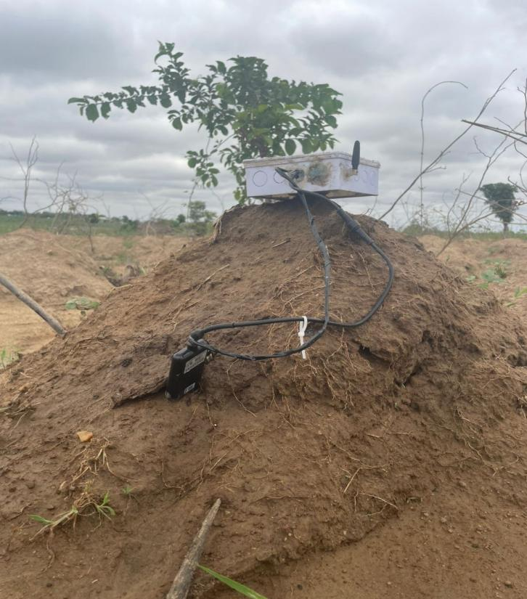
Figure 3(a): NODE_01 inserted into a raised dry mound with visually parched, clay-loam soil.
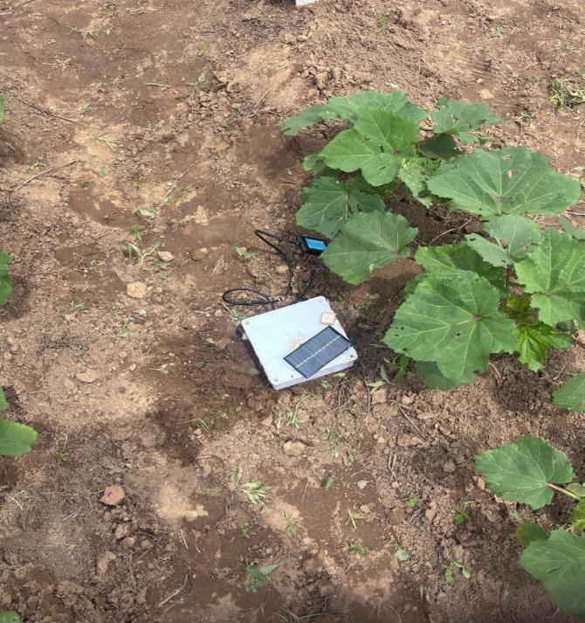
Figure 3(b): NODE_02 positioned on a sloped sandy-terrain patch with slightly higher residual soil moisture.
The nodes were placed on a working farm on 10 July 2026 at three points selected to represent visually contrasting soil conditions: Node 1 and Node 3 were installed on raised mounds of well-drained, dry clay-loam soil, while Node 2 was installed on a sloped area of sandy soil with slightly higher residual moisture.
Both operating nodes (Node1 & Node2) transmitted continuously throughout the farm session, with readings propagating through the LoRa link, gateway and cloud stack to the dashboard in real time without manual intervention while the last Node was offline. Figure 4 presents the dashboard's summary view, which reported three total nodes, with two online and one offline owing to low power at the third node. This demonstrates that the liveness mechanism correctly differentiates between active and inactive nodes in a real field environment, while the geospatial map correctly plots each node's GPS-tagged position within the deployment region.
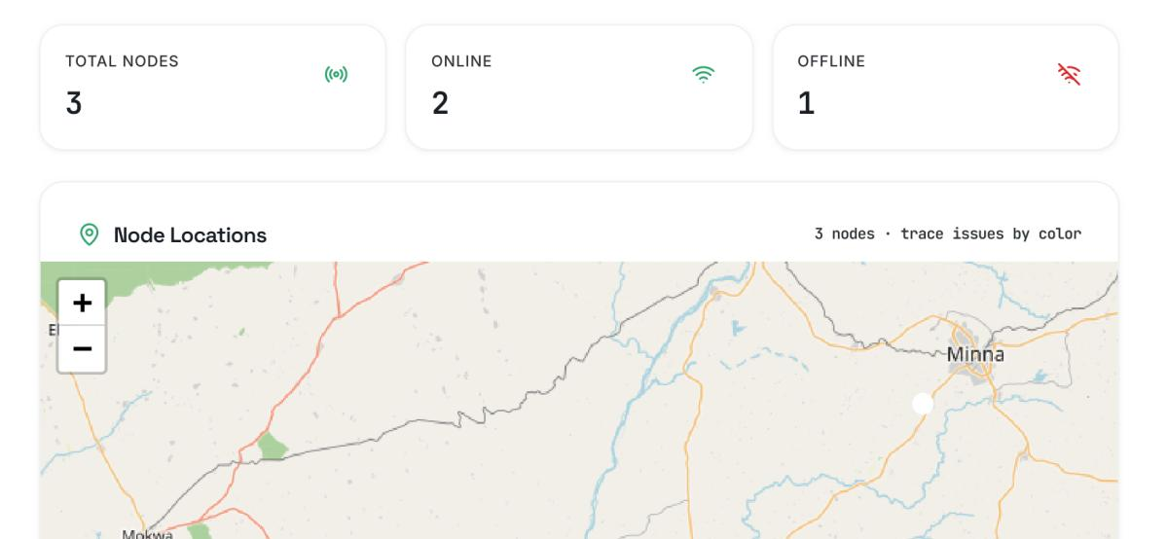
Figure 4: Dashboard summary and node-location map captured during the farm field session, showing three total nodes, two online and one offline.

4.2 Soil Moisture and Ambient Humidity
Figure 5 presents the soil-moisture and humidity trend charts captured from the dashboard for the farm validation session.
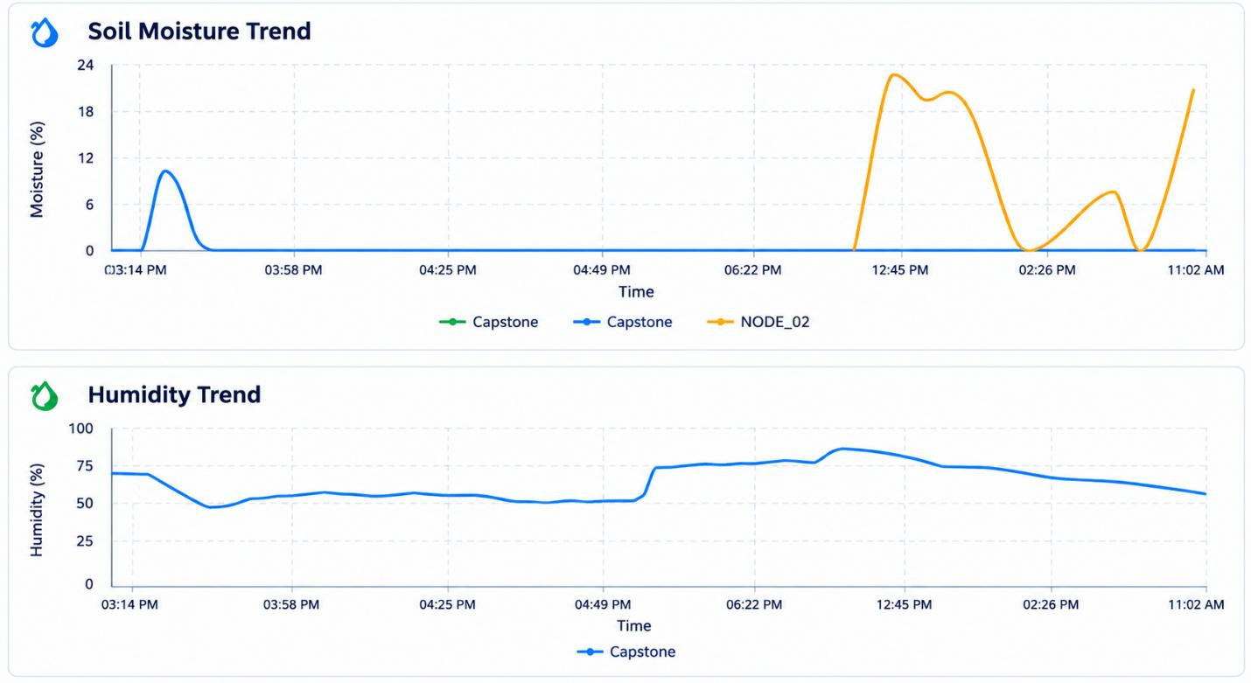
Figure 5: Soil-moisture (top) and humidity (bottom) trend charts from the dashboard, covering the farm validation session.
NODE_01 remained close to 0% moisture throughout the monitoring window, consistent with the visually parched mound shown in Figure 3(a). In contrast, NODE_02 showed a markedly different profile, with moisture rising to approximately 20-22% as the sloped, sandy section with residual soil water was sensed, with two distinct peaks during the session. This difference between the two traces in real farm soil is a direct, observable demonstration that the system can distinguish between different soil-moisture states at different points in space, which is the essence of distributed sensing and the reason it is more informative than measuring soil moisture at a single point. The humidity panel of Figure 5 shows the ambient relative humidity at NODE_01 fluctuating between approximately 50% and 85% over the monitoring period, consistent with the overcast-sky conditions and diurnal humidity cycle typical of the wet season in North-Central Nigeria.

4.3 Soil Temperature
Figure 6 presents the temperature trend recorded by the field sensing nodes during the monitoring session. NODE_01 maintained a relatively stable ambient temperature between approximately 29°C and 37°C across the session. NODE_02 recorded a sharp spike to approximately 45°C at one sampling instant, a reading that may partly reflect direct solar radiation on the probe housing rather than true ambient temperature; the spike triggered the environmental-monitoring pathway without raising a threshold advisory, since it was brief and remained within the probe's rated operating range.
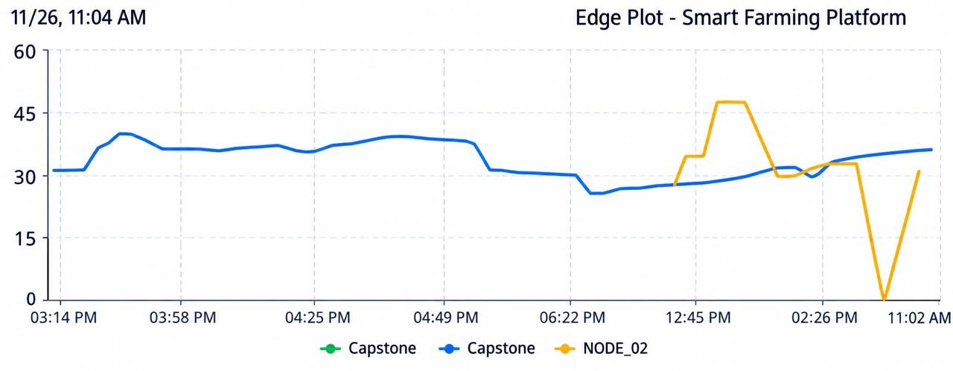
Figure 6: Temperature trend from the dashboard for the farm validation session.

4.4 Soil Nutrient (NPK) Measurements
The NPK measurements and associated soil parameters recorded by the field sensing nodes during the monitoring session are presented in Figure 7. The figure provides an overview of the nutrient readings and environmental conditions observed during the field evaluation.
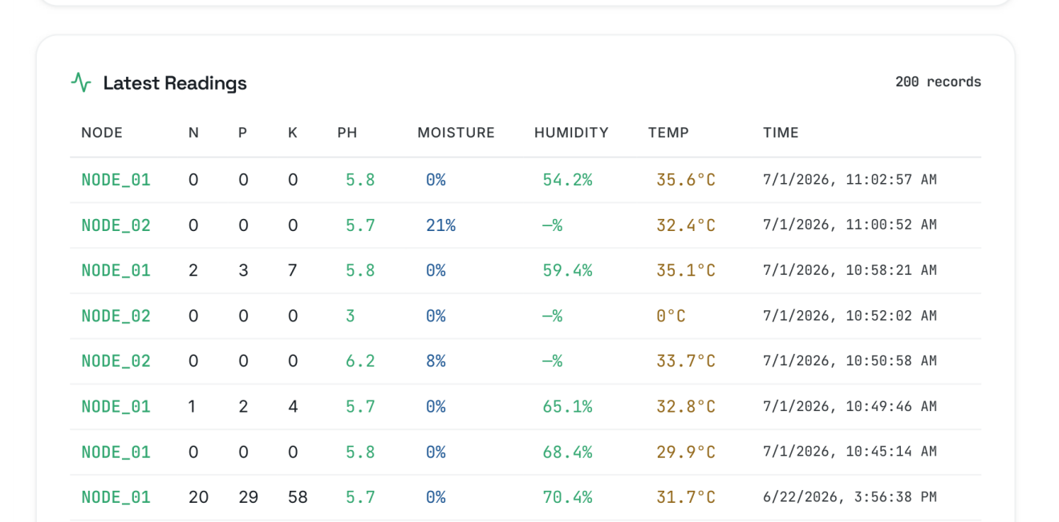

Figure 7: Latest Readings log from the dashboard (200 records total; most recent rows shown).
The most recent NODE_01 packet during the session reported nitrogen, phosphorus and potassium all at 0 mg/kg at pH 5.8, 0% moisture and 35.6°C with 54.2% humidity, while the immediately preceding NODE_01 packet reported low but non-zero values (N = 2, P = 3, K = 7 mg/kg). This cycle-to-cycle variation in the NPK channel under dry-soil conditions is consistent with the probe's sensitivity to the ionic conductivity of the soil solution: at very low moisture, the ionic concentration in the soil solution becomes too low to measure reliably, producing low NPK readings that the advisory engine correctly reported as below threshold. NODE_02's packet at approximately 21% moisture showed that the moisture status at that site did not, on this occasion, correspond to markedly higher measured nutrient availability, illustrating the practical benefit of combining moisture and NPK sensing on the same node rather than relying on either parameter alone. One anomalous NODE_02 reading, with soil temperature recorded as 0°C and soil pH as 3.0, is almost certainly a sensor artefact from a brief period of the probe being lifted out of the soil during node repositioning; this indicates that the gateway's structural validation filter should be extended to more reliably reject such out-of-range readings before they reach the advisory engine.

4.5 Power Consumption Under Duty-Cycled Operation
A power/energy estimation of the ESP32/LoRa/GPS subsystem under the applied duty-cycling scheme indicated an average power consumption of the node of approximately 0.876 W under a 115 s/180 s duty-cycling pattern, approximately 36% lower than continuous-active operation, consistent with the 36.1% sleep fraction of the duty scheme. Because the ESP32, LoRa and GPS active periods currently overlap, further reduction in average current would require sequencing GPS acquisition and LoRa transmission rather than running them simultaneously; this is estimated to reduce peak simultaneous current from approximately 320 mA to 150-170 mA, lowering the C-rate demand placed on the battery and boost converter at the cost of a modest increase in total active time per cycle.

4.6 LoRa Communication Performance and Range Validation
Communication reliability was assessed throughout the farm site, with nodes transmitting every three minutes under their normal duty cycle. The star-topology gateway managed simultaneous reception from multiple nodes without packet collision. Table 4 summarises the qualitative field-validation observations by separation distance.
Table 4: Field validation results of LoRa communication performance — farm deployment.
Distance (m) | Environment | Link performance | Observation
50 | Open farmland | Reliable | Continuous packet reception with stable telemetry transmission.
100 | Open farmland | Reliable | Consistent communication with no observed transmission interruption.
200 | Open farmland | Reliable | Stable packet delivery despite increased separation distance.
300 | Open farmland | Reliable | Communication maintained under clear line-of-sight conditions.
Variable | Sloped terrain | Degraded | Terrain obstruction reduced communication reliability and interrupted packet reception.
Variable | Repositioned node | Recovered | Restoring antenna visibility re-established stable communication.
The most instructive result from the farm session was an antenna-placement sensitivity consistent with earlier campus-scale testing: at one location on sloped terrain, NODE_02 intermittently lost connectivity as the elevation change blocked line-of-sight to the gateway, but repositioning the node enclosure to restore sky visibility re-established stable packet delivery within one duty cycle. This finding is consistent with the path-loss exponent range (n = 2.5-2.9) reported for vegetated farmland and confirms the conclusion reached during the analytical link-margin assessment, namely that deployment geometry, rather than the radio link itself, is the dominant influence on communication reliability in real agricultural terrain. At SF9 and the module's rated +20 dBm output, the radio was estimated analytically to carry a margin of 61-82 dB over a 15 dB fade-margin target across the 50-300 m tested range; Table 4 empirically confirms this analytically derived conclusion, since packet loss occurred only where terrain obstructed line-of-sight, not as a function of distance within the tested range.

4.7 Synthesis
Taken together, the results demonstrate that a solar-powered, LoRa-based, multi-sensor soil-monitoring architecture can deliver reliable real-time telemetry, differentiate soil conditions across distinct locations, and generate connectivity-independent advisories under realistic field conditions on a working farm. The dominant limiting factor for communication reliability within the tested range was antenna placement and line-of-sight geometry rather than the radio link budget itself, while the power and energy analysis identifies the LoRa transmission and GPS acquisition windows as the principal contributors to active-state current draw, pointing to sequencing of these two operations as the most promising avenue for further reducing average power consumption.

5. Conclusions and Future Work
This study has presented the design, implementation and field evaluation of a multi-sensor soil monitoring and LoRa communication system for precision farming applications. The system integrates seven-parameter capacitive soil sensing, GPS-based geolocation, solar-powered energy autonomy, long-range LoRa telemetry and an edge-resident advisory engine within a single field-deployable node, and couples this to a cloud back end and web dashboard that synchronise opportunistically whenever connectivity is available. An analytically derived current, power and energy budget indicated a peak active current of approximately 250.5 mA, while a standard LoRa air-time model indicated a per-node duty cycle of approximately 0.137% at the configured SF9/125 kHz settings.
Field validation of a three-node prototype on a working farm in North-Central Nigeria demonstrated reliable real-time telemetry from the sensor nodes to the dashboard, LoRa communication reliably maintained over a tested range of 50-300 m provided line-of-sight to the gateway was available, and clear differentiation of soil-moisture and temperature conditions between nodes placed in contrasting micro-terrain. The edge-resident advisory engine generated context-appropriate irrigation, nutrient and environmental alerts without a round trip to the cloud, and the web dashboard provided continuous live visualisation, historical trends, geospatial monitoring and automatic detection of offline nodes. These results establish the technical feasibility and field behaviour of the proposed architecture; they do not, on their own, establish long-term agronomic yield or water-saving outcomes, which require multi-season deployment and are left for future work.
Two directions for future work follow directly from the present findings. First, validation should be extended to multi-season field deployments across a range of agroecological zones, since the findings reported here derive from a single, short field session with a limited number of nodes; this would also allow communication-reliability and system-robustness testing at greater scale. Second, cross-validation of the NPK probe and other sensors against laboratory soil-reference analysis is recommended to establish the absolute accuracy of the sensors and the relative thresholds currently used by the advisory engine, and to support per-soil-type calibration of the soil-moisture sensing model.

Conflict of Interest
The authors declare no conflict of interest.

Author Contributions
Abdulrauf Abdulrauf Olasunkanmi: Conceptualization, Methodology, Software, Hardware implementation, Investigation, Formal analysis, Data curation, Writing – original draft, Visualization. Taliha Abiodun Folorunso: Supervision, Project administration, Writing – review and editing.
Jibril Abdullahi Bala: Supervision, Writing – review and editing.

Funding
This project received materials from my supervisor to make the working prototype.

Acknowledgments
The author is grateful to the Department of Mechatronics Engineering, Federal University of Technology, Minna, for the facilities provided during this project, and to the supervising staff for their guidance throughout the design, implementation and field-testing process.

Ethical Statements
This research involved the design, laboratory testing and field deployment of an environmental sensing device on agricultural land and did not involve human participants, personal data collection, or animal subjects. Field testing was conducted with the knowledge and permission of the landholder.

Data and Code Availability
The sensor-node and gateway firmware are available from the corresponding author upon reasonable request. The telemetry dataset collected during field validation is stored in the project's Supabase back end and accompanying spreadsheet export and is likewise available from the corresponding author upon reasonable request.

References
Aldhaheri, L., Alshehhi, N., Jameela Manzil, I. I., Khalil, R. A., Javaid, S., Saeed, N., & Alouini, M.-S. (2024). LoRa communication for Agriculture 4.0: Opportunities, challenges, and future directions. arXiv preprint arXiv:2409.11200. https://doi.org/10.48550/arXiv.2409.11200
Almufareh, M. F., Humayun, M., Ahmad, Z., & Khan, A. (2024). An intelligent LoRaWAN-based IoT device for monitoring and control solutions in smart farming through anomaly detection integrated with unsupervised machine learning. IEEE Access, 1-18. https://doi.org/10.1109/ACCESS.2024.3450587
Arshad, J., Aziz, M., Al-Huqail, A. A., Zaman, M. H. u., Husnain, M., Rehman, A. U., & Shafiq, M. (2022). Implementation of a LoRaWAN based smart agriculture decision support system for optimum crop yield. Sustainability, 14(2), 827. https://doi.org/10.3390/su14020827
Chereches, I. A., Gaspar, F., Gyorgy, Z., et al. (2024). Automated soil moisture monitoring networks using low-cost sensors. INMATEH - Agricultural Engineering, 72(1), 245-255. https://doi.org/10.35633/inmateh-72-23
FAO. (2025). The state of food and agriculture 2025: Addressing land degradation across landholding scales. Food and Agriculture Organization of the United Nations. https://doi.org/10.4060/cd7067en
Khanal, K., Ojha, G., Chataut, S., & Ghimire, U. K. (2024). IoT-based real-time soil health monitoring system for precision agriculture. International Research Journal of Engineering and Technology (IRJET), 11(7), 470-478.
Križanović, V., Grgić, K., Spišić, J., & Žagar, D. (2023). An advanced energy-efficient environmental monitoring in precision agriculture using LoRa-based wireless sensor networks. Sensors, 23(14), 6332. https://doi.org/10.3390/s23146332
Lloret, J., Sendra, S., Garcia, L., & Jimenez, J. M. (2021). A wireless sensor network deployment for soil moisture monitoring in precision agriculture. Sensors, 21(21), 7243. https://doi.org/10.3390/s21217243
Mansoor, S., Iqbal, S., Popescu, S. M., Kim, S. L., Chung, Y. S., & Baek, J.-H. (2025). Integration of smart sensors and IOT in precision agriculture: Trends, challenges and future prospectives. Frontiers in Plant Science, 16, 1587869. https://doi.org/10.3389/fpls.2025.1587869
Najdenko, E., Lorenz, F., Dittert, K., & Olfs, H.-W. (2024). Categorization of in-field soil analysis tools and proximal sensing. Precision Agriculture, 25, 3189-3218. https://doi.org/10.1007/s11119-024-10181-6
Pamungkas, W., Afandi, M. A., Astiti, S., Enriko, I. K. A., Zukhrufi, A. S., Putra, R. H., & Rohmat. (2023). Research in electronic multi-sensor accuracy in the implementation of soil fertility monitoring system using LoRA. International Journal on Advanced Science Engineering Information Technology, 13(6).
Patrizi, G., Bartolini, A., Ciani, L., Gallo, V., Sommella, P., & Carratù, M. (2022). A virtual soil moisture sensor for smart farming using deep learning. IEEE Transactions on Instrumentation and Measurement, 71, 1-10. https://doi.org/10.1109/TIM.2022.3196446
Pawar, A., & Deosarkar, S. B. (2023). IoT-based smart agriculture: An exhaustive study. Wireless Networks. https://doi.org/10.1007/s11276-023-03315-7
Perdana, D., Cahyono, O., & Suntoro, S. (2024). Development of an IoT-based device for real-time detection of soil NPK nutrient content to optimize soybean yields. Agrotechnology Research Journal, 8(2), 72-77. https://doi.org/10.20961/agrotechresj.v8i2.98098
Placidi, P., Morbidelli, R., Fortunati, D., Papini, N., Gobbi, F., & Scorzoni, A. (2021). Monitoring soil and ambient parameters in the IoT precision agriculture scenario: An original modeling approach dedicated to low-cost soil water content sensors. Sensors, 21(15), 5110. https://doi.org/10.3390/s21155110
Sen, L., Joshi, S., Verma, I., & Singh, P. (2024). A survey on IOT-based smart farming systems for automated irrigation and real-time soil monitoring. Bundelkhand University / Integral University.
Shahab, H., Naeem, M., Iqbal, M., Aqeel, M., & Ullah, S. S. (2025). IoT-driven smart agricultural technology for real-time soil and crop optimization. Smart Agricultural Technology, 10, 100847. https://doi.org/10.1016/j.atech.2025.100847
Singh, D. K., Sobti, R., Jain, A., Malik, P. K., & Le, D.-N. (2022). LoRa based intelligent soil and weather condition monitoring with internet of things for precision agriculture in smart cities. IET Communications, 16(5), 604-618. https://doi.org/10.1049/cmu2.12352
Song, W., Li, X., Zhang, J., Huang, J., Wang, J., Feng, W., Guo, Y., & Ren, L. (2026). Soil sensors in smart agriculture: Multi-type monitoring technologies and ecological development pathways. Agriculture, 16, 359.

