1.

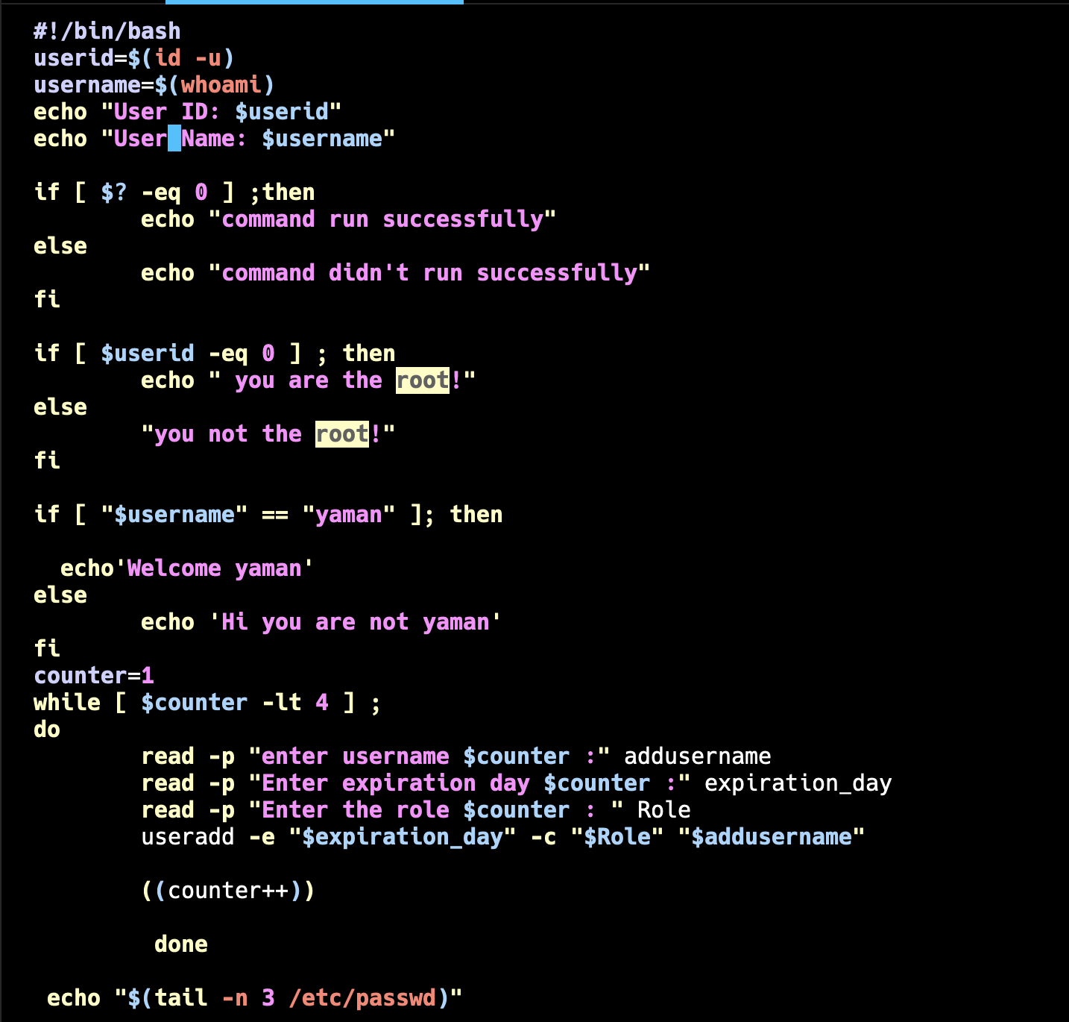

2.

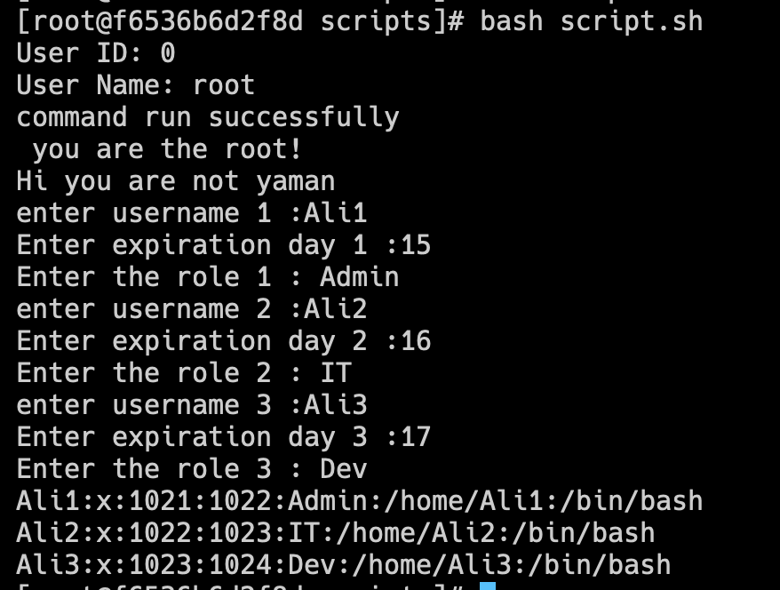

**Additional Challenge:**

