# **TITLE PAGE**

**Project Title**:  
**Corporate Office Network Simulation for a Multi-Department Organization**

**Submitted By**:  
M. Abdulrehman  
Student ID: 22I-1182

**Course**:  
Computer Networks

**Instructor**:  
Miss Hajra

Fast, Islamabad

Due Date: Dec 1, 2024

# **Objective**

This project aims to design and implement a **corporate office network** simulation in **Cisco Packet Tracer** for a **multi-department organization**. The project aims to create a network infrastructure that connects multiple departments—**Sales**, **IT**, and **Human Resources (HR)**—and allows them to communicate securely while providing efficient management of network resources.

The goals of this project include:

1. **Network Segmentation**:  
   The network will be segmented into three subnets: Sales, IT, and HR. Each department will have its own subnet to ensure better traffic management, security, and easier maintenance.
2. **DHCP Implementation**:  
   A **separate DHCP server** will be used to dynamically assign IP addresses to devices in each department’s subnet, ensuring seamless and automated IP management.
3. **Internet Access via NAT**:  
   **Network Address Translation (NAT)** will be configured on the main router to enable all internal devices to access the internet using a single public IP address, providing security and simplifying the IP addressing scheme.
4. **Routing Configuration**:  
   The routers will be configured using **RIP** (Routing Information Protocol) to enable communication between the departments while ensuring that the data flow is efficient and network traffic is balanced.
5. **Scalability and Future Expansion**:  
   The network will be designed in a scalable manner, allowing for future additions, such as new departments or devices, without requiring major reconfiguration.

# **Technologies Used**

The following tools, technologies, and protocols were used in the development and implementation of this network simulation project:

## **Tools and Software:**

### **Cisco Packet Tracer**:

* + Cisco Packet Tracer was used to simulate the entire corporate office network, including routers, switches, PCs, and servers. It allowed for the visualization and configuration of network devices, enabling realistic network simulations and testing of various network protocols (such as RIP, DHCP).
  + **Main Features**:
    - **Device Simulation**: Used to simulate various network devices like routers, switches, PCs, and servers.
    - **Protocol Implementation**: Facilitated the configuration and testing of network protocols like **RIP**, and **DHCP**.
    - **Connectivity Testing**: Allowed ping tests and other methods of connectivity verification between devices across different subnets and interfaces.

## **Protocols:**

### **Routing Information Protocol (RIP)**:

* + RIP was configured on routers to enable communication between the different departments. RIP is a **distance-vector** protocol used to share routing information and allow routers to dynamically learn the best paths for network traffic.
  + **Main Features**:
    - **Dynamic Routing**: Implemented RIP for automatic route advertisement and discovery between the routers.
    - **Routing Table Management**: Allowed routers to update routing tables based on RIP's metric (hop count).

### **Dynamic Host Configuration Protocol (DHCP)**:

* + A **separate DHCP server** was configured to automatically assign IP addresses to devices in each department's subnet.
  + **Main Features**:
    - **Automatic IP Assignment**: Ensured devices in the Sales, IT, and HR departments received appropriate IP addresses automatically.
    - **Subnet and Gateway Management**: Configured the DHCP server to provide the correct subnet mask and default gateway to clients.

## **Hardware Devices Simulated:**

* **Routers**: For routing between subnets (Sales, IT, HR), and for managing the NAT configuration.
* **Switches**: Connected devices within the same subnet, including PCs, printers, and the server.
* **PCs/Laptops**: Client devices in the Sales, IT, and HR departments.
* **DHCP Server**: Provided dynamic IP addressing to the clients.

# **Implementation Details**

## **Network Design and Approach:**

1. **Topology Overview**: The network consists of three main departments—**Sales**, **IT**, and **HR**—each with its own subnet. The **Main Router (Router 1)** connects all the departments via serial links. The **Main Router** also connects to the internet through its **WAN interface**.
2. **Subnetting**:

A **Class C private IP range (192.168.1.0/24)** was used, and subnets were created for each department:

### **Sales Department Subnet (192.168.1.0/26):**

* **Network Address:** 192.168.1.0
* **Usable IP Range:** 192.168.1.1 to 192.168.1.62
* **Broadcast Address:** 192.168.1.63
* **Subnet Mask:** 255.255.255.192

### **IT Department Subnet (192.168.1.64/26):**

* **Network Address:** 192.168.1.64
* **Usable IP Range:** 192.168.1.65 to 192.168.1.126
* **Broadcast Address:** 192.168.1.127
* **Subnet Mask:** 255.255.255.192

### **HR Department Subnet (192.168.1.128/26):**

* **Network Address:** 192.168.1.128
* **Usable IP Range:** 192.168.1.129 to 192.168.1.190
* **Broadcast Address:** 192.168.1.191
* **Subnet Mask:** 255.255.255.192

### **Server Room Subnet (192.168.1.192/29):**

* **Network Address:** 192.168.1.192
* **Usable IP Range:** 192.168.1.193 to 192.168.1.98
* **Broadcast Address:** 192.168.1.199
* **Subnet Mask:** 255.255.255.248

### **Main Router - Sales Router Subnet (192.168.1.200/29):**

* **Network Address:** 192.168.1.200
* **Usable IP Range:** 192.168.1.201 to 192.168.1.206
* **Broadcast Address:** 192.168.1.207
* **Subnet Mask:** 255.255.255.248

### **Main Router - IT Router Subnet (192.168.1.208/29):**

* **Network Address:** 192.168.1.208
* **Usable IP Range:** 192.168.1.209 to 192.168.1.214
* **Broadcast Address:** 192.168.1.215
* **Subnet Mask:** 255.255.255.248

### **Main Router - HR Router Subnet (192.168.1.216/29):**

* **Network Address:** 192.168.1.216
* **Usable IP Range:** 192.168.1.217 to 192.168.1.222
* **Broadcast Address:** 192.168.1.223
* **Subnet Mask:** 255.255.255.248

**3. Routing**:

* **RIP v2** was configured on all routers to facilitate dynamic routing. Each router was configured to advertise and receive routes from neighboring routers.

**4. NAT (Network Address Translation)**:

* On the **Main Router**, **Dynamic NAT** with a public IP pool was configured to translate all private IP addresses to a range of public IP addresses when accessing the internet. This allowed internal devices to access the internet by dynamically mapping their private IP addresses to one of the available public IP addresses from the pool. Unlike **PAT**, where a single public IP is used for all internal devices, **Dynamic NAT** uses a pool of public IPs, enabling more flexible and scalable translation for multiple devices.
* The router’s **inside interface** was connected to the internal network, and the **outside interface** was connected to the external network (internet).

**5. DHCP Configuration**:

* A **separate DHCP server** was configured to automatically assign IP addresses to devices in each subnet (Sales, IT, HR). The DHCP server was connected to the Main Router, relaying DHCP requests from the internal devices to the server.

## **Code Snippets and Configuration Screenshots**

### **Topology Implemented:**

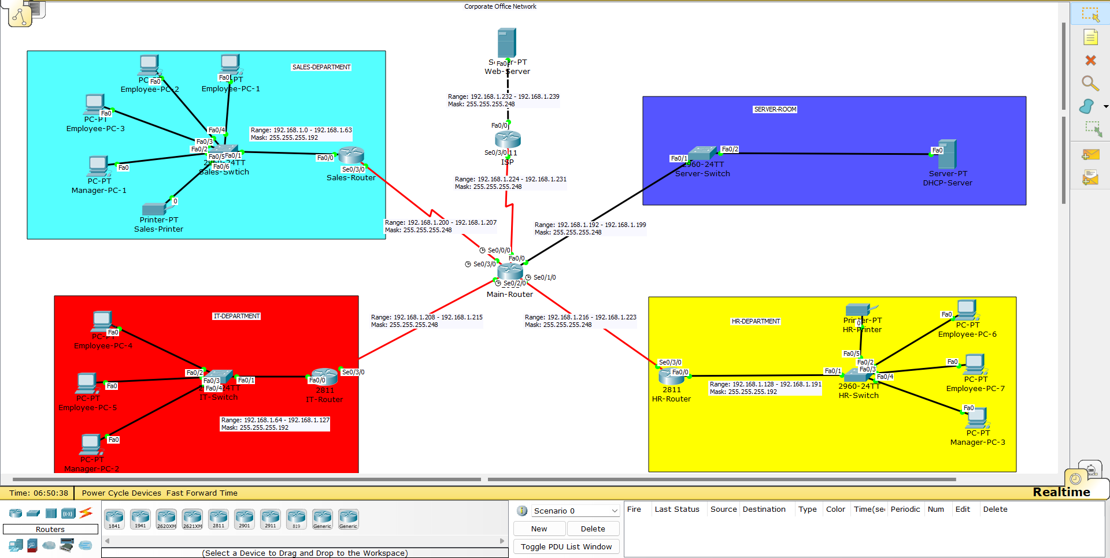

**DHCP Configuration:**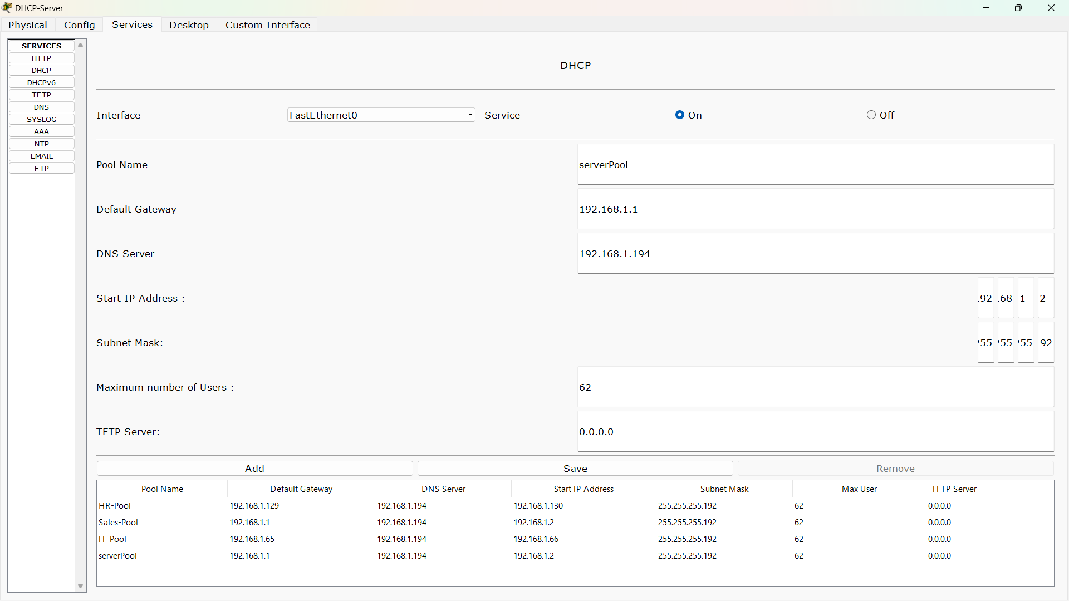

### **NAT Configuration:**

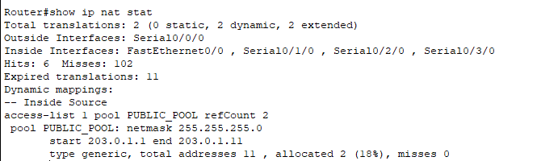

### 

## **Results and Testing**

The network design was tested for the following functionalities:

* **DHCP**: Successful automatic assignment of IP addresses to devices in each department.
* **NAT**: All departments can access the internet using a range of public IPs.
* **Inter-departmental Communication**: Devices in different subnets can communicate seamlessly, ensuring operational efficiency.

## **Challenges and Learnings**

### **Challenges Faced:**

* Configuring NAT with proper access lists to ensure internet access for all departments.
* Managing inter-departmental routing with accurate static routes.
* Optimizing the network for scalability and performance.

### **Lessons Learned:**

* Gained hands-on experience with DHCP, NAT, and routing protocols.
* Improved problem-solving skills in network troubleshooting and configuration.
* Developed an understanding of efficient network segmentation and design.

## **Conclusion**

The project successfully demonstrates a scalable and efficient network design for a university campus. By implementing DHCP, NAT, and routing, seamless inter-departmental communication and secure internet access were achieved. Future enhancements could include:

* Transitioning to dynamic routing protocols (e.g., OSPF or EIGRP) for scalability.
* Incorporating VLANs to further optimize network segmentation.
* Enhancing network security with firewalls and VPNs

## 