Smart Traffic Management System Using Internet of Things

Sabeen Javaid*, Ali Sufian**, Saima Pervaiz**, Mehak Tanveer**

*\* Department of Computer Software Engineering, College of Telecommunication Engineering, National University of Sciences and Technology, Islamabad, Pakistan*.

\**\* Department of Software Engineering, University of Gujrat, Sialkot Campus, Sialkot, Pakistan.*

[sabeen@mcs.edu.pk**,**](mailto:sabeen@mcs.edu.pk) [ali.21311116@uogsialkot.edu.pk**,**](mailto:ali.21311116@uogsialkot.edu.pk) [saima.21311005@uogsialkot.edu.pk**,**](mailto:saima.21311005@uogsialkot.edu.pk) [mehak.21311003@uogsialkot.edu.pk](mailto:mehak.21311003@uogsialkot.edu.pk)

***Abstract—* Traffic management system is considered as one of the major dimensions of a smart city. With the rapid growth of population and urban mobility in metropolitan cities, traffic congestion is often seen on roads. To tackle various issues for managing traffic on roads and to help authorities in proper planning, a smart traffic management system using the Internet of Things (IoT) is proposed in this paper. A hybrid approach (combination of centralized and decentralized) is used to optimize traffic flow on roads and an algorithm is devised to manage various traffic situations efficiently. For this purpose, the system takes traffic density as input from a) cameras b) and sensors, then manages traffic signals. Another algorithm based on Artificial Intelligence is used to predict the traffic density for future to minimize the traffic congestion. Besides this, RFIDs are also used to prioritize the emergency vehicles such as ambulances and fire brigade vehicles during a traffic jam. In case of fire on the road, Smoke sensors are also part of this system to detect this situation. To demonstrate the effectiveness of the proposed traffic management system, a prototype is developed which not only optimizes the flow of traffic but also connects nearby rescue departments with a centralized server. Moreover, it also extracts useful information presented in graphical formats that may help the authorities in future road planning.**

***Keywords—* IoT, Smart City, Smart Traffic Management, Traffic Congestion, Traffic Signal Management.**

# Introduction

A city is a complex system which consists of many interdependent subsystems where traffic system is one of its important subsystems. A study says; it is the cornerstone of the world’s economy [1]. Moreover, it is also declared as one of the major dimensions of the smart city [2]. With the rapid growth of the population of the world, the number of vehicles on roadways is increasing consequently, the rate of traffic jams is also increasing in the same manner [3] [4]. Traffic jams are not just wasting time but in some cases, it is witnessed that criminal activities like mobile snatching at traffic signals also happen in metropolitan cities [5]. On the other hand, it is not only affecting ecosystem badly [6] but the efficiency of industries is also being affected [7].

It is, therefore, identified that active traffic management is a necessity. In majority countries, traffic is managed through fixed time signals whereas, in large cities of some developed countries, traffic is managed through centrally controlled

systems. The paradigm of the Internet of Thing (IoT) has been introduced in traffic management systems [8].

To the best of our knowledge, it is identified that till date the current traffic management systems are centralized. In case of networking issues, such systems may crash. In addition, there is less focus on fluctuations in traffic flow. Therefore, the proposed system manages the traffic on local and centralized servers by exploiting the concepts of IoT and Artificial Intelligence together. The representation of traffic data in statistical form can also be helpful to authorities for real-time controlling and managing traffic. Moreover, it may also be helpful for future planning.

The rest of the paper is structured in four sections. Section II discusses the state of the art. The proposed system is presented and discussed in Section III whereas a discussion on results is being carried on in Section IV. Section V concludes the research.

# Literature Review

A smart traffic management system that is partially deployed in Cambridge city where queue detectors are buried in the roads that detect the traffic queue and inform the central control unit which takes decision accordingly. Since the system is centralized that can slow down due to networking issues [9]. The researcher used surveillance cameras to detect traffic and OCR to identify the vehicles through number plate recognition which is a simple detection method but the system will fail in Pakistan as there are different kinds of traffic including cycles, donkey carts which have no number plate [10].

Osman et al. proposed a system in which they have used surveillance cameras to detect traffic density using MATLAB, a traffic controller and a wireless transmitter used to send images to the server after that server calculated traffic density by using those images of every section. This system used fixed (predefined) thresholds that depend on a number of vehicles on road. An algorithm was used to set a time span of red light for a particular lane of the intersection, which is determined by traffic density on road and forwarded to the microcontroller and then server [11].

Jadhav et al. used surveillance cameras, MATLAB and KEIL (Microcontroller coding) to control traffic congestion. This paper also discusses the priority-based traffic clearance and red

signal broker (Number plate detection). Due to using heavy hardware, it is difficult to manage and become costly [8].

Bui et al. Analyzed a real-time process synchronization based system to manage the traffic flow dynamically. Sensors were used to detect the traffic, where vehicle to vehicle and vehicle to infrastructure communication was done by using wireless communication devices. Controller placed at the center of the intersection received vehicles’ and pedestrians’ information and requests and process using first come first serve method [12].

Swathi et al. proposed smart traffic routing system that chooses the shortest route having the least congestion. Sensors are used to collect data about traffic density, these sensors use solar energy and battery. Sensors kept transmitting infrared light and when an object came near, they detect traffic density by monitoring the reflected light from the vehicle. However, readings may change with the change in temperature and humidity [13].

Al-Sakran et al. proposed a system in which major goals were detecting vehicles and get their location by using sensors and RFIDs after getting data it sent to centralized controlling center by using a wireless connection for further processing. Researchers used cloud computing, RFIDs, GPS, wireless sensor network (WSN), agent and other modern tools and technologies to collect, store, manage and supervise traffic information [14].

# Proposed System

## The proposed system, shown in Figure 1, is designed to govern Fire and human detection at outdoor Areas, sensing through sensors, surveillance cameras, which are embedded on outsides. The system works in a distributed manner, It processes sensors data at the node level and send to the firebase real time database, videos data at the local server, calculates fire and human detections. In addition to this, it also tackles and send notifications to ambulance, fire brigade. it also helps the users to know the congestion status of a area through prediction. The system is divided into three layers. A) Data Acquisition and Collection layer. B) Data Processing and Decision-making layer C) Application and Actuation layer.Data Acquisition and Collection Layer.

Several ways of Fire detection have been used by the researchers in the state of the art which consists ultrasonic sensors, Pir sensor and surveillance cameras. All these sources have merits as well as demerits; the suitable sources in the context of the proposed system are surveillance cameras, ultrasonic sensors and flame sensors. A surveillance camera is the most widely used source to detect the outside situation in this field due to efficiency and ease of maintenance. object detection algorithm (SSD) is applied to the video stream at the local server due to its performance and capability of detect frames accurately [18]. After human and fire detection, a local server sends the Detection results through image processing and deep learning to the firebase.

.

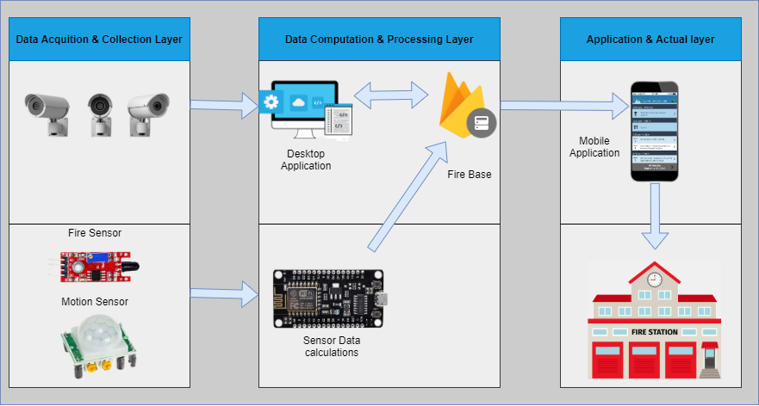

***Figure 1.*** *The System Model*

|  |  |  |
| --- | --- | --- |
| Pir Sensor output | Fire Sensor output | Alert Generate |
| 0 | 1 | 1 |
| 0 | 1 | 1 |
| 0 | 0 | 0 |
| 1 | 0 | 0 |

Apart from the cameras, this system is also using Fire sensors and Pir sensors to enhance the accuracy. Sensors are integral part used to detect fire in many Fire management system applications [13]. Pir sensor that measures infrared light radiating from objects. PIR sensors mostly used in PIR-based motion detectors. Also, it used in security alarms and automatic lighting applications. Since PIR sensors have ranges of **up to 10 meters (30 feet)**, a single detector placed near the entrance is typically all that is necessary for rooms with only a single entrance.. A sensor which is most sensitive to a normal light is known as a flame sensor. That’s why this [sensor module](https://www.elprocus.com/accelerometer-sensor-working-and-applications/) is used in flame alarms. This sensor detects flame otherwise wavelength within the range of 760 nm – 1100 nm from the light source This sensor can be easily damaged to high temperature. So this sensor can be placed at a certain distance from the flame. The flame detection can be done from a 9 feet distance and the detection angle will be 60.P is the pair of ultrasonic sensors. Table 1. shows the states of the sensors and their results are as follow:

***TABLE 1.*** *TRAFFIC DENSITY STATES BY ULTRASONIC SENSORS*

The diagram shows the outcomes when the system generates alert message. When fire sensor and pir sensor both High the microprocessor send alert message to the fire base and then it get by the mobile applications. When only fire sensor is high then its genetates the alert message but not in cause only pir sensor is high. The system is fully automatic only power is given all data will flows automatically.

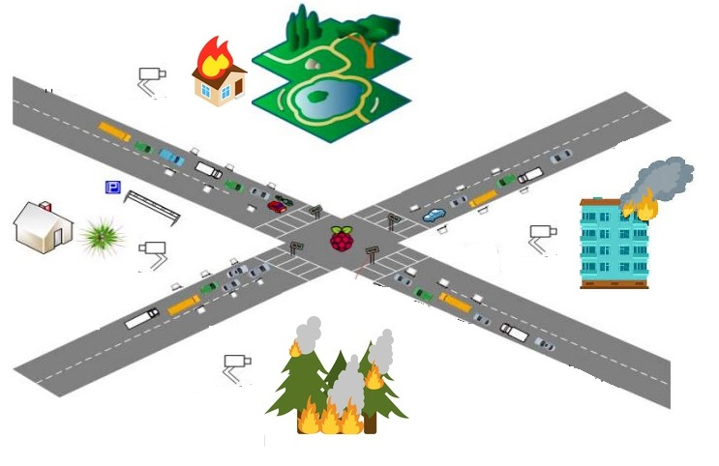

***Figure 2.*** *Sensors Network*

***Camera Results Sensors Results***

|  |  |  |  |  |  |  |
| --- | --- | --- | --- | --- | --- | --- |
| **Situations** | **Human detected** | **Fire**  **detected** | **Human detected** | | **Fire**  **detected** | **Alert sent** |
| **Situation 1** | Yes | Yes | Yes | Yes | | Yes |
| **Situation 2** | Yes | No | Yes No | | | Yes |
| **Situation 3** | No | Yes | Yes Yes | | | Yes |
| **Situation 4** | Yes | Yes | Yes No | | | Yes |
| **Situation 5** | Yes | No | Yes No | | | No |

***TABLE 2.*** *CUMULATIVE DENSITY*

## Data Processing and Decision-Making Layer

The system has All data from sensors and camera video feed. The data goes to the desktop Application where we applied deep learning models on video feed. The abject detection we used is yolo v4 tiny. YOLO v4 Tiny, a version of YOLOv4 developed for edge and lower-power devices, is a real-time object detection algorithm capable of detecting and providing bounding boxes for many different objects in a single image. YOLOv4-tiny is the compressed version of YOLOv4 designed to train on machines that have less computing power. Its model weights are around 16 megabytes large, allowing it to train on 350 images in 1 hour when using a Tesla P100 GPU. YOLOv4-tiny has an inference speed of 3 ms on the Tesla P100, making it one of the fastest object detection models to exist. YOLOv4-Tiny Architecture

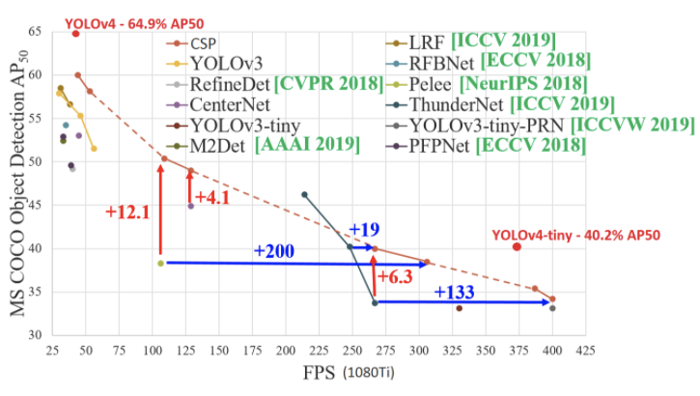

YOLOv4-Tiny utilizes a couple of different changes from the original YOLOv4 network to help it achieve these fast speeds. First and foremost, The number of convolutional layers in the CSP backbone are compressed with a total of 29 pretrained convolutional layers. Additionally, the number of YOLO layers has been reduced to two instead of three and there are fewer anchor boxes for prediction.YOLOv4-Tiny has comparatively competitive results with YOLOv4 given the size reduction. It achieves 40 mAP @.5 on the MS COCO dataset. After the videos detection and finding the final outputs from the Pir sensors and the fire sensors the is send to the Firebase real time database. Realtime syncing makes it easy for your users to access their data from any device: web or mobile, and it helps your users collaborate with one another.

## Application and Actuation Layer

In this layer, the data is delivered to the mobile applications connected to the firebase real-time database the mobile applications are used by the rescue teams such as fire fighters and ambulance operators. The application is light weight and work with the internet. When the application is not opened the notification will pop up as alerts messages such as fire detected and human is detected in the fire. The diagram below shows the working flow of the system. As shown in diagram 100 the sensors and camera detections goes to the firebase and then desktop application consisting Yolov deep learing model fetch required outputs and send back to the fire base . after all data is collected on firebase real time database the mobile application fetch firebase data as alert notifications. The system is automatic sending information after power on. The combinations of Iot and deep learing the results have great accuracy.

The deep learing model will detect Human on all angles as the dataset is consist of human on every any. The System is also tested on the drone live videos streams using the Real time transfer protocol of the ip camera of the drone. The System will works on every IP camera and well as the embedded cctv cameras used in buildings, roads and any indoor or outdoor locations .

**Algorithm 1:**

**Detecting Fire and human**

if (Fire_State >= Cos(2))

Alert = “Fire detected”

alert =firebase.pushstring(Alert)

Delay Time= ((Fire_sate ex sinθ)

If (Pir_state) >= (Cos(2))

Alert = “Fire detected”

alert=firebase.pushstring(Alert)

Delay Time= ((Pir_state ex sinθ)

Else:

System_state == Sin(0)

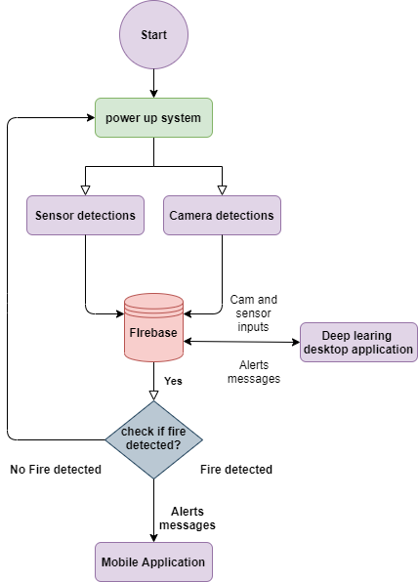

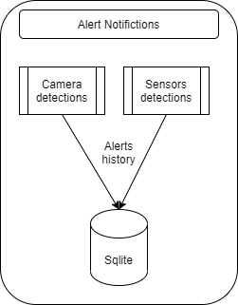

The system checks the state of the fire sensor and camera result if the state is high then it sends data to the firebase database. The desktop application having deep leering model is taking the inputs and keep making decision and send the results to the fire base. If the fire is detected it checks for the presence of human though pir sensors and camera. if the person is found it send the data to the firebase as person is detected.

The Mobile application is consisted of two modules human detection and fire detection. The mobile is fetching data from firebase real time database and shows the results. the mobile application shows the notifications even if the mobile is not open and connect to the internet. The mobile application is able to save the alert history of the data fetching from the firebase and store it in local database SQLite.

# Results and Discussion

A prototype was developed to demonstrate the applicability of our proposed system. Several experiments on real traffic data were carried out to evaluate the efficiency of the proposed algorithm. The traffic density was monitored and calculated by vehicle detection as shown in Figure 5. As soon as the traffic density crosses the specified threshold on a road, the system stopped the normal operation and kept the green light on till the situation on the road became normal. The real-time data was also being sent to the local and central server as well.

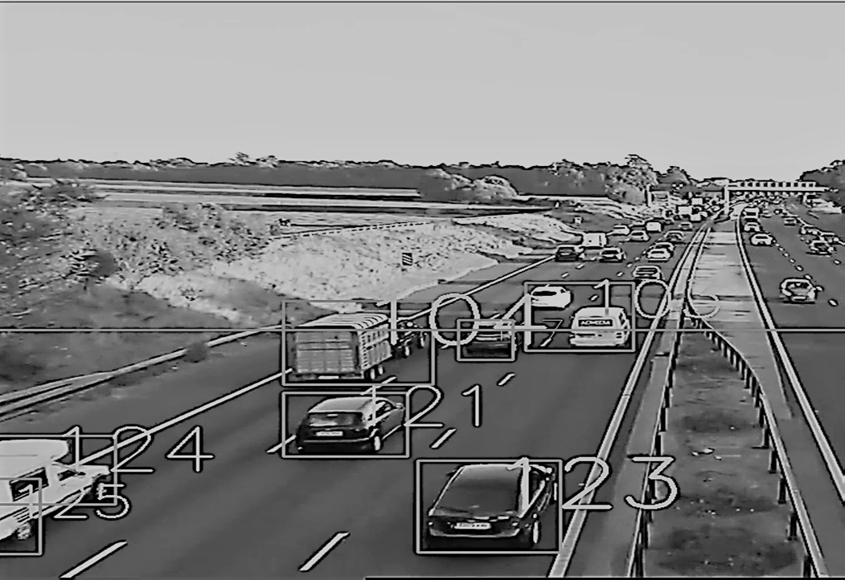

***Figure 5****. Vehicles Detection*

Besides this, a web interface was also developed for the authorities to show them the statistics of traffic on the roads so that they could make real-time and future decisions as discussed in section III. Figure 6 shows the statistical traffic

data i.e. number of vehicles passed in a particular time span at a particular road. The bar graph is representing real-time traffic data. Different bar graphs based on historical and real-time data are being drawn in this application which is helpful for traffic department and other related authorities for i) managing traffic congestions on roads ii) and future planning.

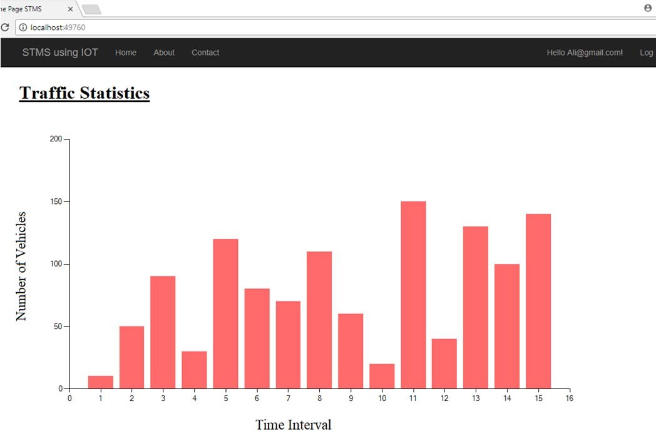

***Figure 6****. Statistical data on traffic*

# Conclusion

This research presents an effective solution for rapid growth of traffic flow particularly in big cities which is increasing day by day and traditional systems have some limitations as they fail to manage current traffic effectively. Keeping in view the state of the art approach for traffic management systems, a smart traffic management system is proposed to control road traffic situations more efficiently and effectively. It changes the signal timing intelligently according to traffic density on the particular roadside and regulates traffic flow by communicating with local server more effectively than ever before. The decentralized approach makes it optimized and effective as the system works even if a local server or centralized server has crashed. The centralized server communicates the nearest rescue department in case of an emergency situation which provides timely human safety. Moreover, a user can ask about future traffic level at particular road hence avoiding wastage of time in traffic jams. The system also provides useful information to higher authorities that can be used in road planning which helps in optimal usage of resources.

# References

1. W. S. Associate, "Transportation and Economy Report," MDOT State Long Range Transportation Plan, Karachi, 2007.
2. K. S. D. M. R. B. Patan Rizwan, "Real-Time Smart Traffic Management System for Smart Cities by Using Internet of Things and Big Data," in *International Conference on Emerging Technological Trends [ICETT]*, Kollam, 2016.
3. C. S. D. L. T. Authority, "Annual Vehicle Statistics," Annual Vehicle Statistics 2015, Karachi, 2015.
4. M. P. a. B. B. Sivasankar, "IoT Based Traffic Monitoring using Raspberry Pi," *Internation Journal of Research in Engineering, Science and Technology (IJRESTs),* vol. 1, no. 7, pp. 2454-664x, 2016.
5. A. Lone, "Karachi’s crime malaise," Tribune.com.pk, 18 August 2011. [Online]. Available: https://blogs.tribune.com.pk/story/7540/karachis- crime-malaise/. [Accessed 20 September 2017].
6. S. Sharief, "Road Accidents in Pakistan Reach Alarming High: Who’s Responsible," Pakwheels.com, 2016. [Online]. Available: https://[www.pakwheels.com/blog/alarming-increase-of-road-accidents-](http://www.pakwheels.com/blog/alarming-increase-of-road-accidents-) in-pakistan/. [Accessed 2017].
7. B. k. Khan, "Traffic jams in Karachi result in losses worth of millions each day," PakWheels.com, 2013. [Online]. Available: https:/[/w](http://www.pakwheels.com/blog/traffic-jams-karachi-result-losses-)w[w.pakwheels.com/blog/traffic-jams-karachi-result-losses-](http://www.pakwheels.com/blog/traffic-jams-karachi-result-losses-) worth-millions-day/. [Accessed 2017].
8. P. K. K. P. S. T. Prashant Jadhav, "Smart Traffic Control System Using Image Processing," *International Research Journal of Engineering and Technology (IRJET),* vol. 3, no. 3, pp. 2395-0056, 2016.
9. E. Leigh, "Advancing integrated and sustainable transport for the Cambridge region," Smarter Cambridge Transport, 2017. [Online]. Available: [http://www.smartertransport.uk/.](http://www.smartertransport.uk/) [Accessed 2017].
10. T. C. N. K. Kartikeya Jain, "Smart vehicle identification system using OCR," in *3rd International Conference on Computational Intelligence & Communication Technology (IEEE-CICT 2017)*, Ghaziabad, India, 2017.
11. T. e. a. Osman, "Intelligent traffic management system for a cross section of roads using computer vision," in *Computing and Communication Workshop and Conference (CCWC), 2017 IEEE 7th Annual*, 2017.
12. D. C. J. E. J. Khac-Hoai Nam Bui, "Real-Time Traffic Flow Management Based on Inter-Object Communication: a Case Study at Intersection," in *7th International Conference on Ambient Intelligence (ISAmI’2016)*, 2016.
13. V. S. A. M. S. D. K. K. Swathi, "Traffic Density Control and Accident Indicator Using WSN," *International Journal for Modern Trends in Science and Technology,* vol. 2, no. 4, pp. 2455-3778, 2016.
14. H. O. Al-Sakran, "Intelligent traffic information system based on the integration of Internet of Things and Agent technology," *International Journal of Advanced Computer Science and Applications (IJACSA),* vol. 6, no. 2, pp. 37-43, 2015.
15. A. S. Nidhi D. Agrawal, "Intelligent Real Time Traffic Controller Using Image Processing – A Survey," *International Journal of Science and Research (IJSR) ISSN (Online),* vol. 4, no. 4, pp. 2319-7064, 2015.
16. J. D. D. M. A. M. A. J. Vismay Pandit, "Smart Traffic Control System Using Image Processing," *International Journal of Emerging Trends & Technology in Computer Science (IJETTCS),* vol. 3, no. 1, pp. 2278- 6856, 2014.
17. D. S. P. S. Y. M. Pranav Maheshwari, "Smart Traffic Optimization," in *3rd International Conference on MOOCs, Innovation and Technology in Education (MITE)*, IEEE, 2015.
18. M. A. M. A. T. R. J. S. A.-M. A. B. Fozia Mehboob, "Automated Vehicle Density Estimation from Raw Surveillance Videos," in *SAI Computing Conference 2016*, London, 2016.
19. K. B. M. R. M. B. Shubham N. Mahalank, *Device to Device Interaction Analysis in IoT based Smart Traffic Management System: An Experimental Approach,* Symposium on Colossal Data Analysis and Networking (CDAN), 2016.

**Sabeen Javaid,** is a PhD scholar in Department of Computer Software Engineering at Military College of Signals, National University of Sciences and Technology (NUST), Islamabad, Pakistan. She holds a MS degree in Computer Software Engineering from NUST, Pakistan. She is also an IEEE member. Her research interests include web services, Collaborative Networks, Web of Things and Internet of Things.

**Ali Sufian,** is a Software Engineer. He completed his BS degree in Software Engineering from University of Gujrat, Sialkot Campus, Pakistan. He joined IEEE as a student member in 2014. He served IEEE UOG Sialkot student branch as a chair from 2015-2017. His field of interests includes Internet of Things and Artificial Intelligence.

**Saima Pervaiz,** is a Software Engineer. He completed her BS degree in Software Engineering from University of Gujrat, Sialkot Campus, Pakistan. She joined IEEE as a student member in 2014. Her field of interests includes Internet of Things, Web of Things and Artificial Intelligence.

**Mehak Tanveer,** is a Software Engineer. She completed her BS degree in Software Engineering from University of Gujrat, Sialkot Campus, Pakistan. She joined IEEE as a student member in 2014. Her field of interests includes Internet of Things, Web of Things and Artificial Intelligence.