Chapter 3 Draft Sections
3.7 Dataset Detail and 3.8 AI Models & Algorithms
Project base: HIPAA-Compliant Home Health and Hospice AI Platform. Prepared for insertion after the architecture diagram in Chapter 3.



3.7 Dataset Deta
The dataset for this project is planned as a controlled, privacy-preserving dataset rather than a collection of real patient records. The primary document format will be OASIS-E2, because CMS lists the final OASIS-E2 instruments and data specifications as effective from April 1, 2026 [1], [2]. OASIS-E2 will be used as the home-health assessment source for field extraction, validation, and feature engineering. Plan of Care documents will be represented through project-created or public/sample templates populated with synthetic clinical values.
The dataset will support three tasks: document extraction, RAG-based Plan of Care drafting, and 30-day readmission-risk prediction. For document extraction, each form will have an associated ground-truth JSON file containing selected high-value fields. For POC drafting, approved extracted fields, source snippets, and care-plan template text will form a small retrieval corpus. The RAG component will retrieve evidence for each POC section and produce a cited draft for clinician review. For risk prediction, validated structured fields will be transformed into tabular features; if a public clinical dataset such as MIMIC-IV is used, it will be treated only as a de-identified baseline for model prototyping because it is hospital EHR data, not a home-health OASIS dataset [6].
Table 3.1 summarizes the planned dataset components.
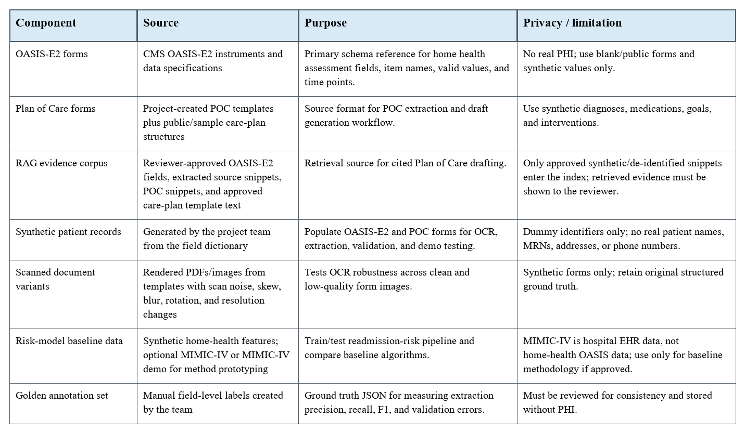

Dataset Creation Process
- Collect the official OASIS-E2 instruments and data specifications from CMS and define the project field dictionary.
- Create synthetic patient profiles covering common home-health scenarios such as chronic disease, mobility limitation, medication complexity, wounds, and recent hospitalization.
- Populate OASIS-E2 and POC templates with synthetic values and render them as PDFs/images.
- Generate scan-quality variants by changing resolution, rotation, blur, contrast, and noise so OCR robustness can be tested.
- Annotate each document with a ground-truth JSON record for selected fields and review the labels manually.
- Create a RAG evidence corpus from approved source snippets, selected OASIS-E2 fields, and care-plan template text; store source IDs for citation.
- Split the golden set into training/development/testing partitions, for example 70%, 15%, and 15%, after enough labeled samples are available.

Selected Field Groups
The MVP should not attempt to extract the full OASIS-E2 instrument in the first iteration. It should focus on fields required for the report KPIs, POC generation, and risk prediction.
Table 3.2 lists the feature groups planned for extraction and modeling.
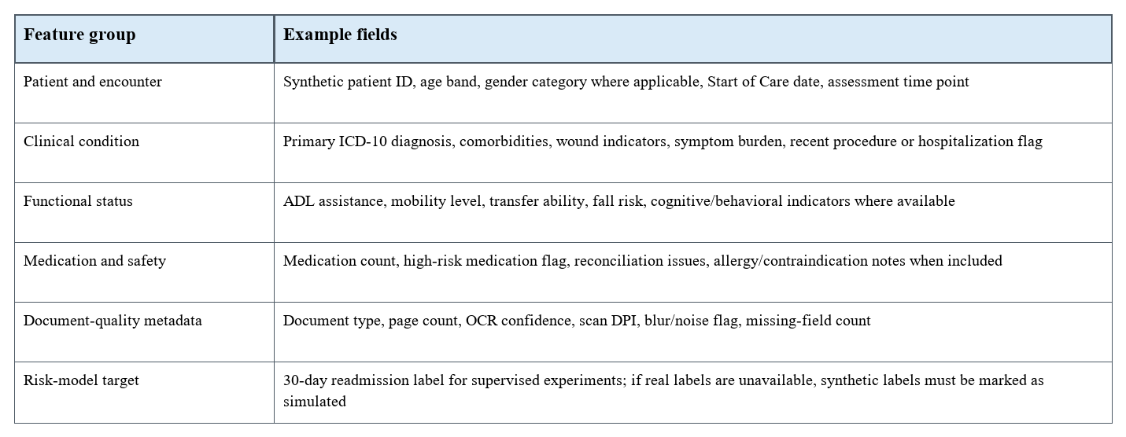

Dataset Size and Evaluation Plan
For FYP-I, the practical target is a small but well-verified golden set rather than a large unverified dataset. A suitable initial target is 50-100 synthetic documents for pipeline testing and 150-300 documents for the MVP evaluation if time allows. Every evaluation result should report the dataset size, document types, scan-quality categories, field count, and whether the readmission labels are real, de-identified, or simulated.
- Extraction metrics: field-level precision, recall, macro-F1, missing-field rate, and low-confidence rate.
- Review metrics: average reviewer time per form, edit rate, accept/reject rate, and error categories.
- POC metrics: section-level approval without modification, citation coverage, and unsupported-statement count.
- Risk metrics: AUROC, Brier score, calibration curve, confusion matrix at selected thresholds, and explanation quality review.

3.8 AI Models & Algorithms
The proposed system uses a modular, student-implementable AI pipeline. The primary MVP keeps OCR, extraction, validation, retrieval, and risk prediction implementable with open-source tools. RAG is a core implementation component for Plan of Care drafting, but it is constrained by approved evidence, citations, missing-evidence warnings, and human review. This design prevents the system from behaving as a black-box clinical decision maker and keeps the project aligned with HIPAA-aware handling of electronic protected health information.
Table 3.3 summarizes the AI models and algorithms planned for the MVP.
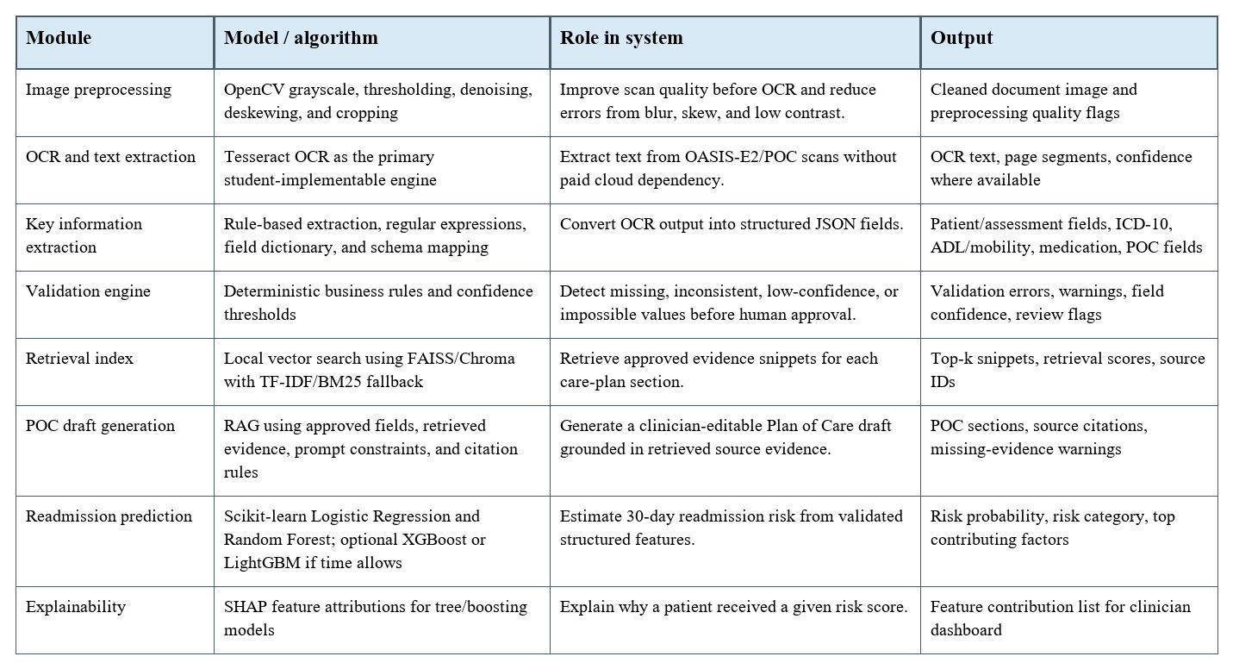

OCR and Key Information Extraction
The first AI step is image preprocessing followed by OCR. OpenCV will be used to convert scans to grayscale, reduce noise, improve contrast, threshold text regions, deskew rotated pages, and crop unnecessary margins [4]. Tesseract OCR will then extract machine-readable text from OASIS-E2 and POC document images [3]. This approach is free, local, and suitable for student implementation. The extraction service will map OCR output into a versioned JSON schema rather than storing unstructured text only.
For the MVP, key information extraction will be implemented through rules, regular expressions, field dictionaries, and template-aware parsing. Examples include detecting patient identifiers, dates, ICD-10-style diagnosis codes, checkbox-like values, ADL/mobility indicators, medication counts, and document metadata. Managed cloud document-AI services can be mentioned only as future benchmarks, but they are not required for the core implementation.

Validation and Human Review
The validation engine should be deterministic wherever possible. Rules will check required fields, date consistency, valid ICD-10 format, field confidence, allowed categorical values, and missing source evidence. Fields that fail validation are not silently corrected; they are flagged for the clinician reviewer. The review screen will allow accept, edit, and reject actions, and each action will be written to the audit log.

RAG-Based Plan of Care Generation
The POC generator will use Retrieval-Augmented Generation as a core MVP feature [10]. Approved OASIS-E2 fields, extracted POC snippets, and care-plan template text will be chunked into a small evidence corpus. For each care-plan section, the system will retrieve the top-k relevant snippets using a local vector index such as FAISS or Chroma, with TF-IDF/BM25 as a fallback if embeddings are not available. The generator will draft sections such as patient summary, problems, goals, interventions, medication notes, safety concerns, and follow-up recommendations only from retrieved evidence.
The generation layer must be constrained. It may use a lightweight local model, an approved API model, or a structured prompt/template wrapper, but every generated section must include source citations and a missing-evidence warning when retrieval is insufficient. Because clinical summarization research shows that hallucinations and omissions can affect patient safety [11], the draft POC will never be finalized automatically. A clinician must review, edit, and approve the generated content before it becomes part of the patient record.

Readmission Risk Prediction
The risk model should start with free scikit-learn baselines before advanced optimization [5]. Logistic Regression is useful as an interpretable baseline, while Random Forest can model nonlinear relationships in structured clinical features. XGBoost and LightGBM are also open-source and can be added as optional comparison models if time allows, because gradient-boosted tree methods are strong tabular-data baselines [7], [8]. The model output should be a calibrated probability of 30-day readmission, not only a class label.
The project should report AUROC for ranking performance and Brier score for calibration. SHAP explanations can be used to show the main factors that increased or decreased a patient's risk score [9]. Example explanation factors include recent hospitalization, high medication count, low mobility, wound presence, multiple comorbidities, and missing or uncertain assessment values.

Algorithmic Workflow
- Step 1: User uploads an OASIS-E2 or POC document through the protected web app.
- Step 2: The raw document is stored securely and preprocessed with OpenCV.
- Step 3: Tesseract OCR extracts text, and rule-based parsing maps selected values into structured JSON fields.
- Step 4: Validation rules flag missing, inconsistent, and low-confidence fields.
- Step 5: A clinician reviews, edits, and approves the structured record.
- Step 6: Approved fields, source snippets, and care-plan template text are indexed for RAG retrieval.
- Step 7: The RAG service retrieves evidence and generates a cited POC draft with missing-evidence warnings.
- Step 8: Structured features are passed to the readmission-risk model.
- Step 9: The dashboard displays the cited POC draft, risk score, explanation, and audit trail.

References Used in This Draft
These references should be merged into the final report reference list in first-citation order.
[1] Centers for Medicare & Medicaid Services, "OASIS Data Sets," CMS, page last modified Apr. 2, 2026. [Online]. Available: https://www.cms.gov/medicare/quality/home-health/oasis-data-sets. Accessed: Apr. 29, 2026.
[2] Centers for Medicare & Medicaid Services, "Home Health Quality Reporting Program: Data Specifications," CMS, page last modified Mar. 10, 2026. [Online]. Available: https://www.cms.gov/medicare/quality/home-health/data-specifications. Accessed: Apr. 29, 2026.
[3] R. Smith, "An overview of the Tesseract OCR engine," in Proc. 9th Int. Conf. Document Analysis and Recognition (ICDAR), 2007, pp. 629-633, doi: 10.1109/ICDAR.2007.4376991.
[4] G. Bradski, "The OpenCV Library," Dr. Dobb's Journal of Software Tools, 2000.
[5] F. Pedregosa et al., "Scikit-learn: Machine Learning in Python," Journal of Machine Learning Research, vol. 12, pp. 2825-2830, 2011.
[6] A. E. W. Johnson et al., "MIMIC-IV, a freely accessible electronic health record dataset," Scientific Data, vol. 10, art. 1, 2023, doi: 10.1038/s41597-022-01899-x.
[7] T. Chen and C. Guestrin, "XGBoost: A Scalable Tree Boosting System," in Proc. 22nd ACM SIGKDD Int. Conf. Knowledge Discovery and Data Mining, 2016, pp. 785-794, doi: 10.1145/2939672.2939785.
[8] G. Ke et al., "LightGBM: A Highly Efficient Gradient Boosting Decision Tree," in Advances in Neural Information Processing Systems, vol. 30, 2017, pp. 3146-3154.
[9] S. M. Lundberg and S.-I. Lee, "A Unified Approach to Interpreting Model Predictions," in Advances in Neural Information Processing Systems, vol. 30, 2017.
[10] P. Lewis et al., "Retrieval-Augmented Generation for Knowledge-Intensive NLP Tasks," in Advances in Neural Information Processing Systems, vol. 33, 2020.
[11] E. Asgari et al., "A framework to assess clinical safety and hallucination rates of LLMs for medical text summarisation," npj Digital Medicine, vol. 8, art. 274, 2025, doi: 10.1038/s41746-025-01670-7.

