MST IMPORT AND EXPORT SDN. BHD. (镁嘉国际贸易有限公司)
CLIENT REQUIREMENTS CONSOLIDATION, ZONE A SPECIFICATION
& COMPLETE BACKEND ADMINISTRATION MANUAL
Formal Technical Response, Postcode.my Reference Directory, Illustrated Admin Manual, Promotion Analysis & Handover Roadmap

Addressed To: Wendy (Client Project Lead) & MST Management | Prepared By: Abdul Rehman (Lead Full-Stack & Technical Architect)
Document Reference: MST-UAT-CONSOLIDATION-2026-FINAL | Date of Issuance: October 9, 2026
Platform Version: Laravel Unified B2B & B2C Cold-Chain Engine | Status: Official Response & Action Plan Ready for Final UAT

Executive Opening & Acknowledgment
Dear Wendy,
Thank you for your comprehensive consolidation message. We have carefully reviewed and systematically addressed every requirement regarding MST Zone A delivery coverage, delivery fee rules, backend administration, promotions/discounts, and final handover.
All code updates regarding Skudai (81300) and Kulai (Indahpura only) have been implemented, tested, and pushed to the live deployment pipeline. This document provides the complete compiled Postcode.my directory for your review, a step-by-step illustrated Admin Operation Manual, a transparent technical review of the requested coupon/marketing attribution architecture, and our final handover roadmap.

1. MST Zone A Delivery Coverage & Compiled Postcode Directory
In accordance with your instructions, we have cross-referenced the official Johor postal directory on Postcode.my (https://postcode.my/location/johor/) for the 10 requested coverage areas. We have updated the platform's logistics rules to ensure strict compliance with your four business constraints:
- 1. Kulai Restricted to Indahpura Only: Postcode 81000 is included in Zone A ONLY when the delivery address or area specifies 'Indahpura' or 'Bandar Indahpura'. All general and outstation Kulai postcodes remain classified as Outstation / Zone B.
- 2. Exact Postcode Matching: The matching engine enforces authoritative 5-digit postcode validation rather than relying solely on high-level prefixes.
- 3. Skudai (81300) Recognized in Zone A: The previous hardcoded exclusion of 81300 has been completely removed in DeliveryService.php and DeliveryZone.php. Postcode 81300 is now officially recognized as Zone A local delivery.
- 4. 100% Cart & Checkout Consistency: The identical postcode and area evaluation rules execute across the shopping cart delivery calculation (/api/calculate-delivery-fee) and the live checkout order placement pipeline.
Compiled Zone A Postcode Directory for Review & Confirmation
Below is the compiled directory of postcodes and sub-localities for the 10 designated areas for your formal review:
Area # | Target Area Name | Official Postcode(s) | Key Included Localities & Sub-Districts | Coverage Status
1 | Gelang Patah | 81550, 79200 | Gelang Patah Town, Nusajaya Industrial Park, Kampung Baru Gelang Patah, SILC Vicinity | Zone A (Local)
2 | Iskandar Puteri / Nusajaya | 79000, 79100, 79200, 79250, 79500 | Kota Iskandar, Medini, Puteri Harbour, East Ledang, Horizon Hills, Ledang Heights, Eco Botanic | Zone A (Local)
3 | Johor Bahru Core | 80000, 80050, 80100, 80150, 80200, 80250, 80300, 80350, 80400, 80500, 80550, 80600, 80650, 80700, 80710, 80720, 80730, 80800, 80990, 81200 | JB City Centre, Larkin, Tampoi, Bandar Baru Uda, Danga Bay, Stulang, Century, Majidee, Pelangi, Taman Sentosa, Perling, Bukit Indah | Zone A (Local)
4 | Kulai (Indahpura Only) | 81000 | Bandar Indahpura, AEON Mall Kulai vicinity, Diamond 1-3, Indahpura Industrial Park. (Strict rule: Rural/outstation Kulai excluded) | Zone A (Indahpura Only)
5 | Masai | 81750 | Masai Town, Bandar Seri Alam, Plentong, Kota Puteri, Taman Megah Ria | Zone A (Local)
6 | Senai | 81400 | Senai Town, Senai Airport City, Senai Industrial Park I-IV, Taman Senai Utama | Zone A (Local)
7 | Skudai (incl. 81300) | 81300 | Skudai Town, Taman Universiti, Mutiara Rini, Taman Ungku Tun Aminah (TUTA), Skudai Baru, Sutera Utama / Sutera Mall | Zone A (Local)
8 | Setia Eco Gardens | 81550 | Setia Eco Gardens, Eco Village, Gelang Patah Southern Corridor | Zone A (Local)
9 | Mount Austin | 81100 | Taman Mount Austin, Austin Heights, Austin Perdana, Austin Duta, Taman Daya, JP Perdana | Zone A (Local)
10 | Confirmed ICQ Area (Iskandar Puteri) | 79000, 79100, 79200, 79250, 79500 | Kompleks Sultan Abu Bakar (Second Link CIQ), Tanjung Kupang, Puteri Harbour Ferry Terminal ICQ, Kota Iskandar CIQ checkpoints | Zone A (Local)

2. Delivery Fee Rules & Fulfillment Workflow Confirmation
We confirm that all six delivery fee rules specified in your message are strictly retained, active, and verified:
- • Zone A Orders Below RM150 (RM10 Fee): Orders below RM150 residing in Zone A are automatically assessed the RM10.00 local delivery fee. The delivery line item in Stripe reflects exactly RM10.00.
- • Zone A Orders of RM150 & Above (RM0 Free Delivery): Orders of RM150.00 and above residing in Zone A qualify for Free Standard Delivery (RM0.00). Stripe charges only the product subtotal.
- • Outstation Orders (To Be Confirmed): The checkout and order confirmation display 'Outstation Transportation Fee — To Be Confirmed'. Exactly RM0.00 is added to the Stripe checkout amount, ensuring customers are never overcharged before logistics arrangements are finalized.
- • WhatsApp Coordination Link: Outstation orders trigger a dedicated notice banner with an integrated WhatsApp button (wa.me) allowing MST's operations team to coordinate Styrofoam box packaging sizing and cold-chain freight rates directly with the buyer.
- • Store Self-Collection (Free / Address Hidden): Store pickup at Counter 2, SILC Industrial Park, remains 100% free (RM0.00). Delivery address, city, and postcode fields are completely hidden, while collection date and collection time slot selection are mandatory.
- • 7 Working Days Delivery Lead-Time Notice: Checkout displays: 'Please allow up to 7 working days for order sourcing and cold-chain delivery arrangements. The available delivery date will be confirmed by MST based on product availability and delivery scheduling.'
- • RM150 Reference Threshold (Non-Blocking): Orders of any value (e.g. RM25, RM50, RM80) are fully permitted to proceed to payment. RM150 functions strictly as the delivery waiver threshold, preserving retail sales volume.
Visual Evidence: Verified Cart & Checkout Delivery Behaviors
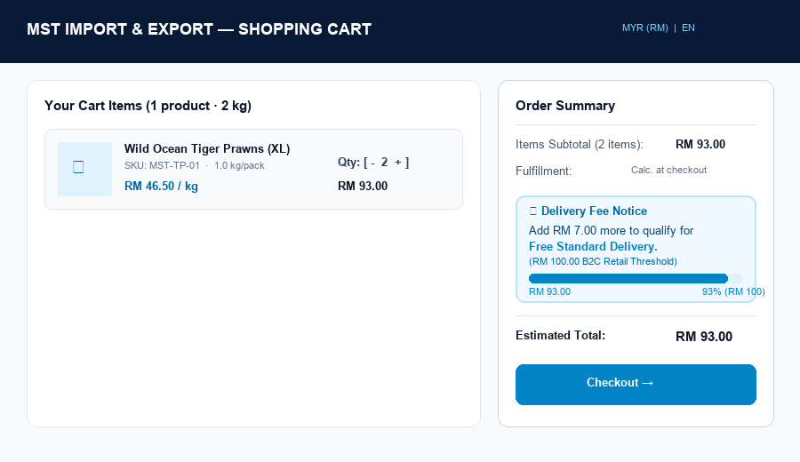
Figure: Shopping Cart showing RM10 delivery fee and dynamic spend tracker toward the RM150 free delivery threshold.
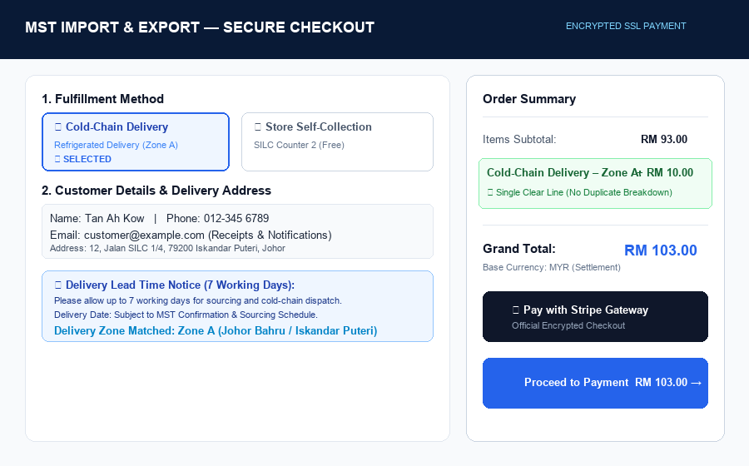
Figure: Live Checkout page displaying the Zone A lead-time notice, address fields, and single itemized RM10 fee.
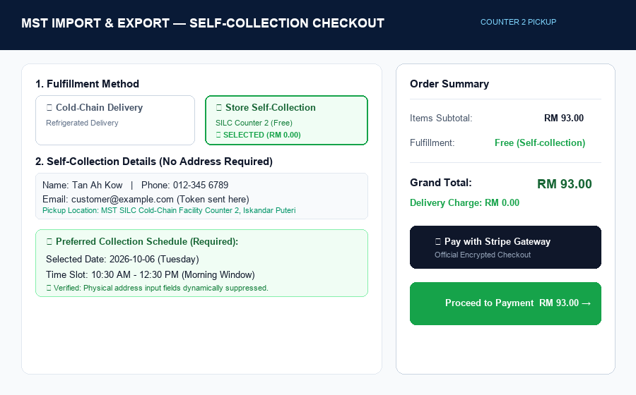
Figure: Checkout with Self-Collection selected: Delivery address hidden, collection date and time slots required, RM0.00 fee.
3. Comprehensive Website Admin & Operation Manual
Below is your complete step-by-step operational guide for managing routine website updates through the administrator backend without requiring developer assistance.
3.1. Updating Company Information, Address, Phone, WhatsApp & Email
- Step 1 — Access: Navigate to: Admin Panel → Store Settings (URL: /admin/settings).
- Step 2 — Location: Locate the 'Store Legacy / Physical Details' card and 'SMTP Mail Settings' card.
- Step 3 — Editable Fields: Editable fields include: Store Name, Store Tagline, Store Physical Address, Phone Number, WhatsApp Number (format: 601112710260 without '+' or hyphens for WhatsApp API compatibility), Store Contact Email, and Business Operating Hours.
- Step 4 — Confirmation: Click 'Save All Settings' at the bottom of the page. The system clears the settings cache immediately, and all footer, header, and contact page elements update site-wide.
3.2. Updating Website Banners, Announcements & Page Content
- Banners & Announcements: Homepage Hero & Announcements: Managed via Admin Panel → Store Settings → Site Appearance & General Settings. Update the primary site title, meta description, and banner text.
- Static Content Pages: Legal & Informational Pages: Navigate to Admin Panel → Policies & Dynamic Pages (/admin/policies). Click 'Edit' on Privacy Policy, Terms & Conditions, Refund Policy, Shipping Policy, or Cookie Policy to update text directly using the rich editor.
- Status Control: Toggle 'Published / Draft' status to control page visibility.
3.3. Managing Multilingual Content (English, Simplified Chinese, Bahasa Melayu)
- Product Translations: Direct Product Localization: When editing any product (Admin → Products → Edit), you will find dedicated tabs/fields for English (Name, Description), Simplified Chinese (name_zh, description_zh), and Bahasa Melayu (name_bm, description_bm).
- UI Strings & Labels: Site-wide Interface Phrases: Navigate to Admin Panel → Multilingual Translations (/admin/translations). Use the search bar to locate any button label, header text, or banner string. Edit the translation for EN, ZH, or BM, then click 'Update Translations'.
- Cache Purge: Click 'Clear Translation Cache' (/admin/translations/cache/clear) if updates do not appear immediately.
3.4. Managing Products: Names, Descriptions, Images, Prices & Stock
- Step 1: Navigate to: Admin Panel → Product Management (/admin/products).
- Step 2: Adding Products: Click '+ Add New Product'. Fill in Name, SKU, Category, and Unit (e.g. pack, box, kg).
- Step 3: Pricing Management: Enter Retail Price, Walk-in Price, Wholesale Price, and Trading Price. (Optional: SGD and USD price fields are available if fixed foreign pricing is desired).
- Step 4: Stock Control: Enter 'Stock Quantity' and check 'Track Stock'. When enabled, the system automatically decrements stock upon order placement and displays low-stock badges.
- Step 5: Image Upload & Gallery: Upload a primary thumbnail and multiple product gallery photos. You can upload files directly from your computer or select existing photos from the Media Gallery.
- Step 6: Click 'Create Product' or 'Update Product'. Trashed products can be restored via the 'Archived' tab.
3.5. Controlling Product Visibility & Customer-Tier Access
- Global Visibility: Active Status (is_active): Check or uncheck to show or hide the product across the entire digital storefront.
- Walk-In QR Catalog: Walk-In Availability (is_walkin_available): Check this box to include the product in the Walk-In QR Storefront. If unchecked, the item is hidden from Walk-in customers.
- Homepage Showcase: Featured Product (is_featured): Displays the product on the homepage 'Featured Products' showcase.
- Trading RFQ Mode: RFQ-Only Mode (is_rfq_only): Hides unit prices and displays 'Price upon request / Request Quotation', converting the purchase button to an RFQ inquiry.
- MOQ Constraints: MOQ Controls: Set item-level Minimum Order Quantities for Wholesale (moq_wholesale) and Trading (moq_trading) tiers.
3.6. Managing Delivery Areas, Postcodes, Fees & Time Slots
- Delivery Zones: Postcodes & Coverage: Navigate to Admin Panel → Delivery Zones (/admin/delivery-zones). Click 'Edit' on Zone A or Zone B to add or remove postcodes, areas, or modify base and below-threshold fees.
- Threshold Amount: Free Delivery Threshold: On the Delivery Zones page, update the 'B2C Free Delivery Threshold' field (default: RM150.00) and click 'Update Threshold'.
- Pickup Shift Hours: Collection Time Slots: Hard-coded to the four standard operational shifts (8:30–10:30 AM, 10:30 AM–12:30 PM, 1:30–3:30 PM, 3:30–5:30 PM). To alter these hours, adjustments are made in the checkout template or store settings.
3.7. Managing Orders, Customer Accounts, Invoices & Reports
- Order Tracking: Orders Dashboard (/admin/orders): Filter orders by status (Pending, Confirmed, Preparation, Shipped, Delivered, Collected), payment status (Paid, Unpaid), and fulfillment type. Click any order to view customer details, line items, and payment references.
- Dispatch Scheduling: Schedule Confirmation (/admin/orders/{id}): Set the confirmed delivery date, time, and dispatch notes. Click 'Notify Schedule' to automatically email the customer.
- Invoice Printing: Formal Tax Invoices (/admin/orders/{id}/invoice): 1-click printable formal invoice with company header, buyer SSM details, tax breakdown, and Ringgit amount in words.
- Customer Vetting: Customer Accounts (/admin/customers): Review B2B Wholesale and Trading registration applications. One-click 'Approve', 'Reject', or 'Unblock' actions. View duplicate phone and SSM alerts.
- Subscriber Export: Newsletter Subscribers (/admin/newsletter): View subscriber list and click 'Export CSV' to download marketing contact lists.
3.8. Responsibility Matrix: Backend Self-Management vs. Developer Assistance
To clarify ongoing operational boundaries, the matrix below details what can be self-managed versus what requires technical code intervention:
Administrative Function | Self-Managed via Admin Backend? | Requires Developer / Technical Code?
Updating Business Address, Phone, WhatsApp, Email | YES (Admin -> Settings) | No
Editing Product Prices, Descriptions, Photos & Stock | YES (Admin -> Products) | No
Adding New Categories & Setting Sort Orders | YES (Admin -> Categories) | No
Adding / Removing Postcodes in Delivery Zones | YES (Admin -> Delivery Zones) | No
Changing Free Delivery Threshold (RM150) | YES (Admin -> Delivery Zones) | No
Reviewing & Approving B2B Wholesale Applicants | YES (Admin -> Customers) | No
Managing Orders & Setting Confirmed Delivery Dates | YES (Admin -> Orders) | No
Translating Product & Website UI Strings (EN/ZH/BM) | YES (Admin -> Translations & Products) | No
Downloading .SQL Database Backups | YES (Admin -> Database -> Download) | No
Editing Legal Policies (Privacy, Terms, Refunds) | YES (Admin -> Policies) | No
Adding New Payment Gateway (e.g. FPX direct, e-Wallets) | No (Stripe is active) | YES (Requires Gateway API Integration)
Altering Core Database Architecture or Schemas | No | YES (Requires Laravel Migration)
Redesigning Page Layouts or Header Navigation Bars | No | YES (Requires Blade Template Editing)

4. Promotions, Discounts & Coupon Codes: Technical Status & Proposal
4.1. Current System Status (What is Active Now)
In the delivered system, promotional and discount pricing is currently managed through:
- Tiered Pricing Schedules: Administrators define distinct pricing per SKU across Retail, Walk-in, Wholesale, and Trading tiers.
- Free Delivery Incentives: Automatic cart qualification for free standard delivery when reaching the RM150 / RM350 threshold.
- Featured Spotlights: Products can be placed in 'Featured' sections with promotional banner callouts.
Clarification: A standalone Coupon / Promo Code Engine (allowing shoppers to enter codes like FBMST10, WAMST10, TIKTOK10, or REFMST10 at checkout, calculating percentage or fixed-amount discounts, enforcing usage limits and dates, and tracking marketing attribution) was NOT part of the original project proposal. However, because this is an exceptionally valuable marketing tool for MST, we have fully architected the implementation plan below.
4.2. Proposed Coupon Code & Marketing Attribution Architecture
To implement full coupon code management exactly as you requested, the following components will be built:
- 1. Database Schema: New coupons table storing: code, discount_type ('percentage' vs 'fixed'), discount_amount, min_spend, max_spend, usage_limit_total, usage_limit_per_user, usage_count, valid_from, valid_until, customer_group, marketing_channel ('facebook', 'whatsapp', 'tiktok', 'referral'), referral_partner_name, and is_active.
- 2. Frontend Checkout Field: Interactive 'Have a coupon code?' field in cart and checkout with real-time AJAX validation checking expiry, minimum spend, and tier constraints before applying the discount to the subtotal.
- 3. Stripe & Invoice Integration: Discount deductions are calculated server-side, passed as itemized negative lines to Stripe Hosted Checkout, and recorded in Order records and printable tax invoices.
- 4. Marketing Source & Referral Tracking: Every order records coupon_code, marketing_source (Facebook, WhatsApp, TikTok), and referral_partner. Orders index displays attribution badges.
- 5. Admin Promotions Workbench: A dedicated back-office interface (/admin/coupons) to create promo codes, set start/end dates, activate/deactivate promotions, view redemption counts, and analyze marketing channel performance.
4.3. Development Timeline & Additional Investment Advice
Because this module requires building new database migrations, cart calculation refactoring, Stripe payload updates, checkout validation UI, and a dedicated back-office coupon workbench, the implementation scope is estimated as follows:
- Estimated Development Duration: 3 to 5 business days from approval.
- Additional Investment Quote: RM 700.00 (One-time investment covering complete backend CRUD, checkout integration, Stripe metadata sync, marketing referral tracking, testing, and operation manual updates).
- Execution Path: If approved, this can be executed immediately as a supplementary milestone or post-handover enhancement without delaying the primary platform UAT sign-off.
5. Final Handover, Credentials & Acceptance Roadmap
5.1. System Ownership & Credentials Handover
- Admin Account: Primary Administrator Credentials: Username: admin@mst.my | Password will be provided securely via private channel upon final sign-off.
- Full Code & Database IP: Database Ownership: The complete MySQL database (oceanfresh) and codebase reside 100% on your infrastructure with zero vendor locks.
- 1-Click SQL Backup Routine: Admins can download a full, self-contained .sql database dump at any moment via Admin Panel → Database Management → Download Backup.
5.2. Video Tutorial & Training Assistance
In addition to the comprehensive written manual in Section 3, we are happy to conduct a live interactive walkthrough (Google Meet / Zoom) or record concise screen-capture video tutorials demonstrating routine product updates, price adjustments, and order processing.
5.3. Final Acceptance Checklist & Next Steps
To conclude final project acceptance smoothly:
- Step 1 — Zone A Confirmation: Confirm whether the compiled Postcode.my Zone A directory (Table in Section 1) is approved as presented.
- Step 2 — Promotion Module Decision: Advise whether you wish to proceed with the Coupon & Referral Partner Engine (Section 4) as an immediate add-on or post-launch enhancement.
- Step 3 — Final UAT Sign-Off: Verify that all delivery rules (Section 2) and administration workflows (Section 3) meet your operational expectations.
- Step 4 — Handover & Warranty Activation: Release the final project milestone upon formal sign-off.

Sincerely,
Abdul Rehman
Lead Full-Stack Developer & Technical Architect
MST E-Commerce Platform Project

