MST IMPORT AND EXPORT SDN. BHD. (镁嘉国际贸易有限公司)
COMPLETE WEBSITE ADMIN PANEL & OPERATIONS MANUAL
Step-by-Step Practical Guide for Routine Content, Product Pricing, Translations, Delivery Zones & Order Management

Document Purpose: Official Back-Office User & Operations Manual | Target Audience: Wendy (Client Project Lead) & MST Administrators
Platform Engine: Laravel Unified B2B & B2C Cold-Chain Platform | System Version: Production 2.0 (Live LTS)
Superadmin Account: admin@mst.my | Date of Issuance: October 2026

Purpose & Scope of this Operations Manual
Welcome to the MST Seafood Platform Administration Manual.
This handbook is designed specifically for MST management and operations staff to manage the e-commerce website independently. It provides comprehensive, step-by-step instructions on updating company contact information, managing seafood products and 4-tier pricing, modifying trilingual website translations (English, Chinese, Malay), supervising delivery zones and fees, processing customer orders, and creating 1-click database backups—all directly through your browser without requiring technical coding knowledge.

1. Accessing the Admin Panel & Dashboard Navigation
The administrative panel is protected by role-based authentication and is accessible only to verified administrators.
1.1. How to Log In
- Step 1 — Navigate: Open your web browser (Google Chrome, Microsoft Edge, Safari, or Firefox).
- Step 2 — URL: Go to your website domain followed by /admin (for example: https://yourdomain.com/admin or https://yourdomain.com/login).
- Step 3 — Username: Enter your administrator email address: admin@mst.my
- Step 4 — Password: Enter your secure administrator password and click 'Sign In'.
- Step 5 — Dashboard: Upon successful authentication, you will be redirected to the Admin Overview Dashboard.
1.2. Dashboard Interface Layout
- • Left Navigation Menu: Sidebar Navigation (Left): Provides immediate access to all management modules: Dashboard, Products, Categories, Orders, Customers, Quotations, Media Gallery, Delivery Zones, Translations, Policies, and Store Settings.
- • Top Header: Top Bar (Header): Displays quick links to the live storefront ('View Website'), current active language, notification alerts, and your profile dropdown ('Logout').
- • Summary Widgets: KPI Overview Cards: Summary widgets showing total sales, pending orders, wholesale approval requests, and low-stock alerts.
2. Managing Company Information, Contact Details & Operating Hours
Routine updates to your business address, contact numbers, email addresses, and operating hours can be updated in real time via Store Settings.
- Step 1: Navigate to: Admin Panel → Store Settings (/admin/settings).
- Step 2: Click on the 'Contact Page Settings' tab.
- Step 3 — Editable Fields: Update the following fields as needed:
• Company Name (English): e.g., MST Import and Export Sdn. Bhd.
• Company Name (Chinese): e.g., 镁嘉国际贸易有限公司
• Physical Address: e.g., 7, Jalan SILC 2/18, Kawasan Perindustrian SILC, 79200 Iskandar Puteri, Johor
• Primary Phone Number: e.g., +60 13-280 0168
• WhatsApp Number: Enter as 601112710260 (Important: Enter numbers only, without '+' or hyphens, to ensure the direct chat link works on both mobile and desktop)
• Customer Service Email: info@mst.my
• Wholesale Inquiries Email: wholesale@mst.my
• Business Operating Hours: e.g., Monday – Saturday: 8:00am – 6:00pm (Sunday & Public Holidays: Closed)
- Step 4 — Save: Click the blue 'Save Settings' button at the bottom of the card. Changes take effect across your website footer, contact page, and printed invoices immediately.
3. Updating Banners, Announcements & Legal Policy Pages
3.1. Homepage Hero Banner & Meta Tags
- Location: Navigate to: Admin Panel → Store Settings → General Settings tab.
- Editing: Edit the 'Site Title', 'Site Description' (shows on Google search results), and 'Meta Keywords'.
- Save: Click 'Save Settings' to apply.
3.2. Legal & Information Pages (Terms, Privacy, Refund, Shipping)
- Step 1: Navigate to: Admin Panel → Policies & Dynamic Pages (/admin/policies).
- Step 2: You will see a list of standard policy pages: Privacy Policy, Terms & Conditions, Refund & Return Policy, Shipping & Cold-Chain Policy, and Cookie Policy.
- Step 3: Click the 'Edit' (pencil icon) button next to the policy you wish to update.
- Step 4: Edit the text directly using the built-in rich text editor (supports headings, bold, bullet points, and links).
- Step 5: Ensure the 'Published' toggle is checked, then click 'Update Policy'.
4. Managing Trilingual Content (English, Simplified Chinese, Bahasa Melayu)
The MST platform features a complete trilingual translation management system. Content is localized in two distinct ways:
4.1. Localizing Product Names & Descriptions
When editing any product in Product Management, you have dedicated fields for each language:
- • English (EN): English: 'Product Name' and 'Product Description'
- • Simplified Chinese (ZH): Chinese: 'Product Name (Chinese)' and 'Description (Chinese)' (e.g. 挪威三文鱼片)
- • Bahasa Melayu (BM): Malay: 'Product Name (Malay)' and 'Description (Malay)' (e.g. Filet Ikan Salmon Norway)
When a customer toggles the language switch in the header, the product page displays the corresponding translation automatically.
4.2. Localizing Website Buttons, Labels & Interface Phrases
- Step 1: Navigate to: Admin Panel → Multilingual Translations (/admin/translations).
- Step 2: Use the Search Box to find any button label, header title, or alert message you wish to change (e.g., search for 'Free Standard Delivery' or 'Add to Cart').
- Step 3: Edit the translation directly in the corresponding column (English, 中文, or Bahasa Melayu).
- Step 4: Click 'Save All Translations' at the bottom of the page.
- Step 5 — Cache Purge: Important Tip: If updates do not reflect immediately on the storefront, click the 'Clear Translation Cache' button at the top right of the page.
5. Product Catalog, Inventory & Multi-Tier Pricing Management
Product Management allows full control over your seafood inventory, pricing schedules, images, and tier visibility.
5.1. Adding a New Product
- Step 1: Navigate to: Admin Panel → Product Management (/admin/products) and click '+ Add New Product'.
- Step 2 — Basic Info: Basic Info: Enter the Product Name (EN, ZH, BM), SKU (Stock Keeping Unit, e.g., SALMON-NOR-1KG), select Category, and specify Unit (e.g., kg, pack, carton, box).
- Step 3 — Specifications: Seafood Specifications: Fill in Origin (e.g. Norway, Australia, Local Malaysia), Storage Temperature (-18°C), Glaze Percentage (e.g. 10% Glaze), and Freezing Method (IQF - Individually Quick Frozen).
- Step 4 — 4-Tier Pricing: Multi-Tier Pricing: Enter the distinct unit price (MYR) for each customer tier:
• Retail Price: Price for public guest shoppers (e.g., RM 48.00)
• Walk-In Price: Special promotional price for storefront QR customers (e.g., RM 44.00)
• Wholesale Price: Commercial discounted price for approved restaurants/caterers (e.g., RM 38.00)
• Trading Price: Pallet-scale rate for bulk buyers (e.g., RM 34.00)
• (Optional): Fixed SGD and USD price fields can be filled if you wish to override automated exchange rates.
- Step 5 — MOQs: Minimum Order Quantities (MOQ): Set Wholesale MOQ (e.g., 5 cartons) and Trading MOQ (e.g., 20 cartons).
- Step 6 — Stock: Stock Tracking: Enter the current stock count and check 'Track Stock' to enable automatic stock deduction upon orders.
- Step 7 — Images: Images: Upload a primary thumbnail image and optional gallery images (supports JPG, PNG, WebP).
- Step 8 — Publish: Click 'Create Product' to publish.
5.2. Controlling Product Visibility Flags
- • Global Visibility: Active (is_active): Check to show the product on the website; uncheck to hide it immediately.
- • Walk-In QR Filter: Walk-In Available (is_walkin_available): Check this box only if the item is physically stocked at your SILC Counter 2 storefront. If unchecked, the item is hidden from walk-in QR shoppers.
- • Homepage Showcase: Featured Product (is_featured): Check to display this product on the homepage 'Featured Seafood' showcase.
- • Trading RFQ Mode: RFQ-Only Mode (is_rfq_only): Check this box for floating-market items where you do not wish to publish a fixed price. The 'Buy' button is converted to a 'Request for Quotation' button.
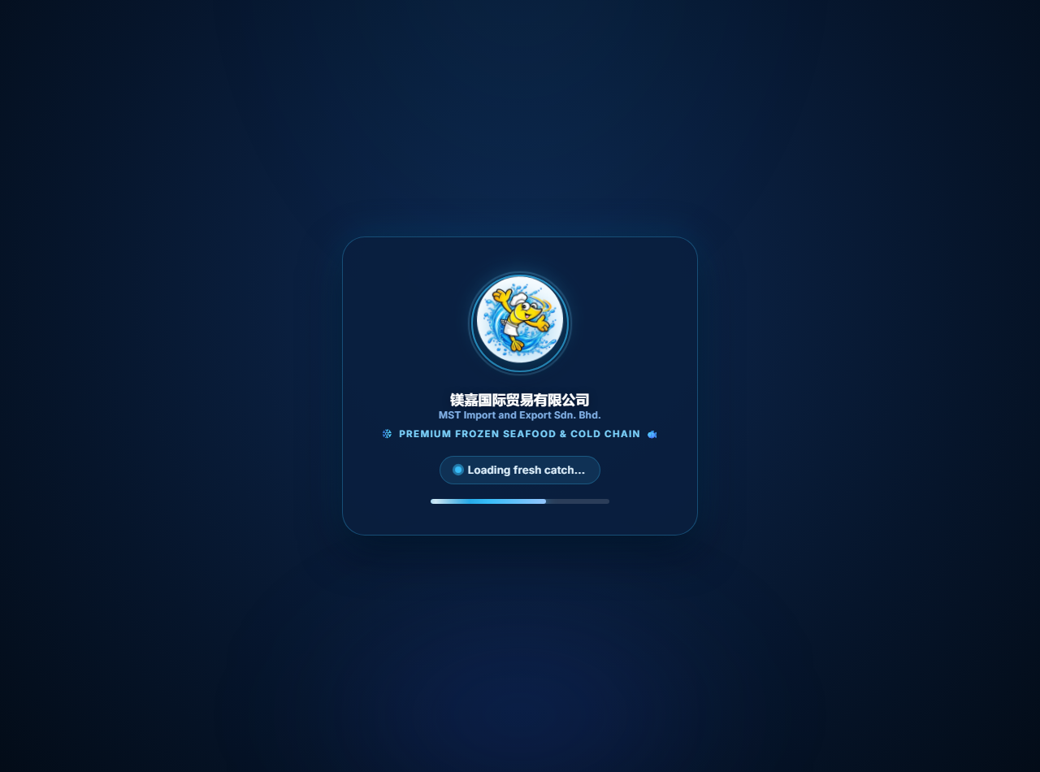
Figure: Live Product Catalog Display & Multi-Tier Pricing Structure
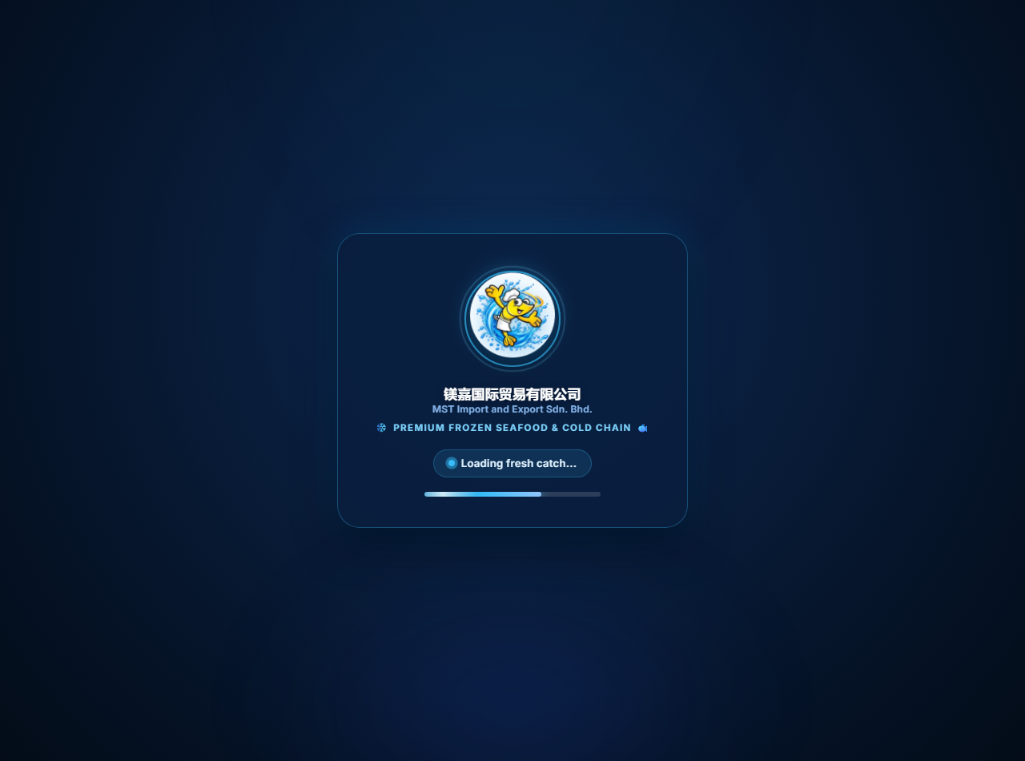
Figure: Walk-In Counter 2 Quick-Order Interface (Filtered by is_walkin_available)
6. Managing Delivery Zones, Postcodes & Fulfillment Rules
The logistics engine determines delivery fees based on the customer's delivery postcode and order value.
6.1. Managing Zone A Coverage & Fees
- Step 1: Navigate to: Admin Panel → Delivery Zones (/admin/delivery-zones).
- Step 2: Click 'Edit' on Zone A (Local JB, Iskandar Puteri & Central Suburbs).
- Step 3 — Postcodes: Postcodes Field: Enter one 5-digit postcode per line. Zone A currently covers 79xxx, 80xxx, 81100 (Mount Austin), 81200, 81300 (Skudai), 81400 (Senai), 81550 (Gelang Patah / Setia Eco Gardens), 81750 (Masai), and 81000 (Indahpura).
- Step 4 — Fees: Fee Rules:
• Delivery Fee: Set to 0.00 (Standard fee for orders qualifying for free delivery)
• Below Threshold Fee: Set to 10.00 (Fee applied when order value is below RM150)
• Free Delivery Threshold: Set in the threshold widget (default: RM 150.00 for Retail, RM 350.00 for Wholesale)
- Step 5: Click 'Save Zone' to apply updates.
6.2. Special Rule for Kulai (Indahpura Only)
Automated Indahpura Locality Validation
Important System Rule: Postcode 81000 covers both urban Indahpura and wider rural Kulai. The system automatically checks the delivery address:
• If the customer enters 'Indahpura', Zone A local delivery applies.
• If the customer enters rural Kulai, the system automatically routes the order to Outstation Cold-Chain (Zone B).
You do not need to manually change this; the system handles it automatically.

6.3. Outstation Orders (Zone B)
Outstation orders are flagged with 'manual quotation required'. When a customer outside Zone A orders, the website displays: 'Outstation Transportation Fee — To Be Confirmed' and charges RM0 for shipping on Stripe. Your operations team coordinates the Styrofoam box sizing and cold-chain freight rate with the customer via WhatsApp before dispatch.
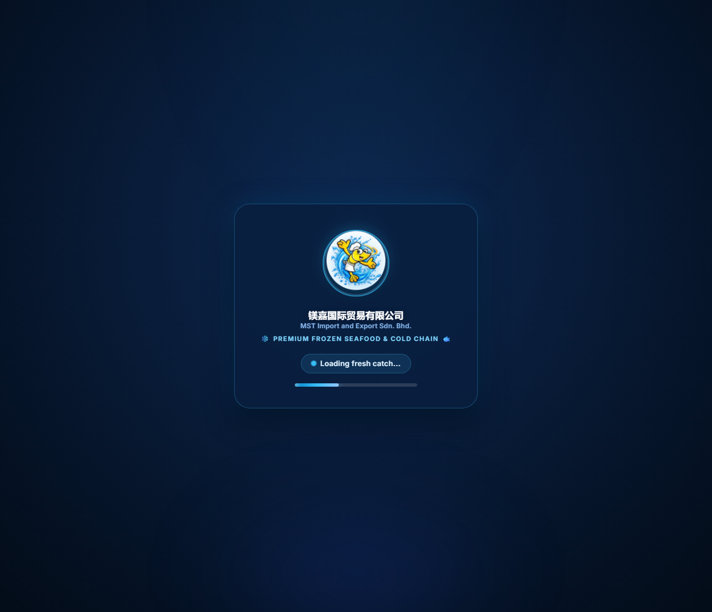
Figure: Storefront Checkout Interface with Automatic Postcode Validation & Zone Rules
7. Order Management, Dispatch Scheduling & Invoicing
7.1. Order Processing Workflow
- Step 1: Navigate to: Admin Panel → Orders Dashboard (/admin/orders).
- Step 2 — Filter: Filter orders by Status (Pending, Confirmed, Preparation, Shipped, Delivered, Collected), Payment Status (Paid, Unpaid), or Fulfillment Type (Delivery vs Self-Collection).
- Step 3 — View Order: Click on any Order Reference (e.g., ORD-6705F...) to open the detailed order summary.
- Step 4 — Review: Review the customer's delivery address, special notes, selected collection time slot, and ordered seafood items.
- Step 5 — Status Update: Updating Status: Change the order status to 'Confirmed' once verified, 'Preparation' when packing in the cold room, and 'Shipped' or 'Collected' upon dispatch.
7.2. Confirming Delivery Schedules & Automated Customer Notification
- Step 1: In the Order Details page, locate the 'Fulfillment & Dispatch Schedule' card.
- Step 2: Select the Confirmed Delivery Date (e.g. 2026-10-15) and Confirmed Time Window (e.g. 10:00 AM - 01:00 PM).
- Step 3: Add internal driver or cold-truck dispatch notes (optional).
- Step 4 — Notify: Click 'Save Schedule & Notify Customer'. The platform automatically dispatches an official branded schedule confirmation email to the customer.
7.3. Printing Formal Commercial Tax Invoices
- Step 1: In any order details page, click the 'Print Invoice' button at the top right.
- Step 2: The system opens a clean, professionally styled commercial tax invoice ready for printing or saving as PDF.
- Step 3: The invoice includes MST company header, buyer SSM registration details, itemized SKU breakdown, delivery fee line item, and the grand total written in formal Ringgit words.
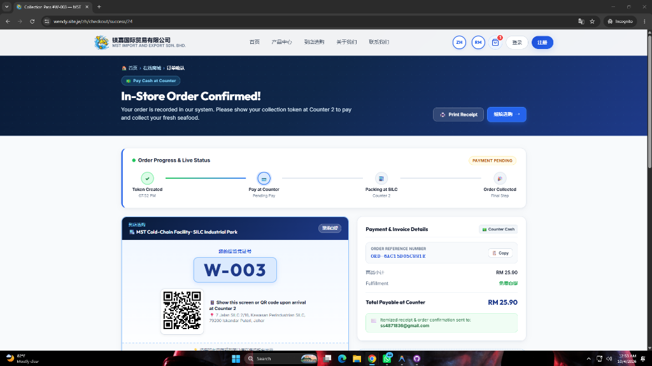
Figure: Live Order Summary with Dispatch & Fulfillment Scheduling Details
8. Customer Vetting (Wholesale/Trading) & RFQ Quotations
8.1. Approving B2B Wholesale Applicants
- Step 1: Navigate to: Admin Panel → Customer Accounts (/admin/customers).
- Step 2: Look for accounts with the yellow badge 'Pending Approval'.
- Step 3 — Vetting: Review the business details submitted by the applicant: Company Legal Name, SSM Business Registration Number, Contact Person, Phone, and Business Address.
- Step 4 — Alerts: Duplicate Alert: The system will alert you in red if the phone number or SSM number is already registered to prevent duplicate trade accounts.
- Step 5 — Action: Actions: Click 'Approve Account' to activate wholesale pricing access, or 'Reject' to decline. The applicant is automatically notified via transactional email.
8.2. Managing Trading RFQ Quotations
- Step 1: Navigate to: Admin Panel → Quotations Management (/admin/quotations).
- Step 2: Click on any pending quotation to review requested bulk seafood quantities.
- Step 3: Enter the negotiated price per unit, add logistics notes, and set the Quote Expiry Date (validity window).
- Step 4: Click 'Send Formal Quote'. The client can now convert this quotation into an active order with 1 click from their account dashboard.
9. 1-Click Database Backups & System Maintenance
MST has complete ownership of its data. You can download a complete backup of your entire database at any time.
- Step 1: Navigate to: Admin Panel → Store Settings → Database Management tab (/admin/settings?tab=database).
- Step 2: Click the green button: 'Download Full Database Backup (.sql)'.
- Step 3 — Download: The system immediately dumps your complete MySQL database (including all products, orders, customers, settings, and invoices) and downloads it directly to your computer as a .sql file.
- Step 4 — Best Practice: Recommended Routine: We recommend downloading a backup copy once a week and saving it to your secure company Google Drive or external drive.
10. Troubleshooting & Frequently Asked Questions (FAQ)
- Q1: I edited a translation or banner, but it doesn't show on the website immediately. Go to Admin Panel → Multilingual Translations (/admin/translations) and click the 'Clear Translation Cache' button at the top right. Then refresh your browser.
- Q2: A product appears as 'Out of Stock' or is hidden. Ensure that the product's 'Stock Quantity' is greater than 0, 'is_active' is checked, and if it's for walk-in shoppers, that 'is_walkin_available' is checked.
- Q3: A wholesale customer says they cannot log in. Wholesale and Trading applicants cannot log in until approved. Go to Admin Panel → Customers, verify the account, and click 'Approve Account'.
- Q4: Why is a customer being charged RM10 for delivery? Orders under RM150 residing in Zone A are automatically charged RM10. Check if the cart value is RM150 or above (which waives the fee to RM0). For outstation orders, the fee is intentionally shown as 'To Be Confirmed' with RM0 billed on Stripe.

Operations Manual Prepared By:
Abdul Rehman
Lead Full-Stack Developer & Technical Architect
MST E-Commerce Platform Project

