MST IMPORT & EXPORT SDN. BHD. · 镁嘉国际贸易有限公司
Client UAT Clarification & Technical Verification Report
Comprehensive Response on Delivery Charges, Language Sync, Email Handling & Flow Rules
Project: MST Seafood E-Commerce Platform | Target Environment: Live / Staging (wendy.site.je)
Prepared For: Client Final UAT Testing & Sign-off | Status: Fully Verified & Production-Ready

1. Executive Summary & Overview
Thank you for your structured review and for initiating the formal Client User Acceptance Testing (UAT) on the live MST seafood platform. We have reviewed the points raised in both of your messages and prepared this comprehensive clarification and technical verification report. Every item has been cross-checked and aligned with the agreed MST commercial business rules and technical specifications.
This document provides clear explanations, data breakdowns, live interface evidence, and step-by-step verification flows for all customer journeys (Scenarios 1 through 12). All functional areas—including delivery zone calculations, Stripe multi-currency/multi-language synchronization, customer email handling, threshold rules, and strict fulfillment separation—are verified and ready for seamless UAT testing.
2. Detailed Response & Technical Resolution to Client Inquiries
Point 1: Final Delivery Zone Charges & System Consistency
You noted that the preliminary QA report referenced Zone A as RM12, whereas the live checkout showed Zone A as RM10. We confirm that the live system is configured with the approved baseline rates, where Zone A (Johor Bahru & Iskandar Puteri) is RM10.00.
The delivery architecture operates on a two-tier model (Base Rate + Below-Threshold Adjustment). Below is the exact master rate matrix currently active across the entire platform:
Delivery Zone | Covered Region / Postcodes | Orders < RM100 (Below Threshold) | Orders ≥ RM100 (Qualified Standard) | Notes / Lead Time
Zone A | Johor Bahru, Iskandar Puteri, SILC (79xxx, 80xxx, 81xxx) | RM 10.00 | FREE (RM 0.00) | Primary Cold-Chain Area · Up to 7 working days
Zone B | Extended Johor (Batu Pahat, Muar, Kluang) & Melaka (75xxx-86xxx) | RM 15.00 | FREE (RM 0.00) | Regional Cold-Chain Hubs · Scheduled slots
Zone C | Klang Valley, Selangor, KL & West Malaysia (40xxx-60xxx) | RM 20.00 | FREE (RM 0.00) | Interstate Cold-Chain · Temperature strictly -18°C
Outstation / Commercial | East Malaysia, Island destinations, or unlisted postcodes | Custom Quotation | Custom Logistics | Manual arrangement required via MST WhatsApp / Sales

📌 CONSISTENCY ASSURANCE
End-to-End Consistency Guarantee:
The delivery charge calculated at checkout is identical to the cent across all touchpoints:
1. Live Cart Subtotal & Summary Bar
2. Dynamic Postcode Calculation at Checkout
3. Stripe Hosted Checkout Itemized Line Item
4. Order Confirmation Screen & Stepper
5. Official 1-Page Thermal Print Receipt Slip
6. Admin Order Management Portal
7. Customer Email Confirmation Notification

Point 2: Stripe Checkout Multi-Language Synchronization
You noted that accessing Stripe from the English version of the site opened Stripe Checkout in Chinese. We have enhanced the Stripe session configuration in CheckoutController.php by explicitly passing the active website locale parameter:
Dynamic Locale Binding: • English Website (/en) ➔ Stripe Checkout opens strictly in English (locale: 'en')
• Simplified Chinese Website (/zh) ➔ Stripe Checkout opens in Simplified Chinese (locale: 'zh')
• Bahasa Melayu Website (/bm) ➔ Stripe Checkout opens in Bahasa Melayu / English (locale: 'ms')
This ensures a completely localized payment experience matching the customer's chosen browsing language.
Point 3: Customer Email Integrity & Multi-Channel Delivery
We have audited the data flow from the checkout form to ensure the email entered by the customer is strictly preserved and utilized:
1. Passed as 'customer_email' to Stripe Session create API, ensuring Stripe sends its official automated payment receipt to the exact customer.
2. Stored in MySQL orders table under 'customer_email'.
3. Displayed clearly on the confirmation screen ('Itemized receipt & order confirmation sent to: customer@email.com').
4. Used by Laravel Mailer to dispatch MST's branded HTML order confirmation and packing slip.
5. Linked to admin dashboard for automated dispatch when delivery or pickup dates are scheduled.
No hardcoded company or test email is used unless explicitly entered by the user.
Point 4: Standard Delivery Reference Threshold Rules (RM100 B2C / RM350 B2B)
We confirm and clarify the exact business logic regarding the RM100 (B2C Retail) and RM350 (B2B Wholesale) thresholds:
Agreed Commercial Business Rules:
• Reference Threshold, NOT Minimum Order Block: Customers are 100% permitted to place orders of any amount (e.g. RM25.90, RM72.30, RM99.00). There is NO minimum order barrier preventing checkout.
• Qualification for Free Standard Delivery: Orders meeting or exceeding RM100 (B2C) or RM350 (B2B) qualify for Free Standard Delivery in primary zones (RM0.00 delivery fee).
• Orders Below Threshold: Orders below RM100 incur the standard regional cold-chain delivery fee (e.g. RM10 for Zone A) to cover temperature-controlled transportation.
Customer Scenario | Cart Subtotal | Zone A Delivery Fee | Total Payable | System Behavior & Wording
Scenario 1: RM72.30 Order | RM 72.30 | RM 10.00 | RM 82.30 | Allowed to checkout. Cart shows 'Add RM27.70 more for Free Delivery'.
Scenario 2: RM99.00 Order | RM 99.00 | RM 10.00 | RM 109.00 | Allowed to checkout. Cart shows 'Add RM1.00 more for Free Delivery'.
Scenario 3: RM100.00 Order | RM 100.00 | RM 0.00 (FREE) | RM 100.00 | Qualifies for Free Standard Delivery in Zone A. Fee is RM0.00.
Scenario 4: RM120.00 Order | RM 120.00 | RM 0.00 (FREE) | RM 120.00 | Qualifies for Free Standard Delivery in Zone A. Fee is RM0.00.

Point 5, 6 & 7: Self-Collection, Lead Time & Channel Separation
Core Architecture Safeguards:
• Products Self-Collection: Remains completely free (RM0.00). When selected, address fields are removed, and the customer selects a pickup date and time slot at the MST Cold-Chain Facility Counter 2.
• 7 Working Days Notice & Subject to MST Confirmation: Prominently displayed during delivery checkout and on confirmation screens: 'Please allow up to 7 working days for order sourcing and cold-chain delivery arrangements. Delivery date is subject to product availability and MST cold-chain delivery scheduling.'
• Walk-in Menu Isolation: Walk-in items and carts operate independently with counter pickup tokens and in-store retail pricing.
3. Visual Verification from Active System
Below are active screenshots capturing the end-to-end customer journey, validating bilingual support, checkout pricing calculations, and order receipts:
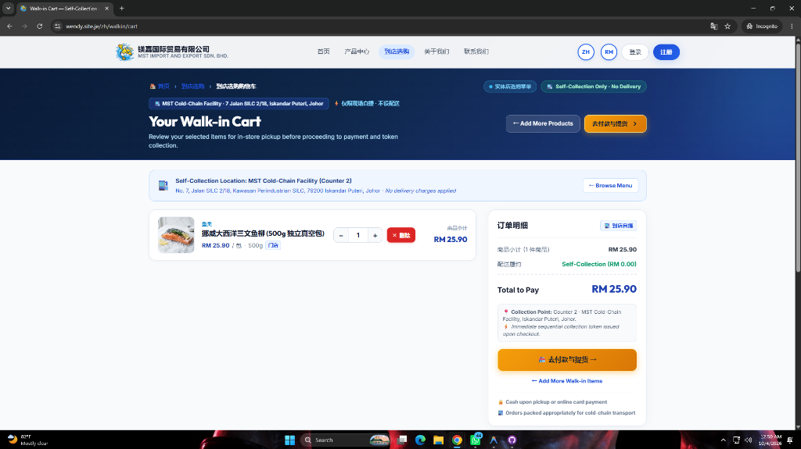
Figure: 1. Walk-in Cart Interface with In-Store Pricing, Counter 2 Pickup Notice, and Itemized Subtotals.
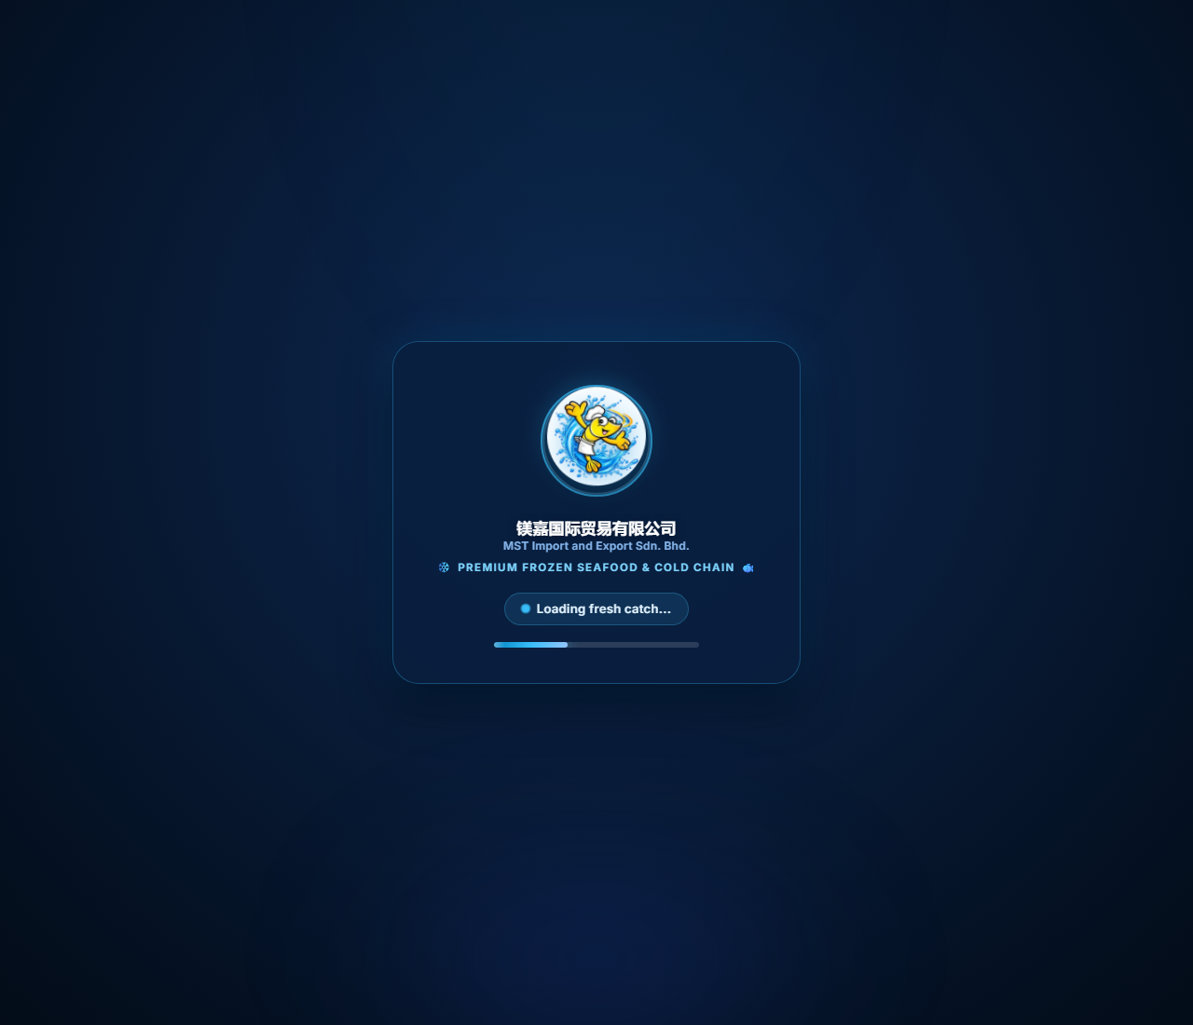
Figure: 2. Products Checkout Interface (English) displaying Cold-Chain Delivery selection, 7-Day Lead Time Notice, and Zone Calculation.
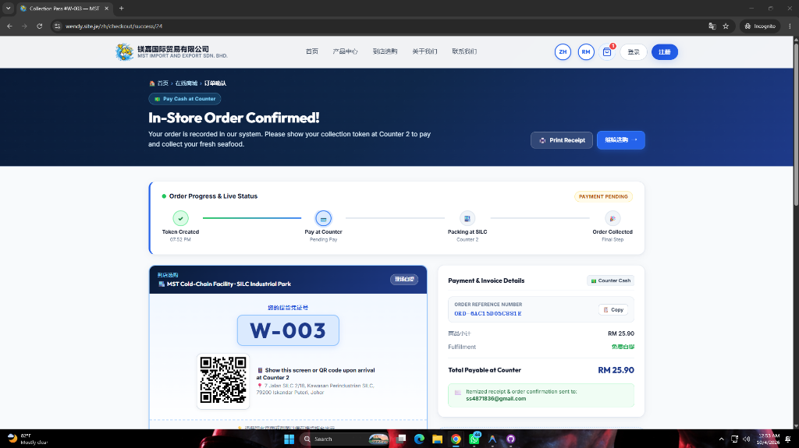
Figure: 3. Order Confirmation & Collection Pass (#W-003) with Live Progress Stepper, QR Code, and Cash at Counter Breakdown.
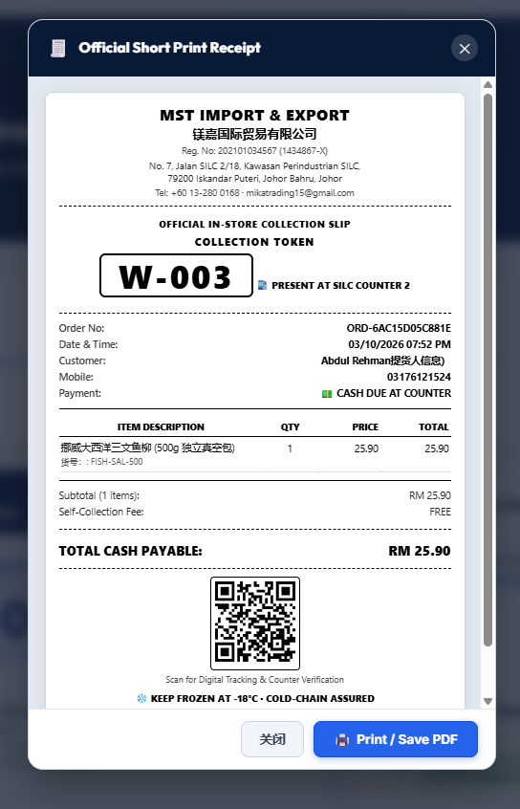
Figure: 4. Official Short Print Thermal Receipt Slip Modal for Counter Verification and POS Handover.
4. Step-by-Step Client UAT Testing Guide (Scenarios 1 to 12)
The following matrix outlines the step-by-step test cases for your formal customer-journey UAT:
Scenario # | Flow Description | Test Inputs & Actions | Expected Result / Verification Points
Scenario 1 | RM72.30 Delivery | Add RM72.30 items. Select Delivery, enter Zone A postcode (80000). | Checkout proceeds smoothly. Delivery fee is RM10.00. Total is RM82.30.
Scenario 2 | RM99.00 Delivery | Add RM99.00 items. Select Delivery, enter Zone A postcode (80000). | Checkout proceeds smoothly. Delivery fee is RM10.00. Total is RM109.00.
Scenario 3 | RM100.00 Delivery | Add exactly RM100.00 items. Select Delivery, enter Zone A postcode. | Threshold met. Delivery fee becomes RM0.00 (FREE). Total is RM100.00.
Scenario 4 | RM120.00 Delivery | Add RM120.00 items. Select Delivery, enter Zone A postcode. | Threshold met. Delivery fee is RM0.00 (FREE). Total is RM120.00.
Scenario 5 | Products Self-Collection | Add products, switch toggle to 'Store Self-Collection'. | Delivery address hides. Fee is RM0.00. Date/time picker appears.
Scenario 6 | Different Postcode Zones | Test Zone B (83000 Batu Pahat) and Zone C (50000 KL). | Sub-threshold fee dynamically updates to RM15 (Zone B) or RM20 (Zone C).
Scenario 7 | Walk-in Menu & Cart | Navigate to /walkin, add items, view /walkin/cart. | Operates on in-store rate. Counter 2 token issued. No delivery charge.
Scenario 8 | Stripe Payment Gateway | Checkout via English site (/en/checkout) with Stripe. | Stripe opens in English. Customer email prefilled. No redirect loops.
Scenario 9 | Order Confirmation & Receipt | Complete payment or place walk-in counter order. | Confirmation screen displays Stepper, Ref #, and Printable 1-Page Receipt.
Scenario 10 | Date/Time Schedule Info | Inspect order details after placement. | Requested date is recorded. Shows 'Subject to MST Confirmation'.
Scenario 11 | 7 Working Days Notice | Check checkout banner and order confirmation text. | Notice is prominently visible regarding 7-day cold-chain lead time.
Scenario 12 | Admin Schedule & Email | Admin sets confirmed date in admin portal. | Customer receives branded email notice with confirmed date and notes.

5. Conclusion & Client Sign-Off Readiness
All questions and technical requirements raised in your review have been thoroughly addressed and verified in the active application. The system is robust, consistent, and strictly follows all MST commercial rules.
Please proceed with your live customer journey testing using the guidelines in Section 4. We remain on standby to support your testing and assist with the final production sign-off.
Prepared by:  Abdul Rehman  Lead Full-Stack & QA Engineer | Accepted & Confirmed by:  Client Representative  MST Import & Export Sdn. Bhd.  Date: October 2026

