EEE415 Digital Image Processing  
  
Lab 06: Hough Transform

1. 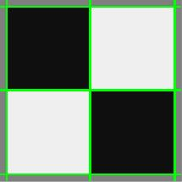**Use Matlab hough function for finding lines. Draw the lines in color on the monochrome intensity (not edge) image. The lines can extend to the edge of the images (aka infinite lines). In addition show Hough accumulator array image. To draw the lines you can use canny, hough, houghpeaks, and houghlines functions of Matlab. To draw lines on the image as shown below, you may use *hold on* together with *plot*. Remember to see the help of the functions to know what each input and output parameter do, which you have already studied in the theory. Apply it to the checker.png/cheker2.png and checker-noisy.png/checker-noisy2.png images. Now apply on a real image ground.jpg.**

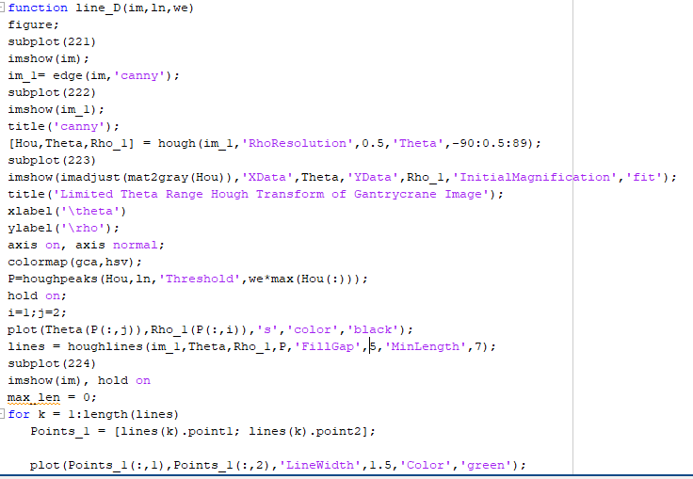

**Code:**

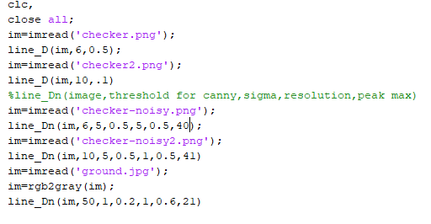

**Result**

**1.**

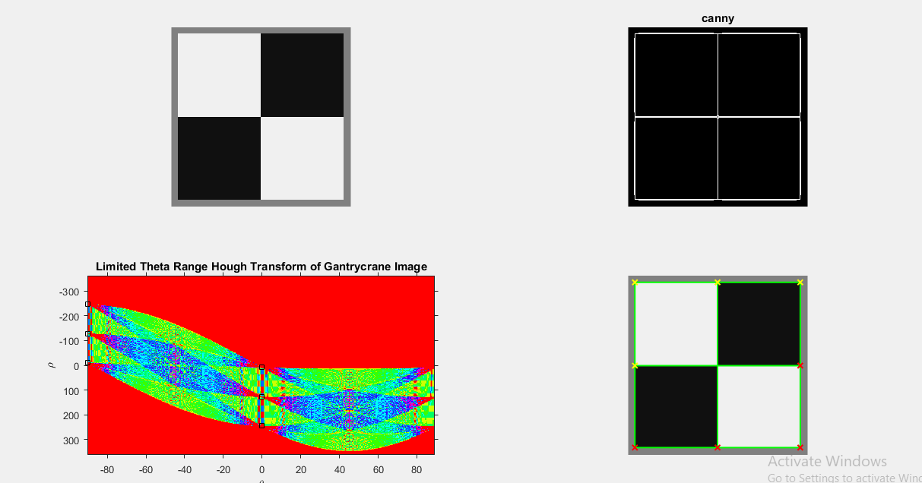

**2.**

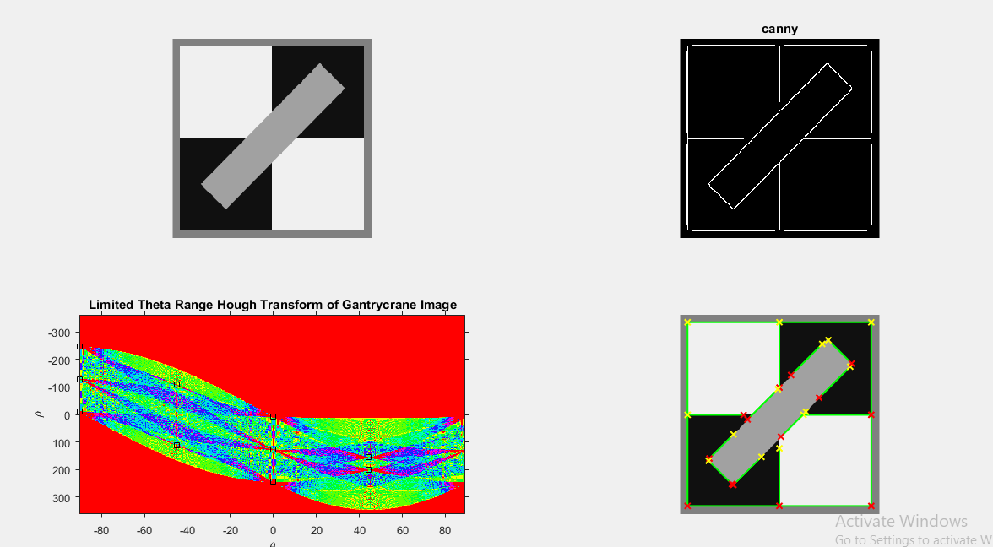

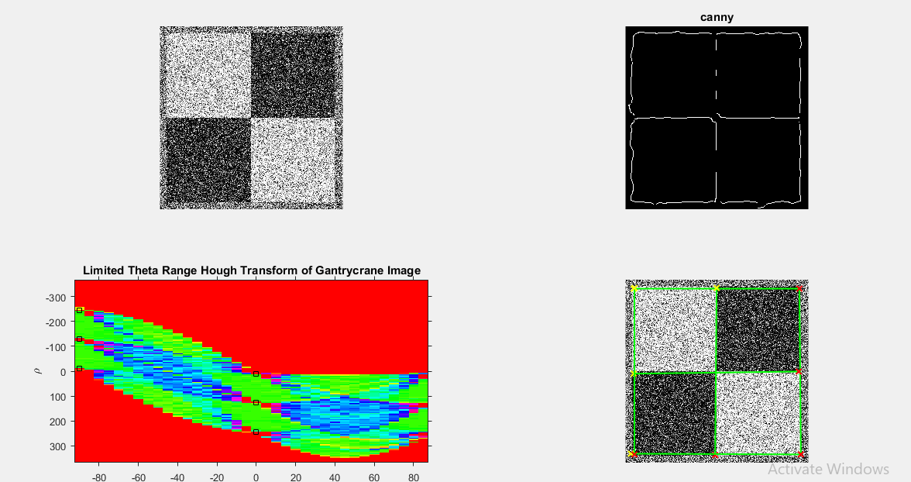**4.**

**5.**

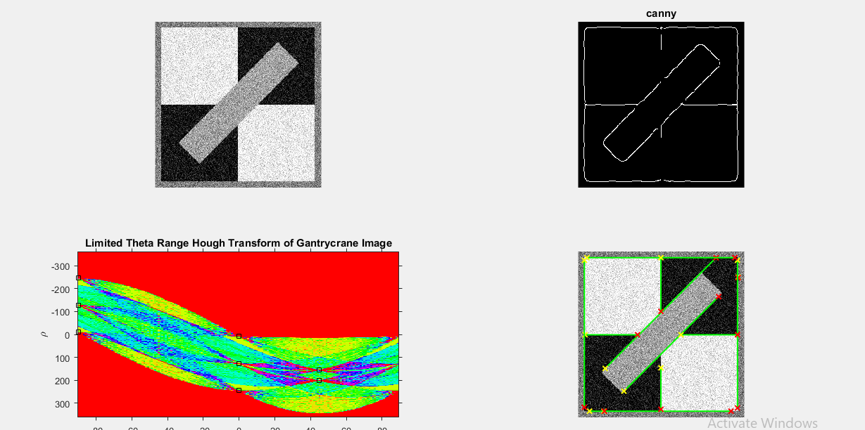

**6.**

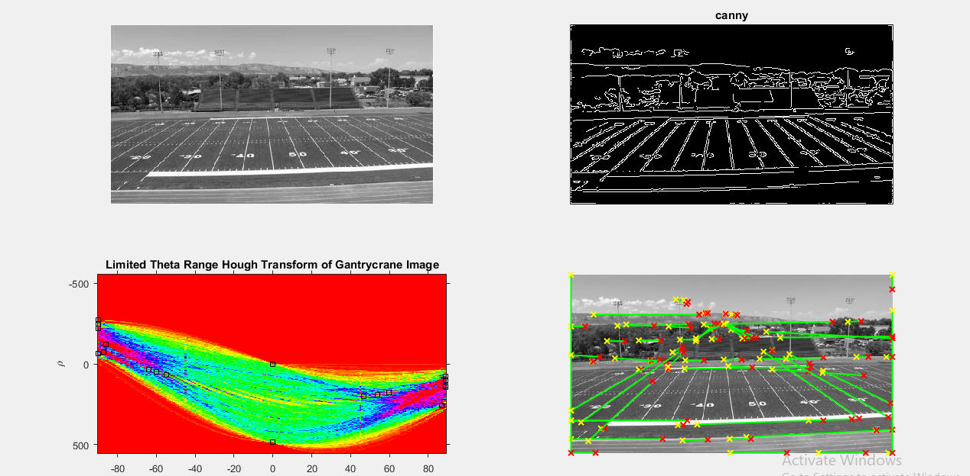

1. **Detect the circles using the circular Hough transforms in the given coins1.png/coins2.png images using the Matlab imfindcircles function. Remember to see the help of the function to know what each input and output parameter do, which you have already studied in the theory.**

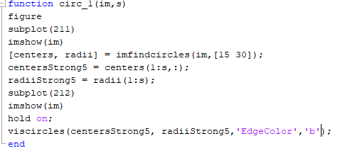**Code:**

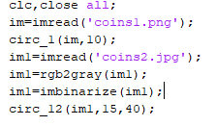

**Result:**

