RIPHAH INTERNATIONAL UNIVERSITY

(RSCI)

Mobile Application and Development

Assignment no 01

Topic: Currency Converter

(PKR TO USD DOLLAR )



Abdul Rehman

Sap_id:13995

Section A

Semester 6th

Submitted to:

Prof Mujtaba Hassan

Topic: Currency Converter

Files:

* activity_main.xml
* Mainactivity.java

App View

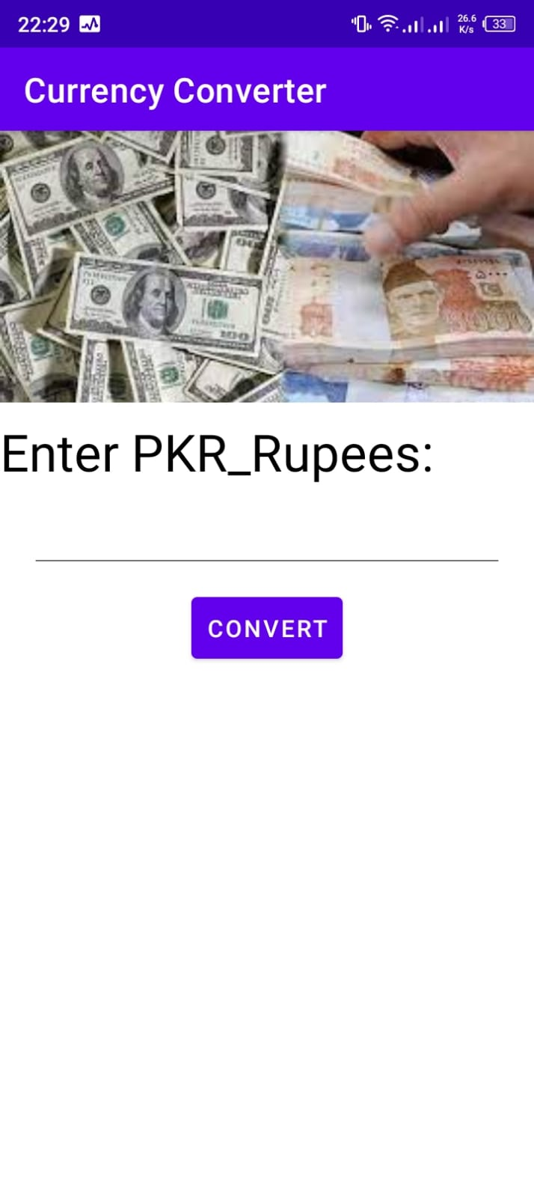

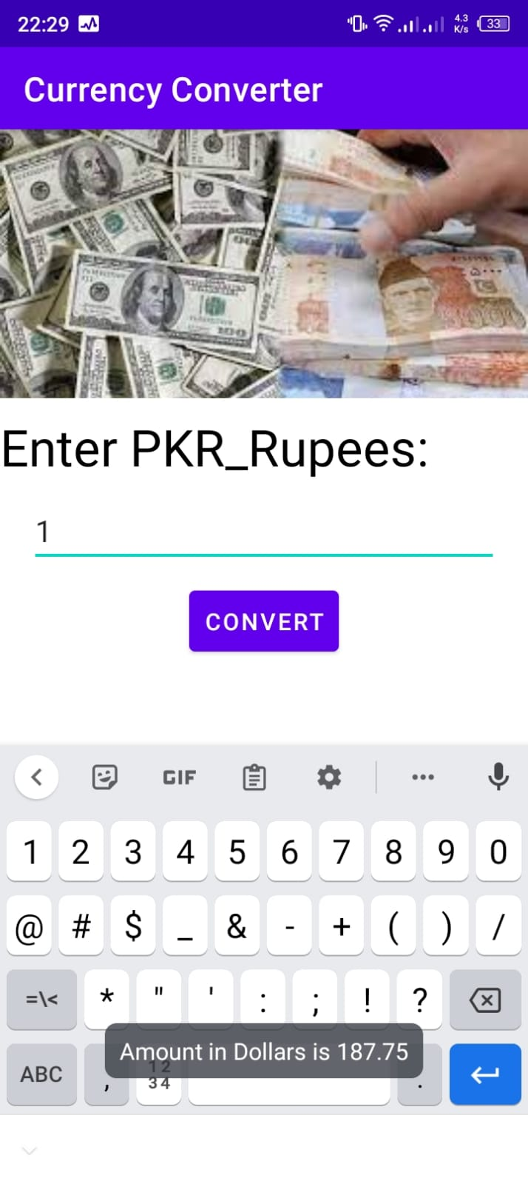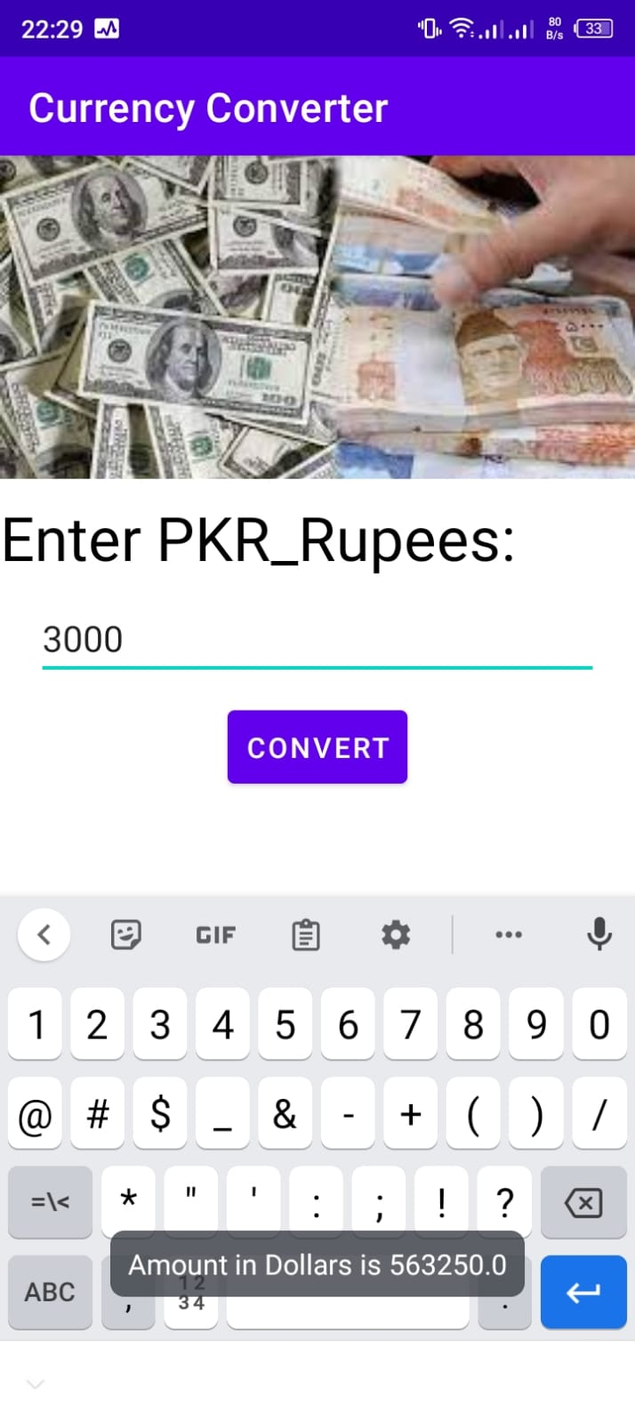

**Code**

Activity_main.xml

<?xml version="1.0" encoding="utf-8"?>  
<androidx.constraintlayout.widget.ConstraintLayout  
 xmlns:android="http://schemas.android.com/apk/res/android"  
 xmlns:tools="http://schemas.android.com/tools"  
 xmlns:app="http://schemas.android.com/apk/res-auto"  
 android:layout_width="match_parent"  
 android:layout_height="match_parent"  
 tools:context=".MainActivity">  
  
 <LinearLayout  
 android:layout_width="match_parent"  
 android:layout_height="match_parent"  
 android:orientation="vertical">  
  
 <ImageView  
 android:layout_width="match_parent"  
 android:layout_height="wrap_content"  
 android:src="@drawable/icon"  
 android:scaleType="centerCrop"/>  
 />  
 <TextView  
 android:layout_width="wrap_content"  
 android:layout_height="wrap_content"  
 android:text="Enter PKR_Rupees:"  
 android:textSize="30sp"  
 android:layout_marginTop="10dp"  
 android:textColor="@android:color/black"  
 />  
 <EditText  
 android:id="@+id/E1"  
 android:layout_width="match_parent"  
 android:layout_height="wrap_content"  
 android:layout_marginStart="20dp"  
 android:layout_marginEnd="20dp"  
 android:layout_marginTop="10dp"  
 />  
 <Button  
 android:id="@+id/btn_convert"  
 android:layout_width="wrap_content"  
 android:layout_height="wrap_content"  
 android:layout_gravity="center"  
 android:text="Convert"  
 android:padding="10dp"  
 android:layout_marginTop="10dp"  
 />  
  
  
  
 </LinearLayout>  
  
  
</androidx.constraintlayout.widget.ConstraintLayout>

MainActivity.java

package com.example.currencyconverter;  
  
import androidx.appcompat.app.AppCompatActivity;  
import android.os.Bundle;  
import android.view.View;  
import android.widget.Button;  
import android.widget.EditText;  
import android.widget.Toast;  
  
public class MainActivity extends AppCompatActivity {  
  
 EditText edittext;  
 Button btn_convert;  
 @Override  
 protected void onCreate(Bundle savedInstanceState) {  
 super.onCreate(savedInstanceState);  
 setContentView(R.layout.*activity_main*);  
  
 edittext=findViewById(R.id.*E1*);  
 btn_convert=findViewById(R.id.*btn_convert*);  
  
 btn_convert.setOnClickListener(new View.OnClickListener() {  
 @Override  
 public void onClick(View view) {  
 convert();  
 }  
 });  
  
 }  
 public void convert()  
 {  
 String amountDollars= edittext.getText().toString();  
 if (amountDollars.equals("")){  
  
 Toast.*makeText*(this, "Enter Valid Numbers", Toast.*LENGTH_SHORT*).show();  
 }  
 else  
 {  
  
 Double amountRsDouble= Double.*parseDouble*(amountDollars) ;  
 Double amountDollarsDouble = amountRsDouble* 187.75;  
 String amountRs= amountDollarsDouble.toString();  
 Toast.*makeText*(this, "Amount in Dollars is "+amountRs, Toast.*LENGTH_SHORT*).show();  
 }  
  
 }  
}