Smart Energy Consumption Controller
Project Summary Report
Live Demo: https://smart-energy-controller.streamlit.app/

This report summarizes a Streamlit-based fuzzy logic application for smart energy management. The project uses a Mamdani fuzzy inference system to recommend an energy usage level based on electricity price, battery level, and solar production.

1. Project Overview
The Smart Energy Consumption Controller models a home or microgrid energy-management decision. The system avoids rigid threshold-based decisions by using fuzzy logic terms such as low, medium, and high. This makes the controller more flexible and easier to explain.
The application converts crisp user inputs into fuzzy membership values, evaluates a rule base, aggregates the active rules, and defuzzifies the result into a final energy usage percentage.
2. Problem Statement
Energy usage decisions depend on changing conditions. For example, high electricity prices may require reducing consumption, while high solar production and a full battery may justify higher usage. Fuzzy logic is suitable because it can represent gradual states and human-like reasoning.
3. Project Objectives
• Build an interactive web interface for testing a fuzzy energy controller.
• Model electricity price, battery level, and solar production as fuzzy input variables.
• Produce an interpretable energy usage recommendation.
• Visualize membership functions, active rules, aggregation, and defuzzification.
• Provide predefined scenarios for validating controller behavior.
• Deploy the application online for easy testing.
4. System Inputs and Output
Variable | Type | Range | Linguistic Terms | Description
Electricity Price | Input | 0-100 cents/kWh | Low, Medium, High | Current grid electricity price
Battery Level | Input | 0-100% | Low, Medium, High | Current battery state of charge
Solar Production | Input | 0-100% | None, Low, Medium, High | Current solar generation level
Energy Usage Level | Output | 0-100% | Very Low, Low, Medium, High, Very High | Recommended energy consumption level
5. Fuzzy Logic Properties
Property | Value
Inference method | Mamdani
Rule evaluation | Min operator
Aggregation | Max operator
Defuzzification | Centroid
Number of inputs | 3
Number of outputs | 1
Number of rules | 20
Membership function types | Triangular and trapezoidal
6. Rule Base Summary
The controller uses 20 IF-THEN rules. The rules are designed to conserve energy when price is high or resources are limited, and increase usage when price is low or renewable/storage resources are strong.
• If electricity price is high, battery level is low, and solar production is none, then energy usage is very low.
• If electricity price is low, battery level is high, and solar production is high, then energy usage is very high.
• If all conditions are balanced, the controller recommends a medium usage level.
7. Application Features
• Interactive Streamlit dashboard with sidebar sliders.
• Membership function plots for each variable.
• Crisp output value and linguistic output label.
• Active rule list with activation strengths.
• Aggregated output visualization with centroid marker.
• Predefined testing scenarios and scenario analysis.
• System overview explaining fuzzy logic and rule behavior.
8. Technology Stack
• Python
• Streamlit
• scikit-fuzzy
• NumPy
• SciPy
• Matplotlib
• NetworkX
9. Deployment
The project is deployed on Streamlit Community Cloud, which supports long-running interactive Streamlit applications.
Live URL: https://smart-energy-controller.streamlit.app/
For other platforms such as Render or Railway, the start command is: streamlit run app.py --server.address=0.0.0.0 --server.port=$PORT
10. Screenshots
Membership Functions
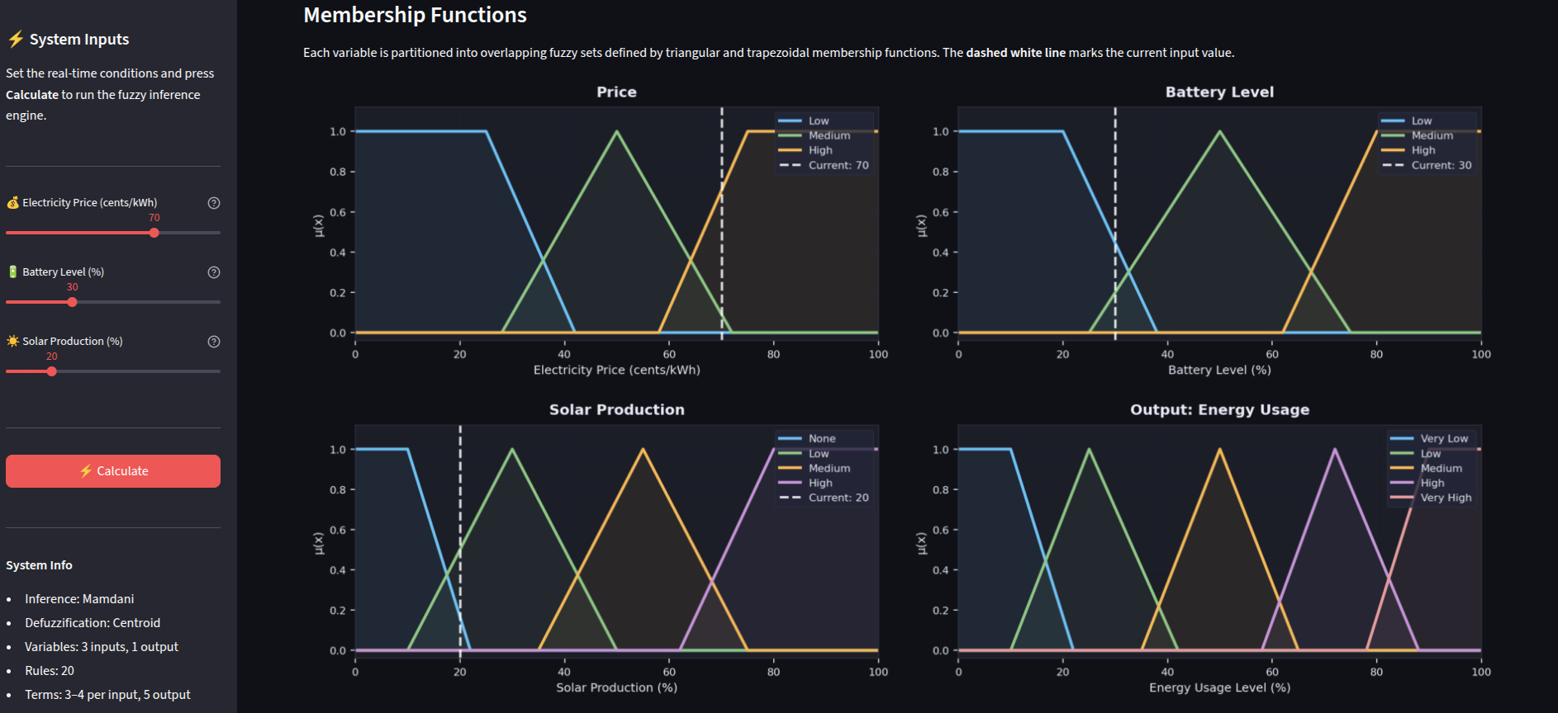
Results and Active Rules
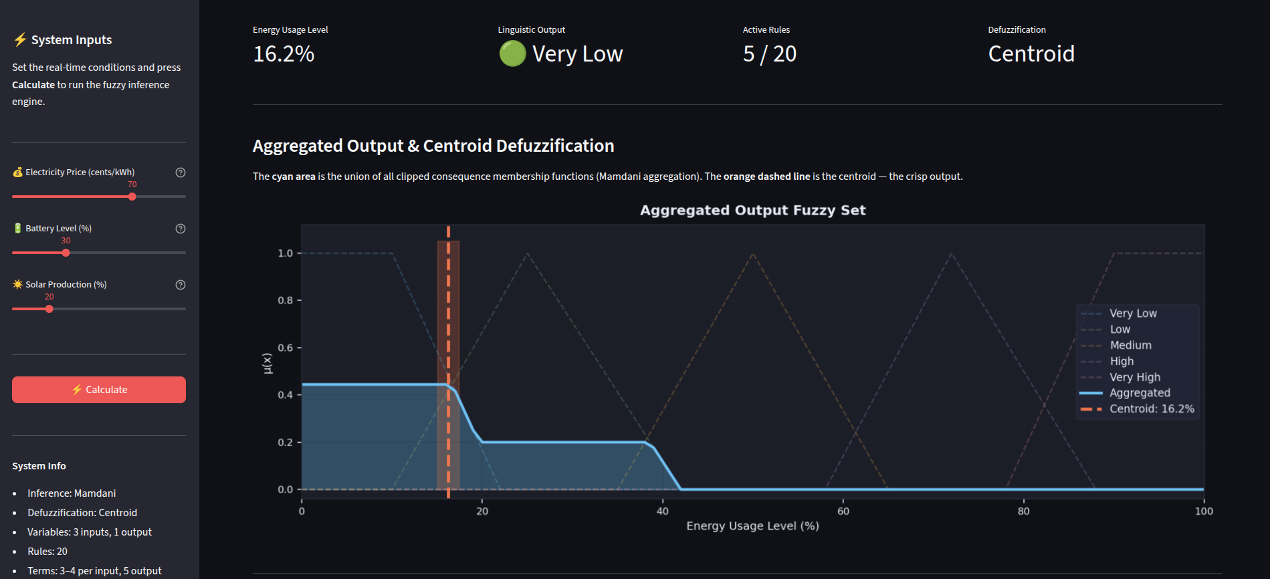
Testing Scenarios
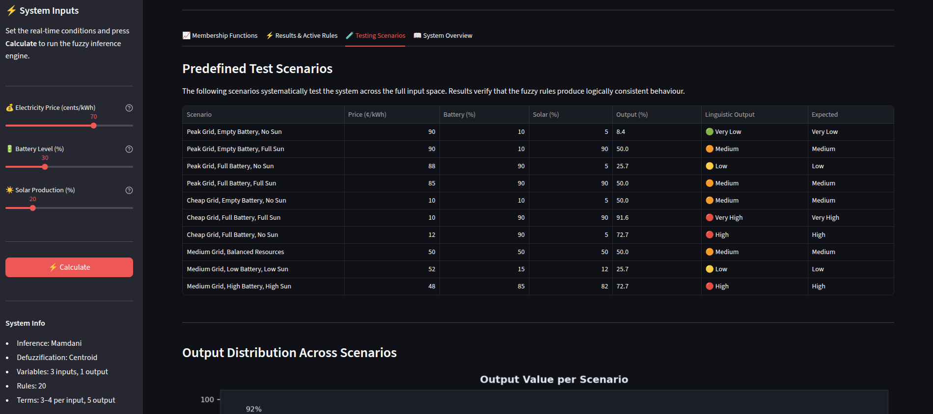
System Overview
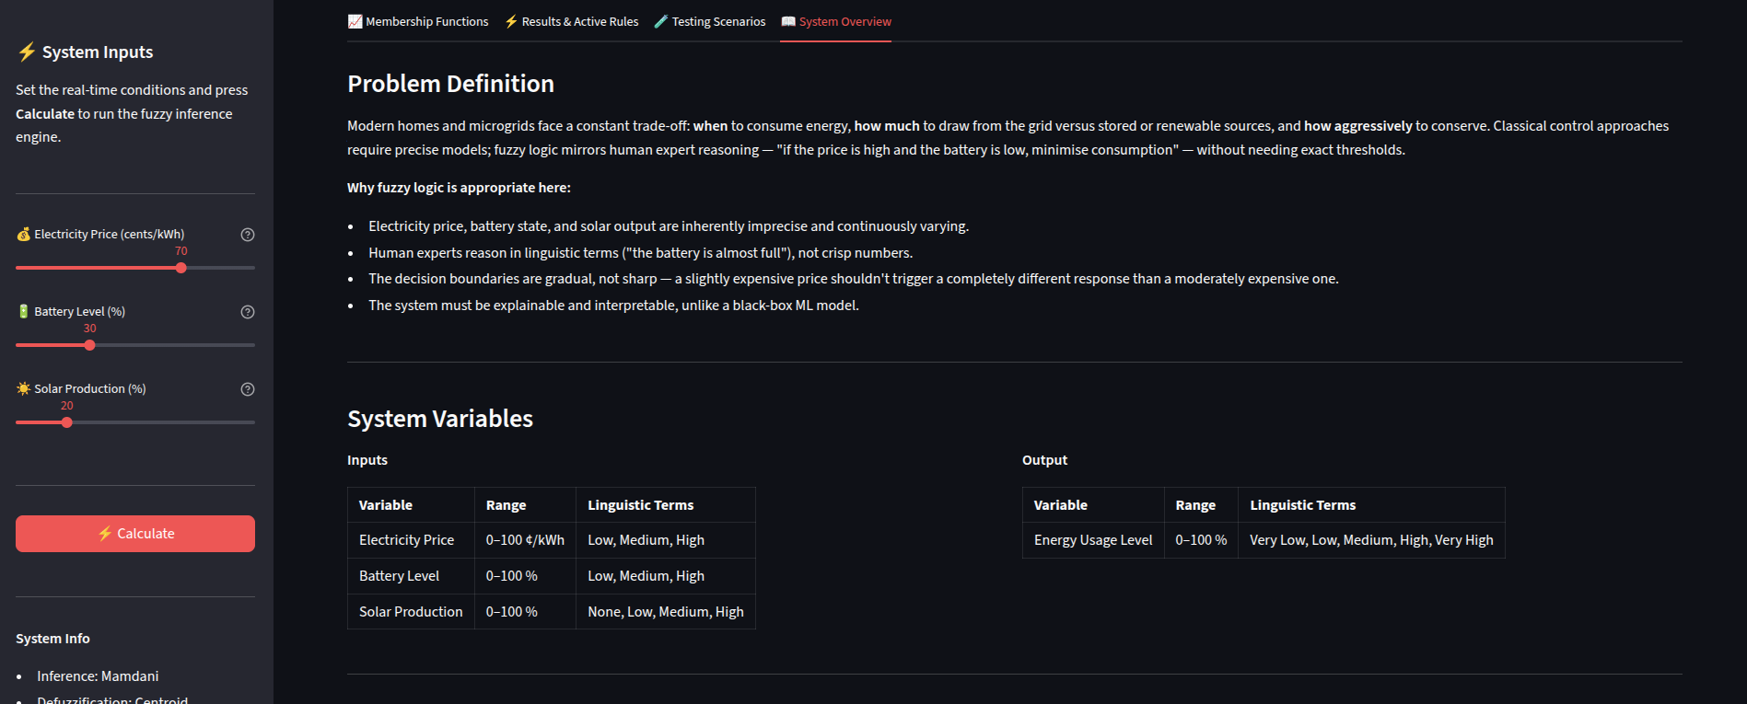
11. Conclusion
The Smart Energy Consumption Controller demonstrates how fuzzy logic can be applied to an energy-management decision problem. The project is interpretable, interactive, and easy to test. Its main advantage is that every recommendation can be explained through membership functions, rule activation, aggregation, and centroid defuzzification.

