HomeScreen
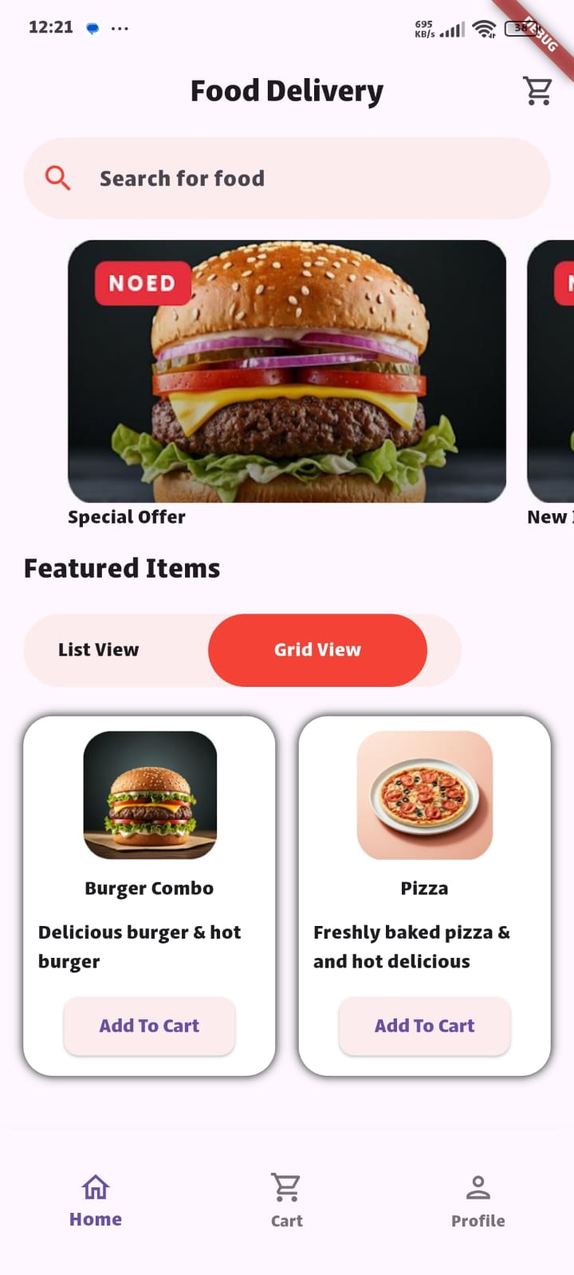
import 'package:flutter/material.dart';
import 'package:food_devlivery_app/gridveiw_item_model.dart';
import 'package:food_devlivery_app/slider_item_model.dart';
import 'package:carousel_slider/carousel_slider.dart';
class HomeScreen extends StatelessWidget {
const HomeScreen({super.key});
@override
Widget build(BuildContext context) {
return Scaffold(
resizeToAvoidBottomInset: true,
appBar: AppBar(
title: Text(
'Food Delivery',
),
centerTitle: true,
actions: [
IconButton(onPressed: (){}, icon: Icon(Icons.shopping_cart_outlined)),
],
),
body: Column(
spacing: 10,
crossAxisAlignment: CrossAxisAlignment.start,
children: [
// Search Bar
Container(
padding: EdgeInsets.symmetric(horizontal: 16 , vertical: 4),
child: TextField(
decoration: InputDecoration(
filled: true,
fillColor: Color.fromRGBO(252,236,237,1),
hintText: 'Search for food',
prefixIcon: Icon(Icons.search_outlined ,color: Colors.red,),
border: OutlineInputBorder(
borderRadius: BorderRadius.circular(30),
borderSide: BorderSide.none,
),
),
),
),
// Carousel Slider
CarouselSlider(
items: sliderItems.map((item){
return _buildItemSlider(item);
}).toList(),
options: CarouselOptions(
height: 200,
aspectRatio: 16/9,
enableInfiniteScroll: false,
),
),
// Featured Items
Container(
padding: EdgeInsets.symmetric(horizontal: 16),
child: Column(
spacing: 17,
crossAxisAlignment: CrossAxisAlignment.start,
children: [
Text(
'Featured Items',
style: TextStyle(
fontSize: 20,
),
),
Container(
width: 300,
height: 50,
decoration: BoxDecoration(
color: Color.fromRGBO(252,236,237,1),
borderRadius: BorderRadius.circular(30),
),
child: Row(
mainAxisAlignment: MainAxisAlignment.spaceAround,
children: [
Text('List View'),
Container(
alignment: Alignment.center,
width: 150,
height: 50,
decoration: BoxDecoration(
color: Colors.red,
borderRadius: BorderRadius.circular(30),
),
child: Text('Grid View',style: TextStyle(color: Colors.white),),
),
],
),
),
],
),
),
//Grid View
Expanded(
child: GridView.builder(
padding: EdgeInsets.symmetric(horizontal: 16 , vertical: 10),
gridDelegate: SliverGridDelegateWithFixedCrossAxisCount(
crossAxisCount: 2,
mainAxisSpacing: 16,
crossAxisSpacing: 16,
childAspectRatio: .70,
),
itemCount: gridItems.length,
itemBuilder: (context,index){
final item = gridItems[index];
return _buildItemGridView(item);
}
),
),
//
],
),
// Buttom Naviagtion
bottomNavigationBar: SizedBox(
height: 100,
child: BottomNavigationBar(
items: [
BottomNavigationBarItem(
icon: Icon(Icons.home_outlined),
label: 'Home',
),
BottomNavigationBarItem(
icon: Icon(Icons.shopping_cart_outlined),
label: 'Cart',
),
BottomNavigationBarItem(
icon: Icon(Icons.person_outlined),
label: 'Profile',
),
],
),
),
);
}
Widget _buildItemSlider(SliderItemModel item){
return SizedBox(
width: 300,
height: 200,
child: Column(
crossAxisAlignment: CrossAxisAlignment.start,
children: [
Expanded(
child: Image.asset(
item.image,
fit: BoxFit.fill,
),
),
Text(item.text),
],
),
);
}
Widget _buildItemGridView(GridViewItemModel itemGrid){
return Container(
width: 300,
padding: EdgeInsets.symmetric(horizontal: 10,vertical: 10 ),
decoration: BoxDecoration(
borderRadius: BorderRadius.circular(20),
color: Colors.white,
boxShadow: [
BoxShadow(
color: Colors.black,
blurRadius: 5,
),
]
),
child: Column(
spacing: 10,
crossAxisAlignment: CrossAxisAlignment.center,
children: [
Expanded(
child: Image.asset(
itemGrid.image,
fit: BoxFit.fill,
),
),
Text(itemGrid.title,style: TextStyle(fontWeight: FontWeight.w800),),
Text(itemGrid.description),
ElevatedButton(
onPressed: (){},
style: ElevatedButton.styleFrom(
backgroundColor: Color(0xffFCECED),
shape: RoundedRectangleBorder(
borderRadius: BorderRadius.circular(10)
)
),
child: Text('Add To Cart')),
],
),
);
}
}
grid_View_Item_Model
class GridViewItemModel {
final String title;
final String description;
final String image;
GridViewItemModel({
required this.title,
required this.description,
required this.image,
});
}
List<GridViewItemModel> gridItems = [
GridViewItemModel(
title: 'Burger Combo',
description: 'Delicious burger & hot burger ',
image: 'assets/images/burgerCombo.png',
),
GridViewItemModel(
title: 'Pizza',
description: 'Freshly baked pizza & and hot delicious',
image: 'assets/images/pizza_hurt.png',
),
];
Slider Item Model
class SliderItemModel {
final String text;
final String image;
SliderItemModel({required this.text, required this.image});
}
List<SliderItemModel>sliderItems=[
SliderItemModel(text: 'Special Offer', image: 'assets/images/burgerSlider.png'),
SliderItemModel(text: 'New Item ', image: 'assets/images/burgerSlider.png'),
];

