DIGITAL EGYPT PIONEERS INITIATIVE (DEPI)
Ministry of Communications and Information Technology — Arab Republic of Egypt

GRADUATION PROJECT DOCUMENTATION
Studex
A Collaborative Study & Assessment Mobile Platform

DEPI Track: [Software Development — Mobile Application Development Track]
Intake / Round: Round 5 , 2025-2026
Prepared By: Abdulrhman Badwy , Ibraam Isaac , Mostafa Amr , Amr Ahmed , Abdulrhman Mohammed
Supervised By: Youssef Guba
Date: 7 - 2026
Repository: github.com/studex

Table of Contents
Table of Contents 1
Abstract 1
1. Introduction 1
1.1 Overview 1
1.2 Problem Statement 1
1.3 Project Objectives 1
1.4 Scope and Target Users 1
2. System Design 1
2.1 System Architecture 1
2.2 State Management 1
2.3 Data Model 1
2.4 Technology Stack 1
2.5 Navigation Flow 1
3. Implementation 1
3.1 Core Modules 1
3.1.1 Authentication & User Roles 1
3.1.2 Study Rooms 1
3.1.3 Real-Time Chat 1
3.1.4 Quiz Engine 1
3.1.5 Monitoring Dashboard 1
3.1.6 Settings & Localization 1
3.1.7 Offline Awareness 1
3.2 Project Structure 1
4. Results 1
4.1 Key Achievements 1
4.2 Screens Overview 1
4.3 Screenshots 1
5. Challenges, Limitations & Future Work 1
5.1 Challenges Faced 1
5.2 Current Limitations 1
5.3 Future Enhancements 1
Conclusion 1
References 1
Appendix A: Project Team 1

(Right-click the table above and choose “Update Field” in Word to populate page numbers.)

Abstract
Studex is a cross-platform mobile application, built with Flutter and Firebase, that gives students a single place to organize collaborative study groups, communicate in real time, and assess their learning through quizzes. The platform allows students to create or join public and private study rooms, exchange messages instantly within those rooms, and take timed quizzes authored by their peers or instructors, with scores automatically compiled onto a room leaderboard. A dedicated monitoring dashboard gives teachers and administrators visibility into exam grades and performance trends across the students they oversee.
The application is developed as a graduation project under the Digital Egypt Pioneers Initiative (DEPI), applying the technical and professional skills acquired throughout the [Track Name] track. It follows modern mobile engineering practices — the BLoC/Cubit state-management pattern, a Clean Architecture approach for its core Quiz module, dependency injection, and declarative navigation — and ships with full Arabic and English localization to serve Egyptian students natively.
This document describes the problem the project addresses, the objectives and scope of the solution, the system design and architecture, the implementation approach, and the results achieved, along with the challenges encountered and directions identified for future work.

1. Introduction

1.1 Overview
Studex is a mobile study-companion application designed for students who study together in groups, whether for coursework, exam preparation, or peer teaching. Rather than splitting group study across a messaging app, a separate quiz tool, and manual grade tracking, Studex brings room-based collaboration, real-time chat, quiz-based self-assessment, and performance monitoring into a single, cohesive Flutter application backed by Firebase.

1.2 Problem Statement
Students who study collaboratively typically rely on a fragmented set of disconnected tools: general-purpose chat apps for communication, separate quiz platforms for self-testing, and no shared, structured way for teachers to track how a group of students is actually performing over time. This fragmentation makes it harder to keep study activity organized around a specific group or topic, and gives teachers little visibility into engagement or results without manually collecting data from multiple sources.

1.3 Project Objectives
- Room-based collaboration: Allow students to create and join topic-focused study rooms, either public or private.
- Real-time communication: Provide instant, room-scoped group messaging so members can coordinate and discuss without leaving the app.
- Self-assessment: Let any room member author a multiple-choice quiz with configurable per-question time limits, and let others take it with automatic scoring.
- Leaderboards: Rank quiz performance within a room so students can see how they compare with their peers.
- Performance monitoring: Give teachers and admins a dashboard summarizing exam grades, performance trends, and recent activity.
- Accessibility: Serve Arabic and English users natively, with a responsive layout across device sizes.
- Reliability: Keep the app usable with Firestore offline persistence and a clear connectivity-loss state.

1.4 Scope and Target Users
The project delivers a Flutter mobile client and a Firebase backend (Authentication and Cloud Firestore). It covers three user roles, each with a distinct set of needs:
- Students — Join or create study rooms, chat with room members, take quizzes, and track their own results on the leaderboard.
- Teachers — Create rooms and author quizzes for their students, and monitor performance through the dashboard.
- Admins — Oversee platform usage and user roles.
The current scope focuses on the mobile experience and core collaboration/assessment features; push notifications, file/avatar storage, and a web/desktop client are identified as future work (see Chapter 5).

2. System Design

2.1 System Architecture
Studex follows a layered architecture inspired by Clean Architecture principles. The Quiz module — the most complex feature in the app — is fully layered into Presentation, Domain, and Data layers, decoupling business rules (use cases such as creating a quiz or submitting answers) from Firestore-specific implementation details. Other features (Authentication, Users, Rooms, and Chat) use a simpler, direct repository pattern for faster iteration, and are natural candidates to migrate to the same layered structure as the codebase matures.
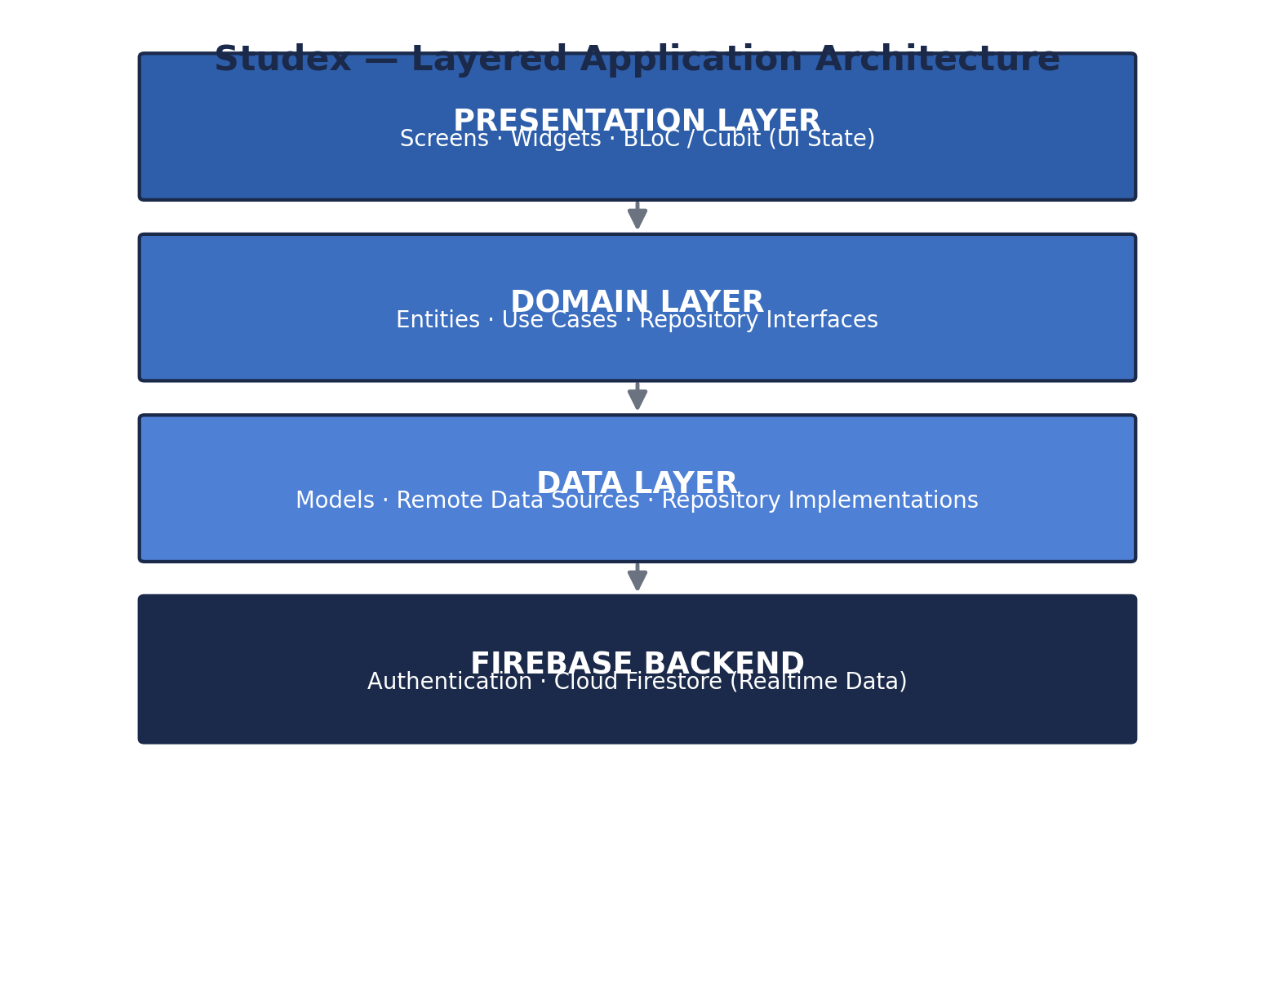
Figure 2.1 — Layered application architecture

2.2 State Management
State is managed consistently across the app using the BLoC/Cubit pattern (flutter_bloc). Two app-wide BLoCs — AuthBloc and UserBloc — manage authentication and user-profile state, while each feature exposes its own local state through a dedicated Cubit (e.g. ChatCubit, CreateQuizCubit, GetQuizzesCubit, SubmitQuizCubit, HomeCubit). This keeps state transitions predictable, testable, and cleanly separated from the UI layer.

2.3 Data Model
Firestore collections are centralized in a single constants file to avoid hardcoded strings throughout the codebase:
Collection | Purpose | Key Fields
users | User profiles and roles | uid, email, name, role
rooms | Study rooms | id, name, description, type, creatorId, members, memberJoinedAt
quizzes | Quizzes created within a room | id, title, description, roomId, questions, timePerQuestion, resultsCount
quiz_attempts | Submitted quiz results | quizId, userId, score, answers, submittedAt
rooms/{id}/messages | Real-time chat messages (subcollection) | id, senderId, senderName, message, createdAt
notifications | Reserved for future notification records | — (schema defined; not yet populated)

2.4 Technology Stack
Category | Technology
Framework | Flutter (Dart)
Backend | Firebase Authentication, Cloud Firestore
Auth Providers | Email / Password, Google Sign-In
State Management | flutter_bloc (BLoC + Cubit)
Navigation | go_router (incl. StatefulShellRoute for tab navigation)
Dependency Injection | get_it
Responsive UI | flutter_screenutil
Typography | google_fonts
Vector Assets | flutter_svg
Local Storage | shared_preferences
Localization | flutter_localizations / intl — Arabic & English
Utilities | uuid, equatable, meta

2.5 Navigation Flow
Routing is centralized in a single AppRoutes class and wired up with go_router, including a StatefulShellRoute that gives the Home, Rooms, Monitoring, and Settings tabs independent navigation stacks. New users are guided through a three-step onboarding carousel before reaching authentication; once signed in, a splash/auth gate routes them into the main tabbed experience.

3. Implementation

3.1 Core Modules
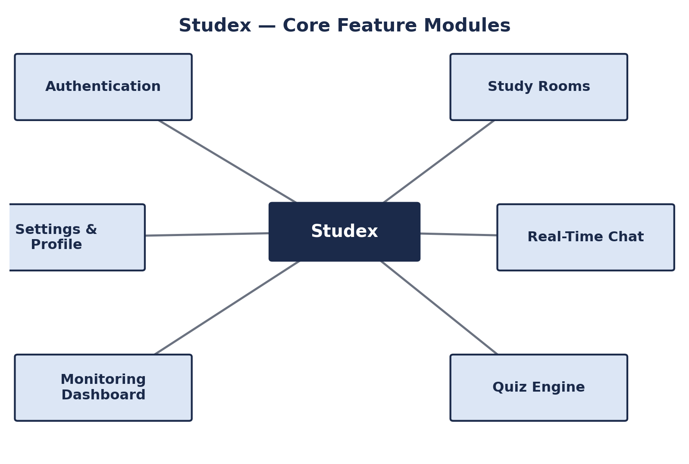
Figure 3.1 — Core feature modules

3.1.1 Authentication & User Roles
Supports email/password registration and login alongside Google Sign-In, with a password-recovery flow and an editable user profile. Three roles — student, teacher, admin — are built into the user data model, and session state is exposed as a stream consumed app-wide by AuthBloc.

3.1.2 Study Rooms
Users can create public or private rooms with a name and description, browse and join existing rooms, and each room tracks its member list along with each member's join timestamp.

3.1.3 Real-Time Chat
Each room includes a group chat backed by Cloud Firestore streams, so messages appear live for every member without a manual refresh. The chat UI distinguishes sent and received messages and includes a dedicated message input field.

3.1.4 Quiz Engine
The most fully-featured module in the app. Quiz creation is a two-step flow: the first step captures the quiz title and description, the second adds multiple-choice questions with a designated correct answer, scoped to a specific room. Taking a quiz presents a guided, per-question flow with a live progress indicator and an enforced time limit per question. On submission, answers are automatically scored, results are shown on a dedicated results screen, and standings are reflected on a room leaderboard.

3.1.5 Monitoring Dashboard
A dedicated panel presents an overview of dashboard items, exam grades, and a performance chart section alongside recent activity — giving teachers and admins a consolidated view of how students in their rooms are performing.

3.1.6 Settings & Localization
The settings screen centralizes profile access, notification preferences, language selection, and sign-out. The app ships with full Arabic (default) and English localization via flutter_localizations, and a responsive layout built with flutter_screenutil that adapts consistently across device sizes.

3.1.7 Offline Awareness
Firestore offline persistence is enabled at startup, and a dedicated no-internet screen is shown when connectivity is lost, keeping the app predictable rather than silently failing.

3.2 Project Structure
The codebase follows a feature-first folder structure, with the Quiz feature demonstrating the target Clean Architecture pattern for the rest of the app to converge on:
lib/ ├── core/ config, theming, routing, DI, constants ├── blocs/ app-wide BLoCs (auth, user) ├── features/ │ ├── auth/ onboarding/ homescreen/ rooms/ chat/ │ ├── quiz/ data / domain / presentation (Clean Architecture) │ ├── monitoringPanel/ settings/ widgets/ ├── models/ shared data models ├── repositories/ shared repositories ├── services/ Firebase, storage, notification services └── main.dart app bootstrap & providers

4. Results

4.1 Key Achievements
- End-to-end room collaboration: Students can register, sign in with email or Google, create/join public or private study rooms, and exchange messages instantly through Firestore-backed real-time chat.
- Functional quiz pipeline: A complete authoring-to-results pipeline: create a multi-question quiz, take it under a per-question timer, get an automatic score, and see standings on a leaderboard.
- Monitoring dashboard delivered: A working dashboard surfaces exam grades, performance charts, and recent activity for oversight roles.
- Bilingual, responsive UI: The app runs natively in Arabic and English with a layout that adapts across screen sizes.
- Clean Architecture proof of concept: The Quiz module demonstrates a full domain/data/presentation split with use cases and dependency injection, serving as the architectural template for the rest of the app.

4.2 Screens Overview
Module | Screens
Onboarding | 3-step first-run introduction
Authentication | Login, Register, Reset Password, Splash
Home | Dashboard with quick actions and recent rooms
Rooms | Room list, room creation, room chat
Quiz | Create quiz (2-step), quiz list, start quiz, take quiz, results, leaderboard
Monitoring | Performance dashboard, exam grades, activity
Settings | Profile editing, preferences, sign-out

4.3 Screenshots
Insert screenshots of the running application in the placeholders below before final submission.
Screen | Screenshot
Onboarding / Login | [Insert screenshot]
Home Dashboard | [Insert screenshot]
Study Room Chat | [Insert screenshot]
Create Quiz | [Insert screenshot]
Take Quiz | [Insert screenshot]
Quiz Results / Leaderboard | [Insert screenshot]
Monitoring Dashboard | [Insert screenshot]

5. Challenges, Limitations & Future Work

5.1 Challenges Faced
- Real-time quiz timing: Coordinating a live, per-question countdown against Firestore's asynchronous, stream-based data model required careful state handling in the Quiz cubits.
- Incremental architecture migration: Introducing Clean Architecture for the Quiz module while keeping the rest of the app on a simpler repository pattern required a clear internal convention so the two approaches stay consistent and mergeable.
- Bilingual RTL/LTR UI: Supporting Arabic (RTL) and English (LTR) from the same layout required consistent use of directional-aware widgets rather than hardcoded alignment.
[Add any team-specific challenges: Firebase quota/config issues, learning curve with BLoC, coordinating a shared Firestore schema, etc.]

5.2 Current Limitations
- Notifications & storage: Notifications and file/avatar storage are not yet implemented, even though the notifications collection and related UI placeholders already exist.
- Incomplete settings destinations: The Settings screen's Language, Help Center, and Privacy Policy entries are visible but not yet wired to destination screens.
- Chat message deletion: Deleting a chat message is defined on the repository layer but not yet implemented end-to-end.
- No automated tests: Automated unit/widget test coverage has not yet been added.
- Security rules: Firestore Security Rules enforcing role-based access (student vs. teacher vs. admin) still need to be authored before production use.

5.3 Future Enhancements
- Notifications: Implement push notifications end-to-end, wired to the existing notifications collection.
- Profile media: Add profile avatar upload via Firebase Storage.
- Settings completion: Build an in-app language switcher and complete the Help Center / Privacy Policy content.
- Architecture migration: Migrate Authentication, User, Rooms, and Chat features to the same Clean Architecture pattern established by the Quiz module.
- Testing: Add unit tests for use cases/Cubits and widget tests for key screens.
- Security hardening: Author and enforce Firestore Security Rules ahead of any production release.

Conclusion
Studex demonstrates a complete, working mobile solution for collaborative studying: students can form study rooms, communicate in real time, assess themselves through quizzes, and see how they compare with peers, while teachers and admins gain visibility into performance through a monitoring dashboard. Built with Flutter and Firebase, and structured around the BLoC pattern with an emerging Clean Architecture, the project reflects the practical, industry-oriented software engineering skills developed throughout the DEPI [Track Name] track. The identified limitations and roadmap in Chapter 5 provide a clear path for continued development beyond the scope of this graduation project.

References
[1] Flutter Documentation — https://docs.flutter.dev
[2] Firebase Documentation — https://firebase.google.com/docs
[3] flutter_bloc Library Documentation — https://bloclibrary.dev
[4] go_router Package — https://pub.dev/packages/go_router
[5] get_it Package — https://pub.dev/packages/get_it
[6] Digital Egypt Pioneers Initiative (DEPI) — https://depi.gov.eg

Appendix A: Project Team
Name | Role / Contribution | DEPI ID
[Team Member 1] | [e.g., Mobile Development, Firebase Integration] | [ID]
[Team Member 2] | [e.g., UI/UX, Quiz Module] | [ID]
[Team Member 3] | [e.g., Authentication, Chat Module] | [ID]
[Team Member 4] | [e.g., Monitoring Dashboard, Testing] | [ID]

Supervisor: [Supervisor Name]
Acknowledgment: [Add any thanks to DEPI instructors, mentors, or partner organizations.]

