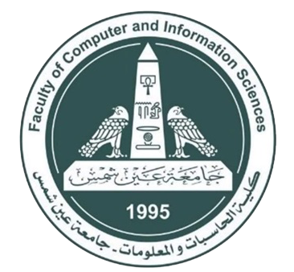

Ain Shams University

Faculty of Computer & Information Sciences

Information Systems Department

2020 - 2021

**Drug Authentication Using Blockchain**

By

Abdulrhman El Sayed Saeed [ Information Systems]

Kareema Magdy Awad [Information Systems]

MennaT'allah Abdel_fattah Mohammed [Information Systems]

Ramy Makram Eyd [Information Systems]

Reham Raafat Shokry [Information Systems]

Under Supervision of

**Dr. Tamer Mostafa**

Information Systems Department

Faculty of Computer & Information Sciences

Ain Shams University

**TA. Eman Bahgat**

Information Systems Department

Faculty of Computer & Information Sciences

Ain Shams University

July 2021