**Comment**

**Regular Expression:**

**/* [other | *]* */**

**NFA using Thompson’s Construction:**

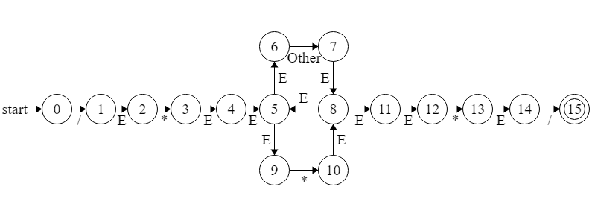

**Subset Construction:**

|  |  |  |  |
| --- | --- | --- | --- |
|  | **Other** | **\*** | **/** |
| **A** | **PHI** | **PHI** | **B** |
| **B** | **PHI** | **C** | **PHI** |
| **C** | **D** | **E** | **PHI** |
| **D** | **D** | **E** | **PHI** |
| **E** | **D** | **E** | **F\*** |
| **F\*** | **PHI** | **PHI** | **PHI** |
| **PHI** | **PHI** | **PHI** | **PHI** |

**DFA using Subset Construction:**

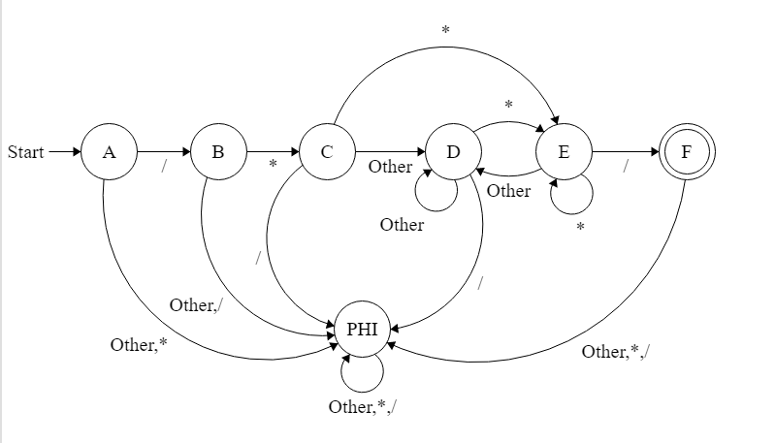

**Minimized DFA:**

**0 Equivalence 🡪 {A,B,C,D,E,PHI} {F}**

**1 Equivalence 🡪 {A,B,C,D,PHI} {E} {F}**

**2 Equivalence 🡪 {A,B,C,E,PHI} {D} {E} {F}**

**3 Equivalence 🡪 {A,B,E,PHI} {C,D} {E} {F}**

**4 Equivalence 🡪 {A ,PHI} {B} {C,D} {E} {F}**

**5 Equivalence 🡪 {PHI} {A} {B} {C,D} {E} {F}**

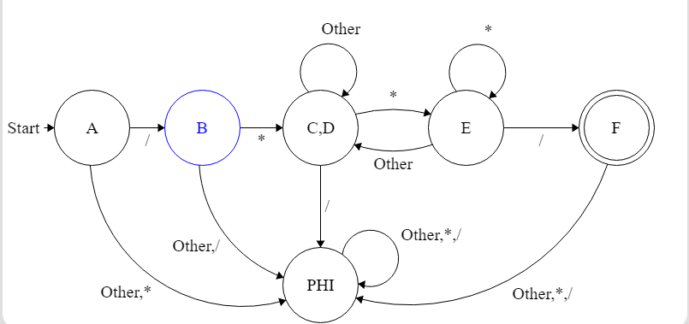

Assignment

Regular Expression:

:=

NFA using Thompson’s Construction:

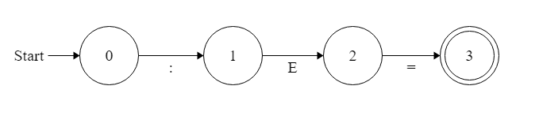

DFA using Subset Construction:

|  |  |  |
| --- | --- | --- |
|  | : | = |
| A | 1 | PHI |
| B | PHI | C* |
| C* | PHI | PHI |
| PHI | PHI | PHI |

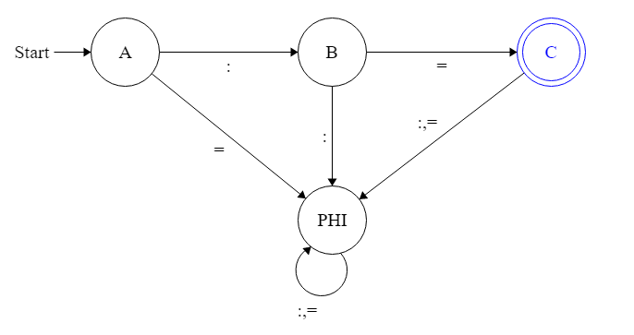

Minimized DFA:

0 Equivalence: {A,B,PHI} {C}

1 Equivalence: {A,B,PHI} {C}

2 Equivalence: {A,PHI} {B} {C}

3 Equivalence: {PHI} {A} {B} {C}



Datatype

Regular Expression:

(int |float|string)

NFA using Thompson’s Construction:

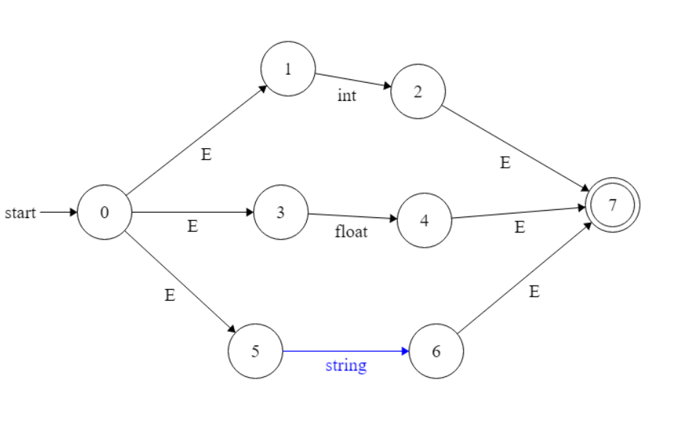

DFA using Subset Construction:

|  |  |  |  |
| --- | --- | --- | --- |
|  | int | float | string |
| ->D0 | D1 | D2 | D3 |
| D1* | Phi | phi | Phi |
| D2* | Phi | Phi | Phi |
| D3* | Phi | Phi | Phi |
| phi | phi | Phi | phi |

Minimized DFA:

0 Equivalence: {D0,phi } {D1,D2,D3}

1 Equivalence: {D0 }{phi} {D1,D2,D3}

2Equivalence: {D0 }{phi} {D1,D2,D3}

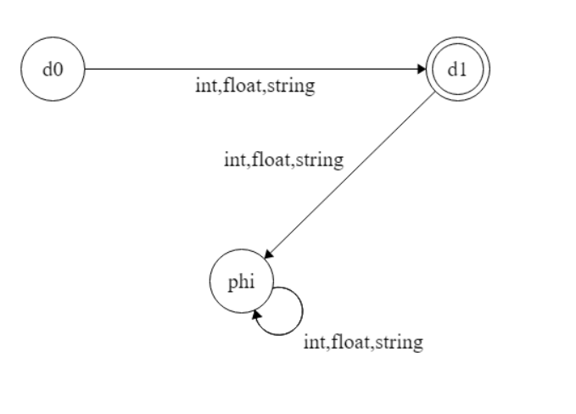

Arithmatic_Operator

Regular Expression:

(+ | - | * | /)

NFA using Thompson’s Construction:

DFA using Subset Construction:

|  |  |  |  |  |
| --- | --- | --- | --- | --- |
|  | + | - | * | / |
| D0 | D1 | D2 | D3 | D4 |
| D1 | Phi | phi | Phi | phi |
| D2 | Phi | Phi | Phi | Phi |
| D3 | Phi | Phi | Phi | Phi |
| D4 | Phi | Phi | Phi | Phi |
| phi | phi | Phi | phi | Phi |

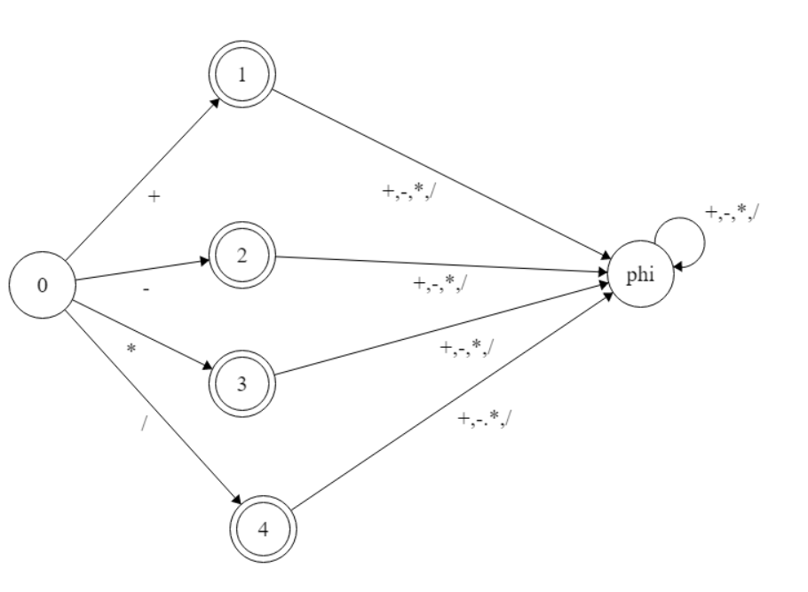

Minimized DFA:

0 Equivalence: {D0,phi } {D1,D2,D3,D4}

1 Equivalence: {D0 }{phi} {D1,D2,D3,D4}

2Equivalence: {D0 }{phi} {D1,D2,D3,D4}

Number

digit = [0-9]

1. R.E

[digit]+((\.)[digit]+)?

2)NFA using Thompson’s

3)NFA to DFA using subset

|  |  |  |
| --- | --- | --- |
| subset | \. | digit |
| S0 | trap | S1* |
| S1* | S2 | S1* |
| S2 | trap | S3* |
| S3* | trap | S3* |

DFA

4)Minimize DFA

0_Equivalence :- {s0,s2,trap} {s1,s3}

1_Equivalence :- {s0,s2}{trap}{s1,s3}

2_Equivalence :- {s0,s2}{trap}{s1,s3}

3_Equivalence :- {s0,s2}{trap}{s1}{s3}

4_Equivalence :- {s0}{s2}{trap}{s1}{s3}

**String**

**Character = Letter|Digit|Special_Character**

**other = Character(^")**

**Regular Expression:**

**"(other)*"**

**NFA using Thompson’s Construction:**

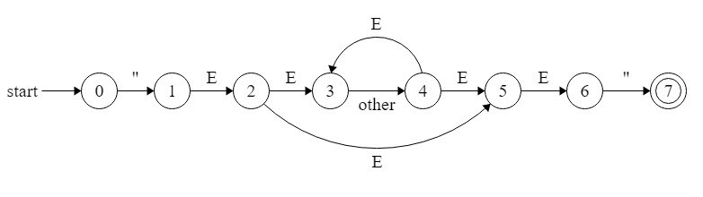

**Subset Construction:**

|  |  |  |
| --- | --- | --- |
|  | **other** | **"** |
| **d0** | **PHI** | **d1** |
| **d1** | **d2** | **d3\*** |
| **d2** | **d2** | **d3\*** |
| **d3\*** | **Φ** | **Φ** |
| **Φ** | **Φ** | **Φ** |

**DFA using Subset Construction:**

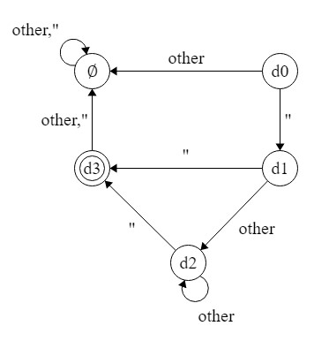

**Minimized DFA:**

**0 Equivalence à {d0, d1, d2, Φ} {d3}**

**1 Equivalence à {d0, d1, Φ} {d2} {d3}**

**2 Equivalence à {d0, Φ} {D} {d1, d2} {d3}**

**3 Equivalence à {Φ} {d0} {d1, d2} {d3}**

**d1’**

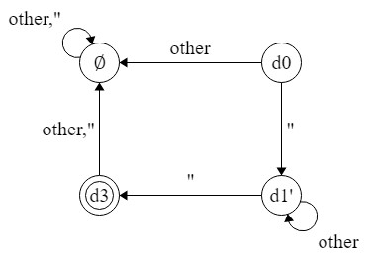

***Identifier***

**Prerequired REs:**

* **Letter: Letter = [a-z|A-Z]**
* **Digit=[0-9]**

1-RE: letter(letter|digit)*

2-NFA using Thomson’s :

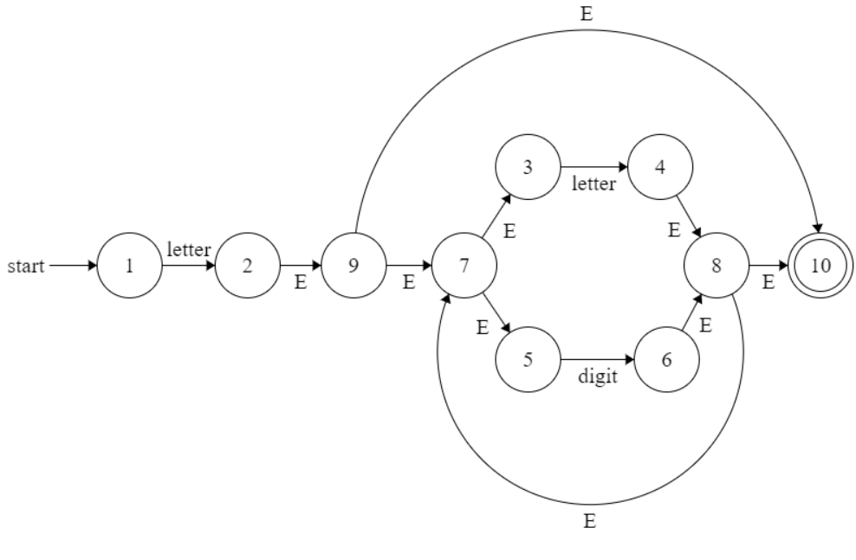

3-converting NFA to DFA using subset construction:

|  |  |  |  |
| --- | --- | --- | --- |
| DFA | NFA | letter | Digit |
| 1 | -> {1} | {2,3,5,7,9,10}* | Փ |
| 2* | {2,3,5,7,9,10}* | {3,4,5,7,8,10}* | {3,5,6,7,8,10}* |
| Փ | Փ | Փ | Փ |
| 3* | {3,4,5,7,8,10}* | {3,4,5,7,8,10}* | {3,5,6,7,8,10}* |
| 4* | {3,5,6,7,8,10}* | {3,4,5,7,8,10}* | {3,5,6,7,8,10}* |

|  |  |  |
| --- | --- | --- |
| DFA | letter | digit |
| -> 1 | 2 | Փ |
| 2* | 3 |  |
| Փ | Փ | Փ |
| 3* | 3 | 4 |
| 4* | 3 | 4 |

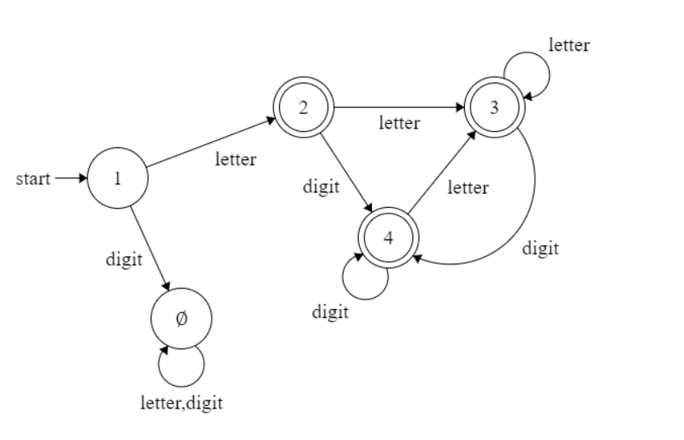

4-Minimizing DFA:

0 eq: {1, Փ }{2,3,4}

1 eq:{1}{ Փ }{ 2,3,4}

2 eq: {1}{ Փ }{ 2,3,4}

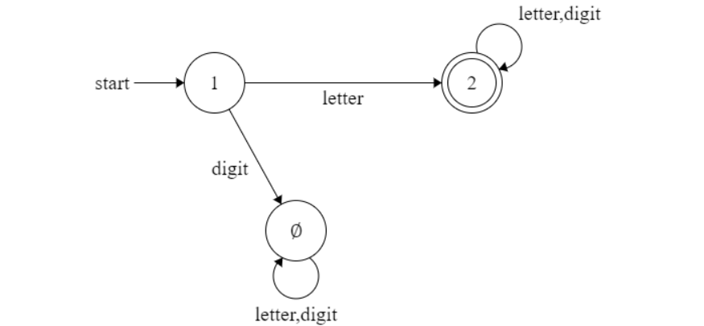

**Boolean Operator**

R.E: (&&|\|\|)

**NFA using Thompson’s Construction:**

**DFA using Subset Construction:**

|  |  |  |  |
| --- | --- | --- | --- |
| **NFA STATE** | **DFA STATE** | || | && |
| {0,1,3} | A | B | C |
| {2,5} | B | Փ | Փ |
| {4,5} | C | Փ | Փ |
| Փ | Փ | Փ | Փ |

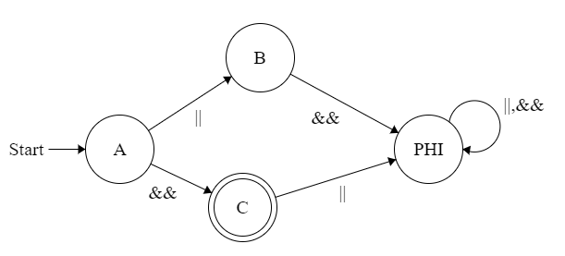

Minimized DFA:

|  |  |  |
| --- | --- | --- |
| **DFA STATE** | **Min-DFA STATE** | ||,&& |
| {A} | 1 | 2 |
| {B, C} | 2 | Փ |
| Փ | Փ | Փ |
|  |  |  |
|  |  |  |

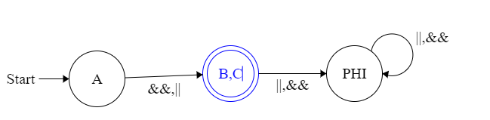

**Condition Operator**

R.E: (<|>|=|<>)

**NFA using Thompson’s Construction:**

**DFA using Subset Construction:**

|  |  |  |  |  |
| --- | --- | --- | --- | --- |
| **NFA STATE** | **DFA STATE** | < | = | > |
| {0,1,3,5,7} | A | B | C | D |
| {2,8,10} | B | PHI | PHI | E |
| {6,10} | C | PHI | PHI | PHI |
| {4,10} | D | PHI | PHI | PHI |
| {9,10} | E | PHI | PHI | PHI |
| PHI | PHI | PHI | PHI | PHI |

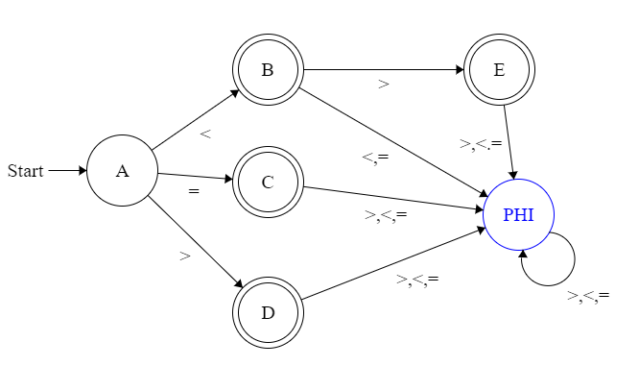

Minimized DFA:

|  |  |  |  |  |
| --- | --- | --- | --- | --- |
| **DFA STATE** | **Min-DFA STATE** | < | =,> | > |
| {A} | 1 | 2 | 3 | PHI |
| {B} | 2 | PHI | PHI | 3 |
| {C,D,E} | 3 | PHI | PHI | PHI |

