**ABDULRHMAN** MOTHANA

**+964 7700725707**

**Iraq-As sulaimanyah - Bakrjo**

**Abdulrhmanmoth@gmail.com**

**SKILLS**

Communication skills

Time management

Problem solving

Microsoft office

Windows Server

SQL Server

Networking

Software & hardware configure

**LANGUAGES**

Arabic - Native speaker

English - Intermediate

Kurdish - Intermediate

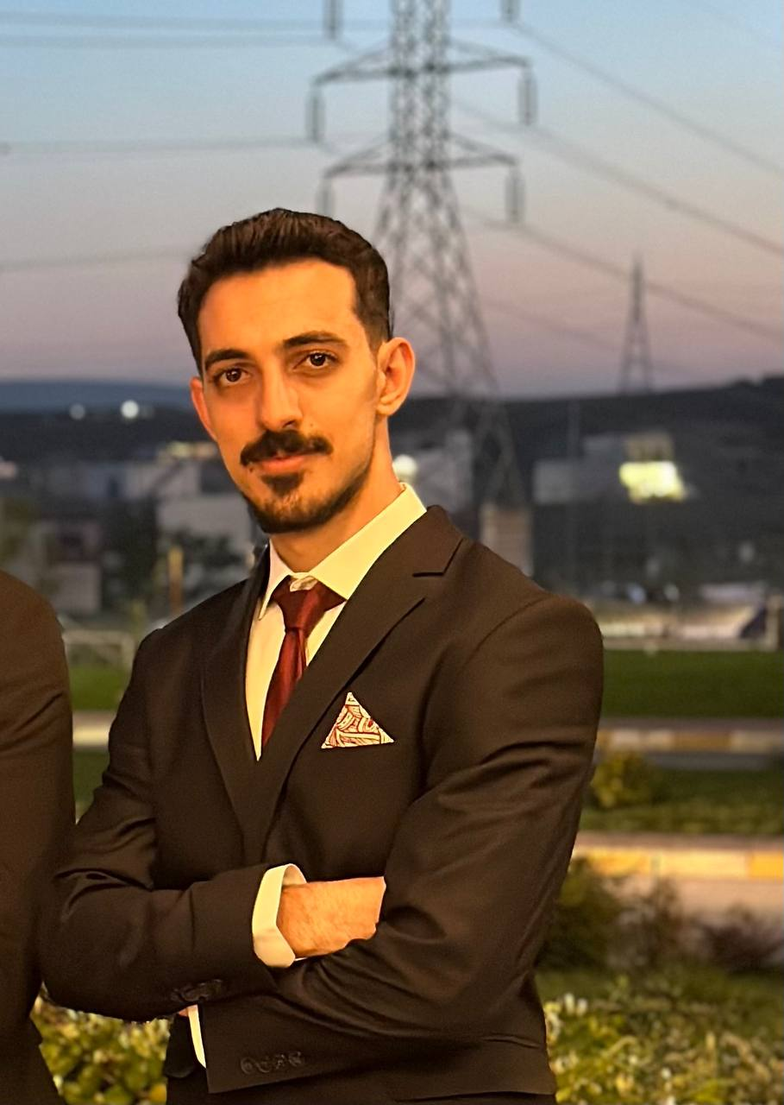

# Information Technology Department

# PROFESSIONAL EXPERIENCE

# I have experience in solving problems related to software and hardware, installing and configuring devices, as well as solving problems related to networks, installing and updating operating systems, devices and programs, as well as experience in Microsoft programs.

# WORK EXPERIENCE

**AHMED SHARY COMPANY | IT Technician 2023**

I did all the technical work like computer repair, system repair and printer repair.

**AL SABAA COMPANY | IT Technician 2023**

I completed my university training work like computer repair, system overhaul and printer repair and graphic design.

**FREELANCER | GRAPHIC DESIGN - WEB DESIGN 2022**

Created many websites for clients using figma and front-end languages such as Java, HTML, and CSS and worked freelancer as a graphic design .

**FREELANCER | FLUTTER DEVELOPER 2024**

I have experience in creating mobile applications for Android and iPhone using Dart and Flutter.

Firebase/Sqlite

Dart/Flutter

# EDUCATION

Html/css/js/tailwind css

**Sulaimani Polytechnic University, 2020-2024 (Graduated)**

Bachelor of Information Technology