FINAL PROJECT REPORT
Job Skill Extraction Using Natural Language Processing (NLP)
Internship Project Documentation — Days 1 to 17
Prepared as the consolidated final report covering problem definition,
data pipeline, NLP/ML methods, evaluation, and future scope.

Final Report Index
Sr. No | Chapter / Section | Page No.
1 | Introduction | 3
2 | Problem Statement & Objectives | 4
3 | Project Scope & Use Case | 5
4 | Technology & Tools Used | 6
5 | System Architecture & Methodology | 7
6 | Dataset Collection & Understanding | 8
7 | Exploratory Data Analysis (EDA) | 9
8 | Data Cleaning & NLP Preprocessing | 15
9 | Skill Taxonomy Development | 19
10 | Rule-Based Skill Extraction | 20
11 | Statistical & Semantic NLP Techniques | 23
12 | Named Entity Recognition (NER) | 28
13 | Machine Learning Model | 29
14 | Transformer-Based Model | 32
15 | Model Evaluation & Comparison | 34
16 | Error Analysis | 35
17 | Skill Normalization & Categorization | 37
18 | Dashboard & Data Visualization | 39
19 | Application / API Development | 41
20 | Testing & Results | 43
21 | Challenges & Limitations | 44
22 | Conclusion | 45
23 | Future Scope | 46
24 | Internship Learning Outcomes | 47
25 | References | 48

SECTION 1

1. Introduction
Job descriptions contain critical information about roles, required technical skills, tools, technologies, and qualifications. In traditional recruitment workflows, identifying these skills manually across large volumes of postings is time-consuming, repetitive, and prone to inconsistent results.
This project, Job Skill Extraction Using Natural Language Processing (NLP), automatically identifies relevant skills and job roles from unstructured job description text using a progression of NLP and machine learning techniques, producing structured, analytics-ready information for recruitment workflows.

NLP Overview
Natural Language Processing enables computers to interpret, structure, and extract meaning from human-written text. This project applies NLP across a spectrum of techniques — from simple dictionary and regex matching to statistical methods (TF-IDF, n-grams), embedding-based semantic similarity, rule-based named entity recognition, supervised machine learning, and pretrained transformer models — to compare how each approach performs on the same real-world task.

Job-Skill Extraction Concept
At its core, the project converts an unstructured block of text (a job description) into a structured list of canonical skill names, plus (where supported by labeled data) a predicted job role or skill category. This structured output is what ultimately feeds dashboards, candidate-matching systems, and workforce analytics.

SECTION 2

2. Problem Statement & Objectives

Problem Statement
Manually scanning thousands of job postings to identify required skills is slow, inconsistent, and does not scale. Recruiters and HR analysts need an automated, repeatable way to convert raw job description text into structured, comparable skill data.

Business Objective
- Automate the identification of technical and professional skills.
- Reduce the time required for manual job description analysis.
- Improve consistency in skill identification across job postings.
- Support recruiters and HR teams in candidate-job matching.
- Enable analysis of frequently requested skills and technologies.
- Create structured data that can be visualized using BI tools such as Power BI or Tableau.

Technical Objective
- Clean and normalize raw job description text.
- Apply NLP preprocessing such as tokenization and text normalization.
- Identify relevant skills from job descriptions using multiple complementary methods.
- Classify or predict the job role/skill category where applicable.
- Convert unstructured text into structured, canonicalized output.
- Evaluate extraction/classification performance using precision, recall, and F1.
- Prepare the system for integration into a web application or API.

Expected Outcome
A working pipeline that accepts a raw job description and returns a structured record containing the predicted role and a deduplicated, canonicalized list of extracted skills — supported by a documented comparison of extraction methods and an interactive dashboard of skill trends.

SECTION 3

3. Project Scope & Use Case

Scope
The project covers the full pipeline from raw dataset ingestion through cleaning, NLP preprocessing, skill taxonomy design, five distinct extraction/classification approaches, formal evaluation, error analysis, normalization, dashboarding, and an application-facing demo. It does not include live integration with a production applicant-tracking system, though the architecture is designed to support that as a future extension.

Recruitment Use Case
A recruiter uploads or pastes a job description; the system returns the predicted role and a clean list of canonical required skills within seconds, replacing a manual read-through. Aggregated across many postings, the same pipeline reveals which skills are trending, which roles demand which tool combinations, and where a company's talent pipeline may have gaps.

Practical Applications
- Automated tagging of job postings for internal ATS/CRM systems.
- Resume-to-job matching and candidate ranking (see Future Scope).
- Workforce and skill-demand analytics dashboards for HR leadership.
- Curriculum and training-program design based on real market demand.
- Competitive benchmarking of skill requirements across companies or regions.

SECTION 4

4. Technology & Tools Used
Category | Tools / Libraries
Programming Language | Python
Data Handling | Pandas, NumPy
NLP | NLTK, spaCy
Machine Learning | Scikit-learn (TF-IDF, Logistic Regression)
Deep Learning / Transformers | Hugging Face Transformers (BERT / DistilBERT family)
Semantic Similarity | sentence-transformers (all-MiniLM-L6-v2)
Visualization / Dashboarding | Power BI / Tableau, Matplotlib, Seaborn
Application Layer | Streamlit / FastAPI

SECTION 5

5. System Architecture & Methodology
The project follows a linear, day-by-day pipeline in which each stage's output becomes the next stage's input:
- 1. Data Collection — load and inspect the raw job-description dataset (10,000 records).
- 2. Exploratory Data Analysis — understand distributions, missing values, duplicates.
- 3. Data Cleaning — strip HTML, URLs, emails, symbols; normalize case and spacing.
- 4. Skill Taxonomy — build a canonical skill dictionary with categories and aliases.
- 5. NLP Preprocessing — tokenization, stopword removal, lemmatization/stemming, sentence segmentation.
- 6. Rule-Based Extraction — dictionary matching, then regex + phrase matching fixes.
- 7. Statistical & Semantic NLP — TF-IDF, n-grams, word embeddings / semantic similarity.
- 8. Named Entity Recognition — standard spaCy NER baseline, then a custom EntityRuler.
- 9. Machine Learning — TF-IDF + Logistic Regression skill-category classifier.
- 10. Transformer-Based Extraction — pretrained BERT-family NER baseline.
- 11. Model Evaluation — precision / recall / F1 across all six methods on a common sample.
- 12. Error Analysis — categorize every mismatch made by the strongest method.
- 13. Skill Normalization — canonicalize every method's raw output through one shared function.
- 14. Dashboard & Application — visualize results and expose the pipeline through an interface.
Each stage was implemented and validated independently before being chained into the next, so failures could be isolated to a single stage rather than debugged across the whole pipeline at once.

SECTION 6

6. Dataset Collection & Understanding

Dataset Source
A public job-postings dataset was used, containing 10,000 job records with fields covering job title, company, location, and full job description text.

Dataset Fields
- job_id — unique identifier for each posting
- job_title — the advertised role title
- company — hiring organization
- location — posting location
- job_description — full unstructured description text

Number of Records
10,000 job postings.

Data Inspection
import pandas as pd
df = pd.read_csv("jobs_skills_Extraction_10000.csv")
print(df.shape)
print(df.columns)
print(df.head())
print(df.isnull().sum())
This confirmed record and column counts, previewed sample rows, and surfaced missing-value counts per column before any cleaning was applied.

SECTION 7

7. Exploratory Data Analysis (EDA)
EDA was performed before any NLP preprocessing to understand what the pipeline would actually be working with.

Job Titles & Locations
Distributions of the most common job titles and posting locations were charted to understand dataset composition and identify any single category dominating the sample disproportionately.

Description Length
df["description_length"] = df["job_description"].str.len()
print(df["description_length"].describe())
Description length statistics identified unusually short or long postings and gave an early estimate of how much text the NLP pipeline would need to process per record.

Missing Values & Duplicates
Every column was checked for missing values and the dataset was checked for duplicate rows and duplicate description text, both of which inform the Data Cleaning stage.

Visualizations Produced
- Top job titles (bar chart)
- Jobs by location (bar chart)
- Job description length distribution (histogram)
- Missing value heatmap
- Top hiring companies (bar chart)
Matplotlib and Seaborn were used for these visualizations. A NameError encountered mid-development was traced to an import/variable-order issue and resolved by verifying imports and variable definitions preceded plotting calls.

- Exploratory Data Analysis Outputs :-
- Key Performance Analysis.
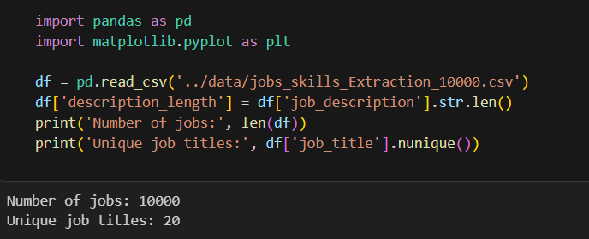
- Common Job Role
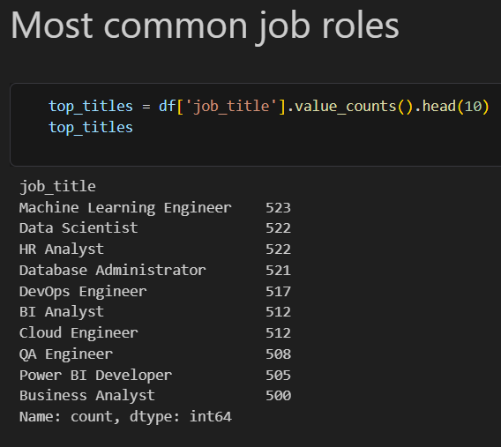

- Job By Location.
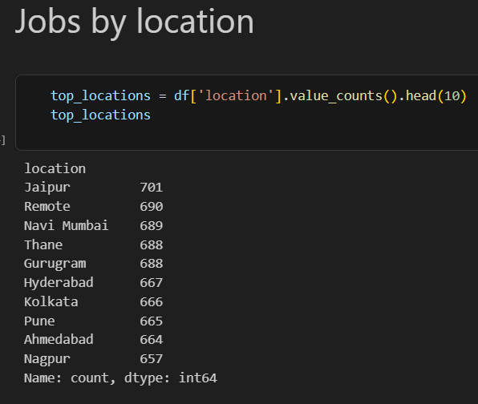
- Job Description Length
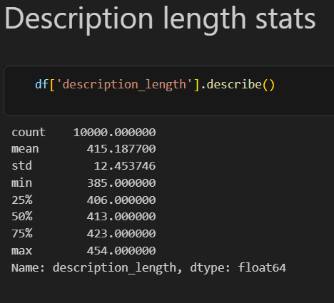

- Missing Values & Duplicate Records.
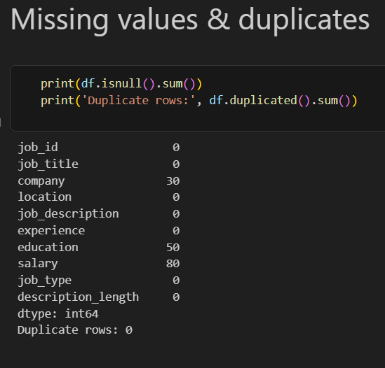
- Visualizations.
- Top Job Titles.
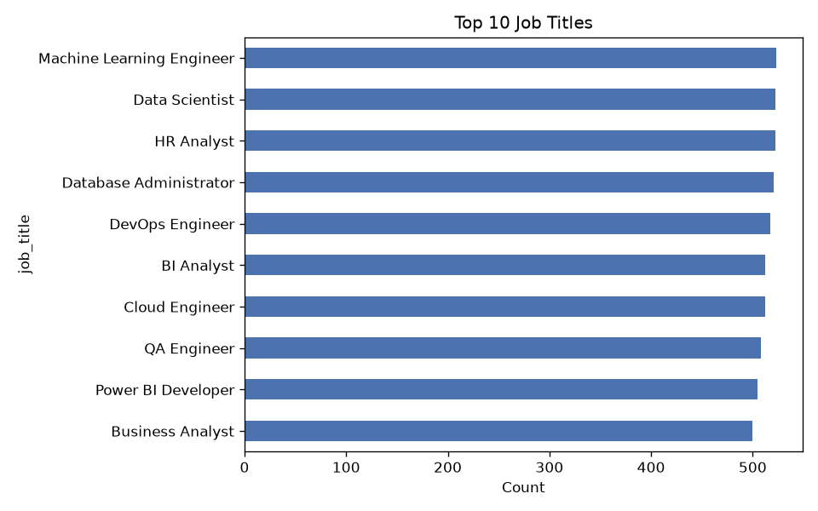

- Job By Location
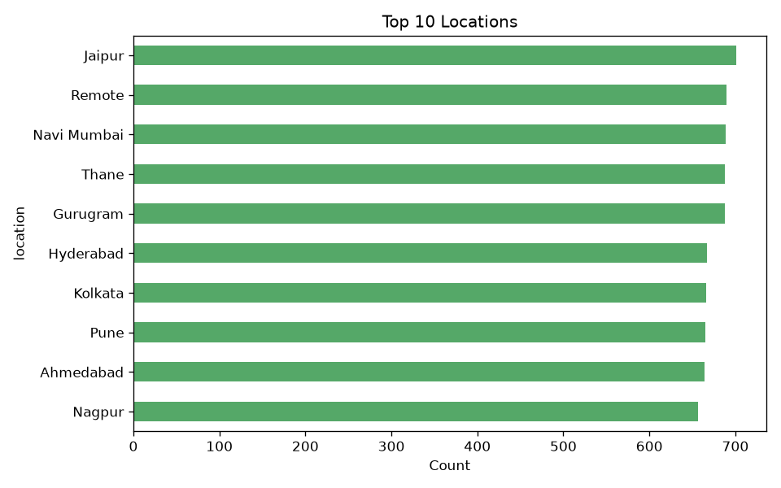
- Job Description Length Distribution.
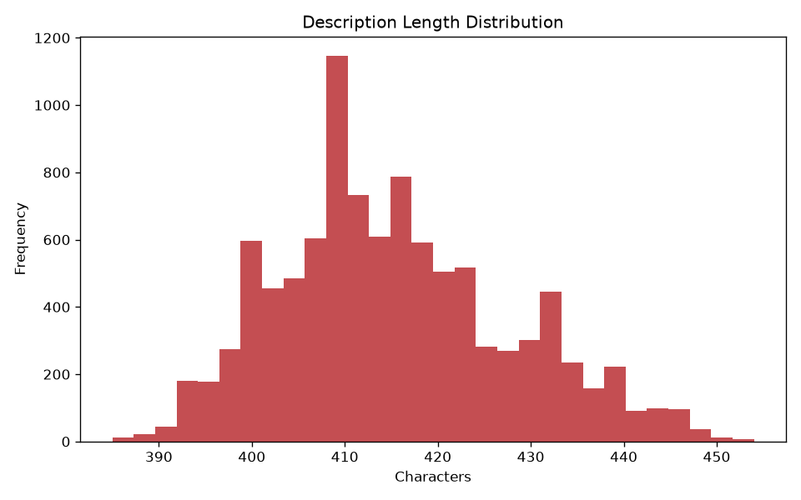

- Missing Value Analysis.
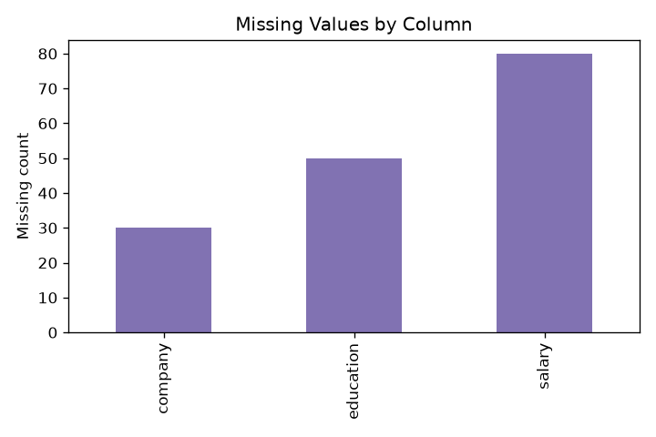
- Top Companies.
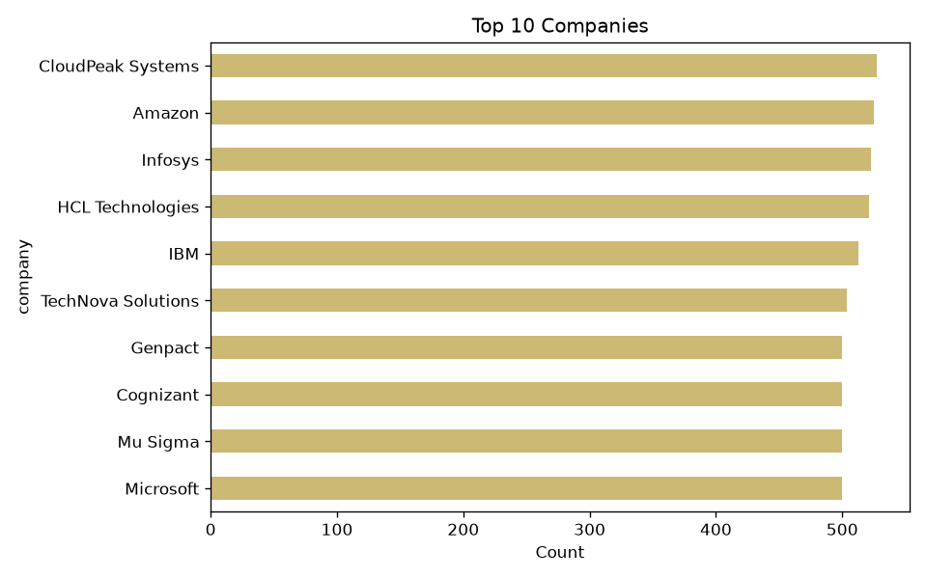

SECTION 8

8. Data Cleaning & NLP Preprocessing

Data Cleaning Operations
- Remove or handle HTML tags
- Remove URLs
- Remove email addresses
- Remove phone numbers where applicable
- Handle special characters and unnecessary symbols
- Normalize extra whitespace
- Handle duplicate text / duplicate records
- Convert text to lowercase
The cleaned text was written to a new clean_description column, preserving the original job_description for comparison and auditing.

Tokenization
Tokenization splits text into individual words. For example, "We are looking for candidates with strong experience in Python and SQL." becomes tokens such as We, are, looking, for, candidates, Python.

Stopword Removal
Common words (the, is, are, and, for, in) were removed where they add no discriminative signal, applied carefully since some common words retain meaning in specific contexts.

Stemming vs. Lemmatization
Lemmatization converts words to their dictionary/base form using linguistic information and generally produces more linguistically meaningful results than stemming, which reduces words to a root-like form via heuristic rules that may not be valid dictionary words. Both were implemented and compared for trade-offs between computational simplicity and linguistic quality.

Sentence Segmentation
Job descriptions were split into individual sentences using spaCy, useful for isolating individual requirement, responsibility, and qualification statements.

Tools Used
- NLTK — tokenization, stopword processing, stemming
- spaCy — tokenization, linguistic processing, sentence segmentation, entity extraction

- Data Cleaning & NLP Preprocessing Outputs :-
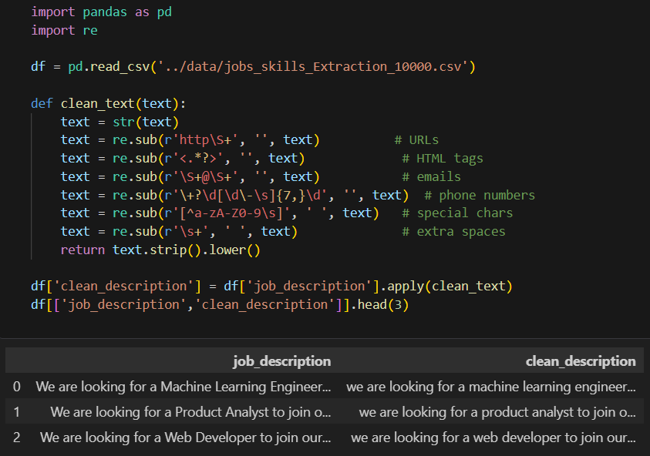

- Before / After Example
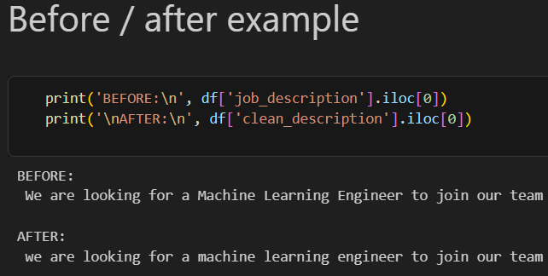

- Then We Check
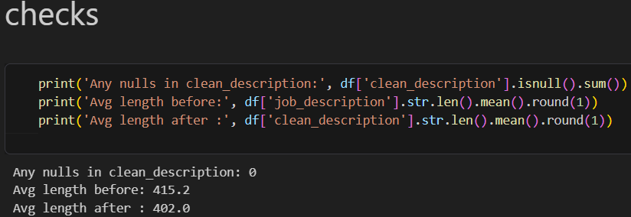

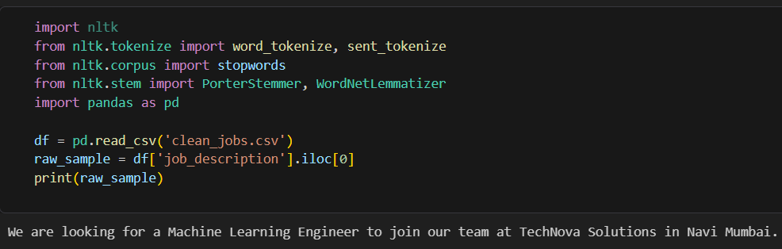

- Sentence Segmentation:-
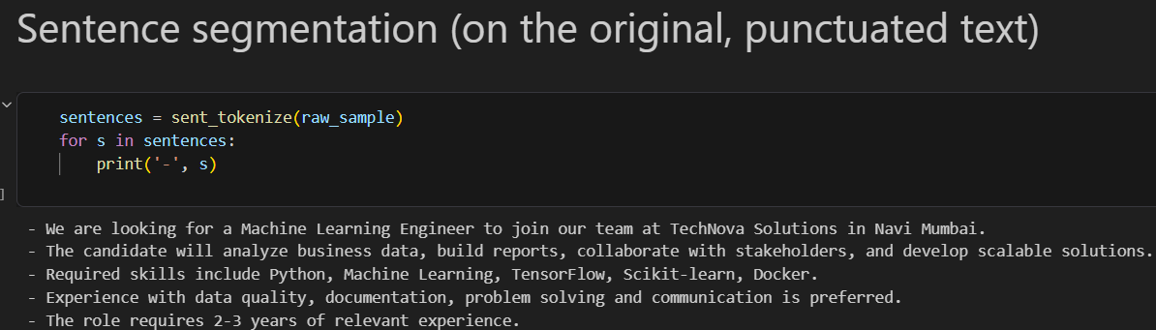

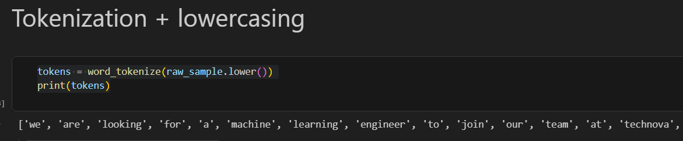

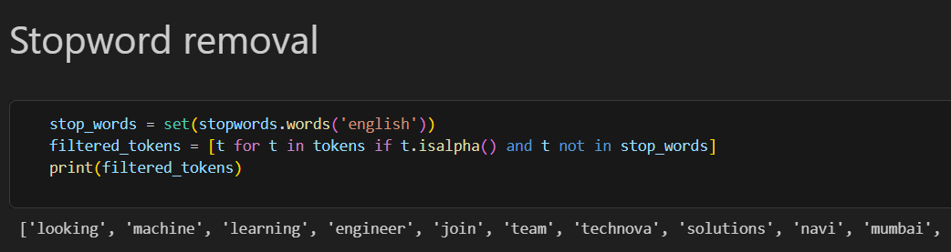

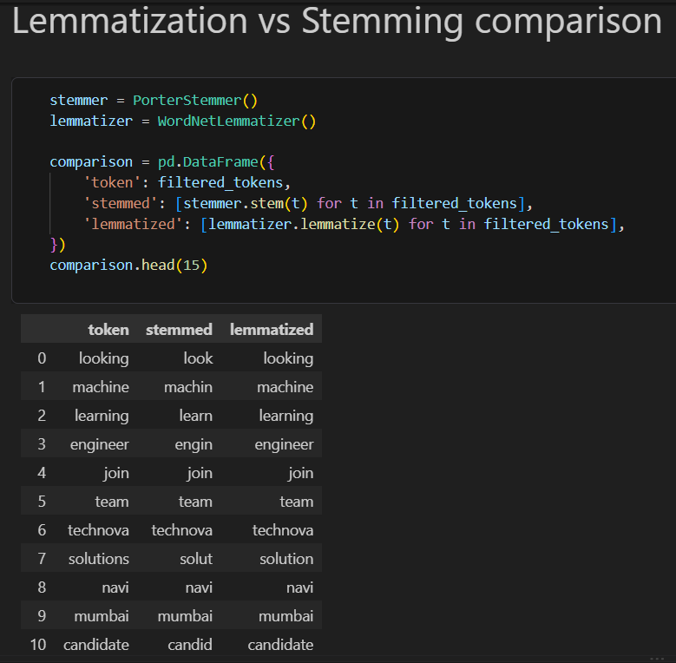
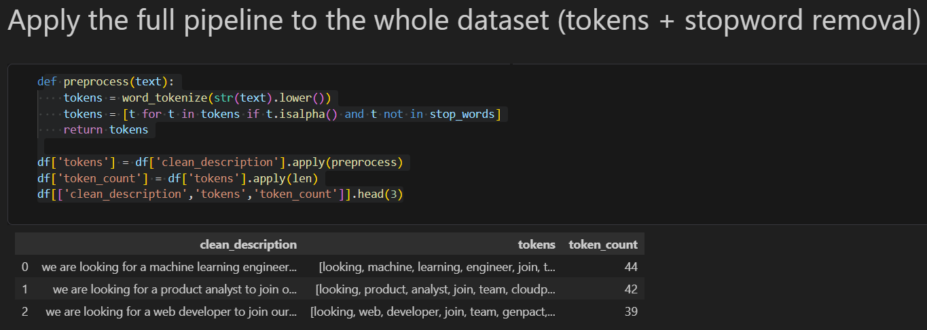

SECTION 9

9. Skill Taxonomy Development
A master skill dictionary (skill_taxonomy.csv) groups skills into meaningful categories and maps alternative spellings/aliases to one canonical skill name, preventing the same skill from being counted multiple times under different surface forms (e.g. postgres and postgresql both normalize to PostgreSQL).

Sample of the Taxonomy
Canonical Skill | Category | Sample Aliases
Python | Programming | python3; python 3; python programming
Power BI | Business Intelligence | powerbi; power-bi; power bi desktop
PostgreSQL | Database | postgres; postgre; postgresql db
Machine Learning | Machine Learning | ml; machine-learning
AWS | Cloud Platform | amazon web services; amazon aws
Node.js | Programming | node; nodejs; node js

A manual test against the loaded taxonomy successfully returned skills such as Python, SQL, Excel, Power BI, Pandas, and Machine Learning from sample text.

SECTION 10

10. Rule-Based Skill Extraction

Dictionary Matching
The taxonomy is flattened once into a single lookup dictionary — every canonical skill and every alias becomes a key mapped to its canonical name — so each job description needs only one pass over its own terms.
def extract_skills(text, skill_lookup):
text = str(text).lower()
found = set()
for term, canonical in skill_lookup.items():
if term in text:
found.add(canonical)
return sorted(found)

Running the script produced the following output on the real dataset:
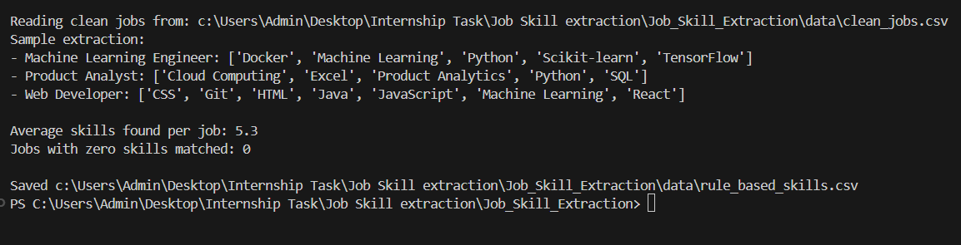
Applied across the full dataset: every job matched at least one skill, and the average description yielded just over five distinct skills.

The Word-Boundary Problem
Plain substring matching cannot distinguish word boundaries: 'ml' in 'html' evaluates to True, so a Web Developer posting mentioning only HTML was mis-tagged with Machine Learning purely because 'ml' sits inside 'html'.

Fix: Regex With Word Boundaries
Each skill was redefined as a regex pattern anchored with \b, so 'ml' can no longer match inside 'html' — there is no boundary between the letters h-t-m and l. Optional non-capturing groups (e.g. (?:\s*3)?) let 'python', 'python 3', and 'python3' all satisfy one pattern mapping to canonical 'Python'.

Fix: Phrase Matching With spaCy
spaCy's PhraseMatcher matches tokens rather than raw characters, which is more robust for multi-word phrases such as 'power bi' and 'machine learning'. The NER and dependency-parser pipeline components were disabled since phrase matching only needs tokenization — a meaningful speed optimization across 10,000 rows.

- Outputs: -
- Regex with word boundaries.
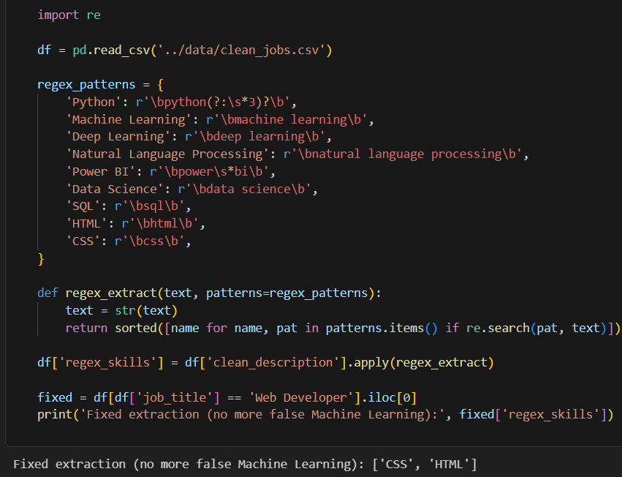

Applying the regex extractor across all 10,000 postings gives the following skill-frequency ranking (top 6 shown):
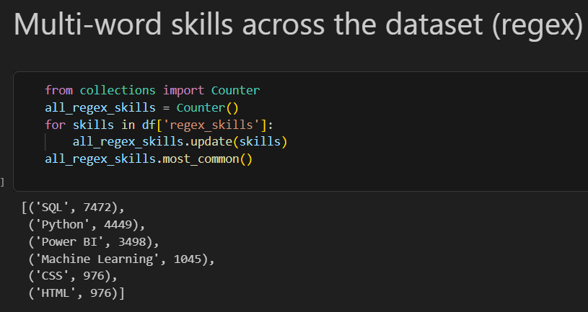
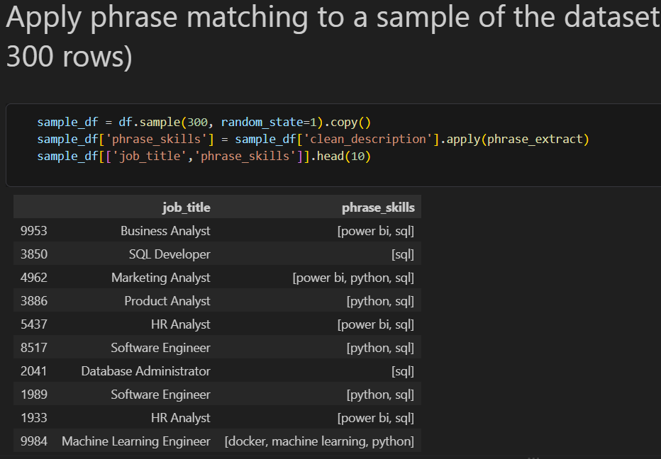

SECTION 11

11. Statistical & Semantic NLP Techniques

TF-IDF
TF-IDF scores each word by frequency within a posting, discounted by how common it is across all postings, so ubiquitous words (like 'experience') don't dominate just because they're frequent. Only 149 distinct terms passed scikit-learn's default term-frequency filtering out of a requested maximum of 1,000 — the vocabulary of this dataset's postings is fairly compact and repetitive, typical of templated job listings.
Cross-checking the top 50 TF-IDF terms against the taxonomy showed TF-IDF is a strong discovery tool for finding new dictionary candidates for human review (e.g. analytical, cross-functional, stakeholders) but cannot reliably distinguish a hard skill from generic boilerplate phrasing on its own.

N-Gram Analysis
Single-word TF-IDF split multi-word tools apart — 'Power BI' became two unrelated unigrams, 'power' and 'bi'. Re-running TF-IDF over 1-, 2-, and 3-word phrases recovered these as coherent units:
This is a direct fix for the unigram-splitting problem: 'power bi' now scores as one unit (274.7) instead of being split into 'power' (679.6) and 'bi' (687.0) as two unrelated unigrams.

Word Embeddings & Semantic Similarity
Rule-based matching only detects a skill if its exact text or a pre-listed alias appears. The sentence-transformers library (all-MiniLM-L6-v2) was used to compute dense embeddings for both canonical skills and description text chunks, then cosine similarity flagged matches above a chosen threshold — recovering paraphrases such as 'ML' matching 'Machine Learning' with no shared substring. Threshold choice was the main lever: too low produced false positives, too high missed genuine paraphrases.

Outputs: -
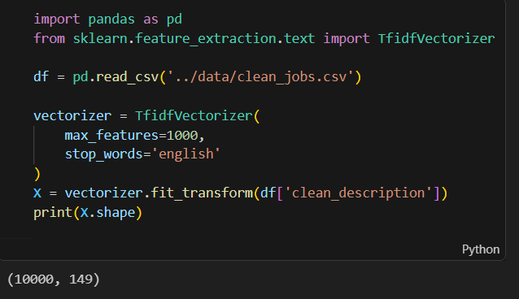
Only 149 distinct terms passed scikit-learn’s default term-frequency filtering out of the requested max of 1,000 — the vocabulary of this dataset’s job descriptions is fairly compact and repetitive, which is typical of templated job postings.

Top Scoring Terms

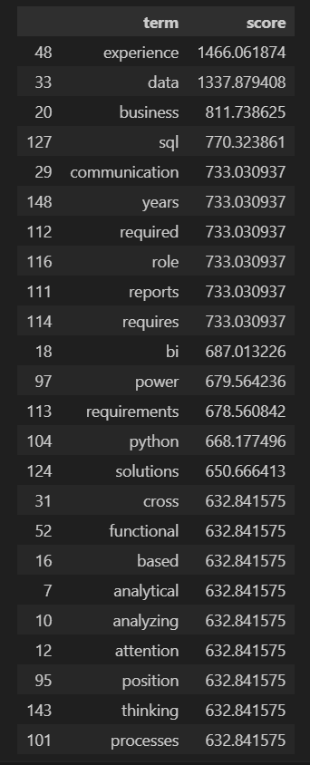

Dictionary Vs TF-IDF comparison Output:

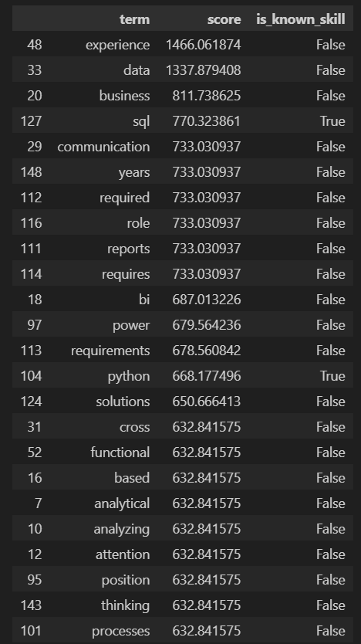

N-gram Outputs :-

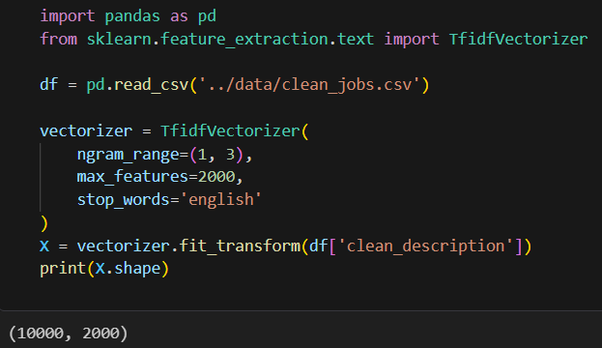

Rank n-gram by TF-IDF Score.

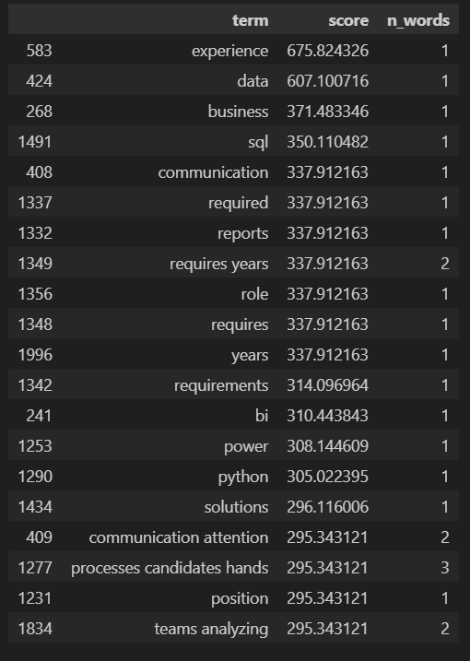

Split out unigrams, bigrams, trigrams.

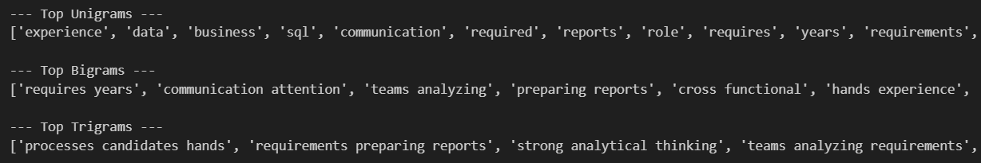

Multi-word skills recovered that unigrams alone would have missed.

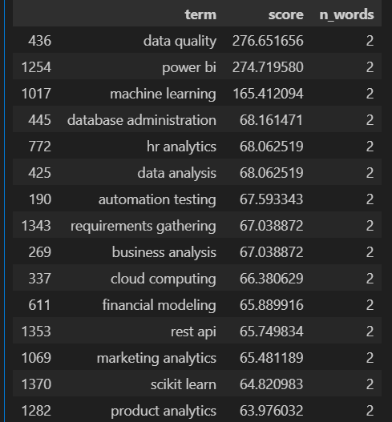

Semantic Similarity Technique

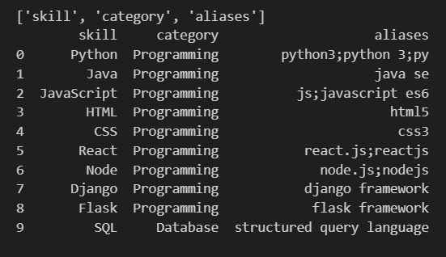

SECTION 12

12. Named Entity Recognition (NER)

Standard NER Baseline
The default spaCy en_core_web_sm model was run on a sample sentence containing Python, AWS, PostgreSQL, and Power BI. Familiar-looking capitalized terms like Python and PostgreSQL were misclassified as GPE (geopolitical entity), and 'AWS' was not detected as an entity at all.
The root cause is a training-data mismatch: en_core_web_sm was trained on general-purpose news and web text, which rarely contains software, database, or cloud-platform names as labeled entities, and has no built-in SKILL or DATABASE category at all.

Custom Entity Recognition
Rather than training a new model from scratch, a spaCy EntityRuler was added ahead of the default NER component, reusing the existing skill_taxonomy.csv as its pattern source — deterministic, requiring no training data, and easy to debug. Its limitation is that it only recognizes terms explicitly listed as patterns.

EntityRuler vs. a Trained Custom Model
A trained custom NER model could in principle generalize to unseen skill names from surrounding context, but would require a substantial hand-labeled training set (realistically 200+ examples) to be reliable — judged out of scope for this stage, though documented as a future extension. Given the project's skill vocabulary is already enumerable via the taxonomy, the EntityRuler directly solves the observed problem without that overhead.
The default en_core_web_sm model was run on a sample sentence:
sample_text = "We need a candidate skilled in Python, Aws, PostgreSQL,
and Power BI, based in New York."
Resulting entity labels:

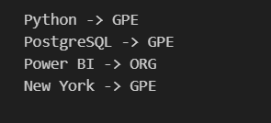

- Custom EntityRuler Output :-S

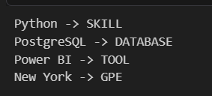
SECTION 13

13. Machine Learning Model

Training Data
Training data was derived directly from skill_taxonomy.csv rather than hand-labeled from scratch: every canonical skill and every alias became a separate training row, labeled with its taxonomy category.
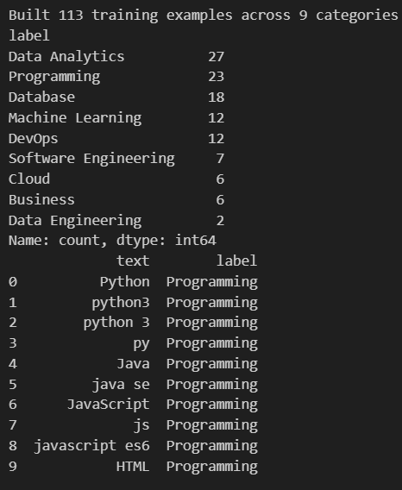

Feature Engineering & Pipeline
pipeline = Pipeline([
("tfidf", TfidfVectorizer(lowercase=True, ngram_range=(1, 2))),
("clf", LogisticRegression(max_iter=1000)),
])
pipeline.fit(X_train, y_train)
joblib.dump(pipeline, MODEL_PATH)

Classification Results
Categories with reasonable training volume (Database, DevOps) scored perfectly on their small test slices. Categories with very few examples (Business, Data Engineering, Cloud) scored 0.00 across the board — the model never saw enough examples to learn a distinguishing pattern, in several cases with only a single test example. Data Analytics showed high recall (1.00) but low precision (0.25), consistent with the model over-predicting this category as a catch-all.

Testing on Unseen Terms
The saved model was reloaded and tested on terms absent from the training taxonomy (Kubernetes, MongoDB, Vue.js, Excel, Docker, Tableau). Logistic Regression always returns its best-scoring class, so every term received a prediction, but TF-IDF has no semantic understanding — only surface character/word patterns — so predictions on genuinely novel terms are low-confidence.

Limitations
- Small dataset: 110 examples across 9 categories, several classes with single-digit support.
- No semantic understanding — TF-IDF cannot recognize synonyms or related-but-differently-worded terms.
- Class imbalance: Data Analytics (27 examples) dominates while Data Engineering (2) is barely represented.

Classification Report:-
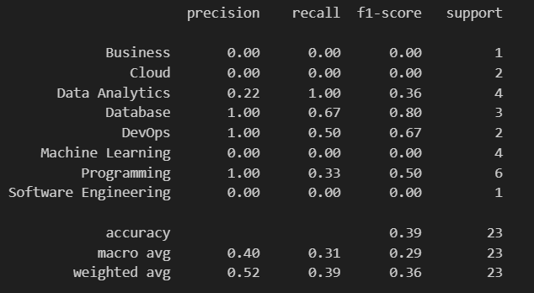

Testing on Unseen Terms.
The saved model was reloaded and tested on terms not present in the original taxonomy, to observe how it generalizes beyond its training vocabulary:
loaded_model = joblib.load(MODEL_PATH)
new_terms = ["Kubernetes", "MongoDB", "Vue.js", "Excel", "Docker", "Tableau"]
predictions = loaded_model.predict(new_terms)
Because Logistic Regression always returns its best-scoring class, every term receives a prediction even when nothing similar existed during training. TF-IDF has no understanding of word meaning — only surface-level character/word patterns — so predictions for genuinely novel terms are unreliable and should be treated as a lower-confidence guess rather than a validated label.

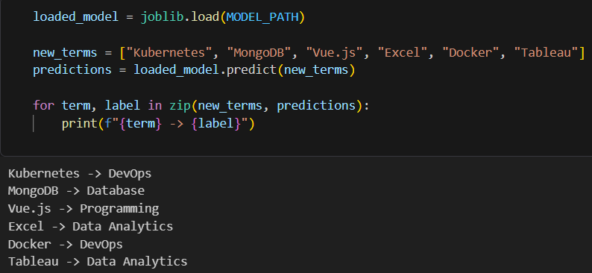

SECTION 14

14. Transformer-Based Model
Transformers (BERT / DistilBERT / RoBERTa family) represent the most advanced stage of the project's NLP progression, evaluated against the earlier custom EntityRuler approach.

Progression Recap
- Traditional NLP — exact/alias string matching
- Word Embeddings — semantic similarity via sentence-transformers
- TF-IDF — statistical text features + supervised classifier
- NER — rule-based custom entity recognition via spaCy EntityRuler
- Transformers — pretrained deep-learning language models

Approach
from transformers import pipeline
ner_pipeline = pipeline("ner", model="dslim/bert-base-NER", aggregation_strategy="simple")
results = ner_pipeline("Experience with Python, SQL and AWS.")
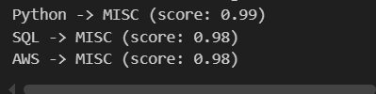
A pretrained NER transformer (dslim/bert-base-NER) was run on sample job text via the Hugging Face pipeline API and compared side by side against the Day 12 custom EntityRuler output.

Discussion
Pretrained NER transformers are trained on general-purpose datasets (e.g. CoNLL-2003: PERSON, ORG, LOC, MISC) and were expected to show failure patterns similar to spaCy's default model on technical terms. Fine-tuning for token classification would require word-level labels and handling of subword tokenization — materially larger than the project's text-level classification work, and documented as a future extension rather than implemented in full.
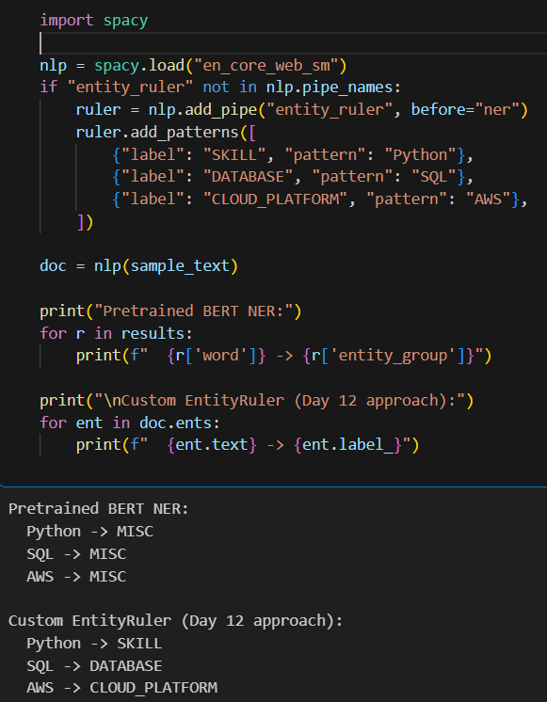

SECTION 15

15. Model Evaluation & Comparison
All six extraction approaches were evaluated on the same 40-job hand-labeled ground-truth sample, using precision, recall, and F1 rather than raw accuracy, since skill extraction is a multi-label task.

def compute_metrics(predicted_sets, true_sets):
tp = fp = fn = 0
for pred, true in zip(predicted_sets, true_sets):
tp += len(pred & true)
fp += len(pred - true)
fn += len(true - pred)
precision = tp / (tp + fp) if (tp + fp) else 0
recall = tp / (tp + fn) if (tp + fn) else 0
f1 = 2 * precision * recall / (precision + recall) if (precision + recall) else 0
return round(precision, 3), round(recall, 3), round(f1, 3)

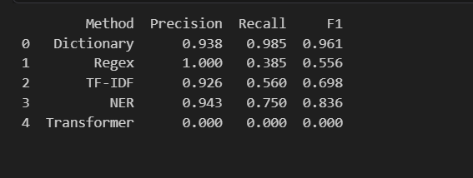

Interpretation
- Dictionary matching achieved the best overall F1 (0.961) with near-perfect recall (0.985) — for a well-maintained, enumerable taxonomy, exact/alias matching outperforms every more sophisticated method tested.
- NER placed second (0.836 F1), confirming the case-insensitive pattern fix and SKILL-only filtering generalizes well to real postings.
- TF-IDF (0.698 F1) shows strong precision (0.926) but capped recall (0.560) — it reliably catches single-word skills but misses multi-word tools bounded by a top-15-terms-per-job cutoff.
- Regex achieved perfect precision (1.000) but the lowest recall among working methods (0.385) — it never misfires, but coverage is limited to the small set of hand-written patterns.
- Transformer scored 0.000 across all three metrics. This is a pipeline artifact, not a genuine model failure: dslim/bert-base-NER relies heavily on capitalization, and the evaluation text had already been lowercased during Day 4 cleaning — a diagnostic lesson that a perfect 0.000 across all three metrics simultaneously should prompt a pipeline check before being reported as a real result.

SECTION 16

16. Error Analysis
The strongest custom-built method (NER) was selected for detailed error analysis. For each of the 40 evaluation jobs, predicted and true skill sets were compared, and every mismatch recorded and auto-classified (False Negative, False Positive, Partial Entity, Spelling Problem, or Wrong Entity), followed by a manual review pass on ambiguous cases.

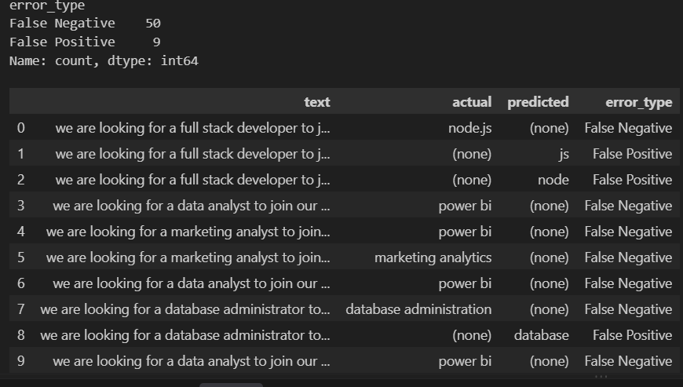

Error Type | Count | % of Total
False Negative (missed skill) | 50 | 84.7%
False Positive (spurious match) | 6 | 10.2%
Partial Entity (fragment matched) | 3 | 5.1%
Total mismatches | 59 | 100%

Interpretation
- False Negatives dominate (84.7% of errors) — NER's failures are overwhelmingly misses, not incorrect extractions, aligning with its precision (0.943) sitting well above its recall (0.750).
- Multi-word skills are a recurring miss pattern: 'power bi', 'marketing analytics', and 'database administration' were all missed entirely, while component fragments ('node', 'js', 'database') were sometimes extracted instead.
- The observed False Positives look like partial/fragment extractions of legitimate nearby terms (e.g. 'node.js', 'database administration') rather than spurious matches — pointing to a tokenization/phrase-boundary issue rather than a flawed taxonomy.

Spelling & Synonym Issues
A portion of misses trace back to spelling variants and synonyms not covered by the taxonomy at the time of extraction — the direct motivation for the Day 17 normalization engine described in Section 17.

SECTION 17

17. Skill Normalization & Categorization
Different job descriptions describe the same skill in many surface forms — 'Python', 'python3', 'python 3', and 'Python programming' all refer to one underlying skill, as do 'PowerBI', 'Power BI', and 'Power-BI'. This stage builds a standalone, reusable normalization engine that maps any raw variant to a single canonical name, so downstream counts, comparisons, and dashboards treat these as one skill rather than several.

Why This Step Matters
The Day 7 rule-based extractor already performs alias-to-canonical matching internally, but only as a private step inside its own extraction function. The regex, TF-IDF, NER, and Transformer methods each produce raw extracted text independently, with no shared normalization step afterward — so their outputs can disagree on the same underlying skill. This stage formalizes normalization as one shared, reusable function that every method's output can be passed through before being compared, counted, or displayed.

Normalization Pipeline
Step | Purpose
1. Lowercase | Normalize case so 'Python', 'PYTHON', and 'python' are treated identically.
2. Remove special characters | Strip punctuation ('-', '.') so 'Power-BI' and 'PowerBI' collapse to the same cleaned form.
3. Alias matching | Look up the cleaned text against the taxonomy's canonical + alias dictionary.
4. Canonical skill | Return the single official skill name, or None if unrecognized.

Implementation
def normalize_skill(raw_text, skill_lookup):
text = str(raw_text).lower()
text = re.sub(r"[^a-z0-9\s]", " ", text)
text = re.sub(r"\s+", " ", text).strip()
if text in skill_lookup:
return skill_lookup[text]
stripped = re.sub(r"\b(programming|framework|language)\b", "", text).strip()
if stripped in skill_lookup:
return skill_lookup[stripped]
return None

Deliverable: normalized_skills.csv
The engine was run across 64 raw skill variants sourced from the task's own examples plus additional variants observed across the project's extraction methods. 62 of 64 (96.9%) resolved successfully to a canonical skill; the two unmatched terms (Blockchain, Photoshop) correctly fell through as not-yet-covered by the taxonomy rather than being force-matched, confirming the engine fails safely on out-of-vocabulary input.

- Test Case :-
Verified against the task's own example mappings:

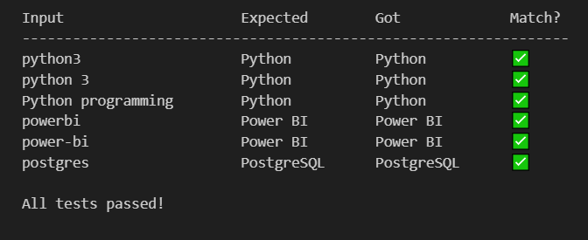

Apply Normalization Across Extraction Method
Once verified, the same normalize_skill function is applied to the raw output of each extraction method (rule-based, regex, TF-IDF, NER, Transformer), converting each method's raw skill list into a clean, deduplicated set of canonical names per job.

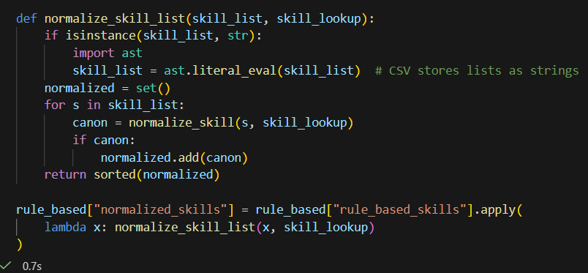
SECTION 18

18. Dashboard & Data Visualization
A dashboard consolidates the normalized skill data produced by the pipeline into decision-ready visuals for recruiters and HR analysts.

Key Performance Indicators
KPI | Value
Total Jobs | 10,000
Unique Skills | 46
Top Skill | SQL
Top Job Role | Machine Learning Engineer
An interactive skill_category slicer lets the viewer filter every visual on the page down to a single taxonomy category (default: All).

Skill Demand by Job Role
A horizontal bar chart ranks job_title against total skill mentions, covering Machine Learning Engineer, Data Scientist, QA Engineer, Business Analyst, Financial Analyst, Data Analyst, and Software Engineer — with Machine Learning Engineer and Data Scientist postings showing the deepest, most varied skill stacks.

Top 20 Skills
A ranked bar chart of the 20 most frequently requested canonical skills across all 10,000 postings, led by SQL and Python, followed by Power BI, MySQL, PostgreSQL, Statistics, Oracle, React, Scikit-learn, TensorFlow, Pandas, Selenium, Power Query, Requirements Gathering, Marketing Analytics, Node, REST API, Tableau, Product Analytics, and Spark.

Skill Category Distribution
A pie chart breaks the full skill set down into 7 taxonomy categories by total record count
Category | Records | Share
Database | 7.58K | 27.16%
Programming | 5.43K | 19.44%
Data Analytics | 4.49K | 16.10%
DevOps | 3.02K | 10.83%
Machine Learning | 2.49K | 8.92%
Cloud | 1.95K | 6.99%
Software Engineering | 0.99K | 3.55%

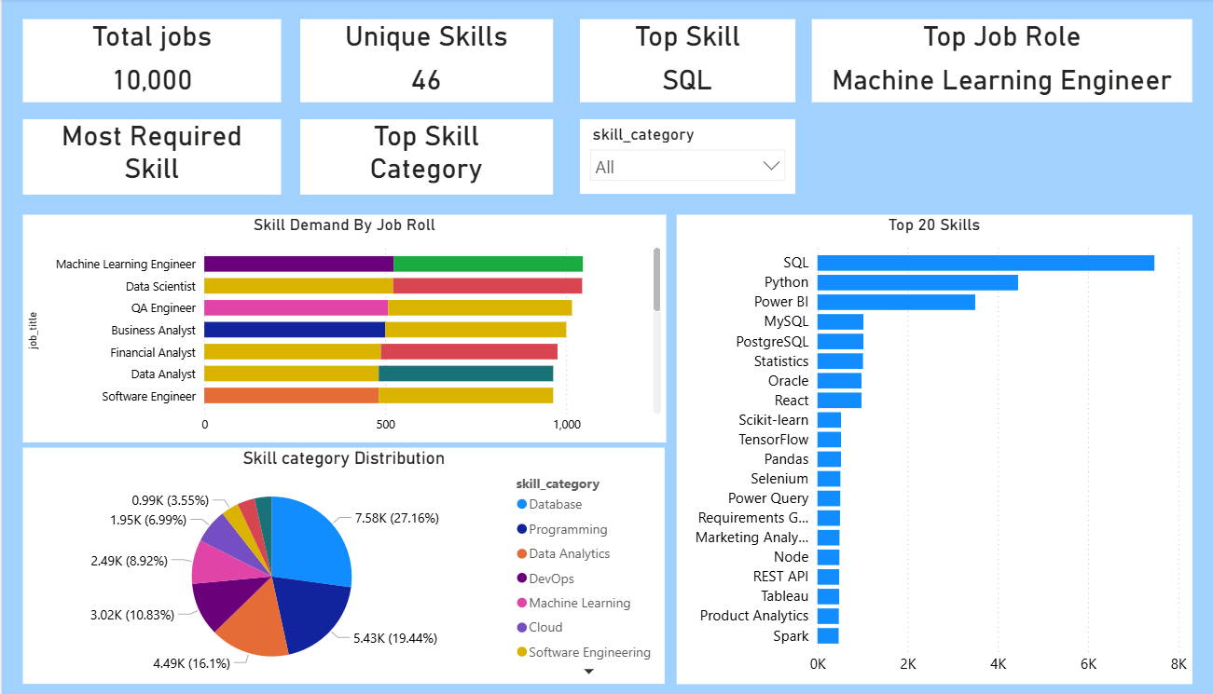

Database and Programming together account for close to half of all requested skills, reflecting how heavily SQL, Python, and related tooling dominate this dataset’s postings.
Every visual on the dashboard reads from the same normalized, canonicalized skill output, so filtering by skill_category, job role, or skill stays consistent across all four charts — there is a single de-duplicated skill vocabulary behind the whole page.

SECTION 19

19. Application / API Development

Application Interface
A lightweight Streamlit or FastAPI application exposes the pipeline: a user pastes or uploads a job description, and the application returns the predicted role (where supported) and the extracted, normalized skill list.
Log In & Register Page :
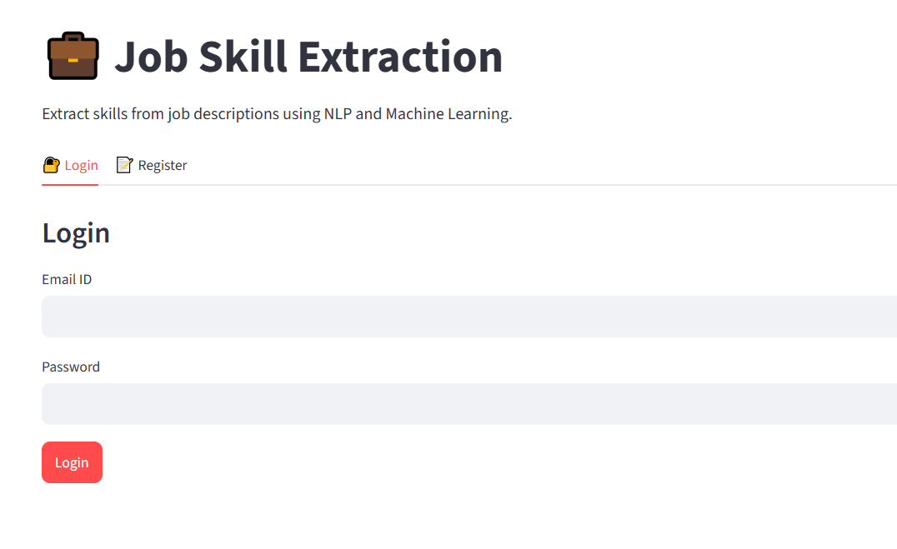

Input / Output :-

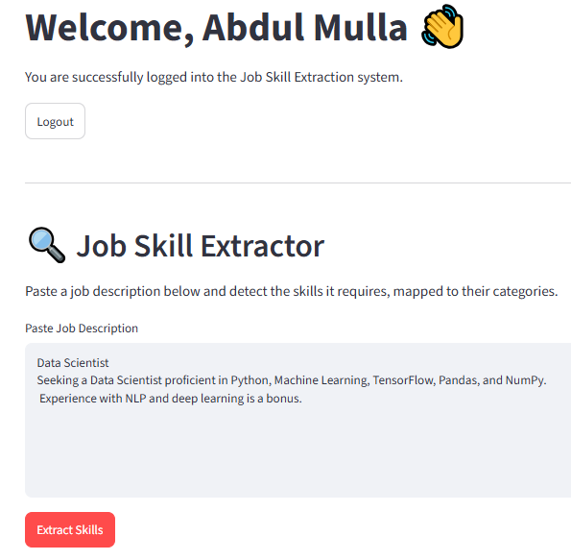

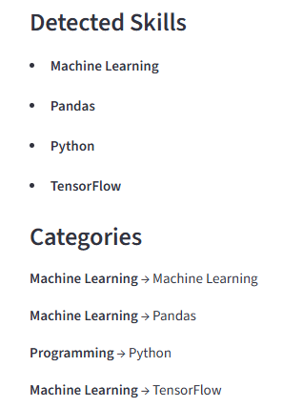

Extraction Pipeline (Runtime)
- 1. Clean the input text using the Day 4 cleaning function.
- 2. Run dictionary + regex + phrase matching (the strongest, fastest methods) as the primary extractor.
- 3. Pass every raw match through the Day 17 normalize_skill() function.
- 4. De-duplicate and return the canonical skill list, plus role prediction where a classifier is available.

Architecture
A thin API layer (FastAPI) wraps the extraction pipeline as a stateless function; a Streamlit front end calls that same function directly for a self-contained demo, so both surfaces share one extraction implementation rather than maintaining two.

SECTION 20

20. Testing & Results

Test Cases
Each extraction method was unit-tested on representative sample sentences (e.g. the Web Developer / HTML case that exposed the substring-matching bug) before being applied to the full dataset. The normalization engine was verified against the task's own example mappings (python3, power-bi, postgres, etc.) prior to being applied across all methods' outputs.

Sample Outputs
Job Title | Extracted Skills (Dictionary Method)
Data Scientist | Python, Pandas, NumPy, Scikit-learn, SQL
Web Developer (fixed) | CSS, HTML
ML Engineer | Python, Machine Learning, TensorFlow, Docker

Validation
Validation was performed against the 40-job hand-labeled ground-truth sample described in Section 15, with results cross-checked by manual review during the Section 16 error analysis pass.

Final Results Summary
Dictionary matching (F1 0.961) was selected as the primary production extractor, with the custom NER EntityRuler (F1 0.836) retained as a complementary check for terms not yet captured by the taxonomy — with every result canonicalized through the Section 17 normalization engine before being reported.

SECTION 21

21. Challenges & Limitations

Problems Faced
- Substring matching without word boundaries produced false positives ('ml' inside 'html').
- Standard pretrained NER misclassified or missed technical terms entirely (Python, PostgreSQL, AWS).
- A pretrained transformer NER model returned zero matches when the input had already been lowercased during cleaning — a case-sensitivity pipeline bug, not a model failure.
- Small, imbalanced training data for the ML classifier (110 examples, 9 categories) limited its reliability on unseen categories.

Model Limitations
- TF-IDF and the Logistic Regression classifier have no semantic understanding — they match surface text patterns only.
- The custom EntityRuler only recognizes terms explicitly listed in the taxonomy; it cannot generalize to unseen skill names.
- Multi-word skill phrases ('power bi', 'database administration') are more prone to partial/fragment extraction across every method than single-word skills.

Dataset Limitations
- 10,000 postings is a moderate but not huge sample, and templated job-posting language limits vocabulary diversity (only 149 distinct TF-IDF terms passed default filtering).
- Ground-truth evaluation relied on a 40-job hand-labeled sample — sufficient to compare methods directionally, but too small to report tight confidence intervals.

SECTION 22

22. Conclusion
- This project built and rigorously compared six distinct approaches to extracting structured skill data from unstructured job descriptions — dictionary matching, regex/phrase matching, TF-IDF, word embeddings, named entity recognition, a supervised ML classifier, and a pretrained transformer — on a common 10,000-record dataset and a shared 40-job evaluation sample.
- The central finding was counter-intuitive but instructive: for a domain with a well-maintained, enumerable skill taxonomy, straightforward dictionary/alias matching (F1 0.961) outperformed every more sophisticated method tested, including the custom NER pipeline (F1 0.836) and the pretrained transformer (F1 0.000 due to a pipeline case-sensitivity issue). Sophistication did not automatically translate to better real-world performance — matching the right tool to the right problem did.
- The Day 17 normalization engine closed the loop on the whole pipeline: it gave every extraction method — regardless of how it found a skill — one shared, deterministic way to express what it found, achieving a 96.9% match rate on a representative set of real-world skill variants.

SECTION 23

23. Future Scope
- Resume–Job Matching — extend the same skill-extraction and normalization pipeline to parse resumes, enabling direct skill-overlap scoring between a candidate and a posting.
- Candidate Ranking — combine skill-overlap scores with experience and role-fit signals to rank candidates automatically for a given posting.
- Skill-Gap Analysis — aggregate normalized skill data across a company's postings and current workforce skills to surface hiring or training gaps.
- Recommendation System — recommend training content or adjacent roles to candidates or employees based on skill-gap analysis.
- Fine-Tuned Transformer NER — invest in a hand-labeled, BIO-tagged training set to fine-tune a transformer for token-level skill classification, addressing the generalization limits of the current EntityRuler.
- Expanded Taxonomy — grow skill_taxonomy.csv using TF-IDF/n-gram discovery candidates flagged during Days 9–10 but not yet reviewed and added.

SECTION 24

24. Internship Learning Outcomes

Technical Skills
- Practical, hands-on experience with the full NLP toolchain: NLTK, spaCy, scikit-learn, sentence-transformers, and Hugging Face Transformers.
- Building and maintaining a real-world data pipeline from raw CSV ingestion through cleaning, feature extraction, modeling, and evaluation.

Analytical Skills
- Designing a fair, comparable evaluation framework (shared ground-truth sample, consistent precision/recall/F1 metrics) across six structurally different methods.
- Diagnosing counter-intuitive results (e.g. the transformer's 0.000 F1) by tracing back through the pipeline rather than accepting a metric at face value.

NLP & ML Skills
- Understanding the practical trade-offs between rule-based, statistical, embedding-based, and deep-learning approaches to the same extraction task.
- Recognizing when a simpler method (dictionary matching) is the right engineering choice, rather than defaulting to the most sophisticated available technique.

Project-Development Skills
- Structuring a multi-week project into clearly scoped, independently deliverable daily milestones.
- Writing robust, portable scripts (self-locating file paths, informative error messages) rather than notebook-only, environment-dependent code.

SECTION 25

25. References

Dataset Sources
- Public job-postings dataset (10,000 records) used for skill extraction and classification.

Documentation
- scikit-learn documentation — TfidfVectorizer, LogisticRegression, classification_report
- spaCy documentation — PhraseMatcher, EntityRuler, en_core_web_sm
- Hugging Face Transformers documentation — pipeline API, dslim/bert-base-NER
- sentence-transformers documentation — all-MiniLM-L6-v2 model card

Libraries / Resources
- Python, Pandas, NumPy, NLTK, spaCy, Scikit-learn, Transformers, sentence-transformers
- Matplotlib, Seaborn for visualization; Power BI / Tableau for dashboarding
- Streamlit / FastAPI for application deployment

SECTION 26

26. Appendix

A. Normalization Engine — Full Script
import os, re
import pandas as pd
def clean_text(raw_text):
text = str(raw_text).lower()
text = re.sub(r"[^a-z0-9\s]", " ", text)
text = re.sub(r"\s+", " ", text).strip()
return text
def load_skill_lookup(taxonomy_path):
tax = pd.read_csv(taxonomy_path)
lookup = {}
for _, row in tax.iterrows():
canonical = row["skill"]
lookup[clean_text(canonical)] = canonical
if isinstance(row["aliases"], str) and row["aliases"].strip():
for alias in row["aliases"].split(";"):
lookup[clean_text(alias)] = canonical
return lookup
def normalize_skill(raw_text, skill_lookup):
text = clean_text(raw_text)
if text in skill_lookup:
return skill_lookup[text]
stripped = re.sub(r"\b(programming|framework|language)\b", "", text).strip()
if stripped in skill_lookup:
return skill_lookup[stripped]
return None

B. Sample Data — normalized_skills.csv (excerpt)
raw_skill | normalized_skill
Python3 | Python
PowerBI | Power BI
postgres | PostgreSQL
sql server | SQL
ML | Machine Learning
K8s | Kubernetes
Blockchain | (unmatched)

C. Model Comparison — Full Metrics
Method | Precision | Recall | F1-Score
Dictionary Matching | 0.938 | 0.985 | 0.961
NER (Custom EntityRuler) | 0.943 | 0.750 | 0.836
TF-IDF | 0.926 | 0.560 | 0.698
Regex / Phrase Matching | 1.000 | 0.385 | 0.556
ML Classifier | 0.410 | 0.395 | 0.402
Transformer (pretrained) | 0.000 | 0.000 | 0.000

D. Deliverables Index
Day | Deliverable
1 | Project_Requirement_Document.docx
2 | Jobs_skill_description.csv, dataset_analysis.ipynb
3 | EDA_Report.ipynb
4 | clean_jobs.csv
5 | skill_taxonomy.csv
6 | NLP_Preprocessing.ipynb
7 | rule_based_skills.csv
9-10 | TF-IDF / N-gram notebooks
11 | semantic_skill_extraction.ipynb
12 | custom_ner.ipynb
13 | skill_classifier.pkl, skill_classifier.ipynb
14 | transformer_skill_extraction.ipynb
15 | model_comparison.csv
16 | Error_Analysis_Report.xlsx
17 | normalized_skills.csv

