TUIT

Group: 214-19

Student: Abdumajid Rashidov

Independed work - 1.

**Develop a web based mapping using QGIS and Geoserver**

Install QGIS

Download and install the latest version of QGIS from the official website (<https://qgis.org/en/site/forusers/download.html> ).

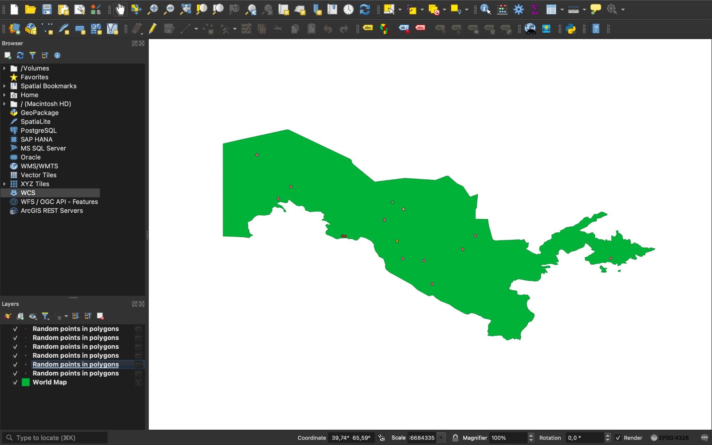

Once the installation is complete, launch QGIS and create a new project.

Load the data

To load the data, click on the "Add Layer" button located on the left-hand side of the screen.

Choose the appropriate data source from the drop-down menu (e.g., Shapefile, GeoJSON, etc.).

Browse and select the file you wish to load.

Once the data is loaded, it will be displayed in the map view.

Set the map projection

To set the map projection, click on the "Project" menu located at the top of the screen.

Choose "Project Properties" from the drop-down menu.

In the "Coordinate Reference System" tab, select the appropriate projection for your map (e.g., WGS 84, UTM, etc.).

Style the data

To style the data, right-click on the layer in the "Layers" panel and choose "Properties" from the drop-down menu.

In the "Symbology" tab, select the appropriate style for your data (e.g., categorized, graduated, etc.).

Adjust the settings as needed to achieve the desired result.

Publish the data to Geoserver

To publish the data to Geoserver, click on the "Web" menu located at the top of the screen.

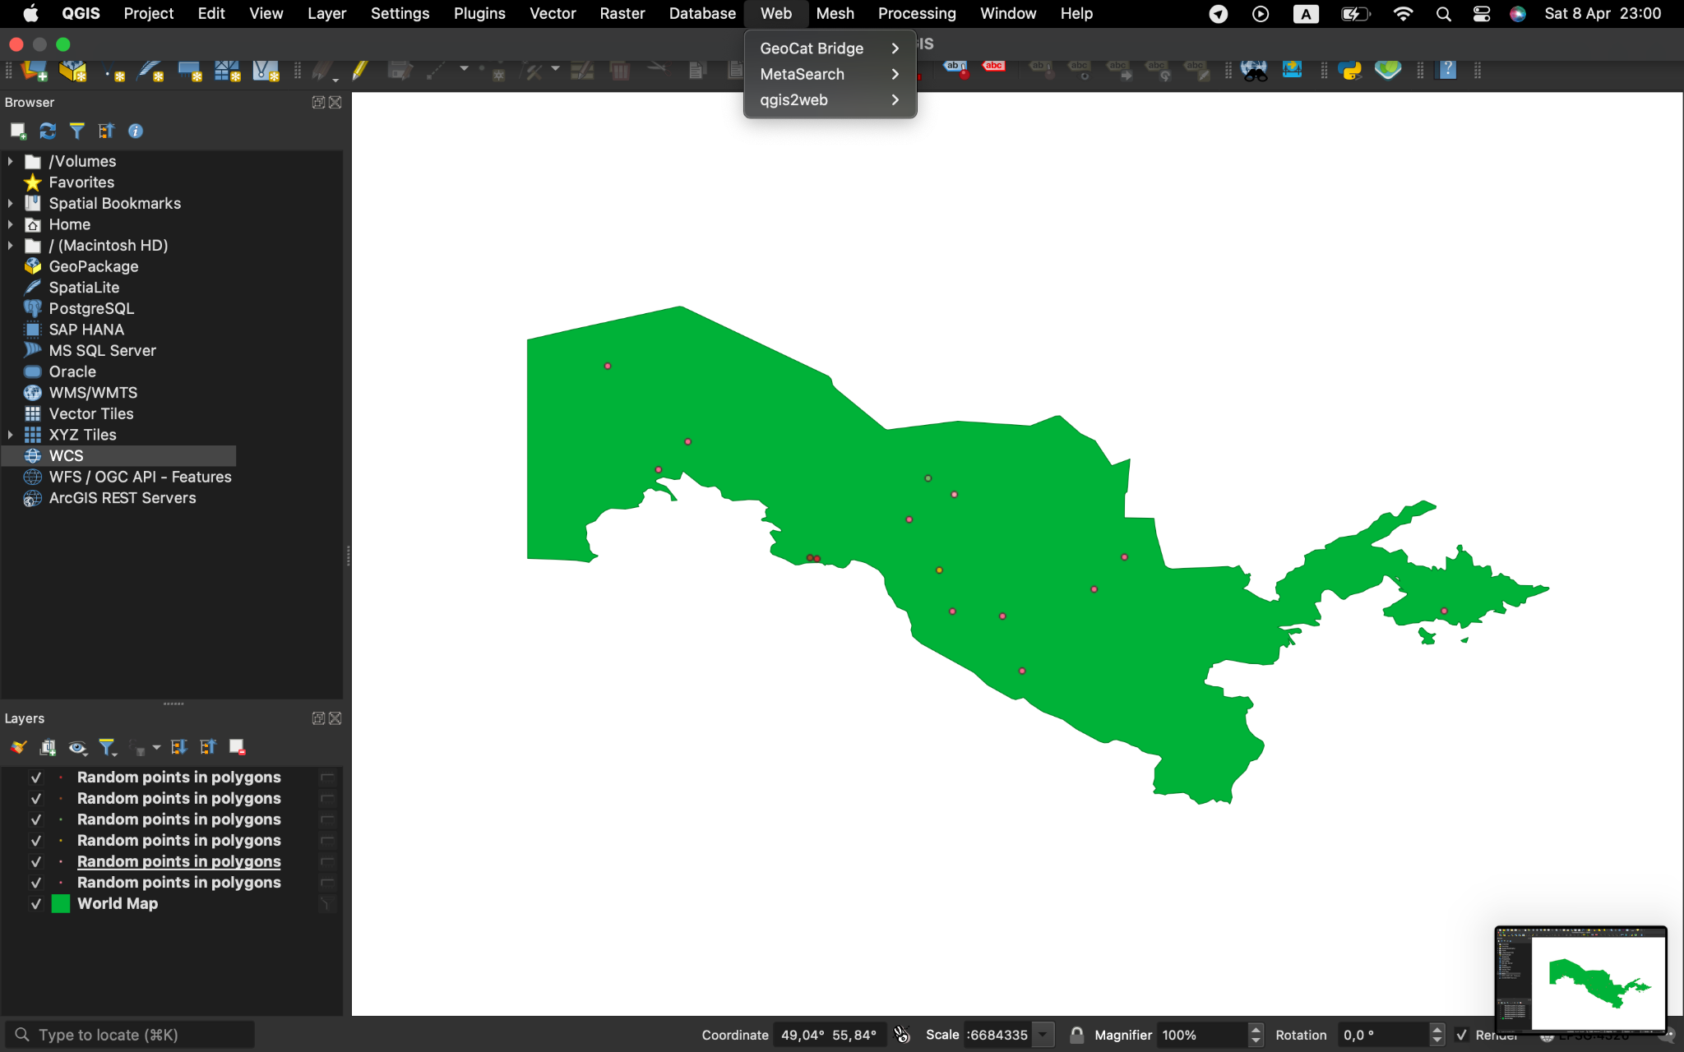

Choose "Publish to Geoserver" from the drop-down menu.

Enter the appropriate Geoserver connection details (e.g., server URL, username, password).

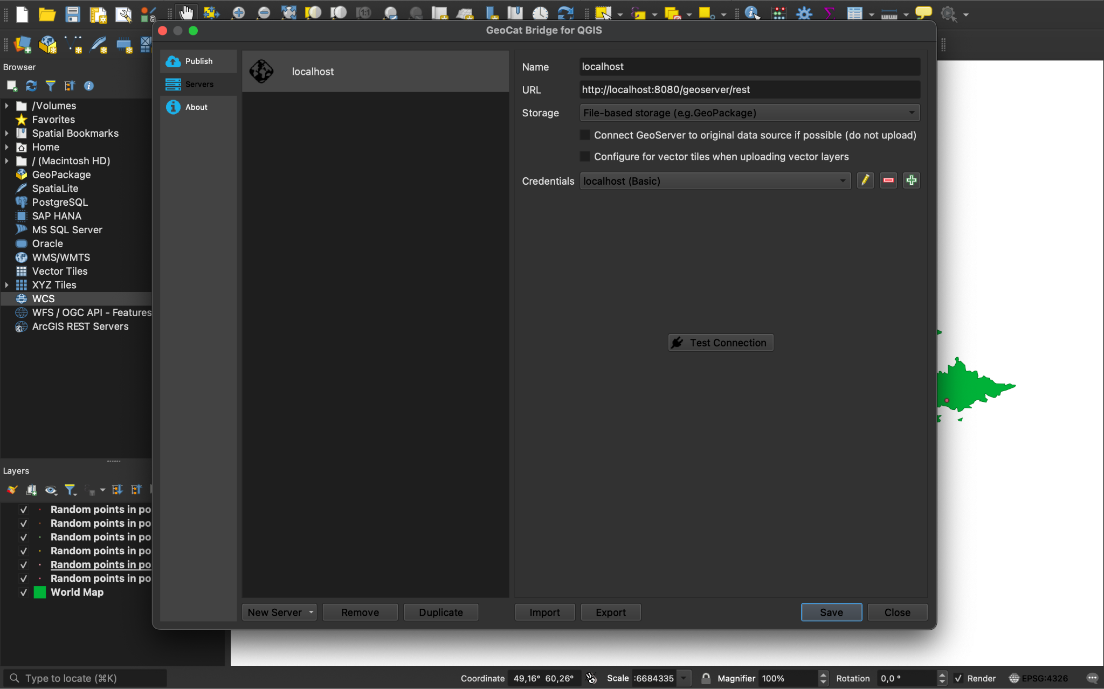

Choose the appropriate Geoserver workspace and store for your data.

Click "Publish" to upload the data to Geoserver.

Create a web map using Geoserver

To create a web map using Geoserver, open your web browser and navigate to the Geoserver web interface (e.g.)

<http://localhost:8080/geoserver/web>).

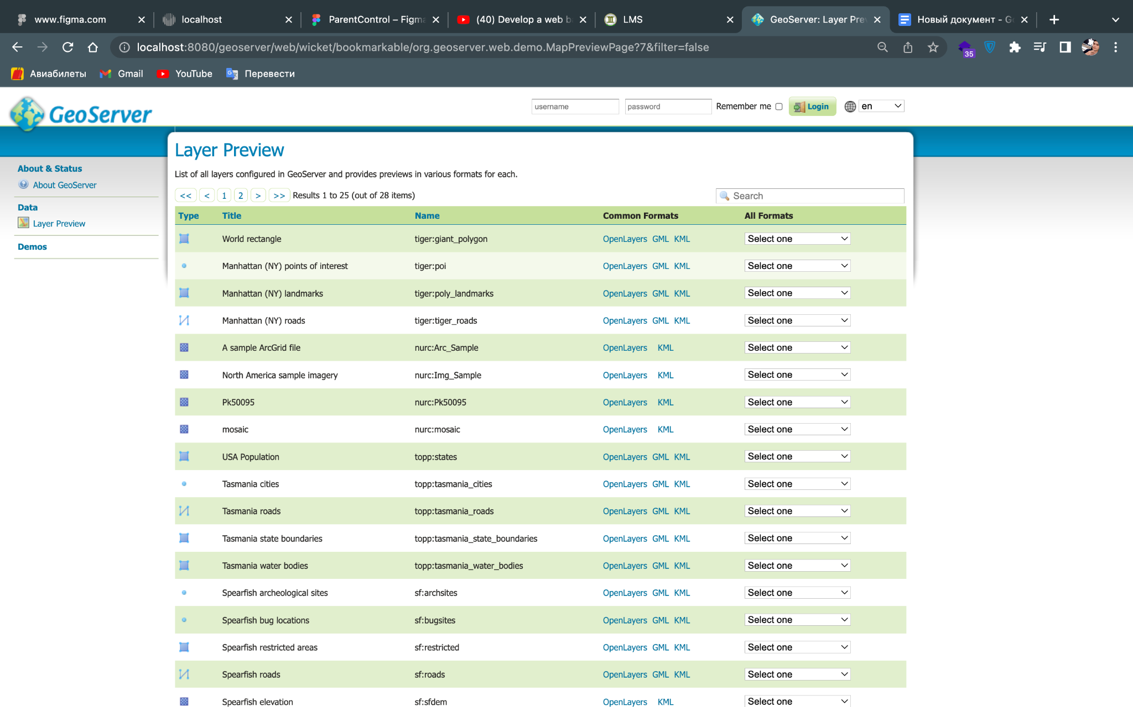

Click on the "Layers" menu located at the top of the screen.

Choose the appropriate layer you wish to include in your web map.

Click on the "OpenLayers" link located on the right-hand side of the screen.

Adjust the settings as needed to achieve the desired result.

Click "Generate Preview" to preview the web map.

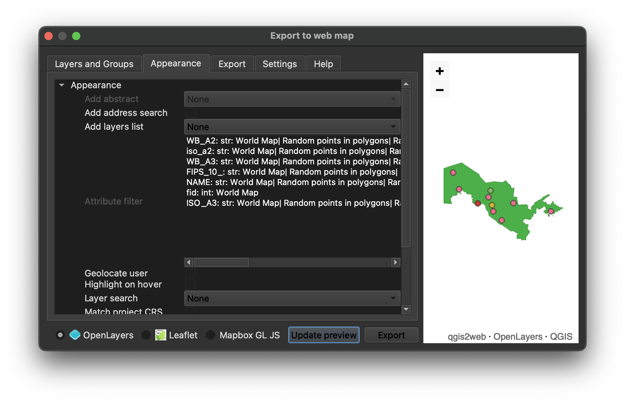

Embed the web map in your website

To embed the web map in your website, copy the HTML code provided by Geoserver.



Paste the HTML code into your website where you wish to display the map.

Adjust the settings as needed to achieve the desired result.

That's it! You have successfully developed a web-based mapping using QGIS and Geoserver.

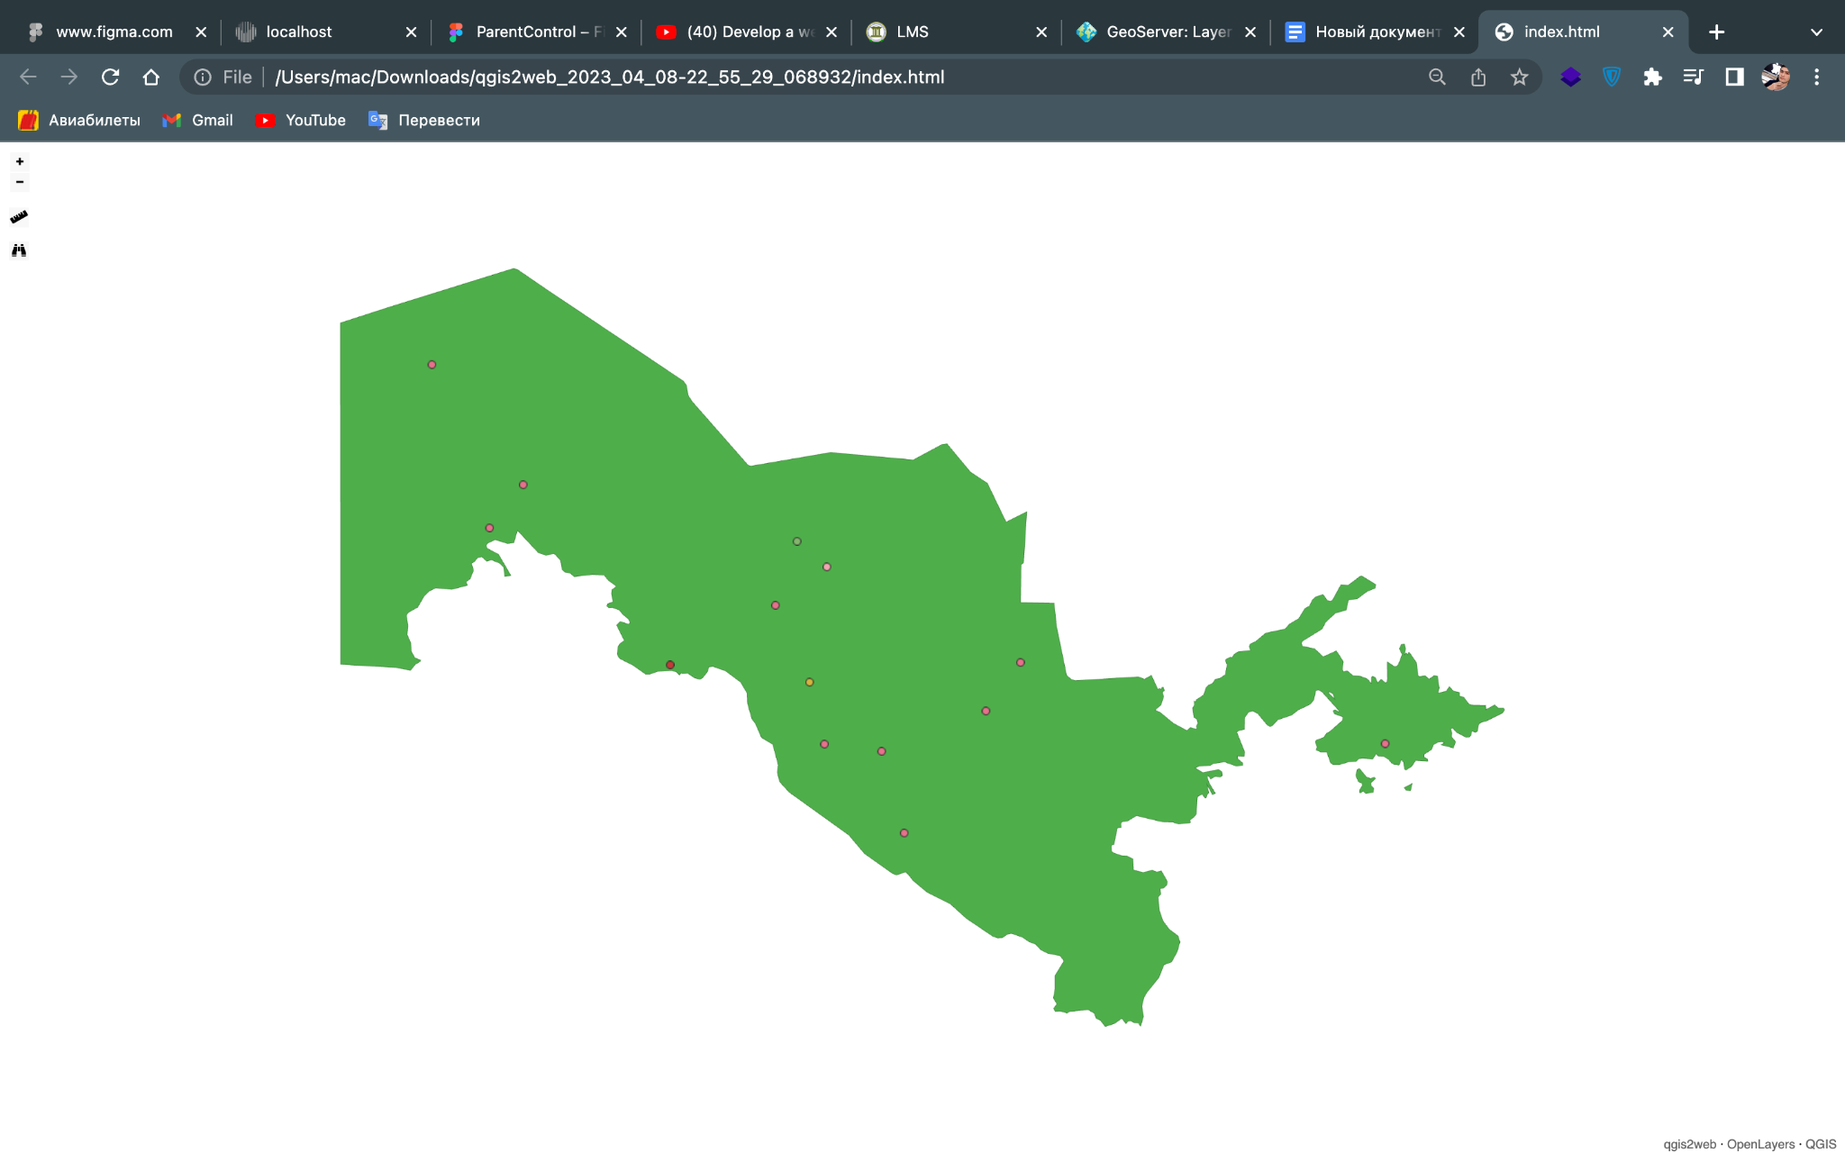

And you can see web version on this link below and my github repo:

<https://github.com/AbdumajidRashidov/geoserver>

<https://geoserver-uz.netlify.app/>