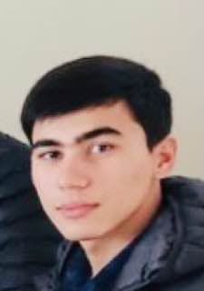 |  | Ermatov Abdumalik  Junior full-stack web developer
About me  Hello. I am Abdumalik Ermatov. I was born in 04.06.2004. I live in Uzbekistan. I am a student of KSPI. I am in first grade. I have finished special courses in web-programming. I have enough knowledge with : HTML , CSS , BOOTSTRAP, PHP, GIT, LARAVEL, JS, VueJS, MYSQL . I did some small projects.  Connect with me by:  Contact number:  +998913241772  Email adress:  ermatovabdumalik5@gmail.com  Hobbies  Learning new languages  Writing codes  Traveling |  | Education  Kokand State Pedogogical Institute  09/2021 — 06/2025  I am student of KSPI. Faculty is “Foreign languages”.  Skills  - Excellent written and verbal communication skills in russian and in english languages. I have an IELTS sertificate (overall 6.0).  - Ability to work independently  - Ability to control the teams  Knowledge

