Electronic Medical Record System
Note: All information must be reflected from the Consultant Dashboard to the EMR. Only in specific cases (mentioned where needed in this document), additional forms may be added directly in the EMR. However, nothing should be editable—only new forms can be added. All other data must be strictly reflected from the Consultant Dashboard without modification.

LOGIN PAGE AND AUTHENTICATION
- Username, Password fields, Login button
- Below login: Two text links: Disclaimer, Privacy Policy
- Source Files Provided for SMAART Healthcare: Templates of disclaimer and privacy policy [1]
- (Login credentials to be created only by Super Master Admin or Super Admin via Admin Panel → User Management → Create New User)

- User table with fields: user_id, password
- Auto-logout timer: 10 minutes (set via session timeout or token expiry)

Login and Type need to be given by admin based on the role
1. Login & Role-Based Access

Role Classification (from Super Master Admin Panel)
- Super Master Admin (Main SMAART HQ)
Required fields for user creation from super master admin dashboard:
- Full Name
- Email
- Staff ID
- Temporary Password (auto-generated or entered manually)
- Assigned Role (dropdown selector)
  - Department Admin (Gen Med, Physiotherapy, Minds, Eyes, Pharmacy, Metabolism)
  - Consultant
  - Nurse
  - Billing Staff
  - Pharmacy
- Department (dropdown, optional based on role)
- Mode of Access (Read / Write / Restricted)

- Super Admin (Partners)
Required fields for partner creation (Super Admin):
- Clinic/Hospital name
- Email
- Hospital ID
- Temporary Password (auto-generated or entered manually)
- Assigned Role (Super admin (Partner)
- Mode of Access (Read / Write / Restricted)

- Department Admin
- Consultant
- Front Desk/Billing (no access to patient medical records, only billing details and can able to raise or create invoice)
- Pharmacy
- Nurse/Assistant
- Telehealth Support
- Relationship Associate

POST-LOGIN REDIRECT & ROLE-BASED SETUP

Step-by-Step
- After login → Redirect to role check
- Role-specific UI loaded
- User selects Clinic and Department from dropdown
  - SMAART Gen Med, SMAART Physiotherapy, SMAART Eyes, SMAART Minds, SMAART Metabolism, SMAART Pharmacy
  - Note: Whatever services we add in the future, they need to be added here as well.
- Based on role and department, restrict navigation and data fetch
- Consultant can only see patients assigned to their department
After logging in, the page information setup should be as follows:
Role-Based Navigation: (need to access only the desired patients)
- Department Selection on Login:
  - Example:
    - Clinic Name: SMAART Healthcare and partner names list that need to be scrolled
    - Select Specialty:
      - SMAART Physiotherapy
      - SMAART Minds
      - SMAART Metabolism
      - SMAART Eyes
      - SMAART Pharmacy
      - SMAART GP
      - SMAART Cardio
      - SMAART Ortho
      - SMAART Neuro
      - Relationship Manager
  - Consultant can only see patients assigned to their department
2. Dashboard (Department-Specific)
- Department Overview: Active Patients, Upcoming Appointments, Pending Documentation
When a user logs in, they first select their department (SMAART Gen Med, SMAART Physiotherapy, SMAART Minds, SMAART Metabolism, SMAART Eyes, SMAART Pharmacy).
The dashboard then displays an overview of:
- Active Assigned Patients: Total number of their assigned patients currently undergoing treatment in that department.
- Upcoming Appointments: A list of upcoming sessions scheduled for that consultant or department.
- Pending Documentation: Alerts for incomplete patient records, SOAP notes, or progress reports.
- Mode of Treatment: In-Person, Virtual, Hybrid, Home Care (count need to be visible and can able to sort using this)

3. Patient Tab – Overview
Overall Patients Tab View (Need to extract from user and consultant dashboard)
S.No | Department | Total No. of Patients | visited on
1 | Physiotherapy | 123 | 12-Sep-2024
2 | Minds | 456 | 14-Sep-2024
3 | Eyes | 789 | 15-Sep-2024
4 | Pharmacy | 93484 | 16-Sep-2024
5 | Minds | 885 | 17-Sep-2024
6 | Eyes | 4545 | 17-Sep-2024
- Sortable by: Department, Last Visit Date, Mode of Treatment
- Filter by: Virtual, In-person, Referral Source
- Additional Sorting Requirement:
  - Mode of Treatment should be shown as grouped counts (e.g., Total In-person: 23, Virtual: 17, Home Care: 6, Hybrid: 12)
  - If viewing by department, sort should allow: Department → Mode of Treatment → Patient Count
  - UI: Toggle or dropdown to switch between summary view and detailed patient view
  - Backend should support query to fetch treatment mode count per department
  - Visual Tag: Color-coded pill indicator next to each mode (e.g., Blue = In-person, Green = Virtual, Yellow = Hybrid, Red = Home Care)

Analytics & Reports
- Reports filtered by:
  - Number of patients handled or referred
  - Successful return-to-care percentage
  - Drop-out rate
  - Referral source efficiency
Individual Patient Tab: (Need to extract from user and consultant dashboard)
- Patient Profile (Basic Demographics with UHID & Contact Information)
- Case Logs (Departmental Check-Ins, Investigations, Payments)
- Diagnosis History (Multi-Departmental Clinical Assessments)
- Investigation History (Lab Tests, Imaging, and Reports)
Source Provided from SMAART Healthcare: Normative values of tests with traffic light values [2]
- Treatment History (Planned vs. Completed Treatments)
- Progress History (Real-Time Tracking of Rehabilitation & Assessments)
- Referral

Patient Profile
🔹 Basic Details of the Patient: (Need to be extracted from the consultant dashboard)
Field | Description
First Name | Patient’s first name
Last Name | Patient’s last name
Gender | Male/Female/Other
Date of Birth | DD/MM/YYYY
Age | Auto-calculated from DOB
Marital Status | Yes/No
Aadhaar Number | 1234567995
Mobile Number | Primary contact number
Attender Name:
Relationship with Patient: | Father / Mother / Spouse / Brother / Sister / Guardian
Attender Email ID:
Attender Mobile Number:
Attender WhatsApp Number: (if same tick)
City | City of residence
Address | Full postal address
Nationality
Pin Code | ZIP/Postal code
Mode of Care | In-person/Virtual/Hybrid/Home Care
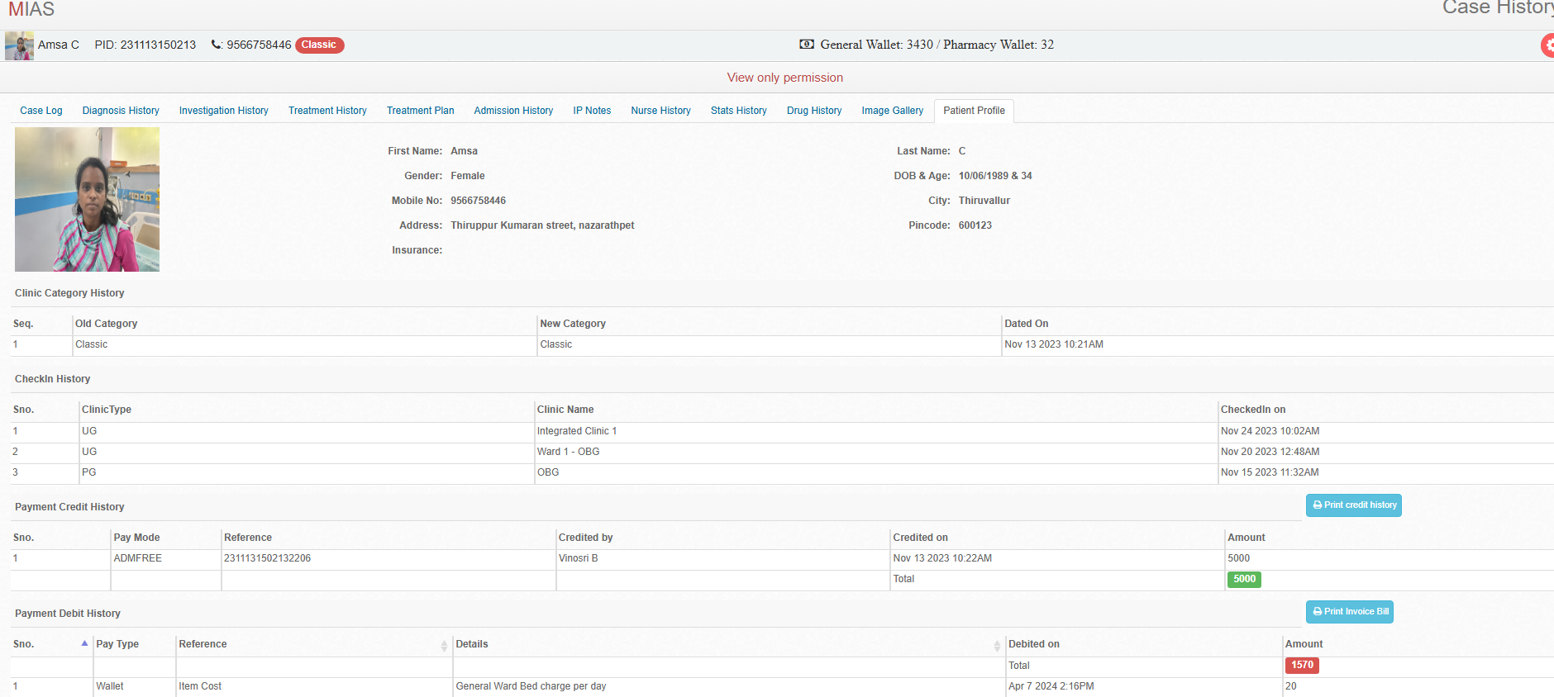
Case Logs (Departmental Check-Ins, Investigations, Treatment)
- Case logs track a patient’s journey across all departments, treatments, and payments.
- Available in Table View and Timeline View.
🔹 Table View Format:
Source file will be provided: Assessment and treatment forms will be provided department wise (eg. Physiotherapy, psychology, general medicine, eyes) [6]
S. No | Department | Details | Entered By | Entered On | View
1 | SMAART Gen Med | Diagnosis: Fever | Dr. XYZ | 12-Sep-2024 | Need to view the general assessment (History, treatment received)
2 | Physiotherapy | Diagnosis: Post-stroke rehab | Dr. XYZ | 12-Sep-2024 | Need to view the general assessment (History, treatment received)
3 | Minds | Diagnosis: Anxiety Disorder | Dr. ABC | 14-Sep-2024 | Need to view the assessment (History, treatment received)
4 | Eyes | Diagnosis: Refractive Error | Dr. LMN | 15-Sep-2024 | Need to view the assessment (History, treatment received)

Table View
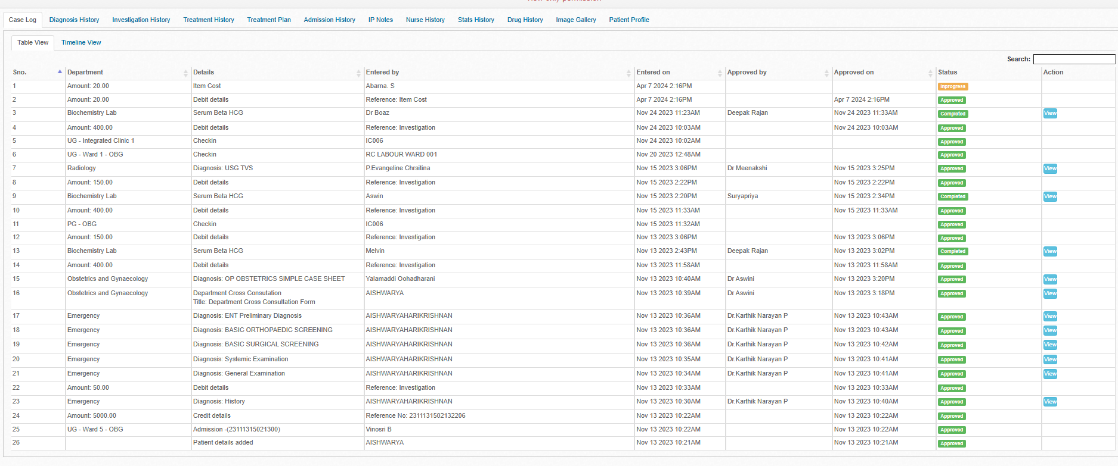

Timeline View
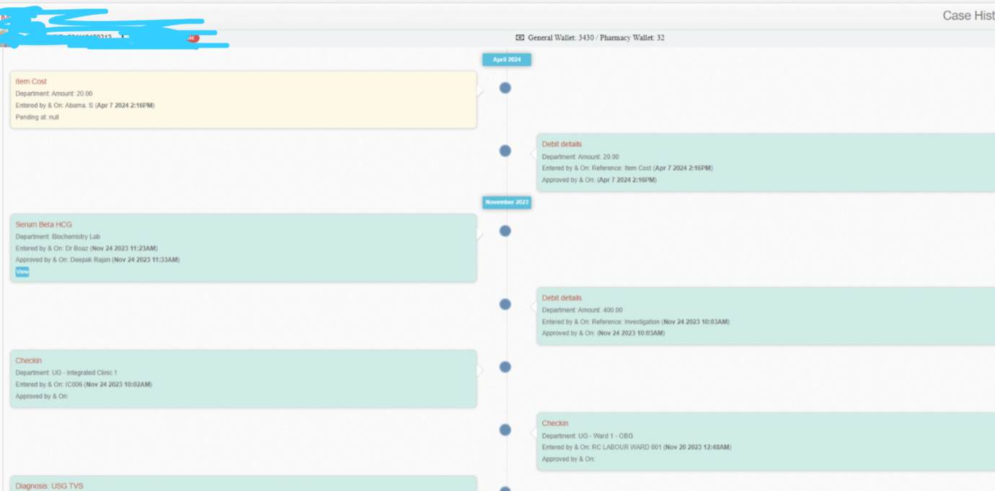

S.No | Patient Name | Age / Sex | Doctor Name
1 | Mr.Karthick | 50 / M | xxxxxxxxxxxxxxx | V
2 | Mrs.Saranya | 45 / F | xxxxxxxxxxxxxxx | V
3 | Mr.Sam | 30 / M | xxxxxxxxxxxxxxx | V
4 | Ms.Lavanya | 25 / F | xxxxxxxxxxxxxxx | V
Once the Vitals for the patients is recorded in EMR it will be turned Green.

Source File provided from SMAART Healthcare: Traffic light logic will be provided in Consultant Dashboard so it can be reflected here. [2]
Compliance Alerts: documentation or pending assessments
  - The system flags missing or overdue documentation.
  - Alerts notify consultant about incomplete patient progress reports, consent forms, or missing eCQM data.
Example: If a consultant forgets to document vitals of a patient's last session, the system will notify them with a pending documentation alert on their dashboard.

Diagnosis History (Cross-Departmental Clinical Records)
- Includes diagnoses from multiple specialties with restricted access per department.
- Physiotherapy Assessments are also recorded here.
- If the patient is referred to other department concerned consultant need to have full access to the patient record
🔹 Table View Format:
Diagnosis | ICD Code & Medical Alert
S.No | Department | Details | Entered By | Entered On | View
1 | Medicine | Fever | Dr. XYZ | 10-Sep-2024 | Need to view the assessment completely except history & investigation
2 | Minds | Anxiety Disorder | Dr. ABC | 12-Sep-2024 | Need to view the assessment completely except history & investigation
3 | Eyes | Myopia (-3.0D) | Dr. LMN | 14-Sep-2024 | Need to view the assessment completely except history & investigation
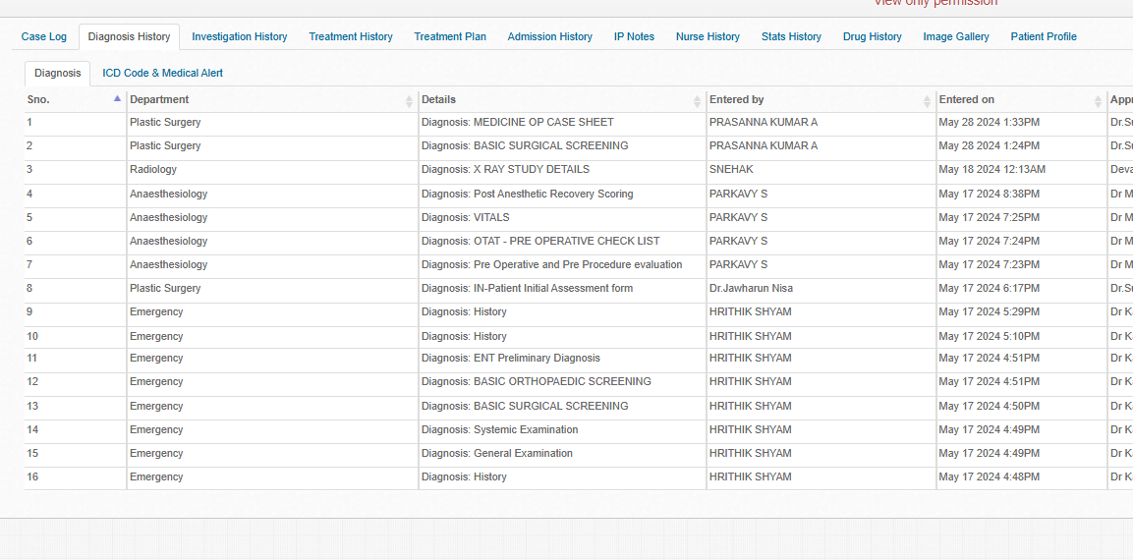

ICD Code & Medical Alert
Source Provided from SMAART Healthcare Team: ICD Code File [7]
ICD Code History
Seq. | ICD Name | Last Updated On
1 | Unsp superficial injury of left middle finger# init encntr | May 17 2024 8:45PM
Medical Alert History
Seq. | Alert Name | Last Updated On
No data available in table
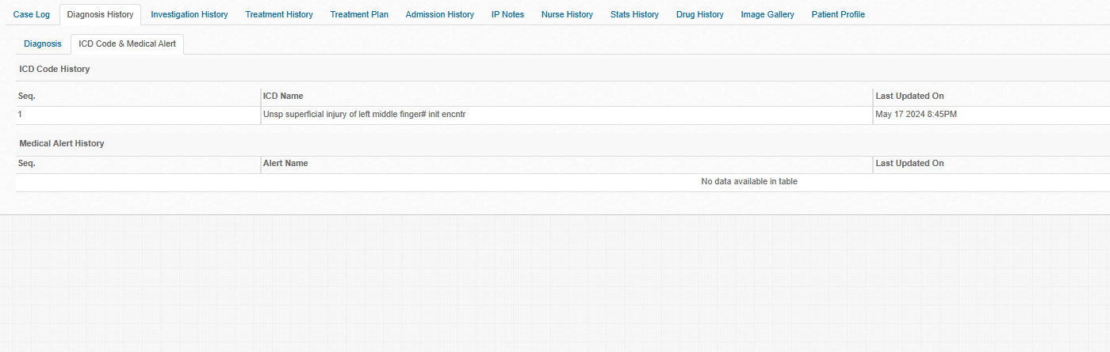
Investigation History (Lab & Imaging Reports)
- Investigations are stored separately and categorized by test type.
- The last column includes a "View File" button for accessing reports.
- Automatic Fetching of results from files when uploaded
- Need to upload Reports as PDF also. (InBody, Vertigo, Vibrasense, and Oivi)
- Source Provided from SMAART: Lab reports and their traffic light colour and values [8]

🔹 Table View Format:
S.No | Department | Test Name | Test Centre Name | Entered By | Entered On | Results | File
1 | Physiotherapy | EMG | NewBerg | Lab Technician | 12-Sep-2024 | Normal | [View File]
2 | Minds | EEG | Cindrella Scans | Dr. ABC | 14-Sep-2024 | Mild Abnormality | [View File]
3 | Metabolism | HbA1c | Scanropy Scans | Dr. LMN | 16-Sep-2024 | 7.5% (High) | [View File]
4 | Eyes | Eye Screening | NewBerg | Dr. jkl | 16-Sep-2024 | Normal | [View File]
eCQM Indicators: Displays quality metrics related to patient outcomes
  - eCQM (Electronic Clinical Quality Measures) track and measure patient outcomes based on treatment effectiveness.
  - The dashboard provides real-time analytics on patient progress, no-show rates, and treatment success rates.
Example:
If a physiotherapy department has a high patient recovery rate within 6 weeks, the system will display this as a quality indicator for reporting.
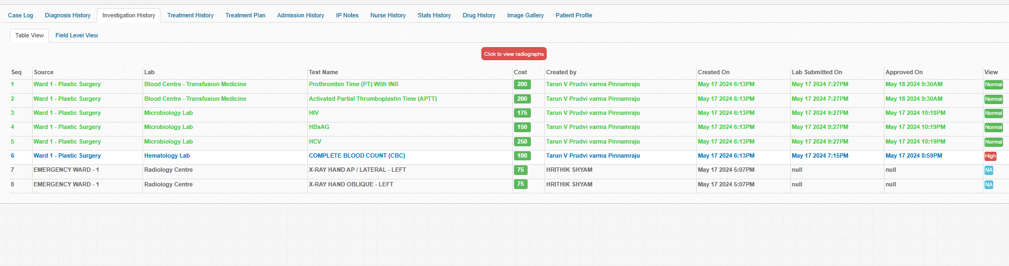
Treatment History (Planned vs. Completed Sessions)
- Tracks the consultant’s treatment plan and patient’s progress.
- Shows completed and pending sessions.
- Need to update here parallelly by tracking the user and consultant dashboard)
- If needed need to add manually (form will be given) (Source file will be provided ) [3]
🔹 Table View Format: (Live tracking with User and Consultant Dashboard)
S.No | Department | Treatment Plan | Sessions (Completed/Pending) | Entered By | Entered On
1 | Physiotherapy | 10 Sessions of Gait Training | 6/10 Completed | Dr. XYZ | 10-Sep-2024
2 | Minds | Cognitive Behavioral Therapy | 4/6 Completed | Dr. ABC | 12-Sep-2024
3 | Metabolism | Lifestyle Modification | 0/10 Ongoing | Dr. LMN | 16-Sep-2024
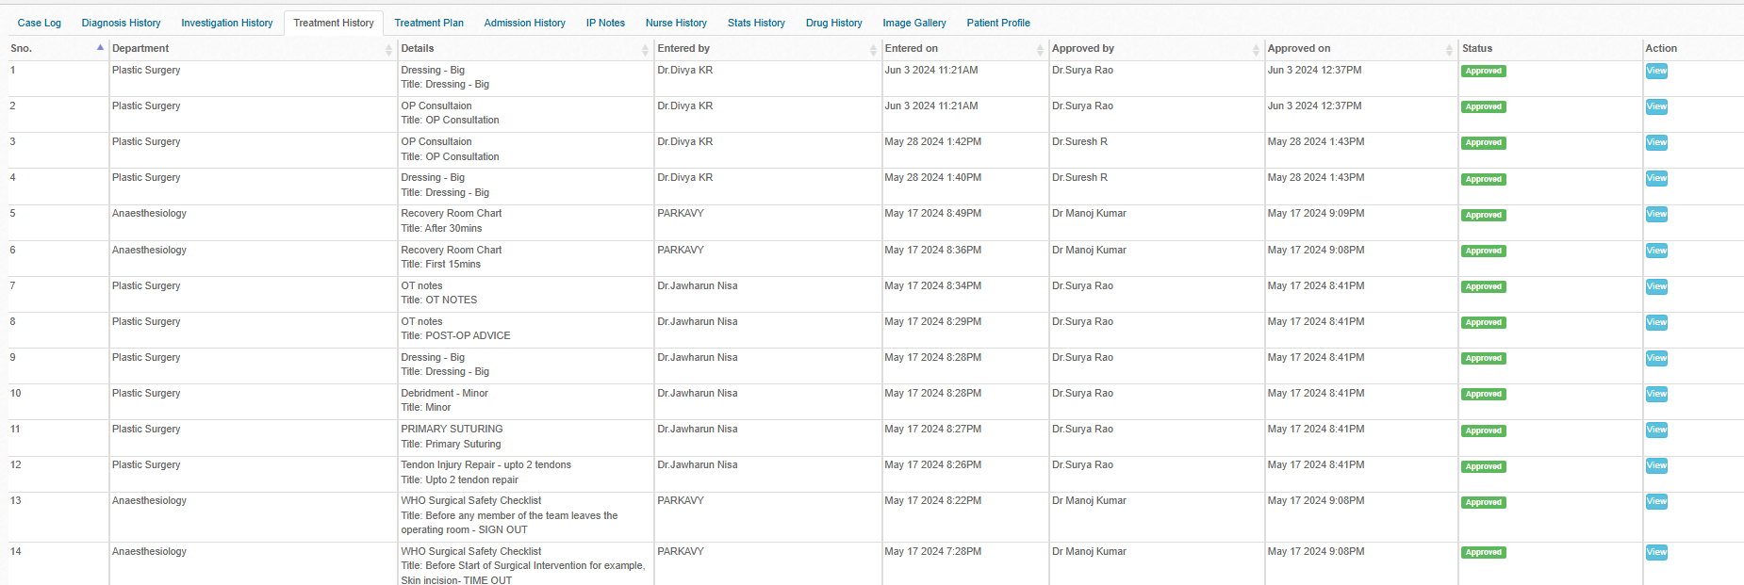
Progress History (Real-Time Patient Data & Assessments)
- Tracks exercise reps, sets, VAS pain scores, BP, and other assessments.
- Extracts real-time data from user dashboards.
- All progress history need to be extracted from user and consultant dashboard
- If needed need to add manually (form will be given) (Source file will be provided ) [3]
- Make a document uploading section with file naming and uploaded by whom.
🔹 Table View Format:
S.No | Parameter | Value | Entered On | Report
1 | Exercise Parameters | 15 reps, 3 sets for 3 hours | 10-Sep-2024 | FILE
2 | Cogni Fit | 80/100 | 10-Sep-2024 | FILE
3 | Blood Pressure | 130/85 mmHg | 12-Sep-2024 | Test Result (From Consultant dashboard)
4 | VAS Scale (Pain) | 4/10 | 14-Sep-2024 | NA
5 | Postural Assessment and all other in the tabs | Forward Head Posture | 16-Sep-2024 | Complete report (File)

Referral System Tab
- Located within Individual Patient View and Admin Panel
- Tracks whether the patient was:
  - Referred TO SMAART: Includes referring hospital/doctor name, date, and summary
  - Referred FROM SMAART: Destination hospital/doctor, date, notes, and expected follow-up
- Referral form will be given (Source file will be provided ) [3]
- Visibility:
  - All referral data logged under this tab
  - Color-coded tags: Inbound (Green), Outbound (Blue)
  - Linked with Relationship Associate tracking
- Integration Required:
  - A master list (dropdown) of hospitals and doctors needs to be imported into the backend (can be CSV or DB table referral_partners with fields: name, type [hospital/doctor], specialty, contact, location)
  - Admin panel should support adding/editing/deactivating referral sources
  - UI: Dropdown for referral source selection + free-text notes
  - Filters in dashboard: Referral by hospital/doctor, referral type (inbound/outbound)
  - Referral partner form will be given) (Source file will be provided ) [3]
A. Informed Consent for Therapy & Psychological Sessions (Integrated via AllyCare App)
- Consultant Dashboard → Consent Status Panel (Tracks consent completion before therapy sessions)
- Admin Panel → Compliance & Legal Section (Monitors organization-wide consent compliance)
- Consent Time, Date, IP address and Signature need to be stored in EMR and User Dashboard.
Feature | Functionality
Mandatory e-Consent | Requires digital consent before tele physiotherapy, psychological counseling, metabolic/nutritional interventions.
Digital Signature via AllyCare | Patients sign via touchscreen, OTP, or digital signature pad directly in the AllyCare app
Auto-Save to Patient Profile | Once signed, consent form is stored securely in the EMR system
Email/Portal Delivery | Patients receive a copy via email or patient portal for reference
Consent Status Alerts | If consent is missing, system triggers alerts in consultant dashboard & AllyCare App

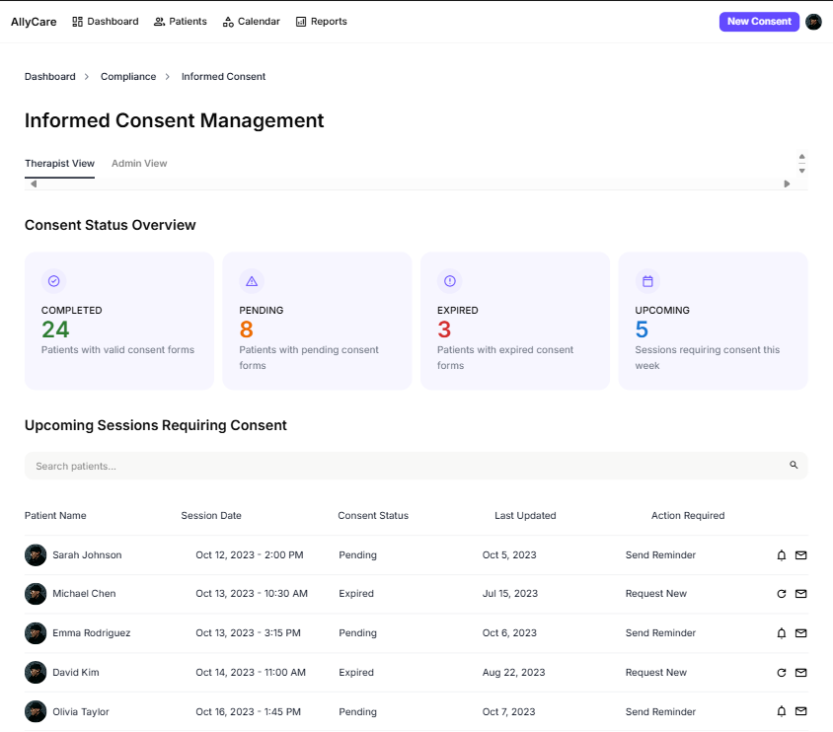
4. In-person & Virtual Consultations
Location: Patient Profile → Telehealth Tab | Admin Dashboard → Telehealth Section

A. Upcoming Telehealth Sessions (Displayed in Patient Profile & Admin Dashboard)

Features | Functionality
Patient Name | Shows the patient’s name for scheduled telehealth sessions
Date & Time | Displays the consultation date and time
Session Status | Tracks session status (Scheduled, Ongoing, Completed, Cancelled)

B. Quick Actions (Within Each Telehealth Session Entry)

Features | Functionality
Start Video Call | Initiates the video consultation session
Send Message | Secure messaging for pre-session communication
Schedule New Session | Allows admin/doctor to set up follow-up telehealth sessions

C. Session Notes & Documentation (Linked to Telehealth Session & Patient Profile)

Features | Functionality
SOAP Note Integration | Enables real-time note-taking by the consultant
Attach Files | Upload lab reports, assessments, prescriptions during session
Auto-Save Notes  (Patient Notes) | Ensures consultation notes are stored securely in patient records

D. Patient Reminders & Notifications (Auto-Triggered from Telehealth Module) (Consultant and Admin)

Features | Functionality
SMS/Email Reminders/Whatsapp | Sends alerts for upcoming sessions
Late Join Alerts | Notifies admin if patient/doctor joins late
Missed Session Alerts | Alerts admin if patient misses the session

E. Multi-Participant Support (Feature for Family & Specialists)

Features | Functionality
Invite Additional Members | Allows caregivers or specialists to join the session
Screen Sharing | Enables doctor to share documents/images for patient education
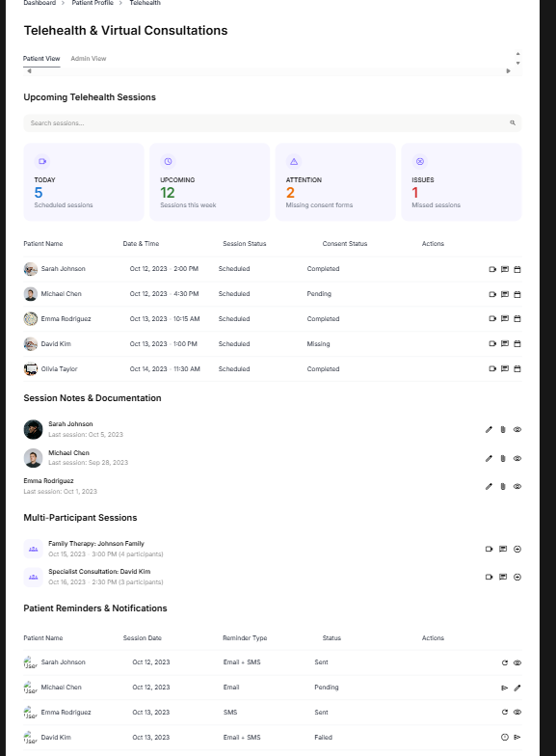
5. Billing & Insurance
A. Billing Dashboard (For Admin & Billing Staff - Main Navigation Panel)
Location: Admin Dashboard → Billing Section
Features | Functionality
Invoice Overview | View pending, completed, and overdue invoices
Search & Filter | Find invoices by patient name, date, or payment status
Real-time Analytics | Displays revenue trends and outstanding payments
Invoice Management (Inside Patient Profile & Billing Dashboard)
Location: Patient Profile → Billing & Transactions Tab
Features | Functionality
Auto-generated Invoices | Created from appointments, treatments, and procedures
Medical Coding | Uses Current Procedural Terminology (CPT), ICD-10, and Healthcare Common Procedure Coding System (HCPCS) codes for accurate billing
Source Provided from SMAART Healthcare: Invoice Template
Insurance & Claims Processing (Within Billing Dashboard & Patient Profile)
Location: Patient Profile → Insurance Tab | Billing Dashboard
Features | Functionality
Insurance Details | Stores patient insurance provider and policy information
Claim Tracking | Monitors claim status (Pending, Approved, Denied, Rejected)
Pre-Authorization Requests | Triggered from Treatment Plan Section for insurance approval
Payment Processing (Patient Profile, Appointment Checkout, & Billing Dashboard)
- Patient Profile → Billing Section
- Appointment Booking Checkout Page
- Billing Dashboard (For Admin & Finance Team)
Features | Functionality
Payment Methods | Supports cash, card, UPI, net banking, and insurance payments
Receipt Generation | Auto-sends receipts via email/SMS
Payment Reminders | Notifies patients of due payments
E. Audit Trail & Compliance (System Logs & Billing Records)
Location: Admin Panel → Audit Logs Section | Security Dashboard
Features | Functionality
Transaction Logs | Tracks all financial transactions with timestamps
Unauthorized Access Alerts | Generates alerts for suspicious activities
Data Encryption | Uses AES-256 encryption for secure storage
F. Reporting & Financial Analytics (Admin Dashboard & Reports Section)
Location: Reports Section in Admin Panel
Features | Functionality
Revenue Reports | Generates daily, weekly, and monthly financial reports
Insurance vs. Self-Pay Breakdown | Shows earnings from different payment sources
Data Export Options | Allows downloads in Excel, PDF, and cloud backup
G. Integration with EMR & Appointments (Data Flow Automation)
Location: Appointment Scheduling Page | Treatment Plan Page | Admin Billing Dashboard
Features | Functionality
Auto-Fetch Fees | Retrieves consultation charges during booking
Treatment Cost Calculation | Pulls cost details from treatment plans automatically
Department-wise Revenue Tracking | Displays income from different departments (Physiotherapy, Mental Health, etc.)

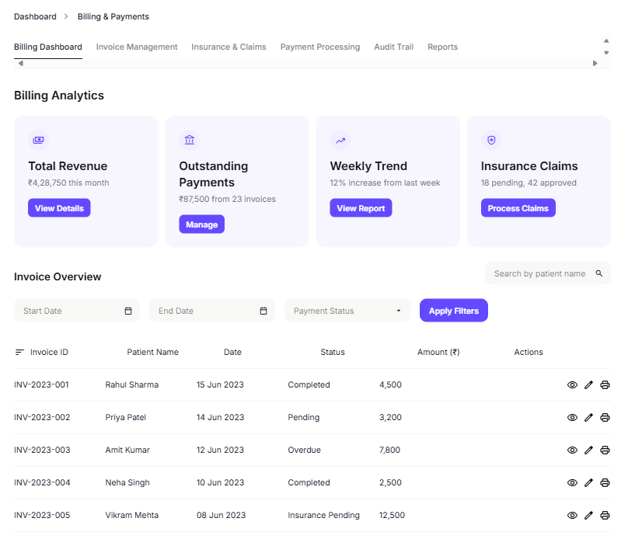

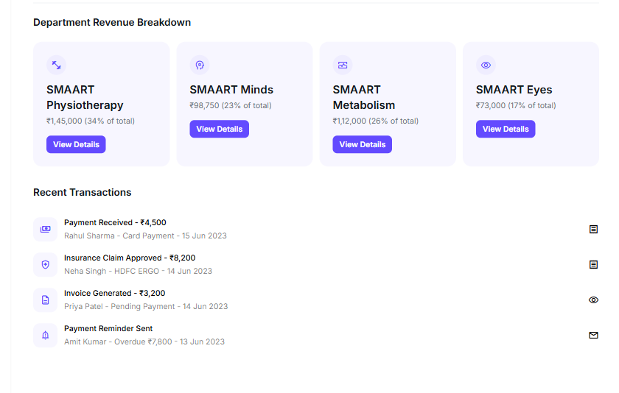

AUDIT TRAIL

Every Action Logged
- What is Logged: Every system interaction must be recorded securely and immutably.
  - Username: Identifies the user who performed the action
  - Action Type: View, Create, Edit, Delete, Login, Logout, Export, Print, Upload
  - Affected Module/Page: Indicates the page or function affected (e.g., Patient Profile, Billing Dashboard)
  - Timestamp: Captures exact date and time of the action (server time)
  - IP Address: Logged for access traceability
  - Location (Geo-IP): Derived from IP, helps detect suspicious access points
  - Device Info (Optional): Browser and device metadata for audit and security
  - Need to be exported in csv or excel.

