SMAART INSTITUTE
AI Proctoring System
Technical & Design Documentation
Complete flow · methods used · why they were chosen · honest verdict on each

Version 1.0
23 July 2026

Contents

Right-click and choose “Update Field” to populate page numbers.

0. Executive summary
SMAART proctoring is a browser-based, AI-assisted, human-decided integrity system for online assessments. All AI processing — face matching, gaze, head-pose, audio and environment checks — runs locally in the candidate’s browser for privacy and cost. The browser only reports events; it never decides outcomes. The server owns every verdict, and it computes that verdict from data the candidate cannot forge — answer timing and a heartbeat gap.
The system runs in flag-only mode: it never interrupts an honest candidate mid-exam. Flags accumulate silently, the whole session is judged once at submit, and every serious case goes to a human reviewer before any score is withheld. Answers are always saved; only publication of the score is ever held.
Is this the best approach? Verdict: yes — for a web-delivered assessment platform of this scale, with two caveats.
The architecture (local AI + server-authoritative decisions + human review) is the correct, defensible design and matches how serious remote-proctoring vendors work. The two caveats: (1) a browser can never be as tamper-proof as a locked-down desktop application, and (2) the operator review screen is the main missing piece — the human-review back-end exists, but reviewers currently have no UI to action it. Full reasoning in Section 12.

1. Design philosophy — the three rules
Every design decision traces back to three governing rules. The rest of this document is their consequences.

Rule 1 — The server owns every decision; the browser only renders the outcome
A tampered browser can silence its own detectors, but it cannot change a verdict, because the two signals that matter most are computed server-side over data the candidate cannot forge:
- Answer timing — reconstructed from the timestamps of submitted answers.
- The heartbeat gap — the absence of an expected request. You cannot forge an absence.
Because the decision lives on the server, defeating the client AI only removes soft signals; the hard signals remain.

Rule 2 — We never assert cheating
Every user-facing message says “we couldn’t verify this attempt,” never “you cheated.” Answers are always saved. The only thing ever withheld is publication of the score, and only until a human decides. This keeps the system fair, legally defensible, and humane to the honest majority who trip a detector by accident.

Rule 3 — Flag-only mode: never interrupt a live exam
The earlier model blocked a candidate mid-exam after three warnings. That punished the honest majority for a swivelling chair, and it judged isolated seconds instead of the whole session — twelve short glances away read very differently from one four-minute absence, and only an end-of-exam view can tell them apart. Now flags accumulate silently, the candidate finishes uninterrupted, and the server decides once, at submit.
Single source of truth. These rules are enforced by one policy file — back-end/config/proctoringPolicy.js — which the live engine, the submit gate and the analytics pass all read. The number that flags a session can never drift from the number that decides its outcome.

2. The complete flow — the candidate’s journey
The candidate moves through a four-step setup wizard, then an uninterrupted monitored assessment, then a single server-side judgement at submit, and finally an outcome. Each step below names the responsible source file.
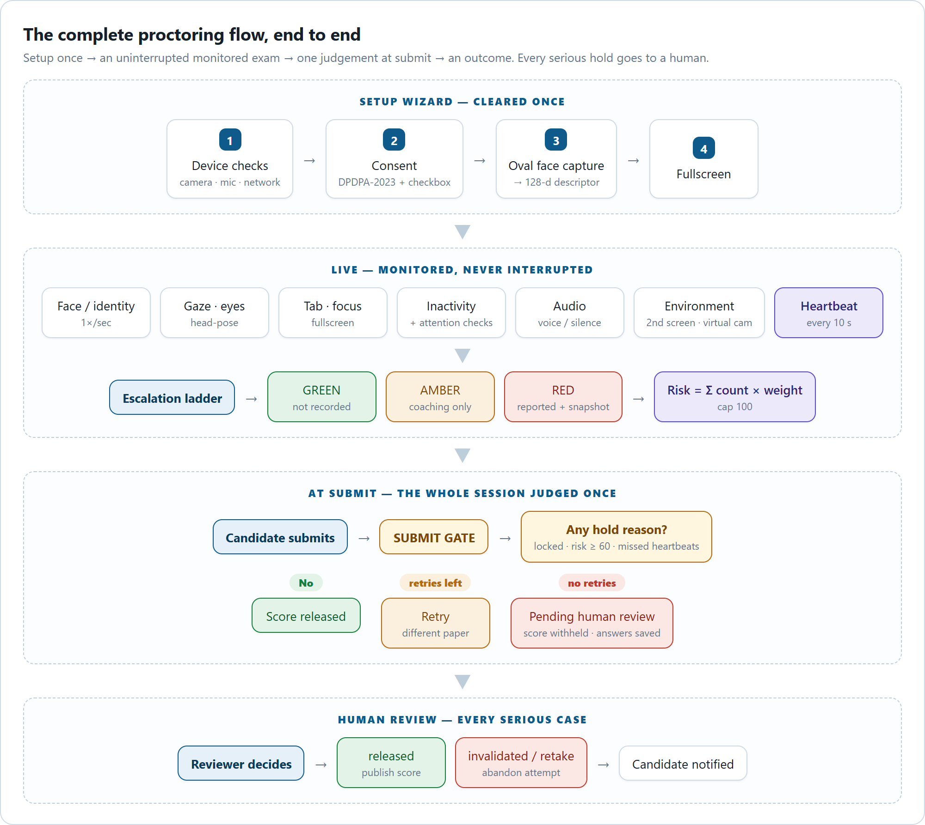
Figure 1 — The complete proctoring flow, end to end.
# | Stage | What happens | Where
1 | Device checks | Camera, microphone and network-latency checks. Camera is soft-gated — a denial warns but does not hard-block. | ProctoringSetup.jsx (step 1)
2 | Consent | DPDPA-2023 privacy notice, per-permission explanations, assessment rules, and a mandatory checkbox: “consent to face registration and identity verification.” The wizard cannot proceed without it. | ProctoringSetup.jsx (step 2)
3 | Oval face capture | An animated oval face-guide (SVG) frames the face. Once stable ~1.6 s, it auto-captures 3 frames at 400 ms intervals, requires ≥2 valid, and averages them into one 128-float descriptor. | registerFace()
4 | Fullscreen | Fullscreen is activated to begin the exam. | ProctoringSetup.jsx (step 4)
5 | Live monitoring | The engine starts: camera stream, face verification 1×/sec, gaze/eyes/head-pose, tab/focus/fullscreen listeners, inactivity timer, audio analysis, environment checks and a 10 s heartbeat. It logs face_registered with the descriptor so identity is provable server-side. | useProctoringEngine.js
6 | Escalation | Each detected condition runs through the green → amber → red ladder. Amber is local coaching only; red reports to the server with a snapshot, and risk is recomputed. | proctoringLadder.js
7 | Submit | The candidate finishes uninterrupted. On submit, the submit gate judges the whole session once. | services/proctoringGate.js
8 | Outcome | Clean → score released. Held with retries → re-sit with a different paper. Held with no retries → pending human review, score withheld, non-accusatory screen shown. | AssessmentHeld.jsx
9 | Human review | A reviewer releases / invalidates / retakes via a secured webhook; the candidate is notified. | webhookUnlock()

Flow at a glance
SETUP device checks → consent → oval face capture → fullscreen
LIVE continuous local AI (face · gaze · tab · inactivity · audio · environment) + 10 s heartbeat → green/amber/red ladder → red events reported to server
SUBMIT server judges whole session: locked? risk ≥ 60? missed heartbeats? → hold or release
OUTCOME release score · retry with different paper · pending human review

The setup wizard, at a glance
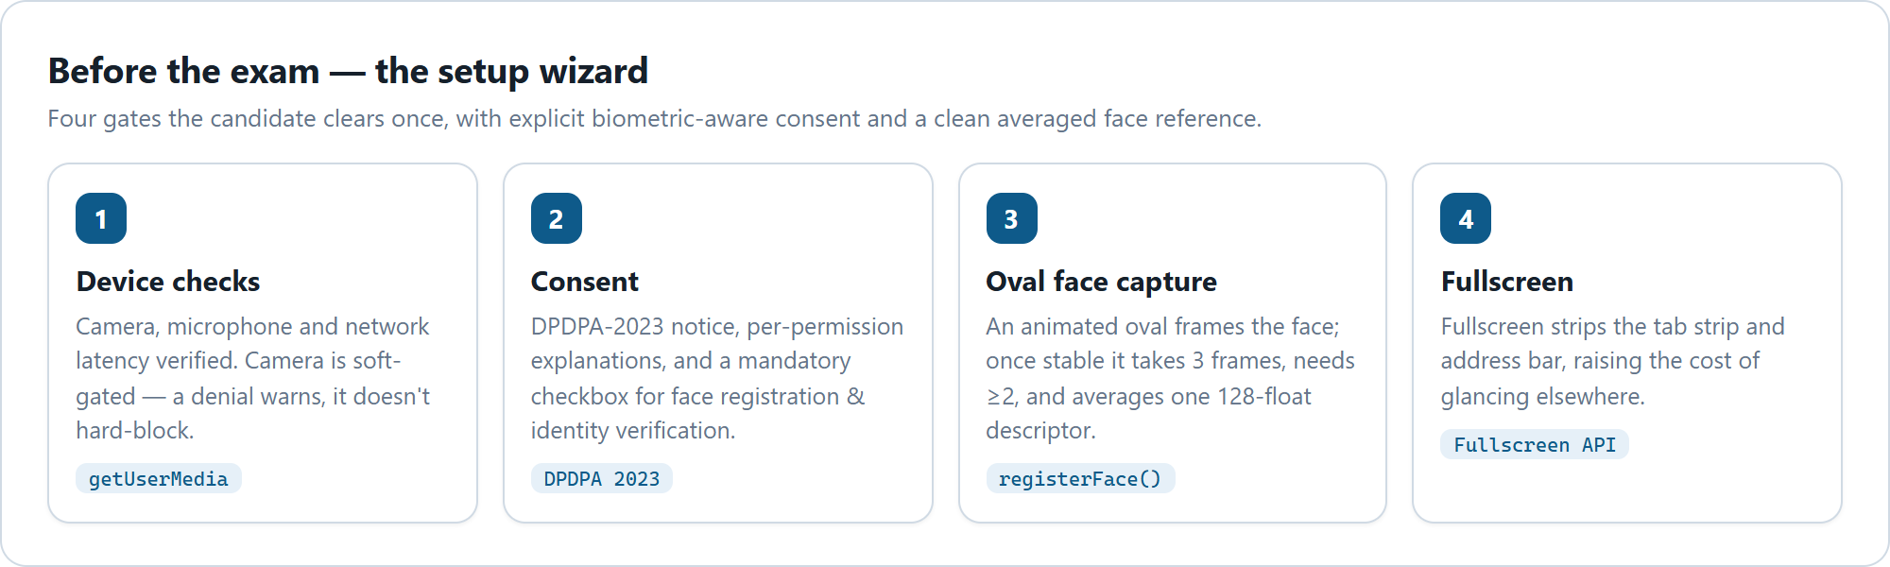
Figure 2 — The four setup steps the candidate clears once.

3. Architecture — who does what
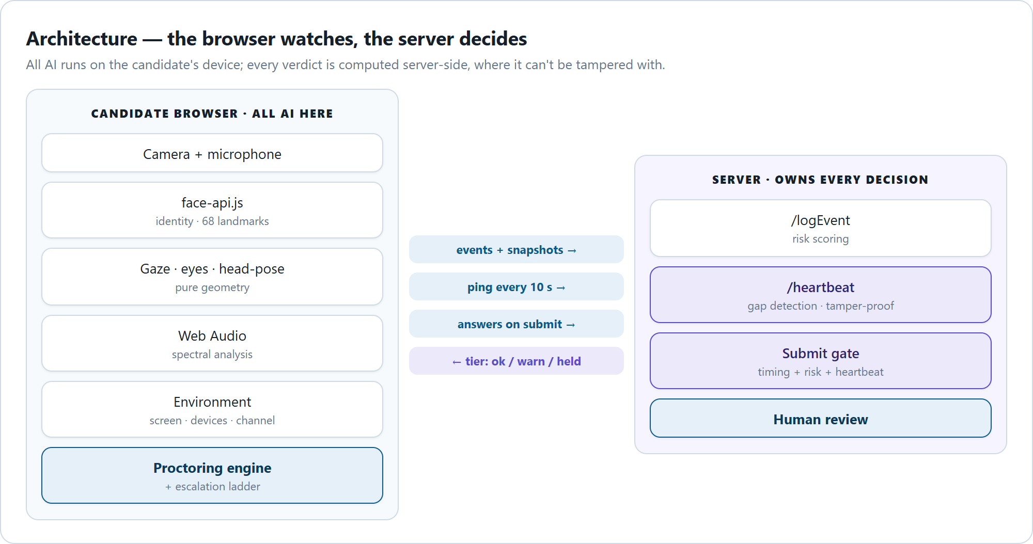
Figure 3 — The browser watches; the server decides.
Layer | Responsibility | Why here
Browser | All AI: face-api.js identity + landmarks, gaze/eyes/head-pose geometry, Web Audio spectral analysis, environment checks, the escalation ladder, and the orchestrator (useProctoringEngine). | Video frames never leave the device (privacy + DPDPA), no server GPU, no per-frame bandwidth.
Server | All decisions: risk scoring, answer-timing analysis, heartbeat-gap detection, the submit gate, and the human-review workflow. | Keeps the verdict honest even if the client is tampered with. The client cannot decide — it only renders the tier the server returns.

Data flow. The browser sends events + snapshots to /logEvent, a ping to /heartbeat every 10 s, and answers to the submit gate on submit. The server returns only a tier (ok / warn / held) that the browser renders. Why this split? Client-side AI keeps video on-device and costs nothing to run at scale; server-side decisions keep the verdict tamper-resistant. This is the standard, defensible architecture for web-delivered proctoring.

4. Method by method — what we use, why, and the honest verdict
For each subsystem: the method, the alternatives considered, why this one was chosen, and a plain verdict on whether it is the best available choice.

At a glance — what’s watched during the exam
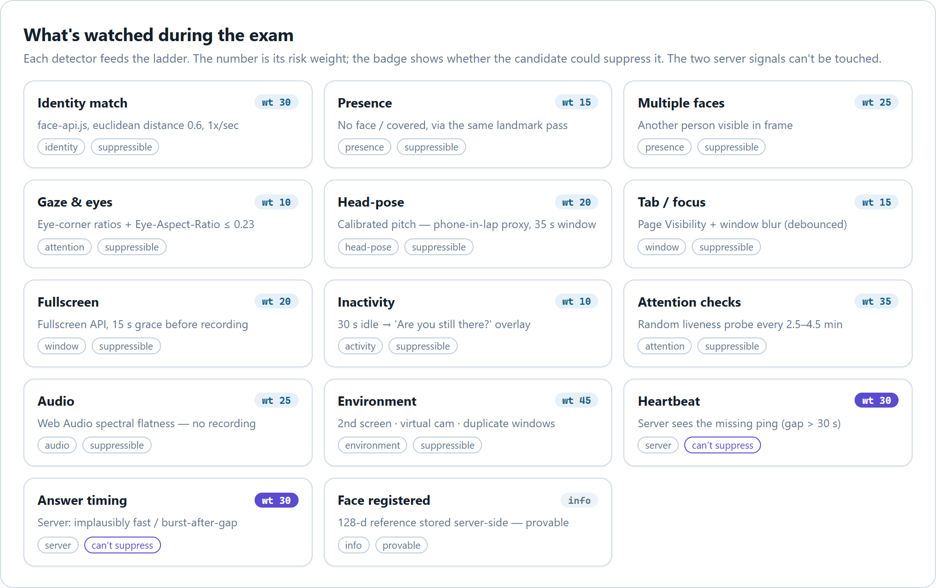
Figure 4 — Every detector, its risk weight, and whether the candidate can suppress it.

4.1 Consent & privacy (DPDPA-2023)
Method | Explicit, informed consent screen with a per-permission breakdown and a mandatory checkbox before any camera capture. Framed under India’s Digital Personal Data Protection Act, 2023.
Alternatives | Implied consent (just request camera permission); a single “I agree” with no detail.
Why this | DPDPA requires free, specific and informed consent for biometric processing. Face descriptors are biometric data. A granular, upfront notice is both the legal requirement and the fair thing to do.
Verdict | Correct and necessary. One gap: consent is collected but not persisted as a timestamped record. For a clean DPDPA audit trail, store a consent flag + timestamp + policy version on the session/result (see Section 13, gap 4).

4.2 Camera & oval face capture
Method | getUserMedia at 640×480 @15 fps, audio off, hidden video element. Registration uses an animated oval guide (SVG), auto-captures once the face is stable, takes 3 frames, requires ≥2 valid, and averages the descriptors.
Alternatives | Single-frame capture; a plain rectangle guide; higher capture resolution.
Why this | 640×480 is enough for a reliable 128-d embedding while keeping CPU low on cheap laptops. The oval guide standardises framing and distance so the reference descriptor is clean. Three-frame averaging cancels a single bad frame (blink, motion blur) — the biggest quality lever for later matching.
Verdict | Best-practice. Multi-frame averaging plus a framing guide is exactly right. The only caveat is a “Skip for now” developer shortcut that bypasses registration — ensure it is disabled in production (Section 13, gap 5).

4.3 Identity verification (face matching)
Method | @vladmandic/face-api (a maintained face-api.js / TensorFlow.js fork). Models: TinyFaceDetector, FaceLandmark68, FaceRecognitionNet (128-d embeddings). Match by euclidean distance, threshold 0.6; min detector confidence 0.5; input size 320. Verification runs 1×/sec. The 128-float reference is sent to the server once (as face_registered) so identity is provable.
Alternatives | MediaPipe Face (Google); AWS Rekognition / Azure Face (cloud); SSD MobileNet detector (same library).
Why this | Runs fully in-browser → video never leaves the device, no server GPU, no per-frame bandwidth. TinyFaceDetector over SSD MobileNet: 193 KB vs 5.6 MB model — a ~29× smaller download, decisive on weak connections. The @vladmandic fork is actively maintained (the original face-api.js is abandoned). 0.6 is the library’s well-established recommended threshold — the industry-default balance between false accept and false reject.
Verdict | A good, pragmatic choice — not the single most accurate on the market, and that is the right trade. Cloud face APIs are more accurate but send biometric video off-device (a DPDPA problem), add latency and cost per call. MediaPipe is faster on modern hardware but heavier to integrate and still local. For a privacy-first, cost-sensitive, wide-device web platform, local face-api.js is correct. Honest limitation: browser face recognition is a deterrent and a signal, not courtroom-grade proof — which is exactly why every serious case is routed to a human rather than auto-failed.

4.4 Full-screen enforcement
Method | Fullscreen API with a fullscreenchange listener and a 15-second grace countdown before recording fullscreen_exit.
Alternatives | Instant violation on any exit; no fullscreen at all.
Why this | Fullscreen removes the tab strip and address bar, raising the cost of glancing at other windows. The 15 s grace absorbs accidental Esc presses and OS popups so honest candidates are not punished for a reflex.
Verdict | Best available in a browser. A browser cannot forcibly prevent exiting fullscreen (by design — no site can trap you), so detect-and-record is the ceiling. A locked-down desktop app could do more, at a large adoption cost. Right call for a web platform.

4.5 Face / presence monitoring
Method | The same face-api tick classifies each second as VERIFIED / NO_FACE / MULTIPLE_FACES / MISMATCH / COVERED, fed into the duration ladder. Without a registered descriptor it drops to presence-only detection.
Alternatives | Separate model passes per concern (identity, presence, gaze, pose).
Why this | Reuses one detector pass for everything — identity, presence, gaze and head-pose all derive from the same 68 landmarks — so it runs one inference per second instead of four.
Verdict | Efficient and correct. Sharing one landmark pass across four detectors is the right performance design.

4.6 Gaze / eyes / head-pose
Method | Pure geometry over the 68 face landmarks — no extra models. Gaze via eye-corner ratios; eyes-closed via Eye Aspect Ratio (EAR ≤ 0.23); head-pose via nose-vs-eye geometry with per-candidate calibration (first 30 frames set a median baseline; looking_down when pitch drops below 0.78× baseline).
Alternatives | A dedicated gaze-tracking model (e.g. WebGazer); an iris-tracking model.
Why this | Landmark geometry is free (already computed), robust and explainable. Per-candidate calibration matters — everyone’s neutral head pose differs, so an absolute threshold would misfire. looking_down is given a long 35 s window because people constantly glance at keyboards and hands; the goal is to catch a phone in the lap, not a normal glance.
Verdict | The right level of ambition. Reliable eye-gaze tracking in a webcam is hard; the code is explicit that head-pose is inference, not proof. Treating it as a weak, calibrated signal that only contributes to risk (weights 15–20), never a hard fail, is exactly correct.

4.7 Tab / window / focus monitoring
Method | visibilitychange → tab_switch; window blur (150 ms debounce, skipped if already hidden) → minimize.
Alternatives | Polling document.hasFocus(); no monitoring.
Why this | The Page Visibility API is the standard, reliable way to know the exam tab lost focus. The debounce prevents a transient blur (clicking browser chrome) from firing a false event.
Verdict | Best available in a browser — same ceiling as fullscreen: you can detect leaving, not prevent it. Correct.

4.8 Environment signals (second screen, virtual camera, duplicate windows)
Method | Second screen via the Multi-Screen Window Placement API (screen.isExtended); virtual camera via enumerateDevices label matching (OBS, ManyCam, Snap Camera, DroidCam…); duplicate exam windows via a BroadcastChannel handshake.
Alternatives | Ignore these vectors; require a native agent to inspect displays/devices.
Why this | These are high-value signals (weights 35–45) — a second screen or a virtual camera is hard to explain innocently — and all three are achievable with standard web APIs at zero server cost.
Verdict | Good signals, honestly best-effort. screen.isExtended is Chromium-only (silently unsupported on Firefox/Safari) and virtual-camera detection is label-based (defeatable by renaming a device). The code treats them as raising the cost of cheating, not as a wall — the honest, correct framing: they add risk, they do not auto-fail.

4.9 Audio monitoring
Method | Web Audio API spectral analysis. Voice band 85–4000 Hz + spectral-flatness heuristic (SFM < 0.5) → voice_detected; ≥60 s below threshold → prolonged_silence. No audio is recorded or transmitted — only a derived flag.
Alternatives | Stream audio to a server for speech detection; run a local speech model.
Why this | A spectral heuristic detects “a human voice is present” (someone helping, a phone call) without recording anything — privacy-preserving by construction, and cheap.
Verdict | Right trade-off. It cannot transcribe or prove what was said (nor should it), but “another voice in the room” is a legitimate signal. Weighted at 25 and human-reviewed, not auto-failed — correct.

4.10 Inactivity & attention checks
Method | 30 s of no input (mouse/key/click/scroll/touch) → a blurred “Are you still there?” overlay with a 30 s grace ring → records inactivity on timeout. Plus random attention checks every 2.5–4.5 min; a miss records attention_check_fail (weight 35).
Alternatives | A fixed-interval prompt; no liveness probe.
Why this | Inactivity is a low-weight housekeeping signal (weight 10, category marked minor — never shown to the candidate). Attention checks are the stronger liveness probe: they confirm a human is actually present and watching.
Verdict | Sensible. Randomised attention checks are a well-known proctoring technique and harder to script around than a fixed timer.

4.11 Answer-timing analysis (server-side, tamper-proof) — the strongest signal
Method | Pure server-side analysis over submitted answeredAt timestamps. Flags: answers under 2000 ms (too fast to read a stem + four options) — 3+ such answers is an anomaly; a long gap (45 s) followed by a burst of 4 answers within 12 s (the classic “stepped away, got the answers, entering them now” signature); and a whole-paper check (≥10 questions averaging <2 s each). Everything is a flag, not a verdict.
Alternatives | Rely only on the camera; ignore timing.
Why this | This is the one signal a tampered client cannot suppress, because it is reconstructed on the server from the answers themselves. It catches the highest-value cheating (someone feeding answers) that all the camera AI would miss.
Verdict | The crown jewel of the design. Most naive proctoring leans entirely on the camera, which is exactly what a determined cheater defeats. Grounding the decision in tamper-proof timing is what makes this system genuinely hard to beat. Strongly correct.

4.12 Heartbeat (server-side, tamper-proof)
Method | The client pings every 10 s; if the server sees a gap >30 s, it records proctoring_offline (weight 30).
Alternatives | Client-reported “I am still here” status; no liveness at all.
Why this | The incriminating signal is the missing request, not a request the client sends — so going offline (closing the lid, killing the tab, pulling the network to disable monitoring) is itself recorded. You cannot forge an absence.
Verdict | Excellent, and the perfect complement to timing analysis. Together, timing + heartbeat mean the two decisive signals both live server-side and both resist client tampering. This elevates the system from “camera theatre” to a real integrity check.

5. Event reference — every signal, weight and rationale
Risk score = Σ (count × weight), capped at 100. At risk ≥ 60 an attempt cannot be verified (held for review). At risk ≥ 90 the session is locked immediately mid-exam — disabled in flag-only mode.
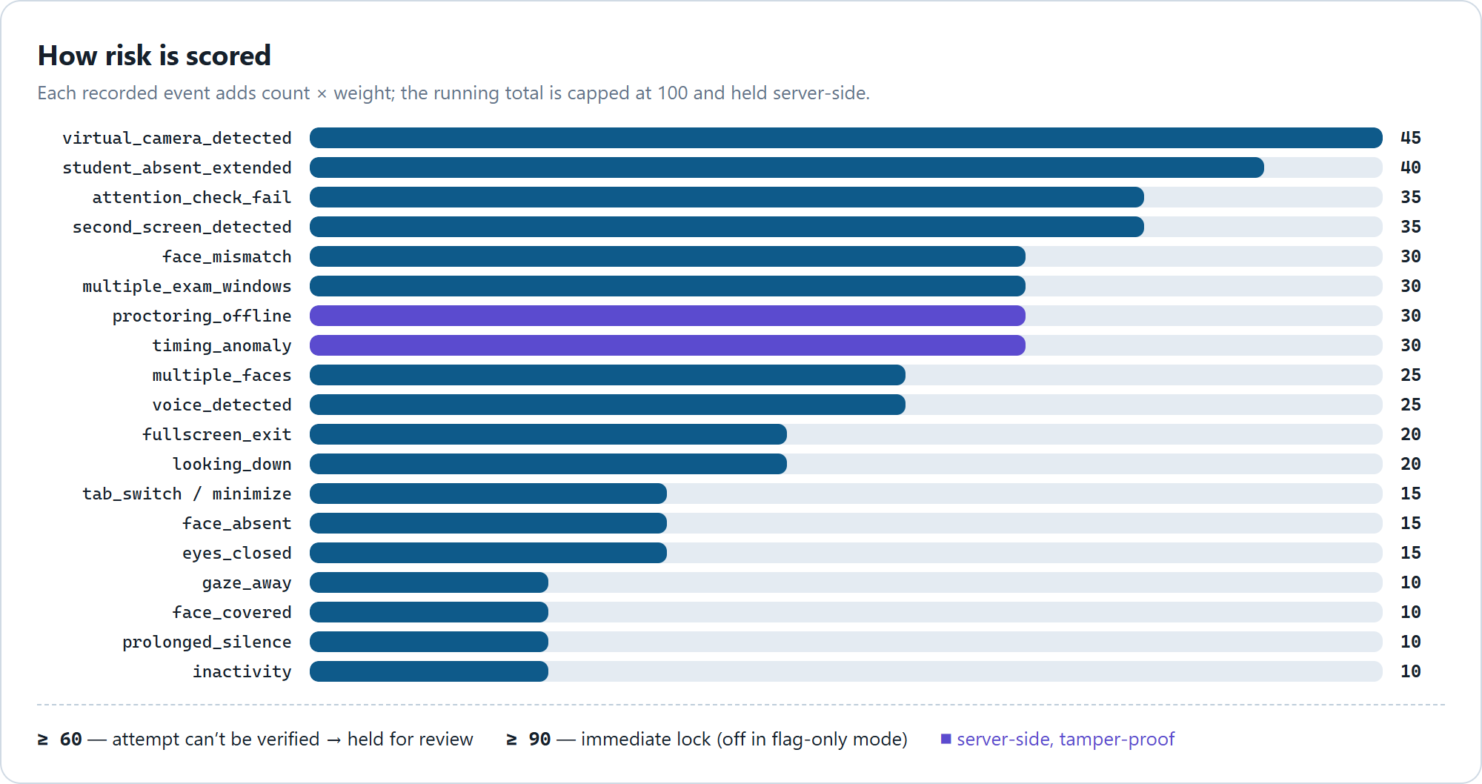
Figure 5 — Risk weight per event. Server-side signals (indigo) cannot be suppressed by the client.
Event | Weight | Type | Client can suppress? | Notes
virtual_camera_detected | 45 | Environment | Partly | Strongest environment signal
student_absent_extended | 40 | Presence | Yes | Away a full minute — flags on its own
attention_check_fail | 35 | Attention | Yes | Missed a liveness probe
second_screen_detected | 35 | Environment | Chromium only | Hard to explain innocently
face_mismatch | 30 | Identity | Yes | Camera ≠ registered face
multiple_exam_windows | 30 | Environment | Yes | Two exam windows open
proctoring_offline | 30 | Server | No | Missing heartbeat
timing_anomaly | 30 | Server | No | Implausible answer timing
multiple_faces | 25 | Presence | Yes | Another person visible
voice_detected | 25 | Audio | Yes | Human voice in the room
fullscreen_exit | 20 | Window | Yes | Left fullscreen >15 s
looking_down | 20 | Head-pose | Yes | Phone-in-lap proxy (calibrated, 35 s)
tab_switch / minimize | 15 | Window | Yes | Left the exam window
face_absent | 15 | Presence | Yes | No face for 30 s
eyes_closed | 15 | Attention | Yes | Eyes closed 25 s
gaze_away | 10 | Attention | Yes | Looking away 25 s
face_covered | 10 | Presence | Yes | Face partly hidden
prolonged_silence | 10 | Audio | Yes | Minor
inactivity | 10 | Activity | Yes | Minor, never shown
face_registered / heartbeat | 0 | Info | — | Informational only

6. The escalation ladder (green → amber → red)
One continuous condition produces one escalating episode; each stage fires at most once; the episode ends only when the condition actually clears. (The old streak-counter reset to zero each time it fired, so one 70-second absence collected four separate warnings — this design fixes that.)
- Green — nothing happening.
- Amber — needs attention, nothing on the candidate’s record (local coaching only). This is where the honest majority lives and is never penalised.
- Red — recorded on the server, counts toward risk.
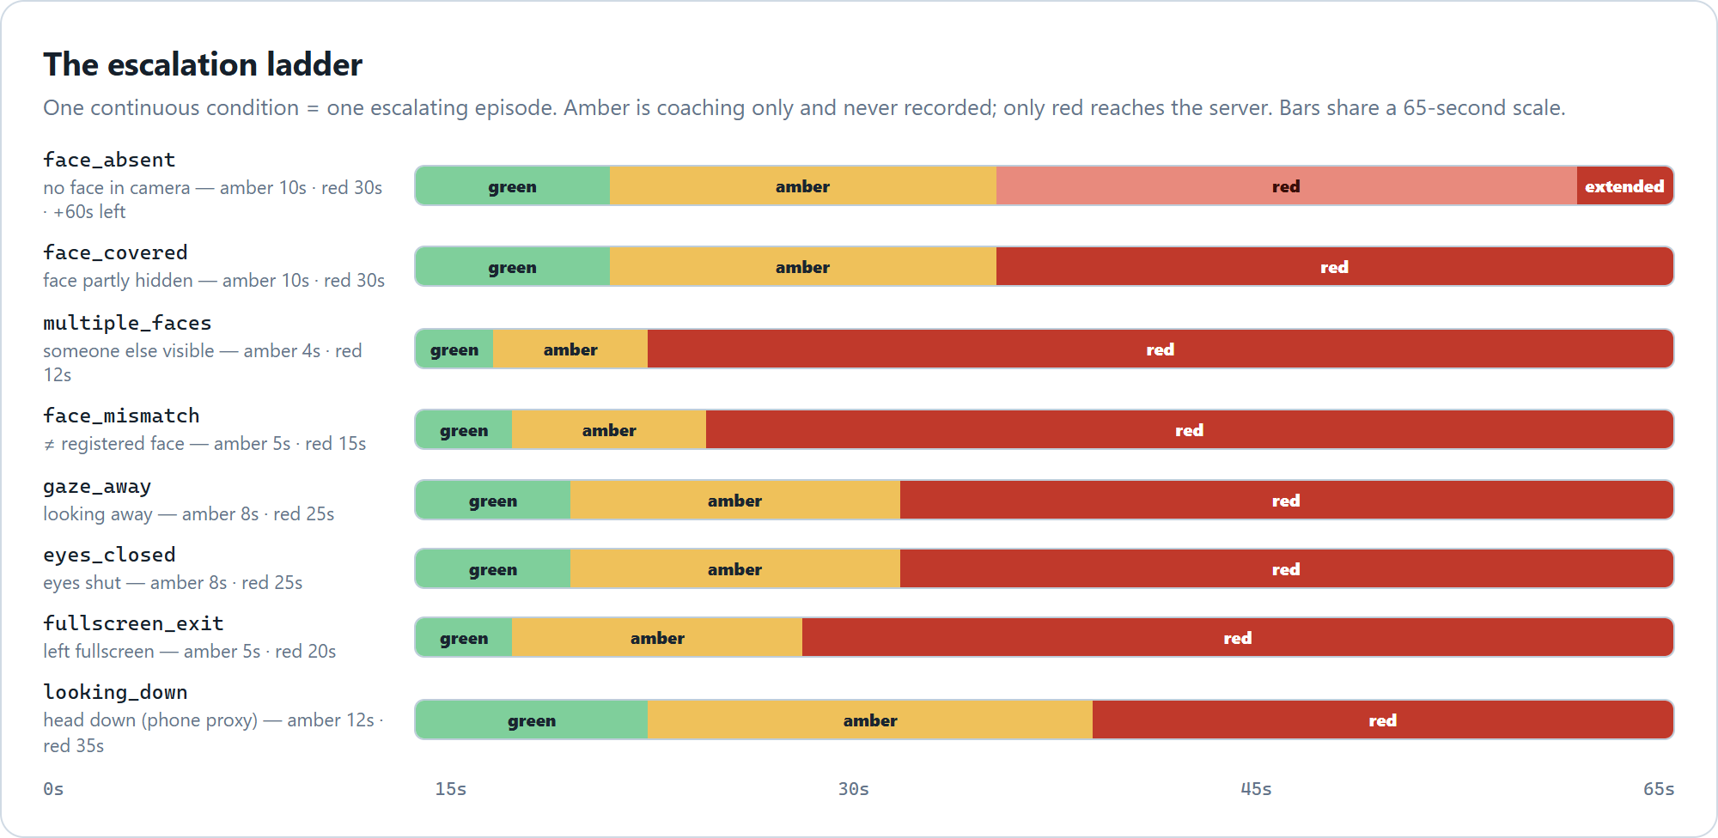
Figure 6 — Each condition on a shared 65-second scale: green (silent) → amber (coaching) → red (recorded).

Condition | Amber at | Red at | Then escalates to
face_absent | 10 s | 30 s → face_absent | 60 s → student_absent_extended
face_covered | 10 s | 30 s → face_covered | —
multiple_faces | 4 s | 12 s → multiple_faces | —
face_mismatch | 5 s | 15 s → face_mismatch | —
gaze_away | 8 s | 25 s → gaze_away | —
eyes_closed | 8 s | 25 s → eyes_closed | —
fullscreen_exit | 5 s | 20 s → fullscreen_exit | —
looking_down | 12 s | 35 s → looking_down | —

The colour a candidate sees is presentation only — the server records every red event at full fidelity, so softening the display never softens enforcement.

7. The submit gate — how the whole session is judged
At submit, services/proctoringGate.js → evaluateAttempt(result) runs before any grading:
- Find the proctoring session for this attempt. No session → unproctored (treated as normal, not a failure — some assessments run unproctored by design).
- Run answer-timing analysis; on suspicion, log a server-side timing_anomaly and bump the counters.
- Recompute risk from the authoritative server-side counters.
- Build the list of hold reasons: (a) session was locked, (b) risk ≥ 60, (c) missed heartbeats.
- If any reason → hold. Answers are saved; score is withheld. Decide the outcome: retry if re-sits remain (up to 3, each a different paper), else ticket → pending human review.
- If no reason → score released, completionStatus = completed.
The gate is checked on both the feature-flag path and the normal grading path, so a held attempt can never silently unlock the next stage.

8. Human review — the safety net for every serious case
Nothing is ever auto-failed. The AI’s entire job is to route a case to a human, never to convict. This is the single most important fairness property of the system.
- A held attempt becomes completionStatus = pending_review, scoreReleased = false, review.state = pending with the reasons and risk score attached.
- The reviewer’s decision is applied via a secured endpoint — POST /api/proctoring/webhook/unlock — with decision ∈ {released, invalidated, retake}. It unlocks the session, updates the Result, records who decided, and notifies the student.
- released → score published (completed + scoreReleased = true); invalidated / retake → attempt abandoned.
Security note. This webhook is admin-only and sits above the general auth middleware. It was previously public — anyone could have pushed fake unlock notifications; that hole is closed.

9. Data model (the parts that matter)
Collection | Key fields
ProctoringSession | status (active/completed/terminated/flagged/locked), isLocked, lockReason, activeTicketId, totalViolations, violationsByType (Map), riskScore, heartbeat{lastAt,sequence,missedCount}, referenceDescriptor (128 floats, select:false).
ProctoringEvent | eventType, severity, timestamp, details, screenshotUrl (one per red event).
Result | completionStatus (adds pending_review), scoreReleased, proctoringSessionId, review{state,reasons,riskScore,decidedBy,decidedAt,note}, responses[].answeredAt (feeds timing analysis).

Snapshot security. An evidence image’s URL is derived from the server-verified upload filename (strict regex proctor-<24hex>-<ts>-<rand>.<ext>, must start with this session’s id), never from the client body, and is served through an authenticated route with Cache-Control: private, no-store.

10. Security & anti-tamper — why this is hard to beat
Threat | Defence
Disable the client AI | The two decisive signals (timing, heartbeat) are server-side. Disabling the camera AI only removes soft signals and raises risk via the missing heartbeat.
Go offline to kill monitoring | The absence of a heartbeat is itself recorded (proctoring_offline).
Get answers fed to you | Answer-timing analysis catches the burst-after-gap signature server-side.
Forge a “clean” verdict from the client | The client cannot decide — it only renders the tier the server sends.
Probe other users’ sessions | Ownership guard returns identical “not found” for missing and not-owned sessions.
Forge an evidence URL | URL derived from the server-verified filename, bound to the session id.
Push a fake “unlock” | The unlock webhook is admin-only, above the auth middleware.
Swap in a virtual camera / second screen | Detected (best-effort) and heavily weighted (45 / 35).

The honest ceiling. This is a browser. A browser can never be as tamper-proof as an OS-level lockdown browser. A determined attacker with a second physical device the camera cannot see, who never triggers a timing or heartbeat anomaly, can still beat any webcam-based system. The design accepts this and compensates the right way — raise the cost, gather signals, and put a human in the loop — rather than pretending the AI is infallible.

11. What method you use — the one-line “is it best?” answers
Subsystem | Method | Is it the best choice?
Face recognition | @vladmandic/face-api (TinyFaceDetector + 128-d embeddings), local, threshold 0.6 | Best for privacy-first web (cloud is more accurate but off-device & costly)
Face capture | Oval guide, 3-frame averaged descriptor | Best-practice
Gaze / head-pose | Pure 68-landmark geometry, calibrated | Right ambition (real gaze tracking is unreliable in-browser)
Fullscreen / tab | Fullscreen API + Page Visibility API | Best a browser can do (detect, not prevent)
Environment | screen.isExtended, device labels, BroadcastChannel | Good but best-effort (Chromium-only / defeatable)
Audio | Web Audio spectral flatness, no recording | Right privacy trade
Timing analysis | Server-side, over answeredAt timestamps | Crown jewel — strongly correct
Heartbeat | Server sees the gap | Excellent, tamper-proof
Decision authority | Server-only, flag-only, human review | The correct, defensible architecture

12. Overall verdict — is this the best approach?
Yes — this is a strong, defensible and honestly-engineered design for a web-delivered assessment platform, and it is better than most.
- It doesn’t trust the camera to convict. The decisive signals are server-side and tamper-resistant (timing + heartbeat). Most web proctoring is “camera theatre” that a determined cheater defeats; this isn’t.
- It’s fair by construction. Flag-only mode, amber-never-recorded, never-assert-cheating, always-save-answers and human-decides-every-serious-case together protect the honest majority — the failure mode that sinks most proctoring products (false accusations) is designed out.
- It’s privacy-first and cheap. All AI is local; no video leaves the device; no server GPU. That’s both a DPDPA posture and an operating-cost win.
- It’s internally consistent. One policy file is the single source of truth, so the number that flags can’t drift from the number that decides.

Where it is not yet best — the two things to fix
- The operator review UI is missing (biggest gap). The entire back-end for human review exists, but there is no admin screen to see the queue and click release/invalidate/retake — a reviewer must currently call the webhook out-of-band. Since human review is the safety net the whole design leans on, this is the highest-priority build.
- Consent isn’t persisted. For a clean DPDPA audit trail, store the consent + timestamp + policy version, not just the environmentCheck booleans.

How to frame this to a stakeholder.
“No browser-based proctoring can guarantee catching every cheater — that requires OS-level lockdown or a live human watching each candidate. What this system does is (a) make cheating expensive and risky, (b) never falsely punish an honest candidate, and (c) put every serious case in front of a human before any score is affected. That is the correct standard for a scalable, fair, privacy-respecting online assessment.”

13. Known gaps & recommended next steps
# | Gap | Impact | Recommendation
1 | No admin review UI | Reviewers can’t action holds in-product | Highest priority. Build a pending_review queue with release/invalidate/retake buttons wired to webhookUnlock.
2 | identity_verified event never emitted | One-time verified marker is unused (verification is continuous) | Emit it once after a successful first match, or remove the unused type.
3 | onLockout not wired in BaseLineTest | Dormant in flag-only mode; would misfire if flag-only is turned off | Wire it before ever disabling flag-only mode.
4 | Consent not persisted to the session | Weak DPDPA audit trail | Store consentGiven, timestamp and policy version on the session/result.
5 | “Skip for now” bypasses face registration | Weakens identity if shipped enabled | Gate behind a dev-only flag; disable in production.
6 | faceVerificationPassRate / totalFaceChecks / faceChecksPassed declared but never populated | Aggregate face stats unavailable to reviewers | Populate from the per-second checks.
7 | releaseScoresImmediately (per-assessment) ignored by the gate | Admin toggle has no effect | Honour it in the gate, or remove it.
8 | Second-screen / virtual-camera detection is best-effort | Chromium-only / defeatable | Keep as risk signals only (already correct); document the limitation for reviewers.

Appendix — key source files
Area | File
Policy (single source of truth) | back-end/config/proctoringPolicy.js
Live engine / endpoints | back-end/controllers/proctoringController.js
Submit gate | back-end/services/proctoringGate.js
Timing analysis | back-end/services/answerTimingAnalysis.js
MCQ scoring | back-end/services/mcqScoring.js
Routes | back-end/routes/proctoring.js
Client orchestrator | front-end/src/hooks/useProctoringEngine.js
Face / identity | front-end/src/services/faceVerificationService.js
Head-pose | front-end/src/services/headPoseService.js
Environment signals | front-end/src/services/environmentSignals.js
Escalation ladder | front-end/src/services/proctoringLadder.js
Setup wizard | front-end/src/components/proctoring/ProctoringSetup.jsx
Held screen | front-end/src/components/proctoring/AssessmentHeld.jsx

End of document

