**Explanation of Simplex Method**

**Introduction**

The Simplex method is an approach to solving linear programming models by hand using slack variables, tableaus, and pivot variables as a means to finding the optimal solution of an optimization problem. A linear program is a method of achieving the best outcome given a maximum or minimum equation with linear constraints. Most linear programs can be solved using an online solver such as MatLab, but the Simplex method is a technique for solving linear programs by hand. To solve a linear programming model using the Simplex method the following steps are necessary:

* Standard form
* Introducing slack variables
* Creating the tableau
* Pivot variables
* Creating a new tableau
* Checking for optimality
* Identify optimal values

This document breaks down the Simplex method into the above steps and follows the example linear programming model shown below throughout the entire document to find the optimal solution.



**Step 1: Standard Form**

Standard form is the baseline format for all linear programs before solving for the optimal solution and has three requirements: (1) must be a maximization problem, (2) all linear constraints must be in a less-than-or-equal-to inequality, (3) all variables are non-negative. These requirements can always be satisfied by transforming any given linear program using basic algebra and substitution. Standard form is necessary because it creates an ideal starting point for solving the Simplex method as efficiently as possible as well as other methods of solving optimization problems.

To transform a minimization linear program model into a maximization linear program model, simply multiply both the left and the right sides of the objective function by -1.



Transforming linear constraints from a greater-than-or-equal-to inequality to a less-than-or-equal-to inequality can be done similarly as what was done to the objective function. By multiplying by -1 on both sides, the inequality can be changed to less-than-or-equal-to.



Once the model is in standard form, the slack variables can be added as shown in Step 2 of the Simplex method.

**Step 2: Determine Slack Variables**

Slack variables are additional variables that are introduced into the linear constraints of a linear program to transform them from inequality constraints to equality constraints. If the model is in standard form, the slack variables will always have a +1 coefficient. Slack variables are needed in the constraints to transform them into solvable equalities with one definite answer.



After the slack variables are introduced, the tableau can be set up to check for optimality as described in Step 3.

**Step 3: Setting up the Tableau**

A Simplex tableau is used to perform row operations on the linear programming model as well as to check a solution for optimality. The tableau consists of the coefficient corresponding to the linear constraint variables and the coefficients of the objective function. In the tableau below, the bolded top row of the tableau states what each column represents. The following two rows represent the linear constraint variable coefficients from the linear programming model, and the last row represents the objective function variable coefficients.



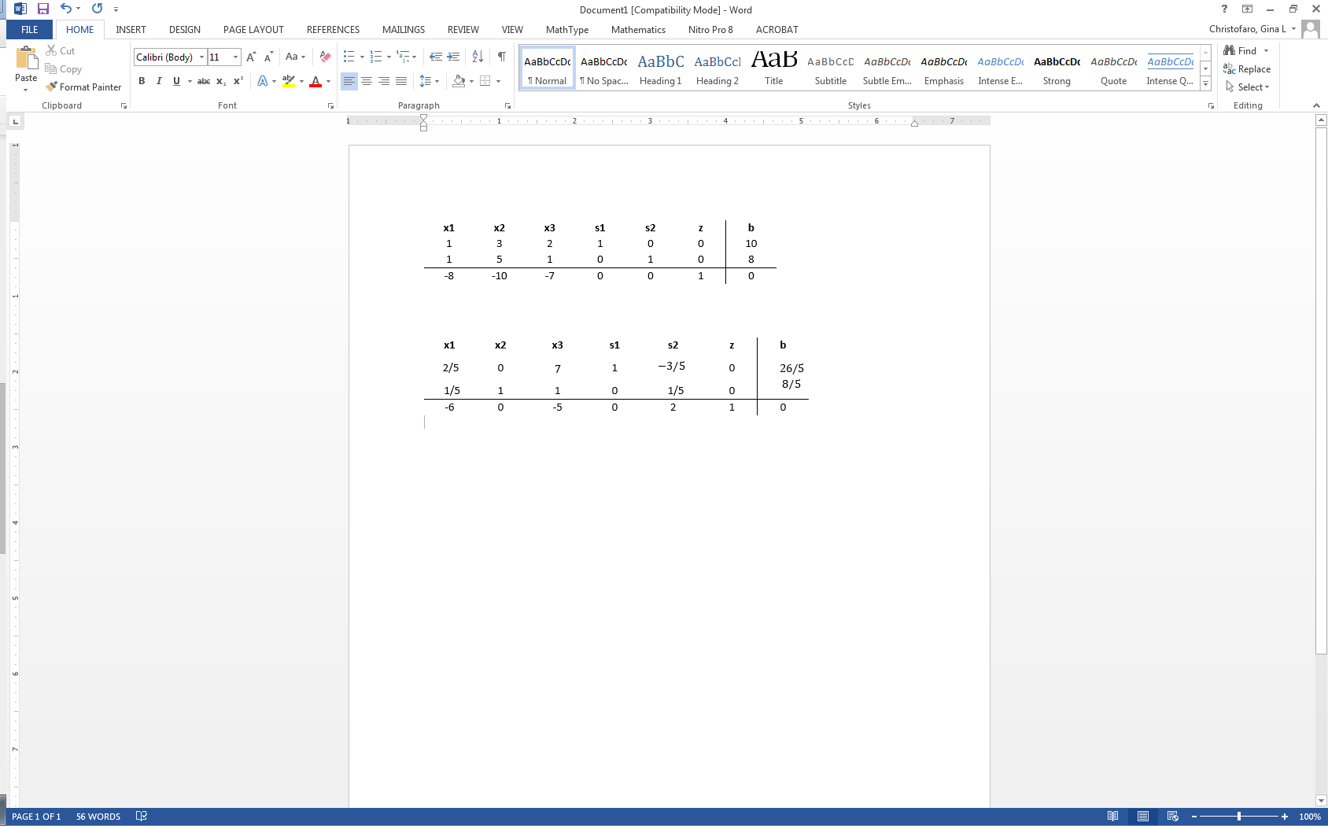

Once the tableau has been completed, the model can be checked for an optimal solution as shown in Step 4.

**Step 4: Check Optimality**

The optimal solution of a maximization linear programming model are the values assigned to the variables in the objective function to give the largest zeta value. The optimal solution would exist on the corner points of the graph of the entire model. To check optimality using the tableau, all values in the last row must contain values greater than or equal to zero. If a value is less than zero, it means that variable has not reached its optimal value. As seen in the previous tableau, three negative values exists in the bottom row indicating that this solution is not optimal. If a tableau is not optimal, the next step is to identify the pivot variable to base a new tableau on, as described in Step 5.

**Step 5: Identify Pivot Variable**

The pivot variable is used in row operations to identify which variable will become the unit value and is a key factor in the conversion of the unit value. The pivot variable can be identified by looking at the bottom row of the tableau and the indicator. Assuming that the solution is not optimal, pick the smallest negative value in the bottom row. One of the values lying in the column of this value will be the pivot variable. To find the indicator, divide the beta values of the linear constraints by their corresponding values from the column containing the possible pivot variable. The intersection of the row with the smallest non-negative indicator and the smallest negative value in the bottom row will become the pivot variable.

In the example shown below, -10 is the smallest negative in the last row. This will designate the *x2* column to contain the pivot variable. Solving for the indicator gives us a value of for the first constraint, and a value of for the second constraint. Due to being the smallest non-negative indicator, the pivot value will be in the second row and have a value of 5.

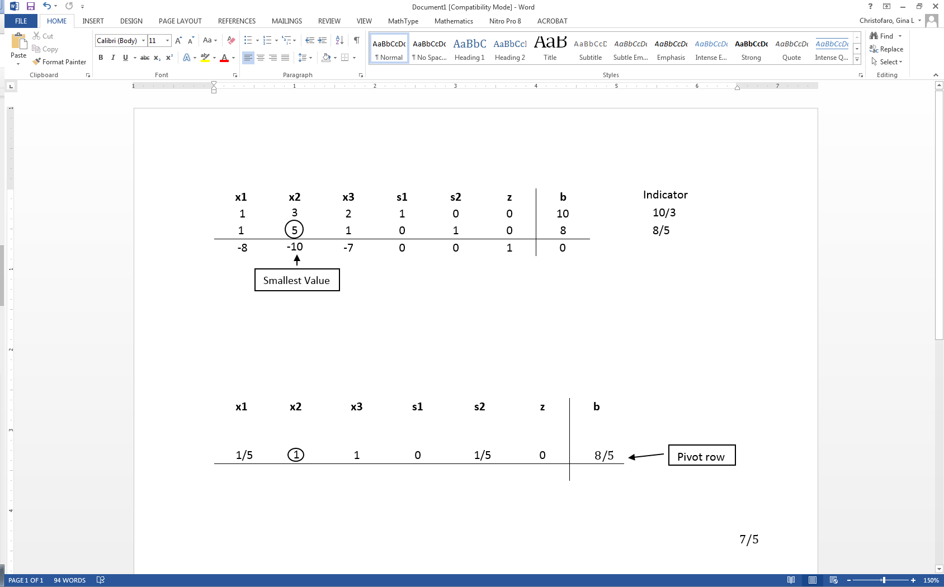

Now that the new pivot variable has been identified, the new tableau can be created in Step 6 to optimize the variable and find the new possible optimal solution.

**Step 6: Create the New Tableau**

The new tableau will be used to identify a new possible optimal solution. Now that the pivot variable has been identified in Step 5, row operations can be performed to optimize the pivot variable while keeping the rest of the tableau equivalent.

1. To optimize the pivot variable, it will need to be transformed into a unit value (value of 1). To transform the value, multiply the row containing the pivot variable by the reciprocal of the pivot value. In the example below, the pivot variable is originally 5, so multiply the entire row by .

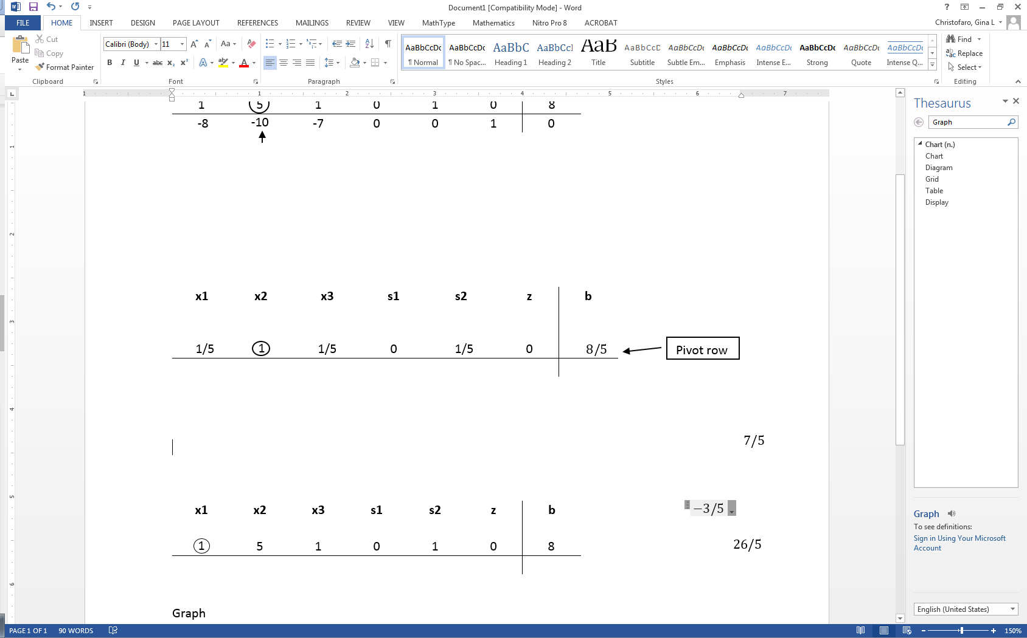

1. After the unit value has been determined, the other values in the column containing the unit value will become zero. This is because the x2 in the second constraint is being optimized, which requires x2 in the other equations to be zero.

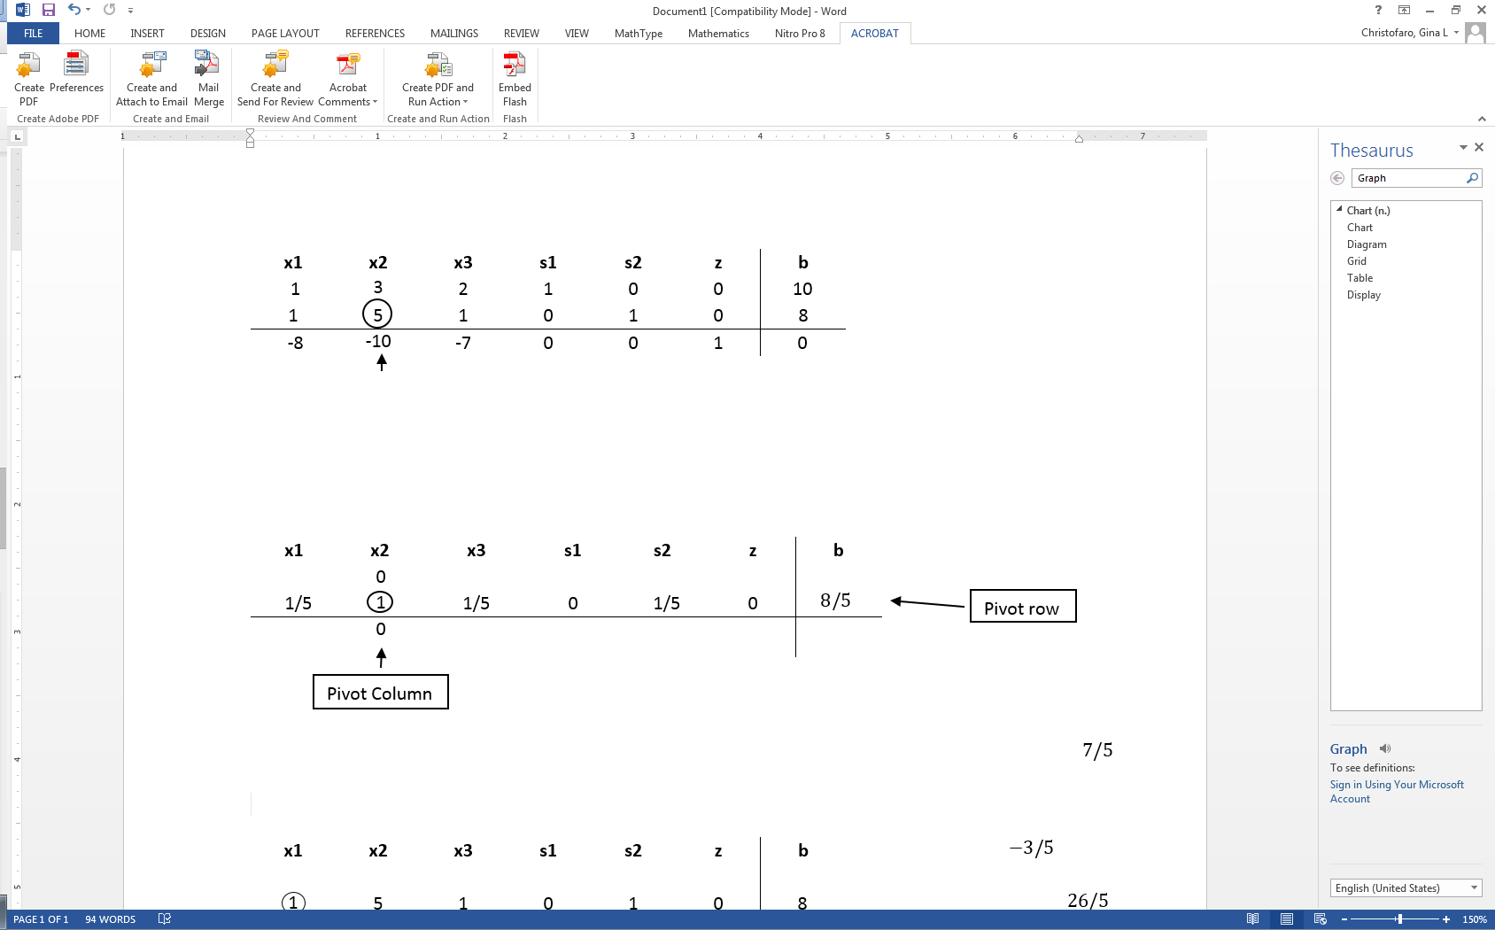

1. In order to keep the tableau equivalent, the other variables not contained in the pivot column or pivot row must be calculated by using the new pivot values. For each new value, multiply the negative of the value in the old pivot column by the value in the new pivot row that corresponds to the value being calculated. Then add this to the old value from the old tableau to produce the new value for the new tableau. This step can be condensed into the equation on the next page:

New tableau value = (Negative value in old tableau pivot column) x (value in new tableau pivot row) + (Old tableau value)

***Old Tableau:***

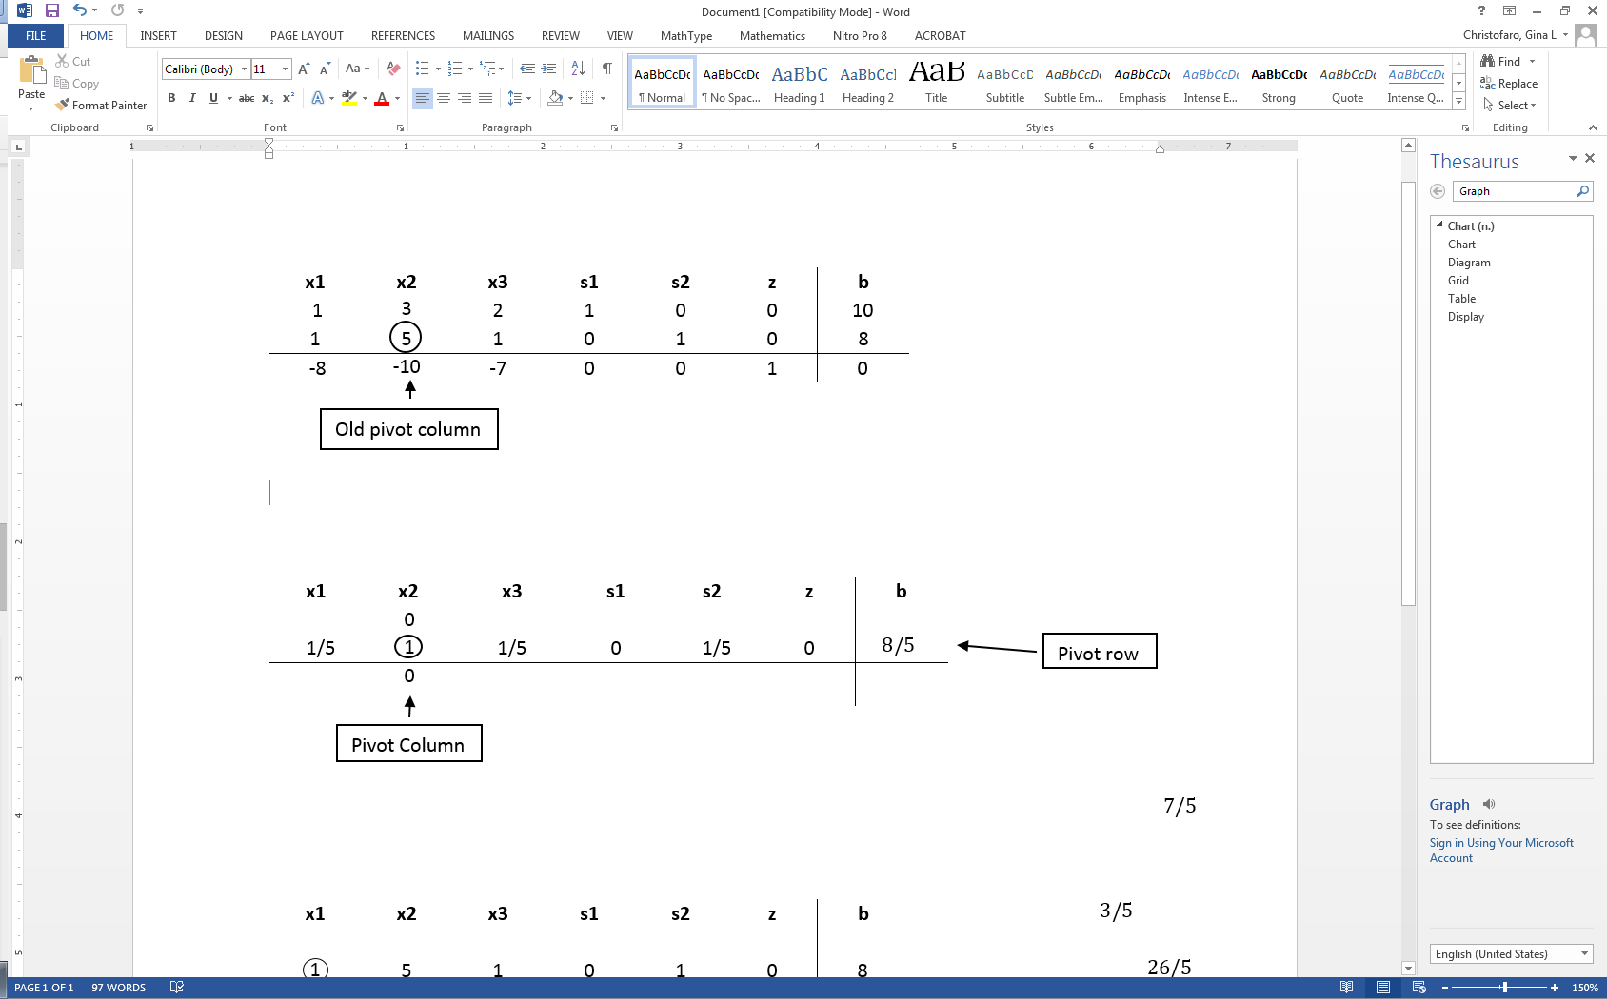

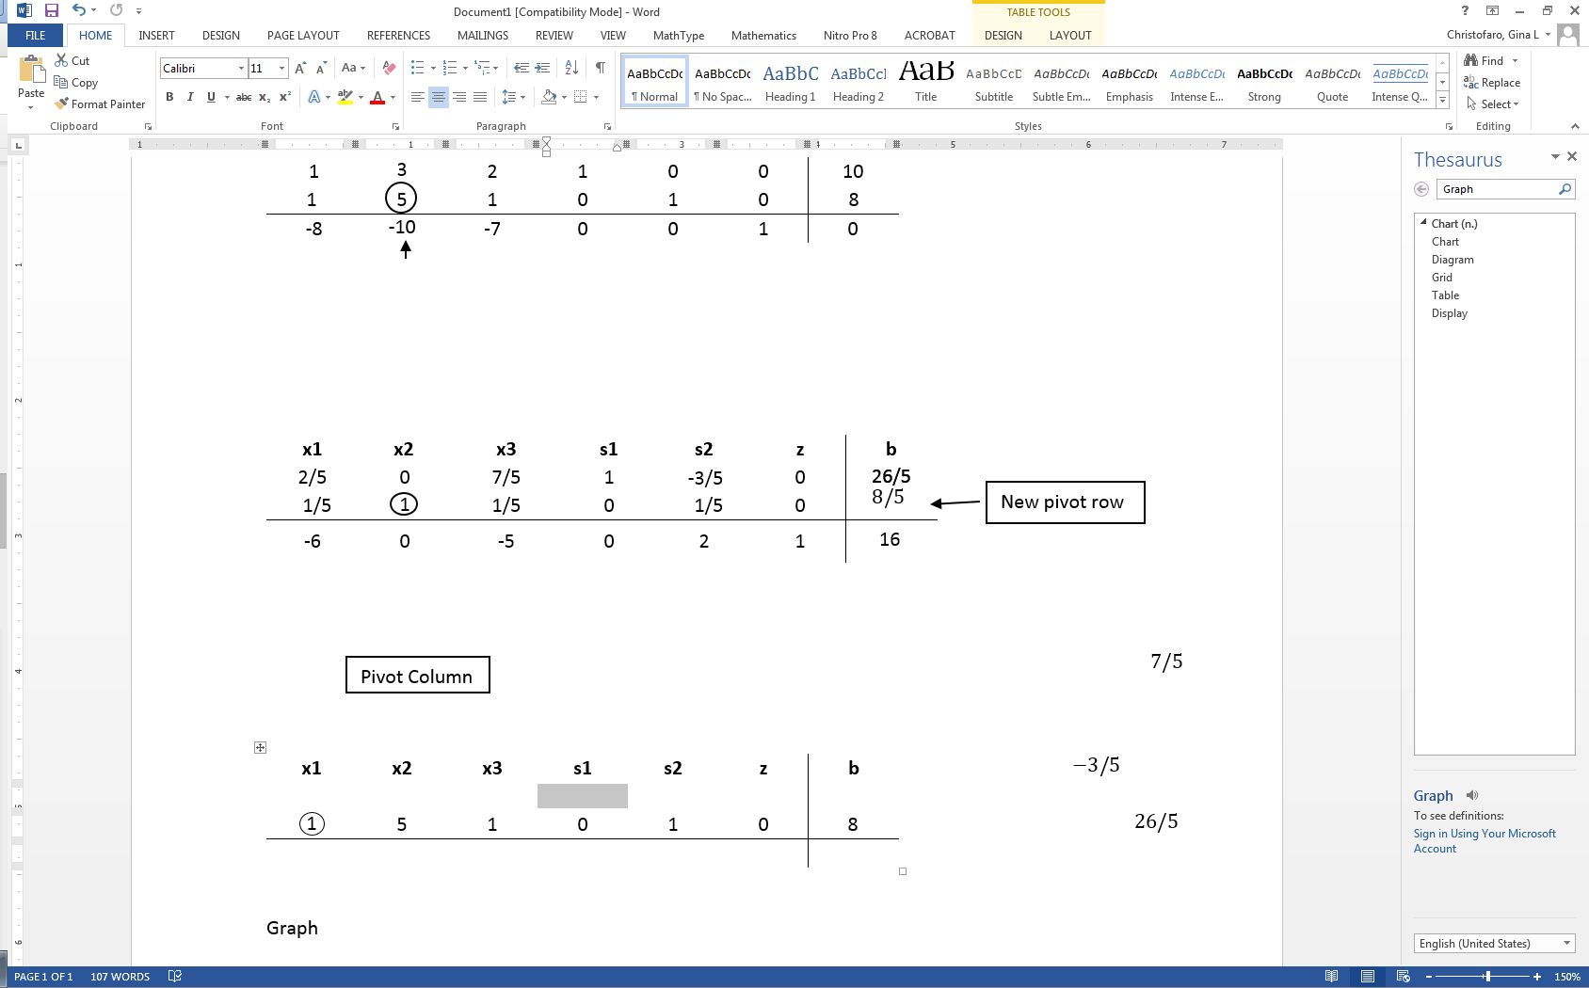***New Tableau:***

Numerical examples are provided below to help explain this concept a little better.

***Numerical examples:***

1. *To find the s2 value in row 1:*

New tableau value = (Negative value in old tableau pivot column) * (value in new tableau pivot row) + (Old tableau value)

New tableau value = (-3) * () + 0 = -

1. *To find the x1 variable in row 3:*

New tableau value = (Negative value in old tableau pivot column) * (value in new tableau pivot row) + (Old tableau value)

New value = (10) * () + -8 = -6

Once the new tableau has been completed, the model can be checked for an optimal solution.

**Step 7: Check Optimality**

As explained in Step 4, the optimal solution of a maximization linear programming model are the values assigned to the variables in the objective function to give the largest zeta value. Optimality will need to be checked after each new tableau to see if a new pivot variable needs to be identified. A solution is considered optimal if all values in the bottom row are greater than or equal to zero. If all values are greater than or equal to zero, the solution is considered optimal and Steps 8 through 11 can be ignored. If negative values exist, the solution is still not optimal and a new pivot point will need to be determined which is demonstrated in Step 8.

**Step 8: Identify New Pivot Variable**

If the solution has been identified as not optimal, a new pivot variable will need to be determined. The pivot variable was introduced in Step 5 and is used in row operations to identify which variable will become the unit value and is a key factor in the conversion of the unit value. The pivot variable can be identified by the intersection of the row with the smallest non-negative indicator and the smallest negative value in the bottom row.

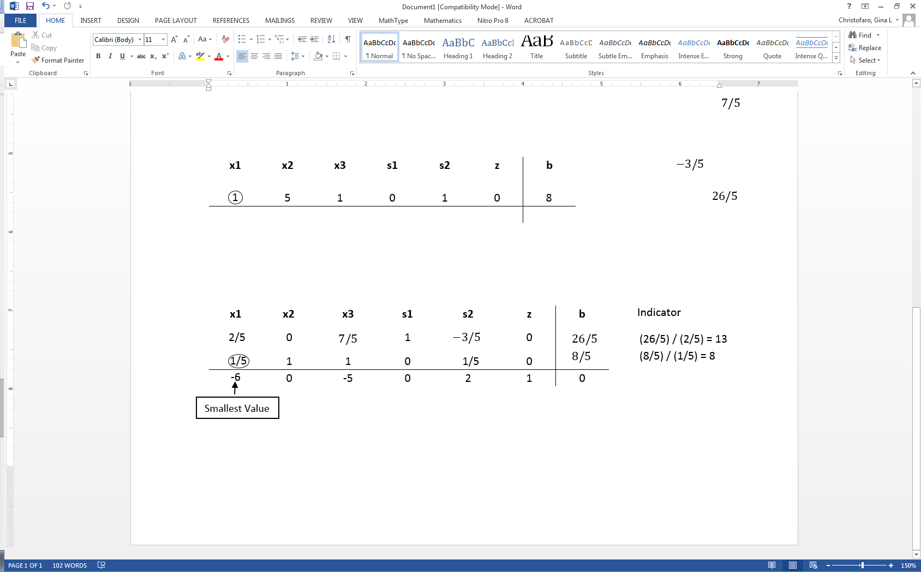

With the new pivot variable identified, the new tableau can be created in Step 9.

**Step 9: Create New Tableau**

After the new pivot variable has been identified, a new tableau will need to be created. Introduced in Step 6, the tableau is used to optimize the pivot variable while keeping the rest of the tableau equivalent.

1. Make the pivot variable 1 by multiplying the row containing the pivot variable by the reciprocal of the pivot value. In the tableau below, the pivot value was , so everything is multiplied by 5.

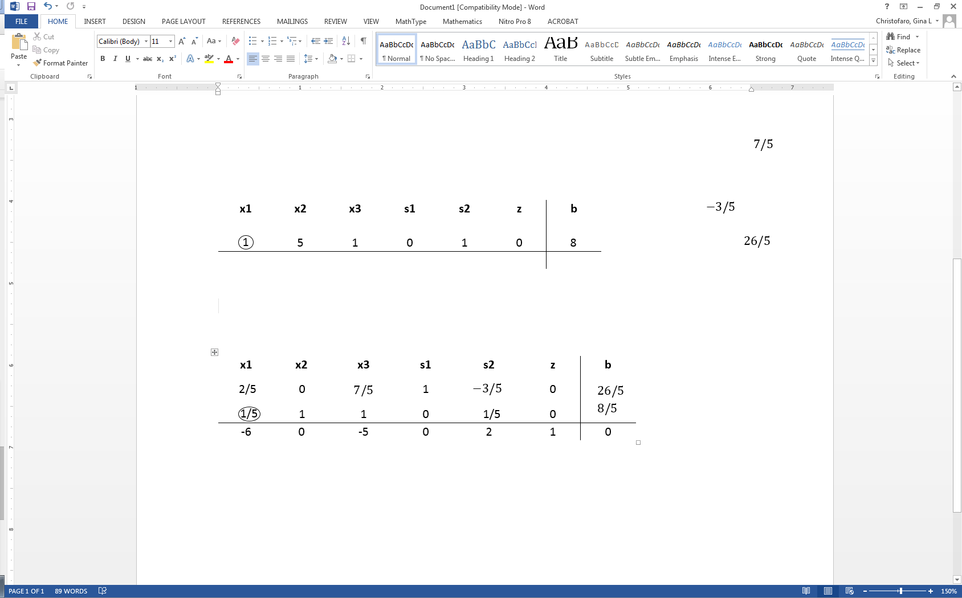

1. Next, make the other values in the column of the pivot variable zero. This is done by taking the negative of the old value in the pivot column and multiplying it by the new value in the pivot row. That value is then added to the old value that is being replaced.

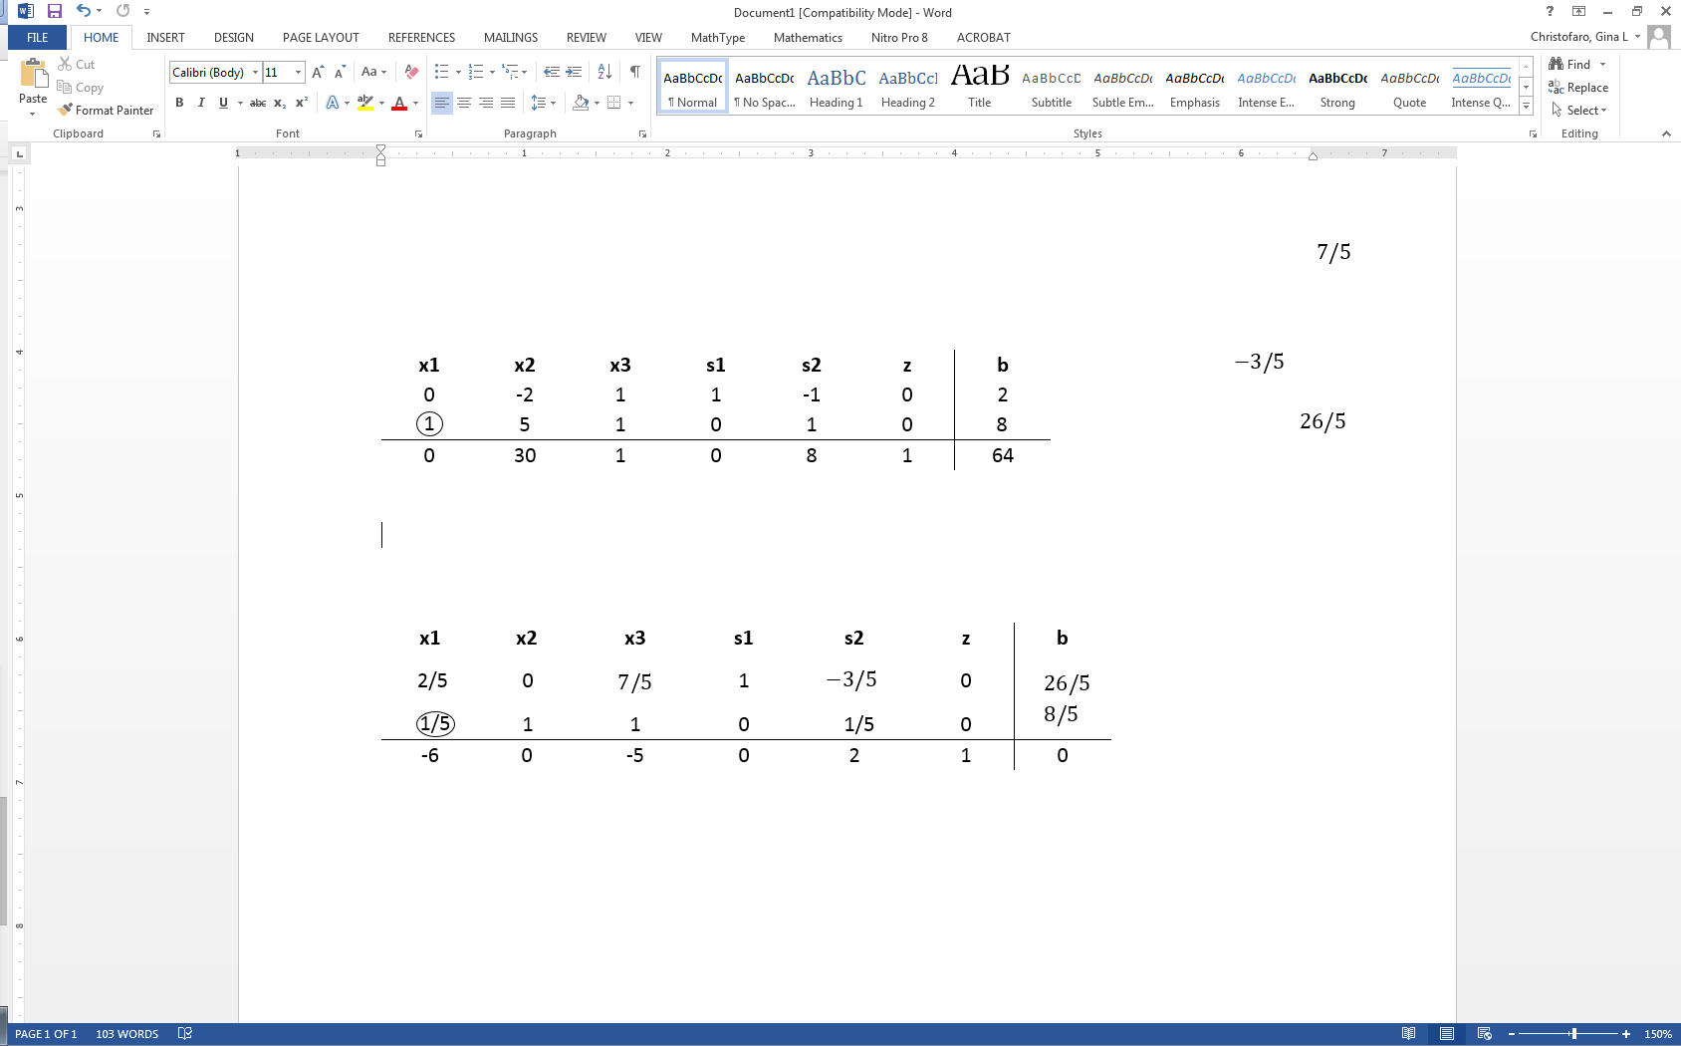

**Step 10: Check Optimality**

Using the new tableau, check for optimality. Explained in Step 4, an optimal solution appears when all values in the bottom row are greater than or equal to zero. If all values are greater than or equal to zero, skip to Step 12 because optimality has been reached. If negative values still exist, repeat steps 8 and 9 until an optimal solution is obtained.

**Step 11: Identify Optimal Values**

Once the tableau is proven optimal the optimal values can be identified. These can be found by distinguishing the basic and non-basic variables. A basic variable can be classified to have a single 1 value in its column and the rest be all zeros. If a variable does not meet this criteria, it is considered non-basic. If a variable is non-basic it means the optimal solution of that variable is zero. If a variable is basic, the row that contains the 1 value will correspond to the beta value. The beta value will represent the optimal solution for the given variable.

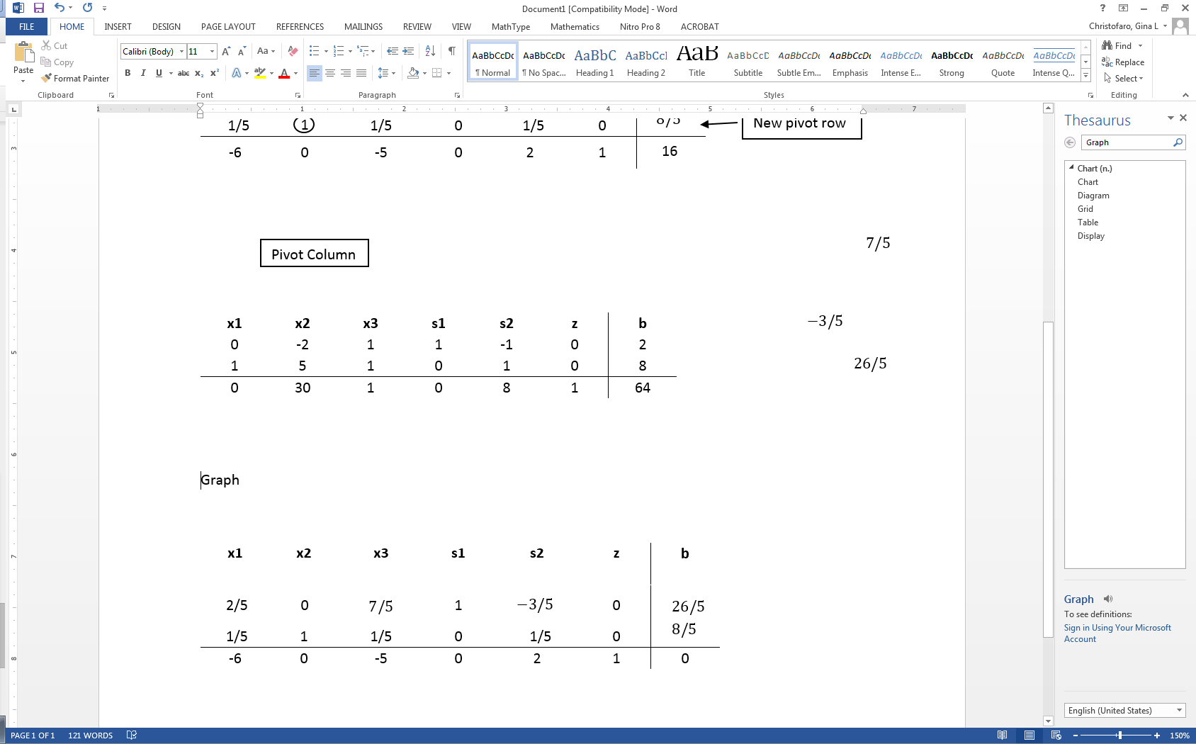

Basic variables: x1, s1, z

Non-basic variables: x2, x3, s2

For the variable x1, the 1 is found in the second row. This shows that the optimal x1 value is found in the second row of the beta values, which is 8.

Variable s1 has a 1 value in the first row, showing the optimal value to be 2 from the beta column. Due to s1 being a slack variable, it is not actually included in the optimal solution since the variable is not contained in the objective function.

The zeta variable has a 1 in the last row. This shows that the maximum objective value will be 64 from the beta column.

The final solution shows each of the variables having values of:

|  |  |  |  |
| --- | --- | --- | --- |
| x1 | = 8 | s1 | = 2 |
| x2 | = 0 | s2 | = 0 |
| x3 | = 0 | z | = 64 |

The maximum optimal value is 64 and found at (8, 0, 0) of the objective function.

**Conclusion**

The Simplex method is an approach for determining the optimal value of a linear program by hand. The method produces an optimal solution to satisfy the given constraints and produce a maximum zeta value. To use the Simplex method, a given linear programming model needs to be in standard form, where slack variables can then be introduced. Using the tableau and pivot variables, an optimal solution can be reached. From the example worked throughout this document, it can be determined that the optimal objective value is 64 and can be found when x1=8, x2=0, and x3=0.

**Glossary**

**Basic variables** are variables that are non-negative in terms of the optimal solution.

**Constraints** are a series of equalities and inequalities that are a set of criteria necessary to satisfy when finding the optimal solution.

**Inequality** is an expression that does not have one definite solution and is distinguishable by its ‘greater than’ or ‘less than’ symbols in the place of a traditional equal sign.

**Linear program** is a model used to achieve the best outcome given a maximum or minimum equation with linear constraints.

**Non-basic variables** are variables that are zero in terms of the optimal solution.

**Optimal solution** of a maximization linear programming model are the values assigned to the variables in the objective function to give the largest zeta value. The optimal solution would exist on the corner points of the graph of the entire model.

**Pivot variable** is used in row operations to identify which variable will become the unit value and is a key factor in the conversion of the unit value.

**Simplex method** is an approach to solving linear programming models by hand using slack variables, tableaus, and pivot variables as a means to finding the optimal solution of an optimization problem.

**Simplex tableau** is used to perform row operations on the linear programming model as well as for checking optimality.

**Slack variables** are additional variables that are introduced into the linear constraints of a linear program to transform them from inequality constraints to equality constraints.

**Standard form** is the baseline format for all linear programs before solving for the optimal solution.