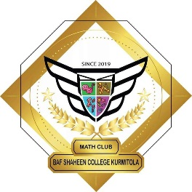

BAFSK MATH CLUB
Alumni Association
BAF Base Bir Uttom A.K. Khandker, Dhaka Cantonment, Dhaka-1206.
Contact: 01871634084, 01309589454

Date : 22-07-2025

Excited to Serve – Presenting Our Panel for BAFSKMC Alumni Association:

Name | Designation | Previous Working Position | Membership Id
1.Abdur Rahman Rafi | Chairman | Former President (20-21) | BAFSK2020MC01
2.Sazzad Ur Rahman | Vice-Chairman | Former VP (21-22) | BAFSK2021MC01
3.Mehzab Galib | Secretary-General | Former VP (22-23) | BAFSK2022MC01
4.Anika Niha | Deputy Secretary | Former VP(20-21) | BAFSK2020MC02
5.Erteza Ershad Samar | Administrative Secretary | Former OS (21-22) | BAFSK2021MC02
6.Nazia Tabassum | Chief Strategy Officer | Former VP (21-22) | BAFSK2021MC03
7.Srabony Akter Mim | Director Of Alumni Relations | Former AGS (21-22) | BAFSK2021MC04
8.Kazi Mehjabin Islam | Head Of Academic Affairs | Former President (21-22) | BAFSK2021MC05
9. Md Hamza | Chief Advisor | Former VP(22-23) | BAFSK2022MC02
10.Sahil Islam Siam | Senior Advisor | Former GS (20-21) | BAFSK2020MC03
11.Radi Billah | Asst. Senior Advisor | Former VP(23-24) | BAFSK2023MC01
12.Nadia Islam Nura | Fundraising Officer | Former AGS (22-23) | BAFSK2022MC03
13. Md Shafiul Hasan | Club Controller | Former President (23-24) | BAFSK2023MC02
14. Md Nazmuz Sakib | Alumni Engagement Coordinator | Former VP(23-24) | BAFSK2023MC03
15.Samirah Saba Nesa | Club Monitor | Former VP (23-24) | BAFSK2023MC04
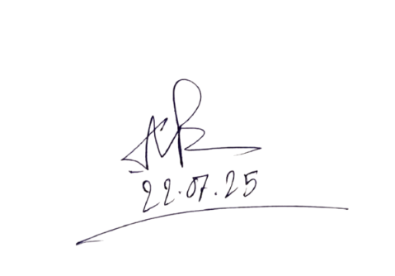
Name | Designation
- Khairul Islam Swapon | Human Resource
- Rahat Ehsan | Chief Executive Moderator

Chairman of the Association

