RentalPro
Digital Rental Management System
DELIVERABLE 5
Feature Completion Report

Field | Details
Student Name | Abdur-Rahmaan Muhammad Ali
Student ID | ST10201821
Course Code | IT401
Project Name | RentalPro — Digital Rental Management System
Deliverable | Deliverable 5 — Feature Completion (closing the gaps between Deliverable 3 and the SRS)
Version | v1.0 — September 2026
Sections | Introduction · Gap Analysis · Implementation · Design and Data Changes · Testing · Requirements Traceability · Conclusion
Appendix | Appendix A — Verifying the Deliverable 5 Features
Prior Deliverables | Deliverable 1 — SRS · Deliverable 2 — UML & Database Design · Deliverable 3 — Partially-Developed Application · Deliverable 4 — Complete Project Report

Table of Contents
1. Introduction 3
1.1 Purpose of Deliverable 5 3
1.2 Starting Point 3
1.3 Approach 3
1.4 Results at a Glance 3
2. Gap Analysis 5
2.1 How the Gaps Were Found 5
2.2 The Eleven Gaps 5
3. Implementation 6
3.1 Editing Units and Occupancy Rules (FR-004, FR-005) 6
3.2 Property and Unit Photos (FR-003) 6
3.3 Maintenance Photos (FR-028) 7
3.4 Tenant ID Document and Lease Download (UC-07, UC-10, FR-012) 7
3.5 Tenant Blacklisting (FR-016) 7
3.6 Administrator User and Role Management (UC-02) 8
3.7 Staff Account Creation (FR-044) 9
3.8 Configurable Late Fees (FR-022) 10
3.9 Rent History CSV Export (UC-17) 10
3.10 Excel Report Export (FR-043) 11
4. Design and Data Changes 13
4.1 Data Model 13
4.2 One Validator and One Storage Gateway 13
4.3 Access Control on the New Routes 13
4.4 Audit Trail 14
5. Testing 15
5.1 The Deliverable 5 Test Module 15
5.2 Results 15
6. Requirements Traceability 16
6.1 Summary 18
7. Conclusion 19
7.1 What Deliverable 5 Achieved 19
7.2 Remaining Work 19
7.3 What Came Next 19
Appendix A: Verifying the Deliverable 5 Features 21
A.1 Run the Tests 21
A.2 Try Them in the Application 21

1. Introduction

1.1 Purpose of Deliverable 5
Deliverable 3 delivered a working RentalPro application in which every one of the 25 use cases from the Software Requirements Specification (SRS) had a route, a screen and at least one automated test. A use case being reachable, however, is not the same as every functional requirement behind it being met. Deliverable 5 closed that remaining distance: it audited the running application against all 44 functional requirements (FR-001 to FR-044) and the 25 use cases, identified what was missing or only partly built, and implemented, tested and documented each gap.
This report records that work: what the gaps were (Section 2), how each one was closed (Section 3), what it changed in the design and data model (Section 4), how it was tested (Section 5), and where every functional requirement now stands (Section 6).

1.2 Starting Point
At the start of Deliverable 5 the application already covered authentication and role-based access, property and unit creation, tenant onboarding and invitations, lease upload, rent recording and statements, online payment in dev mode, the maintenance lifecycle, the four background jobs and portfolio reporting, verified by 93 automated tests. The audit found eleven places where the SRS asked for more than the application did — for example, units could be created but not edited afterwards, no photos could be attached anywhere, and there was no way to blacklist a tenant, configure a late fee, or manage users as an administrator.

1.3 Approach
- Audit first. Each FR and use case was read against the routes, templates and tests of the running application, and every shortfall was written down with the requirement it failed.
- One vertical slice per gap. Each gap was built end to end — model fields, route, template, access control, audit logging and tests — and checked in the browser before moving to the next.
- Additive changes only. Every change added fields with safe defaults or new routes; nothing existing was renamed or removed, so the 13-table schema and all 93 existing tests stayed valid.
- Re-verify the documents. Once the code was complete, Deliverables 3 and 4 were re-audited against it and their text, diagrams and figures corrected.

1.4 Results at a Glance
Measure | Before Deliverable 5 | After Deliverable 5
Gaps against the SRS | 11 identified | 11 closed
Use cases with a route, screen and test | 25 / 25 | 25 / 25
Database tables | 13 | 13 (new fields only, no new tables)
Automated tests | 93 | 124 (31 new, in tests/test_deliverable5.py)
Statement coverage | — | 79%
Test failures | 0 | 0

Note on later work: since Deliverable 5 the system has grown further — a billing engine, a property map, a redesigned Harare interface, Harare demonstration data, and English, Shona and Arabic interface languages (see Deliverable 4, Appendix C, and the Deliverable 6 report). Two requirements this report records as met after Deliverable 5 — a tenant history per unit (FR-015) and a maintenance summary per period (FR-036) — were completed in September 2026 (Section 7.3). Today the suite has 244 tests at 83% coverage, and all 31 Deliverable 5 tests still pass. Screenshots in this report were taken from the current application, so they show the newer interface around the Deliverable 5 features.

2. Gap Analysis

2.1 How the Gaps Were Found
Every functional requirement was checked in three ways: is there a route or scheduled job that performs it; does a user of the right role reach it from the interface; and does an automated test prove it. A requirement failing any of the three was recorded as a gap. The use cases were then re-read the same way, which added the lease-document download (UC-10) and CSV export (UC-17) — both named in a use case but not in a single FR on their own.

2.2 The Eleven Gaps
# | Gap | Requirement | Before Deliverable 5
1 | Edit an existing unit’s details and status | FR-005, FR-004, UC-04 | Units could be created but never edited
2 | Property photos (up to 10) and unit photos (up to 5) | FR-003 | No photo storage anywhere
3 | Maintenance photos on submission and on completion (up to 3 each) | FR-028, UC-18, UC-20 | Text-only requests
4 | Tenant ID document upload | UC-07 | Not captured
5 | Lease document download for management and the tenant | UC-10, FR-012 | Uploaded PDFs could not be retrieved
6 | Blacklist / unblacklist a tenant, blocking future leases | FR-016 | Not available
7 | Administrator user and role management | UC-02 | Roles could only be set in the database
8 | Staff account creation with a welcome email | FR-044 | Only tenant accounts could be created
9 | Configurable late fees per property (fixed or percentage) | FR-022 | No late fees
10 | CSV export of a lease’s rent history | UC-17 | On-screen history only
11 | Excel export of the portfolio report | FR-043, UC-25 | PDF export only

3. Implementation
Each subsection below states the requirement, what was built, the rules the system now enforces, and where it lives in the code.

3.1 Editing Units and Occupancy Rules (FR-004, FR-005)
A new Edit Unit form (/properties/<id>/units/<id>/edit) lets an Owner, Manager or Administrator change a unit’s floor, type, size, monthly rent and deposit at any time, add photos, and set its status. Two rules keep the occupancy figures honest:
- A unit cannot be set to Occupied by hand — it becomes Occupied only when a lease is activated against it.
- A unit with an active lease cannot be set back to Vacant; the status field is locked and explains why.
- Under Maintenance can be set freely on a vacant unit, so a unit being repaired is not offered to new tenants.
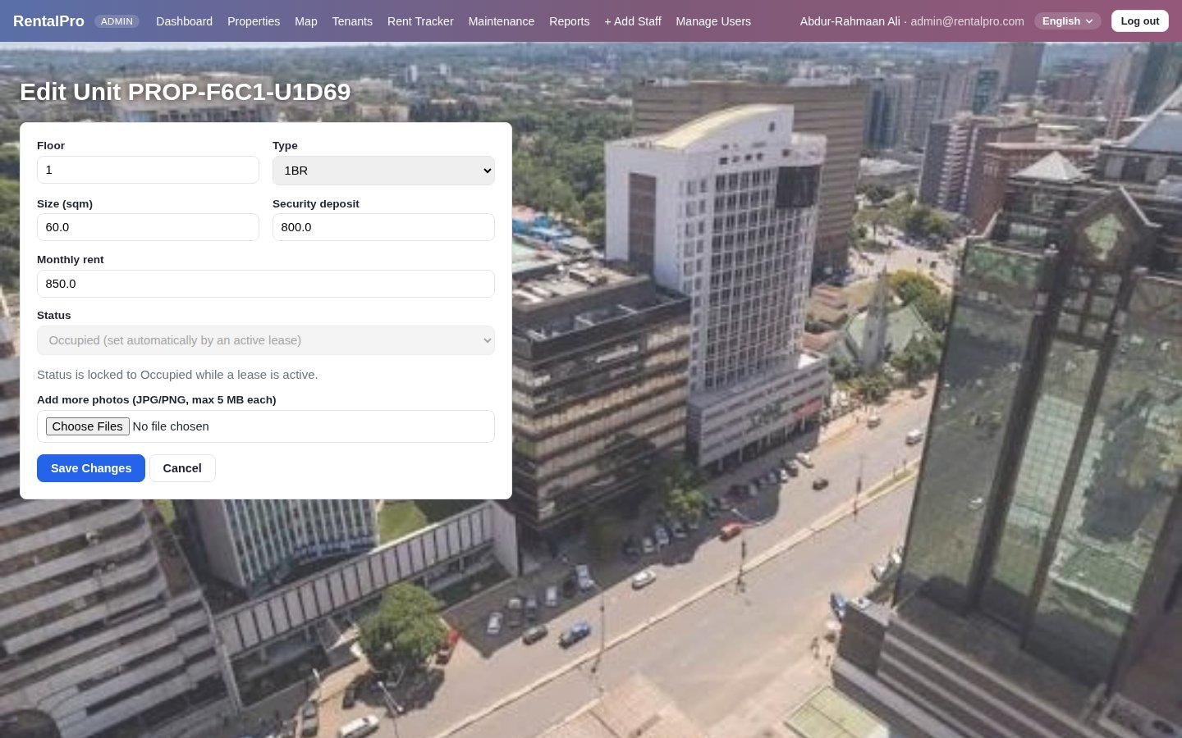
Figure 1: Edit Unit — the status is locked while a lease is active

3.2 Property and Unit Photos (FR-003)
The Add/Edit Property form accepts up to 10 photos per property, and the Add/Edit Unit forms up to 5 per unit, matching the SRS limits exactly. The limit counts photos already stored, so a property with 8 photos can take only 2 more. Each file must be a genuine JPEG or PNG of at most 5 MB: the system reads the file’s first bytes and compares them with the JPEG (FF D8 FF) and PNG (89 50 4E 47) signatures, so a renamed PDF or executable is rejected whatever its extension. Rejected files are reported by name rather than silently dropped.
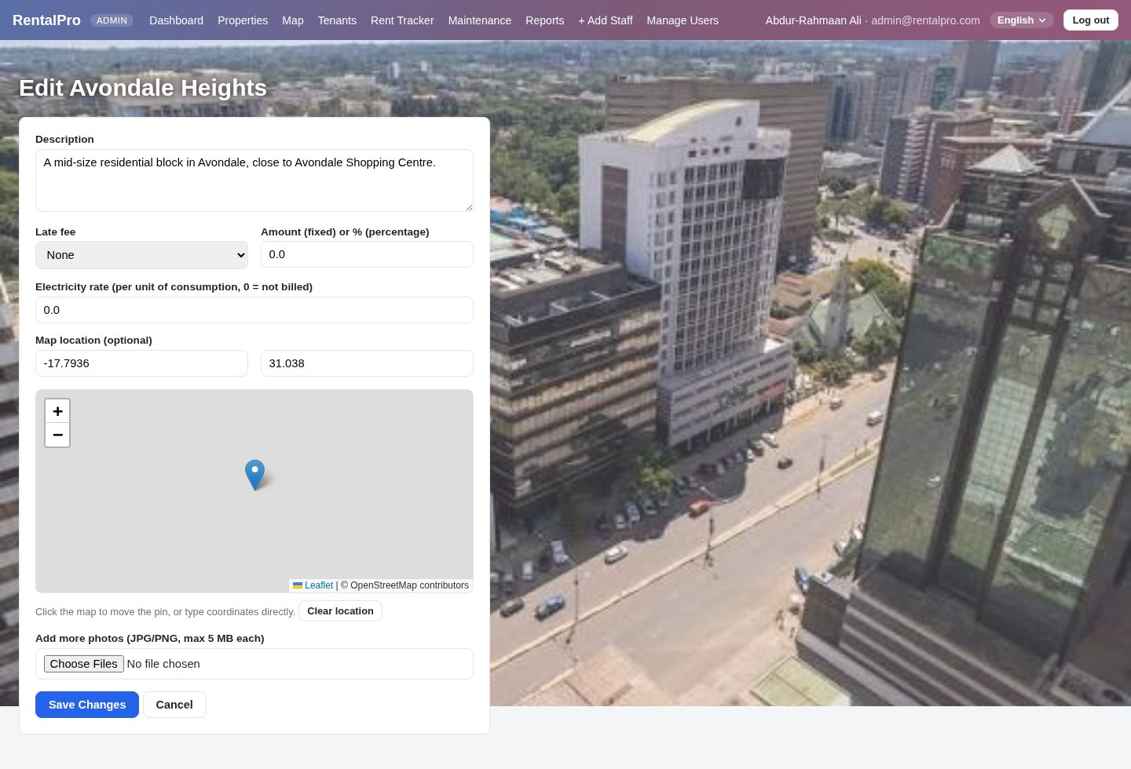
Figure 2: Edit Property — late-fee settings and the photo upload (up to 10, JPG/PNG, 5 MB each)

3.3 Maintenance Photos (FR-028)
A tenant can attach up to 3 photos when submitting a maintenance request, so staff can see the problem before they arrive, and the assigned staff member can attach up to 3 completion photos when marking the work done. Both sets appear on the ticket for the tenant and for management, and are served only to users allowed to see that ticket.

3.4 Tenant ID Document and Lease Download (UC-07, UC-10, FR-012)
The Create Tenant Profile form now accepts an identification document (JPEG, PNG or PDF, up to 10 MB). Signed lease PDFs, which could already be uploaded, can now be downloaded again — by management, or by the tenant the lease belongs to. Both documents are served through authenticated routes that check the requester’s role and, for a tenant, that the document is their own (assert_tenant_self), so one tenant can never open another’s ID or lease.

3.5 Tenant Blacklisting (FR-016)
An Owner, Manager or Administrator can flag a tenant as blacklisted from the tenant’s profile. A reason is required and is shown wherever the flag appears. While the flag is set, the tenant cannot be given a new lease — the lease-upload form refuses with the reason — but a lease already in force is left alone, as the SRS asks only for future leases to be prevented. Removing the flag is one click, and both actions are written to the audit log.
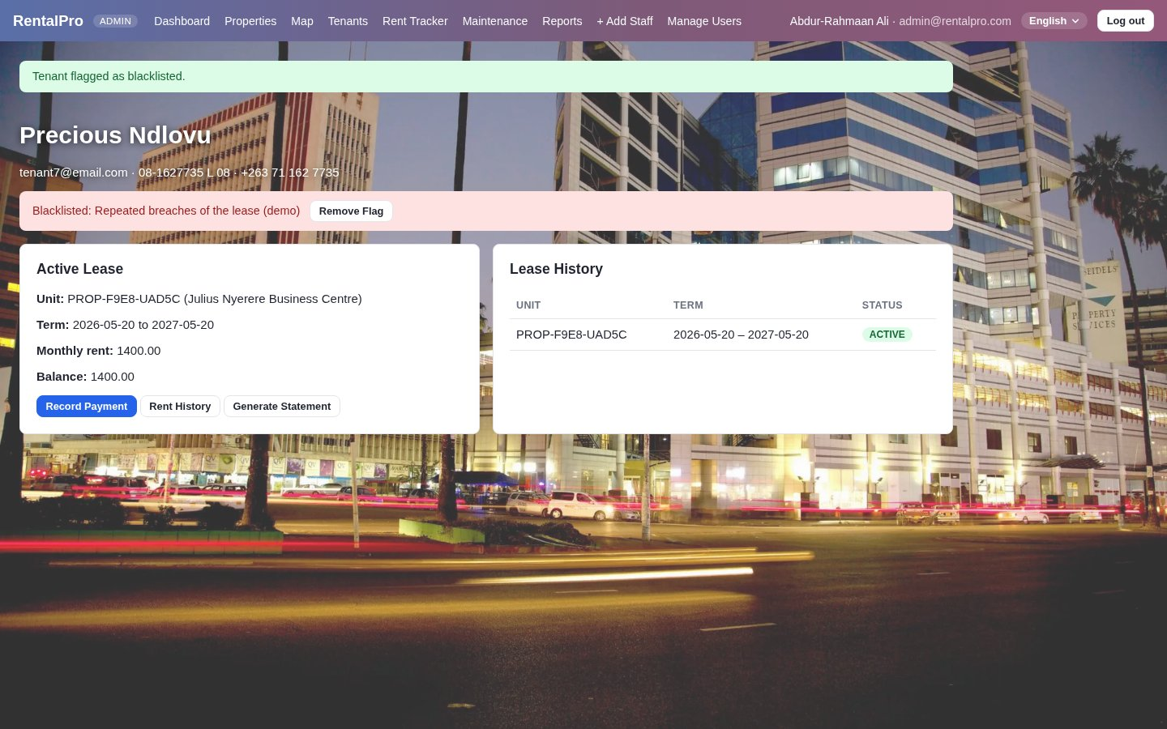
Figure 3: A blacklisted tenant — the reason is shown with a Remove Flag action; the current lease is unaffected

3.6 Administrator User and Role Management (UC-02)
The Manage Users & Roles console (/admin/users, Administrator only) lists every account with its role and status, and lets the Administrator change a role or deactivate an account; a deactivated account cannot log in. One safeguard protects the portfolio: the system will not demote or deactivate the last active Property Owner, since nobody would then be able to add properties. Every change is audited with the old and new values, and the affected user is emailed.
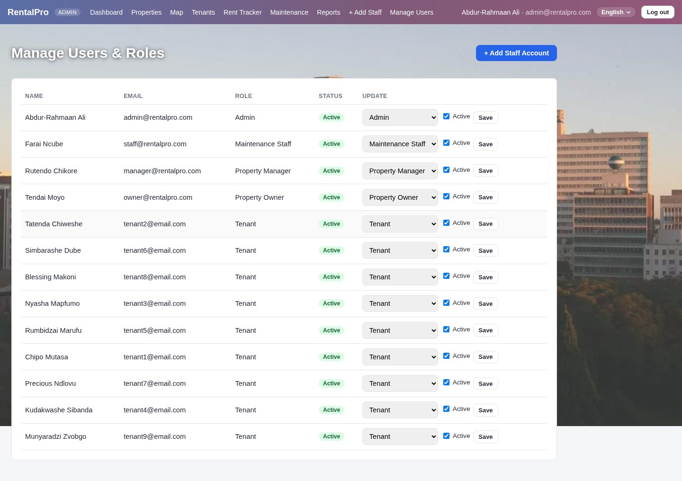
Figure 4: Manage Users & Roles — role and active status for every account

3.7 Staff Account Creation (FR-044)
Owners, Managers and Administrators can create a Maintenance Staff account from “+ Add Staff”. The new user receives a welcome email with a link to set their own password, valid for 24 hours; an Administrator can later change the account’s role in the console if it should be a Manager instead. The SRS asks for a welcome email “with login credentials”; RentalPro deliberately sends a set-password link instead, so no password is ever sent by email.
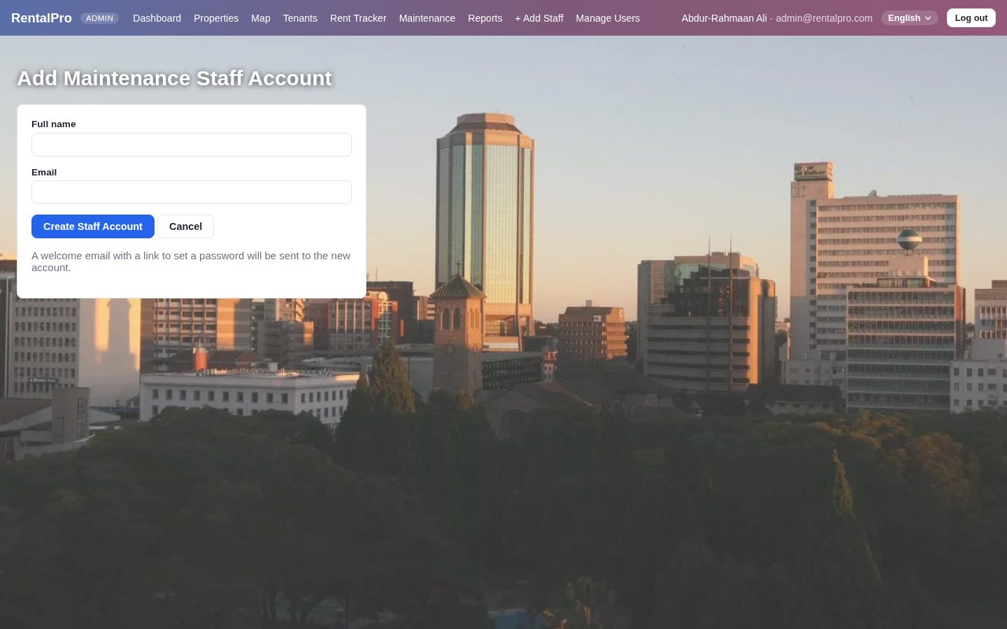
Figure 5: Add Maintenance Staff Account

3.8 Configurable Late Fees (FR-022)
Each property now has a late-fee type — None, Fixed or Percentage — and an amount (Figure 1). The fee is calculated, never stored, by Lease.late_fee_due():
- It is zero unless the current billing period is past its due date and the lease is not fully paid for the periods due so far.
- A Fixed fee adds the configured amount; a Percentage fee adds that percentage of the lease’s current monthly rent.
- The fee is folded into the lease balance, so it shows on the rent tracker, statements and the tenant portal, and disappears once the overdue amount is paid.
- New properties default to None, so no existing lease changed when the feature was introduced.
Example: a $850 lease on a property with a 5% late fee, unpaid past its due date, carries a $42.50 fee (850 × 5%); with a Fixed fee of $25 it carries $25.

3.9 Rent History CSV Export (UC-17)
Every lease’s rent history page has an Export CSV button that downloads each payment’s date, type, amount, method, receipt number and notes — ready for a spreadsheet or accounting package. Management can export any lease they can see; a tenant can export only their own.
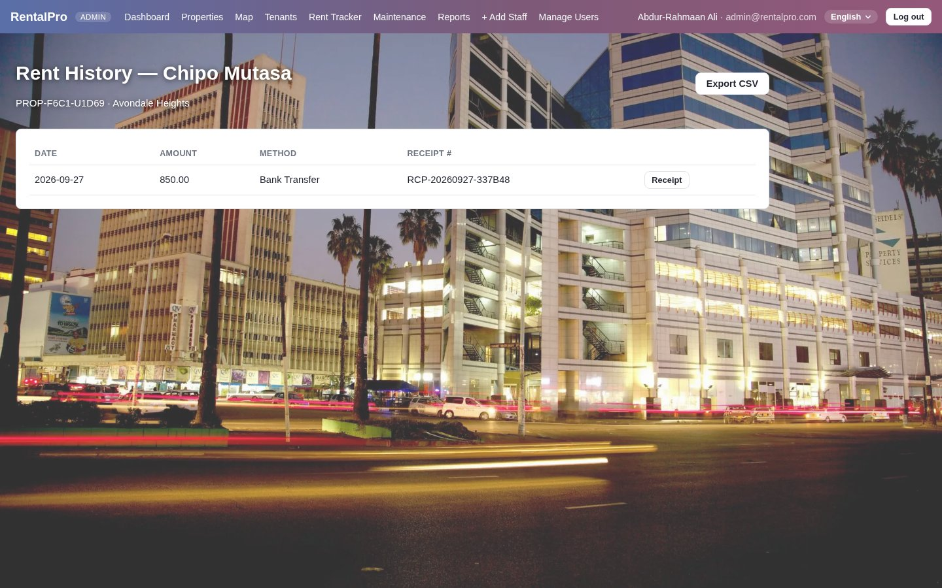
Figure 6: Rent history with the Export CSV button

3.10 Excel Report Export (FR-043)
The Property Performance Report, which could already be exported as PDF, can now also be exported as an Excel workbook, for the whole portfolio or a single property. The workbook has two sheets — Portfolio Summary and By Property — built with openpyxl, so an owner can sort, filter and chart the figures themselves.
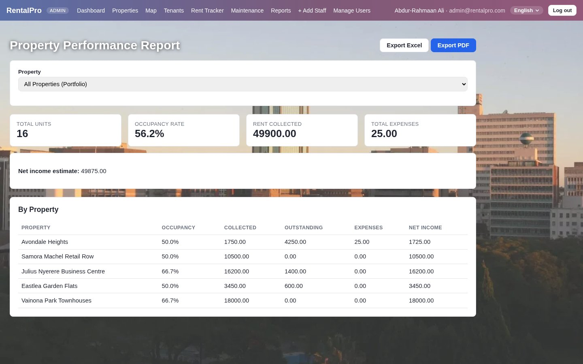
Figure 7: Property Performance Report with Export Excel and Export PDF

4. Design and Data Changes

4.1 Data Model
All eleven gaps were closed without a new table. Photos and documents are stored as file paths on the record they belong to, which kept the 13-table schema from Deliverable 2 intact:
Model | New field(s) | Type and default | Used by
Property | photo_paths | JSON list, default [] | Property photos (3.2)
Property | late_fee_type, late_fee_amount | NONE / FIXED / PERCENTAGE; amount 0 | Late fees (3.8)
Unit | photo_paths | JSON list, default [] | Unit photos (3.2)
Tenant | is_blacklisted, blacklist_reason | Boolean false; text up to 300 characters | Blacklisting (3.5)
Tenant | id_document_path | Text, nullable | ID document (3.4)
MaintenanceRequest | photo_paths, completion_photo_paths | JSON lists, default [] | Maintenance photos (3.3)
Lease | late_fee_due() (method, not a column) | Calculated | Balance with late fee (3.8)

4.2 One Validator and One Storage Gateway
All five upload points share the same two pieces of code rather than each having its own:
- validate_upload() in security.py checks the extension, the size limit for that field and the file’s magic bytes. It already existed for lease PDFs; Deliverable 5 extended it to JPEG and PNG.
- services/storage.py provides save_upload(), save_uploads() and serve_upload(). Files are saved under the uploads folder with generated names, and served only through routes that have already checked the user’s role and ownership. Moving to cloud storage later means changing this one module, not the routes.
Upload | Accepted types | Size limit | Count limit
Property photos | JPG, PNG | 5 MB each | 10 per property
Unit photos | JPG, PNG | 5 MB each | 5 per unit
Maintenance photos | JPG, PNG | 5 MB each | 3 on submission, 3 on completion
Tenant ID document | JPG, PNG, PDF | 10 MB | 1
Signed lease | PDF | 20 MB | 1 per lease

4.3 Access Control on the New Routes
Route | Roles allowed | Further check
/properties/<id>/edit, /properties/<id>/units/<id>/edit | Admin, Owner, Manager | assert_owner — an Owner edits only their own properties
/tenants/<id>/blacklist, /unblacklist | Admin, Owner, Manager | Reason required to blacklist
/tenants/<id>/id-document, /lease-document/<lease_id> | Management and Tenant | assert_tenant_self — a tenant sees only their own
/admin/users, /admin/users/<id>/edit | Admin only | Last active Owner cannot be removed
/admin/staff/add | Admin, Owner, Manager | Duplicate email rejected
/rent/<lease_id>/history.csv | Management and Tenant | assert_tenant_self
/reports/export.xlsx | Admin, Owner, Manager | assert_owner when a single property is chosen

Documents are served through these authenticated routes rather than through time-limited signed URLs (NFR-012). With files on local disk this gives the same protection — no URL works without a logged-in, authorised session — and signed URLs remain the natural choice once storage moves to the cloud.

4.4 Audit Trail
Each new action writes to the append-only audit log with the acting user and time: unit_updated, tenant_blacklisted, tenant_unblacklisted, user_role_changed (with the old and new role and status), staff_created, rent_history_exported and report_exported.

5. Testing

5.1 The Deliverable 5 Test Module
All eleven gaps are covered by tests/test_deliverable5.py — 31 tests that drive real HTTP requests through Flask’s test client (sessions, CSRF, role checks and the database), plus direct model tests for the late-fee arithmetic.
Area | Tests | What they prove
Unit and property editing | 4 | Fields update; Vacant is refused while a lease is active; Under Maintenance is allowed; late-fee settings save
Photo uploads | 5 | Property, unit and maintenance photos upload and are served; completion photos save; a non-image is rejected; PNG accepted
Blacklist and ID document | 5 | Blacklisting blocks a new lease; removing the flag allows it again; a reason is required; the ID document is downloadable by the right people and blocked for another tenant
User and role management | 7 | Admin lists users; non-admins are refused; the last active Owner cannot be removed; roles change when another Owner exists; a user can be deactivated; staff accounts are created; duplicate emails rejected
Late fees | 4 | Fixed and percentage fees apply once overdue; no fee before the due date; no fee when fully paid
CSV and Excel export | 5 | Management and the tenant can export the CSV; another tenant cannot; the Excel workbook has the right sheets, for the portfolio and for one property
Lease document download | 1 | Management can download a signed lease

5.2 Results
Run | Tests | Passed | Failed | Coverage
End of Deliverable 5 | 124 | 124 | 0 | 79%
Deliverable 5 module today | 31 | 31 | 0 | —
Full suite today (September 2026) | 244 | 244 | 0 | 83%

The whole suite runs offline in about two minutes, with no payment, email or SMS account needed; the same tests run on every push in GitHub Actions.

6. Requirements Traceability
The table traces every functional requirement in the SRS to where it is implemented and a test that proves it. “D3” means it was already met at Deliverable 3; “D5” means Deliverable 5 completed it; “After D5” means it was completed later, in September 2026. Where the application meets a requirement in a different way, the table says so.
FR | Requirement | Status | Where | Evidence (test)
FR-001 | Register a property | D3 | /properties/add | add_property_generates_code
FR-002 | Add units with details and rent | D3 | /properties/<id>/add-unit | add_unit_generates_code_and_vacant_status
FR-003 | Up to 10 property and 5 unit photos | D5 | Property and unit forms | property_photo_upload_and_serve, unit_photo_upload_*
FR-004 | Show Vacant / Occupied / Under Maintenance | D3 + D5 | Unit status, Edit Unit | edit_unit_allows_under_maintenance
FR-005 | Update unit details, rates and availability | D5 | /properties/<id>/units/<id>/edit | edit_unit_updates_fields
FR-006 | Unique property and unit codes | D3 | Property / Unit models | property_code_format
FR-007 | Occupancy dashboard | D3 | /dashboard | property_occupancy_rate_with_units
FR-008 | Archive units and properties | D3 | Archive routes | archive_unit_blocked_by_active_lease
FR-009 | Tenant profile with national ID and contacts | D3 | /tenants/add | add_tenant_creates_user_and_tenant
FR-010 | Self-registration by invitation link | D3 | /tenants/invite | accept_invitation_creates_tenant_and_logs_in
FR-011 | Link tenant to unit and lease | D3 | /tenants/<id>/upload-lease | upload_lease_sets_unit_occupied
FR-012 | Upload and secure storage of signed leases | D3 + D5 | Upload; authorised download | upload_lease_rejects_non_pdf, lease_document_download_by_manager
FR-013 | Lease dates, rent and deposit | D3 | Lease model | upload_lease_sets_unit_occupied
FR-014 | Lease expiry alerts at 60, 30 and 7 days | D3 | job_lease_expiry_alerts | lease_expiry_alert_fires_at_30_days
FR-015 | History of all tenants per unit | After D5 | Unit History page (Sept 2026) | unit_history_lists_past_and_current_tenants_newest_first
FR-016 | Blacklist a tenant with a reason | D5 | /tenants/<id>/blacklist | blacklist_blocks_new_lease
FR-017 | Tenant views profile, lease and payments | D3 | /portal, /portal/history | lease_statement_api_allowed_for_own_tenant
FR-018 | Record payments with method and receipt | D3 | /rent/record | record_payment_generates_receipt_and_updates_balance
FR-019 | Calculate outstanding balance | D3 | Lease.balance | lease_balance_never_negative_when_overpaid
FR-020 | Rent reminders 7 and 1 days before due | D3 | job_rent_due_alerts | rent_due_alert_fires_at_7_and_1_day_thresholds
FR-021 | Overdue notices on due date, then every 3 days | Variation | job_overdue_alerts: daily, escalating notices plus an owner summary | overdue_alert_creates_notification_and_owner_summary
FR-022 | Late fees per property, fixed or % | D5 | Property settings, Lease.late_fee_due() | late_fee_fixed_applies_once_overdue (+3)
FR-023 | Monthly rent statement as PDF | D3 | /rent/<id>/statement.pdf | test_account_statements.py
FR-024 | Partial payments and remaining balance | D3 | Lease.balance | lease_total_paid_accumulates
FR-025 | Rent collection summary per property | D3 | /reports | reports_page_and_json_export
FR-026 | Online payment via gateway | D3 | /portal/pay (Stripe, dev-mode fallback) | pay_rent_online_dev_mode_end_to_end
FR-027 | Immutable audit of payments | D3 | No edit/delete route; audit log | idempotent_payment_duplicate_gateway_ref_creates_one_payment
FR-028 | Maintenance request with optional photos | D3 + D5 | /maintenance/add | maintenance_request_photo_upload_and_serve
FR-029 | Unique ticket number and timestamp | D3 | MaintenanceRequest | ticket_number_format
FR-030 | Assign with priority and target date | D3 | /maintenance/<id>/update | maintenance_full_lifecycle
FR-031 | Notify tenant on status change | D3 | Email on assignment and each update | maintenance_full_lifecycle
FR-032 | Six request stages | D3 | MAINT_STATUSES | maintenance_full_lifecycle
FR-033 | Staff progress notes and completion | D3 + D5 | Update form; completion photos | maintenance_completion_photo_upload
FR-034 | Tenant confirms or reopens | D3 | close / reopen actions | maintenance_full_lifecycle (confirm)
FR-035 | Log maintenance cost | D3 | /maintenance/<id>/costs/add | maintenance_cost_accumulation
FR-036 | Maintenance summary: open, in progress, closed per period | After D5 | Reports → Maintenance Summary (Sept 2026) | maintenance_summary_groups_the_six_stages_into_three
FR-037 | Escalate overdue requests | D3 | job_escalate_overdue_maintenance | maintenance_escalation_fires_for_open_overdue
FR-038 | Role-based access control | D3 | role_required, assert_owner | test_auth.py (RBAC and IDOR tests)
FR-039 | Dashboard per role | D3 | /dashboard, /portal, work queue | login_success_redirects_by_role
FR-040 | Arabic and English interfaces | After D5 | English, Shona and Arabic, right to left (Sept 2026) | test_i18n.py
FR-041 | Property performance report | D3 | /reports | reports_page_and_json_export
FR-042 | Audit trail of all actions | D3 | AuditLog | audit_log_safe_outside_request_context
FR-043 | Export reports as PDF or Excel | D3 + D5 | /reports/export.pdf, .xlsx | reports_excel_export_structure
FR-044 | Welcome email for new tenant or staff | D5 (variation) | Set-password link, not credentials | add_staff_account_by_manager

6.1 Summary
Status | Count | Requirements
Met in full | 39 | All others
Met in a different way | 2 | FR-021 (daily escalating overdue notices), FR-044 (set-password link instead of credentials)
Met after Deliverable 5 | 3 | FR-015 (tenant history per unit), FR-036 (maintenance summary per period), FR-040 (interface languages) — all September 2026

All 25 use cases are implemented and tested. At the end of Deliverable 5, 41 of the 44 functional requirements were met (two of them in a different way by design), FR-015 and FR-036 were met only in part, and FR-040 was not yet built. All 44 are met today: FR-015 and FR-036 gained the screens they were missing, and FR-040 arrived with the interface languages (Section 7.3).

7. Conclusion

7.1 What Deliverable 5 Achieved
Deliverable 5 took RentalPro from “every use case works” to “every requirement has been checked”. Eleven gaps were closed — unit editing, photos, maintenance photos, ID documents, lease downloads, blacklisting, user management, staff accounts, late fees, CSV export and Excel export — each with its own tests, access control and audit logging, and without adding a single table or breaking an existing test. The suite grew from 93 to 124 tests at 79% coverage, and the Deliverable 3 and 4 documents were corrected to match the code.

7.2 Remaining Work
- Signed URLs for documents (NFR-012): adopt once uploads move to cloud storage, which storage.py already isolates.
- Exports of the maintenance summary: the new summary (Section 7.3) is on screen only; adding it to the Excel and PDF exports would complete FR-043 for it too.

7.3 What Came Next
After Deliverable 5, the demonstration and presentation package (Deliverable 6) was produced, and the system was extended with a billing engine (charges, metering, pro rata and variable rent, automated billing, statements, receipts and expenses), a property map, a redesigned interface with Harare photography and demonstration data, and interface languages in English, Shona and Arabic — which also met FR-040. Those additions are described in Deliverable 4, Appendix C, and in the Deliverable 6 report.
In September 2026 the two requirements Deliverable 5 had left partly met were completed, with 13 new tests (tests/test_unit_history_and_maintenance_summary.py):
- Tenant history per unit (FR-015): a History button on every unit opens a list of each tenant who has occupied it — active, terminated and expired leases, newest first — with national ID, lease dates, rent and status (Figure 8). Owners see only their own properties; tenants and staff are refused.
- Maintenance summary per period (FR-036): the Reports page counts requests raised in a chosen date range as Open (submitted, acknowledged or assigned), In Progress or Closed (completed or closed), per property and in total, defaulting to the current month (Figure 9).
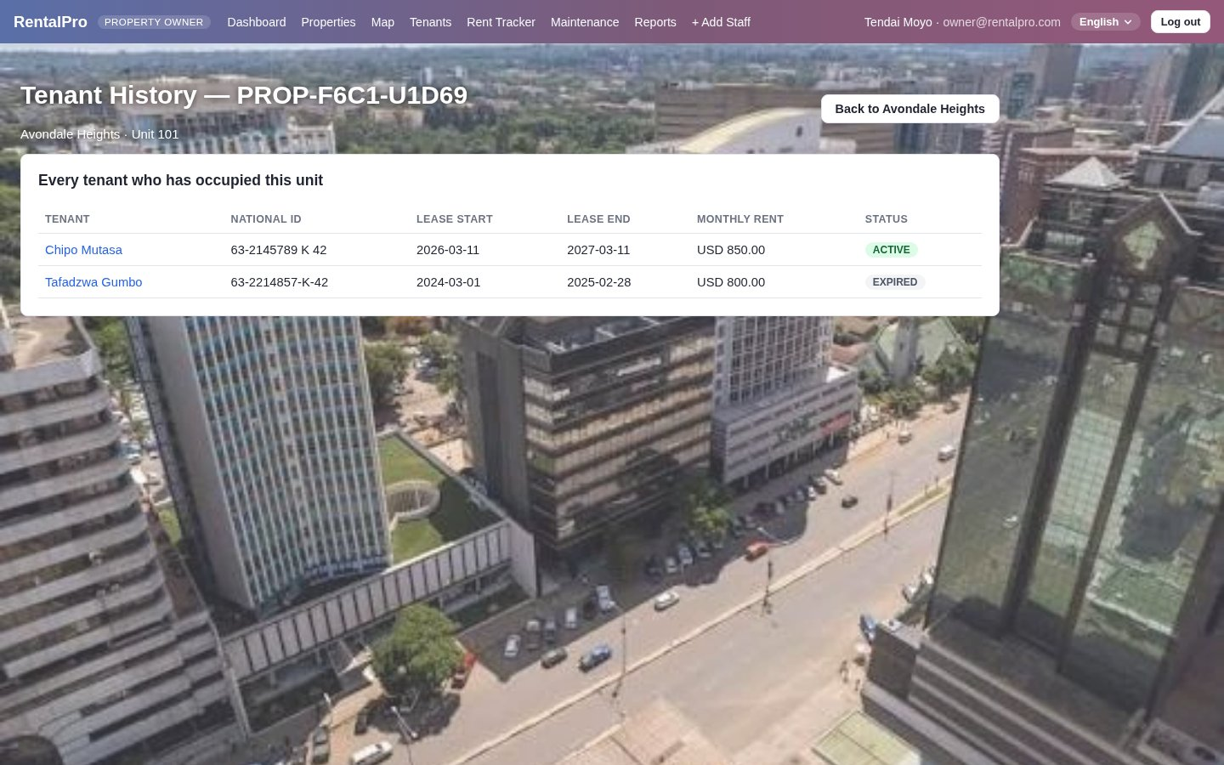
Figure 8: Tenant history for Avondale Heights, Unit 101 (FR-015)
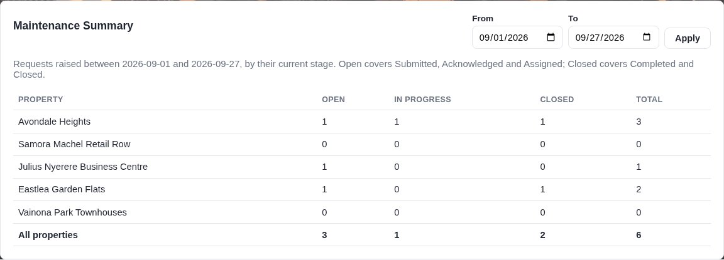
Figure 9: Maintenance Summary on the Reports page (FR-036)

Appendix A: Verifying the Deliverable 5 Features

A.1 Run the Tests
pytest tests/test_deliverable5.py -v # the 31 Deliverable 5 tests
pytest tests/ --cov=backend # the whole suite with coverage

A.2 Try Them in the Application
Start the application (Deliverable 4, Appendix A) and sign in with the password demo123:
Feature | Sign in as | Where to go
Edit a unit, unit photos | owner@rentalpro.com | Properties → a property → Edit on a unit
Property photos, late fees | owner@rentalpro.com | Properties → a property → Edit Property
Blacklist a tenant | manager@rentalpro.com | Tenants → a tenant → enter a reason → Blacklist Tenant
Manage users and roles | admin@rentalpro.com | Manage Users
Create a staff account | admin@rentalpro.com | + Add Staff
Maintenance photos | tenant1@email.com | Submit Request → attach photos
Rent history CSV | tenant1@email.com | Payment History → Export CSV
Excel report | owner@rentalpro.com | Reports → Export Excel
Tenant history per unit (after D5) | owner@rentalpro.com | Properties → a property → History on a unit
Maintenance summary (after D5) | owner@rentalpro.com | Reports → Maintenance Summary → choose dates → Apply

